Supplemental Figure S9
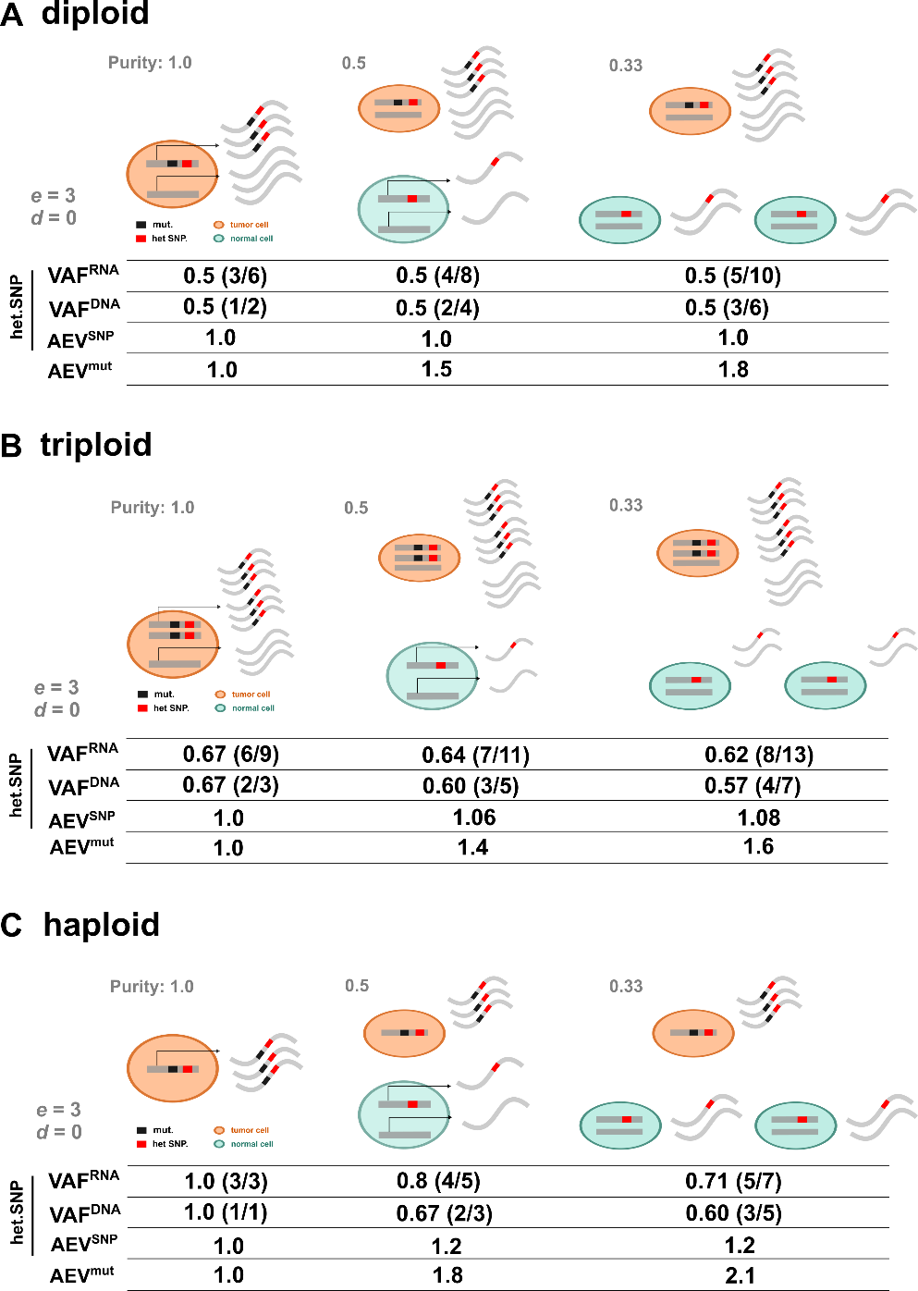

Figure S9. Effect of confounding factors on AEV of heterozygous SNPs. Under the scenario that the gene expression per copy is 3 times higher in tumor than in normal (e = 3) with absence of NMD (d = 0), the SNP-based AEV (AEV^{SNP}) is shown at tumor purities 1.0, 0.5, and 0.33 for A) diploid, B) triploid and C) haploid regions. The mutation-based AEV of (AEV^{mut}) is shown in the bottom row for comparison.

