Supplemental Figure S8.

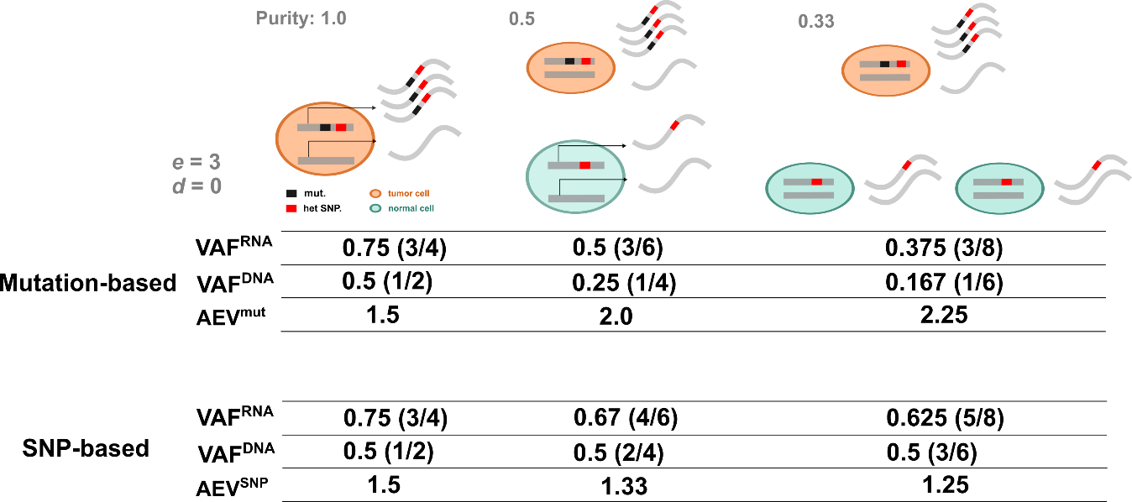

Figure S8. Illustration of mutation-based versus SNP-based allelic imbalance analyses. In this example, the haplotype harboring the mutant allele is transcribed 3 times more than the wild-type allele in tumor cells (true ASE) and there is no differential expression in the wild-type allele in tumor and normal cells. Allelic imbalance in this scenario is calculated in samples with purity 1.0, 0.5 and 0.33. The mutation-based approach (top) uses the read counts of the somatic mutation to calculate the imbalance (AEV) as the ratio of VAF^{RNA} to VAF^{DNA}, while the SNP-based approach (bottom) uses the heterozygous SNP read counts.

