Supplemental Figure S6.

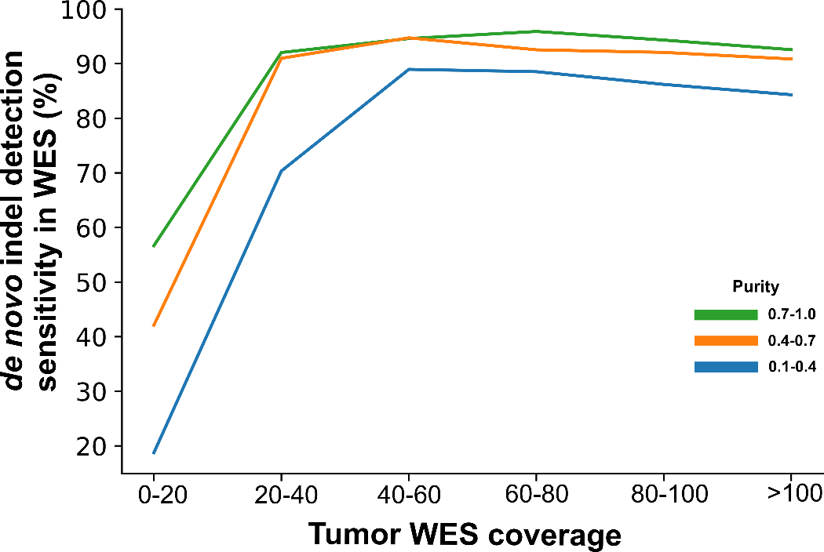

Figure S6. Assessment of DNA-based indel detection sensitivity stratified by WES coverage and tumor purity. Somatic driver indels detected by RNA-seq and validated by paired WES (RNA-only in Fig. 5A) and those detected from paired WES (DNA-only and Shared) were combined to make a truth set of high-confidence indels. The WES coverage at indel loci and sample’s purity were binned as shown. The sensitivity by the DNA-based approach at each coverage and purity bin was defined by the proportion of DNA-only and Shared indel at each data point.

