Supplemental Figure S5.
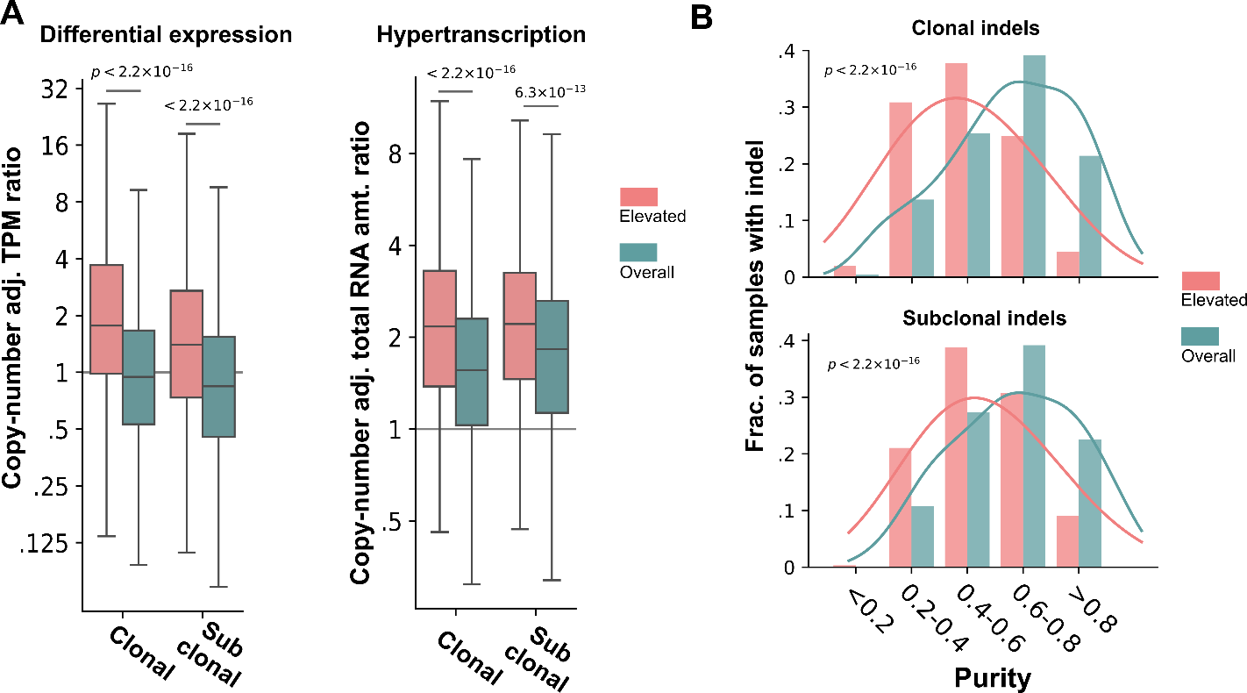
Figure S5. Evaluation of the AEV model with clonal and subclonal indels. A) The association between expression differences and AEV (Fig. 3C and D) was separately reanalyzed for clonal and subclonal indels. B) The inverse relationship between purity and AEV (Fig. 3E) was separately reanalyzed for clonal (top) and subclonal (bottom) indels.

