Supplemental Figure S3
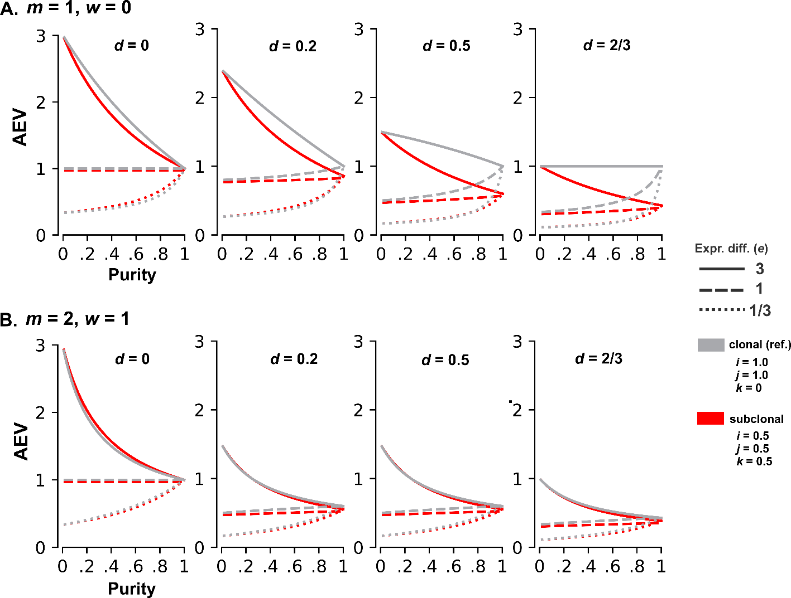
Figure S3. Simulation results of AEV for subclonal CNA/mutation. A) The AEV model is simulated for a copy loss of wild-type allele (m = 1 and w = 0) under clonal and subclonal scenarios at varying NMD efficiency and expression difference. The subclonal model has 3 additional parameters to represent subclonality (Equation 8 in METHODS): i for fraction of tumor cells carrying CNA, j for fraction of tumor cells with CNA carrying the mutant allele, and k for fraction of tumor cells without CNA carrying the mutant allele. The subclonal case is plotted in red for i = 0.5, j = 0.5, k = 0.5. The clonal case is added in gray as reference: i = 1, j = 1, and k = 0. Other subclonal scenarios including mutation associated with CNA can be simulated by a custom script (aev_sim.py) with similar patterns. B) Corresponding simulation for a copy gain of mutant allele case (m = 2, w = 1).

