Supplemental Figure S2
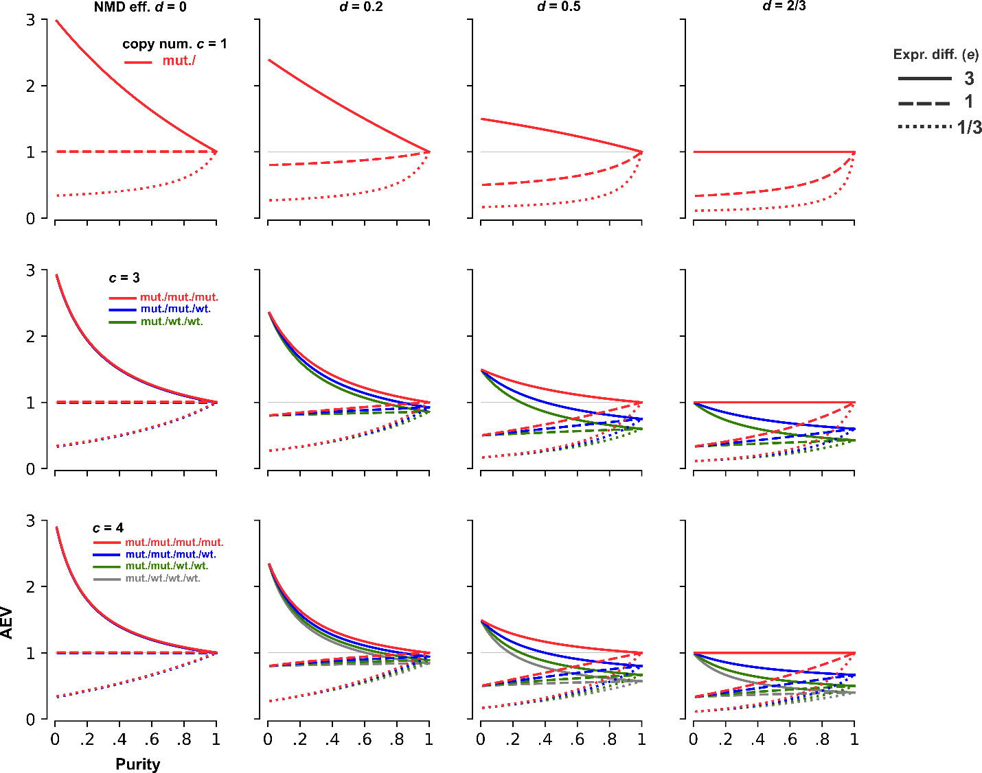

Figure S2. Simulation results of AEV in non-diploid regions. The AEV model is simulated for copy numbers c = 1 (top), 3 (middle) and 4 (bottom) at varying NMD efficiency. Possible mutant allele dosage for each copy number category is labeled by a distinct color. The fourth column illustrates the NMD efficiency d = 2/3, representing the upper bound of efficiency to observe an elevated AEV for copy-number adjusted expression difference e = 3.

