Supplemental Figure S11.
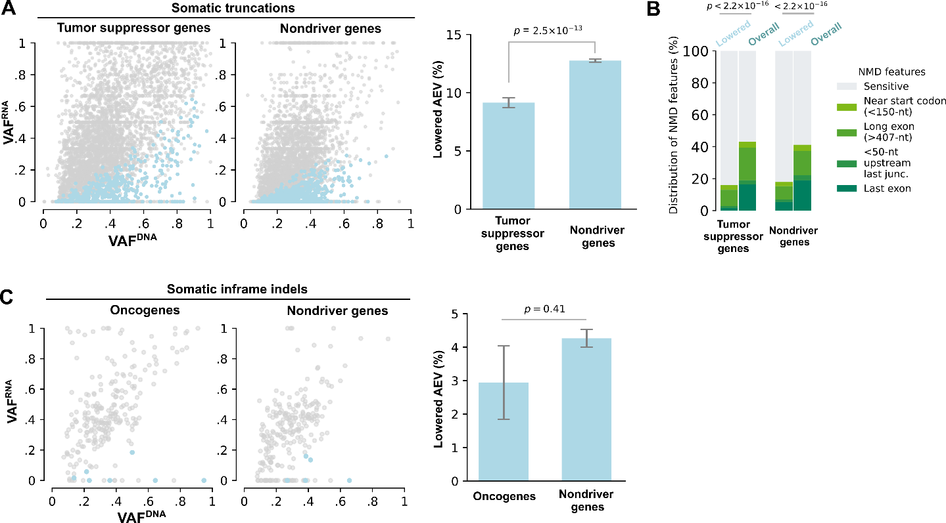
Figure S11. Reduced AEV in TCGA indels. A) Reduced AEV (VAF ratio < 0.8 with FDR < 0.01) for somatic truncating indels in TSGs (left) and non-drivers (right). The scatter plot is shown in a format similar to Fig. 3A except that reduced AEV cases are shown in blue. B) The distribution of NMD features in somatic truncations with reduced AEV was compared to the overall distribution in each gene category (similar to main Fig. 3G).C) Reduced AEV for somatic in-frame indels in oncogenes and non-drivers in the same format as for elevated AEV shown in Fig. 4A.

