Supplemental Figure S10

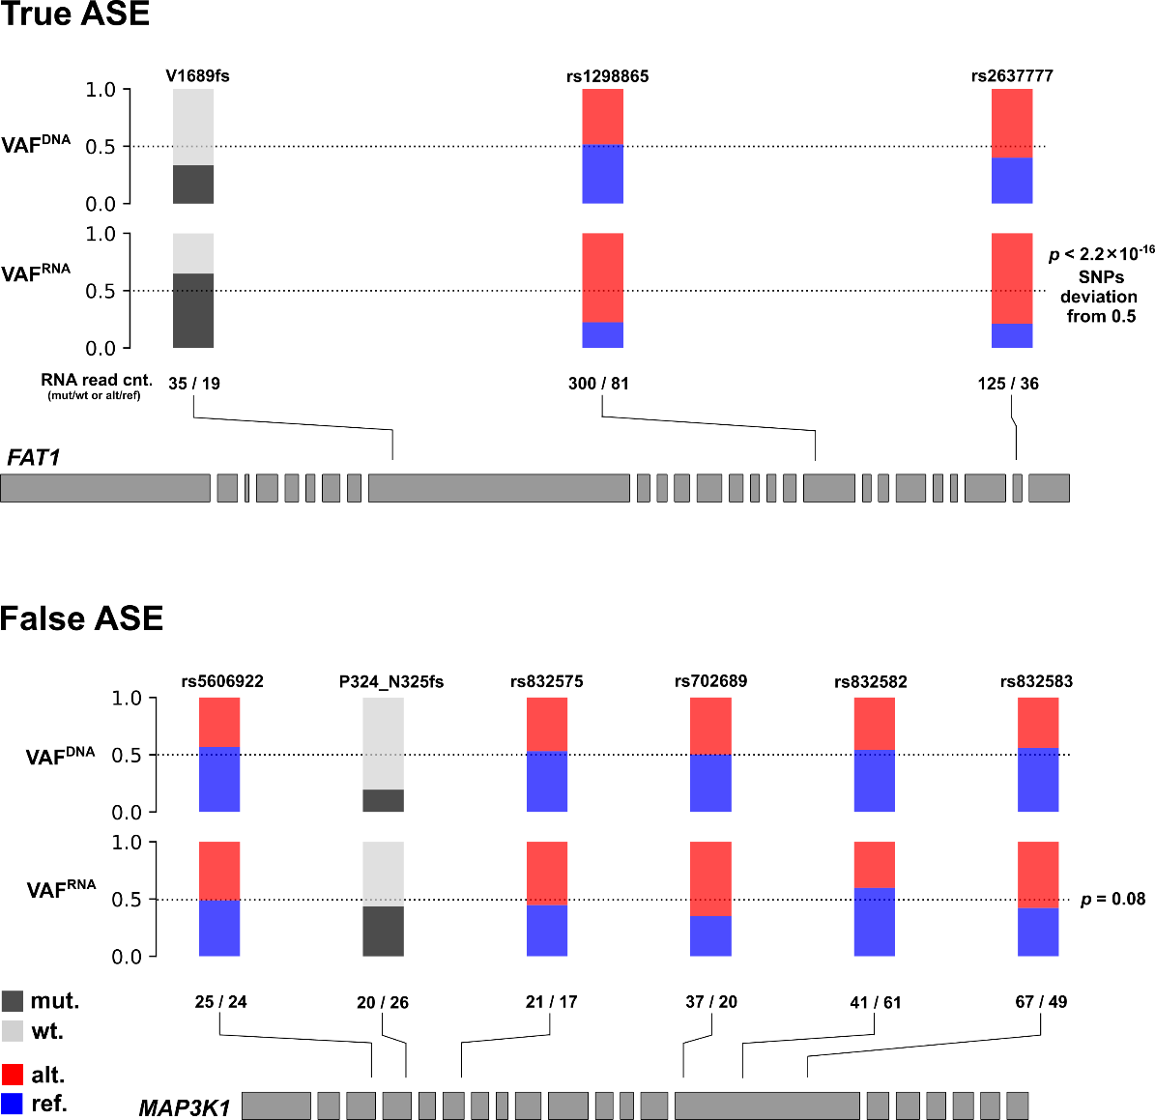

Figure S10. Distinguishing AEV caused by true ASE from that by confounding factors. The examples used here represent genes in diploid regions. Top: true ASE event with FAT1 V1689fs in a head-and-neck squamous cell carcinoma (TCGA-DQ-5629) characterized by the SNP VAF^{RNA} deviating from 0.5 (excluding mutation VAF^{RNA}) with a simulation-based p = 2.2×10⁻¹⁶ (METHODS). Bottom: false ASE with MAP3K1 P324_N325fs in a breast cancer (TCGA-BH-A0DT) exhibited an insignificant deviation with p = 0.08.

