Supplemental Figure S1
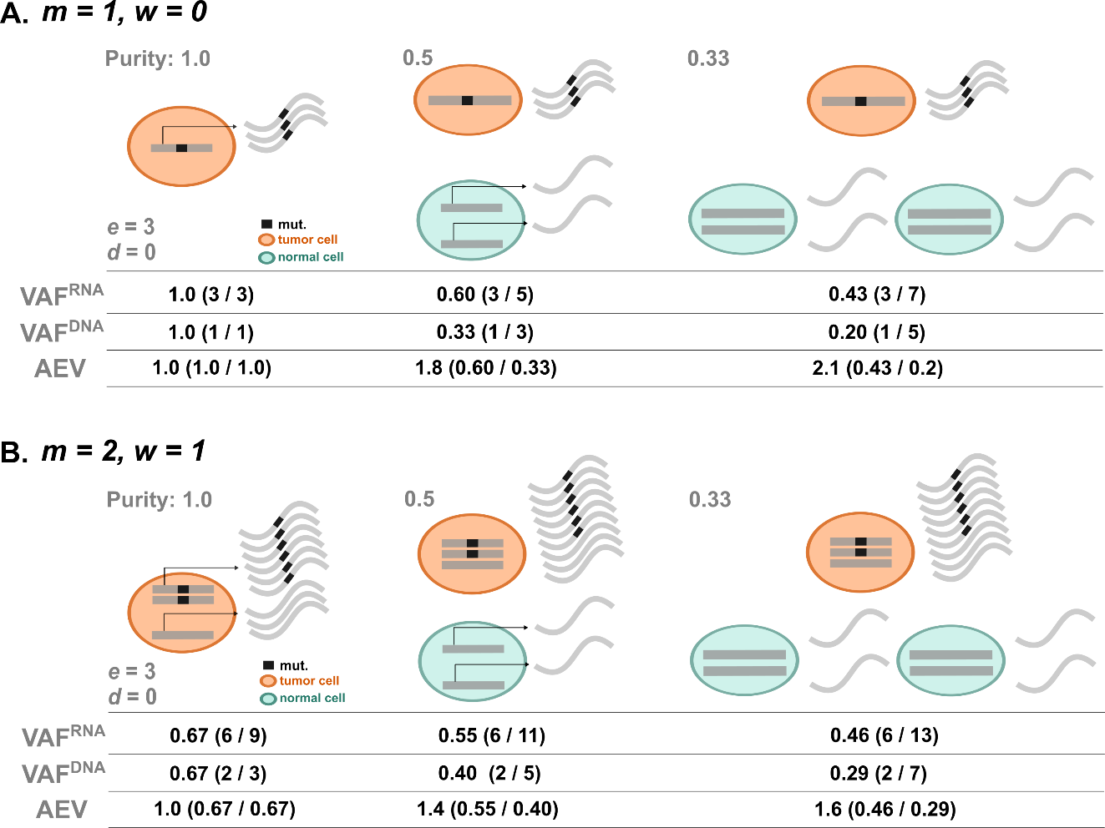

Figure S1. Illustrative examples for non-diploid cases. A) Illustration for a copy loss of wild-type allele case (mutant allele m = 1 and wild-type allele w = 0). Under the same scenario in main Fig. 2A (tumor/normal expression difference e = 3 with absence of NMD d = 0), the elevation of AEV is shown with the deceasing purity. B) Similar illustration for a copy gain of mutant allele case (m = 2 and w = 1).

