Supplemental Figures
Supplemental Fig S1. Full-length cDNA of Adar transcript in A. mellifera validated by RACE. The coding sequence has been translated into protein.

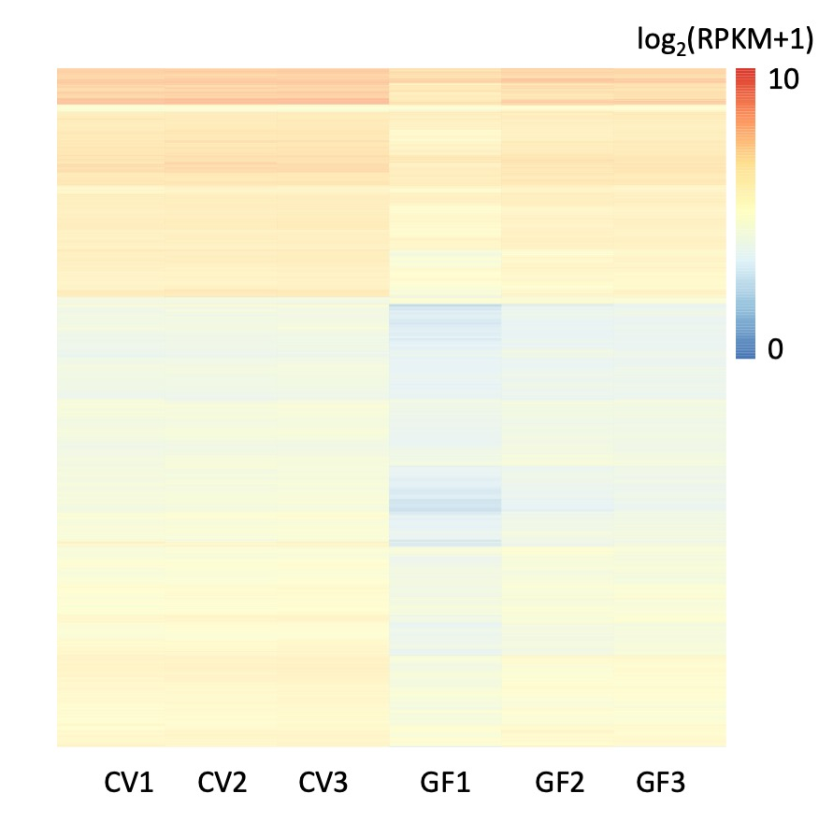
Supplemental Fig S2. Heatmap illustrating the expression levels of heads of six honey bee samples. CV: conventional. GF: germ-free.

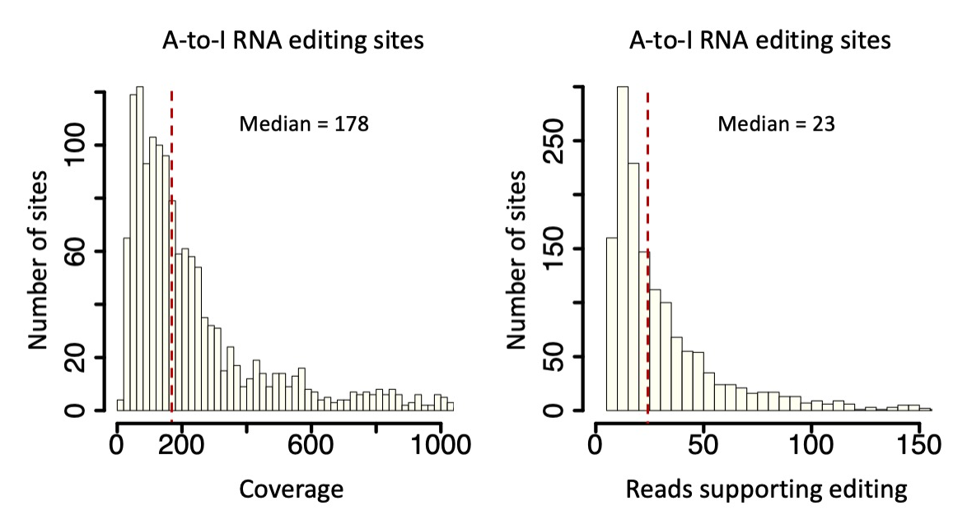
Supplemental Fig S3. Histograms showing the numbers of reads covering editing sites, and the numbers of reads supporting the editing events.

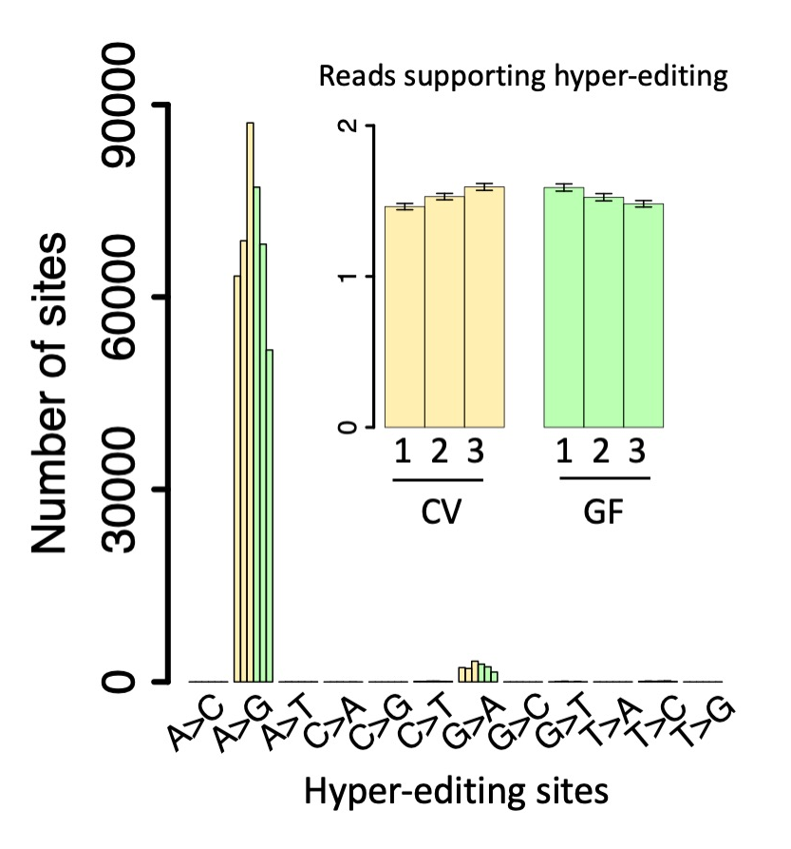
Supplemental Fig S4. The numbers of hyper-editing sites in each sample. The numbers of reads supporting editing events were also shown. Error bars represent standard error of mean. CV: conventional. GF: germ-free.

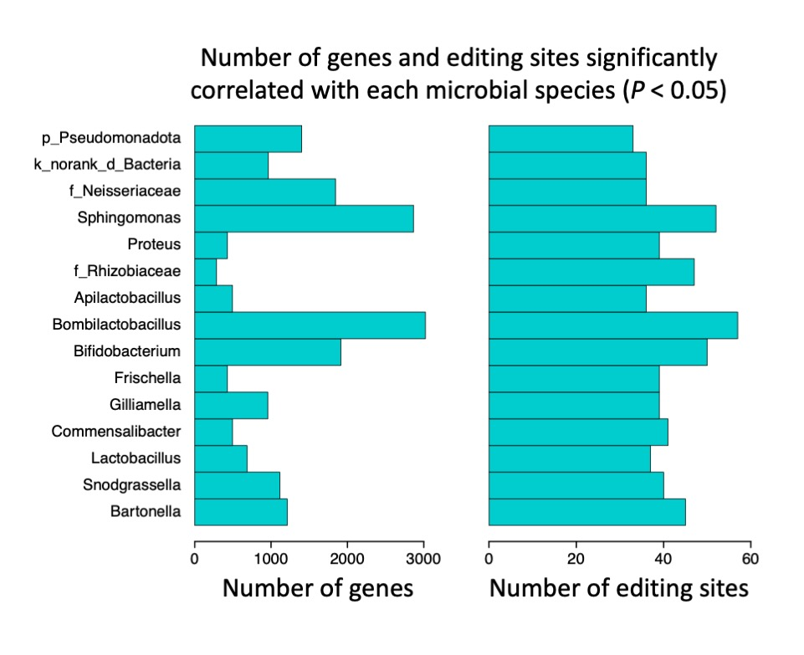
Supplemental Fig S5. Barplots showing the numbers of editing sites and genes with significant correlation (P < 0.05) with the relative abundance of each microbial lineage.

Supplemental Tables

Supplemental Table S1. Information of identified A-to-I RNA editing sites (txt).

Information of the 1,528 A-to-I RNA editing sites identified in Apis mellifera. AApos: position of the edited amino acid in protein sequence. AAchange: the change of amino acid caused by RNA editing. Non-coding variants were denoted as “NNN”.

Supplemental Table S2. Number of RDDs and RNA editing sites in each sample.
Sample | Number of RDDs | Number of editing sites
CV1 | 1954 | 1326
CV2 | 2030 | 1391
CV3 | 2120 | 1474
GF1 | 2051 | 1405
GF2 | 2022 | 1387
GF3 | 1877 | 1295
CV pooled | 2227 | 1522
GF pooled | 2224 | 1523

Supplemental Table S3. Primers used in the study
Experiment | Primer name | Primer sequence (5’-3’)
Adar RACE | CDS-F | ATGGAGCAGCCAAACATTTGCA
Adar RACE | CDS-R | TCAGATATCAACTTCAAACATATCTTG
Adar RACE | 5' GSP | TGCAAGTTCAGCAGCAGCATGTTTTGCC
Adar RACE | 5' Nested GSP | ATATTGGAGCATGCGTGGGGCCAGTTTG
Adar RACE | 3' GSP | CCCAAGCCATATGTATAGGGCGGTCTGC
Adar RACE | 3' Nested GSP | CGATCCAAGGATTACCGCCCCCATACAG
16s rRNA (Liu et al. 2016) | 338F | ACTCCTACGGGAGGCAGCAG
16s rRNA (Liu et al. 2016) | 806R | GGACTACHVGGGTWTCTAAT
qPCR (Zufelato et al. 2004) | q-Adar-F | CCGAATCGAAGAGCAAGAGG
qPCR (Zufelato et al. 2004) | q-Adar-R | GTCCGAACACGACATCGTCA
qPCR (Zufelato et al. 2004) | q-actin-F | TGCCAACACTGTCCTTTCTG
qPCR (Zufelato et al. 2004) | q-actin-R | AGAATTGACCCACCAATCCA
Sanger sequencing for validation of RNA editing sites | Adar-F | CCGAATCGAAGAGCAAGAGG
Sanger sequencing for validation of RNA editing sites | Adar-R | GGCTTGGGTTCAATAGACTGCC
Sanger sequencing for validation of RNA editing sites | Shab-F | AAGACGACTCAACACTGGCG
Sanger sequencing for validation of RNA editing sites | Shab-R | ACCGACAACAGCAACTCCTC
Sanger sequencing for validation of RNA editing sites | Lap-F | ACTCTGCAGTGCTCAAGACC
Sanger sequencing for validation of RNA editing sites | Lap-R | TCGTCAAACGCGCTCTTACT
Sanger sequencing for validation of RNA editing sites | qvr-F | CACTTCCGAGGGATCAACCG
Sanger sequencing for validation of RNA editing sites | qvr-R | TTCGGACGACGAGGAATGTG
Sanger sequencing for validation of RNA editing sites | LOC412243 protein split ends-F | GGCAGTTTCTACACGAGCGA
Sanger sequencing for validation of RNA editing sites | LOC412243 protein split ends-R | GCCGCGATGACGATCTAAGT
Sanger sequencing for validation of RNA editing sites | LOC725596 leukocyte receptor cluster member 8 homolog-F | GGGACCAAGAACCTTTGCCT
Sanger sequencing for validation of RNA editing sites | LOC725596 leukocyte receptor cluster member 8 homolog-R | CCTCGACCTTGACCGTTTGT

Supplemental Data

Supplemental Data S1. Sanger sequencing files generated in this study.

Supplemental Methods

Extraction and sequencing of DNA and RNA from GF and CV honey bees
For the first batch of honey bees, RNA was extracted from the heads of three honey bees using TRIzol, and designated as one biological replicate. For both GF and CV groups, three biological replicates were sequenced using an Illumina HiSeq X Ten platform (PE150). DNA from the thoraxes of the corresponding honey bees in each biological replicate was extracted with TIANamp genomic DNA kit (TIANGEN, Beijing, China), and sequenced with Illunina NovoSeq 6000 platform (PE150).
For the second batch of 12 GF and CV bees, the head of each bee was set as one biological replicate and used for RNA sequencing and quantitative PCR (qPCR). The gut of each honey bee was collected for 16S rRNA sequencing. RNA was extracted from the head of each honey bees using VeZol Reagent (R411-01, Vazyme, Nanjing, China). For both GF and CV groups, DNBSEQ Eukaryotic Strand-specific mRNA library was constructed for each of the 12 biological replicates, sequenced using an DNBSEQ platform (PE150) in Shenzhen BGI Genomics.
The DNA for each gut from CV honey bee was extracted with E.Z.N.A.® soil DNA kit (Omega Bio-tek, Norcross, GA, U.S.). The V3–V4 region of the bacterial 16S rRNA gene was amplified using the primer pair 338F (5'-ACTCCTACGGGAGGCAGCAG-3') and 806R (5'-GGACTACHVGGGTWTCTAAT-3') (Liu et al. 2016). Each 20 μl reaction mixture contained 0.2 μM of each forward and reverse primer and 10 ng of genomic DNA. The amplification protocol consisted of initial denaturation at 95°C for 3 min; followed by 27 cycles of denaturation at 95°C for 30 s, annealing at 55°C for 30 s, and extension at 72°C for 45 s; with a final extension at 72°C for 10 min. The PCR products were separated on a 2% agarose gel, purified using a PCR Clean-Up Kit (YuHua, Shanghai, China), and quantified with a Qubit 4.0 fluorometer (Thermo Fisher Scientific, USA). Purified amplicons were paired-end sequenced on an Illumina NextSeq2000 platform (Illumina, San Diego, USA) following standard protocols by Majorbio Bio-Pharm Technology Co., Ltd. (Shanghai, China).
RACE of Adar gene in honey bee
The full-length nucleotide sequence of Adar was amplified using RACE (Rapid-amplification of cDNA ends) technique with the HiScript-TS 5′/3′ RACE Kit (RA101, Vazyme, Nanjing, China). Gene-specific primers for 5’ RACE (5’ GSP, 5’ Nested GSP) and 3’ RACE (3’ GSP, 3’ Nested GSP) were designed (Supplemental Table S3) based on the known sequences of Adar (Gene ID: 408529) in NCBI. The cDNA templates were synthesized from total RNA extracted from the heads of CV honey bees according to the manual from RACE kit. The amplification conditions of the first PCR run were denaturing at 98℃ for 1 min, then 30 cycles of 98℃ for 10 s and annealing at 69℃ for 15 s, and extension at 72℃ for 3 min, and final extension at 72℃ for 5 min. The PCR products were diluted for 50 folds and used as template for the second PCR. The amplification conditions of the nested PCR run were the same as the first PCR run. The products for the nested PCR were cloned into pCE2-TA-Blunt-Zero vector (C601, Vazyme, Nanjing, China) and ten single clones were sequenced.
Since the gene-specific primers for 5’ RACE were designed near the 5’end and those for 3’ RACE were designed near the 3’end, we also cloned the middle CDS region of Adar to obtain its full-length sequence. The PCR reaction mixture for the CDS fragment cloning (20 μL) includes 1 μL of cDNA, along with 0.4 μM of each primer (Table S4), and 2X Phanta Max Master Mix (Dye Plus) (P525, Vazyme, Nanjing, China). The amplification conditions of the first PCR run were denaturing at 98℃ for 1 min, then 30 cycles of 98℃ for 10 s and annealing at 60℃ for 15 s, and extension at 72℃ for 3 min, and final extension at 72 ℃ for 5 min.
Identification of A-to-I RNA editing sites
To identify authentic RNA editing sites, we need to ensure that the variants occurred on RNA rather than other resources. As described by researchers in this field, the confounding factors in RNA editing detection include (1) sequencing errors (Ramaswami et al. 2013); (2) false positive mismatches produced by misalignments (Li et al. 2014); and (3) genomic polymorphisms or termed single nucleotide polymorphisms (SNP) (Liscovitch-Brauer et al. 2017). By implementing a base quality > 30, the sequencing errors has been mitigated to some extent. Furthermore, ensuring the accuracy of alignments through the support of both aligners addresses concerns related to misalignments. Hence, the primary focus shifts towards effectively excluding SNPs.
In each of the six samples (3 CV and 3 GF), we require (1) coverage ≥ 5 in RNA-seq; (2) alternative reads ≥ 2 in RNA-seq; and (3) P_{(binomial)} < 0.01 in RNA-seq to rule out sequencing errors. Additionally, (4) coverage ≥ 10 in DNA-seq of the matched individual; (5) no alternative reads in DNA-seq of the matched individual were required to exclude genomic SNPs. These stringent requirements ensure that the identified variation are authentic RNA-DNA difference (RDD). Note that P_{(binomial)} was a commonly used parameter in RNA editing studies to measure the probability of a given variation coming from sequencing errors under a particular NGS error rate of 0.001 (Alon et al. 2015; Liscovitch-Brauer et al. 2017). P_{(binomial)} < 0.01 represents a 99% confidence that this observed variation is not caused by sequencing errors.
In each of the six samples, the variants meeting criteria (1) to (5) were regarded as candidate RNA editing sites (RDDs) in that particular sample. To further exclude unknown random factors, and consolidate the authenticity of RNA editing sites, we required a site to appear in at least three out of the six samples. After this step, we obtained 2,251 RDDs and 1,528 (68%) of them were A-to-G variants. Under random expectation, A-to-G variants should only account for 1/12 (or slightly higher) of the 12 possible mismatch types. The observed impressive 68% enrichment of A-to-G was strong evidence indicating that these A-to-G RDDs were likely to be A-to-I RNA editing sites.
For the public brain transcriptomes of CV, GF, F4, F5, and Gi honey bees, no matched DNA-seq were available. We also used two aligners STAR 2.7.6a (Dobin et al. 2013) and BWA 0.7.17-r1198 (Li and Durbin 2009) to map the reads to the reference genome and maintained those alignments supported by two software. We directly extracted the reads count of reference allele and alternative allele for each of the 1,528 editing sites. REDItools version 2.0 was used to facilitate the extraction of editing status on given sites (Picardi and Pesole 2013). Editing levels were calculated by G/(G+A) on each site.
Cumulative editing level refers to the sum of editing levels of all sites in a sample (Alon et al. 2015). In this study, to exclude extreme editing levels caused by low sequencing depth, we required a site to have total depth > 50 among the 24 samples and used these sites to calculate cumulative editing levels in different samples.

References
Alon S, Garrett SC, Levanon EY, Olson S, Graveley BR, Rosenthal JJ, Eisenberg E. 2015. The majority of transcripts in the squid nervous system are extensively recoded by A-to-I RNA editing. eLife 4: e05198.
Dobin A, Davis CA, Schlesinger F, Drenkow J, Zaleski C, Jha S, Batut P, Chaisson M, Gingeras TR. 2013. STAR: ultrafast universal RNA-seq aligner. Bioinformatics 29: 15-21.
Li H, Durbin R. 2009. Fast and accurate short read alignment with Burrows-Wheeler transform. Bioinformatics 25: 1754-1760.
Li Q, Wang Z, Lian J, Schiott M, Jin L, Zhang P, Zhang Y, Nygaard S, Peng Z, Zhou Y et al. 2014. Caste-specific RNA editomes in the leaf-cutting ant Acromyrmex echinatior. Nat Commun 5: 4943.
Liscovitch-Brauer N, Alon S, Porath HT, Elstein B, Unger R, Ziv T, Admon A, Levanon EY, Rosenthal JJC, Eisenberg E. 2017. Trade-off between transcriptome plasticity and genome evolution in cephalopods. Cell 169: 191-202 e111.
Liu C, Zhao D, Ma W, Guo Y, Wang A, Wang Q, Lee DJ. 2016. Denitrifying sulfide removal process on high-salinity wastewaters in the presence of Halomonas sp. Appl Microbiol Biotechnol 100: 1421-1426.
Picardi E, Pesole G. 2013. REDItools: high-throughput RNA editing detection made easy. Bioinformatics 29: 1813-1814.
Ramaswami G, Zhang R, Piskol R, Keegan LP, Deng P, O'Connell MA, Li JB. 2013. Identifying RNA editing sites using RNA sequencing data alone. Nat Methods 10: 128-132.
Zufelato MS, Lourenco AP, Simoes ZL, Jorge JA, Bitondi MM. 2004. Phenoloxidase activity in Apis mellifera honey bee pupae, and ecdysteroid-dependent expression of the prophenoloxidase mRNA. Insect Biochem Mol Biol 34: 1257-1268.

