Supplemental Figures
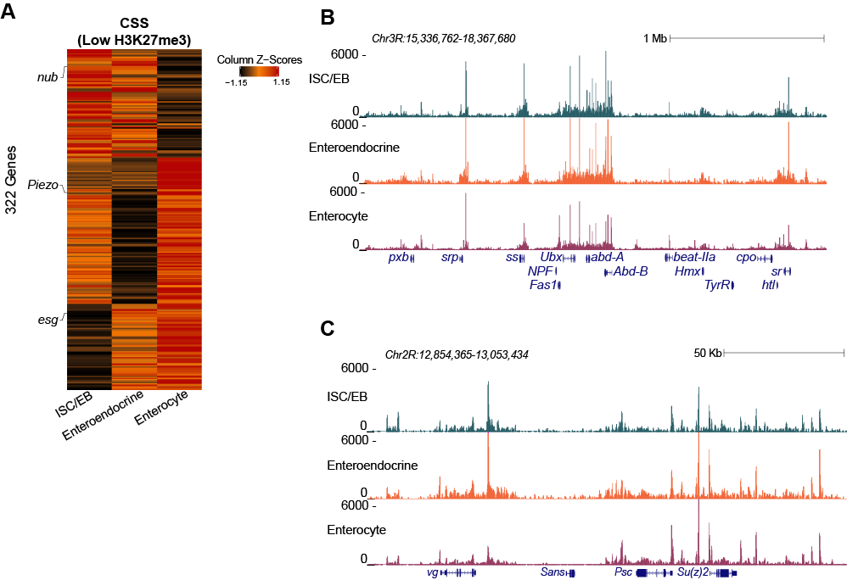
Supplemental Figure S1. H3K27me3 sciCUT&Tag. (A) ArchR heatmap using all cells in the experiment to show chromatin silencing scores (CSS) for genes that have low H3K27me3 signal for each cell type in UMAP in Fig. 1B. (B-C) UCSC Genome Browser tracks of repressed BX-C (B) and Psc-Su(z)2 (C) domains in the three cell types in young guts.

Supplemental Figure S2. Increase in H3K27me3 fragments per cell in aged guts. Violin plots of fragments per cell for three ages of each cell type. P-values represent the results of pair-wise Wilcox tests.

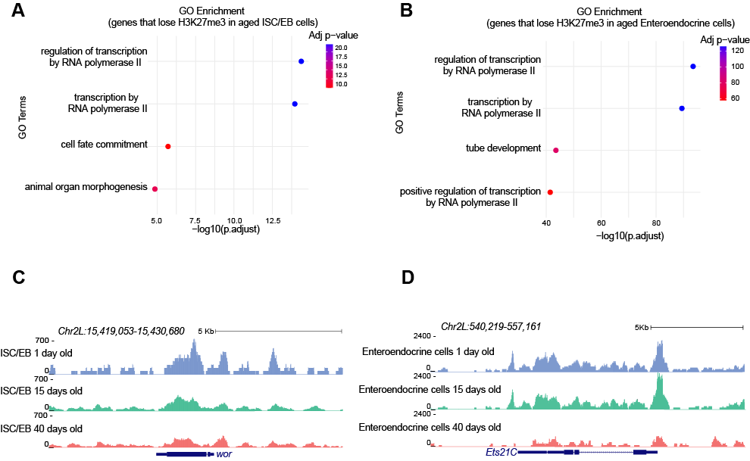
Supplemental Figure S3. Transcription factor genes lose the H3K27me3 mark in aged ISC/EBs and enteroendocrine cells. (A-B) Top four GO terms on genes that lose H3K27me3 signal in aged ISC/EBs (A) and enteroendocrine cells (B) from differential analysis. (C-D) UCSC Genome Browser tracks of example genes from GO analysis listed in panels A and B that lose H3K27me3 signal in aged ISC/EBs at wor (C) and enteroendocrine cells at Ets21C (D).

Supplemental Figure S4. Changes in H3K27me3 signal in regulatory regions in ISC/EBs and Enterocytes. (A-B) Log₂ transformed counts and z-scored normalized heatmaps from differential analysis of H3K27me3 over STARR-seq enhancers (Zabidi et al. 2015) between young and old cells. (A) ISC/EBs have 3 enhancers that gain H3K27me3 signal with age and 15 that lose H3K27me3 signal with age. (B) Enterocytes have 264 enhancers that gain H3K27me3 signal with age and 142 that lose H3K27me3 signal with age. (C-F) Dot plots representing the -log₁₀ q-value and percent of enhancers that contain a specific transcription factor motif from FIMO (Grant et al. 2011). (C) Motifs enriched in enhancers that lose H3K27me3 signal in aged ISC/EBs. (D) Motifs enriched in enhancers that gain H3K27me3 signal in aged ISC/EBs. (E) Motifs enriched in enhancers that lose H3K27me3 signal in aged enterocytes. (F) Motifs enriched in enhancers that gain H3K27me3 signal in aged enterocytes.

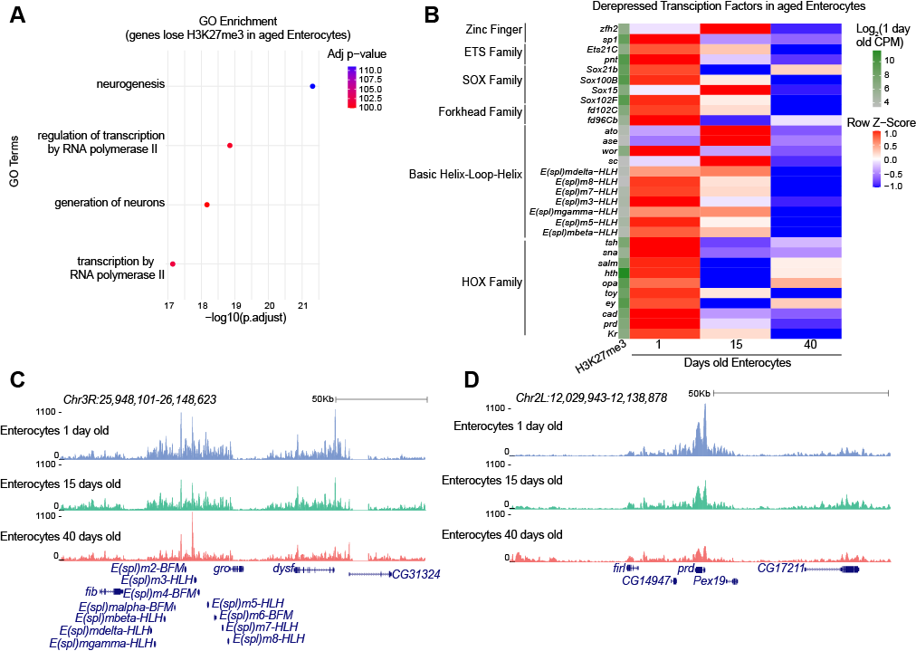

Supplemental Figure S5. Transcription factor genes lose the H3K27me3 mark in aged enterocytes. (A) Top four GO terms on genes that lose H3K27me3 signal in aged enterocytes from differential analysis. (B) Row z-score normalized heatmap of H3K27me3 counts for transcription factor genes identified in GO analysis from panel A that decrease in H3K27me3 signal in aged enterocytes. The first column is the log₂ transformed counts for 1-day old tissue for each gene. (C-D) UCSC Genome Browser tracks of example transcription factors that lose H3K27me3 signal in aged enterocytes: Enhancer of split complex genes (C) and paired (D).

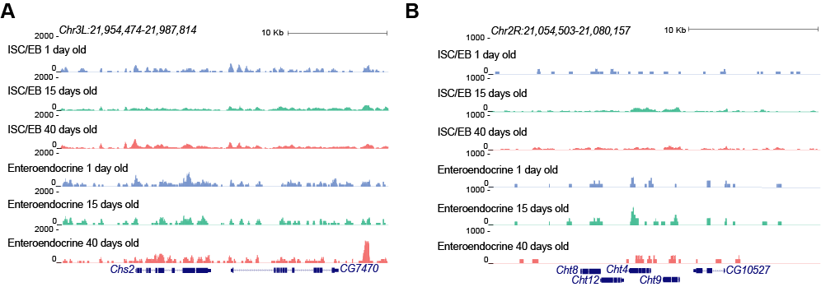
Supplemental Figure S6. Chitin genes lack the H3K27me3 mark in ISC/EBs and enteroendocrine cells. (A-B) UCSC Genome Browser tracks of H3K27me3 signal for ISC/EBs and enteroendocrine cells at Chs2 (A) and cluster of Cht genes (B).

Supplemental Figure S7. Matrix of Pearson’s correlation coefficient for all RNAPIIS5P CUTAC reactions. Replicates between ages show high reproducibility.

Supplemental Figure S8. Genome browser tracks of RNAPIIS5P and Pc signal over chitin genes. (A-B) UCSC Genome Browser track of RNAPII5P over Chs2 (A) and cluster of Cht genes (B) for all three ages. (C-D) UCSC Genome Browser track of Pc over Chs2 (C) and cluster of Cht genes (D) for all three ages. (E-F) UCSC Genome Browser track of Pc over rad (E) and dy (F) for all three ages to illustrate low level of Pc signal that is not above background.
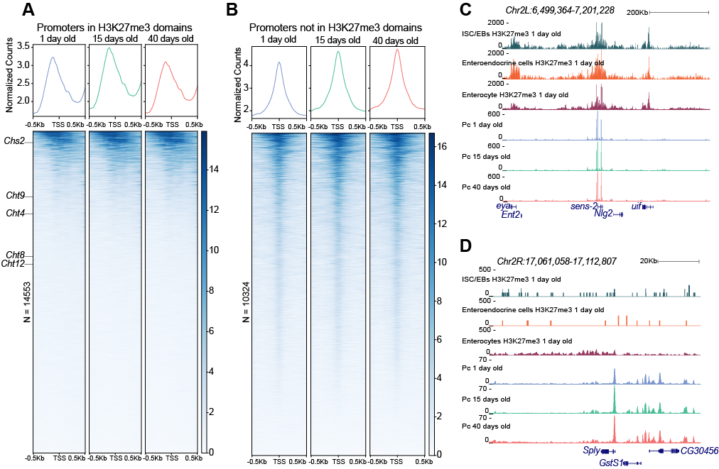

Supplemental Figure S9. Pc protein binds to promoters located inside and outside of H3K27me3 domains. (A-B) Summary plot and heatmap of Pc signal from three ages of guts aligned to transcription start site (TSS) of promoters located within
H3K27me3 domains (A) and promoters located outside of H3K27me3 domains (B). Pc is stably bound during aging. Chitin gene promoters are labelled in A. (C-D) UCSC Genome Browser tracks depicting Pc binding in the sens-2 domain (C) and at the Sply promoter which lacks the H3K27me3 mark (D).

Supplemental Figure S10. Enteroendocrine precursor genes become derepressed in aged ISC/EBs. Row z-score normalized heatmap of H3K27me3 counts of ISC/EBs for precursor enteroendocrine and neural stem cells genes defined in (Tauc et al. 2021). The first column is the log₂ transformed counts for 1-day old tissue for each gene. All of these genes become derepressed with age in ISC/EB.

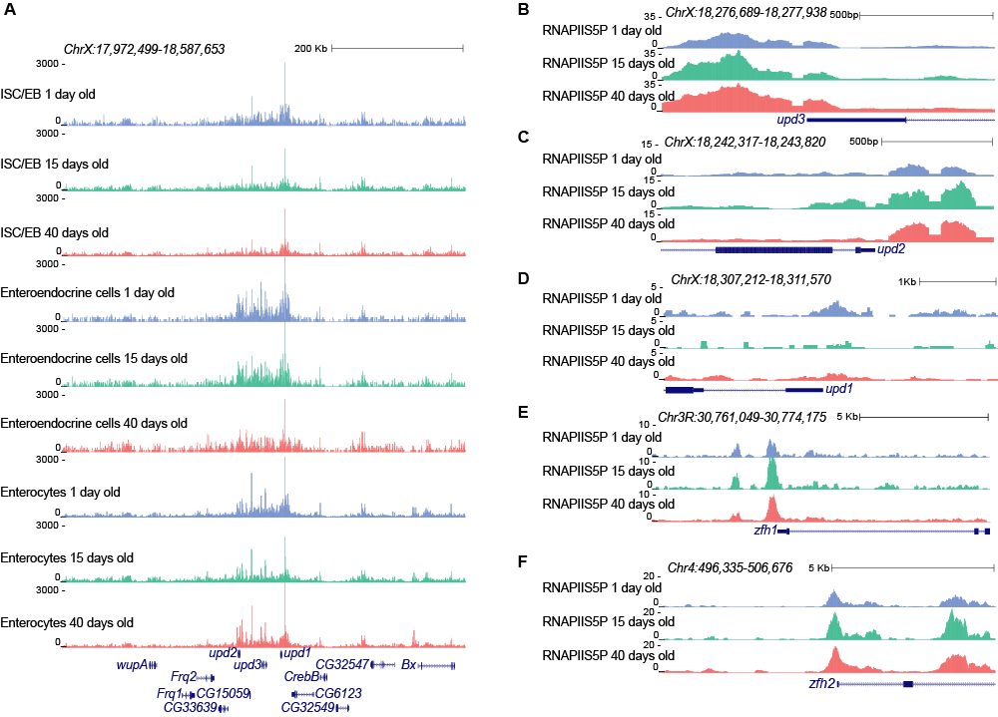

Supplemental Figure S11. Genome browser tracks of JAK/STAT ligands and target genes. (A) UCSC Genome Browser track of H3K27me3 level for all three cell types over the UPD domain. (B-D) UCSC Genome Browser tracks of RNAPIIS5P level over the promoters of upd3 (B), upd2 (C), and upd1. (E-F) UCSC Genome Browser tracks of RNAPIIS5P level over the promoters of known JAK/STAT targets genes such as zfh1 (E) and zfh2 (F).

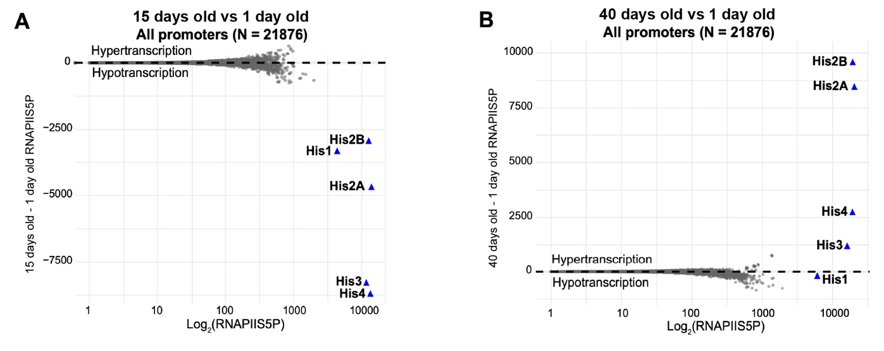
Supplemental Figure S12. S-phase-dependent histone genes gain RNAPIIS5P from 1 day old to 40 days old guts. (A) RNAPIIS5P counts for the absolute difference (15 days old – 1 day old) counts versus average count (log₁₀(15 days old + 1 day old)/2) for all promoters in the Drosophila genome. The core histone genes are highly expressed and lose RNAPIIS5P in mid-age guts. (B) RNAPIIS5P counts for the absolute difference (40 days old – 1 day old) counts versus average count (log₁₀(40 days old + 1 day old)/2) for all promoters in the Drosophila genome. The core histone genes gain RNAPIIS5P signal in 40 days old tissues.

Supplementary Tables (provided as .xlsx):

Table S1: Alignment statistics for sequencing data used in this paper
Table S2: List of peaks called by SEACR on aggregate H3K27me3 sciCUT&Tag data
Table S3: List of fragment numbers per cell for H3K27me3 sciCUT&Tag
Table S4: List of fraction of reads in peaks (FRiPs) per cell for H3K27me3 sciCUT&Tag
Table S5: List of ratio of reads that fall within blacklisted regions per cell for H3K27me3 sciCUT&Tag
Table S6: List of number of cells by cell type for each age and median fragments per cell
Table S7: List of genes that fall within H3K27me3 sciCUT&Tag peaks
Table S8: Gene count table for genes within peaks for ISC/EBs
Table S9: Gene count table for genes within peaks for enteroendocrine cells
Table S10: Gene count table for genes within peaks for enterocytes
Table S11: Results from differential analysis of genes between 1 day old cell types performed on the Degust server
Table S12: Results from differential analysis of genes between 1 day old and 40 days old cells for ISC/EBs performed on the Degust server
Table S13: Results from differential analysis of genes between 1 day old and 40 days old cells for enteroendocrine cells performed on the Degust server
Table S14: Results from differential analysis of genes between 1 day old and 40 days old cells for enterocytes performed on the Degust server
Table S15: Results from Gene Ontology analysis for genes that lose H3K27me3 signal in aged ISC/EBs
Table S16: Results from Gene Ontology analysis for genes that lose H3K27me3 signal in aged enteroendocrine cells
Table S17: Results from differential analysis for STARR-seq enhancers (Zabidi et al. 2015) between 1 day old and 40 days old ISC/EBs performed on the Degust server
Table S18: Results from differential analysis for STARR-seq enhancers (Zabidi et al. 2015) between 1 day old and 40 days old enterocytes performed on Degust server
Table S19: Results from Gene Ontology analysis for genes that lose H3K27me3 signal in aged enterocytes
Table S20: Results from Gene Ontology analysis for genes that gain H3K27me3 signal in aged enterocytes
Table S21: Cell type counts from single-cell RNA-seq data (Hung et al. 2020) for chitin genes
Table S22: Promoter count tables for RNAPIIS5P
Table S23: Cell counts from single-cell RNA-seq from (Tauc et al. 2021)
Table S24: Results from differential analysis of RNAPIIS5P at promoters between 1 day old and 40 days tissues performed on the Degust server
Table S25: Promoter count tables for Pc
Table S26: Pc signal vs IgG for selected promoters from Supplemental Figure S7

References

Grant CE, Bailey TL, Noble WS. 2011. FIMO: scanning for occurrences of a given motif. Bioinformatics 27: 1017-1018.
Hung RJ, Hu Y, Kirchner R, Liu Y, Xu C, Comjean A, Tattikota SG, Li F, Song W, Ho Sui S et al. 2020. A cell atlas of the adult Drosophila midgut. Proc Natl Acad Sci U S A 117: 1514-1523.
Tauc HM, Rodriguez-Fernandez IA, Hackney JA, Pawlak M, Ronnen Oron T, Korzelius J, Moussa HF, Chaudhuri S, Modrusan Z, Edgar BA et al. 2021. Age-related changes in polycomb gene regulation disrupt lineage fidelity in intestinal stem cells. Elife 10: e62250.
Zabidi MA, Arnold CD, Schernhuber K, Pagani M, Rath M, Frank O, Stark A. 2015. Enhancer-core-promoter specificity separates developmental and housekeeping gene regulation. Nature 518: 556-559.

