v. 11sep2025
Supplemental Materials for the manuscript "Strong bias in long-read sequencing prevents assembly of Drosophila melanogaster Y-linked genes"

A. Bernardo Carvalho, Bernard Y. Kim, and Fabiana Uno

(Supplemental Methods, Results, Discussion, Tables, Figures, and References)

Supplemental Methods 3
Assembly of "missing exons" contigs 3
Search for "missing exons" in all D. melanogaster protein-coding genes. 6
Homogeneity of satellite blocks in the human and D. melanogaster genomes. 8
Supplemental Results 9
The complex satellite 1.688 does not cause significant sequencing bias. 9
Supplemental Discussion 10
Estimation of recovery of D. virilis satellite sequences in raw reads. 10
Supplemental Tables 11
Supplemental Table S1. Number of failed ONT reads in selected genomic regions. 11
Supplemental Table S2. Statistical analysis of exon start positions in simulated reads 12
Supplemental Table S3. Statistical analysis of exon start positions in reads using the Kolmogorov-Smirnov test. 13
Supplemental Table S4. Missing exons in non-Y-linked D. melanogaster genes. 14
Supplemental Table S5. Raw read datasets used in this work. 15
Supplemental Figures 16
Supplemental Figure S1. Assembly of Y-linked genes using ONT or Illumina reads. 16
Supplemental Figure S2. Coverage of Y-linked genes by ONT and Illumina reads. 17
Supplemental Figure S3. Coverage of ten random X-linked genes by ONT reads. 19
Supplemental Figure S4. Base quality values along a ONT read covering a simple satellite block. 20
Supplemental Figure S5. Rearranged or quimeric reads in a missing exon region. 21
Supplemental Figure S6. Independent, nearly identical reads covering a missing exon in the kl-3 gene. 22
Supplemental Figure S7. Independent, nearly identical reads covering a missing exon in the kl-5 gene. 23
Supplemental Figure S8. Confirmation of the null hypothesis for exon position within the reads. 24
Supplemental Figure S9. Random genome sampling and read start points (all regions). 25
Supplemental Figure S10. Sequencing bias in the JYalpha gene. 26
Supplemental Figure S11. Sequencing bias in the Marf1 gene 27
Supplemental Figure S12. Sequencing bias in the DIP-lambda gene 28
Supplemental Figure S13. Sequencing bias in the CG42402 gene 29
Supplemental Figure S14. Sequencing bias in the Myo81F gene 30
Supplemental Figure S15. Sequencing bias in the Pzl gene 31
Supplemental Figure S16. Sequencing bias in the klhl10 gene 33
Supplemental Figure S17. Sequencing bias in the Gpa2 gene 34
Supplemental Figure S18. Absence of sequencing bias in the CG11044 gene 35
Supplemental Figure S19. Absence of sequencing bias in the CG40198 gene 36
Supplemental Figure S20. Absence of sequencing bias in the Gfat1 gene 37
Supplemental Figure S21. Effect of the complex satellite 1.688 on read coverage. 38
Supplemental Figure S22. Abundance of non-B DNA motifs in low and normal coverage regions. 40
Supplemental Figure S23. Coverage of Y-linked genes by LILAP PacBio HiFi reads. 41
Supplemental References 43

Supplemental Methods

Assembly of "missing exons" contigs

We started with a BLASTN search using the "missing exon" CDS as the query against a database of all Oxford Nanopore Technology (ONT) reads longer than 1 kb (and adaptor-trimmed with porechop_abi (Bonenfant et al. 2023)). All matching reads were extracted and assembled as follows.
We initially attempted to use CANU (Koren et al. 2017) with the default settings; no contig was assembled. We also tried Flye (Kolmogorov et al. 2019), with very poor results:

flye -g 50k --nano-hq 13reads_CCY.fastq --read-error 0.10 --out-dir ./ --threads 50
# assembled an 11,895 bp contig

# try 2: add --min-overlap 1000 (minimum allowed)
flye -g 50k --nano-hq 13reads_CCY.fastq --read-error 0.10 --out-dir ./try2 --threads 50 --min-overlap 1000
# assembled a 9,011 bp contig

It should be noted that CANU and Flye were not designed for this type of data (shallow; very repetitive).We then tried to assemble the reads using minimap / miniasm (Li 2016), and after trial and error on several parameters (including the undocumented parameter -S, which skips the last steps of miniasm), we got better results. The raw assemblies were then polished with racon (Vaser et al. 2017). Below we provide detailed assembly procedures for each low-coverage region.

# CCY exon 2
# 13 reads match CCY exon 2: SRR22822929.135509 SRR22822929.166350 SRR22822929.167153 SRR22822929.63828 SRR22822930.228961 SRR22822930.229696 SRR26246282.1563188 SRR26246282.1582840 SRR26246282.1604623 SRR26246282.1623242 SRR26246282.1634719 SRR26246282.207242 SRR26246282.409602
# assembly
minimap2 -I10G -k16 -Xw13 -m40 -g5000 -r3000 -f0.0005 -n2 --max-chain-skip 25 -t 20 13reads_CCY.fastq 13reads_CCY.fastq > mmplain_1.paf
miniasm -f 13reads_CCY.fastq -m 40 -i 0.1 -s 40 -c 1 -S 1 mmplain_1.paf | awk '/^S/{print ">"$2"\n"$3}' > CCYexon2_13reads_mmplain1_stage1.fasta
# polishing
minimap2 -t 50 CCYexon2_13reads_mmplain1_stage1.fasta 13reads_CCY.fastq > CCYexon2_13reads_mmplain1_stage1.reads_mapped.paf
racon -t 50 13reads_CCY.fastq CCYexon2_13reads_mmplain1_stage1.reads_mapped.paf CCYexon2_13reads_mmplain1_stage1.fasta | sed 's/>/>CCYexon2_assembly_racon /' > CCY_exon2_region.fasta

# Ppr-Y exon 3
# 18 reads match the Ppr-Y exon 3: SRR22822929.19709 SRR22822929.277518 SRR22822930.1058108 SRR22822930.148478 SRR26246282.1077839 SRR26246282.13567 SRR26246282.1364601 SRR26246282.1416290 SRR26246282.1452085 SRR26246282.1456379 SRR26246282.1589807 SRR26246282.1589819 SRR26246282.1615639 SRR26246282.1673132 SRR26246282.308816 SRR26246282.503891 SRR26246282.512264 SRR26246282.998787
# We removed SRR26246282.308816 because we suspected that it was an artifact. [later we found that read SRR26246282.1589819 was quimeric]
minimap2 -I10G -k16 -Xw13 -g20000 -r3000 -n2 -f0002 --max-chain-skip 25 -t 20 PprY_17reads.fastq PprY_17reads.fastq > PprY_17_f0002.paf done
miniasm -f PprY_17reads.fastq -m 40 -i 0.1 -s 40 -c 1 -S 6 PprY_17_f0002.paf 2>/dev/null | awk '/^S/{print ">"$2"\n"$3}' > PprY_exon3_10jan2025.fasta
minimap2 -t 50 PprY_exon3_10jan2025.fasta PprY_17reads.fastq > PprY_exon3_10jan2025.reads_mapped.paf #
racon -t 10 PprY_17reads.fastq PprY_exon3_10jan2025.reads_mapped.paf PprY_exon3_10jan2025.fasta | sed 's/>/>PprY_exon3_10jan2025_racon /' > PprY_exon3_region.fasta

# kl-5 exons 3-10
# 12 reads match the kl-5 exons 3-10: SRR22822929.1198649 SRR22822929.1691632 SRR22822930.1048180 SRR22822930.1401858 SRR22822930.48732 SRR26246282.1229739 SRR26246282.1574970 SRR26246282.1588900 SRR26246282.1609432 SRR26246282.1621950 SRR26246282.1693451 SRR26246282.641737
minimap2 -I10G -k16 -Xw13 -g20000 -r3000 -n2 -f 0.001 --max-chain-skip 25 -t 20 12reads_kl5_exon_3-10.fastq 12reads_kl5_exon_3-10.fastq > f001.paf
miniasm -f 12reads_kl5_exon_3-10.fastq -m 40 -i 0.1 -s 40 -c 1 -S 6 f001.paf > f001.asm
awk '/^S/{print ">"$2"\n"$3}' f001.asm > kl5_exon3_10_9jan2025.fasta
minimap2 -t 50 kl5_exon3_10_9jan2025.fasta 12reads_kl5_exon_3-10.fastq > kl5_exon3_10_9jan2025.reads_mapped.paf
racon -t 10 12reads_kl5_exon_3-10.fastq kl5_exon3_10_9jan2025.reads_mapped.paf kl5_exon3_10_9jan2025.fasta | sed 's/>/>kl5_exon3_10_9jan2025_racon /' > kl5_exon3_10_region.fasta

# ORY exons 1-2
# 16 reads match the ORY exons 1-2: SRR22822929.1290720 SRR22822929.1596356 SRR22822929.1880029 SRR22822929.764695 SRR22822929.884744 SRR22822930.101362 SRR26246282.1534567 SRR26246282.1568730 SRR26246282.1582594 SRR26246282.1588393 SRR26246282.1598149 SRR26246282.1604603 SRR26246282.1615867 SRR26246282.1622988 SRR26246282.429876 SRR26246282.707544
# We removed SRR26246282.429876 because we suspected that it was an artifact.
minimap2 -I10G -k16 -Xw13 -g20000 -r3000 -n2 -f 0.0002 --max-chain-skip 25 -t 20 ORY_exon1_2_15reads.fastq ORY_exon1_2_15reads.fastq > ORY_exon1_2_15_f0002.paf
miniasm -f ORY_exon1_2_15reads.fastq -m 40 -i 0.1 -s 40 -c 1 -S 100 ORY_exon1_2_15_f0002.paf 2>/dev/null | awk '/^S/{print ">"$2"\n"$3}' > ORY_exon1_2_10jan2025.fasta
minimap2 -t 50 ORY_exon1_2_10jan2025.fasta ORY_exon1_2_15reads.fastq > ORY_exon1_2_10jan2025.reads_mapped.paf #
racon -t 10 ORY_exon1_2_15reads.fastq ORY_exon1_2_10jan2025.reads_mapped.paf ORY_exon1_2_10jan2025.fasta | sed 's/>/>ORY_exon1_2_10jan2025_racon /' > ORY_exon1_2_region.fasta

kl-3 exons 15-16
# 16 reads match the kl-3 exons 15-16: SRR22822930.1340454 SRR22822930.351997 SRR22822930.420066 SRR22822930.547896 SRR22822930.548687 SRR22822930.713307 SRR22822930.958212 SRR26246282.100147 SRR26246282.1283760 SRR26246282.1663906 SRR26246282.1756303 SRR26246282.40230 SRR26246282.538842 SRR26246282.5809 SRR26246282.589868 SRR26246282.858853
# Six reads clearly were artifacts (Supplemental Fig. S5), and others have low quality. We selected three large reads with good quality to assemble: SRR26246282.5809 SRR22822930.713307 SRR26246282.1283760
minimap2 -I10G -k16 -Xw13 -g20000 -r3000 -n2 -f 0.001 --max-chain-skip 25 -t 20 kl3_region1_3reads.fastq kl3_region1_3reads.fastq > kl3_region1_3_f001.paf
miniasm -f kl3_region1_3reads.fastq -m 40 -i 0.1 -s 40 -c 1 -S 6 kl3_region1_3_f001.paf 2>/dev/null | awk '/^S/{print ">"$2"\n"$3}' > kl3_region1_10jan2025.fasta
minimap2 -t 50 kl3_region1_10jan2025.fasta kl3_region1_9reads.fastq > kl3_region1_10jan2025.reads_mapped.paf #
racon -t 10 kl3_region1_9reads.fastq kl3_region1_10jan2025.reads_mapped.paf kl3_region1_10jan2025.fasta | sed 's/>/>kl3_region1_10jan2025_racon /' > kl3_exon15_16_region.fasta

kl-5 exon 14
# 12 reads match the kl-5 exon 14: SRR22822930.1097090 SRR22822930.1282529 SRR22822930.18363 SRR22822930.264587 SRR26246282.1135981 SRR26246282.144620 SRR26246282.335404 SRR26246282.342141 SRR26246282.723960 SRR26246282.745952 SRR26246282.746357 SRR26246282.92922
# Three reads clearly were artifacts (SRR26246282.1135981, SRR26246282.144620, SRR26246282.342141) and one is quimeric (SRR22822930.1282529). We assembled the remaining 8.
minimap2 -I10G -k16 -Xw13 -g20000 -r3000 -n2 -f 0.01 --max-chain-skip 25 -t 20 kl5_exon13_8reads.fastq kl5_exon14_8reads.fastq > kl5_exon14_8_f01.paf
miniasm -f kl5_exon14_8reads.fastq -m 40 -i 0.1 -s 40 -c 1 -S 6 kl5_exon14_8_f01.paf 2>/dev/null | awk '/^S/{print ">kl5_exon14_7feb2025 " $2 "\n"$3}' > kl5_exon14_7feb2025.fasta
minimap2 -t 50 -f 0.005 kl5_exon14_7feb2025.fasta kl5_exon14_8reads.fastq > kl5_exon14_7feb2025.reads_mapped.f005.paf
racon -t 10 kl5_exon14_8reads.fastq kl5_exon14_7feb2025.reads_mapped.f005.paf kl5_exon14_7feb2025.fasta | sed 's/>/>kl5_exon14_7feb2025_racon /' > kl5_exon14_region.fasta

The remaining regions, listed below, were well represented in regular flye assemblies, and were taken from there:
kl5_exon11_13_region.fasta, Pp1Y1_region.fasta, Pp1Y2_region.fasta, PprY_exon4_region.fasta, white_region.fasta

Identification of simple satellites in the "missing exons" reads

We initially used the censor program (Kohany et al. 2006) to identify the main simple satellites in the assembled contigs, but it sometimes misidentified them. We found that srf (Zhang et al. 2023), which was designed for this purpose, is more reliable. We applied srf to the reads as follows. First, we obtained a table with repetitive k-mers and their counts, using kmc (Kokot et al. 2017). This table was then used as input for srf, as exemplified below. We tested different k-mer sizes and found the 17 works well for small satellites and ONT data.

kmc -fa -k17 -t16 -ci10 -cs100000 ORY_exon1_2_16reads.fasta ORY_exon1_2_16reads.kmc .
kmc_dump ORY_exon1_2_16reads.kmc ORY_exon1_2_16reads.kmer_count
srf ORY_exon1_2_16reads.kmer_count > ORY_exon1_2_16reads.fa

The file ORY_exon1_2_16reads.fa (below) contains the monomers of the detected satellites, in decreasing order of abundance:

>circ1-5 min=1193,max=1837,avg=1355
AAACA
>circ2-9 min=1063,max=1694,avg=1402
ACAAACAAA
>circ3-5 min=1214,max=1304,avg=1245
AAGAG
>circ4-18 min=10,max=1067,avg=99
ACAAACAAACAAAACAAG
>circ5-5 min=672,max=698,avg=680
CAAGA

Search for "missing exons" in all D. melanogaster protein-coding genes.

In order to discover if long read sequencing bias due to satellite DNA was restricted to Y-linked genes, we searched for low CDS coverage (i.e., missing exons or missing genes) in all D. melanogaster protein-coding genes in four different assemblies. Two assemblies used ONT reads with different read length cut-offs (1 kb and 45 kb; the coverages are 400× and 100×)) and the flye assembler (Kolmogorov et al. 2019), and two used PacBio HiFi reads with different assemblers (hifiasm and verkko; (Cheng et al. 2021; Rautiainen et al. 2023)). The rationale for testing multiple assemblies is that the coverage of autosomal genes is expected to be twice that of Y-linked genes, so it may be more difficult to detect autosomal missing exons in the assemblies. It should also be noted that the original coverage of the ONT dataset (400×) is higher than the usual. We started by downloading from FlyBase the file dmel-all-CDS-r6.63.fasta.gz, removing non-coding transcripts (tRNA, ncRNA, etc.), and selecting only one isoform of each CDS (usually the "RA", but if not present, then "RB", and so on). We then ran the shell script Ycompleteness_v3.sh, which builds a blast database for the target assembly, runs megablast of the CDS against the formatted database, and outputs for each CDS how much of its sequence is present in the assembly. The command line we used was:

Ycompleteness_v3.sh -p " -W 20 -F F " -P 98 -a 28 -t 100 -s yes -o no -r dmel-all-CDS-r6.63.edited2.nonredundant.fasta HiFi_hifiasmL0_p.fasta > completeness_HiFi_hifiasmL0p_a28_FF.txt

We then extract only the cases missing more than 50 bp to avoid too many false positives. In the initial runs, we found several spurious hits, which upon close examination were found to be either mitochondrial genes (which assemble poorly, possibly due to too high coverage: 2,000 × for HiFi; 7,000 × for ONT), or genes with repetitive exons that confound blast (several mucins, Sgs1, etc.). We blacklisted them as follows:

awk '(NF==5)&&(($3-$4)>50){print $0 "\t\t" ($3-$4) }' completeness_HiFi_hifiasmL0p_a28_FF.txt | grep -v -f completeness_FBallgenes_a28_FF_blacklist.txt

The above scripts were run for each of the four assemblies, and the outputs were combined in Supplemental Table S4.

Homogeneity of satellite blocks in the human and D. melanogaster genomes.
Satellite blocks may be highly homogeneous (i.e., composed of very long, perfect tandem repeats of the monomer) or degenerate (i.e., having base substitutions and indels that interrupt the chain). We assessed the homogeneity of Drosophila and human satellites with the Python script find_tandem_repeats_v2.py. For example, the command for detecting satellite blocks in the CCY exon 2 reads is:
find_tandem_repeats_v2.py allreads.CCY.fasta --min_tandem_copies_block 4 --min_tandem_copies_summary 50 --print_mode summary

The output of the above command was taken directly in the case of the finished human genome sequences. For Drosophila, as we analyzed the raw reads (due to the assembly problems caused by the satellite DNA), we only considered satellites that are present in more than one read, in order to discard sequencing artifacts. We only listed in Table 3 and Fig. 3 the Drosophila satellites that have at least 50 copies in tandem (except for the kl-5 exons 3-10 region, where we used 10 copies cut-off).

Supplemental Results

The complex satellite 1.688 does not cause significant sequencing bias.

All cases of sequencing bias we detected so far involve simple satellites, with repeat units of up to 8 bp. However, D. melanogaster also harbors complex satellites, such as 1.688 and Rsp, which have repeat units of ~359 bp and ~240 bp, respectively. Do these complex satellites also cause sequencing bias? The 1.688 satellite is particularly suitable for such investigation because it is known to occur near or within single-copy genes (Kuhn et al. 2012), and hence coverage variations can be easily detected. We focused on five euchromatic genes known to harbor intronic blocks of the 1.688 satellite (Kuhn et al. 2012) and examined PacBio HiFi and ONT coverage across the exons, also annotating the location of the 1.688 satellite blocks. As shown in Supplemental Fig. S21, no consistent drop in coverage was observed near the 1.688 satellite blocks in the ONT data. For PacBio, coverage was more variable, and, in a few cases, irregular exon coverage suggested a potential bias associated with the 1.688 satellite, but the effect was weak and inconsistent.

Supplemental Discussion

Estimation of recovery of D. virilis satellite sequences in raw reads.

The recovery estimates came from data produced by (Bosco et al. 2007) and (Flynn et al. 2020), which should be consulted for details.((Bosco et al. 2007); Table 4) measured genome sizes and bulk satellite content across multiple Drosophila species. They found that the reference D. virilis genome strain (15010-1051.87) has a genome size of 364 Mbp, with 44% satellite content, equating to ~160 Mbp of total satellite DNA. This estimate refers to fully diploid tissues. However, (Flynn et al. 2020) found that in adult flies, satellite DNA content is reduced by 40%, likely due to severe under-replication in polytenic tissues. So, in adult D. virilis,. we would expect to find ~ 100 Mbp of satellite DNA. (Flynn et al. 2020) found that the total amount of the main satellites for ONT raw reads was 28.2 Mbp (Fig 1B, "AAACTAC + other 7mers"); for PacBio was 10.9 Mbp (Fig. 1B, NCRF, "AAACTAC + other 7mers"); and for Illumina was 15.95 Mb (Fig 1D, "flies"; Jullien Flynn, personal communication). All these raw reads came from the D. virilis reference genome strain (15010-1051.87).

Supplemental Tables

Supplemental Table S1. Number of failed ONT reads in selected genomic regions.
Note that low-coverage regions have a very small number of quality-failed reads, and hence, read failure is not a cause of the low coverage of these regions. The data came from a BLASTN search of selected genomic regions against a database of reads labeled by ONT sequencing software as "failed".

Region | Coverage | Failed ONT reads
CCY exon 2 | low | 0
kl-5 exon 14 | low | 2
kl-5 exons 3-10 | low | 1
kl-3 exons 15-16 | low | 1
ORY exons 1-2 | low | 2
Ppr-Y exon 3 | low | 2
Pp1-Y1 | normal | 12
Pp1-Y2 | normal | 4
Ppr-Y exon 4 | normal | 24
kl-5 exons 11-13 | normal | 9
white | normal | 39

Supplemental Table S2. Statistical analysis of exon start positions in simulated reads
Observed exon positions were replaced by a random uniform variable in the interval [1,read_size]. We maintained the F/R orientation of the original data (hence, the F/R usage stats are the same). As expected, nearly all statistical tests of exon position (columns 5-8) are non-significant (one test in 20 was significant at the 5% level). These results indicate that the null hypothesis we derived and the implementation of the Anderson-Darling test are correct

Region | Coverage | F/R orientation |  | Exon position (F) |  | Exon position (R)
 |  | count | P | AD stats | P | AD stats | P
CCY exon2 | low | 3/10 | 0.092 | 0.50 | 0.735 | 0.31 | 0.929
kl-5 exon14 | low | 6/6 | 1.000 | 0.23 | 0.983 | 0.70 | 0.548
kl-5 exons 3-10 | low | 3/9 | 0.146 | 0.75 | 0.507 | 1.13 | 0.294
kl-3 exons 15-16 | low | 6/10 | 0.455 | 0.88 | 0.423 | 0.75 | 0.514
ORY exons 1-2 | low | 4/12 | 0.077 | 0.53 | 0.702 | 0.57 | 0.674
Ppr-Y exon 3 | low | 3/15 | 0.008 | 0.54 | 0.689 | 1.16 | 0.284
Pp1-Y1 | normal | 87/76 | 0.434 | 1.18 | 0.274 | 0.68 | 0.571
Pp1-Y2 | normal | 53/47 | 0.617 | 2.81 | 0.035 | 0.79 | 0.486
Ppr-Y exon 4 | normal | 111/118 | 0.692 | 0.34 | 0.910 | 0.53 | 0.720
kl-5 exons 11-13 | normal | 69/70 | 1.000 | 0.37 | 0.881 | 0.57 | 0.679

Supplemental Table S3. Statistical analysis of exon start positions in reads using the Kolmogorov-Smirnov test.
This analysis used the same data used in Table 1. The Kolmogorov-Smirnov test is known to have low power with small sample sizes (Razali and Yap 2011).

Region | Coverage | Exon position (F) |  | Exon position (R)
 |  | KS stats | P | KS stats | P
CCY exon2 | low | 0.32 | 0.828 | 0.32 | 0.194
kl-5 exon14 | low | 0.34 | 0.389 | 0.45 | 0.118
kl-5 exons 3-10 | low | 0.08 | 1.000 | 0.39 | 0.095
kl-3_exons 15-16 | low | 0.49 | 0.075 | 0.58 | 0.001
ORY exons 1-2 | low | 0.33 | 0.669 | 0.10 | 0.998
Ppr-Y exon 3 | low | 0.40 | 0.600 | 0.43 | 0.006
Pp1-Y1 | normal | 0.10 | 0.303 | 0.08 | 0.620
Pp1-Y2 | normal | 0.08 | 0.899 | 0.11 | 0.540
Ppr-Y exon 4 | normal | 0.08 | 0.512 | 0.06 | 0.678
kl-5 exons 11-13 | normal | 0.26 | < 10⁻³ | 0.28 | < 10⁻³

Supplemental Table S4. Missing exons in non-Y-linked D. melanogaster genes.
See Supplemental Methods for details.

Gene | Location | mRNA size | Missing sequence (bp) |  |  |  | Main satellite | Comments
 |  |  | ONT 45kb | ONT 1kb | HiFi hifiasm | HiFi verkko
CG11044 | 56F | 1536 | - | - | - | 94 | none found | false positive
Gfat1 | 81F | 2085 | - | - | - | 2085 | none found | false positive
CG40198 | 81F | 555 | - | - | - | 555 | (AATAT)n | false positive ?
JYalpha | 101F | 3030 | - | - | - | 499 | (AATAATAT)n
Marf1 | 40F | 3819 | - | - | - | 3000 | (AATAATAT)n
DIP-lambda | 41A | 1647 | - | 1647 | - | - | (AATATAT)n
CG42402 | 81F | 2244 | - | - | - | 2244 | (AAATATAT)n
Myo81F | 81F | 6249 | - | 824 | - | - | (AATAT)n
Pzl | 81F | 6481 | 548 | - | - | - | (AAGAG)n (AAAAGG)n
Gpa2 | unmapped | 390 | 390 | 390 | - | 390 | (AATAG)n
klhl10 | unmapped | 2304 | 2304 | 2304 | - | 2304 | (AAGAG)n
CG41561 | Y | 1320 | 1320 | 1320 | - | 1320 | not investigated
CCY | Y | 4002 | 4002 | 4002 | 155 | 4002 | not investigated
FDY | Y | 951 | - | 951 | - | - | not investigated
kl-2 | Y | 13380 | 12713 | 13380 | - | 4028 | not investigated
kl-3 | Y | 13782 | 12083 | 12756 | 4489 | 13782 | not investigated
kl-5 | Y | 13680 | 10319 | 6523 | 3971 | 13385 | not investigated
ORY | Y | 2745 | 1451 | 2745 | 512 | 2745 | not investigated
Ppr-Y | Y | 1710 | 463 | 1502 | 432 | 1218 | not investigated
PRY | Y | 3744 | - | 1264 | 2475 | 3744 | not investigated
WDY | Y | 3210 | - | 1080 | - | 1520 | not investigated

Supplemental Table S5. Raw read datasets used in this work.
Accession | Sequencing technology
SRR26246282 | ONT 10.4.1
SRR22822929 | ONT 10.4.1
SRR22822930 | ONT 10.4.1
SRX499318 | PacBio CLR
SRR29479668 | PacBio HiFi
SRR32456688 | Illumina
SRX20676066 | PacBio HiFi (LILAP)
SRX20676067 | PacBio HiFi (LILAP)

Supplemental Figures

Supplemental Figure S1. Assembly of Y-linked genes using ONT or Illumina reads.
 | ONT assembly | Illumina assembly
CG41561 | assembly failure | 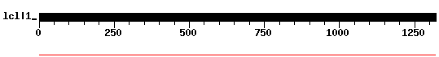
Pp1-Y1 | 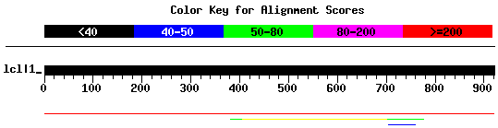
Pp1-Y2 | 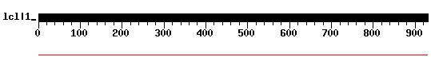 | 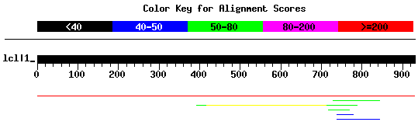
WDY | 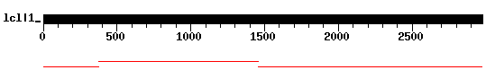 | 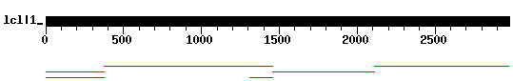
ORY | 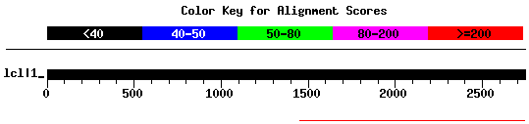 | 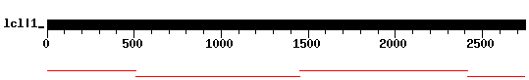
Ppr-Y | 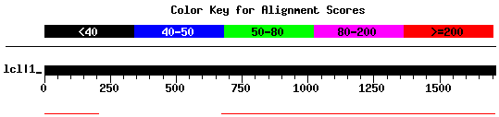 | 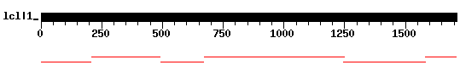
ARY | 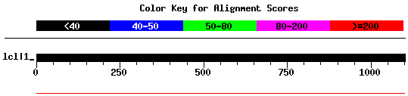
kl-2 | 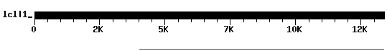 | 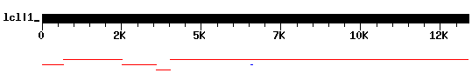
kl-3 | 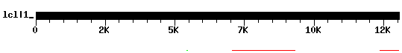 | 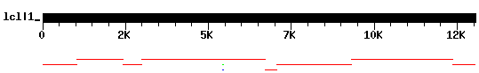
kl-5 | 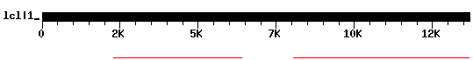 | 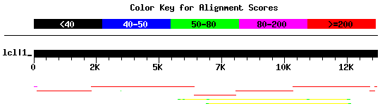
CCY | assembly failure | 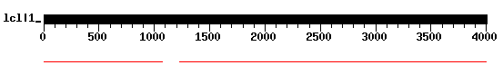
PRY | 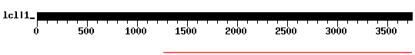 | 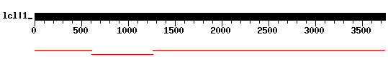

Supplemental Figure S1. Assembly of Y-linked genes using ONT or Illumina reads. ONT reads (Kim et al. 2024) were assembled with Flye (Kolmogorov et al. 2019), while Illumina reads were assembled with SPAdes (BANKEVICH et al. 2012), both using default settings. Illumina reads were subsampled to ~100× coverage before assembly. The ONT-based assembly exhibits a large number of missing exons, whereas the Illumina assembly is nearly complete, highlighting the impact of sequencing biases on long-read technologies.

Supplemental Figure S2. Coverage of Y-linked genes by ONT and Illumina reads.

 | ONT | Illumina
CG41561 | 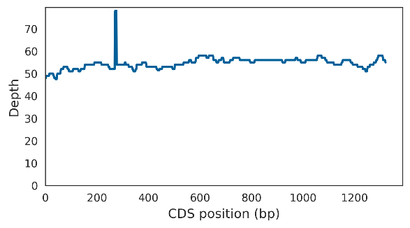 | 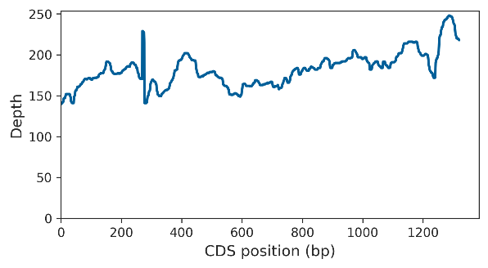
Pp1-Y1 | 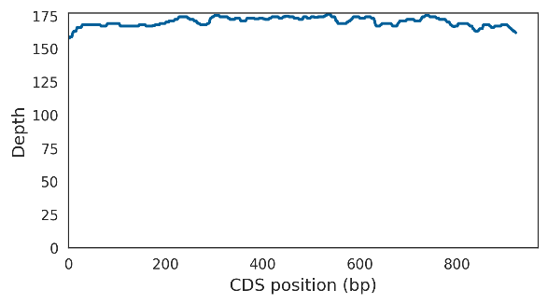 | 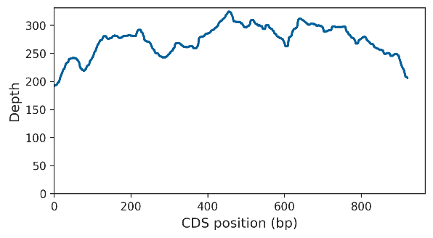
Pp1-Y2 | 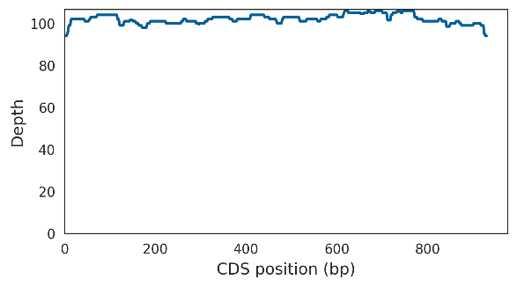 | 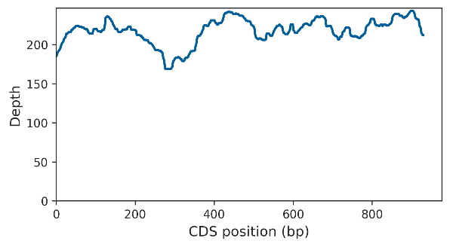
WDY | 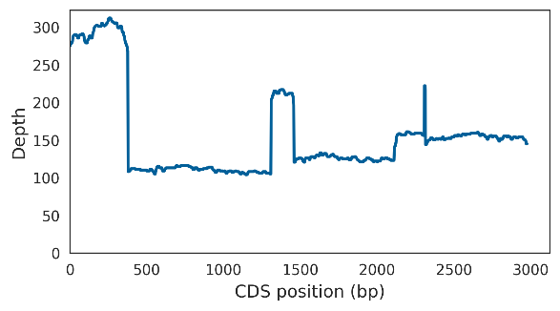 | 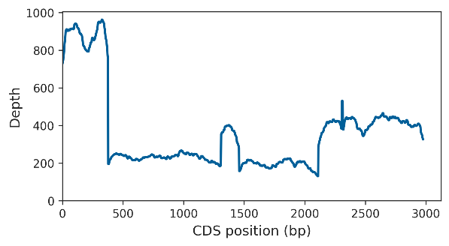
ORY | 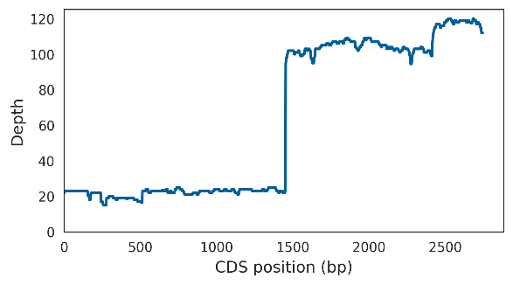 | 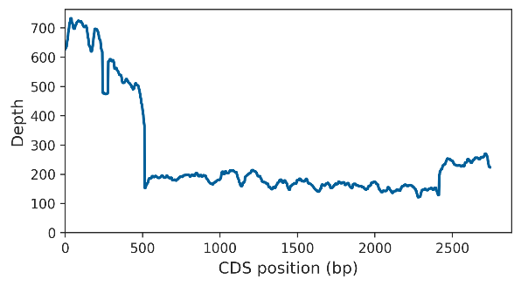
Ppr-Y | 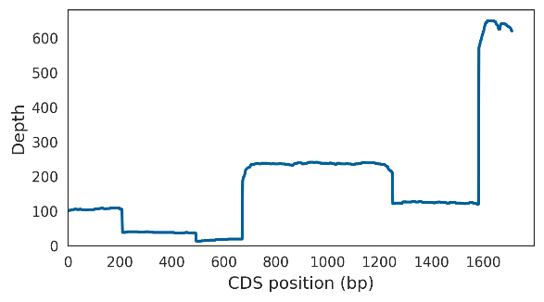 | 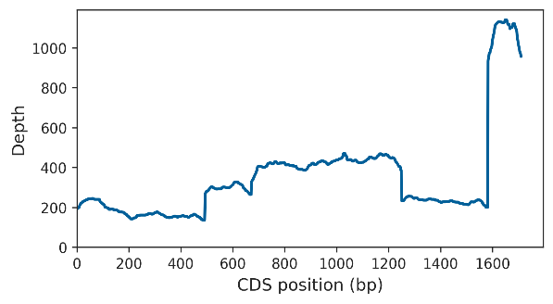
ARY | 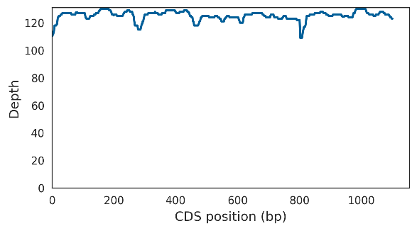 | 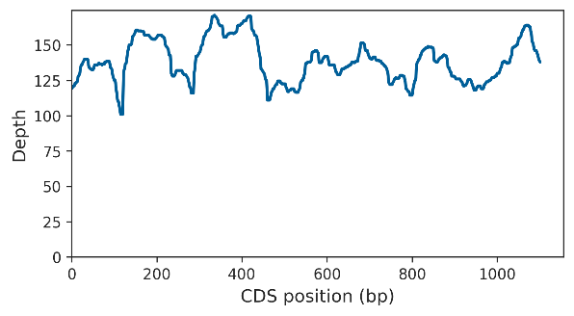
kl-2 | 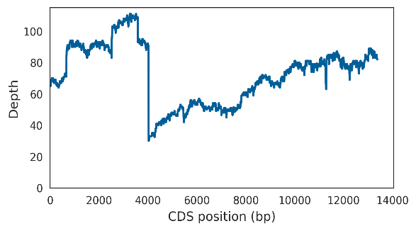 | 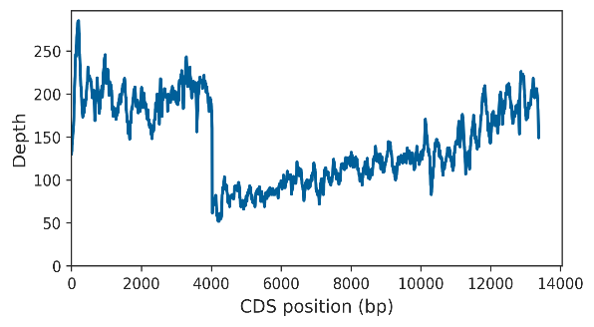
kl-3 | 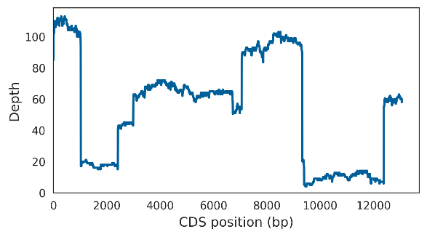 | 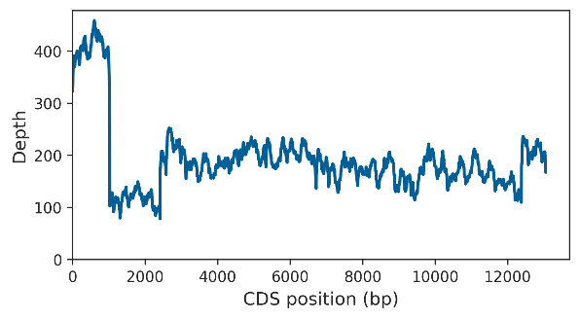
kl-5 | 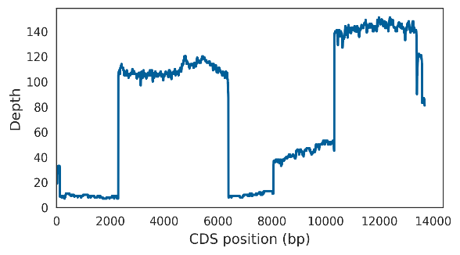 | 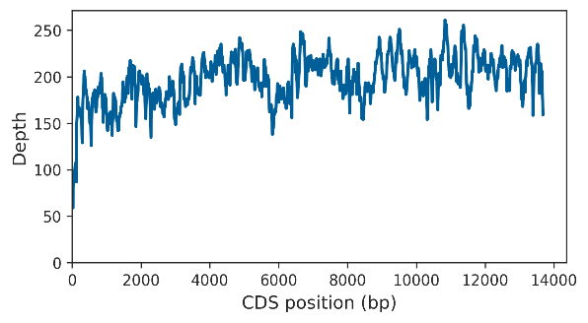
CCY | 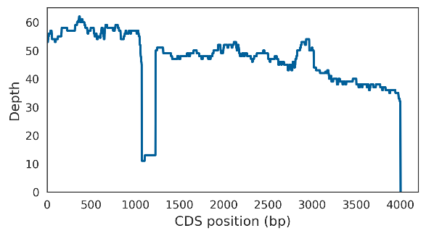 | 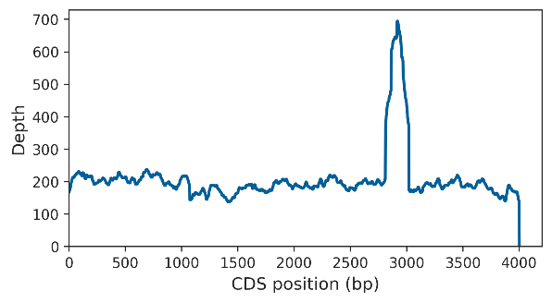
PRY | 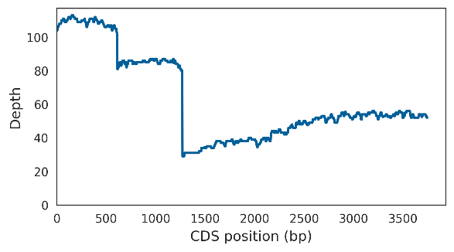 | 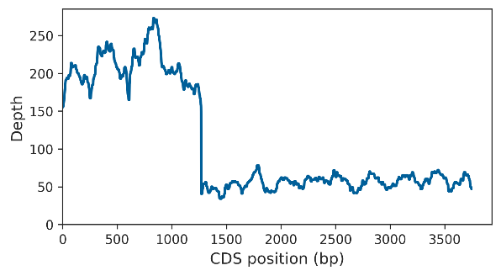

Supplemental Figure S2. Coverage of Y-linked genes by ONT and Illumina reads. Note that the ONT coverage of several Y-linked exons approaches 0 ("missing exons"), a phenomenon not observed with Illumina sequencing. ONT coverage is highly irregular across most genes, even outside these low-coverage regions. Peaks in Illumina coverage are caused by exon duplications, some of which are visible in the final assembly (e.g., see the WDY Illumina assembly in Supplemental Fig. S1).

Supplemental Figure S3. Coverage of ten random X-linked genes by ONT reads.
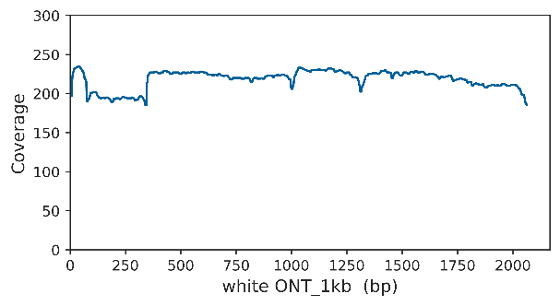 | 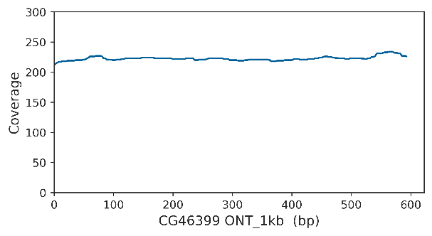
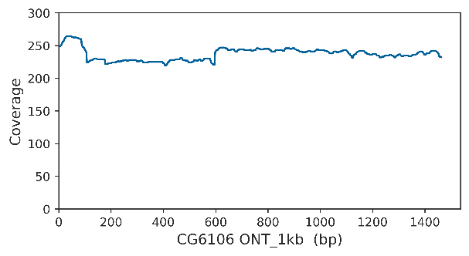 | 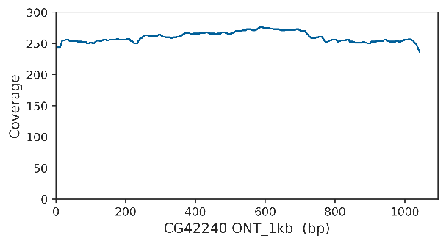
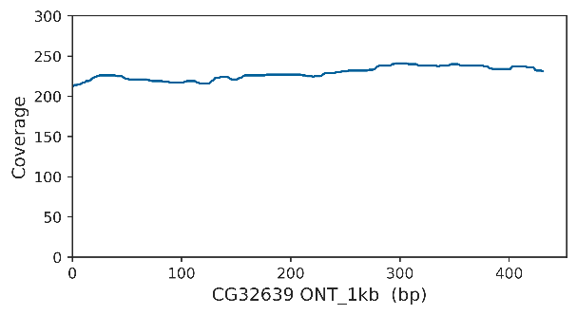 | 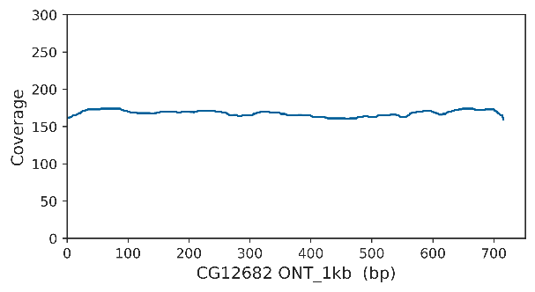
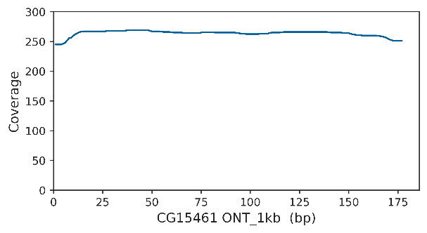 | 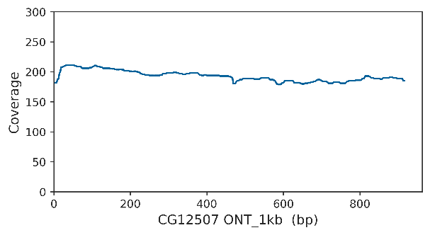
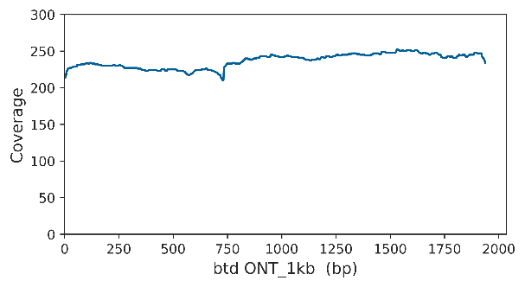 | 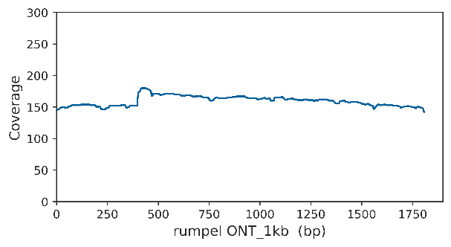

Supplemental Figure S3. Coverage of ten random X-linked genes by ONT reads. Gene names are indicated in the X-axis. Note the uniform coverage profiles, close to the expected depth (200×).

Supplemental Figure S4. Base quality values along a ONT read covering a simple satellite block.

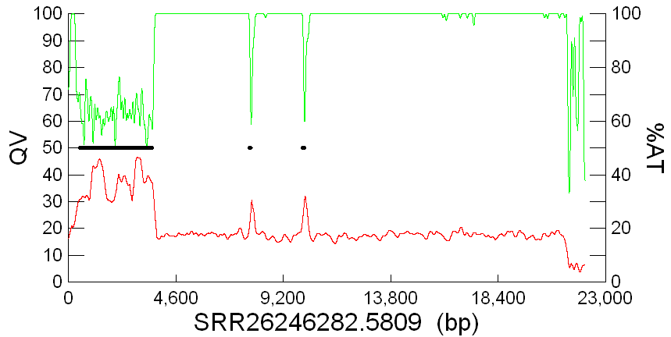

Supplemental Figure S4. Base quality values along a ONT read spanning a simple satellite block. Base quality (red line) is shown as a moving average of 50 bases. Read SRR26245282.5809 starts very close to kl-3 exons 15-16 (thick black line) and extends to the nearby (AATATAT)_{n} satellite block, visible as a 100% AT region (green line). The satellite block is interrupted by two small pseudogenes of the same exons (black dots). Notably, base quality drops sharply upon entry into the satellite block, with a partial recovery observed in the small pseudogenes.

Supplemental Figure S5. Rearranged or quimeric reads in a missing exon region.

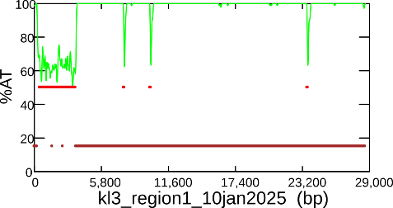 | 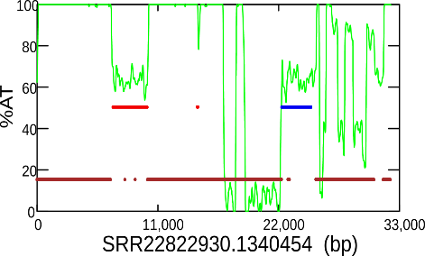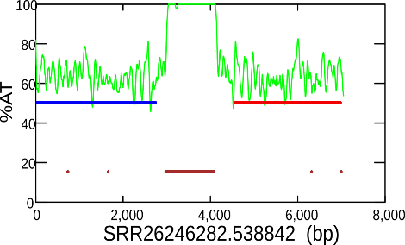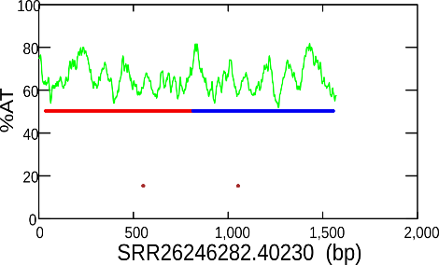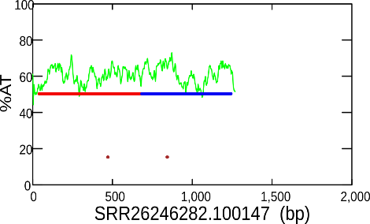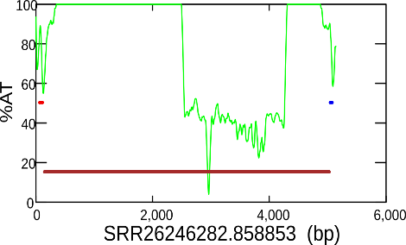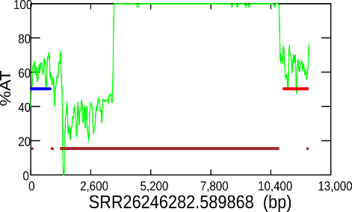

Supplemental Figure S5. Rearranged or chimeric reads in a low-coverage region. Satellite blocks are indicated by thick brown lines and % AT composition (green line). Regions matching the CDS are marked in blue (forward orientation) or red (reverse orientation). Left panel: consensus sequence of the kl-3 exons 15-16 region. This is the same consensus represented in Fig. 3 and is fully supported by four reads (see Supplemental Fig. S6). Right panel: six reads that do not match the consensus. These reads are also mutually incompatible (reads SRR26246282.100147 and SRR26246282.40230 are superficially similar but do not overlap), suggesting that they are sequencing artifacts. We found similar cases in other low-coverage regions. Two chimeric reads were identified: i) the read SRR26246282.1589819 (mentioned in the main text; Fig 6), starting with ~3kb of Chromosome 3L before switching to the Ppr-Y exon 3 region. ii) the read SRR22822930.1282529: its first 27kb came from Chromosome 2L, and the last 10kb belong to the kl-5 exon 14 region. We found these reads in a non-exhaustive search, so there may be other cases.

Supplemental Figure S6. Independent, nearly identical reads covering a missing exon in the kl-3 gene.

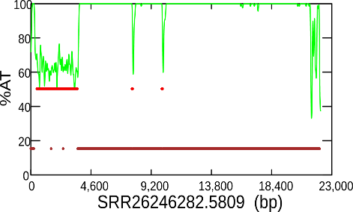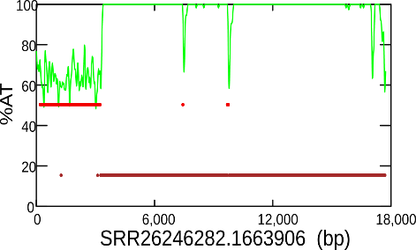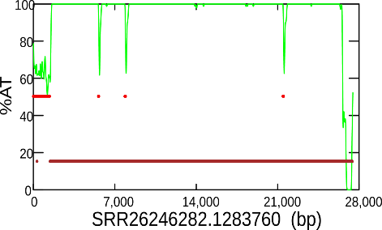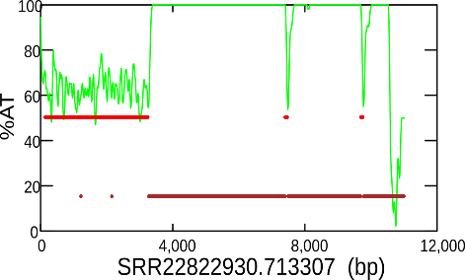

Supplemental Figure S6. Four independent, nearly identical reads covering a missing exon in the kl-3 gene. Among the 16 reads spanning kl-3 exons 15-16, four begin at almost the same position, either inside or very close to the exon sequence (thick red line), and have the same orientation (reverse, in relation to the exon). The location of the (AATATAT)_{n} satellite block is indicated by the thick brown bar and the 100% AT composition (green line). This "stereotyped" pattern suggests that sequencing can only successfully start outside the satellite blocks, which was later confirmed by statistical analysis (see text).

Supplemental Figure S7. Independent, nearly identical reads covering a missing exon in the kl-5 gene.

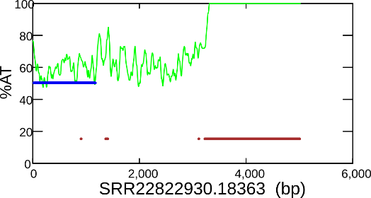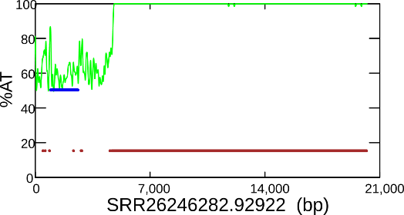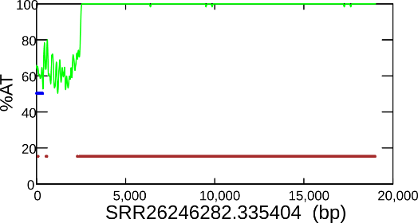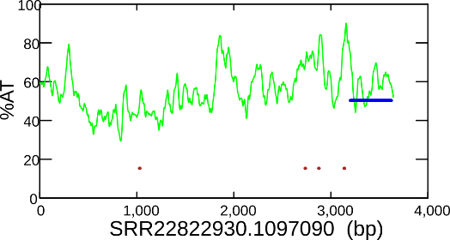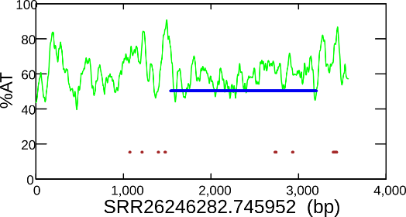 | 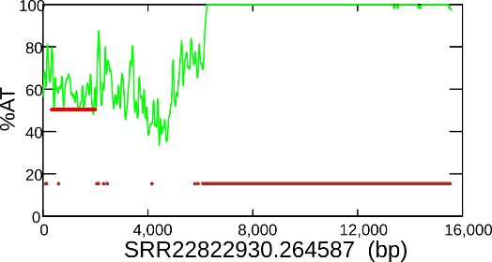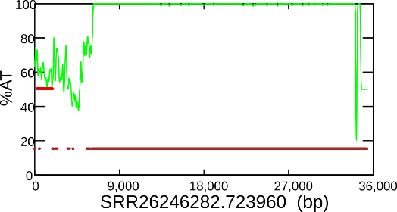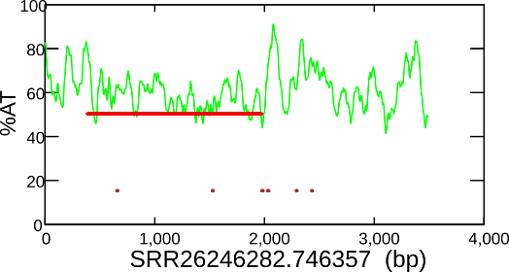

Supplemental Figure S7. Independent, very similar reads covering a missing exon in the kl-5 gene. Twelve reads cover the kl-5 exon 14 region; four of them were excluded here because they are chimeric or have signs of rearrangements (Supplemental Fig. S5). Left panel: Five reads with forward orientation (relative to the exon); all begin at nearly the same position, either inside or close to the exon sequence (thick blue line); the longer reads extend into an AT-rich satellite block (marked by the brown thick bar and by the 100% AT composition green line). Right panel: Three reads in the reverse orientation; note that they start at the same point (inside or close to the exon sequence, shown in a thick red line). These reads extend into a transposable element (not marked in the figure) and then into another AT-rich satellite block. This "stereotyped" read start pattern suggests that sequencing can only successfully start outside the satellite blocks. This was later confirmed by statistical analysis (see main text).

Supplemental Figure S8. Confirmation of the null hypothesis for exon position within the reads.

Forward reads | Reverse reads
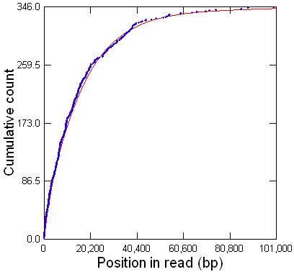 | 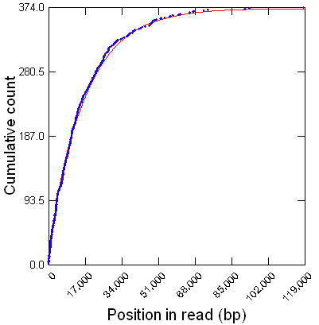

Supplemental Figure S8. Confirmation of the null hypothesis for exon position within the reads. Under random genome sampling and a fixed read size x, the position of a given sequence (e.g., an exon) within the reads is expected to follow a uniform distribution in the interval [1,x]. It seems reasonable to suppose that under variable read size (as occurs in ONT sequencing), the expected position for n reads should follow a composite of n uniform distributions, one for each read size. Putting it formally, UCF(variable_size) = [UCF(1,size₁) + UCF(1,size₂) + … + UCF(1,size_{n})]/n
We confirmed this supposition by simulation, as follows. We replaced the observed exon positions in the reads by a random uniform number in the interval [1, read size] and plotted the cumulative position of the simulated data (blue dots), along with the analytical composite distribution described above (red line). We did this by pooling all reads from the Y-linked regions shown in Table 1 but separating forward and reverse reads (relative to the exon orientation), which served as replicates. The close agreement between the simulated and analytical curves confirms that the composite uniform distribution can be used as a valid null hypothesis for testing the observed exon positions (Table 1). See also Supplemental Table S2.

Supplemental Figure S9. Random genome sampling and read start points (all regions).
 | F orientation | R orientation |  | F orientation | R orientation
CCY exon 2 | 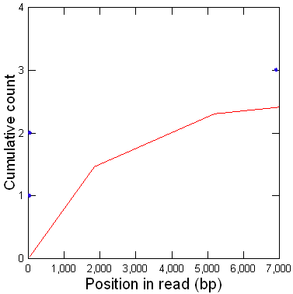 | 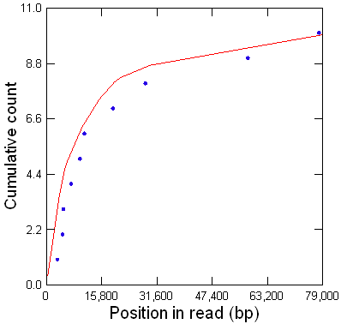 | kl-5 exon 14 | 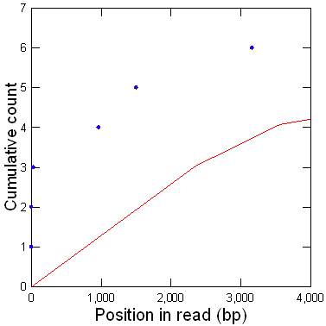 | 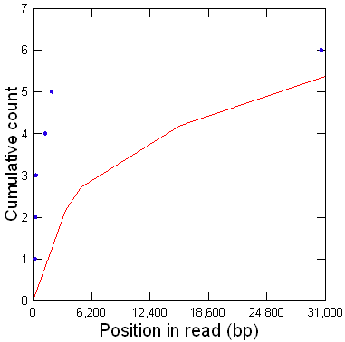
kl-5 exons 3-10 | 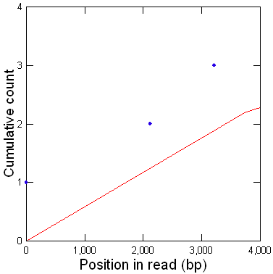 | 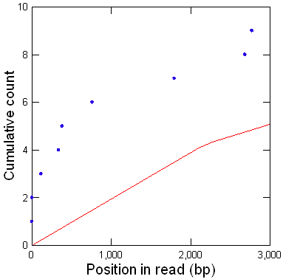 | kl-3 exons 15-16 | 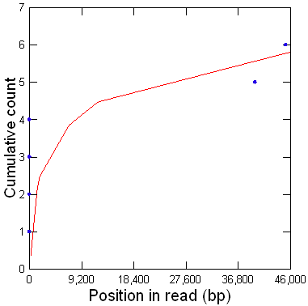 | 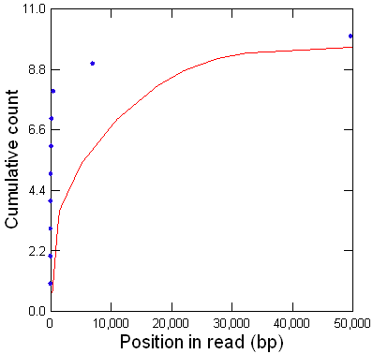
ORY exons 1-2 | 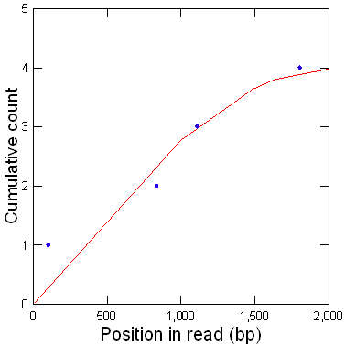 | 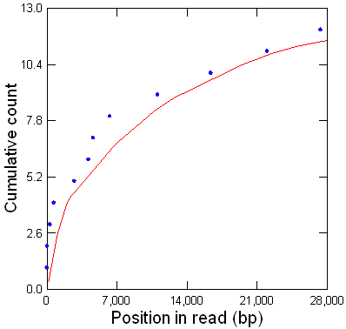 | Ppr-Y exon 3 | 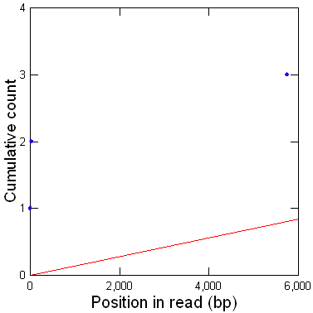 | 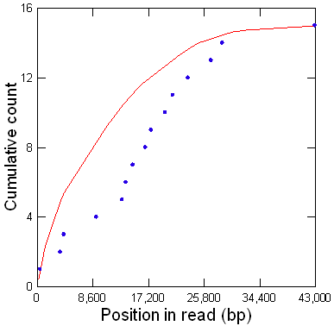
Pp1-Y1 | 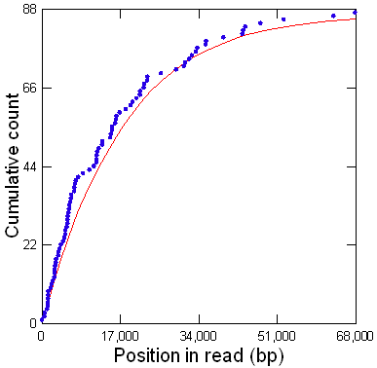 | 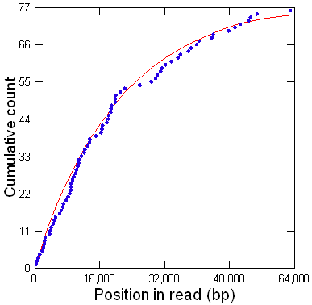 | Pp1-Y2 | 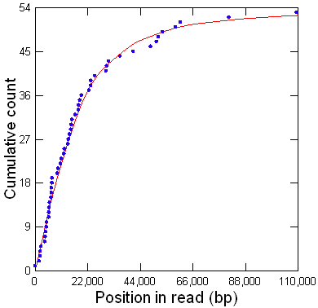 | 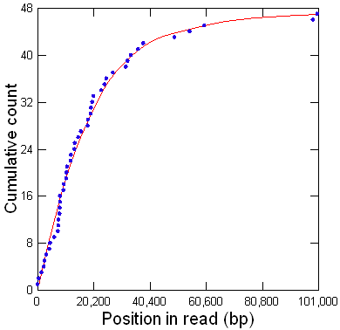
Ppr-Y exon 4 | 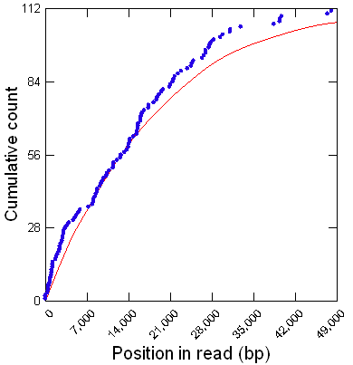 | 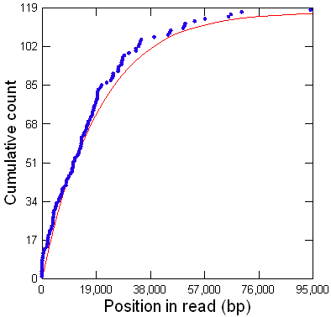 | kl-5 exons 10 -12 | 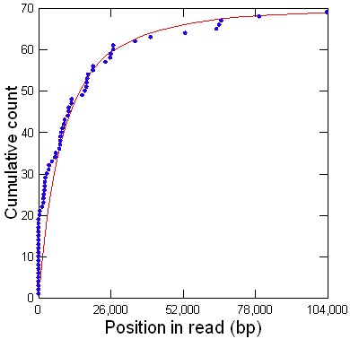 | 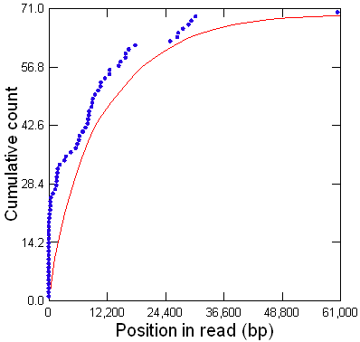

Supplemental Figure S9. Comparison between observed exon positions and their expected random distributions (all regions). This is the complete version of Fig. 5, including all Y-linked regions analyzed. Note that in many low-coverage regions (rows 1-3), there is a strong discrepancy between the observed exon positions within reads (blue dots) and their expected random distributions (red line); in most cases these discrepancies are statistically significant (Table 1). Conversely, in normal coverage regions (rows 4-5), there is a good agreement, and in most cases, the discrepancies are not statistically significant (Table 1). The exception is the kl-5 exons 11-13 region, in which the discrepancies are statistically significant (P < 10⁻³ in both F and R orientations). But note that its deviations from randomness are mild when compared to low-coverage regions; the very low P-values reflect the much higher statistical power in normal coverage regions due to their greater read counts. This region has intermediate characteristics between normal and low coverage regions, most likely because it contains satellite DNA but not in close vicinity to the exons (Fig. 3; see main text).

Supplemental Figure S10. Sequencing bias in the JYalpha gene.

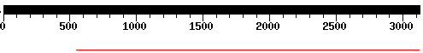
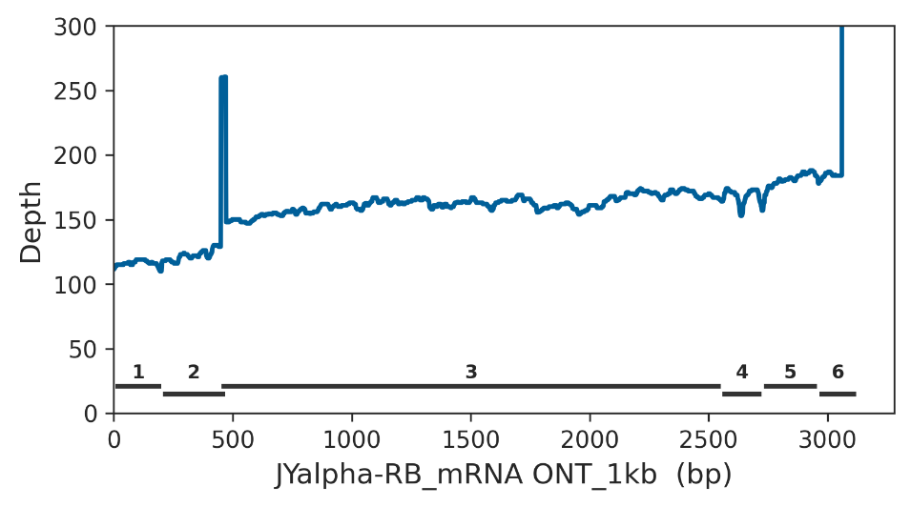
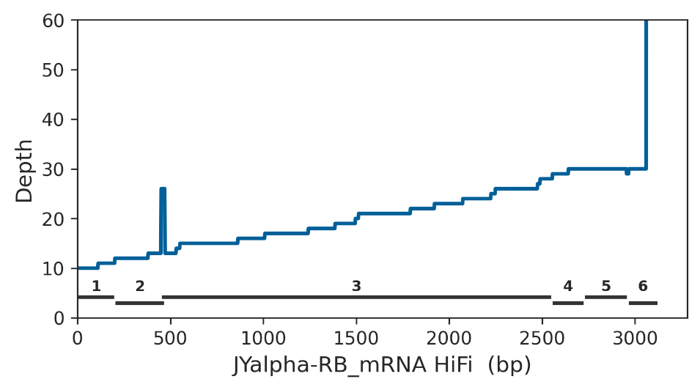
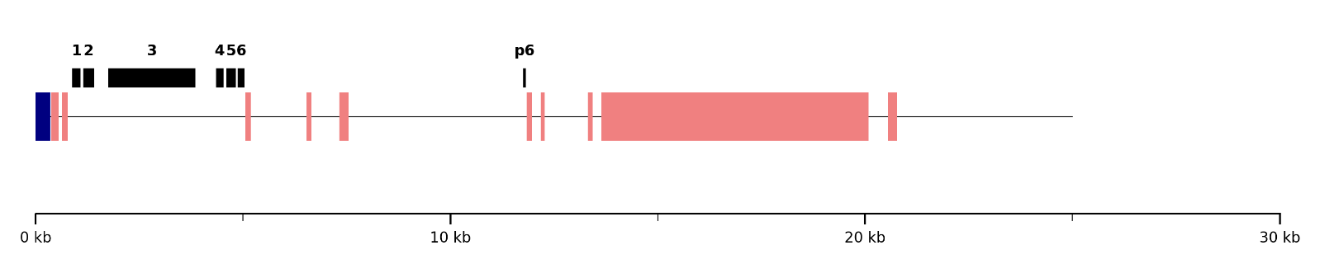

Supplemental Figure S10. Sequencing bias in the JYalpha gene (Chrom. 4, band 101F). Top row: BLASTN search of the JYalpha-RB mRNA against the HiFi verkko assembly, which is missing positions 1-550 (exons 1, 2, and part of the 3). Middle rows: read coverage in the ONT and PacBio HiFi datasets (the black numbered bars mark exon positions). Note that read coverage gradually improves with distance from the (AATAATAT)n satellite block at the beginning of the sequence (bottom graph). The sequence shown in the bottom graph is the scaffold arm4 (Release 6), coordinates 1-25,000, which encompasses all exons of JYalpha (blue blocks, satellite DNA; pink blocks, transposable elements; black blocks, exons; thin line, single-copy DNA). "p6" is a partial pseudogene (a duplication from exon 6). Only repeat blocks bigger than 100bp were shown in the bottom graph.

Supplemental Figure S11. Sequencing bias in the Marf1 gene

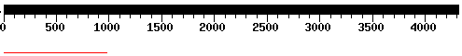
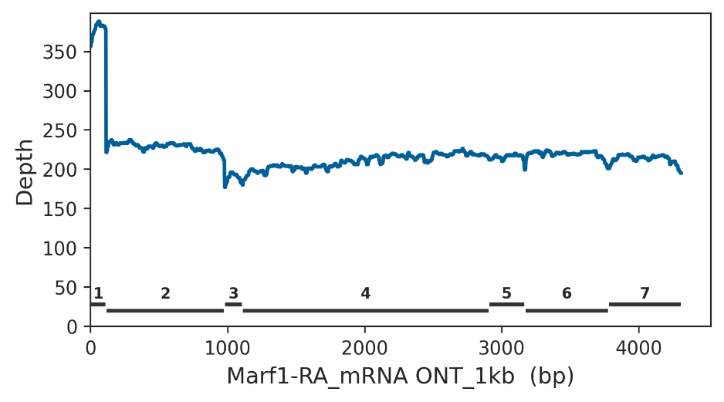
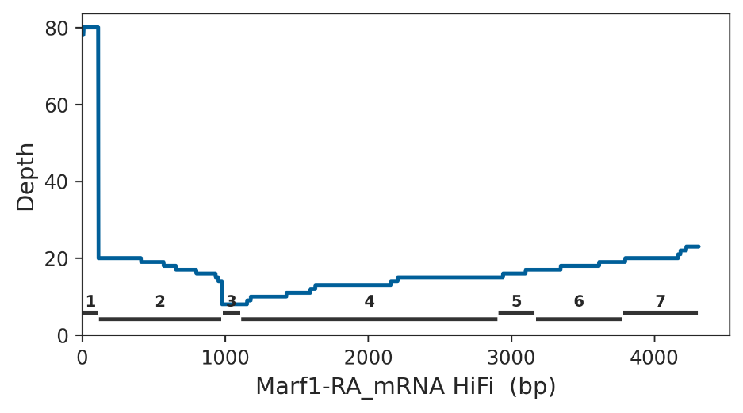
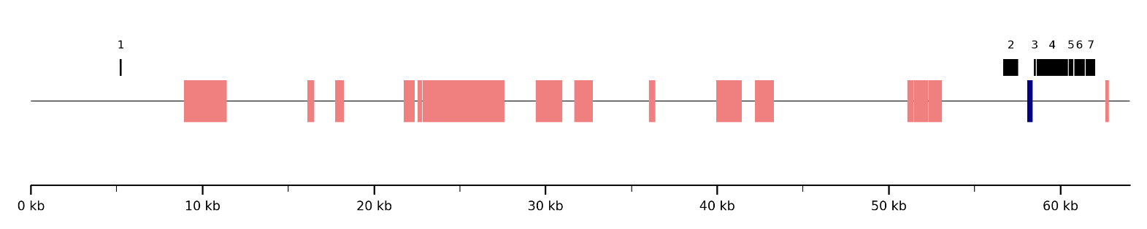

Supplemental Figure S11. Sequencing bias in the Marf1 gene (Chrom. 2L, band 40F). Top row: BLASTN search of the Marf1-RA mRNA against the HiFi verkko assembly, which is missing positions 978-4310 (corresponding to exons 3-7). Note that HiFi read coverage is low across the gene (expected 96×) except in the distant exon 1, with the lowest coverage observed in exon 3. The intron between exons 2 and 3 contains a 340 bp (AATAATAT)n satellite block (bottom graph). Also, note that the effect on ONT coverage was much smaller. These results are similar to those reported by (Nurk et al. 2022) in the human genome (see Discussion). The sequence shown in the bottom graph corresponds to scaffold arm 2L (Release 6), coordinates 22,343,000-22,389,000, which encompasses all exons of Marf1 (blue blocks, satellite DNA; pink blocks, transposable elements; black blocks, exons; thin line, single-copy DNA).

Supplemental Figure S12. Sequencing bias in the DIP-lambda gene

not assembled in ONT 1kb
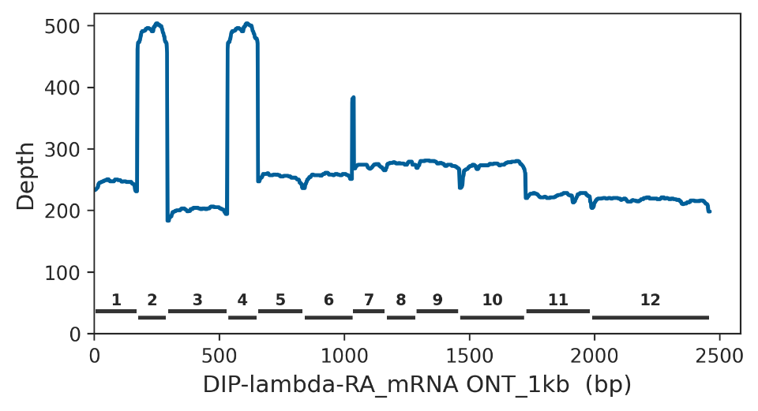
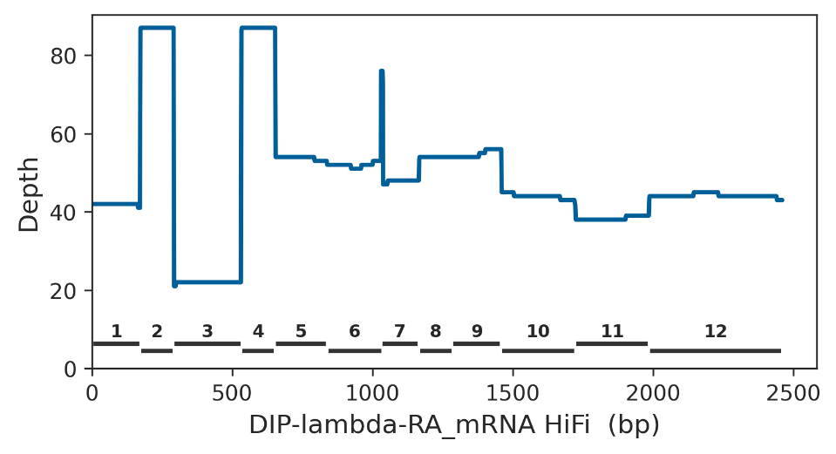
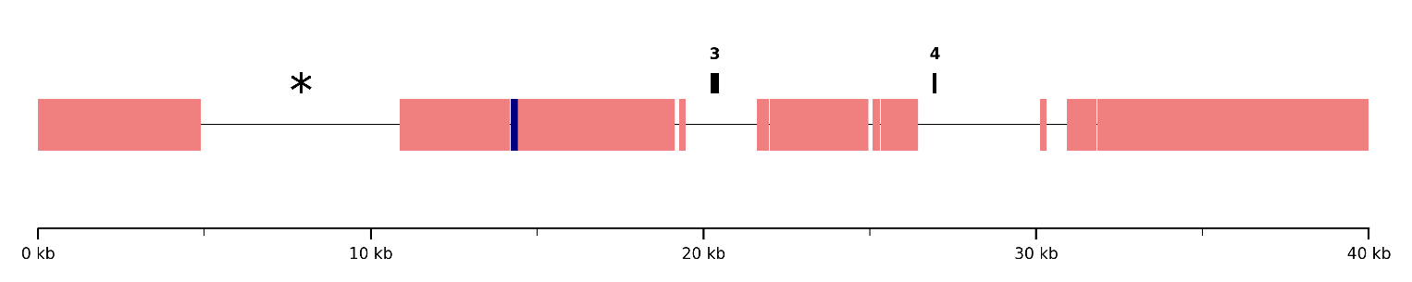

Supplemental Figure S12. Sequencing bias in the DIP-lambda gene (Chrom. 2R, band 41A). The gene was not assembled by flye using the 1kb cut-off ONT reads but was recovered in the flye 45kb cut-off assembly (as well as in both HiFi assemblies; see Supplemental Table S4). This suggests that the assembly failure with the 1kb cut-off was likely due to a glitch. However, there is a drop in read coverage in exon 3. Three nearby features may contribute to this effect: (i) exons 2 and 4 are identical, which may form some structure that interferes with sequencing; (ii) a 221 bp (AATATAT)n block located 6 kb upstream of exon 3; (iii) a large a sequence gap in Release 6 that ends 10 kb upstream of exon 3. The content of this gap is unknown but likely represents a "hard-to-assemble" sequence. Sequence gaps appear as blocks of “NNNNN” in Release 6 and are marked with an asterisk in the bottom graph. The sequence shown in the bottom graph corresponds to scaffold arm2R (Release 6), coordinates 412,000-452,000, covering exons 3 and 4 of DIP-lambda (blue blocks, satellite DNA; pink blocks, transposable elements; black blocks, exons; thin line, single-copy DNA).

Supplemental Figure S13. Sequencing bias in the CG42402 gene

not assembled by verkko
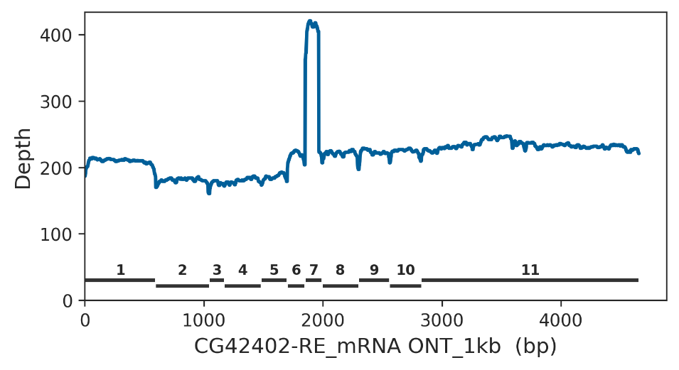
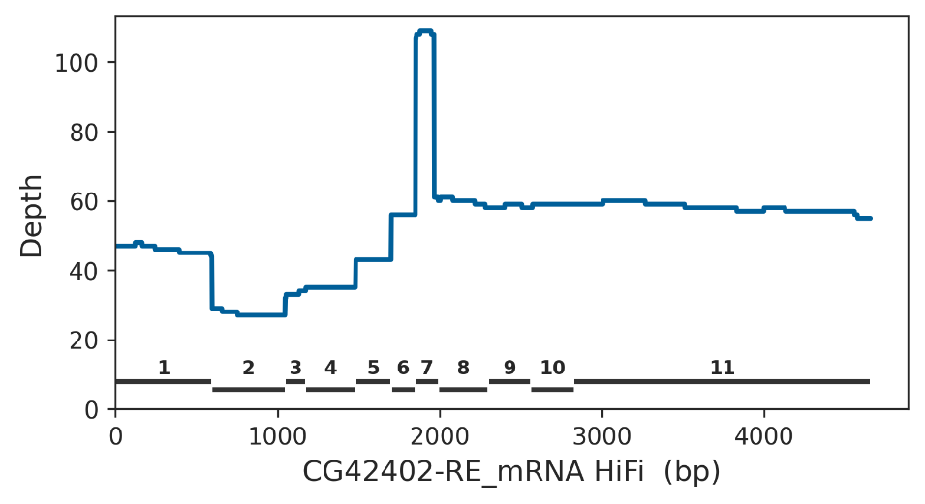
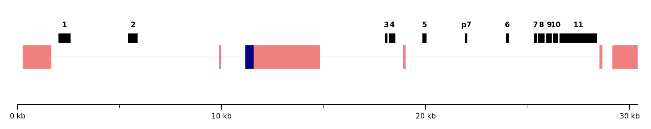

Supplemental Figure S13. Sequencing bias in the CG42402 gene (Chrom. 3R, band 81F). The gene was not assembled by verkko, although read coverage in the last exons is fairly high (60x), suggesting that part of the assembly failure may be caused by a glitch. However, there is a clear drop in read coverage in exon 2, which extends to exons 3-5. A perfect 415 bp (AAATATAT)n satellite block is located between exons 2 and 3. The peak in coverage observed in exon 7 is due to a partial pseudogene, marked as “p7” in the bottom graph. The sequence shown in the bottom graph corresponds to the CG42402 gene region, downloaded from FlyBase (file dmel-all-gene_extended2000-r6.63.fasta.gz). Bottom graph elements: blue blocks, satellite DNA; pink blocks, transposable elements; black blocks, exons; thin line, single-copy DNA.

Supplemental Figure S14. Sequencing bias in the Myo81F gene

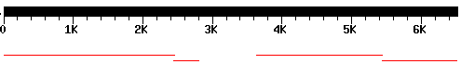
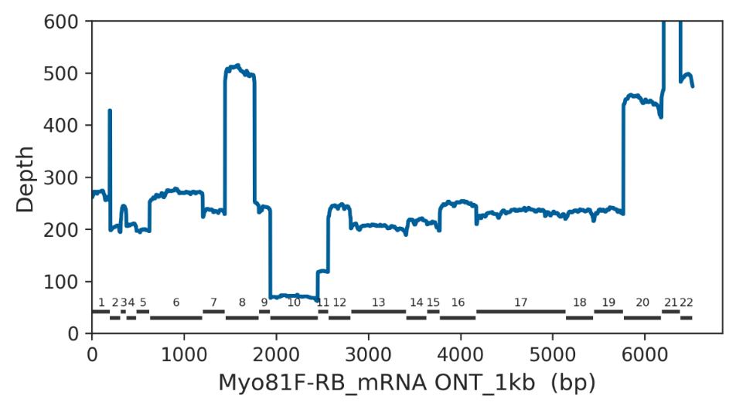
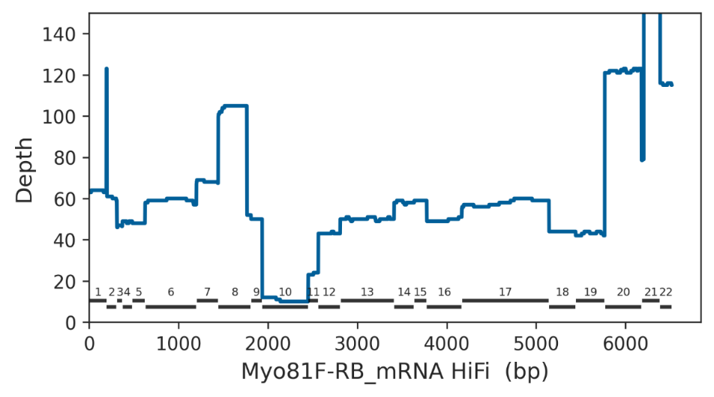
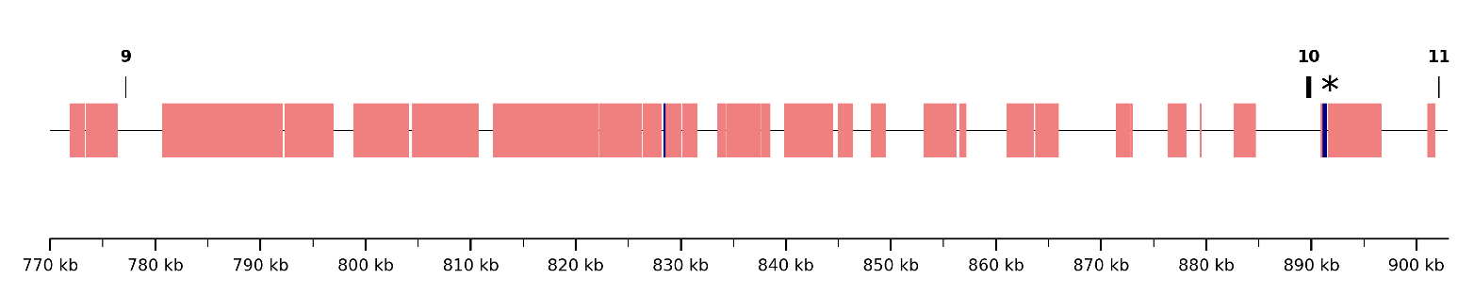

Supplemental Figure S14. Sequencing bias in the Myo81F gene (Chrom. 3R, band 81F). Exons 13-14 (mRNA interval 2809-3632) were missing in the flye assembly generated with the 1kb cut-off ONT reads despite fairly high read coverage in this region. This suggests that the assembly failure was likely due to a glitch. However, there is a clear drop in read coverage at exon 9 and a less pronounced one at exon 10. Because the gene is very large (spanning 1.9 Mbp in Release 6), and includes sequence gaps and duplicated exons, we focused our analysis on the low-coverage region encompassing exons 9-11. The drop in coverage is most likely caused by a (AATAT)n satellite block located ~1kb downstream of exon 10. In Release 6, this block is annotated as 415 bp, but it is adjacent to a stretch of “NNNN” (i.e., a sequence gap, indicated by an asterisk in the bottom figure), suggesting that the satellite block is substantially larger. The peaks in coverage observed at exons 8 and 21 are caused by partial pseudogenes, which inflate the read count in these regions. The sequence shown in the bottom graph is the Myo81F gene region (coordinates 770,000-903,000), downloaded from FlyBase (file dmel-all-gene_extended2000-r6.63.fasta.gz). Bottom graph elements: blue blocks, satellite DNA; pink blocks, transposable elements; black blocks, exons; thin line, single-copy DNA.

Supplemental Figure S15. Sequencing bias in the Pzl gene

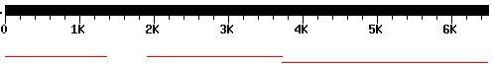
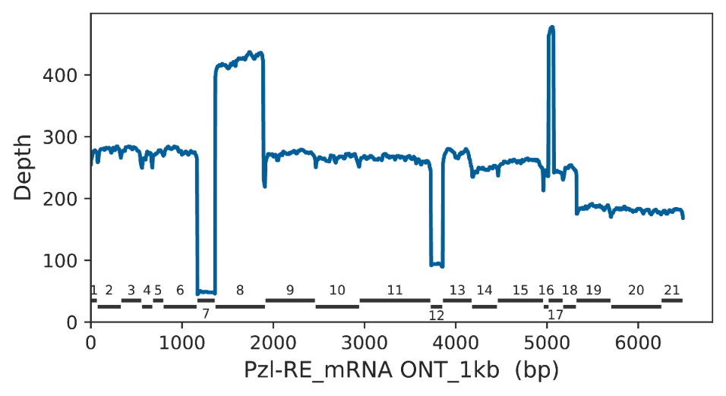
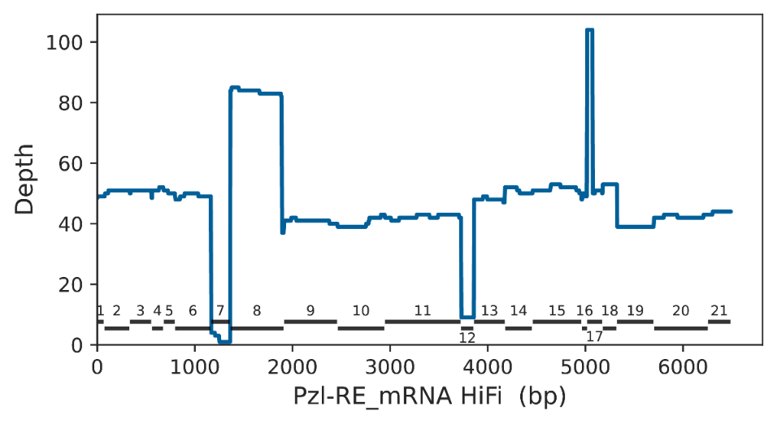
exons 7-8 region
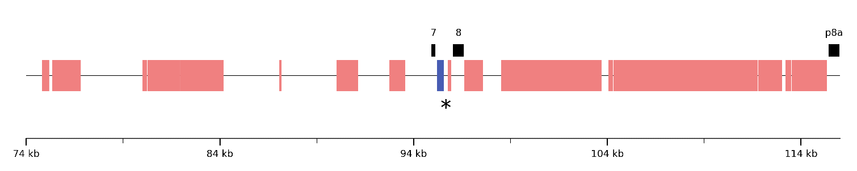

exon 12 region (composite)
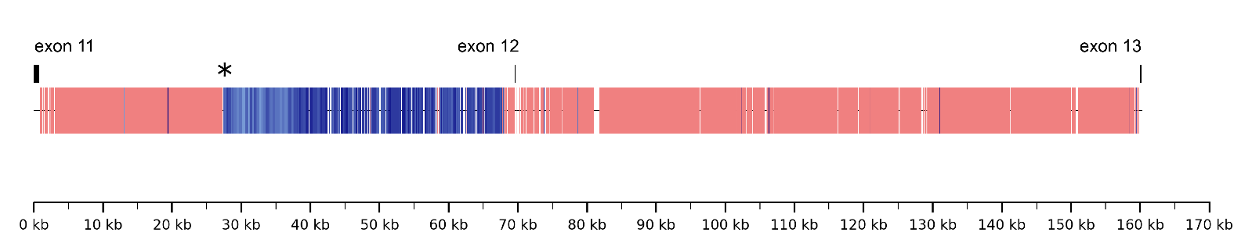

Supplemental Figure S15. Sequencing bias in the Pzl gene (Chrom. 3R, band 81F). The mRNA interval 1363-1910 (exon 8) was not assembled by flye using the 45kb cut-off ONT reads (top graph). There are two deep drops in read coverage, located in exons 7 and 12; we examined them separately. The region of exon 7 shows very low coverage, whereas exon 8 has a very high coverage due to the presence of two pseudogenes arranged in tandem with the real exon. One of these pseudogenes appears in the fourth graph and is labeled "p8a". These repeated copies may have caused the assembly failure of exon 8.. However, the intron between exons 7 and 8 also contains a ~ 500 bp perfect (AAGAG)n satellite block interrupted by a stretch of “NNNN” indicating that the satellite block is most likely much larger. This sequence gap is marked with an asterisk in row 4. It is likely that the real exon 8 also has very low coverage and that the spike observed in the top graphs reflects the contribution of the two downstream pseudogene copies.
The region surrounding exon 12 in Release 6 contains a 600 bp (AAAAGG)n satellite block located ~1.5 kb upstream of the exon. The satellite block is flanked by a sequence gap of unknown size. As a proof of principle, we attempted to better estimate the gap´s size by using long ONT reads that extend into the gap and assembling a composite sequence. Although no read spans the full intron, read SRR26246282.1587204 extends 42 kb into the gap and is composed almost entirely of satellite sequences. The bottom graph represents the composite sequence, which combines data from Release 6 and read SRR26246282.1587204, spanning exons 11-13. The sequence gap is represented by an asterisk. Bottom graph elements: blue blocks, satellite DNA; pink blocks, transposable elements; black blocks, exons; thin line, single-copy DNA.

Supplemental Figure S16. Sequencing bias in the klhl10 gene

unassembled in ONT 45kb, ONT1kb, and Hi Fi verkko
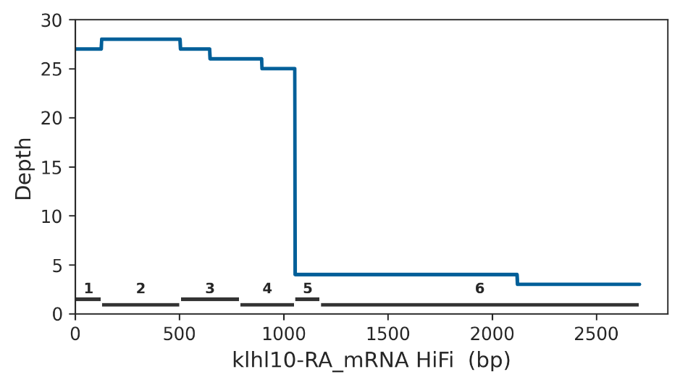
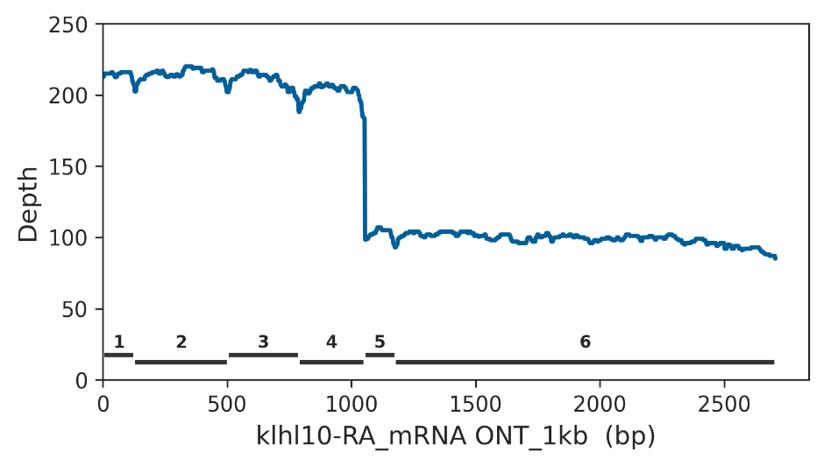
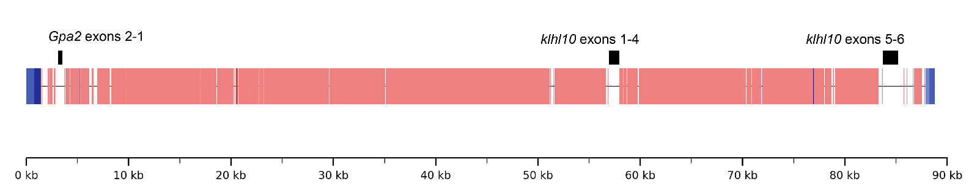

Supplemental Figure S16. Sequencing bias in the klhl10 gene (unmapped). The gene was recovered only in the HiFi hifiasm assembly. In Release 6, klhl10 is located on an 89 kb unmapped scaffold, although FlyBase assigns it to an unknown location on Chromosome 2. Notably, this same scaffold contains the Gpa2 gene (Supplemental Fig. S17, bottom panel). There is a pronounced drop in read coverage in the last two exons of khlh10 (exons 5 and 6, which are separated by a small intron). Approximately 2.5 kb downstream of exon 6, a (AAGAG)n satellite block begins, coinciding with the point at which the Release 6 assembly is interrupted. This satellite block clearly caused both the assembly break in Release 6 and the drop in read coverage. As in similar cases of assembly breaks, the actual size of the block is unknown due to the assembly gap. The bottom graph represents the complete sequence of Release 6 scaffold "Unmapped_Scaffold_8_D1580_D1567". Bottom graph elements: blue blocks, satellite DNA; pink blocks, transposable elements; black blocks, exons; thin line, single-copy DNA.

Supplemental Figure S17. Sequencing bias in the Gpa2 gene

unassembled in ONT 45kb, ONT1kb, and Hi Fi verkko
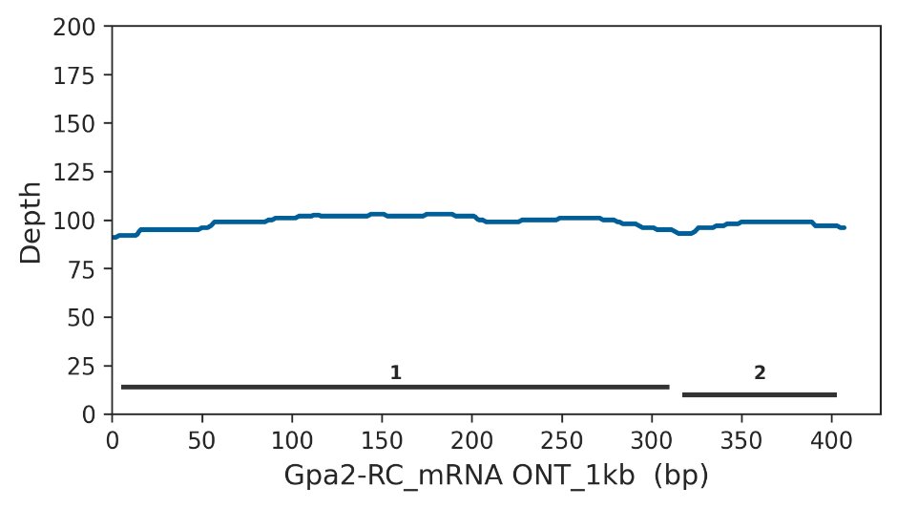
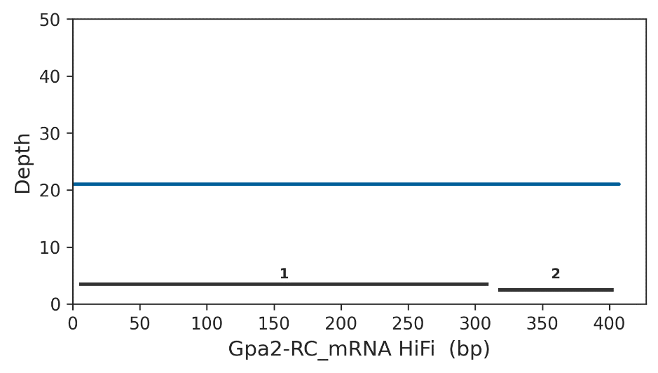

Supplemental Figure S17. Sequencing bias in the Gpa2 gene (unmapped). The gene was recovered only in the HiFi hifiasm assembly. In Release 6, Gpa2 is located on an 89 kb unmapped scaffold, which also contains the klhl10 gene (see Supplemental Fig. S16). Gpa2 consists of two exons, separated by a short intron. PacBio HiFi read coverage across the gene is uniformly low. Approximately 1.5 kb upstream of Gpa2, a 678 bp perfect (AATAG)n satellite block begins, followed by variants repeats and ultimately the scaffold boundary (i.e., the point where the Release 6 assembly is interrupted). This satellite block likely caused both the assembly break in Release 6 and the reduction in read coverage. as in other cases involving assembly breaks, the true size of the satellite block remains unknown. The bottom graph represents the complete sequence of Release 6 scaffold "Unmapped_Scaffold_8_D1580_D1567". Bottom graph elements: blue blocks, satellite DNA; pink blocks, transposable elements; black blocks, exons; thin line, single-copy DNA.

Supplemental Figure S18. Absence of sequencing bias in the CG11044 gene

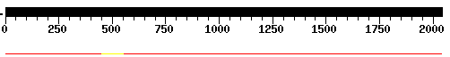
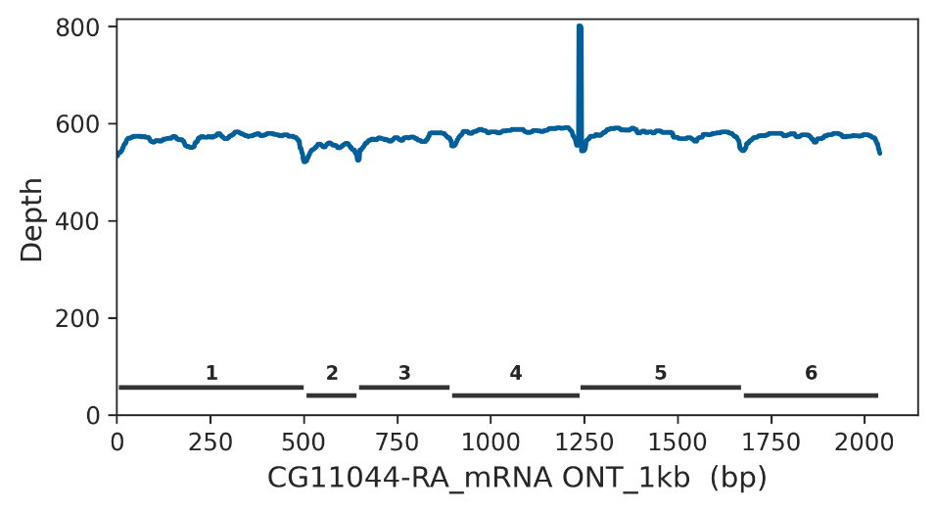
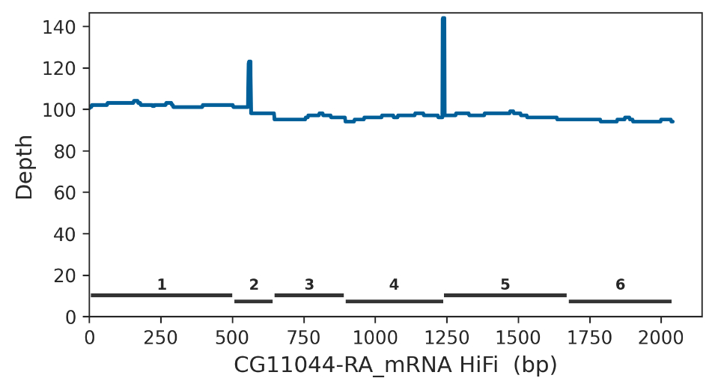
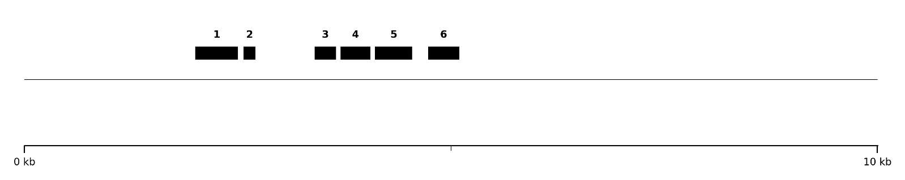

Supplemental Figure S18. Absence of sequencing bias in the CG11044 gene (Chrom. 2R, band 56F, euchromatin). The HiFi verkko assembly of the gene contains an intra-contig deletion that removed positions 450-558 of the mRNA, corresponting to parts of exons 1 and 2 (top panel). Read coverage is uniformly high and consistent with expectations for an autosomal gene (middle panel). The entire gene region appears to be single-copy (bottom panel; note the complete absence of repetitive DNA). Hence, the missing sequence in the verkko assembly is most likely a glitch. The sequence shown in the bottom panel corresponds to the CG11044 gene region, downloaded from FlyBase (file dmel-all-gene_extended2000-r6.63.fasta.gz). Bottom graph elements: black blocks, exons; thin line, single-copy DNA.

Supplemental Figure S19. Absence of sequencing bias in the CG40198 gene

not assembled by verkko
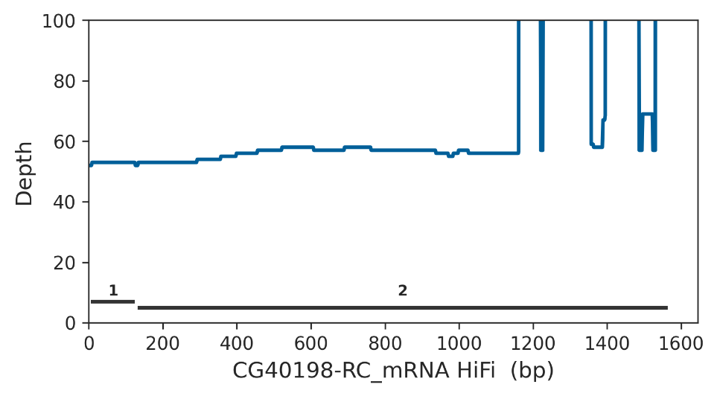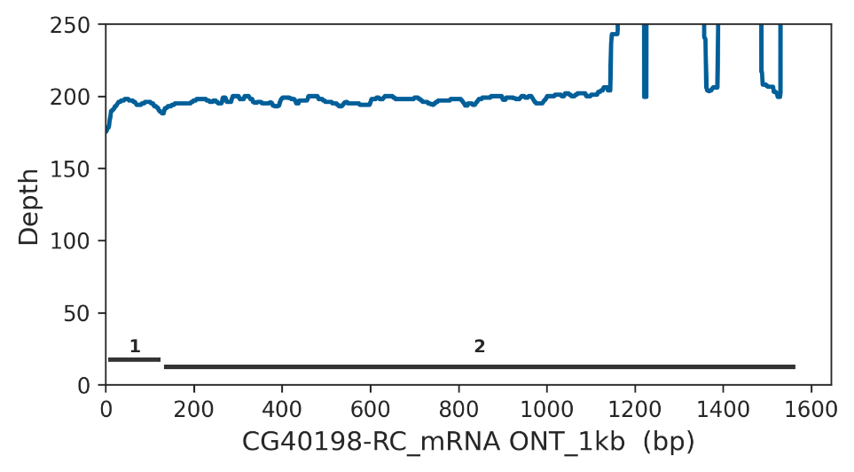
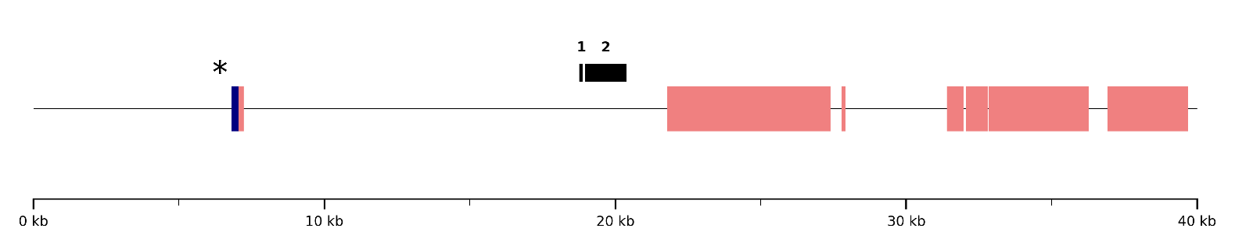

Supplemental Figure S19. Absence of sequencing bias in the CG40198 gene (Chrom. 3R, band 81F). The gene was not assembled by verkko, despite showing relatively high coverage (~50x), suggesting that the assembly failure was due to a glitch. Approximately 11.7 kb upstream of the gene, there is a presumably large (AATAT)n satellite block that caused an assembly break in Release 6, visible as a stretch of “NNNN” (marked with an asterisk in the bottom graph). Although we conservatively classified CG40198 as a false positive, it remains possible that the satellite´s proximity contributed to the verkko assembly failure. The large peaks in coverage near the end of the mRNA are located within the long 3' UTR and were likely caused by underlying repetitive sequences. The sequence shown in the bottom panel corresponds to scaffold arm3R (Release 6), coordinates 4,141,000-4,181,000, encompassing the full mRNA of CG40198. Bottom graph elements: blue blocks, satellite DNA; pink blocks, transposable elements; black blocks, exons; thin line, single-copy DNA.

Supplemental Figure S20. Absence of sequencing bias in the Gfat1 gene

not assembled by verkko
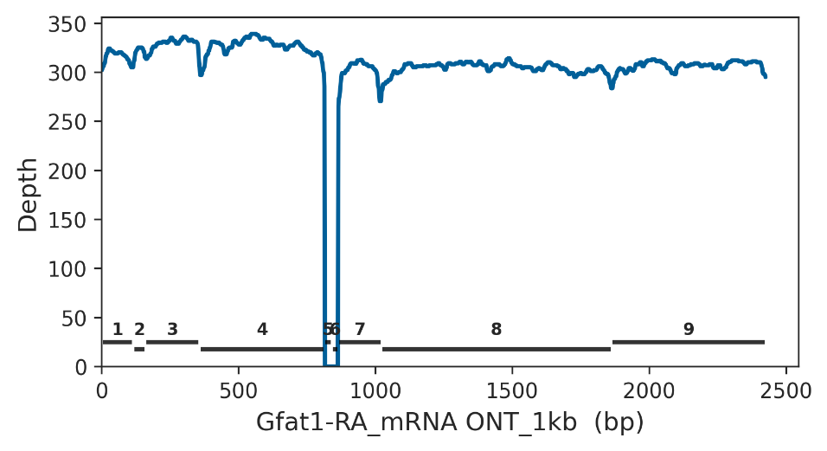
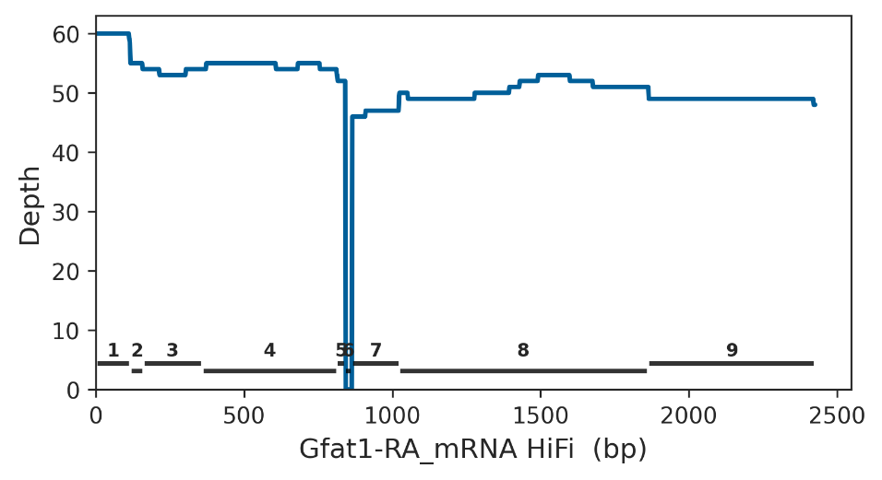
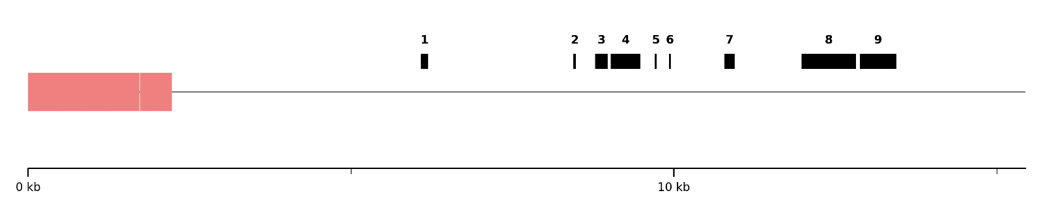

Supplemental Figure S20. Absence of sequencing bias in the Gfat1 gene (Chrom. 3R, band 81F). The deep drop in coverage in the middle of the gene is caused by the small size of exons 5 and 6 (27 bp and 24 bp, respectivelly), which were not detected by our blast-based scripts. Although the gene was not assembled by verkko, read coverage was uniform and fairly high (50x). Furthermore, there is no satellite block in the vicinity. Therefore, the failure in the verkko assembly failure was most likely caused by a technical issue related to the repetitive composition of the whole region. The sequence shown in the bottom graph corresponds to the Gfat1 gene region, downloaded from FlyBase (file dmel-all-gene_extended2000-r6.63.fasta.gz). Bottom graph elements: pink blocks, transposable elements; black blocks, exons; thin line, single-copy DNA.

Supplemental Figure S21. Effect of the complex satellite 1.688 on read coverage.
A
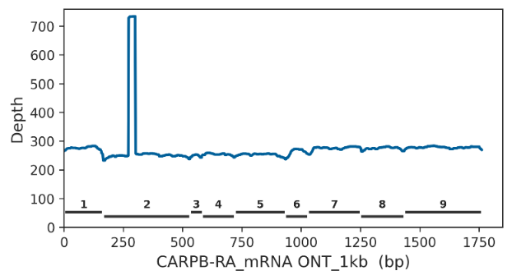 | 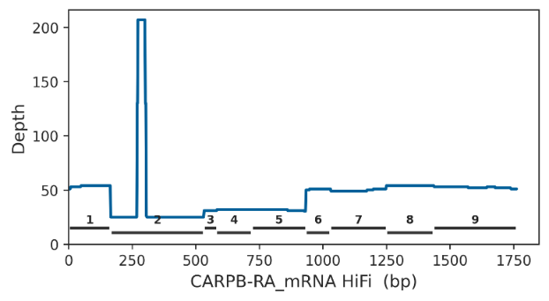
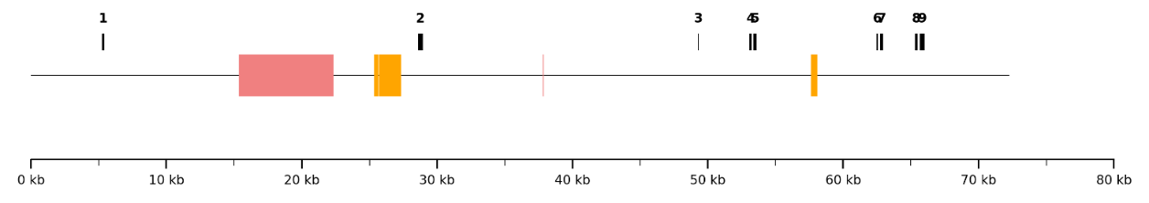
B
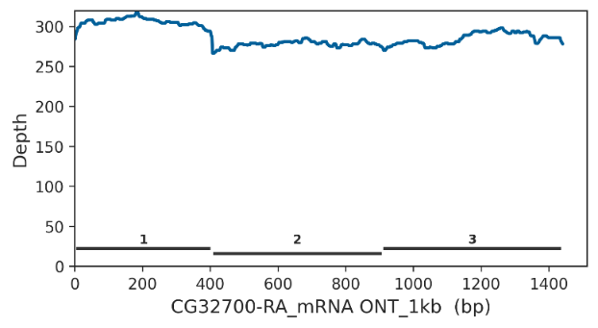 | 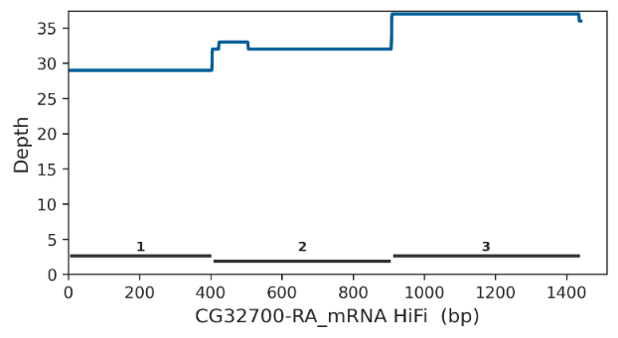
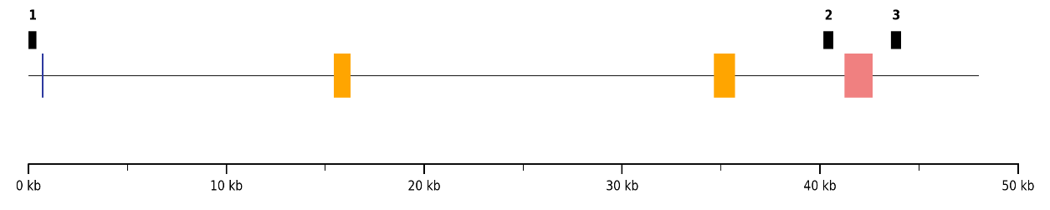
C
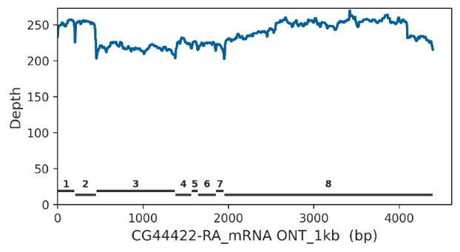 | 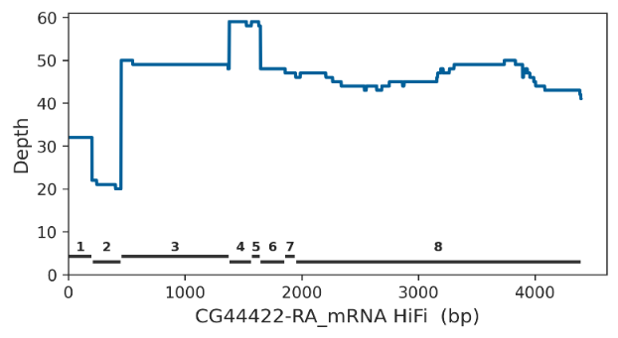
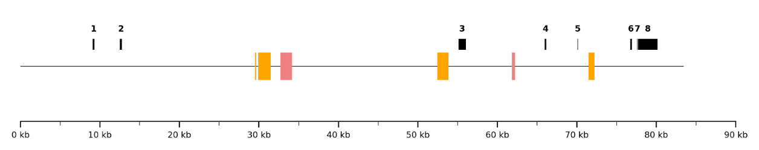

D
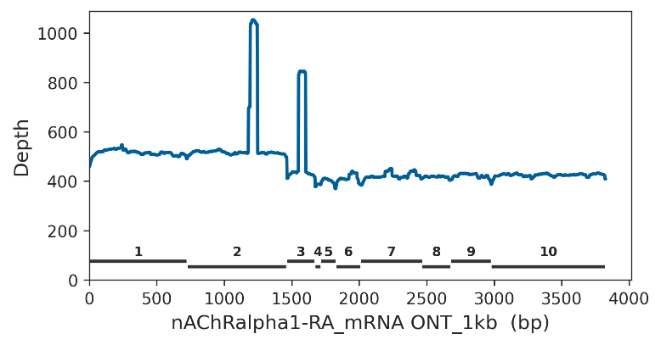 | 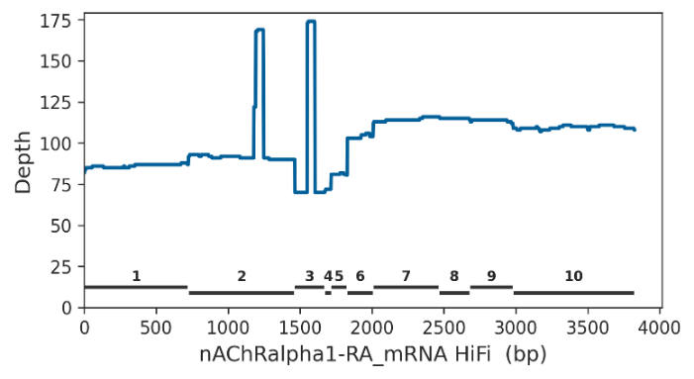
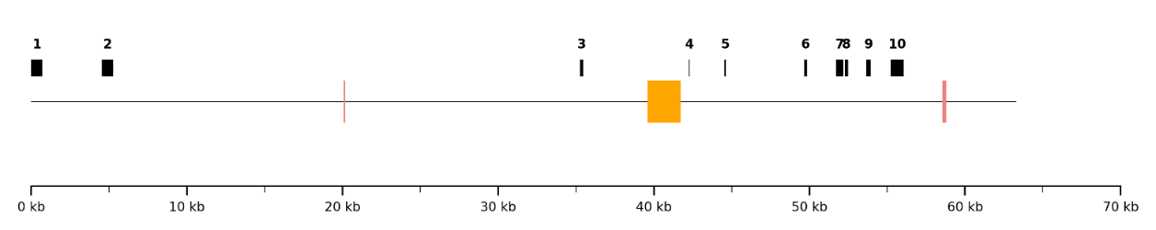
E
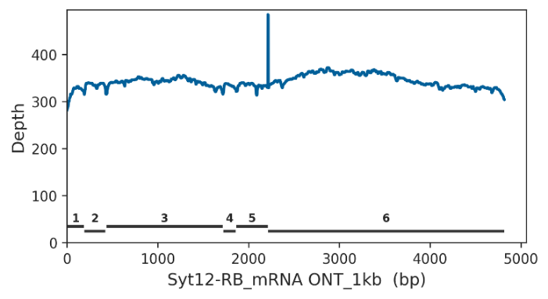 | 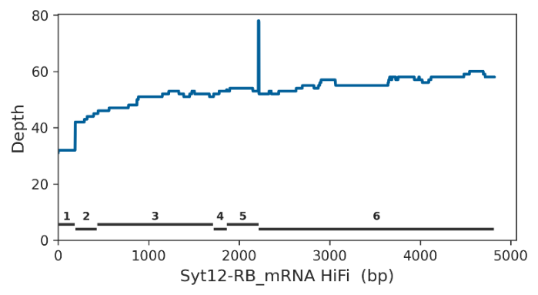
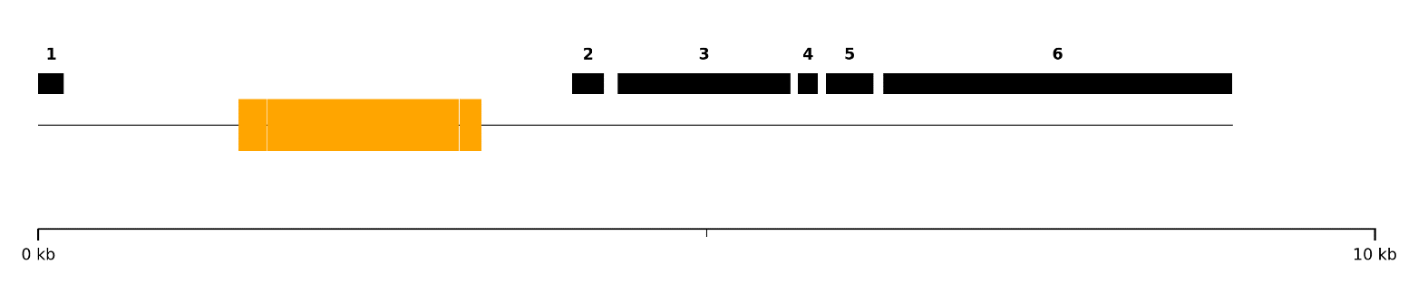

Supplemental Figure S21. Effect of the complex satellite 1.688 on read coverage. Panels A-E show the read coverage in the exons (top graphs) and the sequence composition of the gene region (bottom graph) for five euchromatic genes that have intronic blocks of the 1.688 satellite. nAChRalpha1 is located in 3R, so its expected coverage for PacBio HiFi is 100× and for ONT is 400×, and the remaining four genes are X-linked (expected coverage: 50× and 200×, respectively). Exons are labeled with numbers in all graphs; the bottom graphs show exon positions (black), transposable elements (pink), simple satellites (blue), and 1.688 satellites (yellow); only repeats larger than 100bp are shown. 1.688 block sizes range from 1kb to 2.1kb. Note that for ONT data there is no relevant drop in coverage near 1.688 satellite blocks. For PacBio, there is more irregularity in exon coverage that, in some cases, suggests a bias caused by the 1.688 sateliite (e.g., exon 2 of the CARPB gene; panel A), but the effect is not consistent. For example, exon 2 of the Syt12 gene (panel E) is very close to a large 1.688 block and yet has basically normal PacBio HiFi coverage. Gene regions were downloaded from FlyBase (file dmel-all-gene_extended2000-r6.63.fasta.gz)

Supplemental Figure S22. Abundance of non-B DNA motifs in low and normal coverage regions.

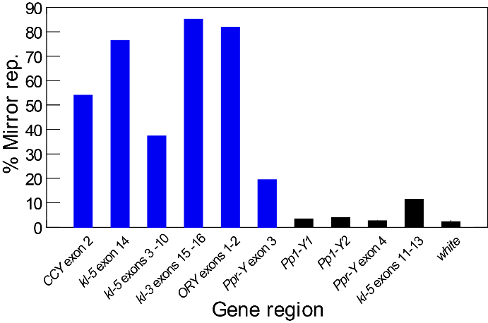 | 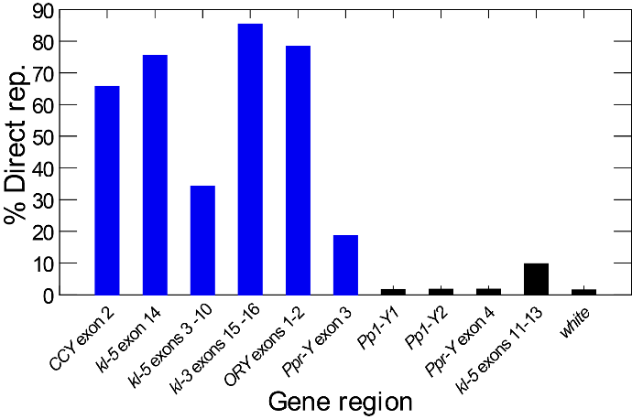
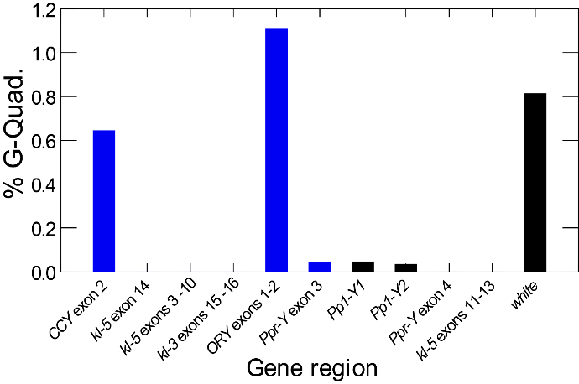 | 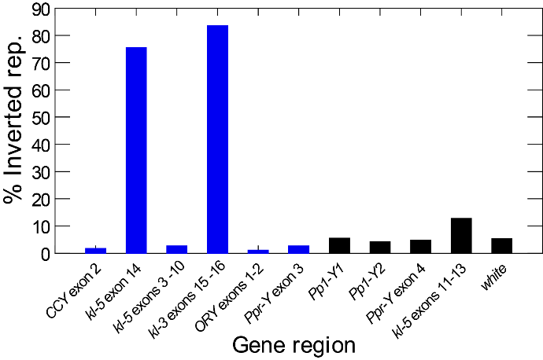
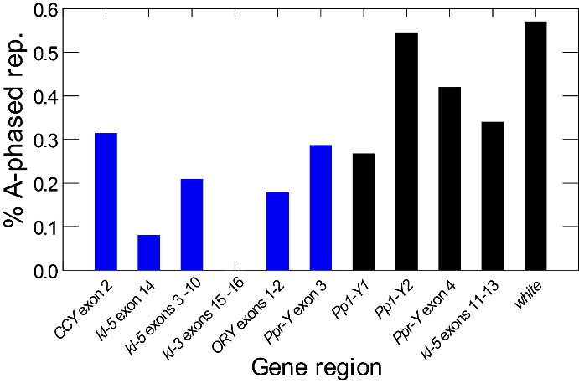 | 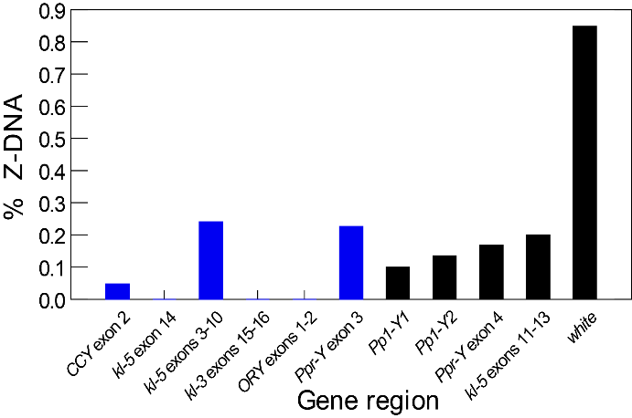

Supplemental Figure S22. Abundance of non-B DNA motifs in low and normal coverage regions. Motifs were detected with the nBMST program (Cer et al. 2013). The percentage of the sequence occupied by the motifs is shown in the Y-axis. Blue bars, low-coverage Y-linked regions; black bars, normal coverage Y-linked regions, plus the euchromatic gene control (white). The investigated motifs are "mirror repeats", "direct repeats", "guanosine quadruplexes", "inverted repeats", "A-phased repeats", and "Z-DNA" (see (Matos-Rodrigues et al. 2023), and references cited therein for a description of the various motifs and non-B DNA structures). Note that only mirror repeats and direct repeats are consistently abundant in low-coverage regions and rare in normal coverage regions. Note also that Supplemental Fig. S22 probably underestimates the association between mirror/direct repeats and read coverage since some low-coverage regions (CCY exon 2 and Ppr-Y exon 3) have a large amount of non-satellite sequence (Fig. 3).The normal coverage region kl-5 exons 11-13 contains satellite blocks, although they are not close to the coding exons.

Supplemental Figure S23. Coverage of Y-linked genes by LILAP PacBio HiFi reads.

 | LILAP | ONT
CG41561 | 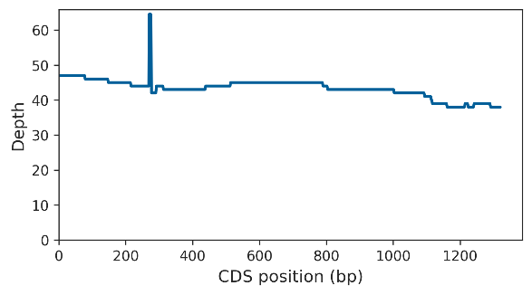
Pp1-Y1 | 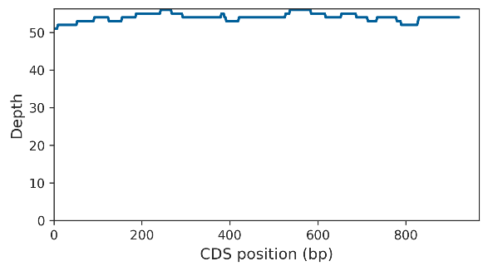
Pp1-Y2 | 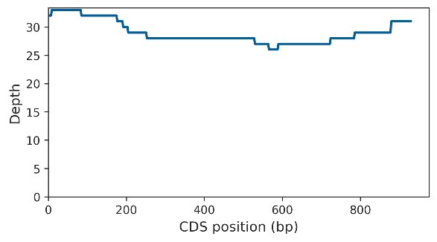
WDY | 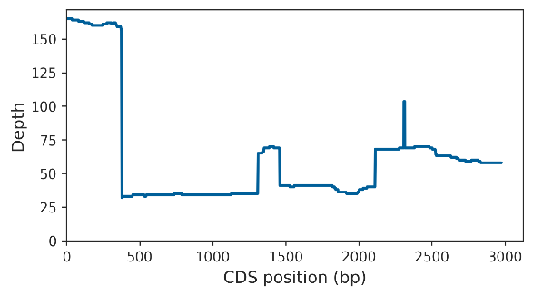
ORY | 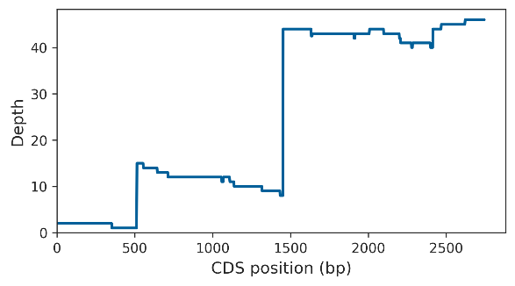
Ppr-Y | 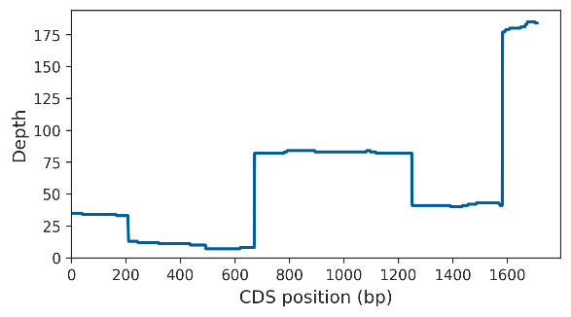
ARY | 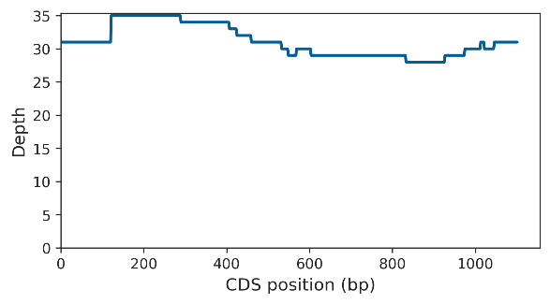
kl-2 | 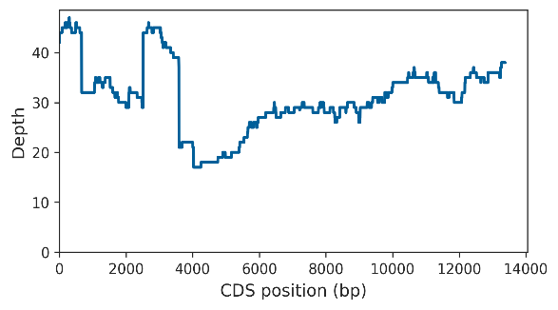
kl-3 | 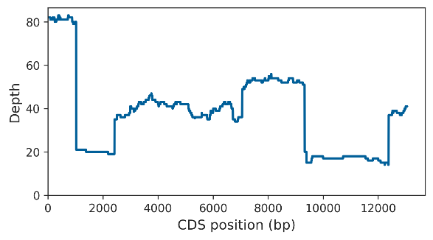
kl-5 | 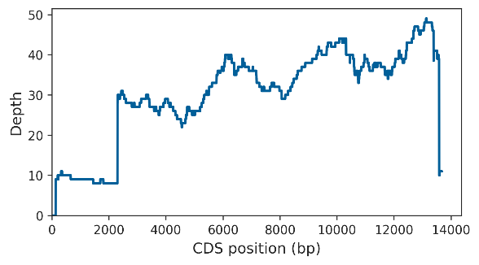
CCY | 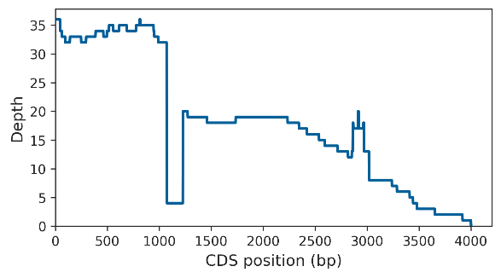
PRY | 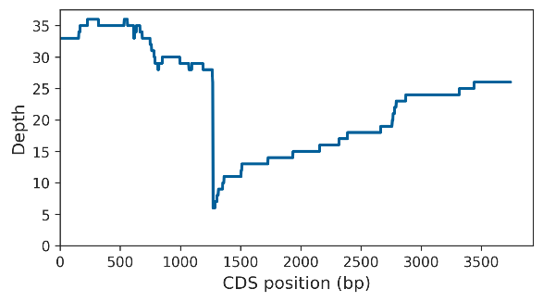

Supplemental Figure S23. Coverage of Y-linked genes by LILAP PacBio HiFi reads. Left panel: Coverage by LILAP PacBio HiFi reads (Jia et al. 2024); right panel: coverage by ONT reads (Kim et al. 2024). Nearly all "missing exons" observed in ONT reads also have low coverage in LILAP reads, implying that the bias affects both technologies. The smaller bias of LILAP reads is likely due to their shorter read lengths compared to ONT reads (see main text). LILAP uses Tn5 transposase instead of DNA ligase to glue the SMRTbell adaptor to the target sequence; their overall similarity to ONT reads is compatible with the idea that DNA ligase is not the primary cause of the observed bias (see main text).

Supplemental References

Bonenfant, Q., L. Noe and H. Touzet, 2023 Porechop_ABI: discovering unknown adapters in Oxford Nanopore Technology sequencing reads for downstream trimming. Bioinform Adv 3: vbac085.
Bosco, G., P. Campbell, J. T. Leiva-Neto and T. A. Markow, 2007 Analysis of Drosophila species genome size and satellite DNA content reveals significant differences among strains as well as between species. Genetics 177: 1277-1290.
Cer, R. Z., D. E. Donohue, U. S. Mudunuri, N. A. Temiz, M. A. Loss et al., 2013 Non-B DB v2.0: a database of predicted non-B DNA-forming motifs and its associated tools. Nucleic Acids Res 41: D94-D100.
Cheng, H., G. T. Concepcion, X. Feng, H. Zhang and H. Li, 2021 Haplotype-resolved de novo assembly using phased assembly graphs with hifiasm. Nat Methods 18: 170-175.
Flynn, J. M., M. Long, R. A. Wing and A. G. Clark, 2020 Evolutionary Dynamics of Abundant 7-bp Satellites in the Genome of Drosophila virilis. Mol Biol Evol 37: 1362-1375.
Jia, H., S. Tan, Y. Cai, Y. Guo, J. Shen et al., 2024 Low-input PacBio sequencing generates high-quality individual fly genomes and characterizes mutational processes. Nat Commun 15: 5644.
Kim, B. Y., H. R. Gellert, S. H. Church, A. Suvorov, S. S. Anderson et al., 2024 Single-fly genome assemblies fill major phylogenomic gaps across the Drosophilidae Tree of Life. PLoS Biol 22: e3002697.
Kohany, O., A. J. Gentles, L. Hankus and J. Jurka, 2006 Annotation, submission and screening of repetitive elements in Repbase: RepbaseSubmitter and Censor. BMC Bioinformatics 7: 474.
Kokot, M., M. Dlugosz and S. Deorowicz, 2017 KMC 3: counting and manipulating k-mer statistics. Bioinformatics 33: 2759-2761.
Kolmogorov, M., J. Yuan, Y. Lin and P. A. Pevzner, 2019 Assembly of long, error-prone reads using repeat graphs. Nat Biotechnol 37: 540-546.
Koren, S., B. P. Walenz, K. Berlin, J. R. Miller, N. H. Bergman et al., 2017 Canu: scalable and accurate long-read assembly via adaptive k-mer weighting and repeat separation. Genome Res 27: 722-736.
Kuhn, G. C., H. Kuttler, O. Moreira-Filho and J. S. Heslop-Harrison, 2012 The 1.688 repetitive DNA of Drosophila: concerted evolution at different genomic scales and association with genes. Mol Biol Evol 29: 7-11.
Li, H., 2016 Minimap and miniasm: fast mapping and de novo assembly for noisy long sequences. Bioinformatics 32: 2103-2110.
Matos-Rodrigues, G., J. A. Hisey, A. Nussenzweig and S. M. Mirkin, 2023 Detection of alternative DNA structures and its implications for human disease. Mol Cell 83: 3622-3641.
Nurk, S., S. Koren, A. Rhie, M. Rautiainen, A. V. Bzikadze et al., 2022 The complete sequence of a human genome. Science 376: 44-53.
Rautiainen, M., S. Nurk, B. P. Walenz, G. A. Logsdon, D. Porubsky et al., 2023 Telomere-to-telomere assembly of diploid chromosomes with Verkko. Nat Biotechnol 41: 1474-1482.
Razali, N. M., and B. W. Yap, 2011 Power comparisons of Shapiro-Wilk, Kolmogorov-Smirnov, Lilliefors and Anderson-Darling tests. Journal of Statistical Modeling and Analytics 2: 21-33.
Vaser, R., I. Sovic, N. Nagarajan and M. Sikic, 2017 Fast and accurate de novo genome assembly from long uncorrected reads. Genome Res 27: 737-746.
Zhang, Y., J. Chu, H. Cheng and H. Li, 2023 De novo reconstruction of satellite repeat units from sequence data. Genome Res 33: 1994-2001.

