Supplemental Information

Efficient integration of spatial omics data for joint domain detection, matching, and alignment with stMSA

Contents
Supplemental Notes 4
Supplemental Note S1 Comparison with other state-of-the-art methods 4
Supplemental Note S2 Batch Effects Arising from Different Experimental Protocols 7
Supplemental Note S3 Ablation study 8
Supplemental Note S4 Evaluation metrics 10
Supplemental Figures 13
Supplemental Figure S1. Spatial domain identification results of the four slices from three donors for 10x Visium DLPFC dataset using different state-of-the-art methods 13
Supplemental Figure S2. Benchmarking spatial domain identification performance on human dorsolateral prefrontal cortex (DLPFC) datasets. 14
Supplemental Figure S3. Comparative spatial domain identification on Stereo-seq DLPFC data using benchmark methods. 15
Supplemental Figure S4. The UMAP and PAGA trajectory inference plot of the embeddings generated by eight methods for all 12 slices 16
Supplemental Figure S5. The summary of resource consumption of the seven methods in DLPFC 151507 slice. 17
Supplemental Figure S6. Spatial domain identification results of mouse brain sagittal sections. 18
Supplemental Figure S7. The UMAP visualization and PAGA trajectory inference of the mouse brain sagittal section 19
Supplemental Figure S8. Spatial domain identification in coronal mouse brain sections. 20
Supplemental Figure S9. Spatial domain identification results for integrated analysis of fresh-frozen (FF) and formalin-fixed paraffin-embedded (FFPE) coronal mouse brain sections. 21
Supplemental Figure S10. Performance evaluation of batch effect correction. 22
Supplemental Figure S11. Integrated analysis of mouse olfactory bulb data from Stereo-seq and Slide-seqV2 platforms. 23
Supplemental Figure S12. Integrated spatial domain analysis of mouse olfactory bulb data from 10x Visium and Spatial Transcriptomics platforms. 24
Supplemental Figure S13. Integrated spatial analysis of mouse embryo data from Stereo-seq and Slide-seqV2 platforms. 25
Supplemental Figure S14. Spatial domain identification results and spatial distribution of the tissue structure and the corresponding marker gene for the mouse embryo dataset. 26
Supplemental Figure S15. Integrated spatial analysis of RNA-Protein coupling human tonsil dataset. 27
Supplemental Figure S16. The high-resolution domain identification results and the spatial variable genes for the lymph follicular region. 28
Supplemental Figure S17. Integration analysis of RNA-protein co-profiling data from mouse spleen. 29
Supplemental Figure S18. Spatial domain identification and alignment performance of stMSA. 30
Supplemental Tables 31
Supplemental Table S1. Summary of all spatial transcriptomic datasets used for experiments in this study 31
Supplemental Table S2. Summary of spatial proteomics datasets used for experiments in this study 32
References 33

Supplemental Notes
Supplemental Note S1 Comparison with other state-of-the-art methods
For multi-slice integration and domain identification, we compared stMSA against several leading methods: Scanorama[1], Harmony[2], SEDR[3], STAligner[4], Stitch3D[5], SPACEL[6], CAST[7], and STAMP[8]. For cross-slice matching, our comparison involved stMSA and SLAT[9]. Below, we provide introductions and list parameter settings for these methods:

Scanorama effectively recognizes datasets that contain cells with similar transcriptional profiles and utilizes these matches for batch correction and data integration. Importantly, it achieves this without merging non-overlapping datasets.
We utilized Scanorama in its default configuration and employed the scanorama.correct_scanpy() function for data integration. Additionally, we applied K-Means[10] clustering to identify multi-slice domains using embeddings generated by Scanorama. The source code of Scanorama can be found at https://github.com/brianhie/scanorama.

Harmony consists of two primary steps: the clustering step and the batch correction step. In the clustering step, embeddings are used to generate soft cluster results. These results are then utilized in the batch correction step to produce new, batch-corrected embeddings. Through iterative processing, Harmony ultimately outputs the batch-corrected embeddings of the input datasets.
We employed the Python implementation of Harmony, known as Harmonypy, using the harmonypy.run_harmony() function for data integration. Harmony was operated with its default settings. For clustering, we applied the K-Means method to the embeddings generated by Harmony. The source code for Harmony, implemented in Python, is available at https://github.com/slowkow/harmonypy.

SEDR generates latent representations for multi-slice datasets using a graph variational autoencoder. Subsequently, it corrects batch effects using the Harmony algorithm.
We applied SEDR as instructed in the documentation located at https://sedr.readthedocs.io/en/latest/Tutorial3_Batch_integration.html. For input, we used 200 principal components (PCs) obtained through the PCA algorithm[11], which were then processed by SEDR. Following this, we ran Harmony to obtain batch-corrected embeddings from those learned by SEDR. We use Mclust [12] for clustering as it recommended. The source code for SEDR is available at https://github.com/JinmiaoChenLab/SEDR.

STAligner utilizes a graph attention autoencoder to generate latent representations. The model parameters are optimized by maximizing the similarity between input gene expressions and the reconstructed gene expressions outputted by the autoencoder. Additionally, the model optimizes the similarity of positive Mutually Nearest Neighbor (MNN) pairs while minimizing the similarity of negative MNN pairs.
We employed STAligner as per the instructions provided at https://staligner.readthedocs.io/en/latest/. We used the script available in the instructions and conducted clustering as recommended. The source code for STAligner is available at https://github.com/zhoux85/STAligner.

Stitch3D processes single-cell reference data and multi-slice ST data as inputs. It constructs a 3D spatial graph for the ST data and trains latent representations using a graph attention network. Additionally, Stitch3D optimizes the model parameters by refining the estimation of cell type proportions and mitigating slice-spot and slice-gene specific effects.
We utilized Stitch3D following the instructions provided at https://stitch3d-tutorial.readthedocs.io/en/latest/tutorials/DLPFC/STitch3D_DLPFC.html. We used the single-cell reference data provided by Stitch3D and generated clustering results using the Gaussian Mixture Model[13] as recommended. The source code for Stitch3D can be found at https://github.com/YangLabHKUST/STitch3D.

SPACEL first uses single-cell data as a reference to generate deconvolution results for spatial transcriptomics data. It then uses the resulting proportion matrix as input to create latent embeddings for each spot using a graph convolutional network.
We utilized SPACEL, applying it with the single-cell data it provided. It is worth noticed that the single-cell data SPACEL used is differ from the one Stitch3D used. We followed the testing script at https://spacel.readthedocs.io/en/latest/tutorials/Visium_human_DLPFC_Spoint.html as instruction. The clustering results were obtained using the splane_model.identify_spatial_domain() function. The source code for SPACEL is available at https://github.com/QuKunLab/SPACEL.

CAST integrates multi-slice spatial transcript data by aligning slices using a graph neural network that leverages molecular and spatial similarities. It generates unified latent embeddings to harmonize cross-slice data, enabling robust spatial pattern matching, differential pathway analysis, and cell-cell interaction mapping across diverse platforms and conditions.
We utilized CAST following the instructions provided at https://cast-tutorial.readthedocs.io/en/latest/notebooks/demo1_CAST_mark.html. We generated clustering results using the K-Means clustering methods as recommended. The source code for CAST can be found at https://github.com/wanglab-broad/CAST.

STAMP integrates multi-slice spatial omics by unifying topic modeling and deep generative models. It aligns slices using a batch-corrected Gamma-Poisson framework, disentangling biological topics from technical noise. A graph convolutional network encodes spatial context and gene expression into interpretable modules.
We utilized STAMP following the instructions provided at https://jinmiaochenlab.github.io/scTM/notebooks/stamp/example6/. For dataset with known cluster number, we generated clustering results using the K-Means clustering methods as recommended, for dataset with unknown cluster. The source code for STAMP can be found at https://github.com/JinmiaoChenLab/scTM.

In all methods, for datasets with unknown cluster numbers, we employed Louvain clustering [14], aligning its resolution parameter with stMSA’s settings for consistency.

SLAT employs a lightweight graph convolutional autoencoder network to learn embeddings between two slices. The model parameters are optimized by maximizing the Wasserstein distance[15] between the embeddings of the two slices and enhancing the similarity between the input gene expressions and their reconstructed outputs from the autoencoder. The SLAT has four initialization settings based on the type of inputs: using all genes (Raw init), using the highly variable genes (HVG init), using dimension-reduced gene expression profile based on principle component analysis (PCA init) or dual-principal component analysis (DPCA init).
We utilized SLAT by following the script provided in its documentation at https://slat.readthedocs.io/en/latest/tutorials/basic_usage.html. The source code for SLAT is available at https://github.com/gao-lab/SLAT.

Supplemental Note S2 Batch effects arising from different experimental protocols
In this section, we investigate the impact of tissue processing protocols, such as fresh-frozen (FF) and formalin-fixed paraffin-embedded (FFPE), on batch effects using spatial transcriptomics datasets of the mouse brain generated with the 10x Visium platform. Specifically, we analyzed three datasets: two FF mouse brain samples (one stained with H&E and the other with immunofluorescence) and one FFPE mouse brain sample.
Although all datasets were generated using the same sequencing technology, differences in tissue preparation experiment protocols introduced significant protocol-driven batch effects, manifesting as systematic biases unrelated to sequencing itself. These biases must be corrected to enable meaningful integrative analyses.

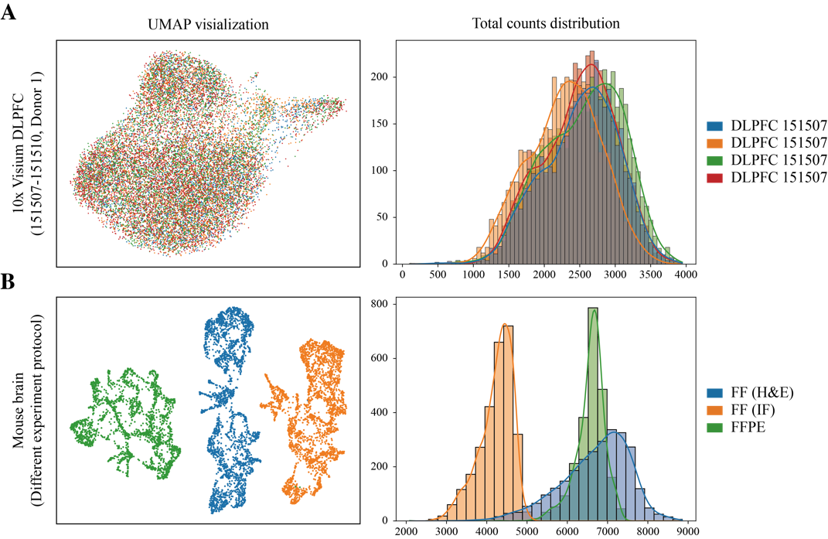
Supplemental Figure S2.1. Comparative analysis of normal and cross-protocol expression profiles. (A) UMAP visualization (left) and total counts distribution (right) for four adjacent slices from human DLPFC (Donor 1, 10x Visium). (B) UMAP visualization (left) and total counts distribution (right) for mouse coronal brain sections processed with distinct experimental protocols (FF (H&E), FF (IF), and FFPE, 10x Visium).

To visualize these effects, we compared the total counts distributions and gene expression patterns between a control group: four slices from the 10x Visium DLPFC dataset (identical protocol and sequencing platform, with minimal batch effects; Supplemental Fig. S2.1A), with the three mouse brain datasets (divergent protocols but the same sequencing platform; Supplemental Fig. S2.1B). The mouse brain datasets exhibited substantial differences in total counts and UMAP projections, indicating clear shifts in expression space due to protocol variation.
These results demonstrate that experimental protocols alone can introduce significant batch effects, even when using the same spatial sequencing platform. Addressing these protocol-specific artifacts is critical for robust cross-sample integration.

Supplemental Note S3 Ablation study
S3.1 Ablation study of the loss function and input HVGs count evaluation:
We performed an ablation study of stMSA on the coronal mouse brain dataset to evaluate its two core optimization strategies:
(1) Multi-slice integration employs contrastive learning to align embeddings in a shared space by maximizing similarity for cross-batch and spatial-niche pairs while minimizing similarity for random pairs.
(2) Biological feature learning combines: Gene expression reconstruction to predict original expression from embeddings; and spatial domain prediction using deep embedded clustering [16] to enhance intra-domain similarity and separate dissimilar regions.

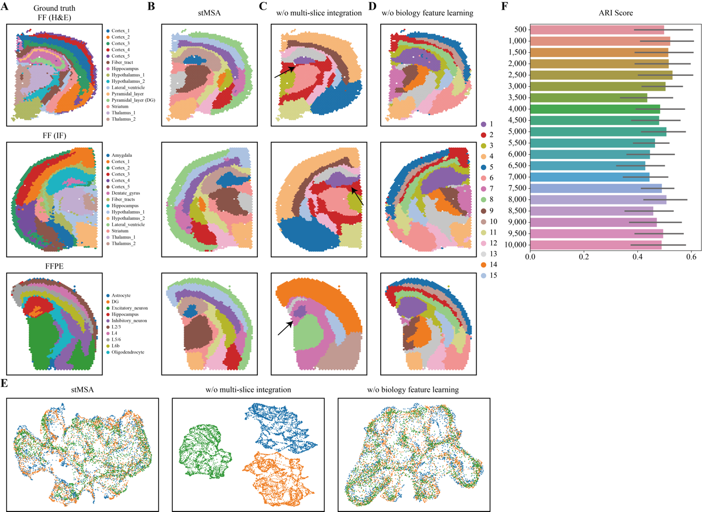
Supplemental Figure S3.1. Ablation study of stMSA on the coronal mouse brain dataset. (A) Manually annotated ground-truth spatial domains. (B) Spatial domains identified by the baseline stMSA model. (C) Results from the stMSA model ablated by removing the multi-slice integration loss. (D) Results from the stMSA model ablated by removing the biological feature learning loss. (E) UMAP visualizations colored by tissue slice for the baseline stMSA and ablated models. (F) The ARI scores for stMSA with varying numbers of highly variable genes as input.

When ablating the biological feature learning loss, the model fails to identify the dentate gyrus (DG) region in the hippocampus (Supplemental Fig. S3.1D). In contrast, ablating the multi-slice integration loss preserves DG identification (Supplemental Fig. S3.1C, domain 1; black arrow pointed), matching the baseline stMSA results (Supplemental Fig. S3.1A, B). These findings highlight the essential role of biological feature learning in capturing domain-specific biological variation.
For multi-slice integration, UMAP visualization demonstrated successful cross-slice embedding alignment in both baseline stMSA and models without biological feature learning loss (Supplemental Fig. S3.1E). However, ablation of multi-slice integration led to severe batch effects, confirming its critical role in cross-slice alignment.
We evaluated the number of inputs HVG for stMSA. We tested stMSA with 500–10,000 highly variable genes (HVGs) across the three mouse brain slices. The results show relatively stable ARI scores (Supplemental Fig. S3.1F), indicating robustness to HVG count. In practice, we recommend using 3,000 HVGs for multi-slice data without significant batch effects (e.g., same experiment protocol/sequencing platform). For cross-platform datasets, we suggest selecting more HVGs and using the intersecting genes as input features.

S3.2 Ablation study of the alignment strategy:
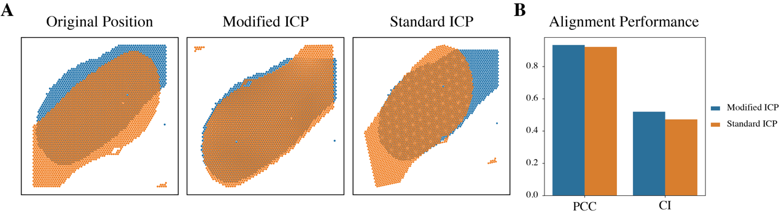
Supplemental Figure S3.2. Ablation study of stMSA modified ICP algorithm. (A) Comparison of spatial alignment in the mouse spleen dataset: original slice positions (left), and modified ICP alignment (middle), standard ICP alignment (right) using stMSA’s landmark domain. (B) The alignment performance evaluation of the modified ICP alignment and standard ICP alignment.

The standard ICP algorithm often converges to local optima, leading to suboptimal spatial alignments. To mitigate this, stMSA introduces a threshold-triggered random rotation mechanism that perturbs the optimization trajectory when alignment errors stagnate (see Methods).
Comparative evaluation of stMSA-modified ICP versus standard ICP (both guided by stMSA’s landmark domains) reveals notable differences. Standard ICP exhibits minimal rotation adjustments (Supplemental Fig. S3.2A), suggesting entrapment in local optima. stMSA-modified ICP dynamically adjusts rotations, achieving coherent alignment (Supplemental Fig. S3.2A). Quantitatively, standard ICP shows significantly lower CI scores (0.473) compared to stMSA-modified ICP (0.52) (Supplemental Fig. S3.2B), underscoring the efficacy of our threshold-based escape mechanism.

Supplemental Note S4 Evaluation metrics

Domain detection:
To evaluate the performance of domain detection, we utilize the metric of the Adjusted Rand index (ARI) , the Normalized Mutual Information (NMI) [17], the completeness metric (COM) and the Homogeneity metric (HOM) [18].
The ARI score is calculated using the following formula:
$$ARI=\frac{\sum_{ij}{\left({n_{ij} \atop 2}\right)}-\left[\sum_{i}{\left({a_{i} \atop 2}\right)\sum_{j}{\left({b_{j} \atop 2}\right)}}\right]/\left({n \atop 2}\right)}{\frac{1}{2}\left[\sum_{i}{\left({a_{i} \atop 2}\right)}+\sum_{j}{\left({b_{j} \atop 2}\right)}\right]-\left[\sum_{i}{\left({a_{i} \atop 2}\right)\sum_{j}{\left({b_{j} \atop 2}\right)}}\right]/\left({n \atop 2}\right)}$$
where $n_{ij}$ denotes the count of spots within the predicted cluster $i$ that are assigned to the ground truth class $j$, $a_{i}$ represents the count of spots within the predicted cluster $i$, $b_{j}$ denotes the count of spots within the ground truth class $j$, and $n$ represents the total count of spots.
The NMI is calculated using the following formula:
$$NMI=\frac{2×I(Y;C)}{[H(Y)+H(C)]}$$
where $Y$ is the class labels, $C$ is the clustering predicted labels, $H(∙)$ denotes the extropy function and$I(Y; C)$ denotes the mutual information between the class label $Y$ and predicted label $C$.
The COM is calculated using the following formula:
$$COM=1-\frac{H(K|C)}{H(K)}$$
where $H(K)$denotes the entropy of the clustering predicted distribution, $H(K|C)$ denotes the conditional entropy of the clusters given the classes label.
The HOM is calculated using the following formula:
$$HOM=1-\frac{H(C|K)}{H(C)}$$
where $H(C)$denotes the entropy of the class distribution, $H(C|K)$ denotes the conditional entropy of the classes label given the clusters.
A higher ARI, NMI, COM, HOM score indicates a more accurate detection of the domains that align with the ground truth labels. All metrics mentioned above were calculated using the Python package Scikit-learn [18].

To evaluate the spatial autocorrelation of the learned latent representations, we utilize the Geary's C [19], which is calculated as follows:
$$C=\frac{\left(N-1\right)\sum_{i,j}{w_{i,j}{\left(x_{i}-x_{j}\right)}^{2}}}{2W\sum_{i}{{\left(x_{i}-\overline{x}\right)}^{2}}}$$
where $N$ denotes the number of spots, $x_{i}$ and $x_{j}$ denote the latent representation of spot $i$ and $j$, $w_{ij}$ denotes the similarity of spot $i$ and $j$, and $W$ is the sum of all the similarity. A lower Geary's C score indicates a higher degree of spatial autocorrelation.
The Moran's I [20] is also a spatial autocorrelation metric we use to evaluate the latent representation. The Moran's I can be calculated as follows:
$$I=\frac{N}{W}\frac{\sum_{i,j}{w_{ij}\left(x_{i}-\overline{x}\right)\left(x_{j}-\overline{x}\right)}}{\sum_{i}{{\left(x_{i}-\overline{x}\right)}^{2}}}$$
where $N$, $x_{i}$, $x_{j}$, $w_{ij}$, and $W$ retain their previous meanings. A higher Moran's I score suggests a greater level of spatial autocorrelation. The Geary's C and Moran's I score are calculated by the Python package SCANPY [21].

Multi-slice integration (batch correction):
To evaluate the performance of integration, we calculate the mean Silhouette Coefficient (SC) [22], the Principal component regression (PCR) comparison score [23], the Local Inverse Simpson’s Index (LISI) [2], and the kBET score [23].
Due to the lack of coherent domain annotation between different slices, we directly calculate the batch SC score. For each data point $i$, the SC score is calculated as follows:
$$s(i) = \frac{b(i)-a(i)}{max(a(i), b(i))}$$
Where $a(i)$ denotes mean distance between $i$ and all other points in the same batch, $b(i)$ smallest mean distance between $i$ and points in any other batch.
The SC score measures how distinctly data points are clustered by comparing intra-cluster similarity to inter-cluster dissimilarity. When clusters correspond to batch, the SC score inversely reflects batch effect elimination: a lower SC score indicates that the embedding fails to distinguish batches (batch effects are minimized), while a higher score suggests persistent batch-related clustering. The SC score was calculated using the Python package Scikit-learn.
The PCR metric quantifies the proportion of variance in the integrated data explained by batch-associated principal components, detailed in [23] Supplemental notes 2. The PCR score was computed using the scib_metrics Python package [24].
The LISI score is calculated as follows:
$$\text{LIS}{\text{I}}_{\text{L}}\left(x,k\right)=D_{L}{\left(k\text{-nn}\left(x\right)\right)}^{-1}$$
where $x$ represents the set of objects embedding vectors, $L$ denotes the corresponding label set for the vector set, $k$ is a perplexity parameter set to 90 by default, $k\text{-nn}\left(⋅\right)$ represents the k-nearest neighbors algorithm, and $D_{L}\left(⋅\right)$ denotes Simpson's index, computed as follows:
$$D_{L}\left(S\right)=\sum_{l∈L}{{\left(\frac{n_{l}}{n}\right)}^{2}}$$
where $S$ denotes the object vector set, $n_{l}$ represents the count of vectors belonging to label type $l$, and $n$ is the overall count of vectors in set $S$.
The LISI score serves as an indicator of the degree of mixing between different label types, where a higher LISI score signifies improved cohesion and enhanced elimination of batch effects. The LISI score was calculated using the Python package HarmonyPy [2].
The kBET score assesses local batch mixing by testing whether the batch composition of each cell’s k-nearest neighbors matches the global batch distribution, reporting the fraction of cells failing this test; lower kBET rejection rates (a higher acceptance rate) reflect better batch harmonization, detailed in [23]. The kBET score was computed using the scib_metrics Python package [24].

Cross-slice matching:
To evaluate the quality of the matching, we compare the identity of the spot's label (such as cell type, tissue type) for each pair, and calculate a matching score $acc$ as depicted below:
$$acc=\frac{1}{N}\sum_{i=1}^{N}{{\text{I}}_{\text{sr}{\text{c}}_{\text{i}}\text{=ds}{\text{t}}_{\text{i}}}}$$
Where $src_{i}$ and $dst_{i}$ represent the cell types of spots $i$ in the source slice and its corresponding spot in the target slice, respectively. The indicator functions ${\text{I}}_{\text{sr}{\text{c}}_{\text{i}}\text{=ds}{\text{t}}_{\text{i}}}$ evaluates to 1 if $src_{i}$ and $dst_{i}$ represent the same cell type, and 0 otherwise. The $acc$ score quantifies the accuracy of the matching process. We utilize the Python package FAISS [25] to improve the efficiency of matching spots.

Multi-slice alignment:
To evaluate the alignment performance, we calculated the Pearson’s Correlation Coefficient (PCC) and Cell type matching Index (CI) score. For both metrics, we first identified the most distant nearest-neighbor pairs between the two aligned slices. Then the PCC score was calculated as the average Pearson’s Correlation Coefficient of the gene expression between two nodes in each pair. A higher PCC score indicates the aligned spot across slices have similar expression patterns, indicates a better alignment result. The CI score is counting the same class label’s pairs and divided the overall pair counts, which indicates better match of class label. A higher CI score indicates a better alignment result. We calculates the PCC and CI score using the evaluation() function in the SANTO [26] Python package.

Supplemental Figures
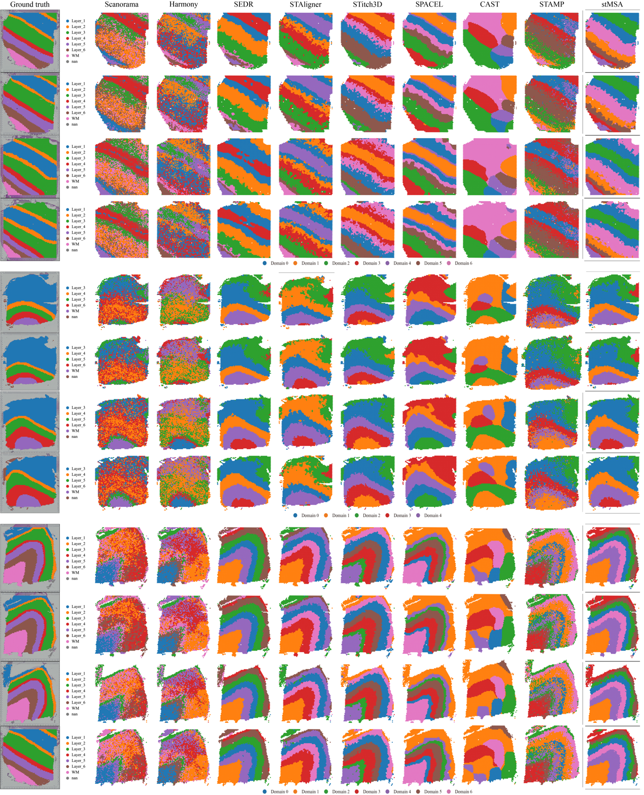
Supplemental Figure S1. Spatial domain identification results of the four slices from three donors for 10x Visium DLPFC dataset using different state-of-the-art methods.

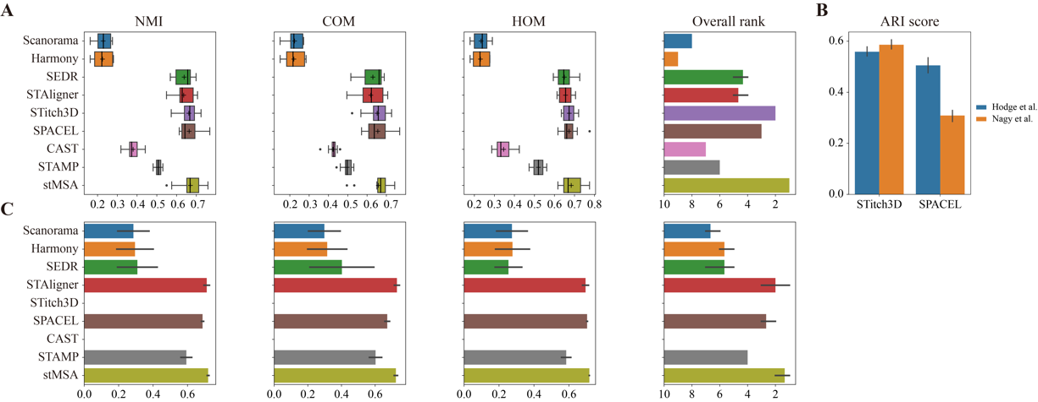
Supplemental Figure S2. Benchmarking spatial domain identification performance on human dorsolateral prefrontal cortex (DLPFC) datasets. (A) Domain identification accuracy assessed by three metrics: Normalized Mutual Information (NMI), Completeness score (COM), and Homogeneity score (HOM) for 10x Visium DLPFC sections. (B) Comparative performance analysis using Adjusted Rand Index (ARI) between Stitch3D and SPACEL on 10x Visium DLPFC samples (151673-151676) when applied with different single-cell reference datasets. Error bars represent the 95% confidence intervals of the ARI scores. (C) Spatial domain prediction performance for Stereo-seq DLPFC data. Error bars represent the 95% confidence intervals of the ARI scores. Notably, STitch3D and CAST were unable to produce results for the Stereo-seq DLPFC dataset on our server with 24 GB GPU memory and 128 GB RAM.

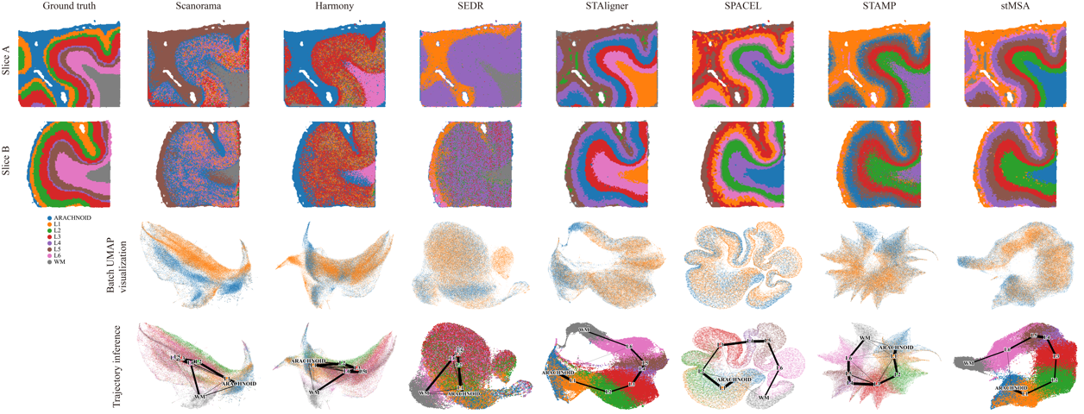
Supplemental Figure S3. Comparative spatial domain identification on Stereo-seq DLPFC data using benchmark methods. For each method, the upper two images are the domain identification results for slice A and slice B, respectively. The latter two images are the batch colored UMAP and the PAGA trajectory inference result, respectively. Note that Stitch3D and CAST failed to process this dataset due to GPU memory limitations.

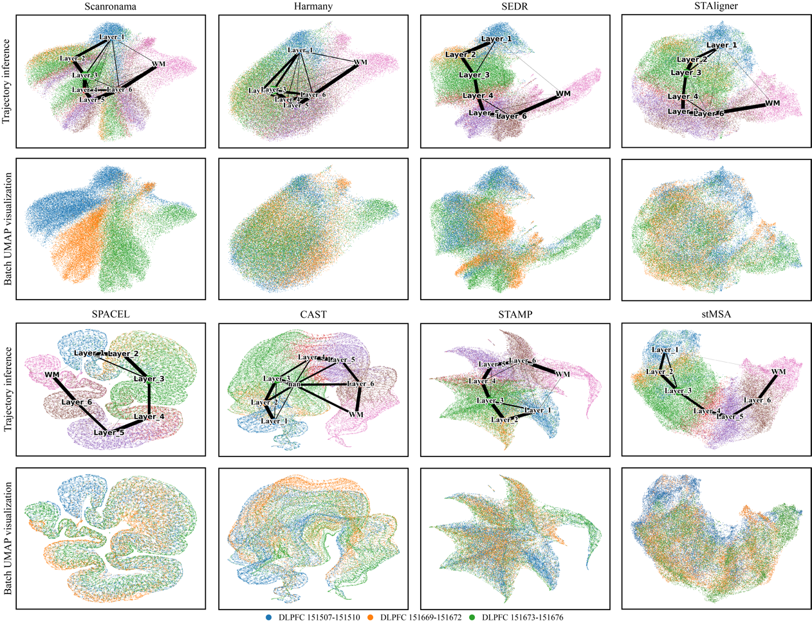
Supplemental Figure S4. The UMAP and PAGA trajectory inference plot of the embeddings generated by eight methods for all 12 slices. In each method, the upper plot showcases the UMAP plot colored by domain label and PAGA trajectory inference result lied on it, while the lower UMAP plot is colored by the donor label. Stitch3D is unable to process in this dataset due to the excessive demand for GPU memory.

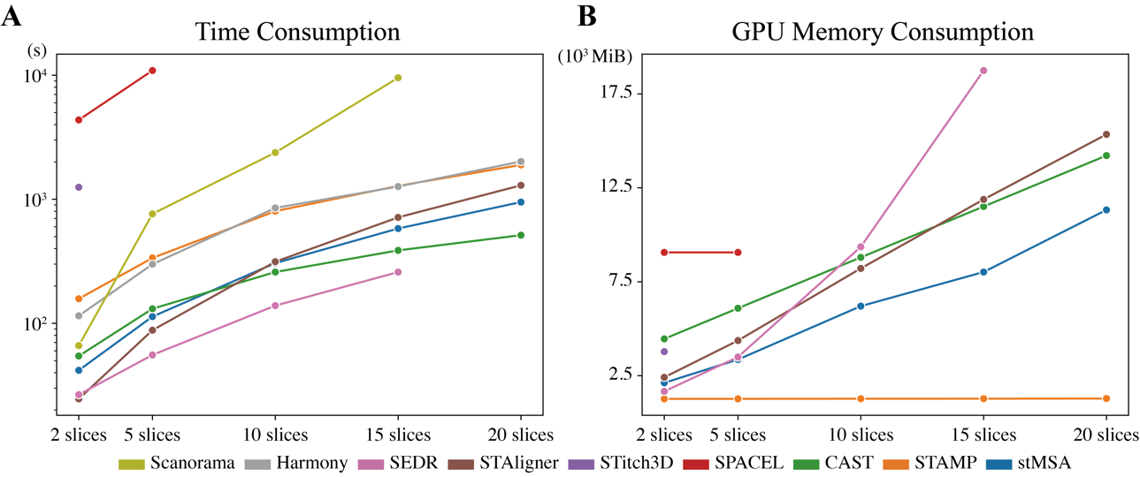
Supplemental Figure S5. The summary of resource consumption of the seven methods in DLPFC 151507 slice. (A) The time consumption of the nine methods for representation learning on 2, 5, 10, 15, and 20 DLPFC 151507 slice. Execution times beyond 3h were truncated to ensure practical scalability. (B) The GPU memory consumption of the seven methods for representation learning on 2, 5, 10, 15, and 20 DLPFC 151507 slice. Harmony and Scanorama do not use GPU resource for representation learning.

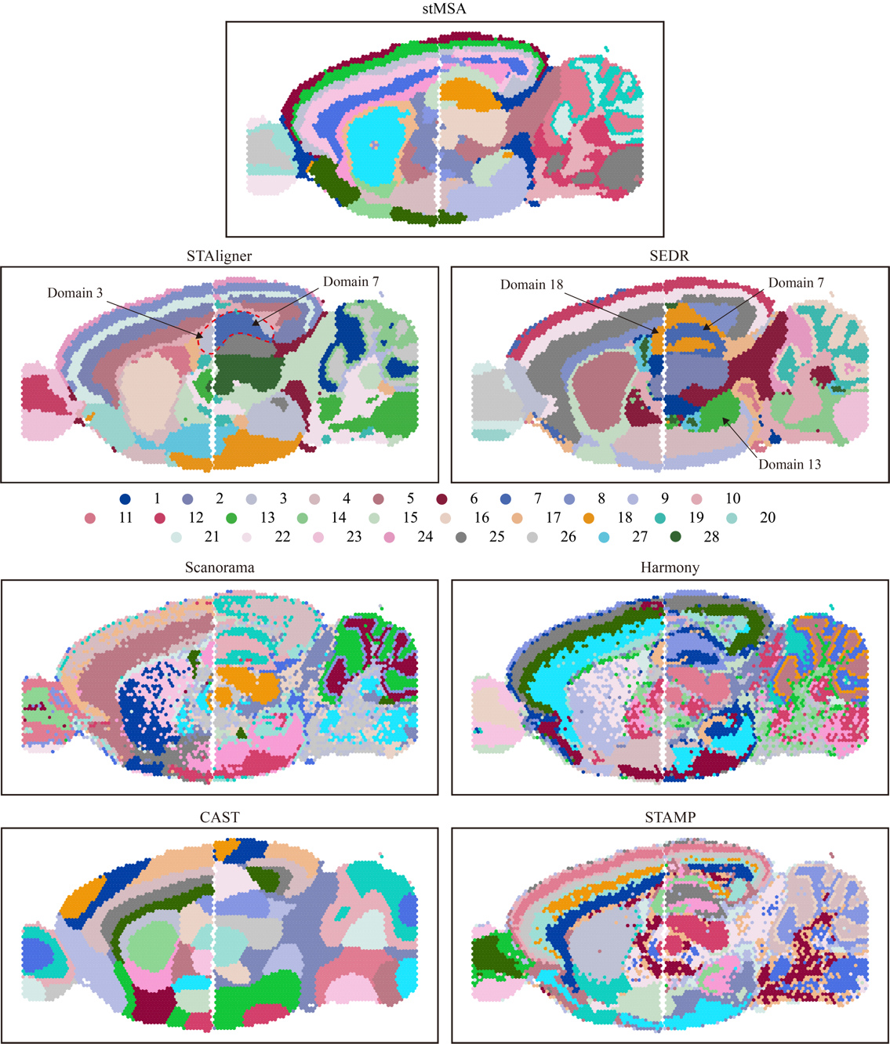
Supplemental Figure S6. Spatial domain identification results of mouse brain sagittal sections.

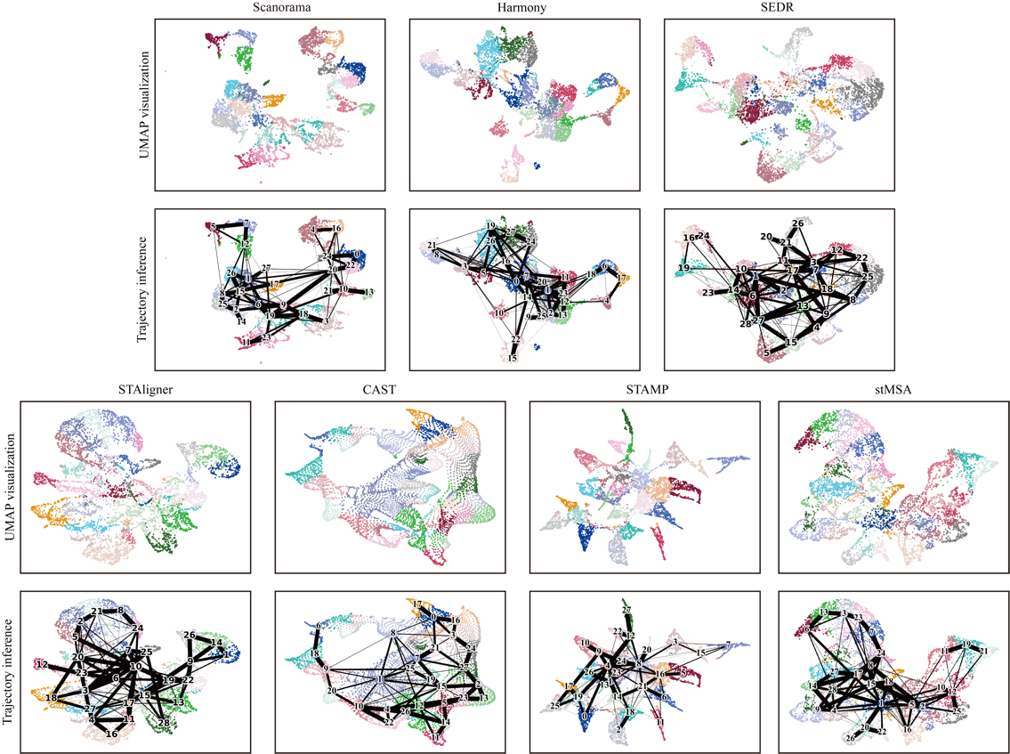
Supplemental Figure S7. The UMAP visualization and PAGA trajectory inference of the mouse brain sagittal section. The UMAP plot and the trajectory inference plot of the learned latent representation by three methods, colored by predicted label. The UMAP plot of stMSA demonstrates a similar relative position to their actual position in the isocortex region.

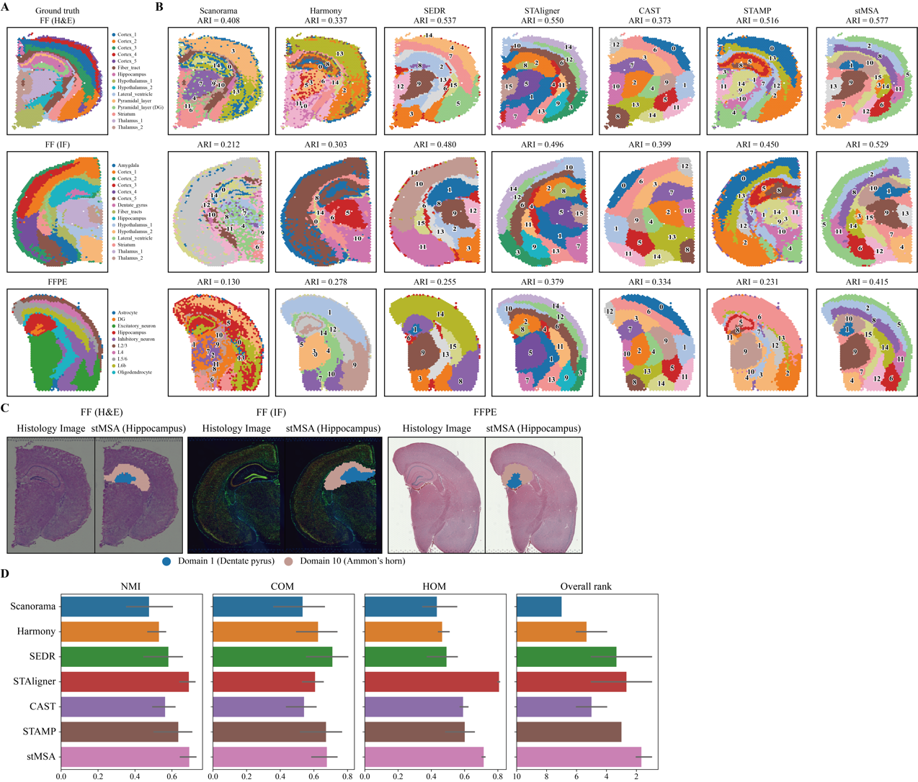
Supplemental Figure S8. Spatial domain identification in coronal mouse brain sections. (A) The manual annotations and domain detection results across mouse brain coronal sections derived from FF (H&E) (fresh frozen H&E stained), FF (IF) (fresh frozen immunofluorescence stained), and FFPE (formalin-fixed paraffin-embedded) slices, respectively. (B) Comparative performance of stMSA versus six state-of-the-art methods on three coronal brain sections. (C) Histology images with stMSA-predicted hippocampal regions in frozen (H&E), DAPI-stained, and FFPE sections. (D) Quantitative domain identification performance (ARI scores) across mouse brain sections. Error bars represent the 95% confidence intervals of the ARI scores.

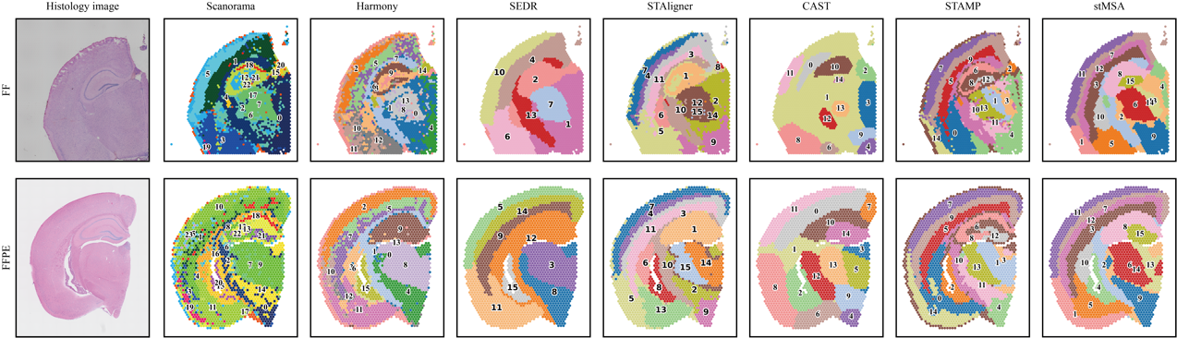
Supplemental Figure S9. Spatial domain identification results for integrated analysis of fresh-frozen (FF) and formalin-fixed paraffin-embedded (FFPE) coronal mouse brain sections.

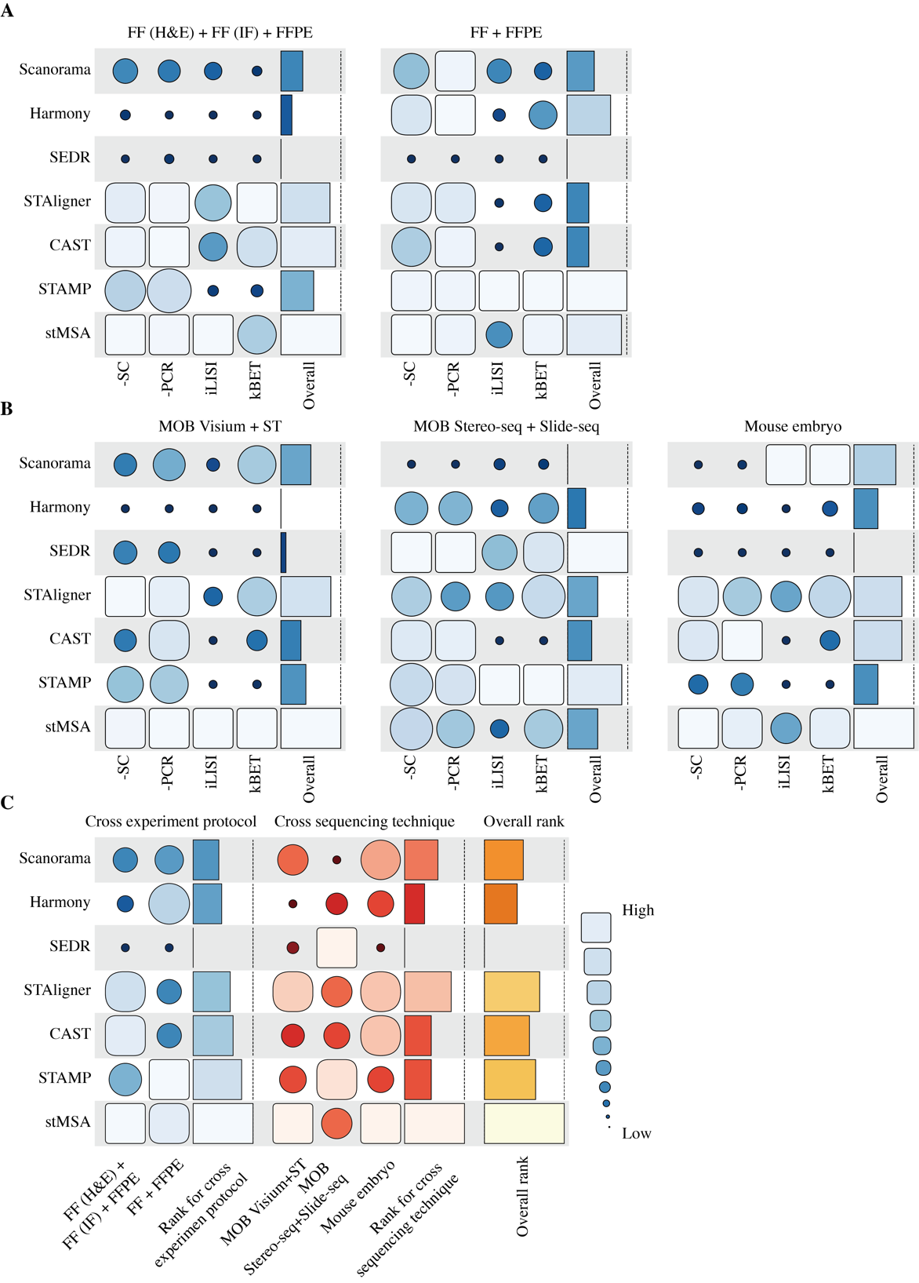
Supplemental Figure S10. Performance evaluation of batch effect correction. (A) Batch removal efficacy for integrating datasets generated using different experimental protocols. (B) Batch correction performance across datasets produced by different sequencing technologies. (C) Comparative integration performance of stMSA versus six benchmark methods.

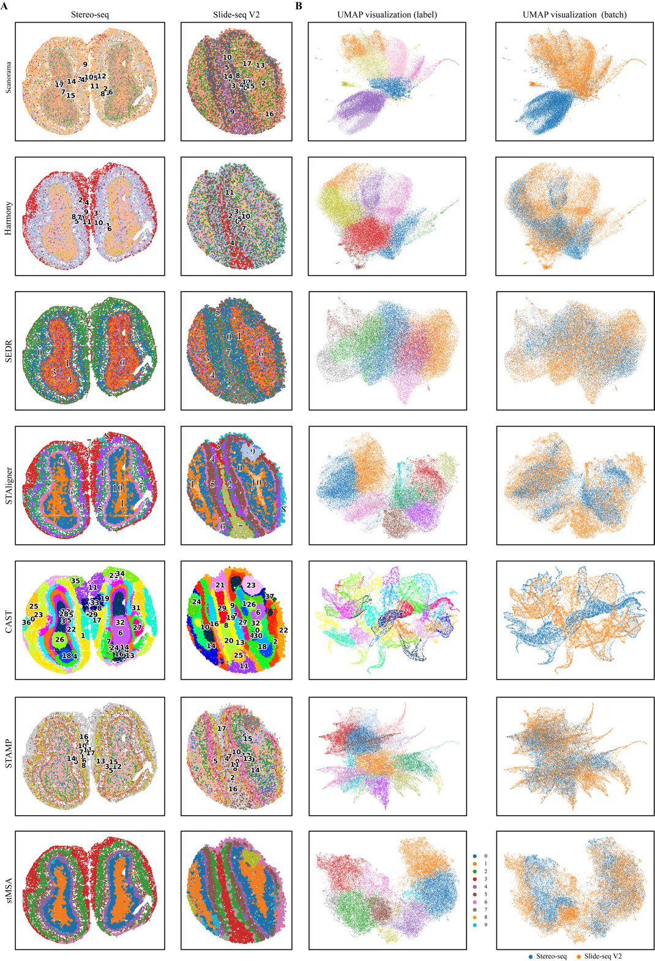
Supplemental Figure S11. Integrated analysis of mouse olfactory bulb data from Stereo-seq and Slide-seqV2 platforms. For each method (rows), spatial domain identification results are shown in the left panel, with corresponding UMAP visualizations (right panel) depicting cluster assignments and batch origins.

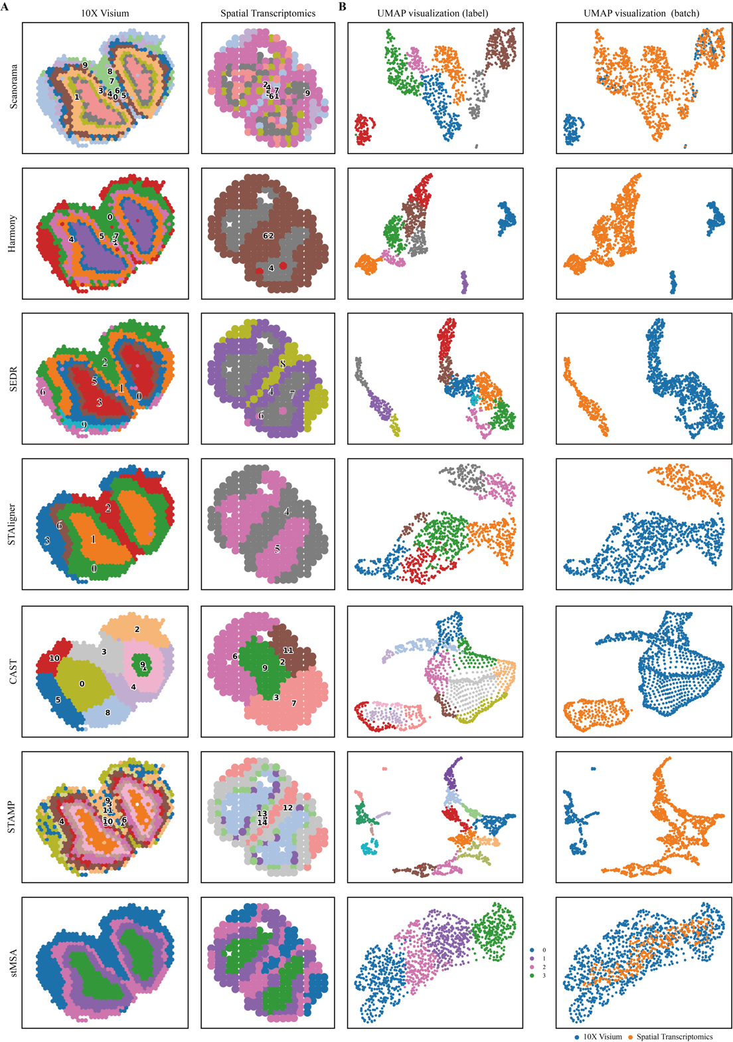
Supplemental Figure S12. Integrated spatial domain analysis of mouse olfactory bulb data from 10x Visium and Spatial Transcriptomics platforms. For each method (rows), the left panel shows the domain identification results, and the right panel shows the UMAP visualization colored by predicted clusters and colored by batch, respectively.

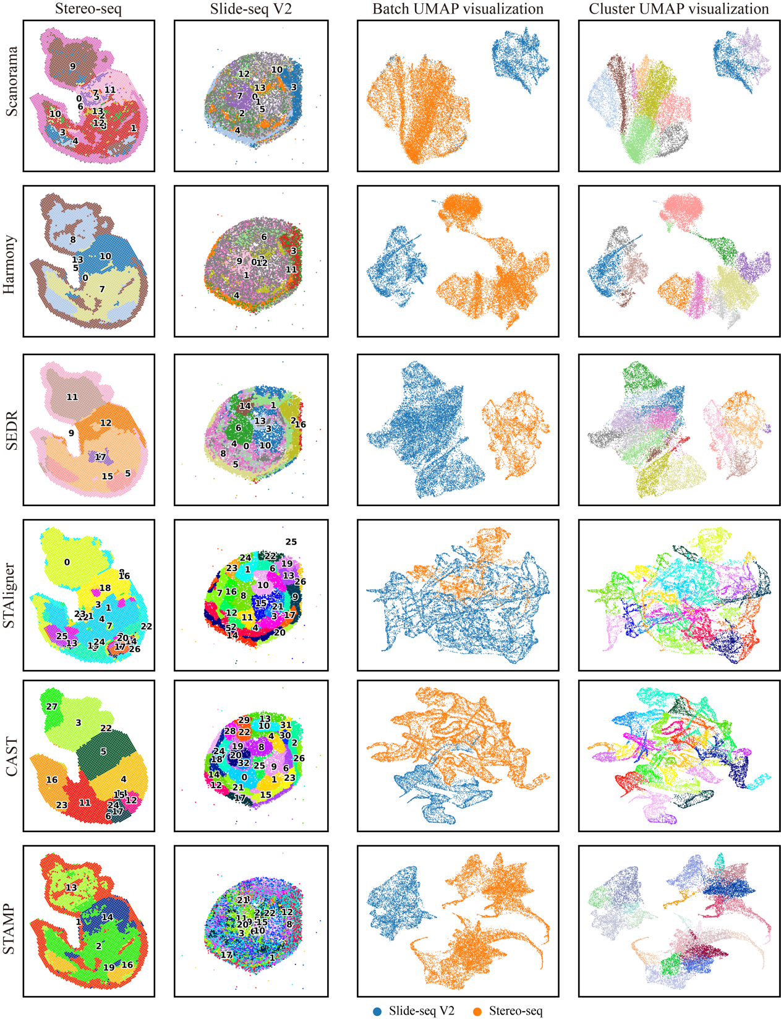
Supplemental Figure S13. Integrated spatial analysis of mouse embryo data from Stereo-seq and Slide-seqV2 platforms. For each method (rows), the left panel shows the spatial domain identification results, and the right panel shows the UMAP visualization colored by batch and colored by predicted clusters, respectively. Spatial domain identification and UMAP visualization of stMSA can be find at Fig. 4.

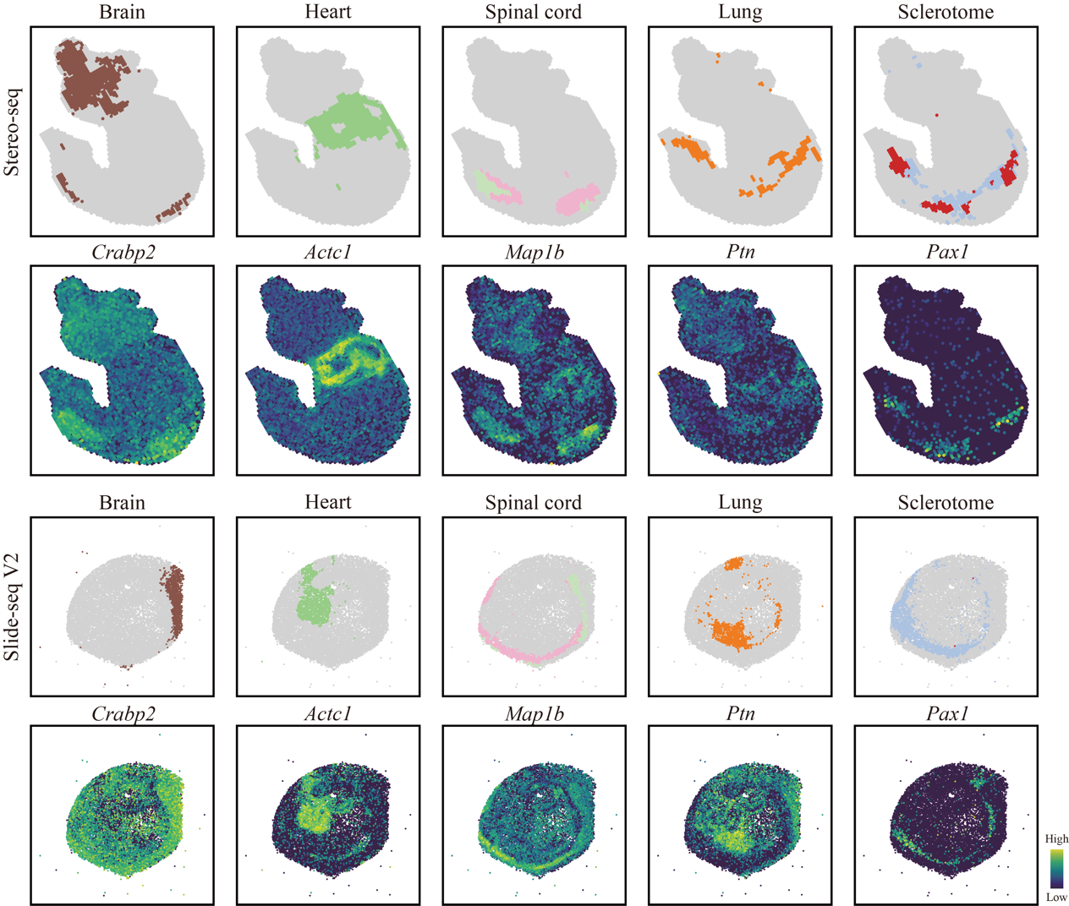
Supplemental Figure S14. Spatial domain identification results and spatial distribution of the tissue structure and the corresponding marker gene for the mouse embryo dataset. The brain, heart, spinal cord, lung, and sclerotome domain structure identified by stMSA and their corresponding marker gene for Stereo-seq and Slide-seq V2 obtained mouse embryo.

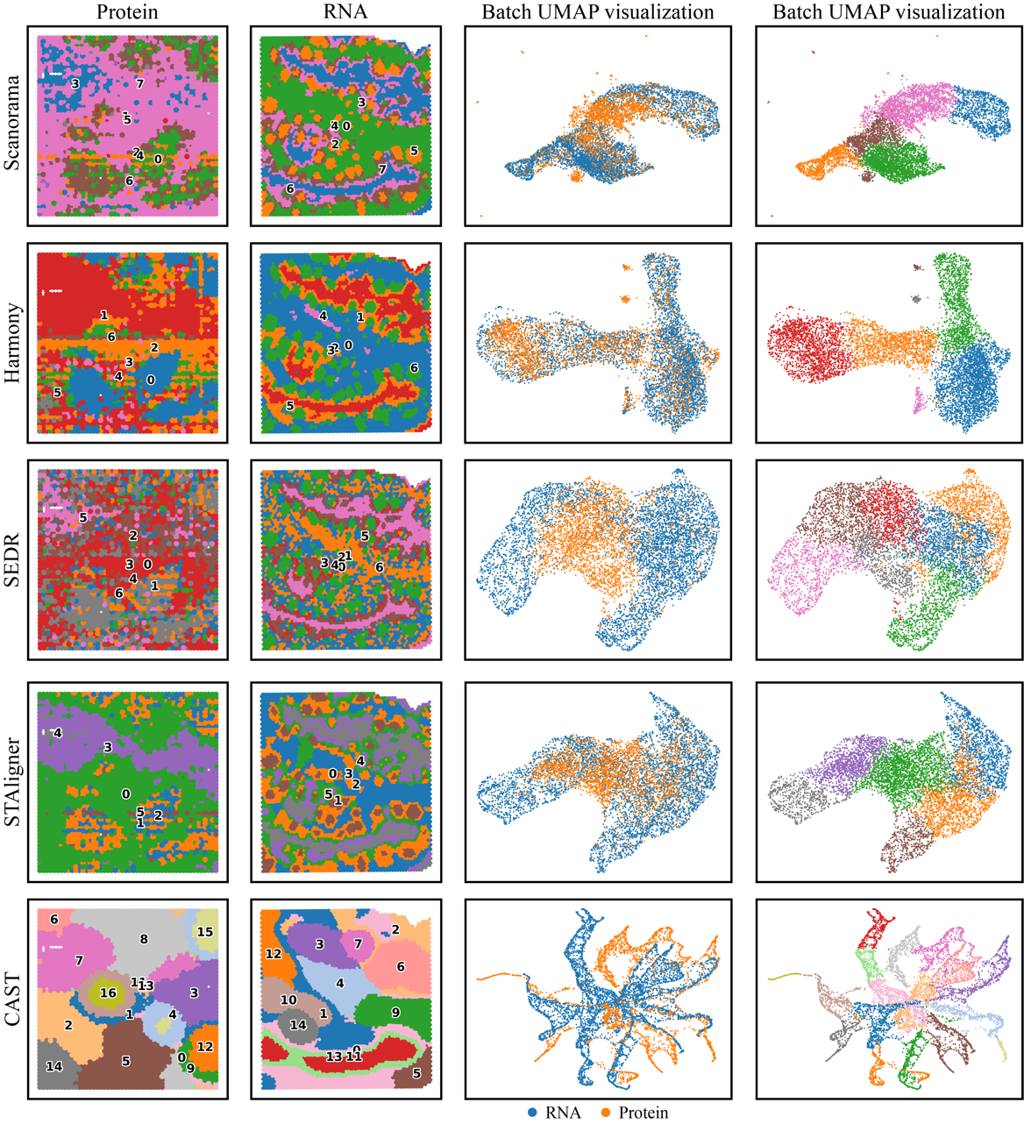
Supplemental Figure S15. Integrated spatial analysis of RNA-Protein coupling human tonsil dataset. For each method (rows), the left panel shows the domain identification results, and the right panel shows the UMAP visualization colored by batch and colored by predicted clusters, respectively. Spatial domain identification and UMAP visualization of stMSA can be find at Fig. 4.

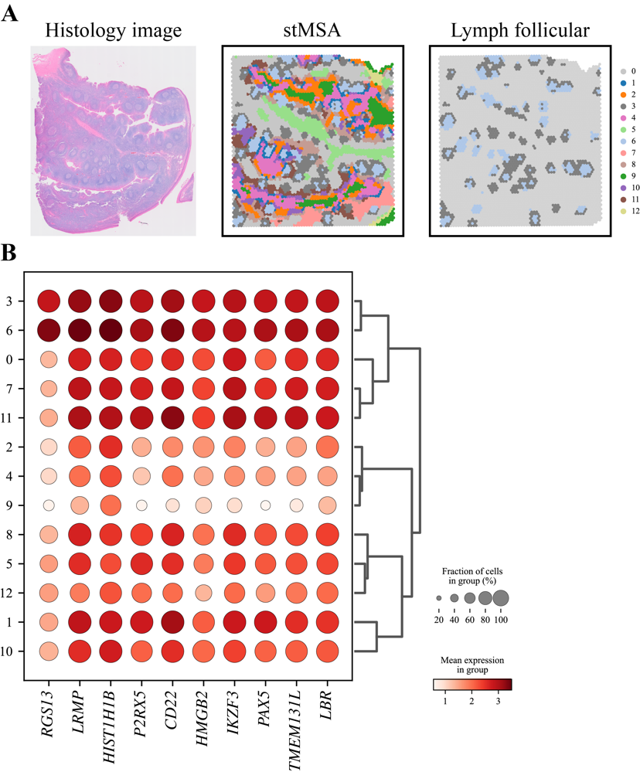
Supplemental Figure S16. The high-resolution domain identification results and the spatial variable genes for the lymph follicular region. (A) The histology image and the high-resolution domain identification results of the transcriptomics tonsil slice. (B) The spatial variable genes for the lymph follicular region.

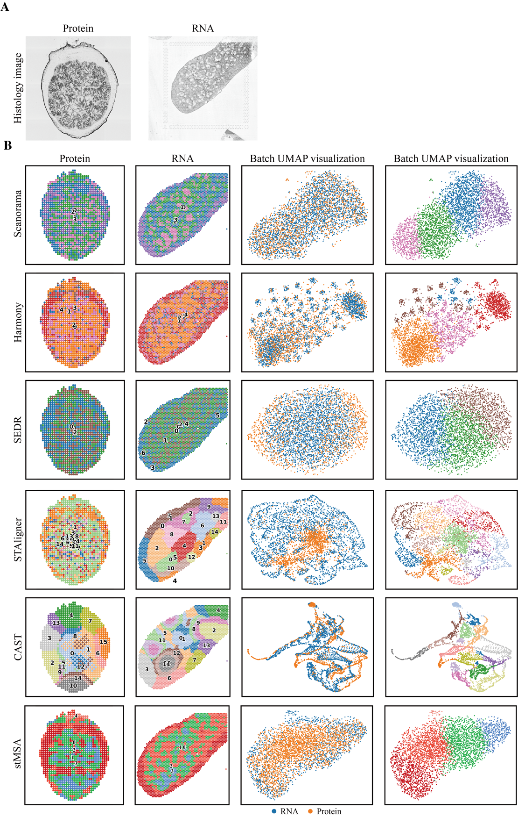
Supplemental Figure S17. Integration analysis of RNA-protein co-profiling data from mouse spleen. (A) Histology images showing matched tissue sections from protein (left) and RNA (right) datasets. (B) Spatial domain identification and batch-effect evaluation. For each integration method (rows), left panels show identified spatial domains overlaid on tissue morphology, and right panels display UMAP visualizations (left: batch labels; right: predicted clusters).

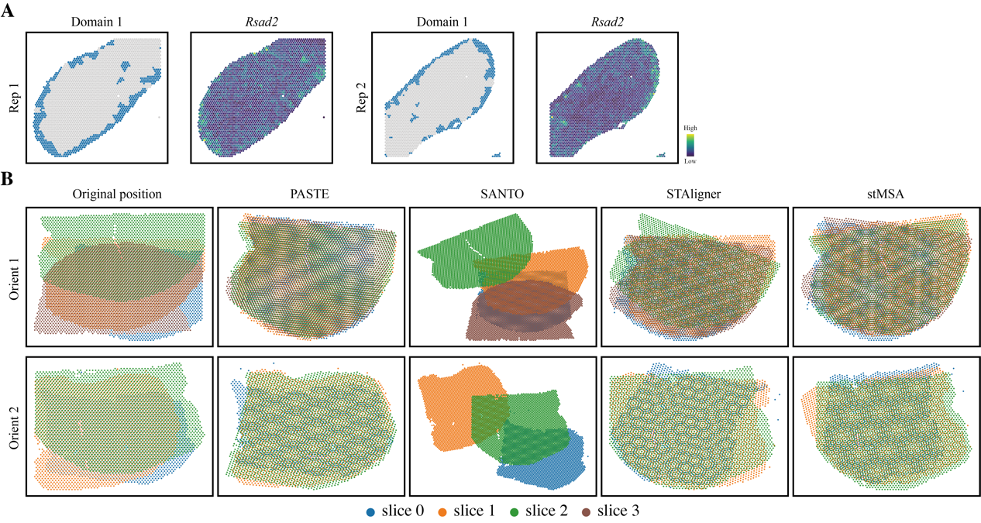
Supplemental Figure S18. Spatial domain identification and alignment performance of stMSA. (A) Spatial mapping of domain 1 (macrophage-enriched region) identified by stMSA in the mouse spleen, alongside the spatial distribution of a macrophage-specific gene marker Rsad2. (B) Comparison of alignment accuracy between stMSA and benchmark methods in the mouse brain dataset. The upper row displays Orientation 1 of the mouse brain dataset, comprising 4 slices, while the lower row corresponds to Orientation 2, which includes 3 slices.

Supplemental Tables
Supplemental Table S1. Summary of all spatial transcriptomic datasets used for experiments in this study.
Tissue | Section ID | Number of spots | Number of genes | Number of clusters | Sequencing technology | Label source
Human Brain Cortex | DLPFC 151507 | 4,226 | 33,538 | 7 | 10x Visium | Lieber Institute GitHub Repo
Human Brain Cortex | DLPFC 151508 | 4,384
Human Brain Cortex | DLPFC 151509 | 4,789
Human Brain Cortex | DLPFC 151510 | 4,634
Human Brain Cortex | DLPFC 151669 | 3,661 | 33,538 | 5 | 10x Visium | Lieber Institute GitHub Repo
Human Brain Cortex | DLPFC 151670 | 3,498
Human Brain Cortex | DLPFC 151671 | 4,110
Human Brain Cortex | DLPFC 151672 | 4,015
Human Brain Cortex | DLPFC 151673 | 3,639 | 33,538 | 7 | 10x Visium | Lieber Institute GitHub Repo
Human Brain Cortex | DLPFC 151674 | 3,673
Human Brain Cortex | DLPFC 151675 | 3,592
Human Brain Cortex | DLPFC 151676 | 3,460
Human Brain Cortex | Slice A | 31,329 | 31,749 | 8 | Stereo-seq | stMSA
Human Brain Cortex | Slice B | 35,772 | 31,972 | 8 | Stereo-seq | stMSA
Mouse brain Saggital | Anterior | 2,696 | 31,053 | - | 10x Visium | None
Mouse brain Saggital | Posterior | 3,353
Mouse brain Coronal | FF (H&E) | 2,688 | 18,078 | 15 | 10x Visium | squidpy
Mouse brain Coronal | FF (IF) | 2,800 | 16,562 | 15 | 10x Visium | squidpy
Mouse brain Coronal | FFPE | 2,264 | 19,465 | 10 | 10x Visium | STOmicsDB
Mouse brain Coronal | FF | 2,797 | 32,285 | - | 10x Visium | None
Mouse brain Coronal | FFPE | 2,310 | 19,465 | - | 10x Visium | None
Mouse brain Coronal | GSM6704280 | 2,522 | 32,285 | - | 10x Visium | None
Mouse brain Coronal | GSM6704281 | 2,831
Mouse brain Coronal | GSM6704282 | 2,752
Mouse brain Coronal | GSM6704283 | 2,816
Mouse brain Coronal | GSM6704284 | 2,108
Mouse brain Coronal | GSM6704285 | 2,639
Mouse brain Coronal | GSM6704286 | 2,741
Mouse olfactory bulb | - | 21,724 | 21,220 | - | Slide-seq V2 | None
Mouse olfactory bulb | - | 19,109 | 27,106 | - | Stereo-seq | None
Mouse olfactory bulb | - | 267 | 16,573 | - | Spatial Transcriptomics | None
Mouse olfactory bulb | - | 918 | 31,053 | - | 10x Visium | None
Human Tonsil | - | 4,908 | 18,085 | - | 10x Visium | None
Mouse Embryo | - | 14,758 | 27,554 | - | Slide-seq V2 | None
Mouse Embryo | E9.5 E2S2 | 4,356 | 24,107 | 13 | Stereo-seq | STOmicsDB
Mouse Embryo | E9.5 E1S1 | 5,913 | 25,568 | 12 | Stereo-seq | STOmicsDB
Mouse Embryo | E10.5 E1S1 | 18,408 | 25,201 | 13 | Stereo-seq | STOmicsDB
Mouse Embryo | E11.5 E1S1 | 30,124 | 26,854 | 19 | Stereo-seq | STOmicsDB
Mouse Embryo | E12.5 E1S1 | 51,365 | 27,810 | 23 | Stereo-seq | STOmicsDB
Mouse Embryo | E13.5 E1S1 | 77,369 | 28,408 | 19 | Stereo-seq | STOmicsDB
Mouse Embryo | E14.5 E1S1 | 102,519 | 28,463 | 26 | Stereo-seq | STOmicsDB
Mouse Embryo | E15.5 E1S1 | 113,350 | 28,798 | 26 | Stereo-seq | STOmicsDB
Mouse spleen | Rep 1 | 2,653 | 32,285 | 3 | SPOTS | SPOTS
Mouse spleen | Rep 2 | 2,768 | 32,285 | 3 | SPOTS | SPOTS

Supplemental Table S2. Summary of spatial proteomics datasets used for experiments in this study.
Tissue | Number of spots | Number of proteins | Technology
Human Tonsil | 2,492 | 410 | Spatial CITE-seq
Mouse Spleen | 1,303 | 282 | SPOTS

References
[1] B. Hie, B. Bryson, and B. Berger, “Efficient integration of heterogeneous single-cell transcriptomes using Scanorama,” Nat. Biotechnol., vol. 37, no. 6, pp. 685–691, Jun. 2019, doi: 10.1038/s41587-019-0113-3.
[2] I. Korsunsky et al., “Fast, sensitive and accurate integration of single-cell data with Harmony,” Nat. Methods, vol. 16, no. 12, Art. no. 12, Dec. 2019, doi: 10.1038/s41592-019-0619-0.
[3] J. Chen et al., “Unsupervised Spatially Embedded Deep Representation of Spatial Transcriptomics,” In Review, preprint, Jul. 2021. doi: 10.21203/rs.3.rs-665505/v1.
[4] X. Zhou, K. Dong, and S. Zhang, “Integrating spatial transcriptomics data across different conditions, technologies and developmental stages,” Nat. Comput. Sci., Oct. 2023, doi: 10.1038/s43588-023-00528-w.
[5] G. Wang, J. Zhao, Y. Yan, Y. Wang, A. R. Wu, and C. Yang, “Construction of a 3D whole organism spatial atlas by joint modelling of multiple slices with deep neural networks,” Nat. Mach. Intell., pp. 1–14, Oct. 2023, doi: 10.1038/s42256-023-00734-1.
[6] H. Xu et al., “SPACEL: deep learning-based characterization of spatial transcriptome architectures,” Nat. Commun., vol. 14, no. 1, Art. no. 1, Nov. 2023, doi: 10.1038/s41467-023-43220-3.
[7] Z. Tang et al., “Search and match across spatial omics samples at single-cell resolution,” Nat. Methods, vol. 21, no. 10, pp. 1818–1829, Oct. 2024, doi: 10.1038/s41592-024-02410-7.
[8] C. Zhong, K. S. Ang, and J. Chen, “Interpretable spatially aware dimension reduction of spatial transcriptomics with STAMP,” Nat. Methods, vol. 21, no. 11, pp. 2072–2083, Nov. 2024, doi: 10.1038/s41592-024-02463-8.
[9] C.-R. Xia, Z.-J. Cao, X.-M. Tu, and G. Gao, “Spatial-linked alignment tool (SLAT) for aligning heterogenous slices,” Nat. Commun., vol. 14, no. 1, Art. no. 1, Nov. 2023, doi: 10.1038/s41467-023-43105-5.
[10] J. MacQueen, “Some methods for classification and analysis of multivariate observations,” Proc. Fifth Berkeley Symp. Math. Stat. Probab. Vol. 1 Stat., vol. 5.1, pp. 281–298, Jan. 1967.
[11] I. T. Jolliffe and J. Cadima, “Principal component analysis: a review and recent developments,” Philos. Trans. R. Soc. Math. Phys. Eng. Sci., vol. 374, no. 2065, p. 20150202, Apr. 2016, doi: 10.1098/rsta.2015.0202.
[12] L. Scrucca, M. Fop, T. B. Murphy, and A. E. Raftery, “mclust 5: Clustering, Classification and Density Estimation Using Gaussian Finite Mixture Models,” R J., vol. 8, no. 1, Art. no. 1, 2016.
[13] N. Kambhatla and T. Leen, “Classifying with Gaussian Mixtures and Clusters,” in Advances in Neural Information Processing Systems, MIT Press, 1994. Accessed: May 30, 2023. [Online]. Available: https://proceedings.neurips.cc/paper_files/paper/1994/hash/621461af90cadfdaf0e8d4cc25129f91-Abstract.html
[14] V. D. Blondel, J.-L. Guillaume, R. Lambiotte, and E. Lefebvre, “Fast unfolding of communities in large networks,” J. Stat. Mech. Theory Exp., vol. 2008, no. 10, Art. no. 10, Oct. 2008, doi: 10.1088/1742-5468/2008/10/P10008.
[15] M. Arjovsky, S. Chintala, and L. Bottou, “Wasserstein GAN,” Dec. 06, 2017, arXiv: arXiv:1701.07875. doi: 10.48550/arXiv.1701.07875.
[16] J. Xie, R. Girshick, and A. Farhadi, “Unsupervised Deep Embedding for Clustering Analysis,” May 24, 2016, arXiv: arXiv:1511.06335. Accessed: Feb. 01, 2023. [Online]. Available: http://arxiv.org/abs/1511.06335
[17] A. J. Gates and Y.-Y. Ahn, “The Impact of Random Models on Clustering Similarity,” J. Mach. Learn. Res., vol. 18, no. 87, Art. no. 87, 2017.
[18] F. Pedregosa et al., “Scikit-learn: Machine Learning in Python,” J. Mach. Learn. Res., vol. 12, no. 85, Art. no. 85, 2011.
[19] J. N. R. Jeffers, “A Basic Subroutine for Geary’s Contiguity Ratio,” J. R. Stat. Soc. Ser. Stat., vol. 22, no. 4, Art. no. 4, 1973, doi: 10.2307/2986827.
[20] P. A. P. Moran, “Notes on Continuous Stochastic Phenomena,” Biometrika, vol. 37, no. 1/2, Art. no. 1/2, 1950, doi: 10.2307/2332142.
[21] F. A. Wolf, P. Angerer, and F. J. Theis, “SCANPY: large-scale single-cell gene expression data analysis,” Genome Biol., vol. 19, no. 1, Art. no. 1, Feb. 2018, doi: 10.1186/s13059-017-1382-0.
[22] P. J. Rousseeuw, “Silhouettes: A graphical aid to the interpretation and validation of cluster analysis,” J. Comput. Appl. Math., vol. 20, pp. 53–65, Nov. 1987, doi: 10.1016/0377-0427(87)90125-7.
[23] M. Büttner, Z. Miao, F. A. Wolf, S. A. Teichmann, and F. J. Theis, “A test metric for assessing single-cell RNA-seq batch correction,” Nat. Methods, vol. 16, no. 1, pp. 43–49, Jan. 2019, doi: 10.1038/s41592-018-0254-1.
[24] M. D. Luecken et al., “Benchmarking atlas-level data integration in single-cell genomics,” Nat. Methods, vol. 19, no. 1, Art. no. 1, Jan. 2022, doi: 10.1038/s41592-021-01336-8.
[25] M. Douze et al., “The Faiss library,” arXiv.org. Accessed: Feb. 28, 2024. [Online]. Available: https://arxiv.org/abs/2401.08281v1
[26] H. Li et al., “SANTO: a coarse-to-fine alignment and stitching method for spatial omics,” Nat. Commun., vol. 15, no. 1, Art. no. 1, Jul. 2024, doi: 10.1038/s41467-024-50308-x.

