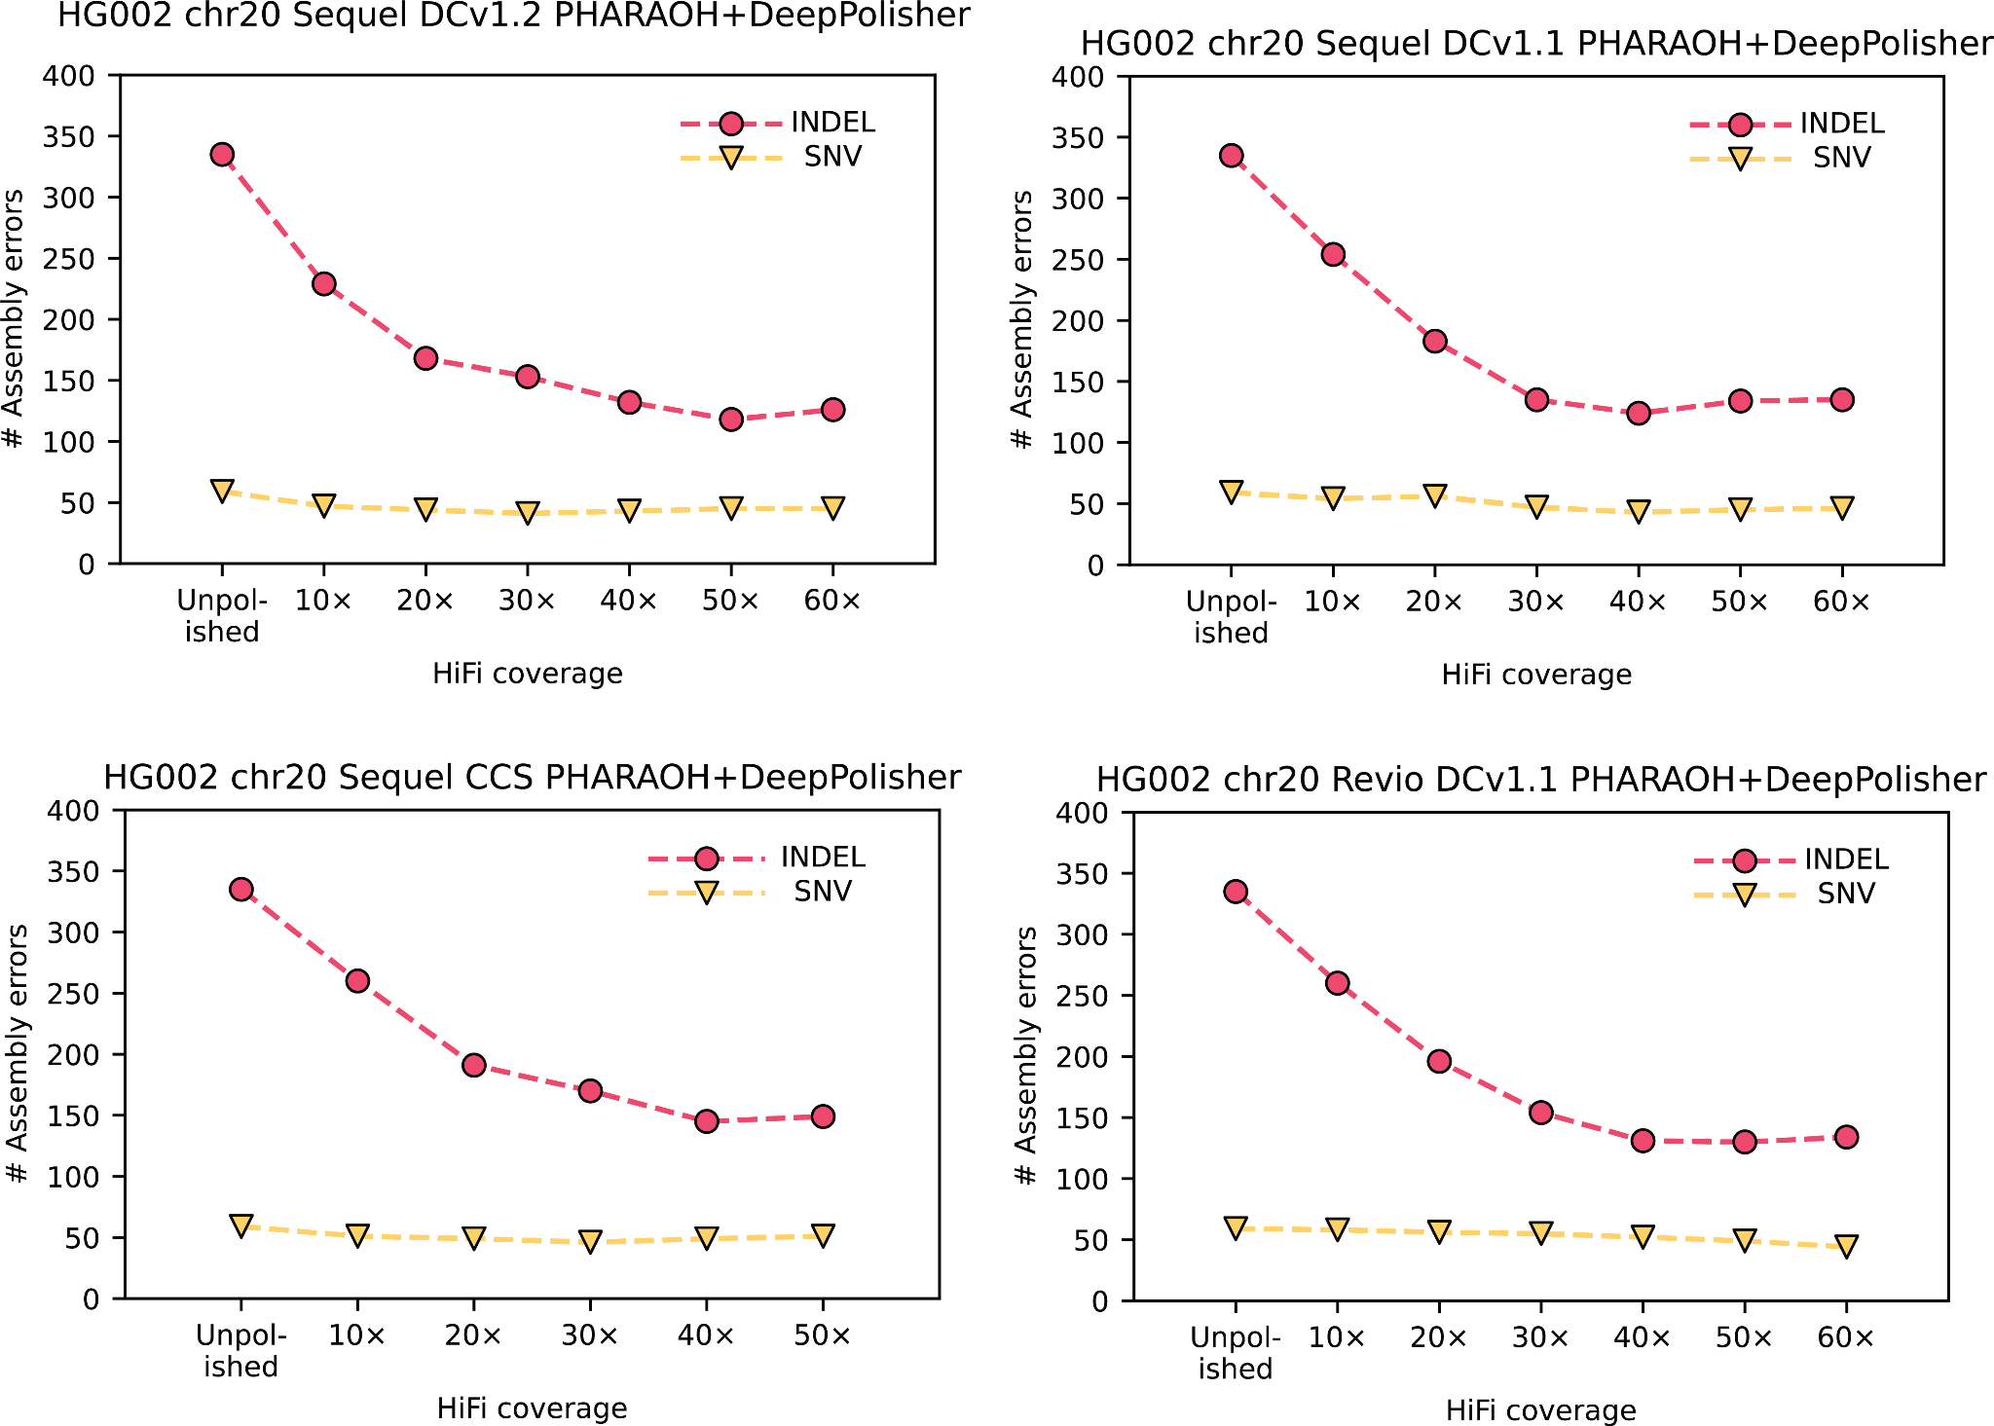

________________________________________________________________________________________________________
Supplementary Figure 1: HG002 Chr20 GIAB variant calling performance for other HiFi read versions, across different coverages. Total GIAB variant calling (assembly) errors for different HiFi read coverages, with indel errors represented in pink circles and SNV errors in yellow triangles
________________________________________________________________________________________________________

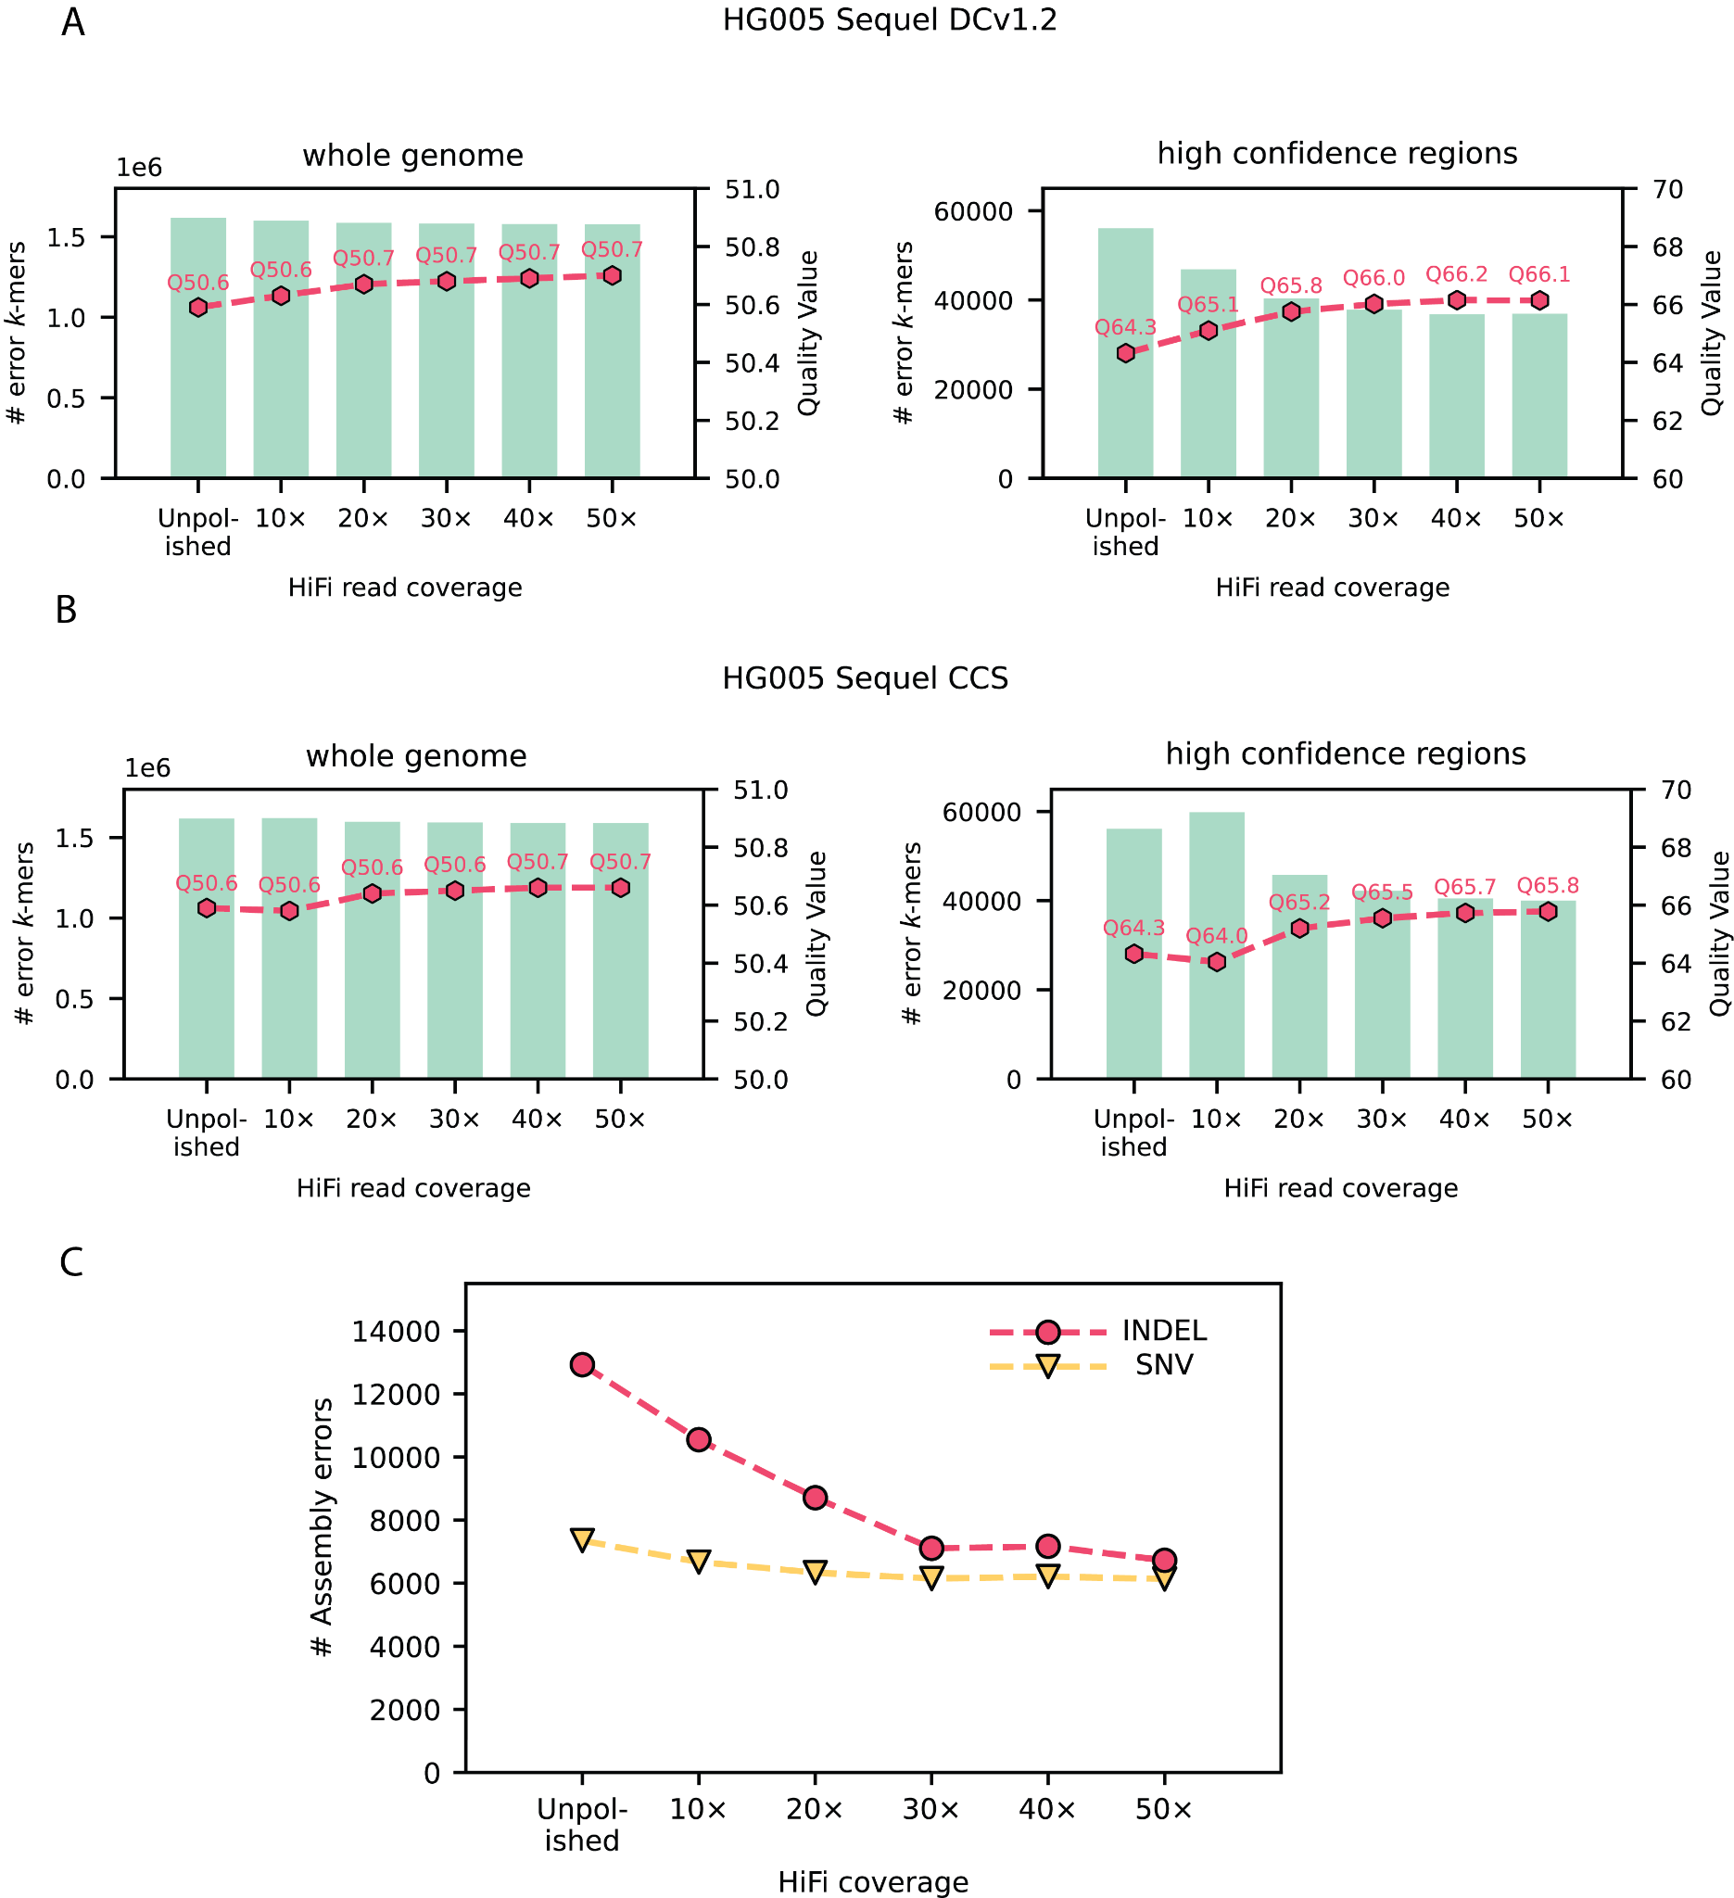

________________________________________________________________________________________________________
Supplementary Figure 2: HG005 data performance across multiple coverages and read technologies. A) Bar plots represent number of error k-mers (left y axis) for HiFi Sequel DCv1.2 at different read coverages, with the corresponding QV plotted on the right y axis for whole genome (left panel) and for the confidence regions (right panel) B) The same for HiFi Sequel CCS data. C) Total GIAB variant calling (assembly) errors for different HiFi read coverages, with indel errors represented in pink circles and SNV errors in yellow triangles ________________________________________________________________________________________________________

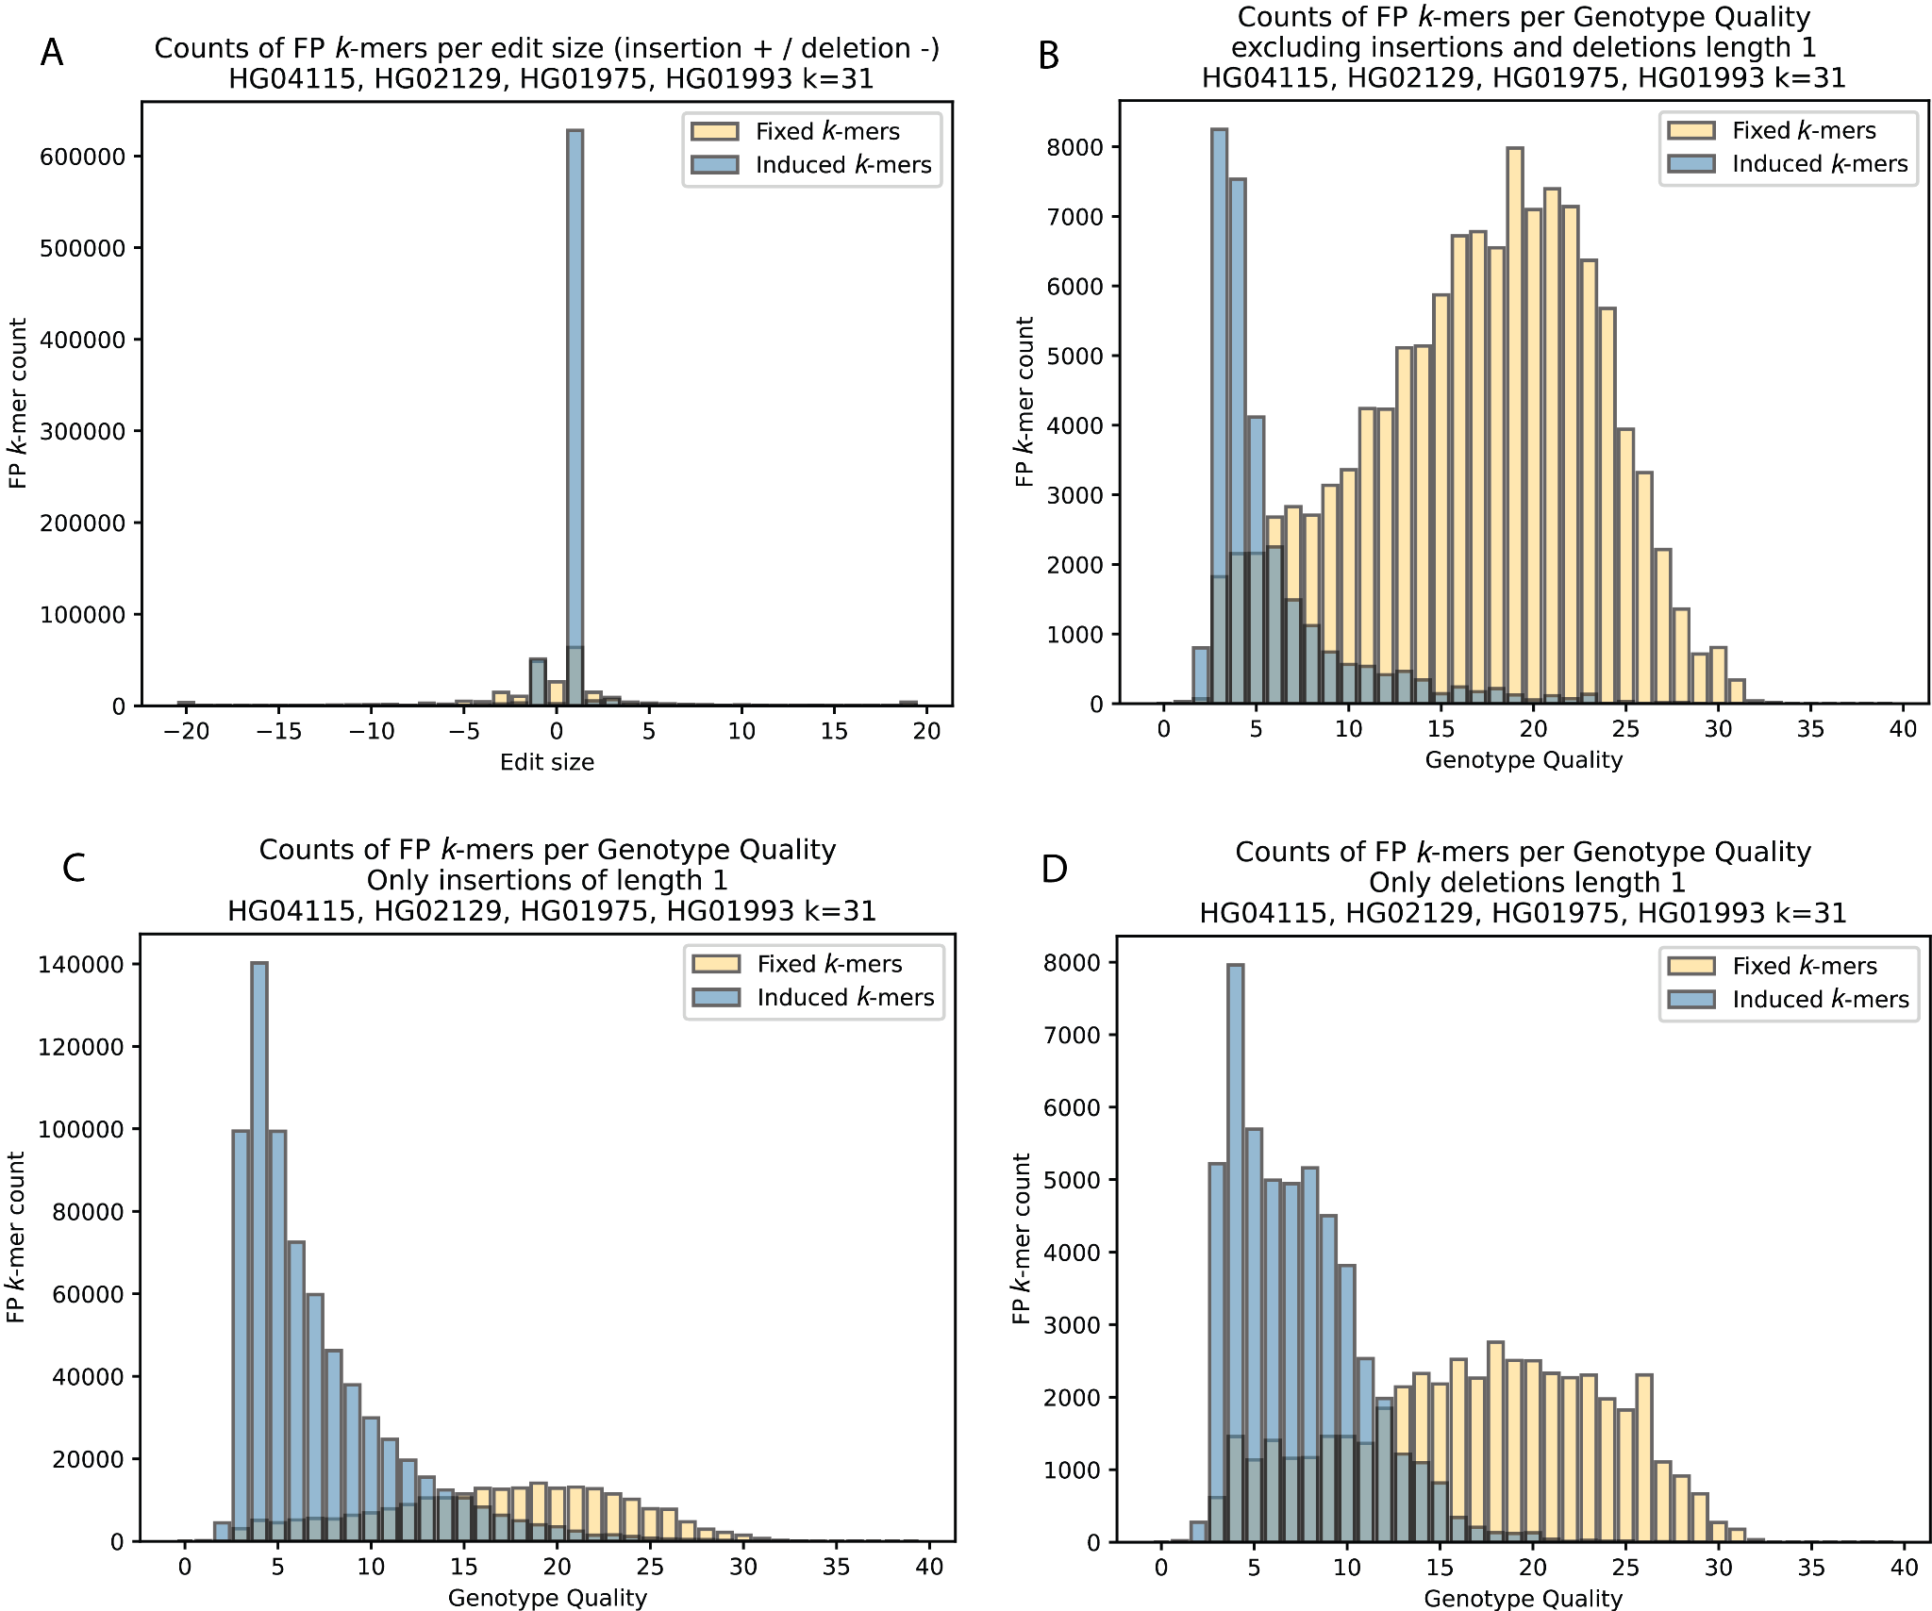
________________________________________________________________________________________________________
Supplementary Figure 3: Optimizing GQ filters for DeepPolisher
A) Count of error (FP) k-mers per polishing edit size, with error k-mers fixed by polishing edit in yellow and error k-mers induced by polishing edit in blue. B) Counts of error (FP) k-mers per genotype quality of polishing edit, excluding insertions and deletions of length 1, and for C) the same for only insertions of length 1, and D) for deletions of length 1. ________________________________________________________________________________________________________

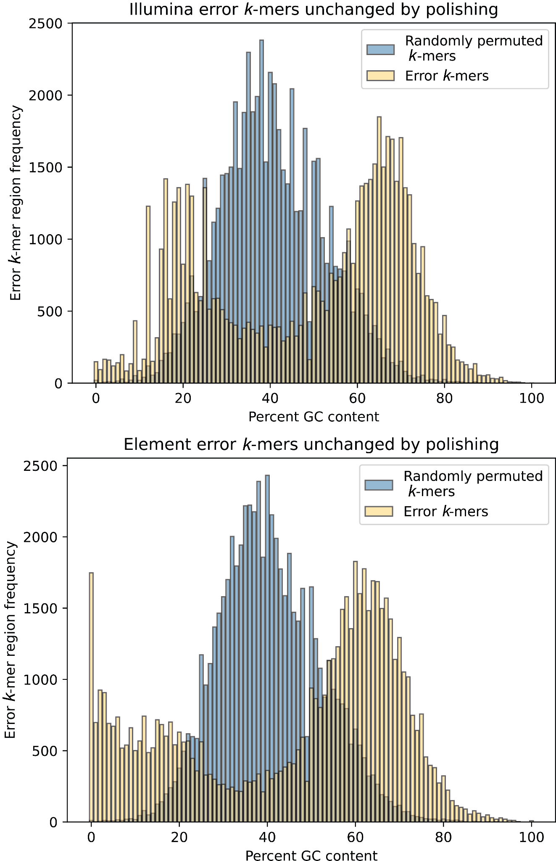

________________________________________________________________________________________________________
Supplementary Figure 4: Percent GC content of error k-mers unchanged by polishing and randomly permuted k-mers. Frequency of merged error k-mer regions per varying GC contents. In yellow shows the actual observed error k-mers produced by Merqury, in blue are randomly permuted k-mers of the same size across the genome. Top panel is for Illumina, bottom panel for Element cloudbreak.
_________________________________________________________________________________

