SUPPLEMENTAL MATERIAL

Comprehensive Functional Annotation of ESR1-Driven Enhancers in Breast Cancer Reveals Hierarchical Activity Independent of Genomic and Epigenomic Contexts
Yanis Zekri^{1,2}, Sebastian Gregoricchio^{1,2}, Elif Yapıcı^{3,4}, Chia-Chi Flora Huang⁵, Tunç Morova⁵, Umut Berkay Altıntaş⁵, Gozde Korkmaz^{3,4}, Nathan A. Lack^{3,4,5}, Wilbert Zwart^{1,2,6,*}

¹ Division of Oncogenomics, the Netherlands Cancer Insitute, Amsterdam, the Netherlands
² Oncode Institute, The Netherlands
³ Koç University School of Medicine, 34450 Istanbul, Turkey
⁴ Koç University Research Center for Translational Medicine (KUTTAM), 34450 Istanbul, Turkey
⁵ Vancouver Prostate Centre, Department of Urologic Science, University of British Columbia, Vancouver, Canada
⁶ Department of Biomedical Engineering, Eindhoven University of Technology, 5600 MB Eindhoven, The Netherlands
* To whom correspondence should be addressed. Email: w.zwart@nki.nl. The Netherlands Cancer Institute (NKI), 1066CX, Amsterdam, The Netherlands.
SUPPLEMENTAL MATERIAL AND METHODS
ChIP-seq analysis
ChIP-seq analysis was conducted using SPACCa (https://github.com/sebastian-gregoricchio/SPACCa). Reads were aligned to the human genome build GRCh38 using BWA (v0.7.17). Reads with a mapping quality (MAPQ) < 20 were removed from further analysis, and duplicates were marked using GATK MarkDuplicates (Cibulskis et al. 2013). Enrichment over input control was determined using MACS2 (Zhang et al. 2008) (q < 0.01). ChIP-seq signal was normalized to 1× coverage and expressed as Reads Per Genomic Content (RPGC, bamCoverage from deepTools) (v3.5.4) (Ramírez et al. 2016). bigWig files were averaged using bigWigAverage from deepTools. Tornado plots were made using plotHeatmap from deepTools. Density profiles were made using the plot.density.profile function from Rseb R-package (Gregoricchio et al. 2022) (v0.3.2) (https://github.com/sebastian-gregoricchio/Rseb).

RNA-seq analysis and Gene Ontology
Raw gene counts of RNA-seq data were collected from publicly available data (GSE99680) (Chi et al. 2019). Gene counts normalization and differential expression analyses were performed using DESeq2 (v1.30.1). Differentially expressed genes were defined by |Fold Change Expression| ≥ 1.5, Padj < 0.05 and BaseMean ≥ 10. Data were visualized using Rseb R-package. Breast cancer specific ATAC-seq based enhancer-promoter loops (Corces et al. 2018) were used to associate distal ERBS to the promoter of regulated genes.

ATAC-seq analysis
ATAC-seq data from E2-stimulated MCF-7 was collected from publicly available data (GSE117943) (Guan et al. 2019). Raw data was mapped to the GRCh38/hg38 genome and analyzed using the snakeATAC package (https://github.com/sebastian-gregoricchio/snakeATAC), using default configuration parameters. Differential binding sites have been define using DiffBind (v3.0.15) (Ross-Innes et al. 2012).
Footprinting scores were calculated using snakeATAC package, based on TOBIAS framework (Bentsen et al. 2020) and motifs from HOCOMOCO v12 (Vorontsov et al. 2023). When several motifs were given for the same chromatin binding protein, we only kept the subtype of higher rank (named ‘.0’), which are primary binding motifs that robustly represent binding sites across multiple experiments (https://hocomoco12.autosome.org). Footprinting scores for each chromatin binding protein were then averaged at ERBS subgroup genomic positions.
ATAC-seq bigWig files from breast tumors were collected from publicly available data (Corces et al. 2018) (https://gdc.cancer.gov/about-data/publications/ATACseq-AWG). Metadata was obtained from the UCSC Xena Browser (Goldman et al. 2020). bigWig files from the same groups (ESR1-negative vs ESR1-positive breast tumors, intraductal vs intralobular carcinoma, etc.) were averaged using bigWigAverage from deepTools (v3.5.4).

Hi-C data processing
Hi-C data was collected from publicly available data (GSE244844) (Joosten et al. 2024). FASTQ data from four biological replicates were analyzed at 40kb resolution using the snHiC pipeline (v0.2.0) (Gregoricchio and Zwart 2023) applying default parameters and the hg19/GRCh37 genome assembly. Aggregate region analyses at ERBS have been performed using GENOVA (v1.0.1) (van der Weide et al. 2021), using a bin size of 25.

ChIA-PET analysis
ChIA-PET data was collected from publicly available and analyzed data (ENCODE, ENCSR000BZZ) (Fullwood et al. 2009). BED12 files of three biological replicates were directly downloaded (ENCSR000BZZ). ChIA-PET interactions were overlapped with ERBS subgroups using GenomicRanges to determine which ERBS were involved in chromatin-chromatin interaction, the percentage of ERBS subgroups involved in such interactions, the size of these interactions and the number of interactions each individual ERBS were involved in. ChIPseeker was run on the regions interacting with ERBS to determine their genomic distribution. Area proportional Venn diagrams were created using the eulerr R package (Micallef and Rodgers 2014). Loops were represented using the function genomic.tracks from Rseb R-package.

SUPPLEMENTAL FIGURES
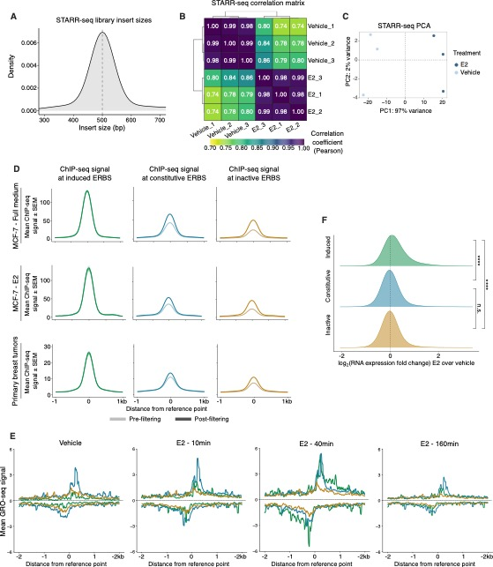
Supplemental Figure S1
Supplemental Figure S1 | Quality control, STARR-seq peaks filtering and validation of ERBS annotation
(A) Density plot of library size inserts. (B) Pearson correlation of STARR-seq from each biological replicate. (C) PCA-plot of STARR-seq from each biological replicate. (D) ChIP-seq intensity signal of ESR1 before (light color) and after (dark color) filtering for ERBS found in MCF-7 full-medium (GSE32222) (Ross-Innes et al. 2012). Intensity signal are given for ESR1 in MCF-7 in full-medium (GSE32222) (Ross-Innes et al. 2012), MCF-7 treated with E2 (GSE54855) (Guertin et al. 2014), and primary breast tumors (Joosten et al. 2024). Filtering increased signal intensity at constitutive and inactive sites. (E) GRO-seq signal upon E2 treatment time course (GSE27463) at ERBS subgroups. (F) Expression changes of genes most-proximal to ERBS, for each class.
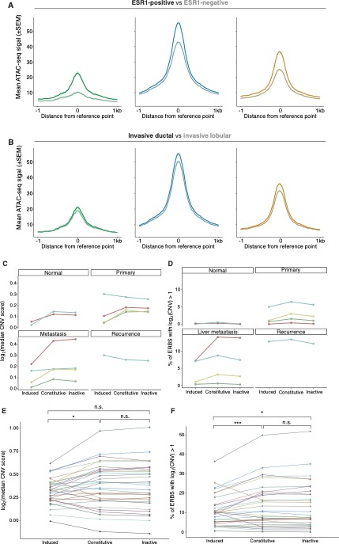
Supplemental Figure S2
Supplemental Figure S2 | Chromatin accessibility and copy number variations at ERBS subclasses
(A) Average ATAC-seq signal at ERBS in ESR1-positive (54 samples) and ESR1-negative (12 samples) breast tumors. Signal is shown as the average across patients. (B) ATAC-seq signal at ERBS in invasive ductal (52 samples) and invasive lobular (15 samples) breast tumors. Signal is shown as the average across patients. (C) Median CNV scores at ERBS subgroups genomic regions, shown in healthy mammary tissue, primary tumors and metastases. (D) Percentage of ERBS subgroups located in genomic regions with a CNV score greater than 2, shown in the same patient cohort as in (C). In (C) and (D), the same colors reflect samples retrieved from the same patients. (E) Median CNV scores at ERBS subgroups genomic regions, shown in a cohort of 31 primary breast tumors (Ross-Innes et al. 2012; Jansen et al. 2013; Severson et al. 2018). (F) Percentage of ERBS subgroups located in genomic regions with a CNV score greater than 2, shown in the same patient cohort as in (E). In (E) and (F), each color represents a different patient. P-value of paired Wilcoxon test is indicated.
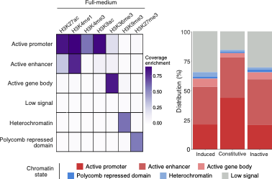
Supplemental Figure S3

Supplemental Figure S3 | Association of ERBS subclasses with chromatin states in full-medium condition
Left panel displays heatmaps of emission parameters, where each row corresponds to a distinct chromatin state, and each column corresponds to a different histone mark. The color intensity reflects the coverage enrichment. Right panel shows the distribution (percentage) of ERBS subgroups across defined chromatin states. Active (red) and repressive chromatin states (blue) are indicated. Histone mark ChIP-seq data used to build this model was from MCF-7 cultured in full-medium (GSE85158) (Franco et al. 2018).

Supplemental Figure S4
Supplemental Figure S4 | Association of ERBS subclasses with histone post-translational modifications
(A) Cluster dendrogram from the heatmap shown in Figure 3E. Histone marks belonging to the two clusters showing overlap with at least one the ERBS subgroups are colored in purple. (B) Average ChIP-seq signal for H3K4me1, H3K4me2, H3K4me3 and H3K27ac at ERBS subgroups in different growth conditions (vehicle, E2 and full-medium, Supplemental Table 5). P-value of unpaired Wilcoxon test is indicated
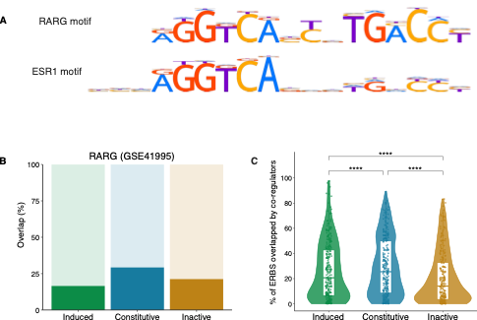
Supplemental Figure S5

Supplemental Figure S5 | Overlap of ERBS subclasses with co-regulators
(A) ESR1 (ESR1.H12CORE.0.P.B) and RARG (RARG.H12CORE.0.P.B) consensus motifs obtained from Hocomoco v12 (Vorontsov et al. 2023). (B) Percentage of ERBS subgroups that overlap with RARγ (GSE41995) (Kittler et al. 2013) in MCF-7. (C) Violin-plots of ERBS overlap by co-regulators. Each dot represents one of the 280 tested ChIP-seq datastreams. P-value paired of Wilcoxon test is indicated.
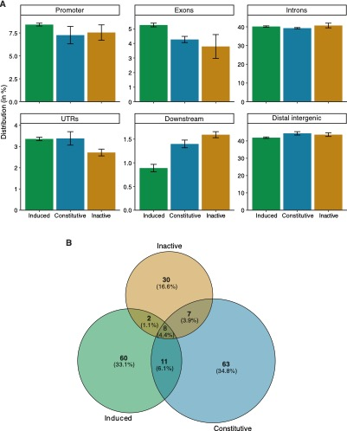
Supplemental Figure S6

Supplemental Figure S6| ERBS subclasses are associated with distinct long-range chromatin looping features
(A) Stacked bar plot depicting the genomic localization frequency of ERBS linked regions, as identified by ESR1 ChIA-PET data. Error-bars represent the standard error of the mean from the three replicates. (B) Venn-diagram of genes of which the promoter is looped by ERBS using ChIA-PET data, illustrating the overlap of genes promoters connected by different ERBS subgroups. Promoters connected by at least two out of the three biological replicates were kept.
REFERENCES
Bentsen M, Goymann P, Schultheis H, Klee K, Petrova A, Wiegandt R, Fust A, Preussner J, Kuenne C, Braun T, et al. 2020. ATAC-seq footprinting unravels kinetics of transcription factor binding during zygotic genome activation. Nat Commun 11: 4267.
Chi D, Singhal H, Li L, Xiao T, Liu W, Pun M, Jeselsohn R, He H, Lim E, Vadhi R, et al. 2019. Estrogen receptor signaling is reprogrammed during breast tumorigenesis. Proc Natl Acad Sci U S A 116: 11437–11443.
Cibulskis K, Lawrence MS, Carter SL, Sivachenko A, Jaffe D, Sougnez C, Gabriel S, Meyerson M, Lander ES, Getz G. 2013. Sensitive detection of somatic point mutations in impure and heterogeneous cancer samples. Nat Biotechnol 31: 213–219.
Corces MR, Granja JM, Shams S, Louie BH, Seoane JA, Zhou W, Silva TC, Groeneveld C, Wong CK, Cho SW, et al. 2018. The chromatin accessibility landscape of primary human cancers. Science 362: eaav1898.
Franco HL, Nagari A, Malladi VS, Li W, Xi Y, Richardson D, Allton KL, Tanaka K, Li J, Murakami S, et al. 2018. Enhancer transcription reveals subtype-specific gene expression programs controlling breast cancer pathogenesis. Genome Res 28: 159–170.
Fullwood MJ, Liu MH, Pan YF, Liu J, Xu H, Mohamed YB, Orlov YL, Velkov S, Ho A, Mei PH, et al. 2009. An oestrogen-receptor-alpha-bound human chromatin interactome. Nature 462: 58–64.
Goldman MJ, Craft B, Hastie M, Repečka K, McDade F, Kamath A, Banerjee A, Luo Y, Rogers D, Brooks AN, et al. 2020. Visualizing and interpreting cancer genomics data via the Xena platform. Nat Biotechnol 38: 675–678.
Gregoricchio S, Polit L, Esposito M, Berthelet J, Delestré L, Evanno E, Diop M, Gallais I, Aleth H, Poplineau M, et al. 2022. HDAC1 and PRC2 mediate combinatorial control in SPI1/PU.1-dependent gene repression in murine erythroleukaemia. Nucleic Acids Res 50: 7938–7958.
Gregoricchio S, Zwart W. 2023. snHiC: a complete and simplified snakemake pipeline for grouped Hi-C data analysis. Bioinforma Adv 3: vbad080.
Guan J, Zhou W, Hafner M, Blake RA, Chalouni C, Chen IP, De Bruyn T, Giltnane JM, Hartman SJ, Heidersbach A, et al. 2019. Therapeutic Ligands Antagonize Estrogen Receptor Function by Impairing Its Mobility. Cell 178: 949-963.e18.
Guertin MJ, Zhang X, Coonrod SA, Hager GL. 2014. Transient estrogen receptor binding and p300 redistribution support a squelching mechanism for estradiol-repressed genes. Mol Endocrinol Baltim Md 28: 1522–1533.
Jansen MPHM, Knijnenburg T, Reijm EA, Simon I, Kerkhoven R, Droog M, Velds A, van Laere S, Dirix L, Alexi X, et al. 2013. Hallmarks of aromatase inhibitor drug resistance revealed by epigenetic profiling in breast cancer. Cancer Res 73: 6632–6641.
Joosten SEP, Gregoricchio S, Stelloo S, Yapıcı E, Huang C-CF, Yavuz K, Donaldson Collier M, Morova T, Altintaş UB, Kim Y, et al. 2024. Estrogen receptor 1 chromatin profiling in human breast tumors reveals high inter-patient heterogeneity with enrichment of risk SNPs and enhancer activity at most-conserved regions. Genome Res 34: 539–555.
Kittler R, Zhou J, Hua S, Ma L, Liu Y, Pendleton E, Cheng C, Gerstein M, White KP. 2013. A Comprehensive Nuclear Receptor Network for Breast Cancer Cells. Cell Rep 3: 538–551.
Micallef L, Rodgers P. 2014. eulerAPE: Drawing Area-Proportional 3-Venn Diagrams Using Ellipses. PLOS ONE 9: e101717.
Ramírez F, Ryan DP, Grüning B, Bhardwaj V, Kilpert F, Richter AS, Heyne S, Dündar F, Manke T. 2016. deepTools2: a next generation web server for deep-sequencing data analysis. Nucleic Acids Res 44: W160–W165.
Ross-Innes CS, Stark R, Teschendorff AE, Holmes KA, Ali HR, Dunning MJ, Brown GD, Gojis O, Ellis IO, Green AR, et al. 2012. Differential oestrogen receptor binding is associated with clinical outcome in breast cancer. Nature 481: 389–393.
Severson TM, Kim Y, Joosten SEP, Schuurman K, van der Groep P, Moelans CB, Ter Hoeve ND, Manson QF, Martens JW, van Deurzen CHM, et al. 2018. Characterizing steroid hormone receptor chromatin binding landscapes in male and female breast cancer. Nat Commun 9: 482.
van der Weide RH, van den Brand T, Haarhuis JHI, Teunissen H, Rowland BD, de Wit E. 2021. Hi-C analyses with GENOVA: a case study with cohesin variants. NAR Genomics Bioinforma 3: lqab040.
Vorontsov IE, Eliseeva IA, Zinkevich A, Nikonov M, Abramov S, Boytsov A, Kamenets V, Kasianova A, Kolmykov S, Yevshin IS, et al. 2023. HOCOMOCO in 2024: a rebuild of the curated collection of binding models for human and mouse transcription factors. Nucleic Acids Res 52: D154–D163.
Zhang Y, Liu T, Meyer CA, Eeckhoute J, Johnson DS, Bernstein BE, Nusbaum C, Myers RM, Brown M, Li W, et al. 2008. Model-based Analysis of ChIP-Seq (MACS). Genome Biol 9: R137.

