Supplemental Figures

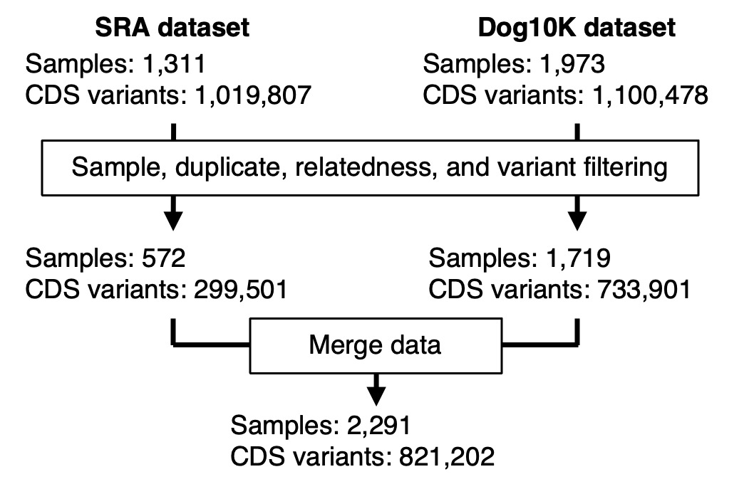
Supplemental Fig. S1: Variant data from SRA and Dog10K were filtered and combined to create a single dataset used throughout the analysis. Only SNVs and small indels in coding sequence and splice-sites were analyzed.

Supplemental Fig. S2: Genome-wide breed population statistics. Pi indicates nucleotide diversity. F_{ROH} is the mean fraction of the genome in runs of homozygosity per breed. F_{ST} is a measure of the mean pairwise F_{ST} between all breeds and the target breed. N represents the population size of each breed used in the study. Low singleton is the fraction of individuals per breed with <40 coding singletons. Breeds are organized into higher-order clades based on Dog10K information.

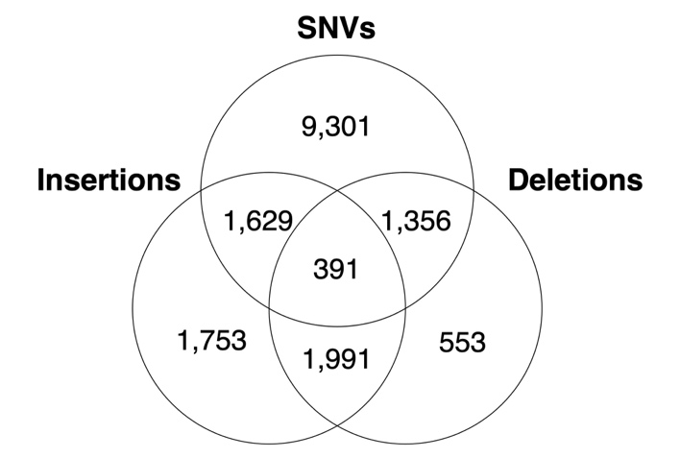
Supplemental Fig. S3: Multiallelic variants occupying the same sites.

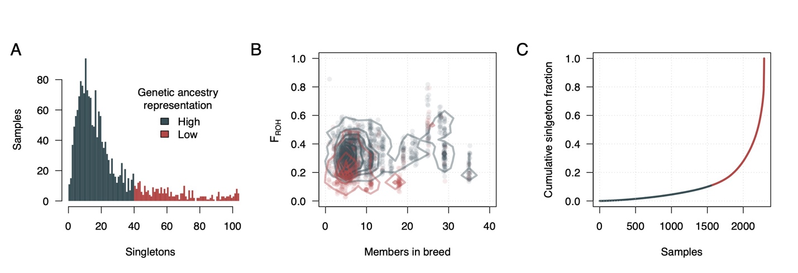
Supplemental Fig. S4: Characterizing genetic ancestry representation in dogs. A) Singletons per dog. Dogs with less than 40 singletons were classified as having highly represented ancestry. B) Dogs with highly represented ancestry have more breed members in the dataset and higher rates of F_{ROH} than dogs with low ancestry represented ancestry. C) A minority of singletons are found in dogs with highly represented ancestry.

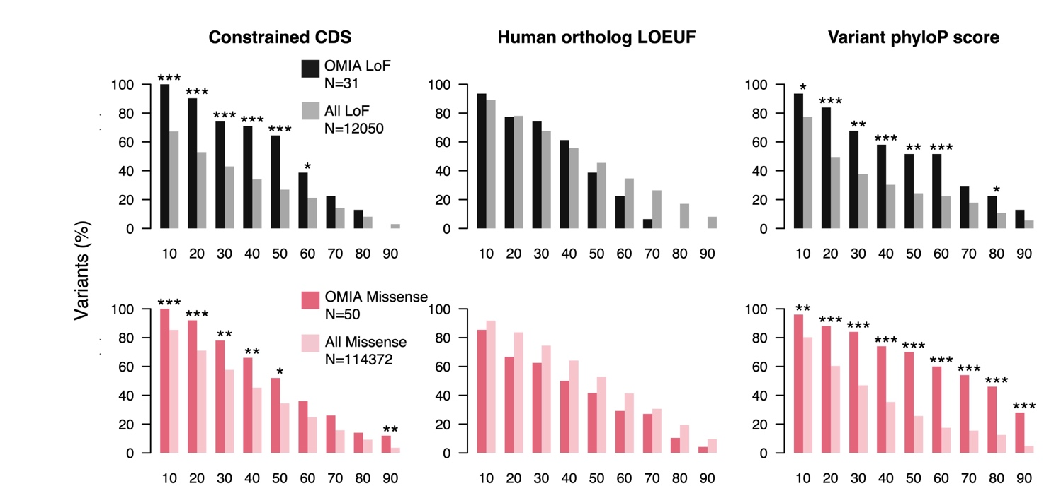
Supplemental Fig. S5: Enrichment of OMIA variants after variant/gene constraint filtering. Vertical bars show the fraction of OMIA and all other variants that remain after implementing each filtering threshold. Significance was determined using a Fisher test. “*” indicates P-value < 0.05, “**” indicates P-value < 0.01, and “***” indicates P-value < 0.001.

Supplemental Fig. S6: Breed specificity of OMIA variants within the analysis cohort

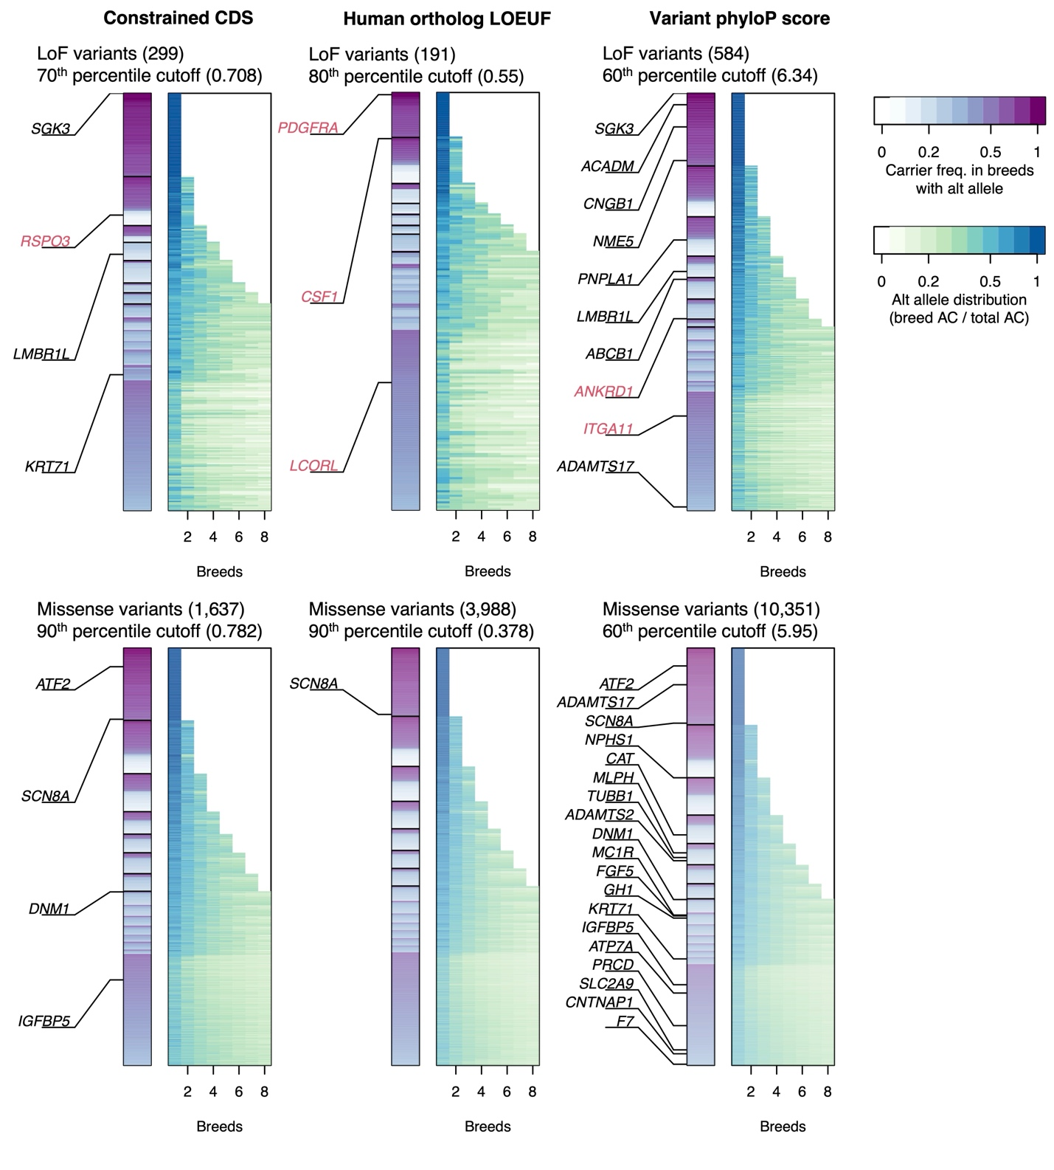
Supplemental Fig. S7: List of candidate LoF/missense variants for trait associations. Variants are ordered along the y-axis according to number of breeds they are found in and the proportion of individuals in those breeds carrying the variant. Breeds carrying the variant are ordered along the x-axis according to the proportion of the alt alleles they are carrying. Gene names printed in black text contain OMIA variants. Gene names in red are non-OMIA variants that were identified after manual curation of the variant list. Variant type and constraint cutoff are displayed for each panel.

Suplemental Fig. S8: Breed ancestry of mixed breed bifid nose dogs. Boxplots indicate the total amount of identity-by-descent between the target dog and breed representatives. Breeds with significant sharing are labeled. Breed reference data is from array genotypes that were used to build the phylogentic tree (Supplemental Data S1). The red mark below each X-axis indicates Çatalburun samples.

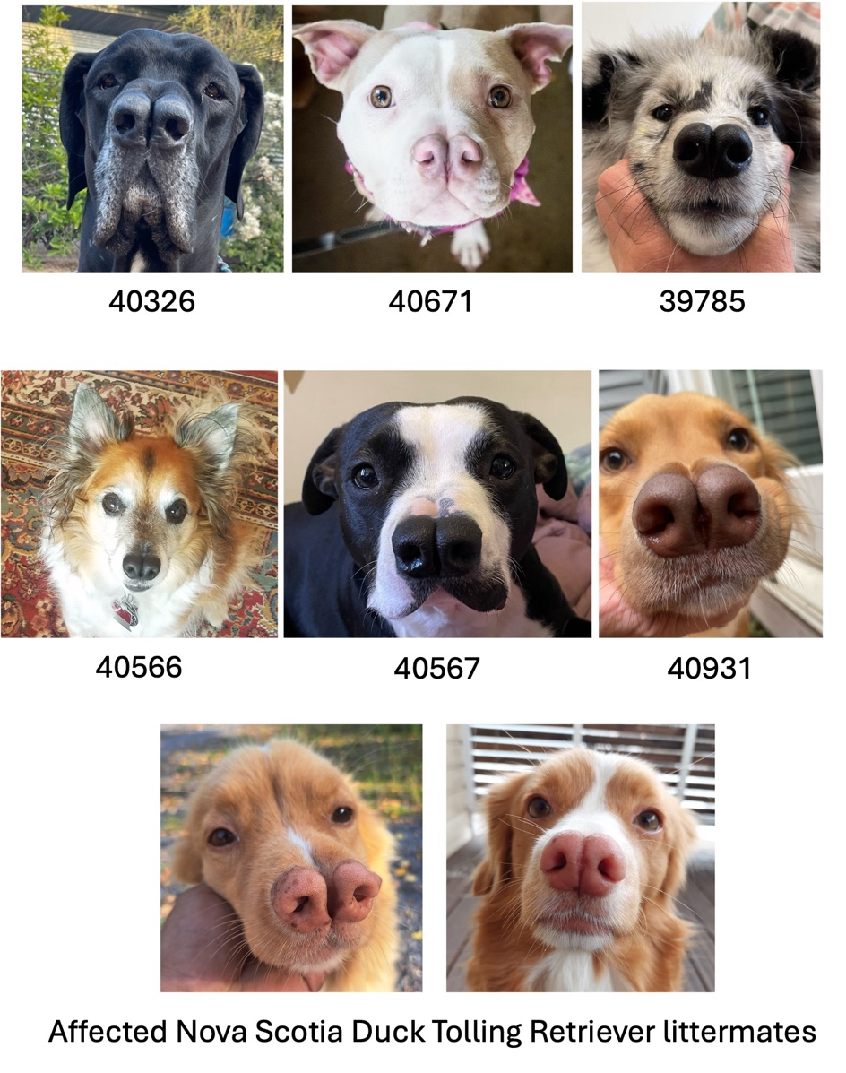
Supplemental Fig. S9: Recruited dogs with bifid nose phenotype.

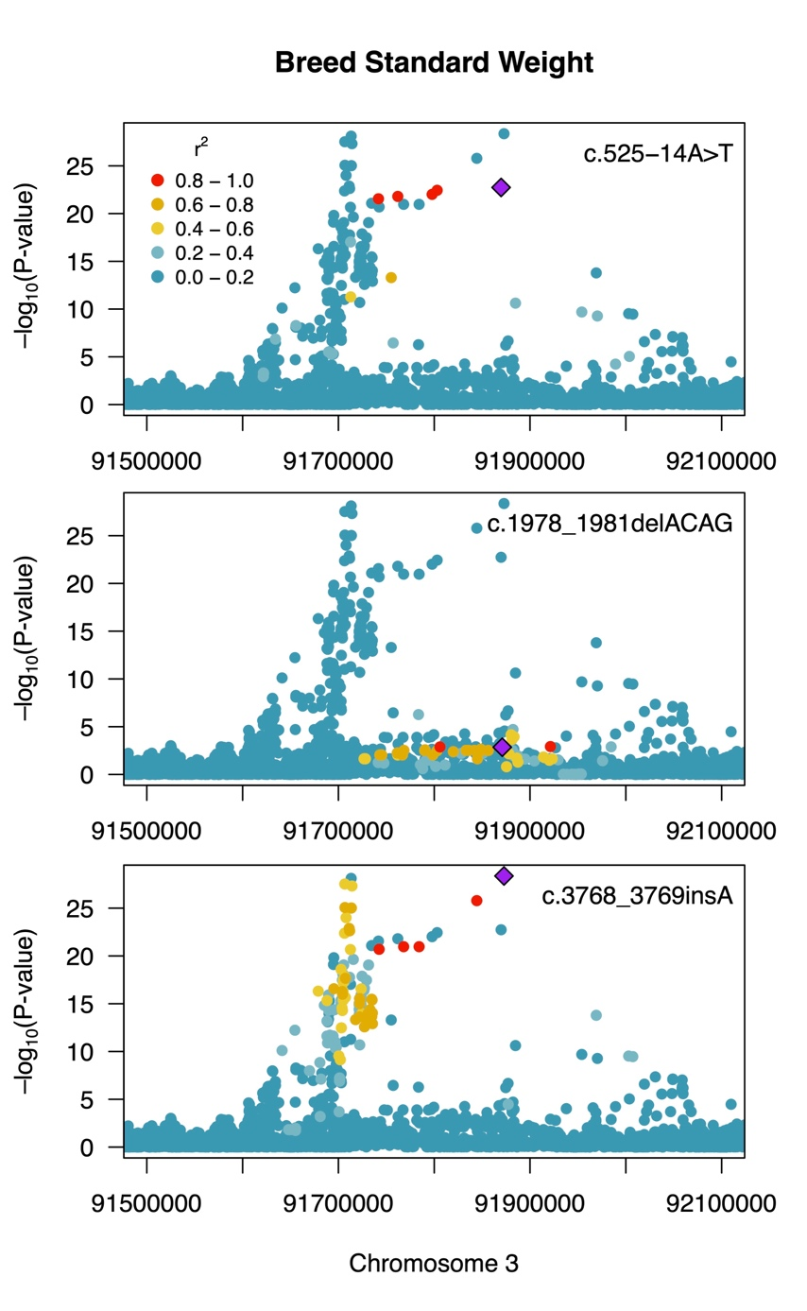
Supplemental Fig. S10: Manhattan plots at the LCORL locus showing association with breed standard weight for three different variants in separate linkage groups.

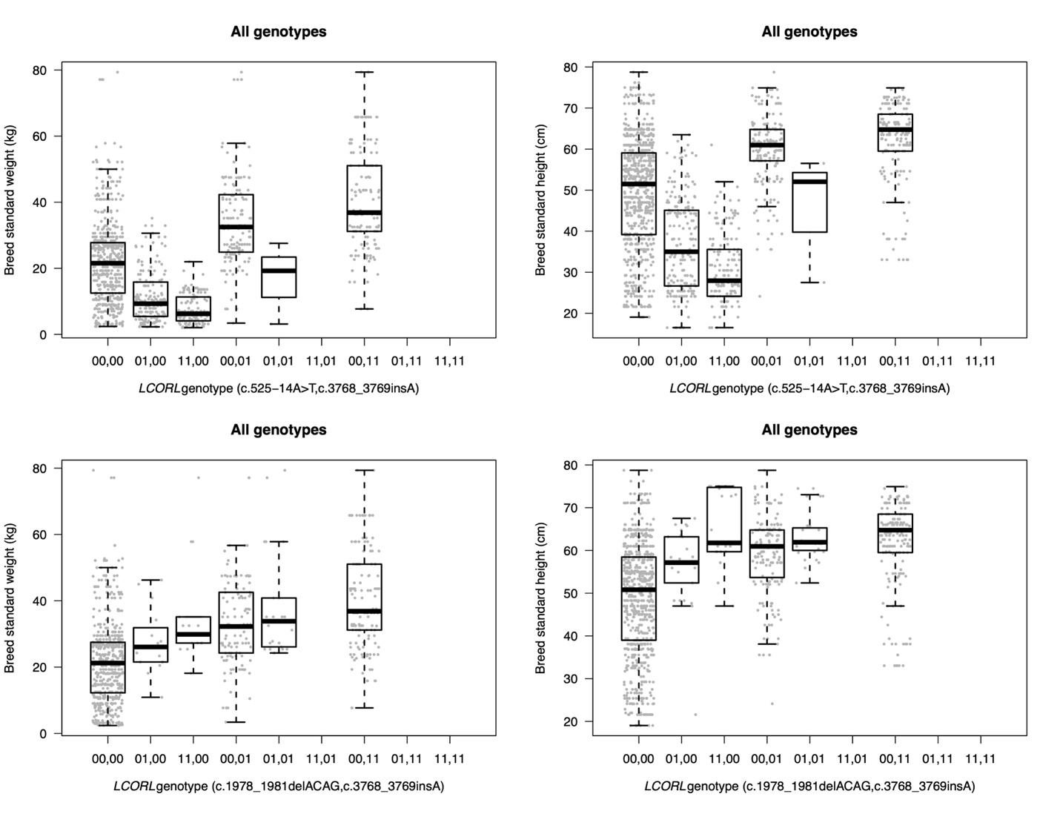

Supplemental Fig. S11: Boxplots showing associations between all LCORL size associated genotypes and breed standard height and weight.

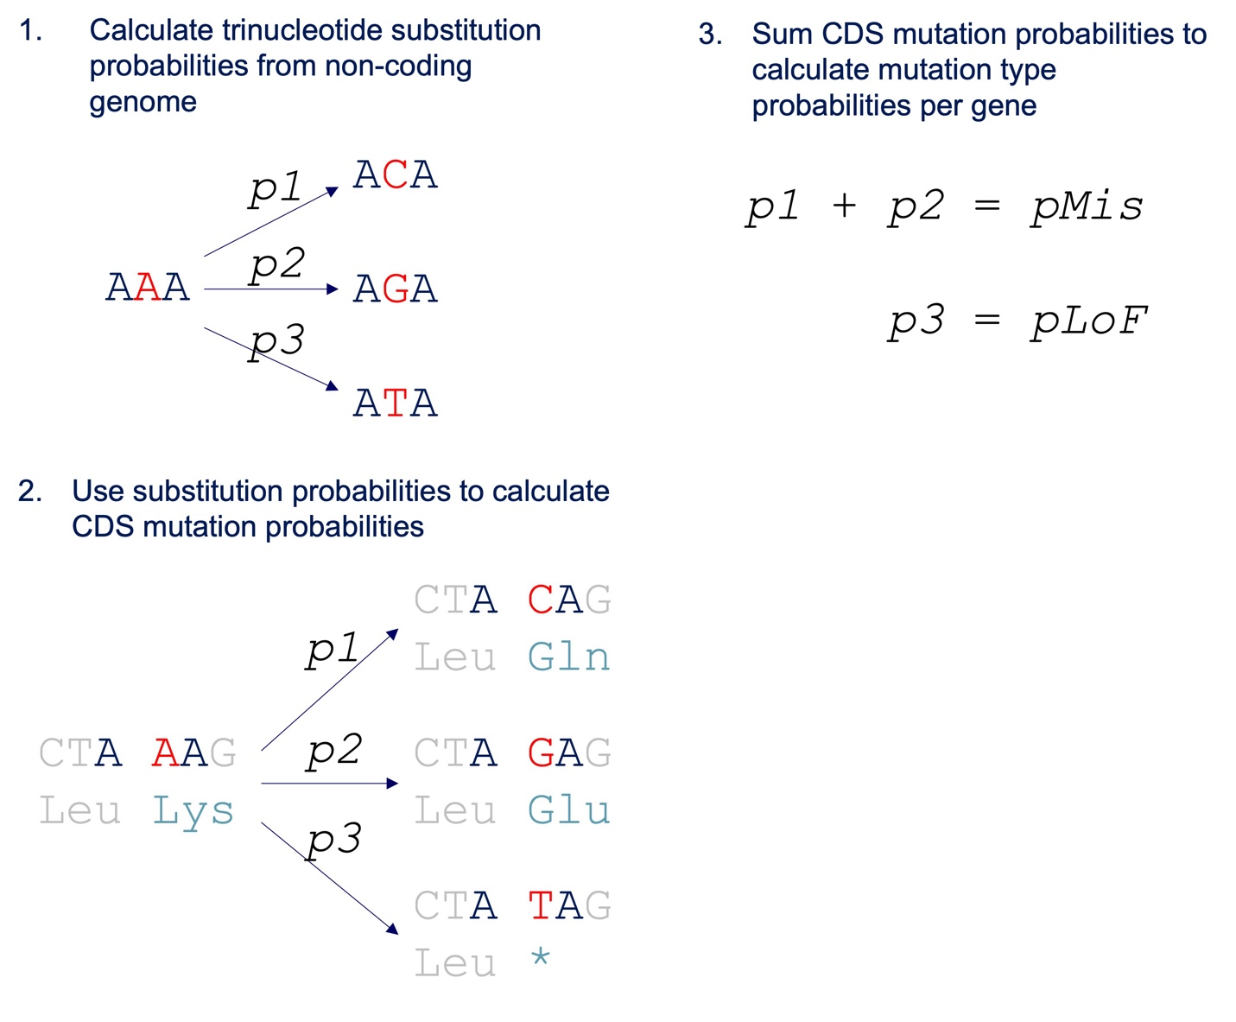
Supplemental Fig S12: Steps for building mutation model.

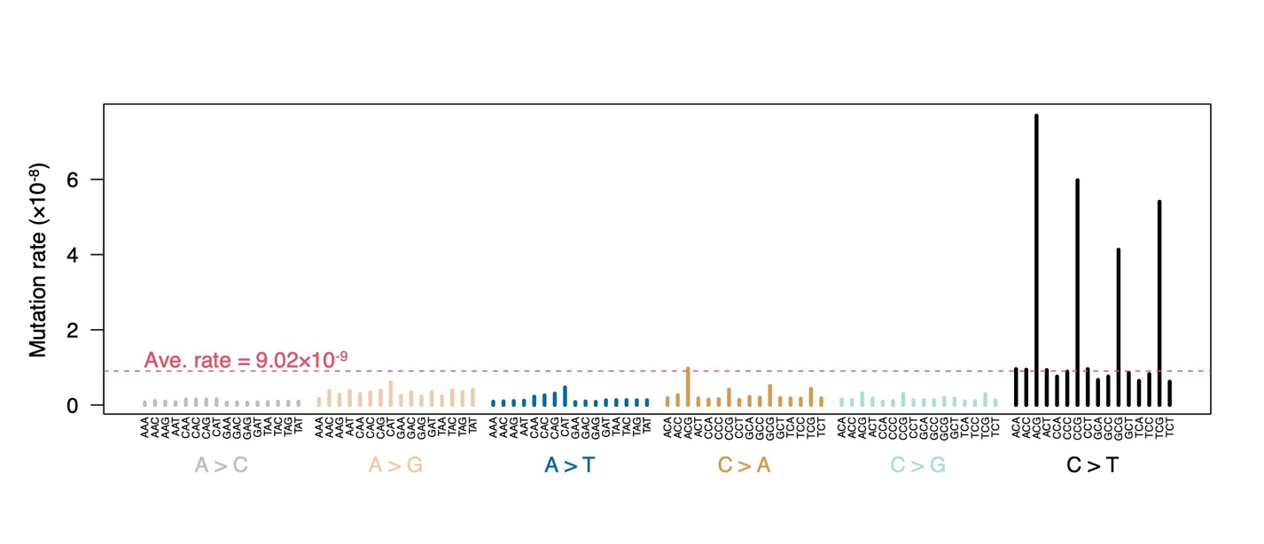
Supplemental Fig S13: Trinucleotide mutation rates in dogs. For each substitution, trinucleotide contexts rotate between the characters A, C, T, and G at the first and third position. The character for the first position changes on every fourth iteration, while the character for the third position changes on every single iteration.

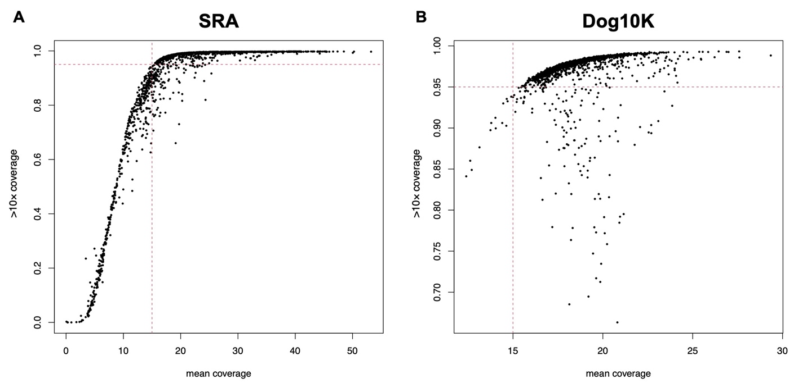
Supplemental Fig. S14: mean coverage of sites and proportion of sites with coverage > 10x for all samples. A) Results for SRA dataset. B) Results for Dog10K dataset. Red dotted lines in A and B indicate minimum threshold values for samples to pass filtering criteria.

Supplemental Fig. S15: Distributions of allele balance for heterozygous genotypes. A-B) Allele balance (AB) for all heterozygous genotypes in the A) SRA dataset and the B) Dog10K dataset. Vertical dotted lines indicate different allele balance cutoff values for declaring failed het genotypes. C-D) The cumulative distribution of per sample genotype failure rates at each allele balance cutoff for the C) SRA dataset and the D) Dog10K dataset. The red solid line indicates a per sample heterozygous failure rate of 5%. For example, in D, all samples have > 5% heterozygous failure rate at an AB cutoff of 30%.

Supplemental Fig. S16: Samples removed for failing filtering criteria at rates > 5%. Filtering criteria are described in Supplemental Table S23. A-B) Samples are sorted along the X-axis according to mean coverage level across all sites. Shading is used to indicate samples in the A) SRA dataset or the B) Dog10K dataset that were removed for failing a specific criterion. C-D) Upset plots indicating the number of samples removed for failing different combinations of filtering criteria. Data is provided for both the C) SRA dataset and the D) Dog10K dataset.

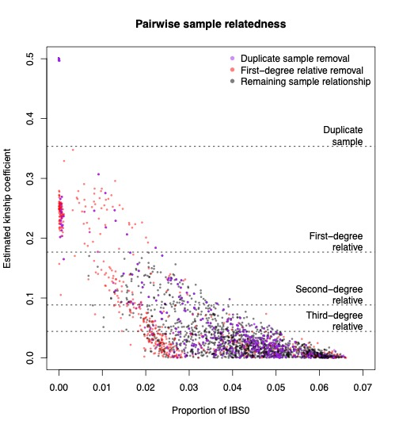
Supplemental Fig. S17: Relatedness of remaining samples after quality filtering and merging. The estimated kinship coefficient reflects the degree of relatedness between two samples. The proportion of IBS0 indicates the fraction of tested sites where no identity by state was observed between a pair of samples. Each datapoint indicates a pairwise relationship between two samples. Purple datapoints were removed after filtering out duplicated samples. Red datapoints were removed after iteratively filtering out the samples with the most first-degree relatives. The black datapoints remain after all filtering and have kinship coefficient values below the first-degree relative cutoff.

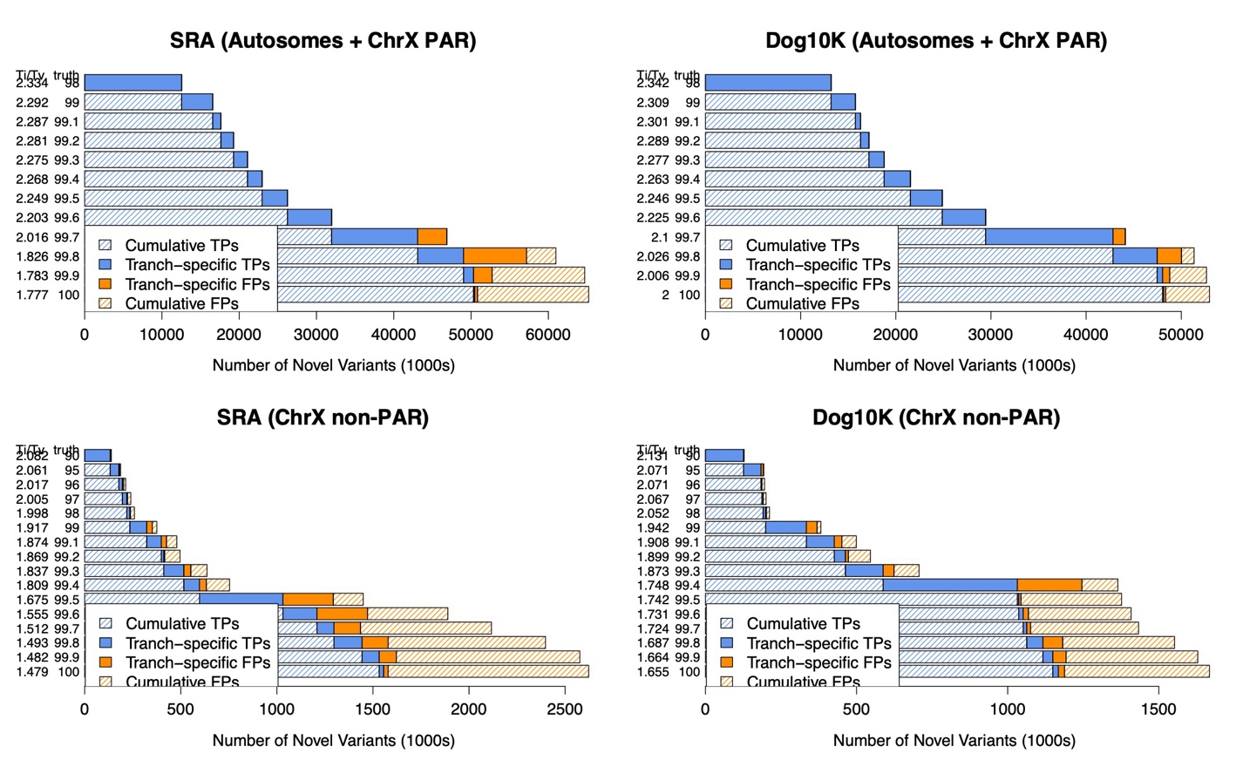
Supplemental Fig. S18: Graphical output from VariantRecalibrator (GATK v4.5.0.0) for the SRA and Dog10K datasets and both autosomes and Chromosome X. At each truth sensitivity threshold, the Ti/Tv ratio, the total number of variants within each tranche, and the proportion of true positive (TP) and false positive (FP) variants are displayed.
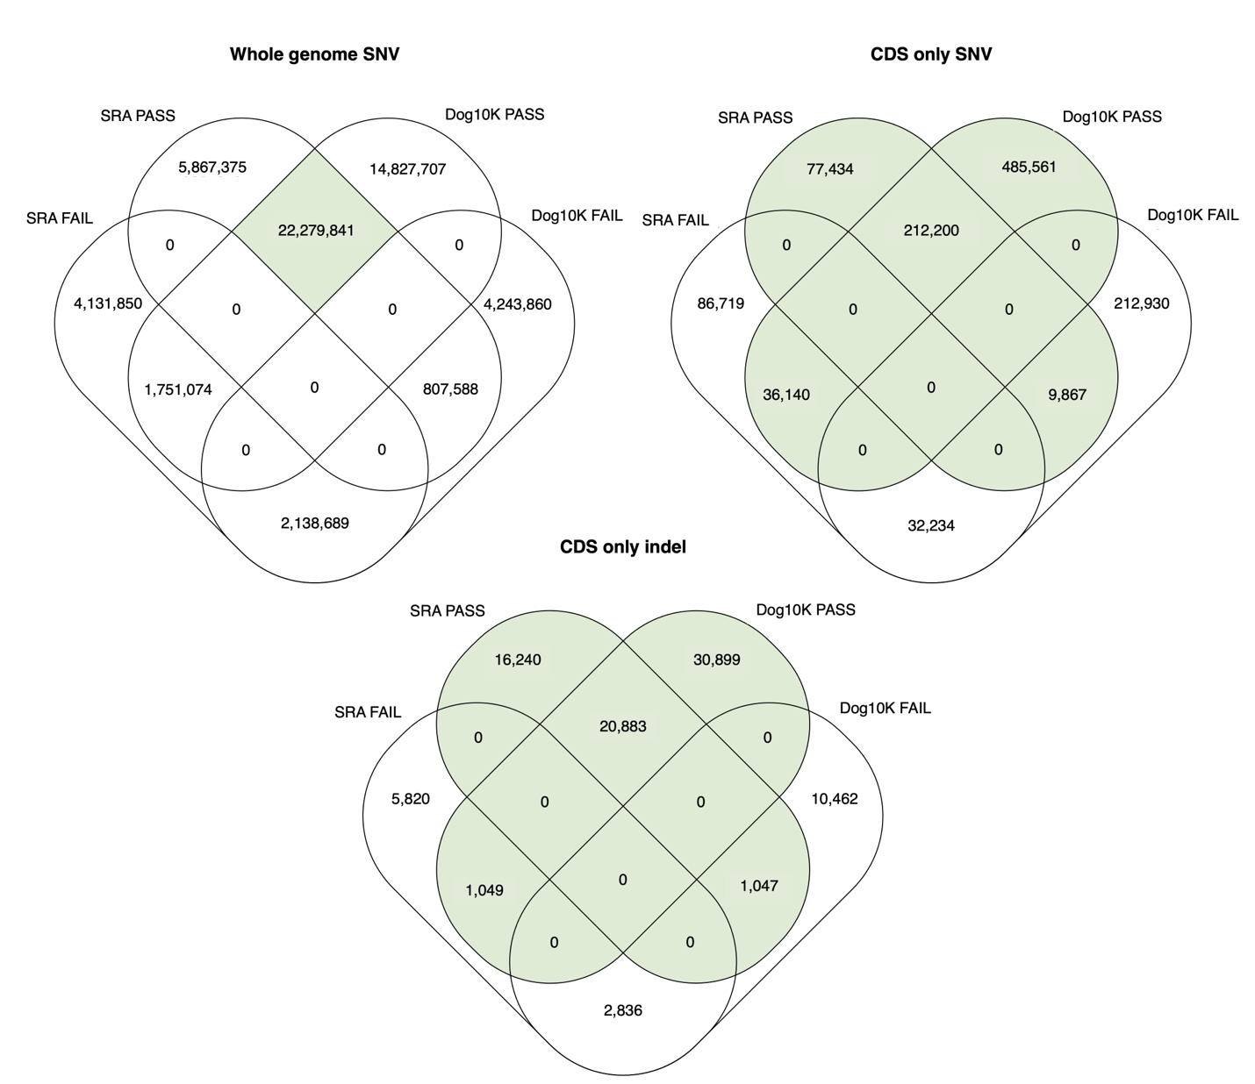
Supplemental Fig. S19: The number of shared and unique VQSR PASS/FAIL SNV sites from each dataset after sample filtering. The green shading indicates that for whole genome analyses, only VQSR PASS sites in both datasets were used for further analysis. For coding sequence (CDS) analyses, only sites that are VQSR PASS in either dataset were used for further analysis. Whole genome SNV analyses used a total of 22,279,841 sites, CDS-only SNV analyses used a total of 821,202 sites, and CDS-only indel analyses used a total of 70,118 sites.

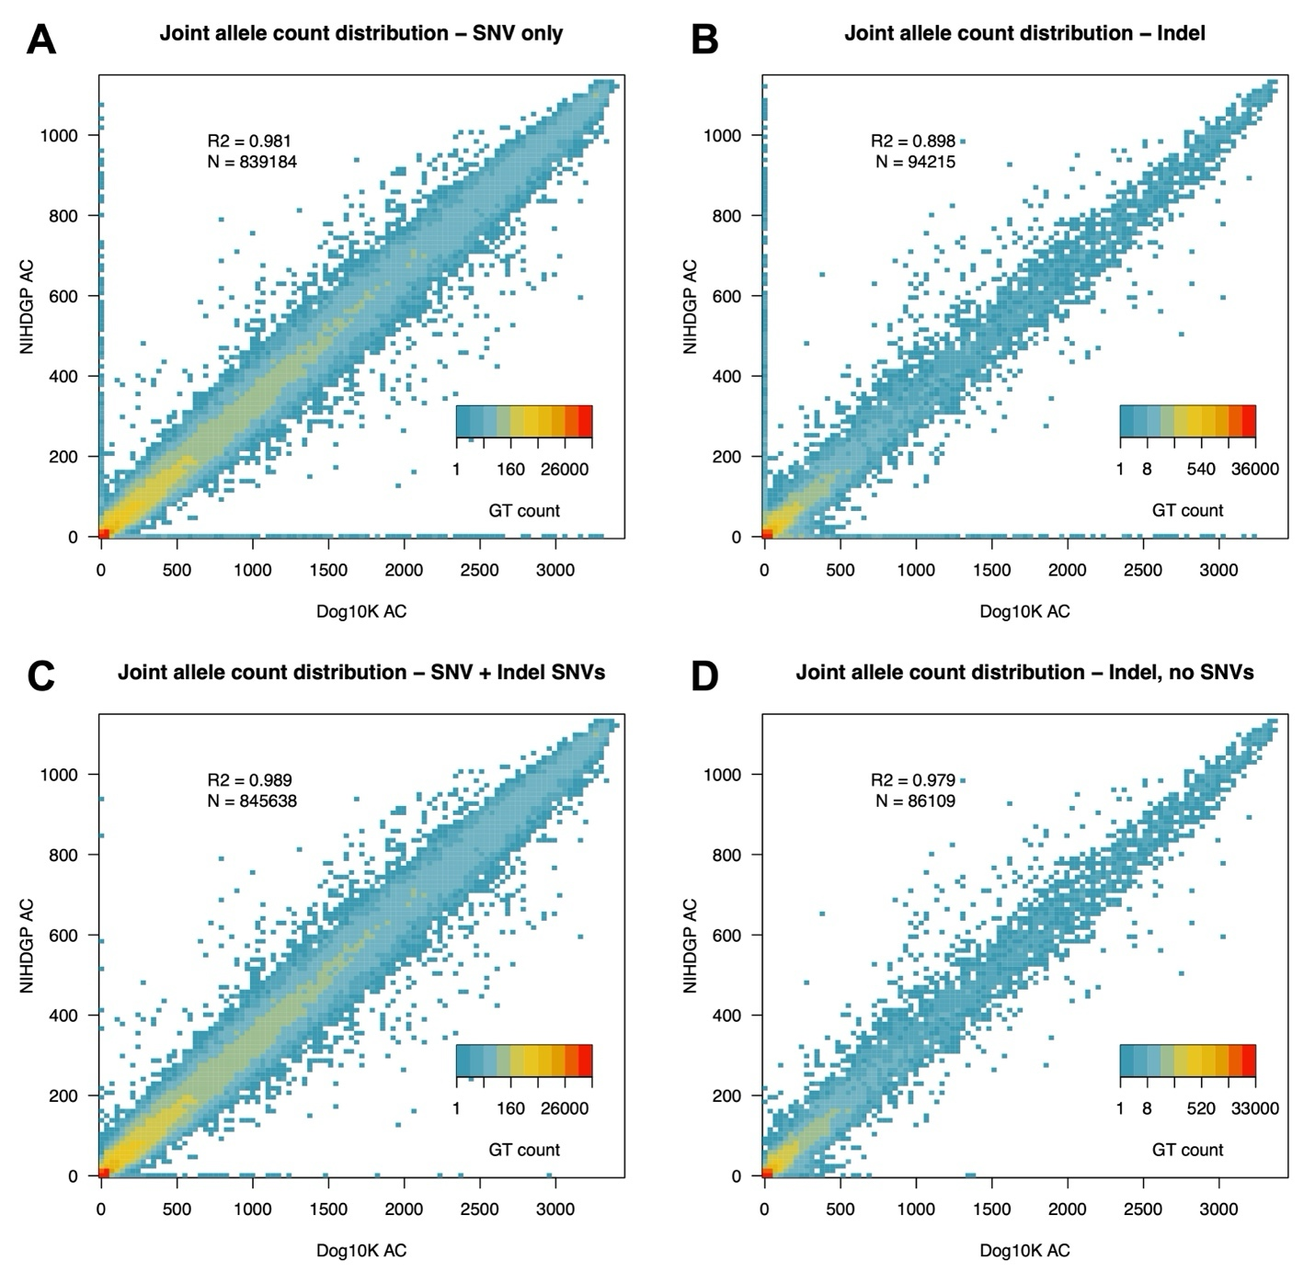
Supplemental Fig. S20: Allele counts of CDS variants assigned as SNV or indel in the Dog10K and SRA cohorts. A) Allele counts for variants that were initially identified as SNVs in each cohort. B) Allele counts for variants that were initially identified as indels in each cohort. C) Allele counts of initially identified SNVs and SNVs recovered from the indel set. D) Allele counts of indels after removing SNVs.

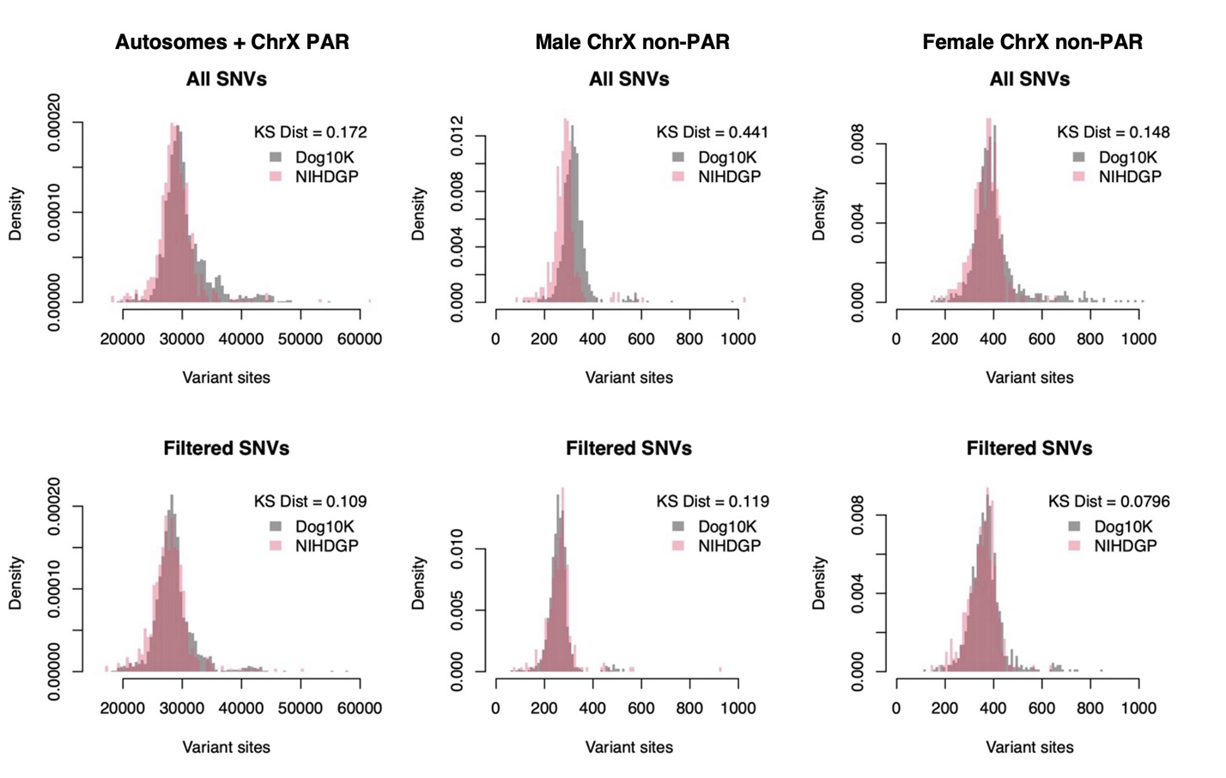
Supplemental Fig. S21: CDS SNVs per dog before and after genotype filtering. KS dist represents the Kolmogorov–Smirnov distance of the cumulative densities of each distribution. In each case, genotype filtering leads to both datasets reporting similar numbers of CDS SNVs per dog. Males and females were analyzed separately for the non-PAR region of ChrX due to differences in ploidy.

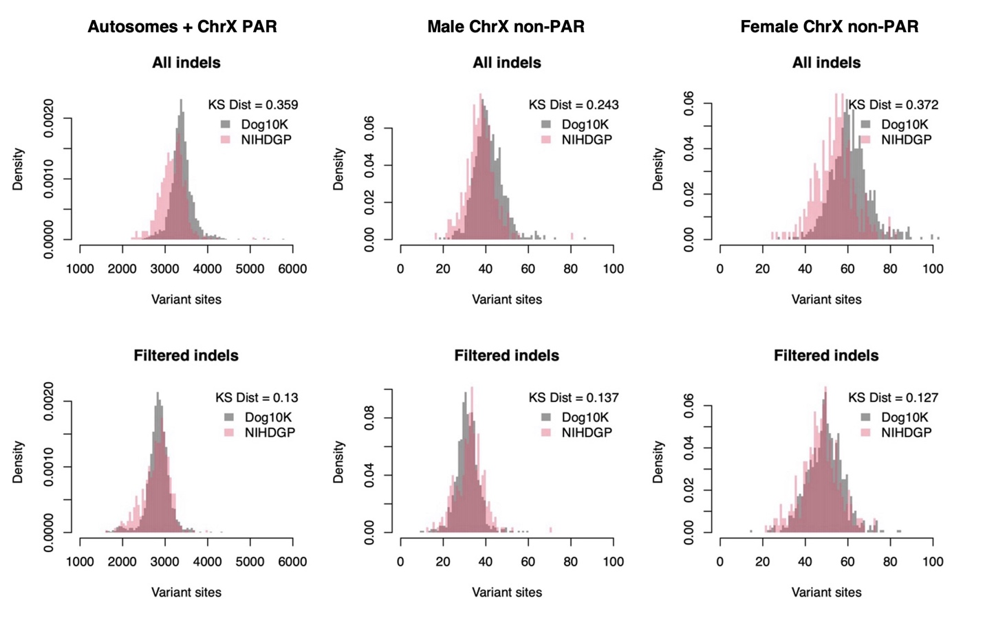
Supplemental Fig. S22: CDS indels per dog before and after genotype filtering. KS dist represents the Kolmogorov–Smirnov distance of the cumulative densities of each distribution. In each case, genotype filtering leads to both datasets reporting similar numbers of CDS indels per dog. Males and females were analyzed separately for the non-PAR region of ChrX due to differences in ploidy.

