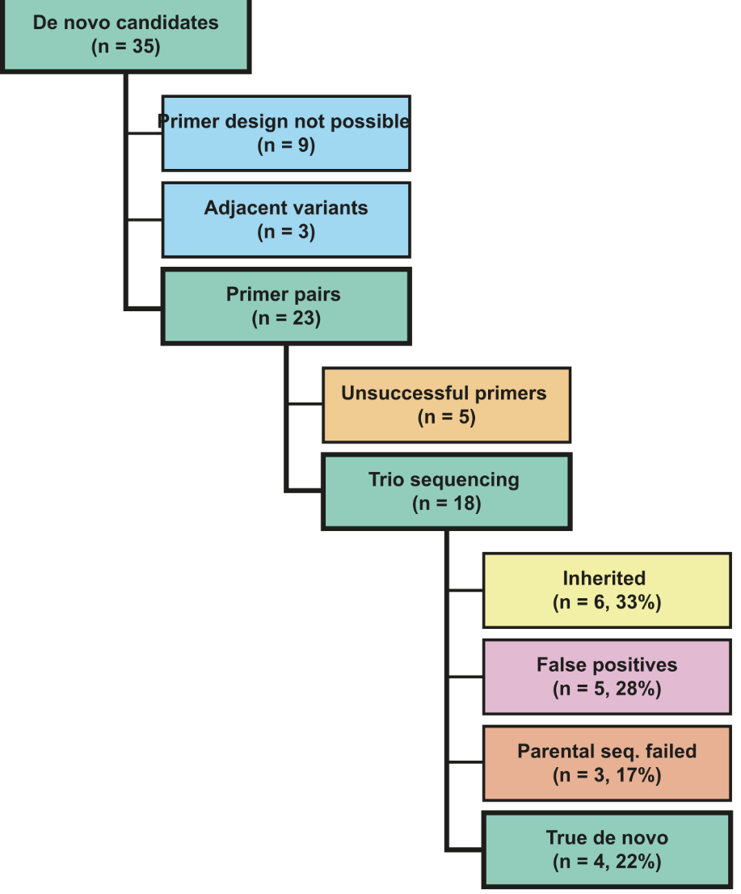
Figure S1: Flow of de novo variant validations by targeted LRS.

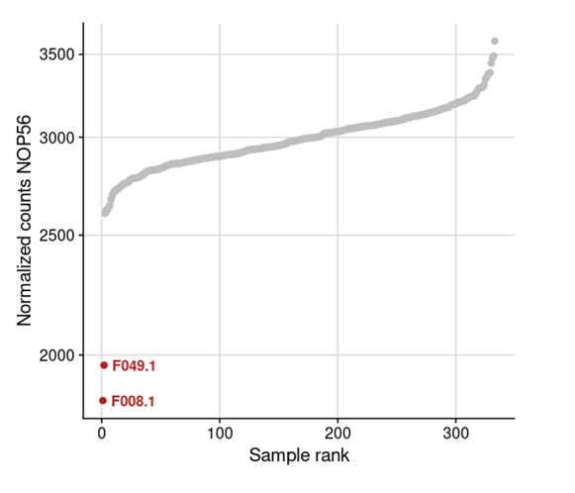
Figure S2: RNA-seq outlier analysis for NOP56. The vertical axis in the figure displays the normalized NOP56 read count, the horizontal axis indicates the rank of the samples according to the sorted normalized read count. Two samples show aberrant mRNA expression: P0018996 and P0018504 (affected sister of the index P0016368). The reduction in expression with respect to the mean across the Solve-RD RNA-seq cohort is 35% for P0018996 and 39% for P0018504. In both cases this is indicative for the loss of one NOP56 allele.

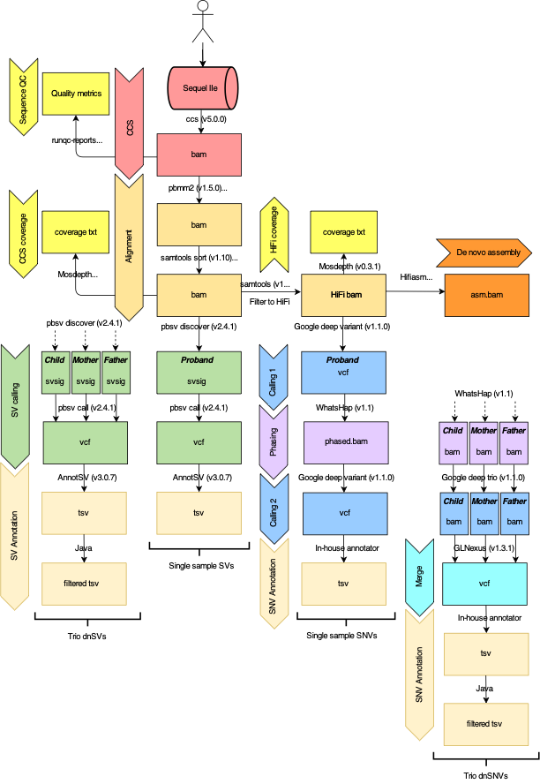
Figure S3: Schematic overview of the data analysis workflow

