Table of contents
Supplemental Fig S1: X-Chromosome inactivation (trio) analysis for case 27 carrying the maternally inherited Chromosome Xp22.2 duplication.
Supplemental File 1: Clinical description of individuals carrying heterozygous deletion of AMER1 gene

Supplemental Fig S1: X-Chromosome inactivation (trio) analysis for case 27 carrying the maternally inherited Chromosome Xp22.2 duplication.
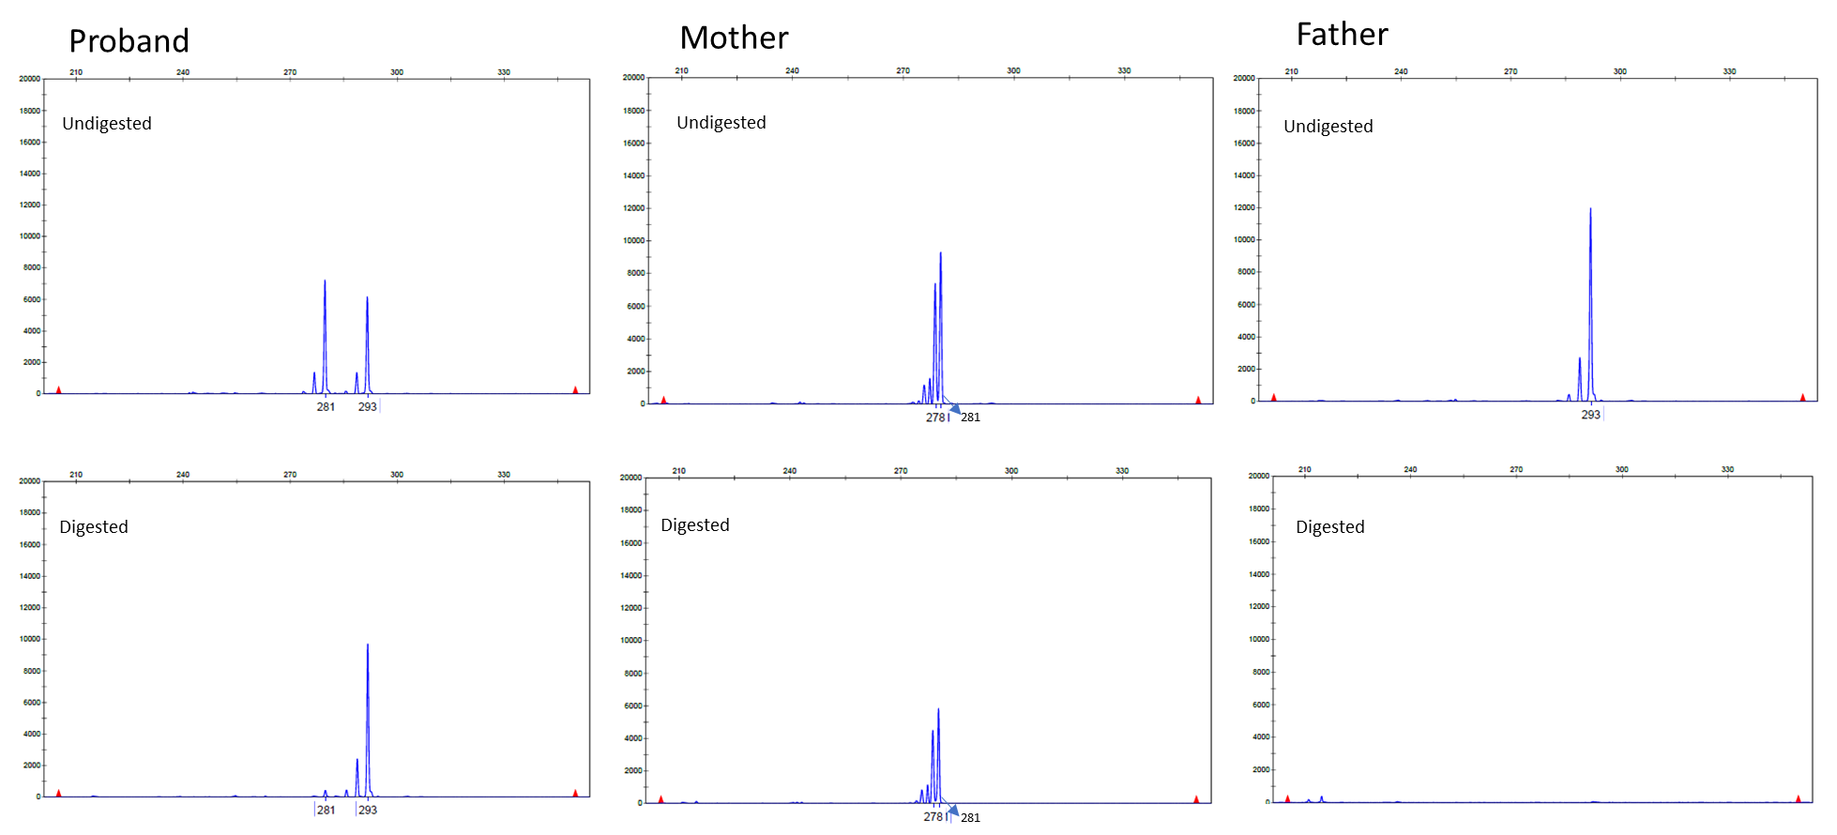
The proband showed highly skewed X inactivation, with the allele inherited from the mother being the active allele

Supplemental File 1: Clinical description of individuals carrying heterozygous deletion of AMER1 gene
Case Reports
I-2 (Figure 1) had a clinical diagnosis of OS-CS, and characteristic dysmorphic facial features.
II-1 was first seen for genetic evaluation at 16 years of age. Her physical examination was limited as she was in a wheelchair, with weight at the 34th percentile and head circumference of 67 cm (>97th percentile). She had narrow palpebral fissures, small ears that were slightly cupped and incompletely folded, broad nasal tip, thick broad lips, repairs to the palate, and malpositioned widely spaced teeth. She had mild intellectual disability and her speech was difficult to understand. Her history was notable: the right kidney was removed in the neonatal period for Wilms tumor; ventricular septal defect was repaired at age 5 months; cleft palate was repaired and tongue reduction performed at age 1 year; neck surgery because of cartilage deterioration at age 3 years; hip surgery at age 4 years; tracheotomy at age 6 years; and orthopedic surgery for scoliosis in teenage.
II-2 was a female fetus identified with multiple abnormalities that included anencephaly, cervical rachischisis, bilateral cleft lip and palate, umbilical cord hernia, humeral dislocation, and intestinal malrotation (Figure 2).
II-3 was a fetus identified with leg abnormalities on prenatal ultrasound and the pregnancy was discontinued.
Array Confirmation
The chromosomal microarray analysis confirmed a 7.8 kbp deletion [arr(GRCh36) Xq11.2(63321770_63329590)x1] of the exon 2 of AMER1 in I-2 and II-1, and II-2 (Figure 3).

Figure 2S. Pedigree of family with osteopathia striata congenita with cranial sclerosis.
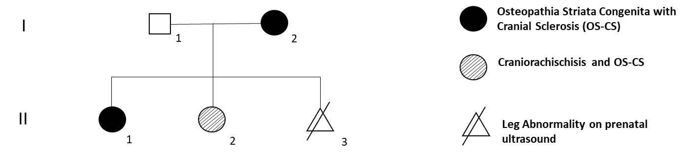

Figure 3S. Affected fetus (II.2) with craniorachischisis and deletion of AMER1 (A). Radiograph showing absence of calvaria, widening of lateral pedicle and hypoplasia of cervical vertebrae, and increased density of facial bones and remnant calvaria (B, C).
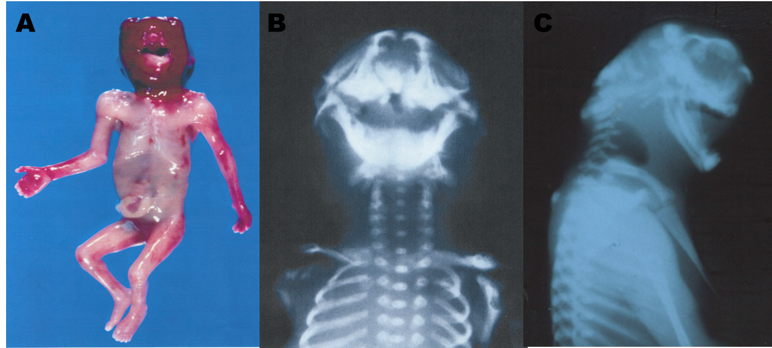
Figure 4S. Microarray data showing a ~7.8 kbp deletion of AMER1 (aka WTX and FAM123B) [arr(GRCh36) Xq11.2(63321770_63329590)x1].
