Medini et al 2025 Supplemental Figures

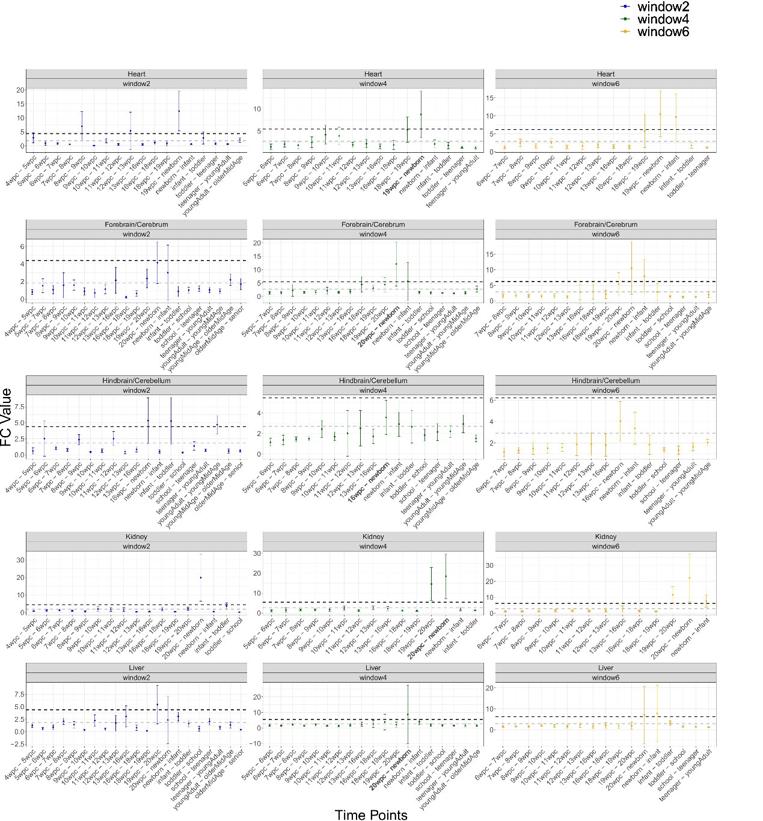
Figure S1. Fold-change (FC) values of mtDNA gene expression in five Homo Sapiens tissues across developmental time points. X-axis - the developmental time points. Y-axis - the average FC values with standard deviation. Color code for each panel: sliding window sizes of w=2 (blue), w=4 (green), and w=6 (yellow). The highest FC values according to the w=4 analysis are highlighted in bold. Horisontal dashed grey line - average FC across the time points. Black dashed line – standard deviation above the average.

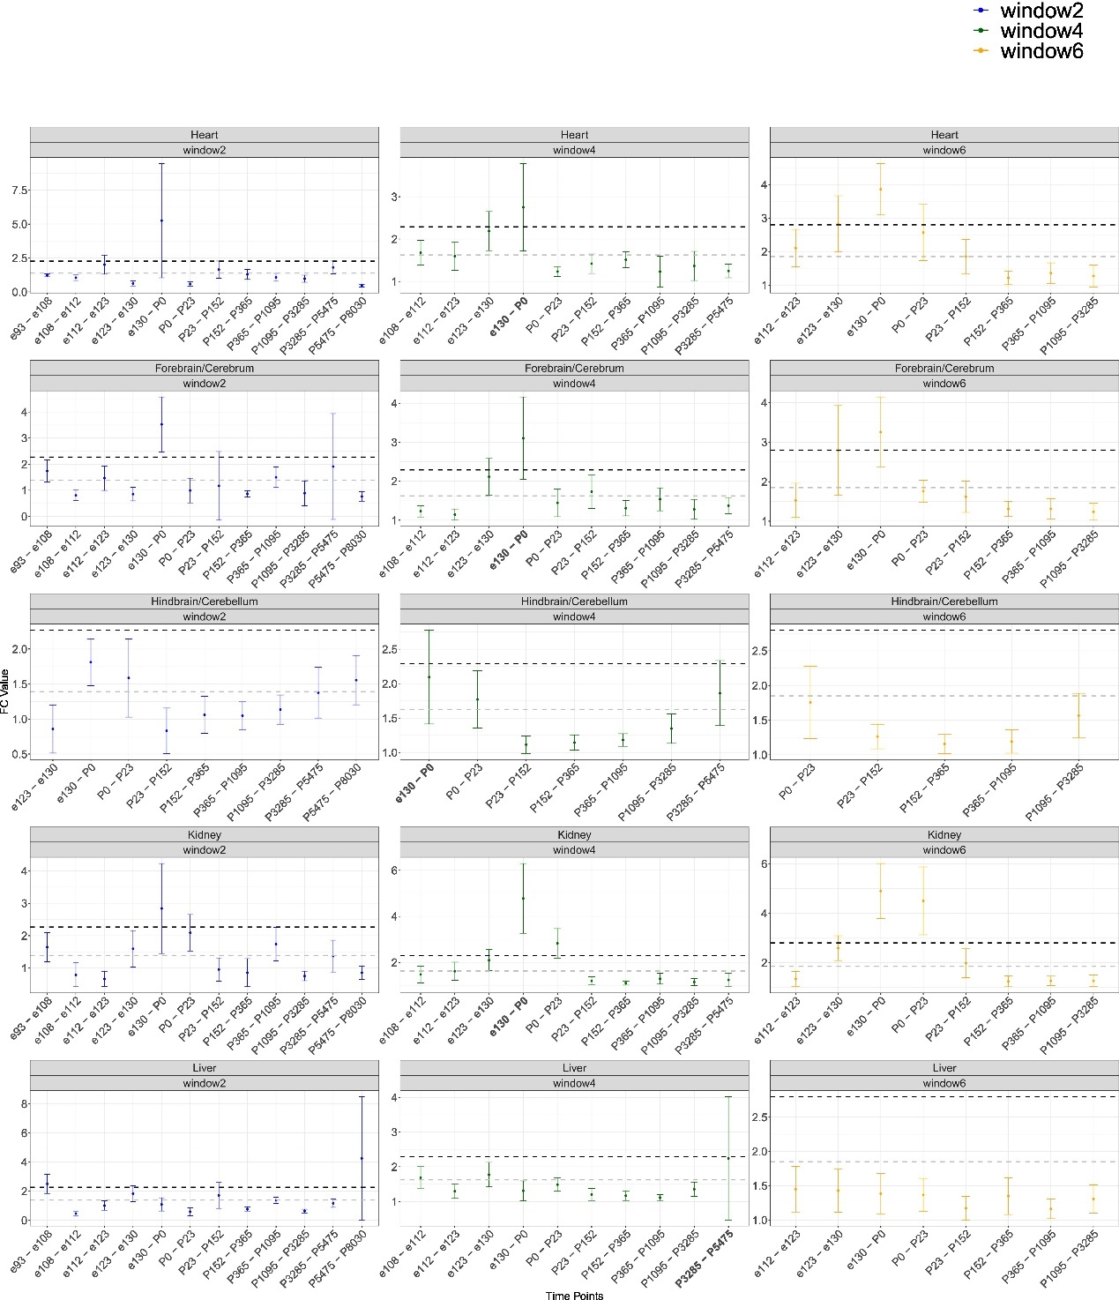
Figure S2. Fold-change (FC) values of mtDNA gene expression in five Macaca mulatta tissues across developmental time points. X-axis - the developmental time points. Y-axis - the average FC values with standard deviation. Color code for each panel: sliding window sizes of w=2 (blue), w=4 (green), and w=6 (yellow). The highest FC values according to the w=4 analysis are highlighted in bold. Horizontal dashed grey line - average FC across the time points. Black dashed line – standard deviation above the average.

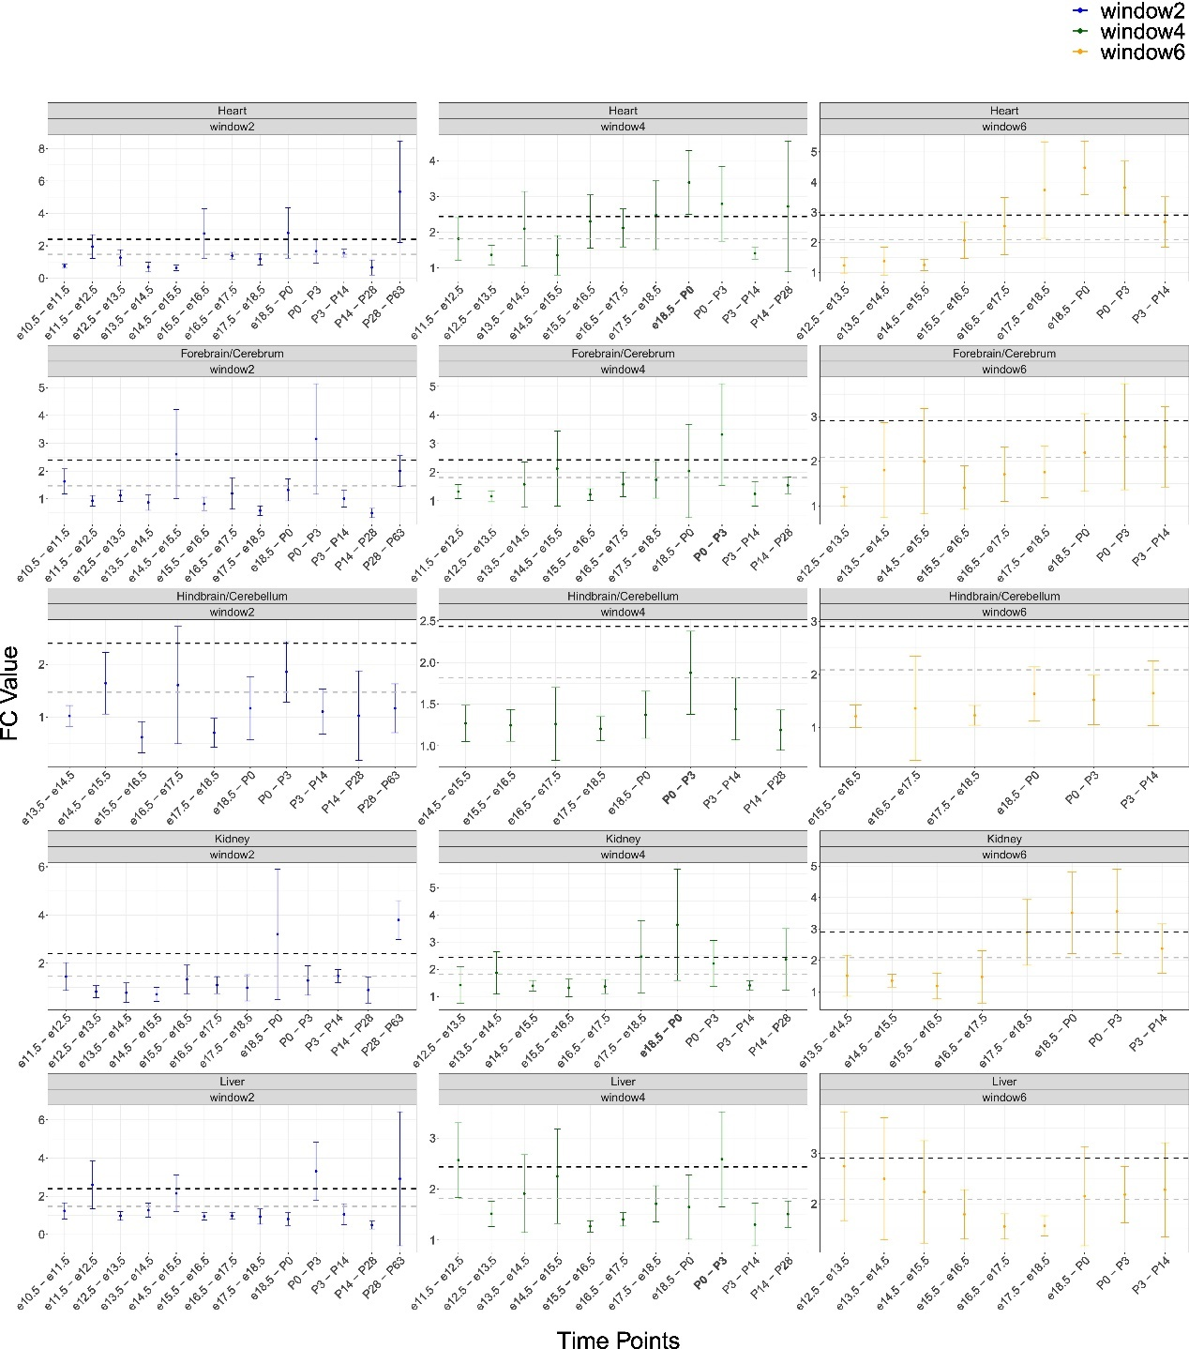
Figure S3. Fold-change (FC) values of mtDNA gene expression in five Mus musculus tissues across developmental time points. X-axis - the developmental time points. Y-axis - the average FC values with standard deviation. Color code for each panel: sliding window sizes of w=2 (blue), w=4 (green), and w=6 (yellow). The highest FC values according to the w=4 analysis are highlighted in bold. Horisontal dashed grey line - average FC across the time points. Black dashed line – standard deviation above the average.

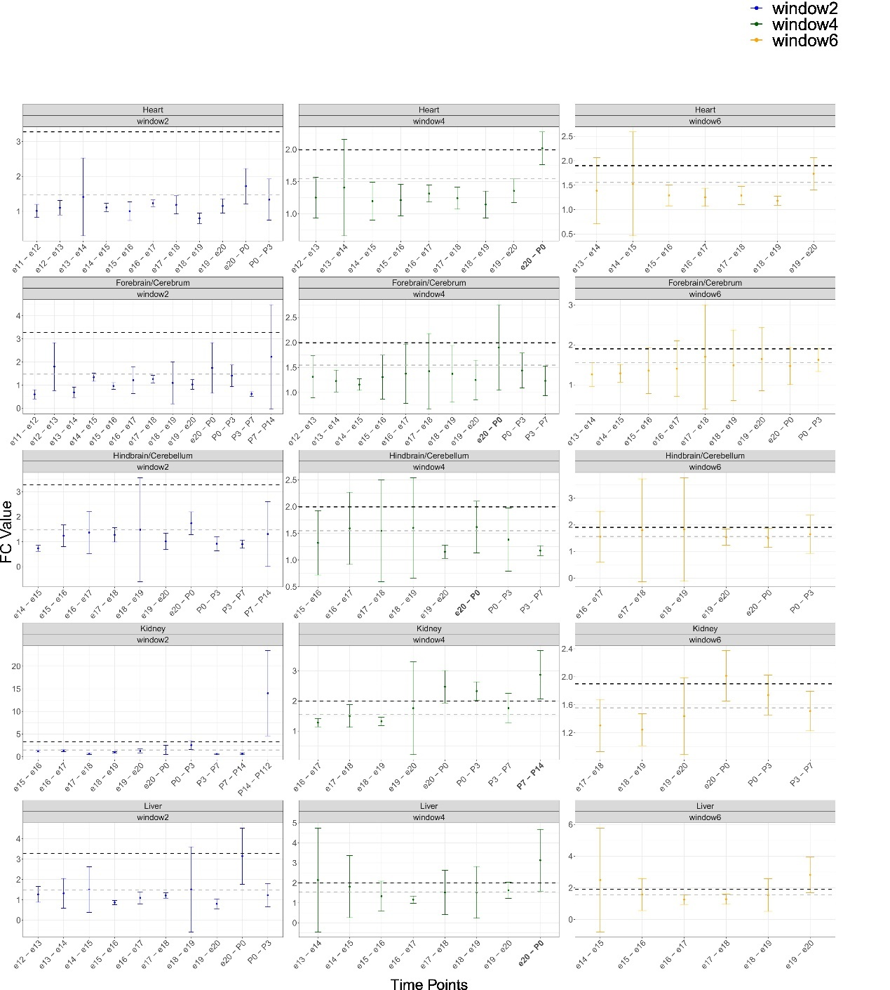
Figure S4. Fold-change (FC) values of mtDNA gene expression in five Ratus norvegicus tissues across developmental time points. X-axis - the developmental time points. Y-axis - the average FC values with standard deviation. Color code for each panel: sliding window sizes of w=2 (blue), w=4 (green), and w=6 (yellow). The highest FC values according to the w=4 analysis are highlighted in bold. Horisontal dashed grey line - average FC across the time points. Black dashed line – standard deviation above the average.

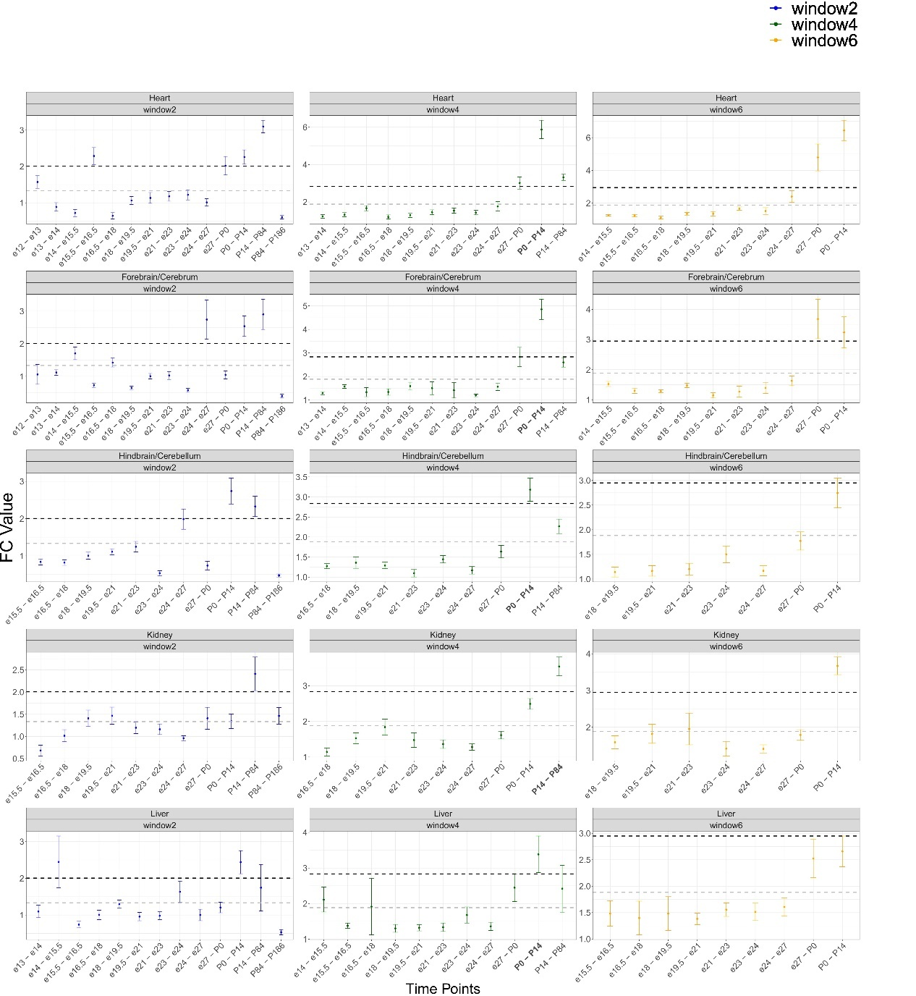
Figure S5. Fold-change (FC) values of mtDNA gene expression in five Oryctolagus cuniculus tissues across developmental time points. X-axis - the developmental time points. Y-axis - the average FC values with standard deviation. Color code for each panel: sliding window sizes of w=2 (blue), w=4 (green), and w=6 (yellow). The highest FC values according to the w=4 analysis are highlighted in bold. Horisontal dashed grey line - average FC across the time points. Black dashed line – standard deviation above the average.

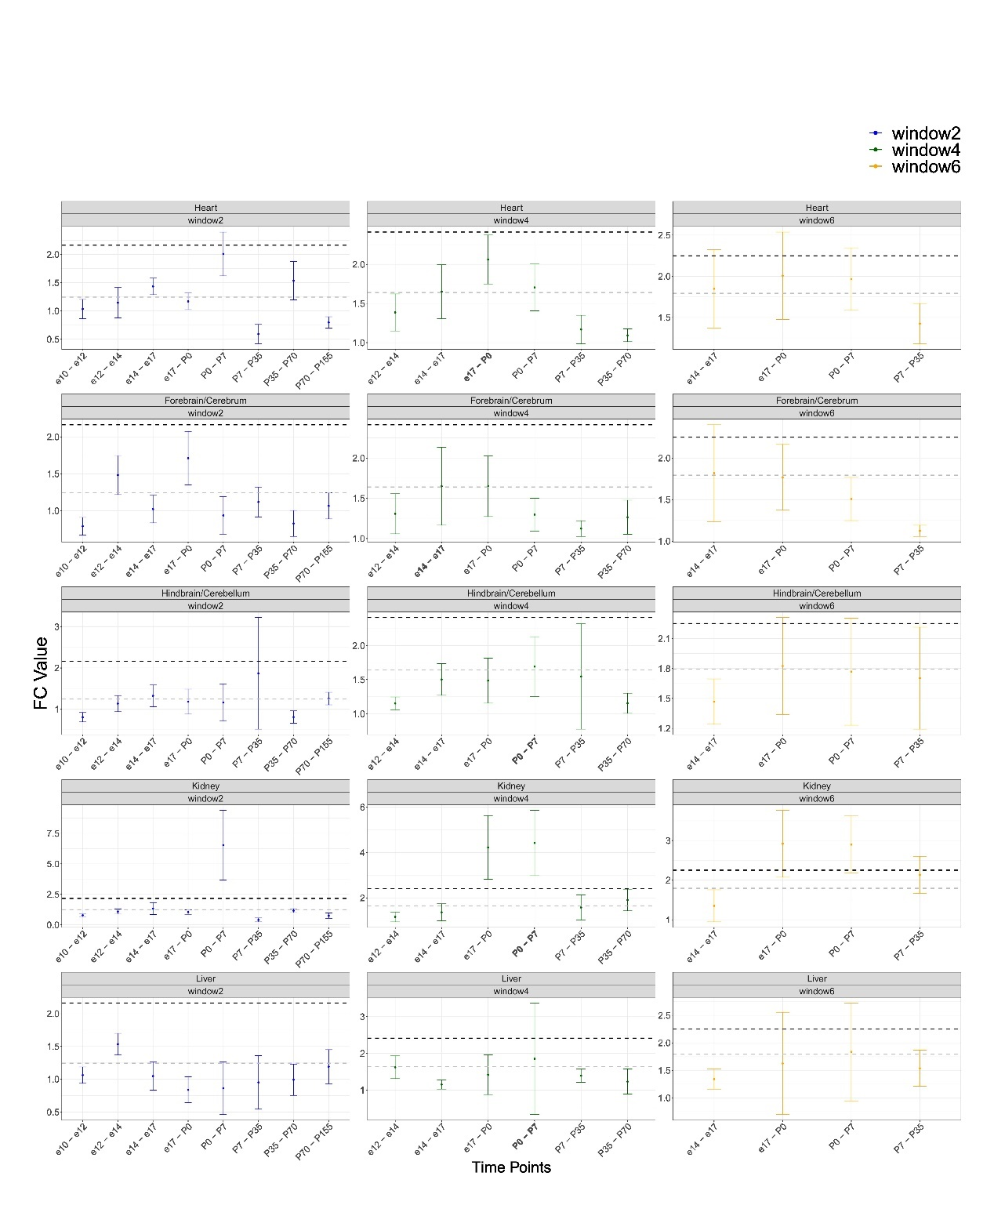
Figure S6. Fold-change (FC) values of mtDNA gene expression in five Gallus gallus tissues across developmental time points. X-axis - the developmental time points. Y-axis - the average FC values with standard deviation. Color code for each panel: sliding window sizes of w=2 (blue), w=4 (green), and w=6 (yellow). The highest FC values according to the w=4 analysis are highlighted in bold. Horisontal dashed grey line - average FC across the time points. Black dashed line – standard deviation above the average.

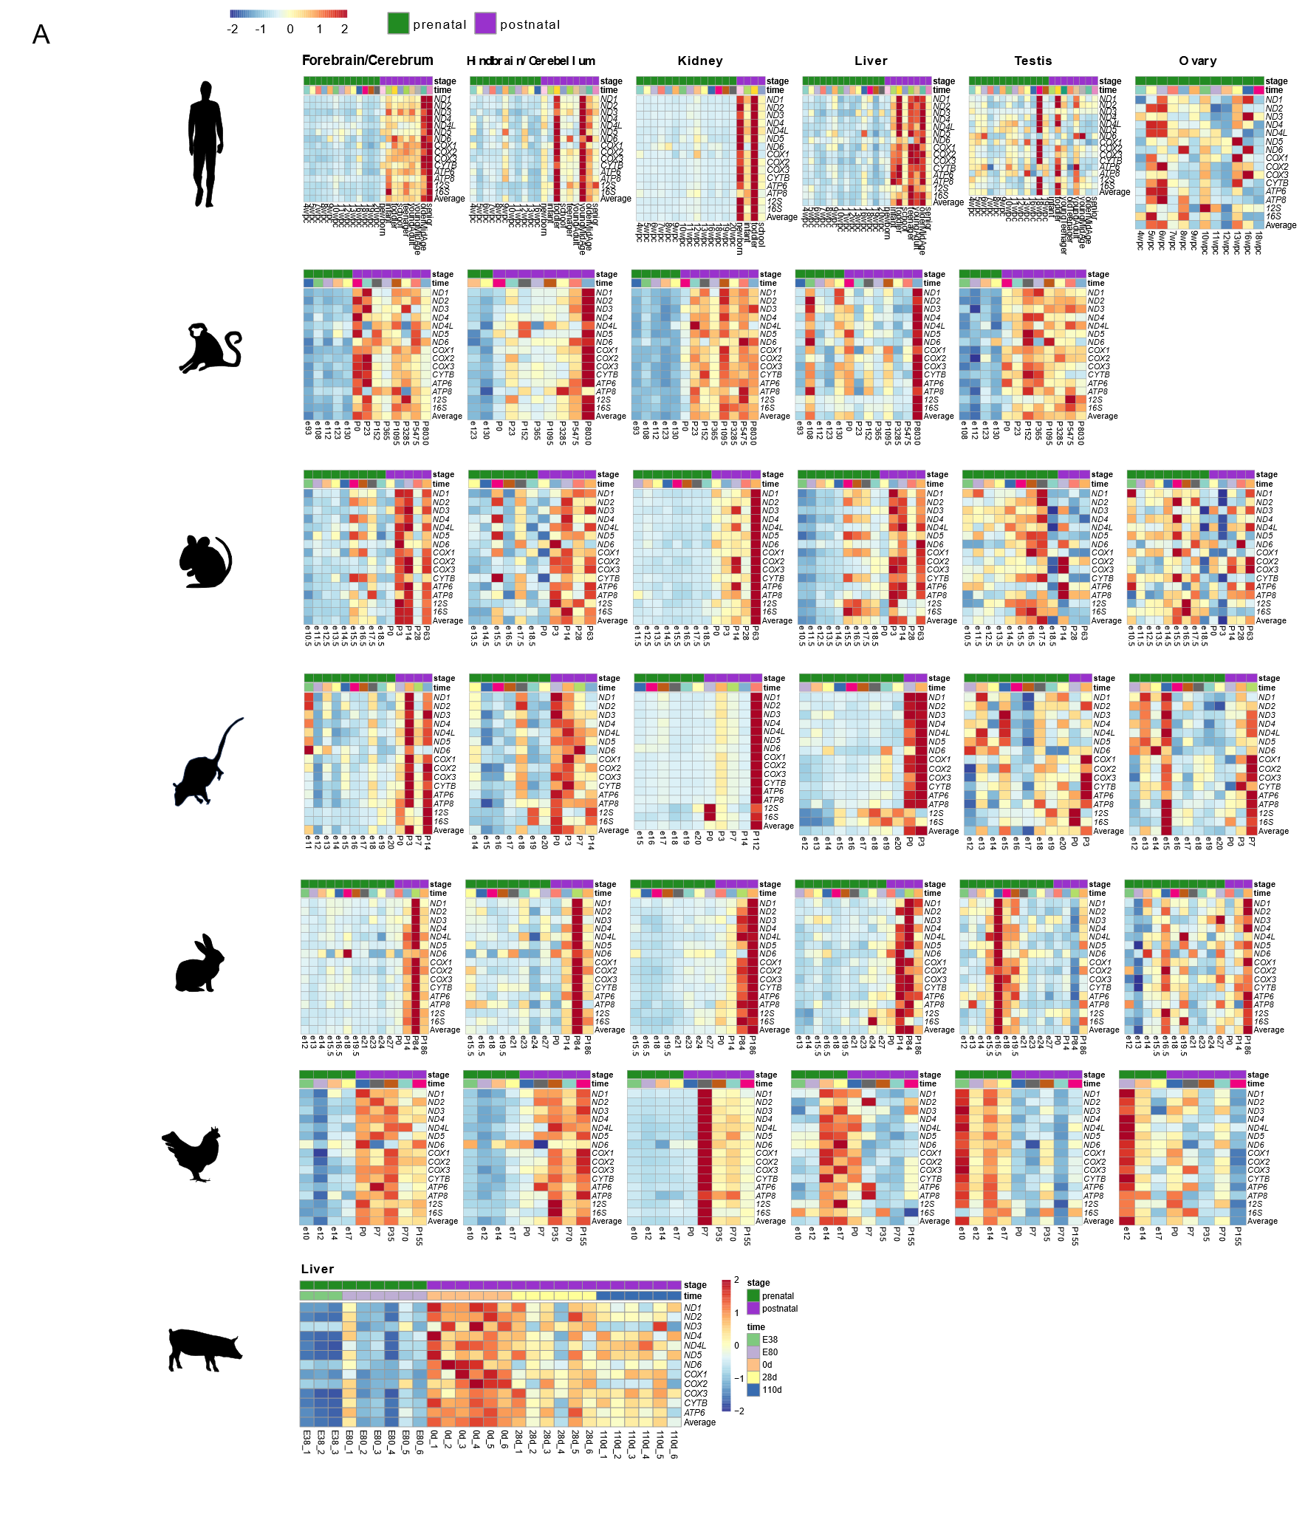

Figure S7. mtDNA genes expression during prenatal and postnatal development in vertebrates. (A) Heatmaps representing mtDNA gene expression in six tissues from five mammals and a non-mammalian vertebrate (chicken). Color bar indicates the scaled expression level changes. Red scale: elevated expression, blue scale: reduced expression. X axis: prenatal (green) and postnatal (purple) stages of sample collection; we calculated the median expression level of samples from each given developmental stage. Y axis: mtDNA genes. Available also in figshare: https://figshare.com/articles/figure/Figures_S7_and_S11/27612132

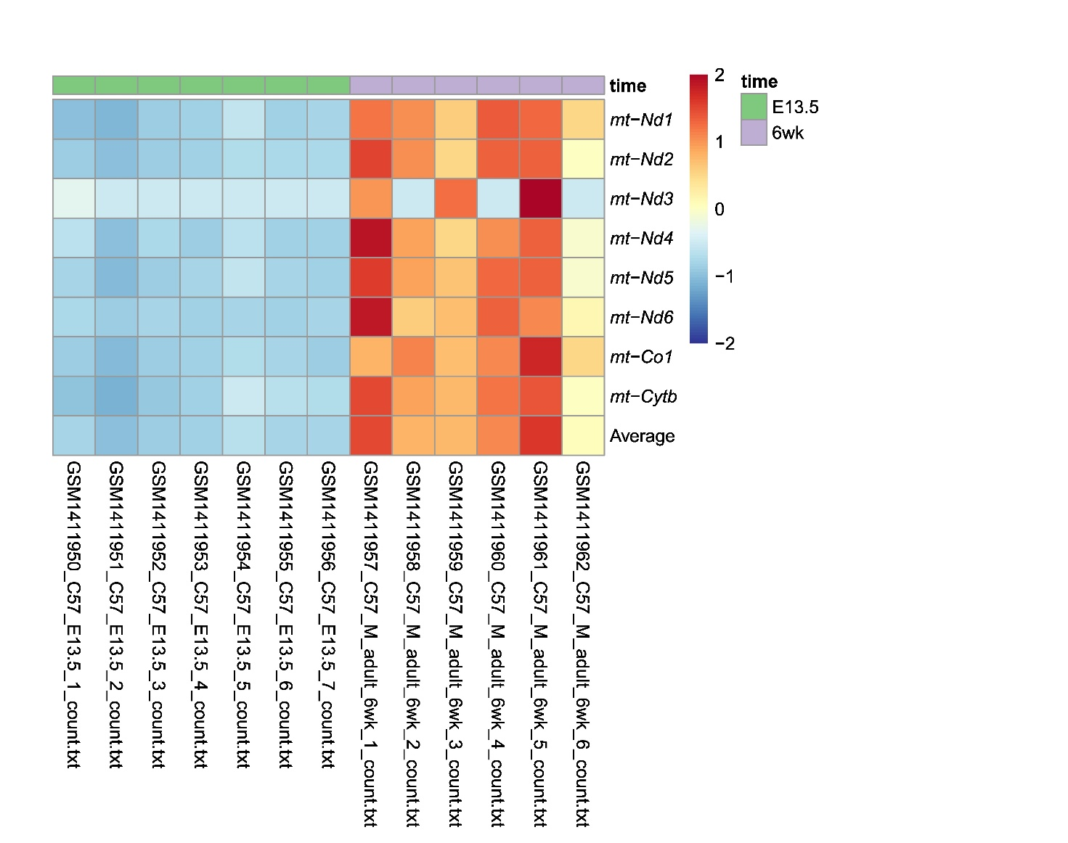
Figure S8. Heatmap of mtDNA gene expression in the mouse (Mus musculus) heart (day 13.5 vs 6 weeks after birth) (Dataset IV). X-axis: samples – prenatal (green) and postnatal (purple). Y axis – mtDNA genes. Color code: blue – reduced expression, red – elevated expression.

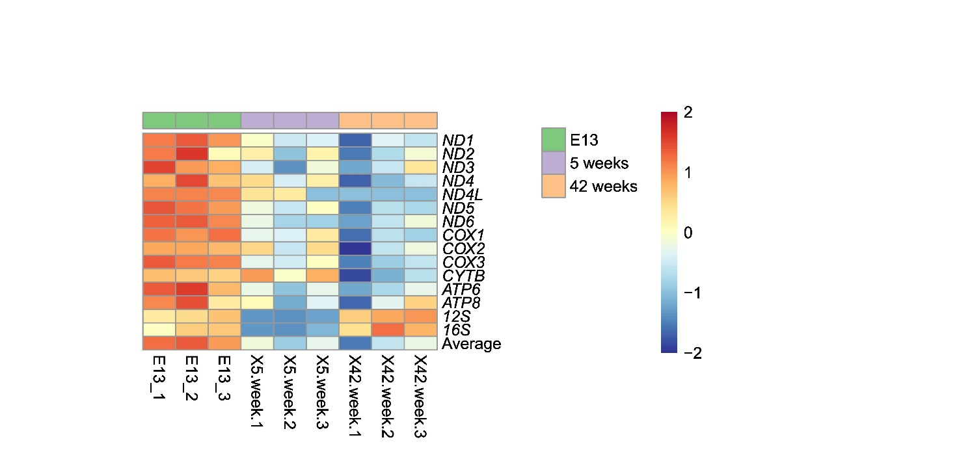
Figure S9. mtDNA gene expression in chicken (Gallus gallus) liver samples collected 5 weeks and 42 weeks after birth display lower expression as compared to day 13 of embryo development (Dataset III). Color bar indicates the scaled expression. Red scale: elevated expression, blue scale: low expression. X axis: prenatal samples and postnatal samples (Dataset III), Y axis: mtDNA genes. Annotation of barplot: green line indicates the prenatal stage (E13), purple line indicates 5 weeks postnatal stages, orange line indicates 42 weeks.

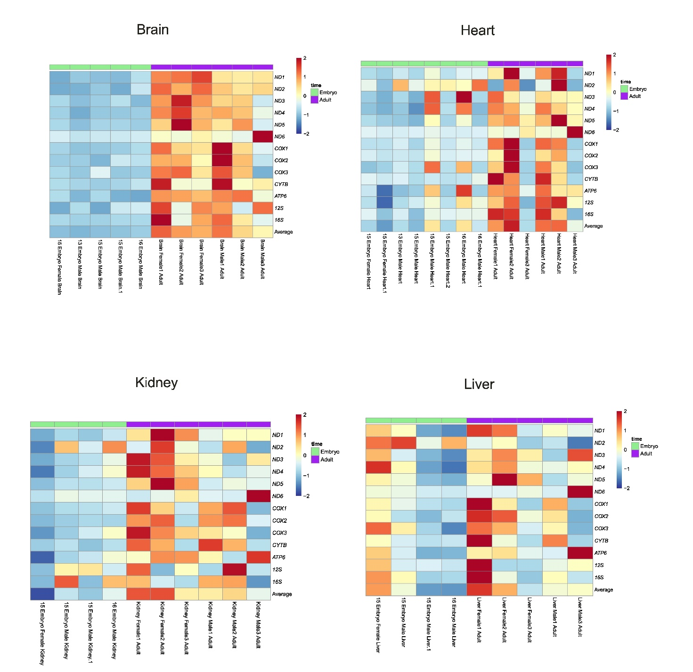
Figure S10. Heatmaps of mtDNA gene expression from embryo and adult Anolis carolinensis samples from four organs (brain, heart, kidney, liver) (Dataset V). X-axis – analyzed samples; Y-axis – mtDNA genes. Horizontal green line – prenatal samples; Horizontal purple line – postnatal samples.

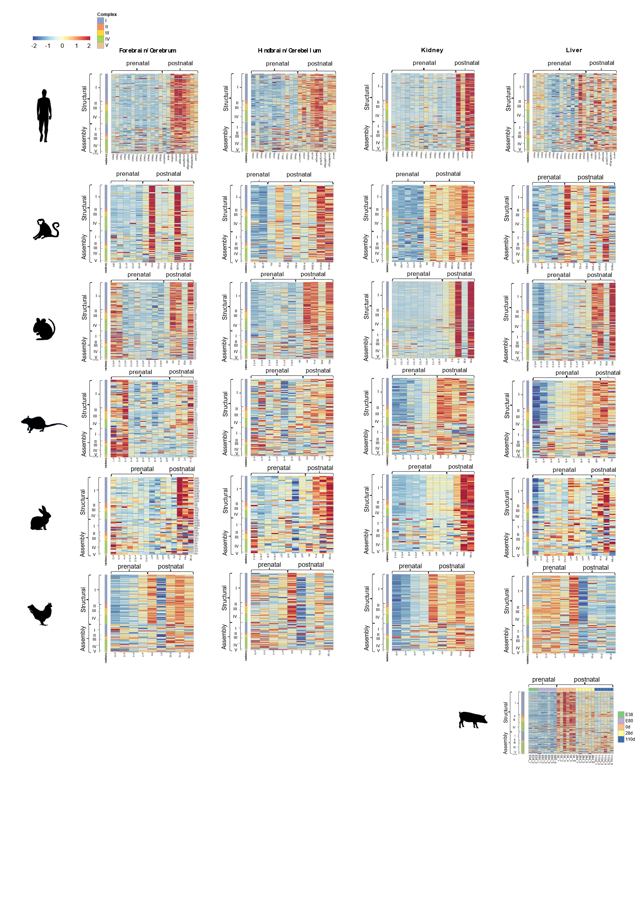
Figure S11. Nuclear DNA-encoded OXPHOS genes expression in embryo development and postnatal stages across vertebrates. Heatmaps representing expression of nuclear DNA-encoded OXPHOS gene in six tissues from five mammals (six mammals in liver) and a non-mammalian vertebrate (chicken). Color bar: Red scale - elevated expression, blue scale: reduced expression. For each developmental stage the median expression of the relevant samples was used for calculation (Dataset I). are the labels of the prenatal and postnatal samples. X axis: developmental stages. Y axis: nuclear DNA-encoded genes, divided according to OXPHOS complexes, structural and assembly genes and Cytochrome C (CYCS). Available also in figshare: https://figshare.com/articles/figure/Figures_S7_and_S11/27612132.
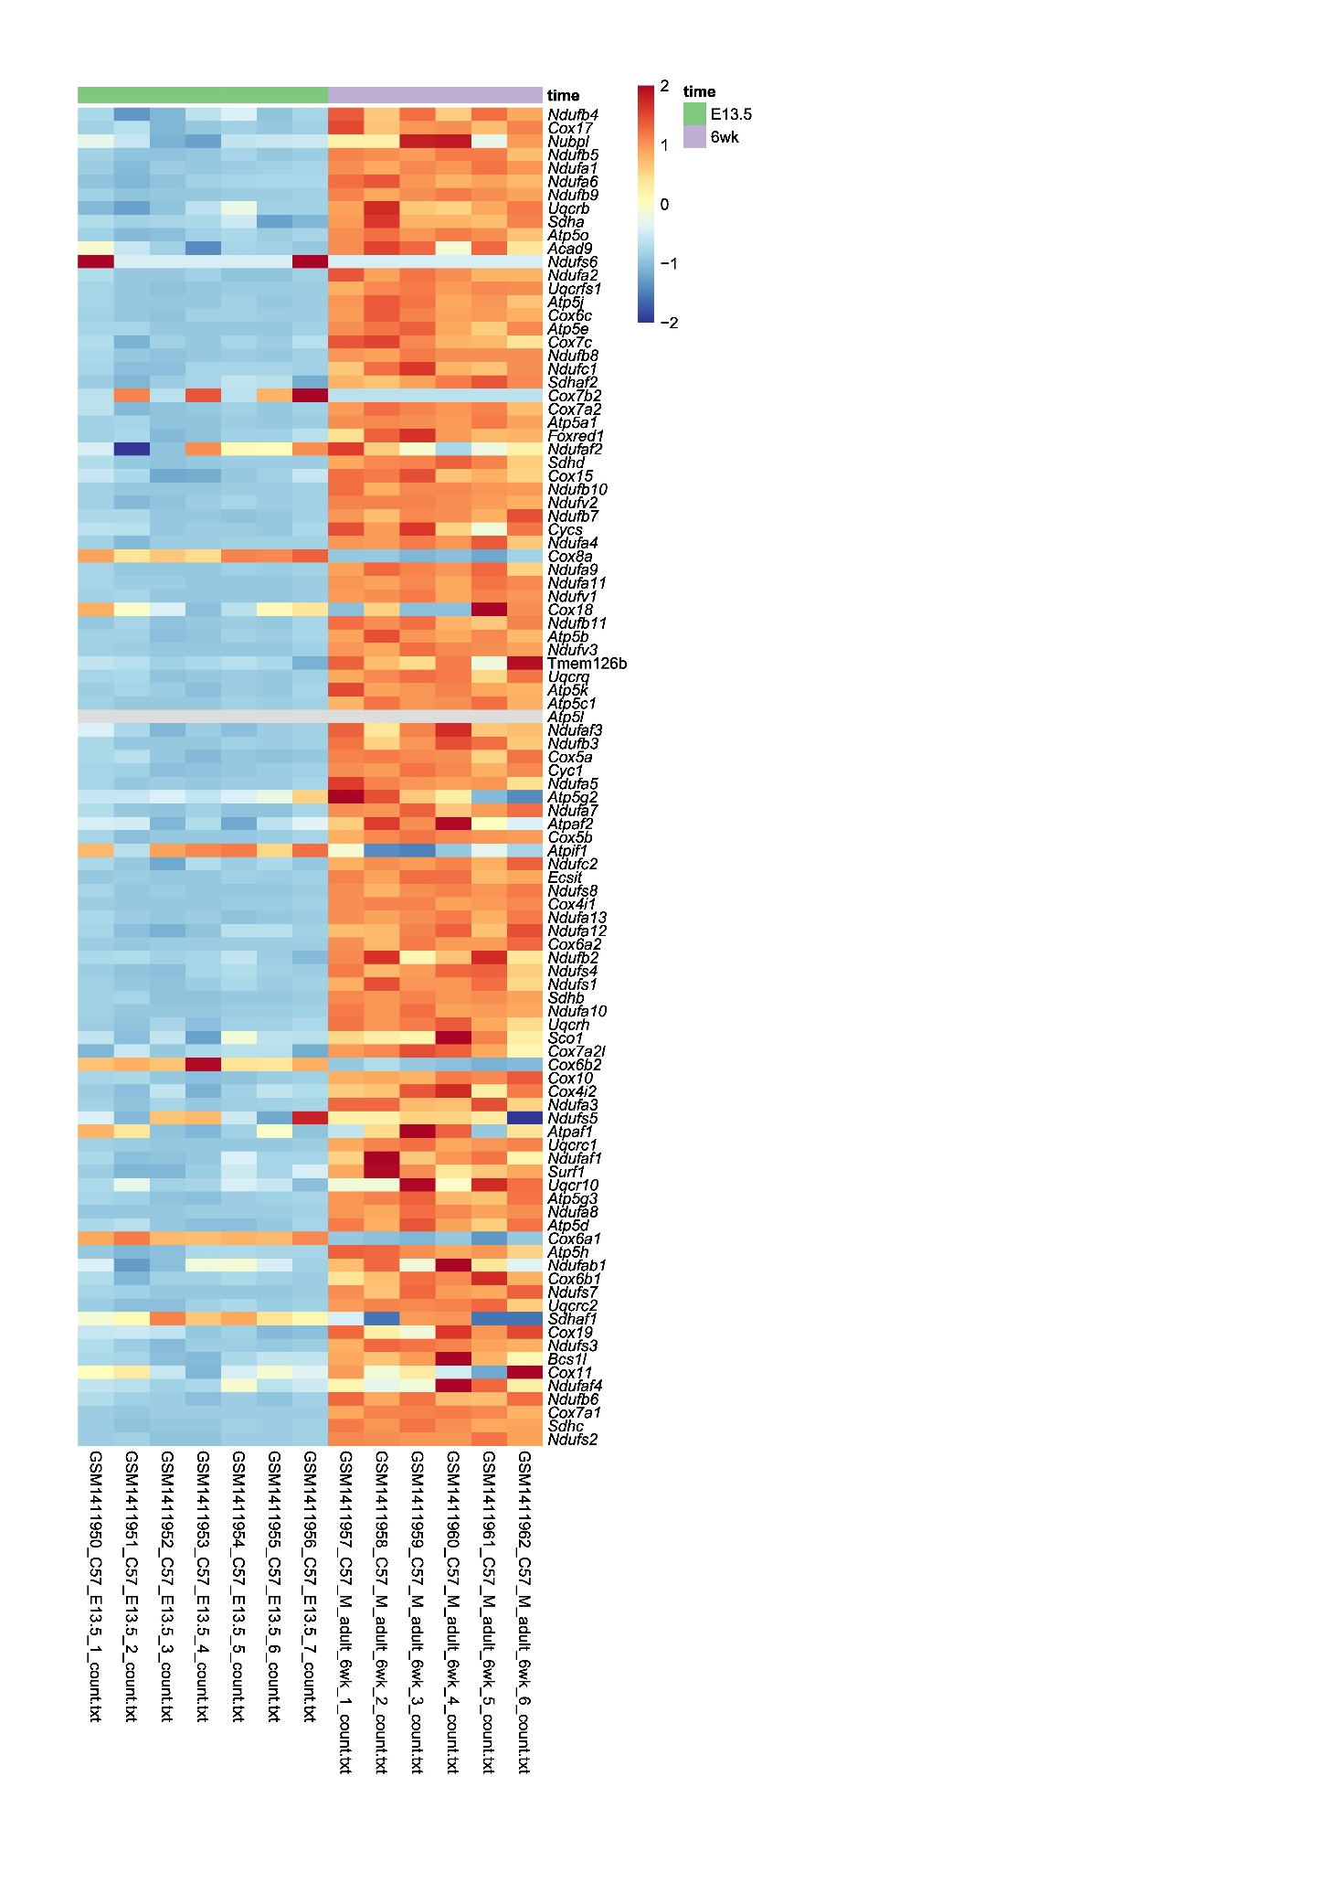
Figure S12. Heatmap of nuclear OXPHOS gene expression in the mouse (Mus musculus) heart (day 13.5 vs 6 weeks after birth) (Dataset IV). Horizontal green line - fetal (E13.5) samples, horizontal purple line - 6 weeks samples. The color bar indicates the scaled expression: Red scale - elevated expression, blue scale - reduced expression. X axis: prenatal samples and postnatal samples, Y axis: OXPHOS genes.
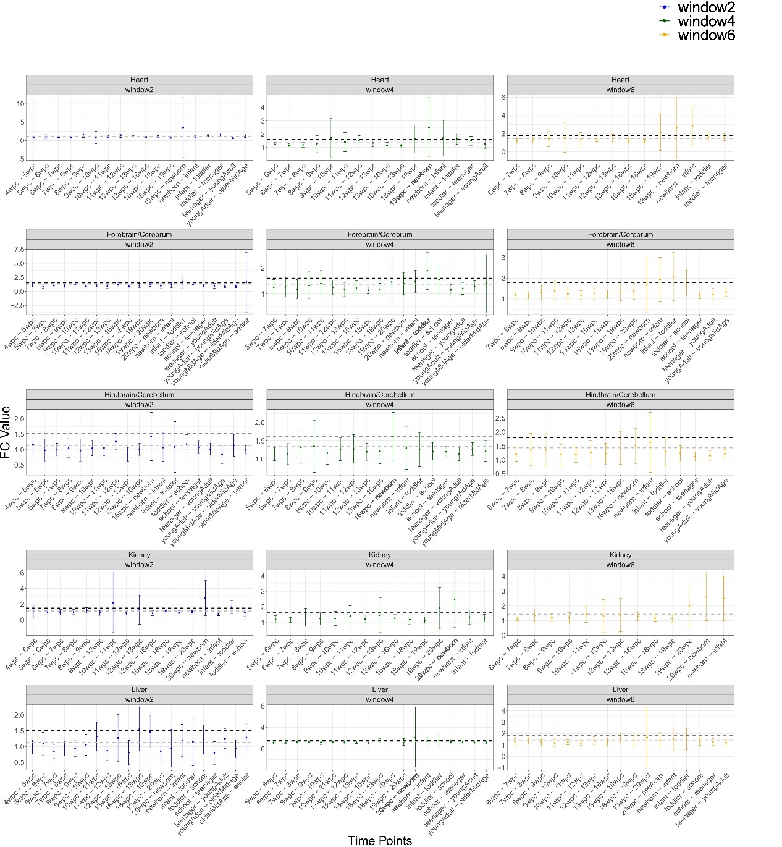
Figure S13. Fold-change (FC) values of nuclear-encoded OXPHOS gene expression in five Homo sapiens tissues across developmental time points. X-axis - the developmental time points. Y-axis - the average FC values with standard deviation. Color code for each panel: sliding window sizes of w=2 (blue), w=4 (green), and w=6 (yellow). The highest FC values according to the w=4 analysis are highlighted in bold. Horisontal dashed grey line - average FC across the time points. Black dashed line – standard deviation above the average.

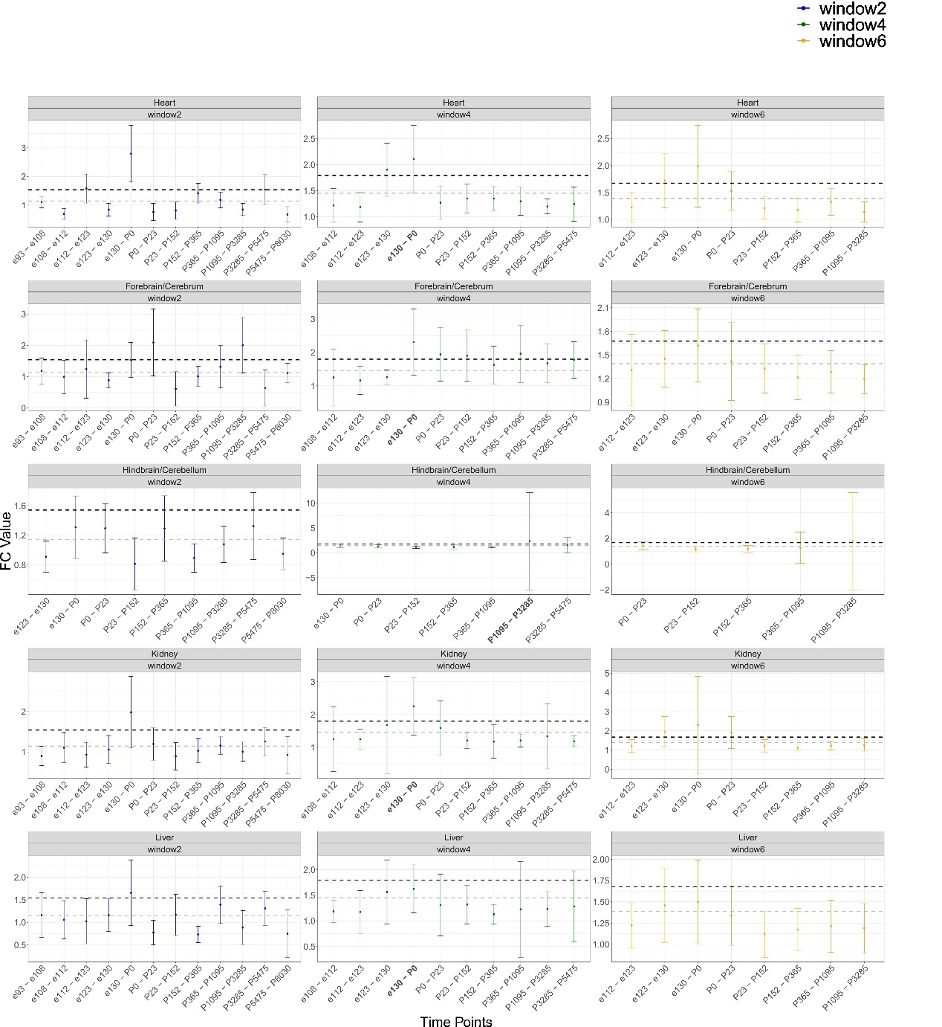
Figure S14. Fold-change (FC) values of nuclear encoded OXPHOS gene expression in five Macaca mullata tissues across developmental time points. X-axis - the developmental time points. Y-axis - the average FC values with standard deviation. Color code for each panel: sliding window sizes of w=2 (blue), w=4 (green), and w=6 (yellow). The highest FC values according to the w=4 analysis are highlighted in bold. Horisontal dashed grey line - average FC across the time points. Black dashed line – standard deviation above the average.
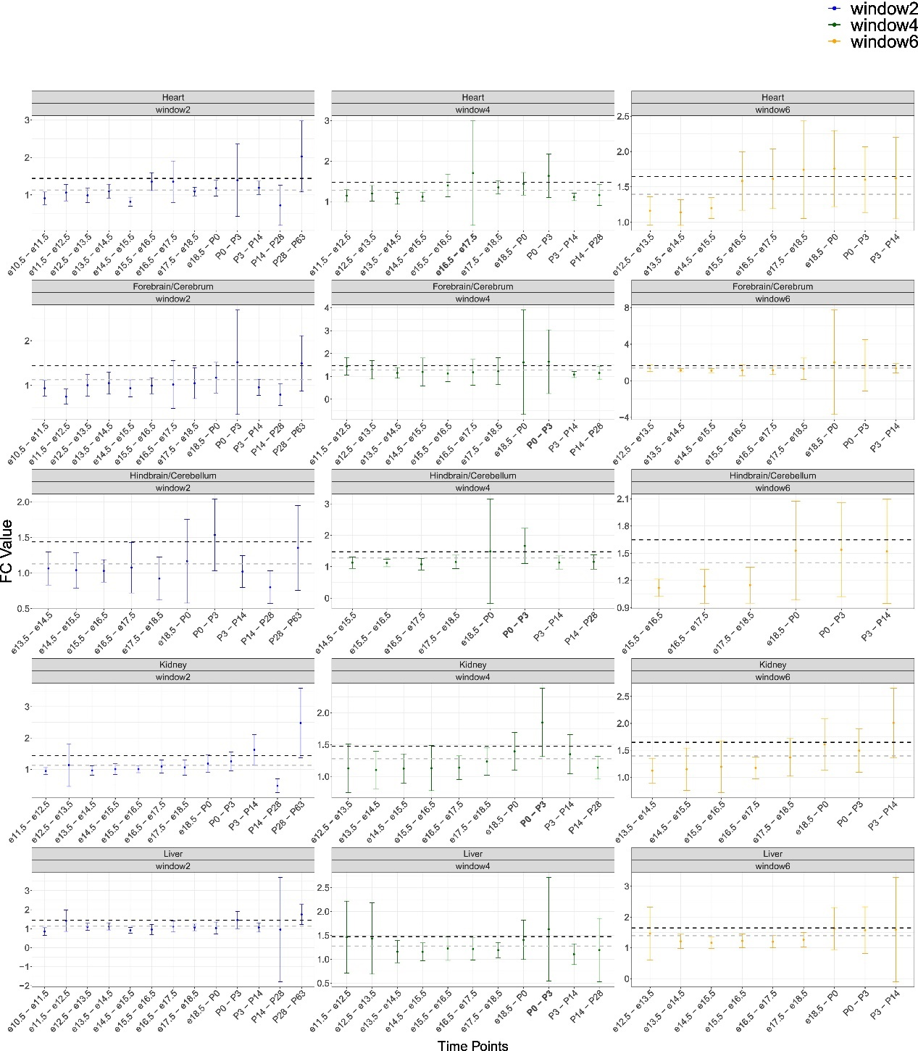

Figure S15. Fold-change (FC) values of nuclear encoded OXPHOS gene expression in five Mus musculus tissues across developmental time points. X-axis - the developmental time points. Y-axis - the average FC values with standard deviation. Color code for each panel: sliding window sizes of w=2 (blue), w=4 (green), and w=6 (yellow). The highest FC values according to the w=4 analysis are highlighted in bold. Horisontal dashed grey line - average FC across the time points. Black dashed line – standard deviation above the average.
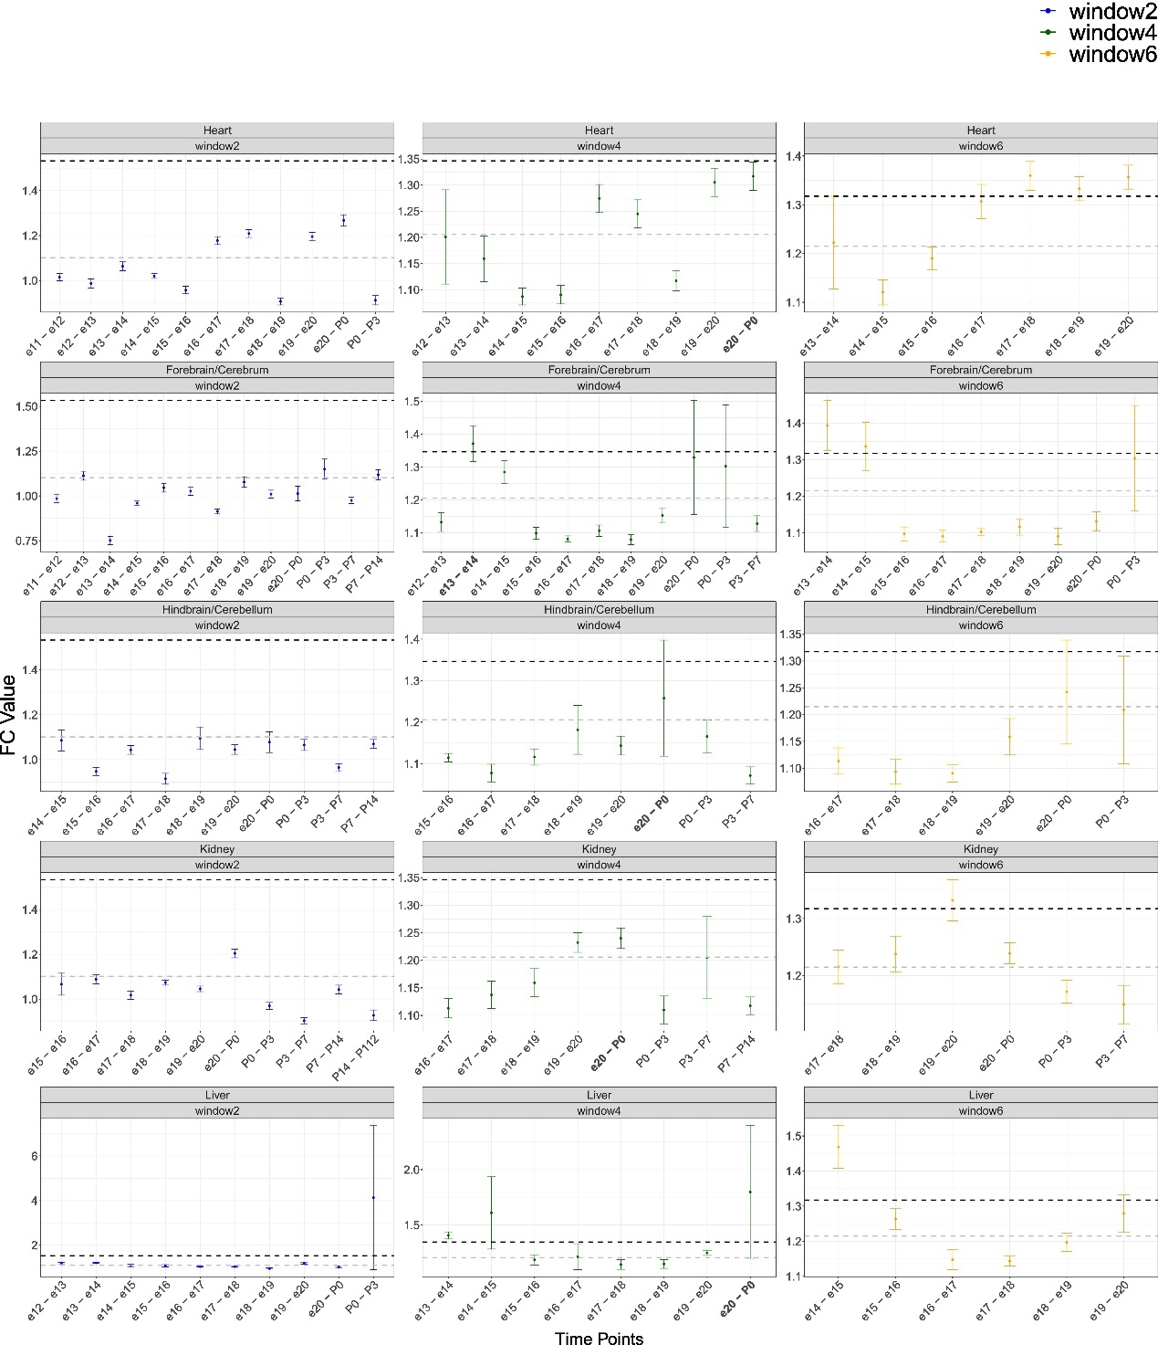
Figure S16. Fold-change (FC) values of nuclear encoded OXPHOS gene expression in five Rattus norvegicus tissues across developmental time points. X-axis - the developmental time points. Y-axis - the average FC values with standard deviation. Color code for each panel: sliding window sizes of w=2 (blue), w=4 (green), and w=6 (yellow). The highest FC values according to the w=4 analysis are highlighted in bold. Horisontal dashed grey line - average FC across the time points. Black dashed line – standard deviation above the average.
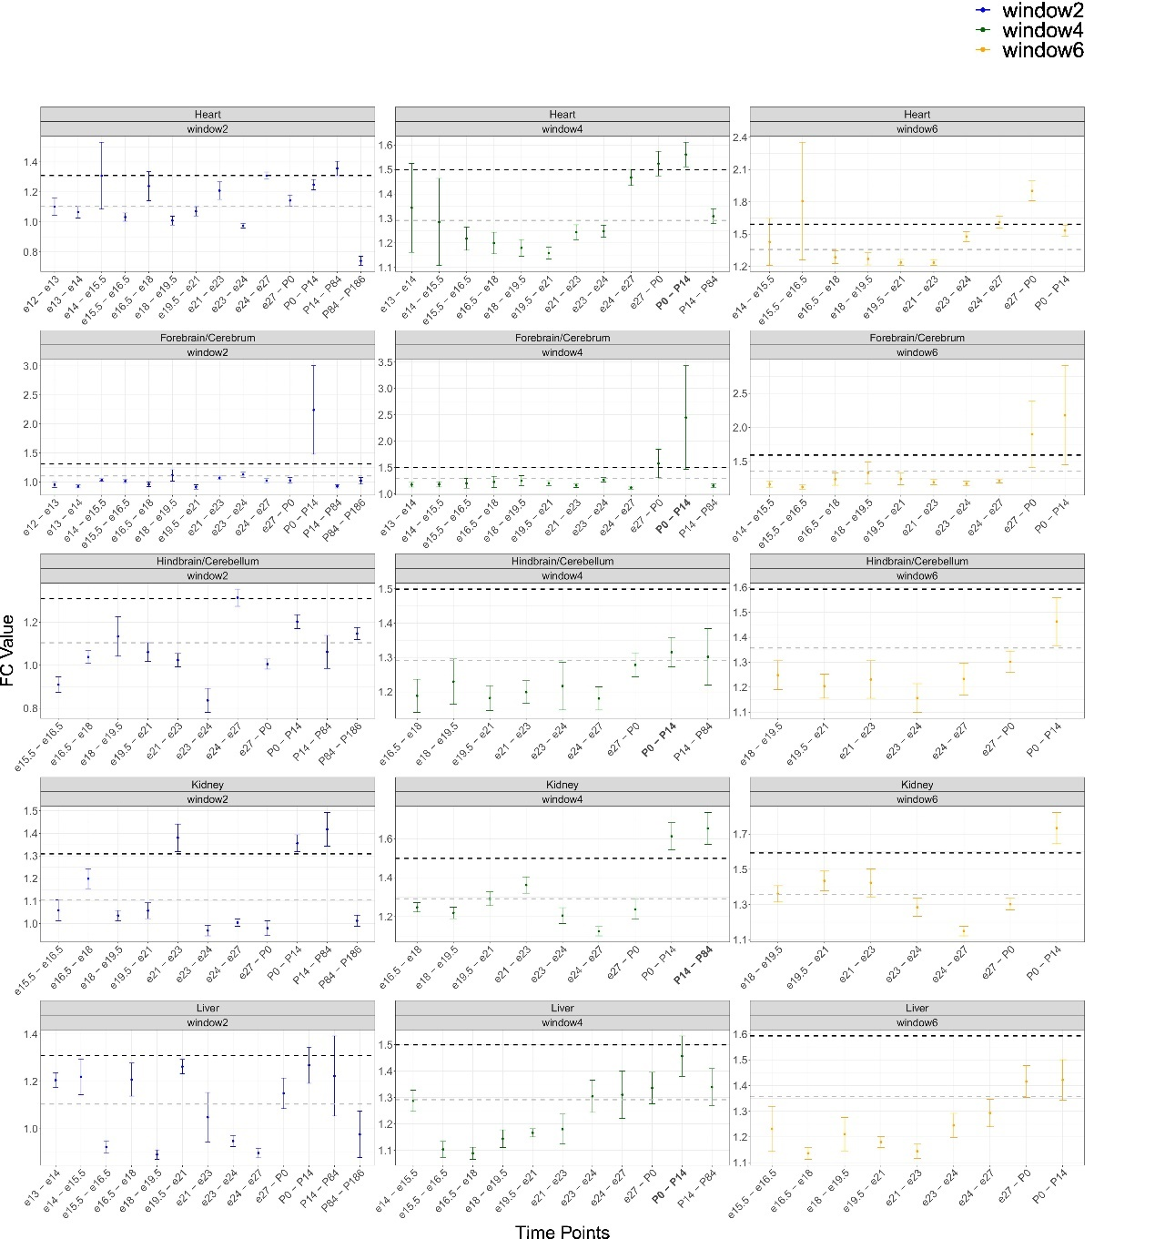
Figure S17. Fold-change (FC) values of nuclear encoded OXPHOS gene expression in Oryctolagus cuniculus tissues across developmental time points. X-axis - the developmental time points. Y-axis - the average FC values with standard deviation. Color code for each panel: sliding window sizes of w=2 (blue), w=4 (green), and w=6 (yellow). The highest FC values according to the w=4 analysis are highlighted in bold. Horisontal dashed grey line - average FC across the time points. Black dashed line – standard deviation above the average.

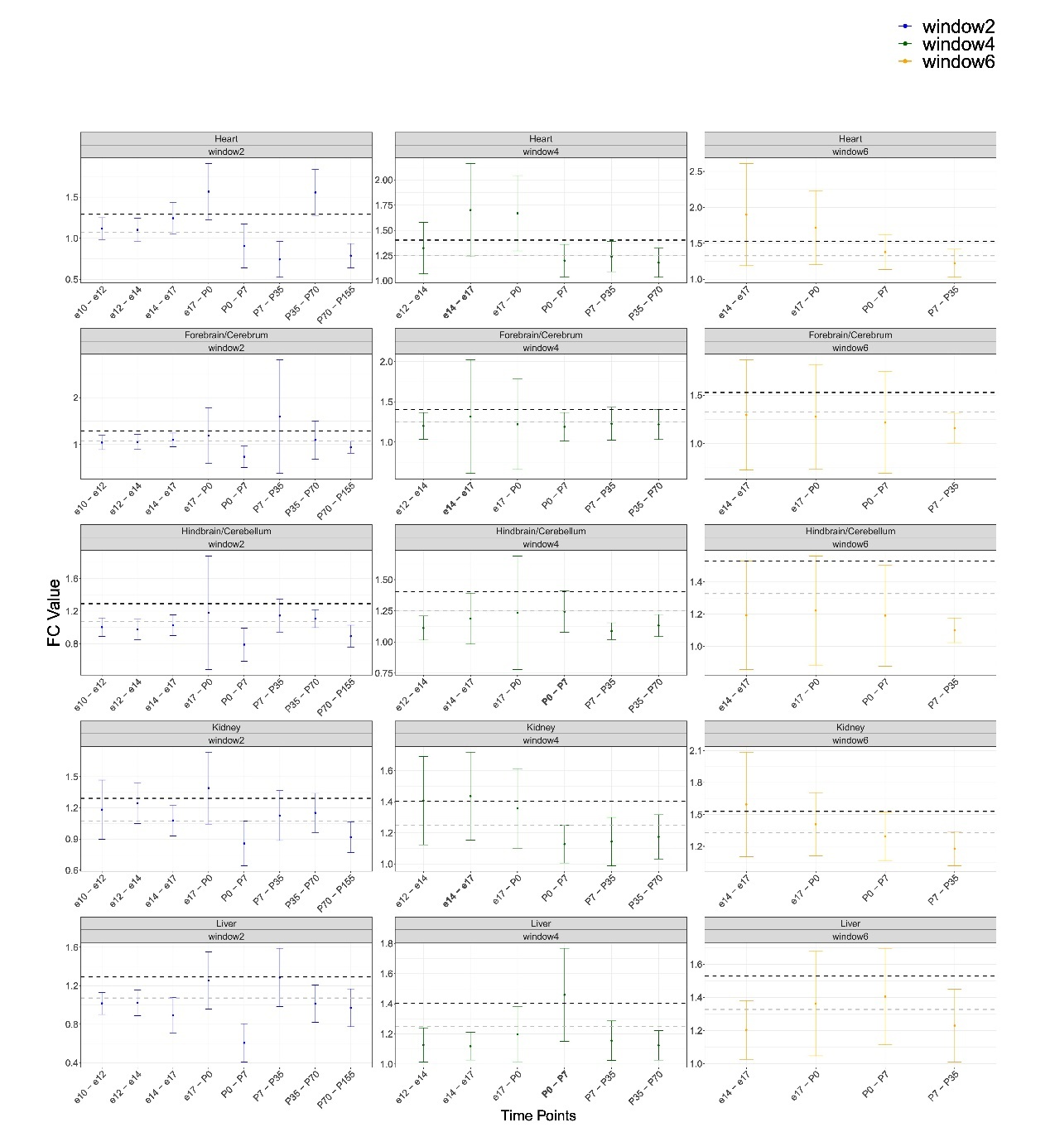
Figure S18. Fold-change (FC) values of nuclear encoded OXPHOS gene expression in five Gallus gallus tissues across developmental time points. X-axis - the developmental time points. Y-axis - the average FC values with standard deviation. Color code for each panel: sliding window sizes of w=2 (blue), w=4 (green), and w=6 (yellow). The highest FC values according to the w=4 analysis are highlighted in bold. Horisontal dashed grey line - average FC across the time points. Black dashed line – standard deviation above the average.

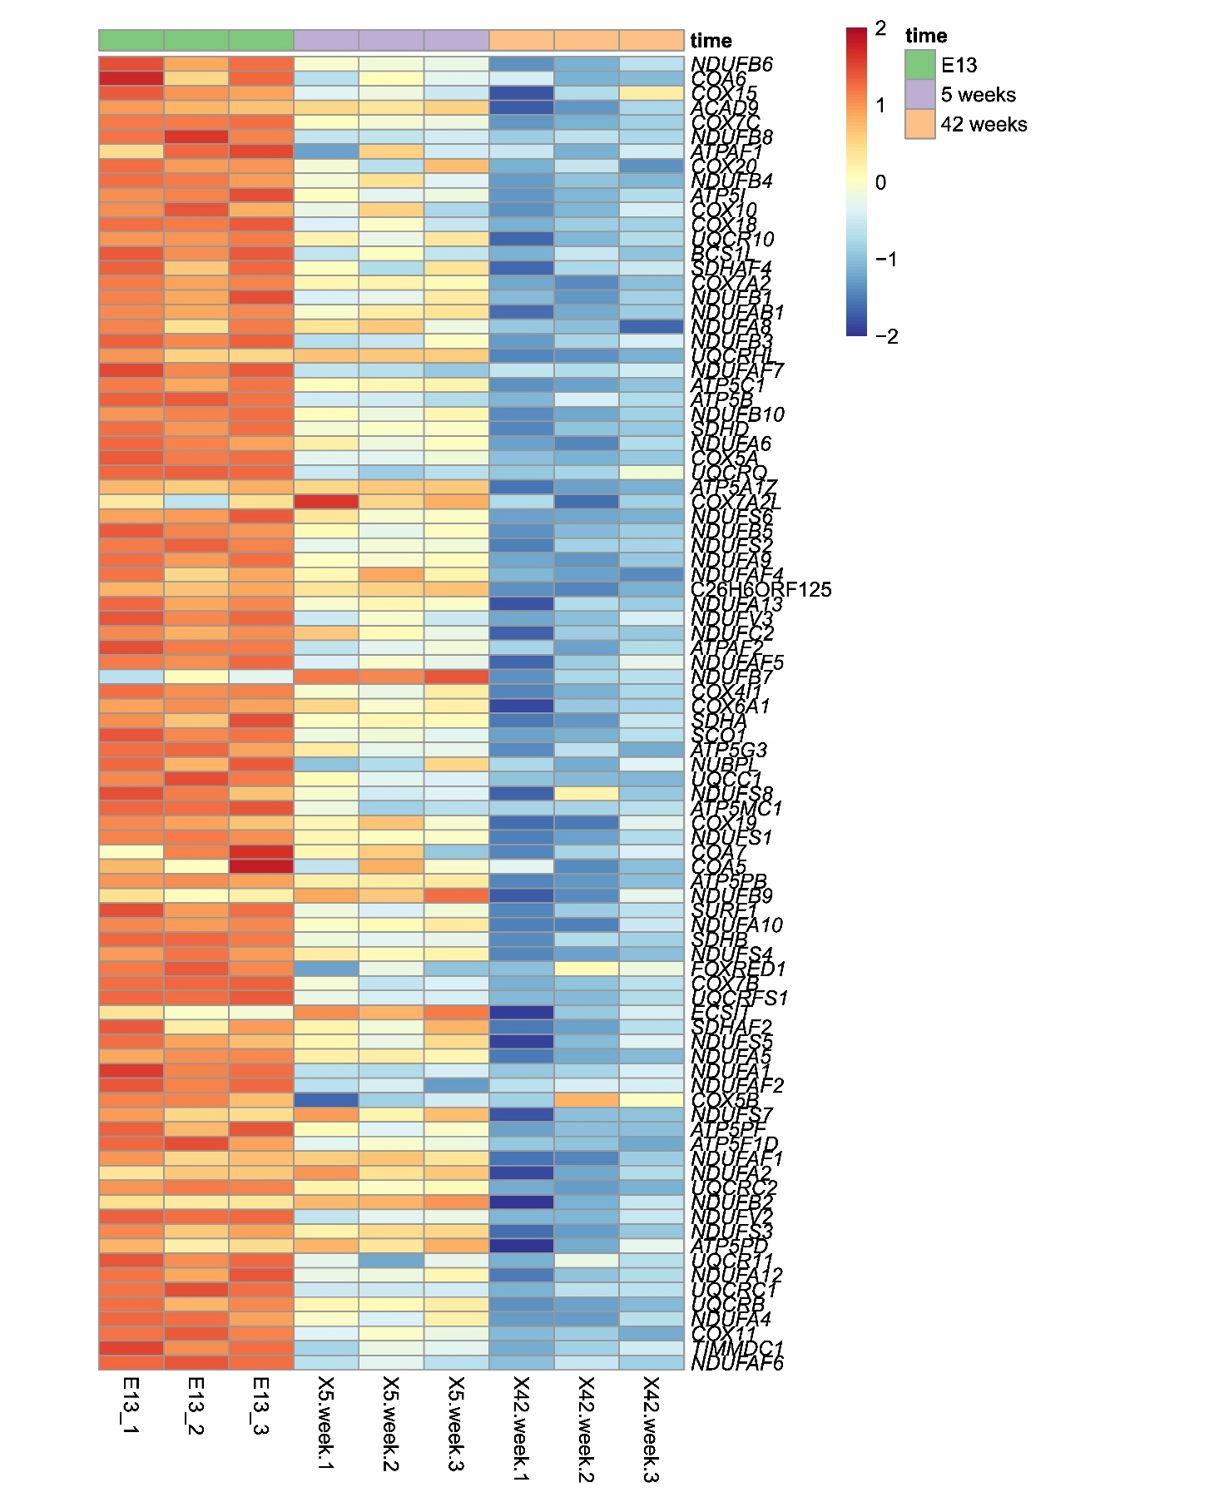
Figure S19. Chicken (Gallus gallus) liver samples collected 5 weeks and 42 weeks after birth have lower expression of nuclear OXPHOS genes as compared samples collected during embryo development (Dataset III). Color bar indicates the scaled expression: Red scale - elevated expression, blue scale: reduced expression. X axis: prenatal samples and postnatal samples (dataset III), Y axis: mtDNA genes. Horizontal barplots: green line indicates the prenatal stage (E13), purple line indicates 5 weeks postnatal stages, orange line indicates 42 weeks postnatal.

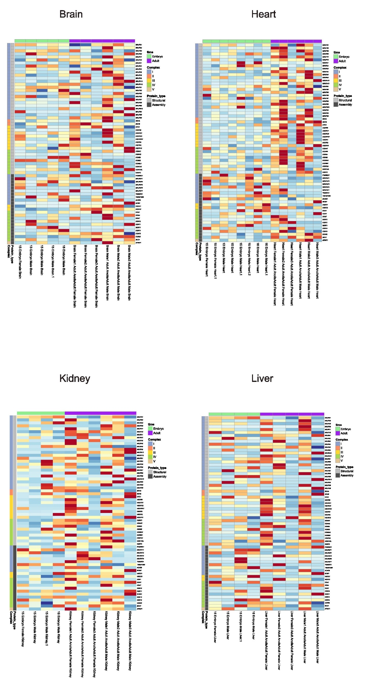
Figure S20. Heatmaps of nuclear OXPHOS gene expression from embryo and adult Anolis carolinensis samples from four organs (brain, heart, kidney, liver) (Dataset V). X-axis – analyzed samples; Y-axis – nuclear-DNA encoded OXPHOS genes. The color bar indicates the scaled expression: Red scale: elevated expression, blue scale: reduced expression.

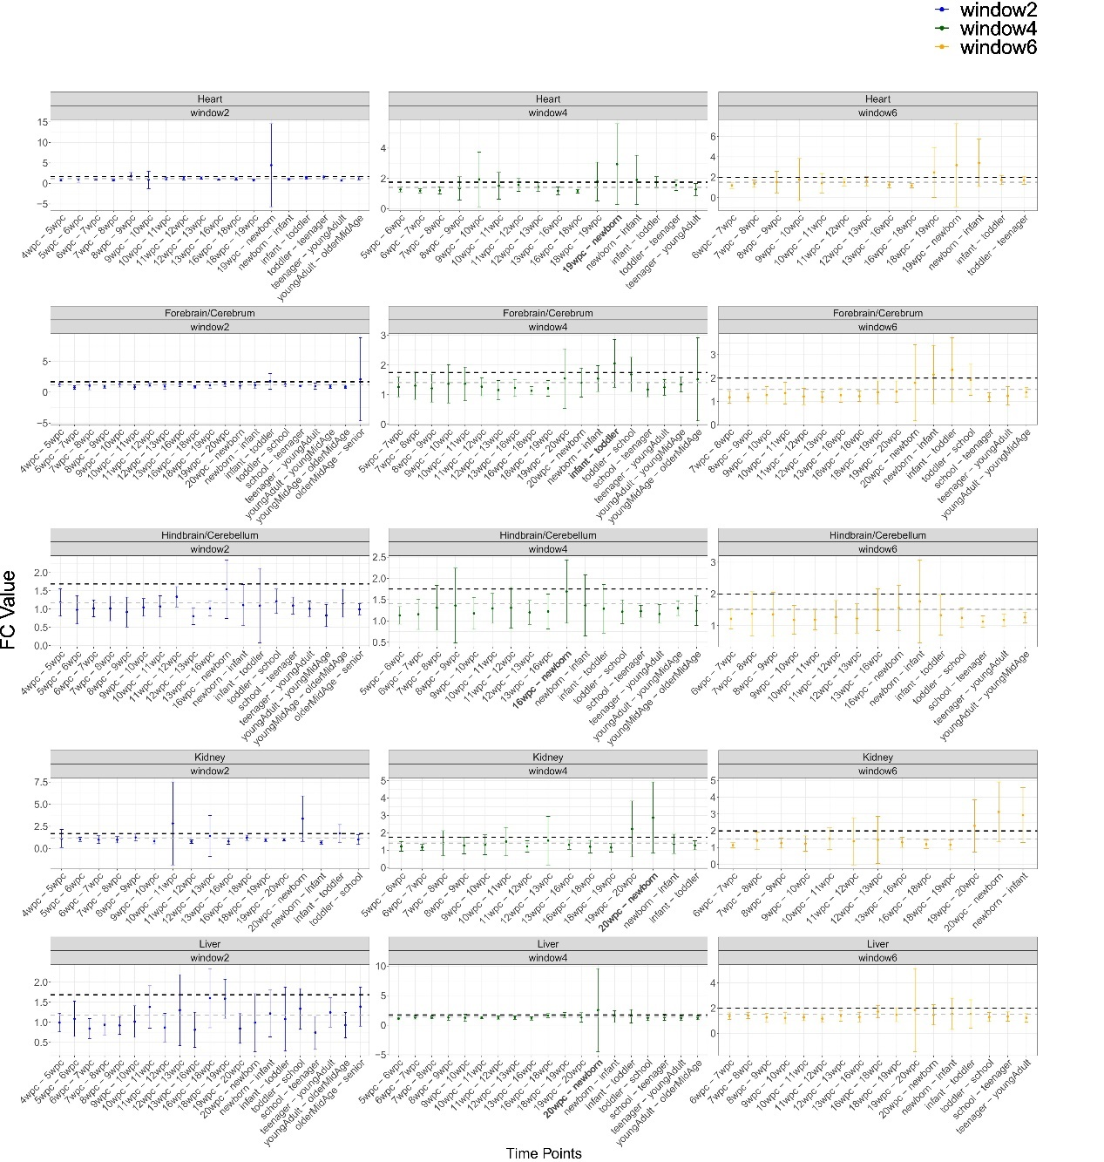
Figure S21. Fold-change (FC) values of gene expression of OXPHOS structural factors in five Homo spaiens tissues across developmental time points. X-axis - the developmental time points. Y-axis - the average FC values with standard deviation. Color code for each panel: sliding window sizes of w=2 (blue), w=4 (green), and w=6 (yellow). The highest FC values according to the w=4 analysis are highlighted in bold. Horisontal dashed grey line - average FC across the time points. Black dashed line – standard deviation above the average.

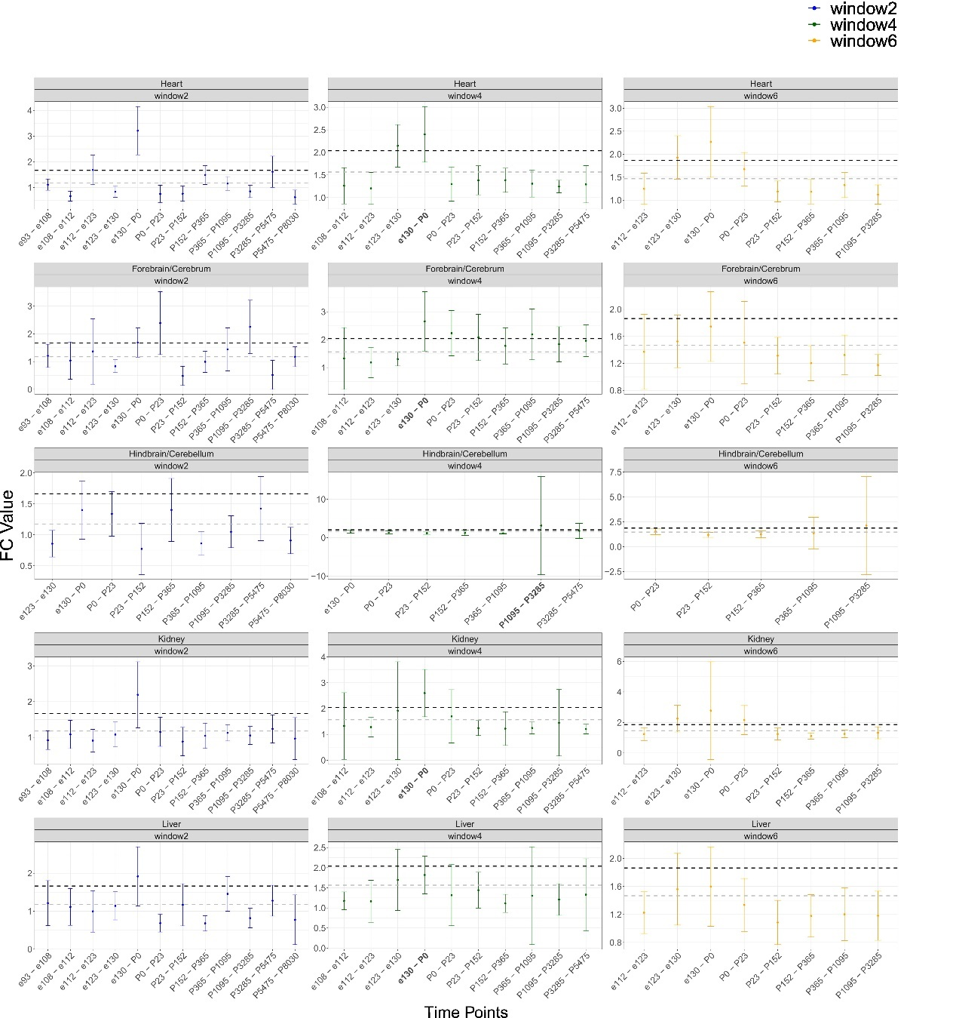
Figure S22. Fold-change (FC) values of gene expression of OXPHOS structural factors in five Macaca mullata tissues across developmental time points. X-axis - the developmental time points. Y-axis - the average FC values with standard deviation. Color code for each panel: sliding window sizes of w=2 (blue), w=4 (green), and w=6 (yellow). The highest FC values according to the w=4 analysis are highlighted in bold. Horisontal dashed grey line - average FC across the time points. Black dashed line – standard deviation above the average.

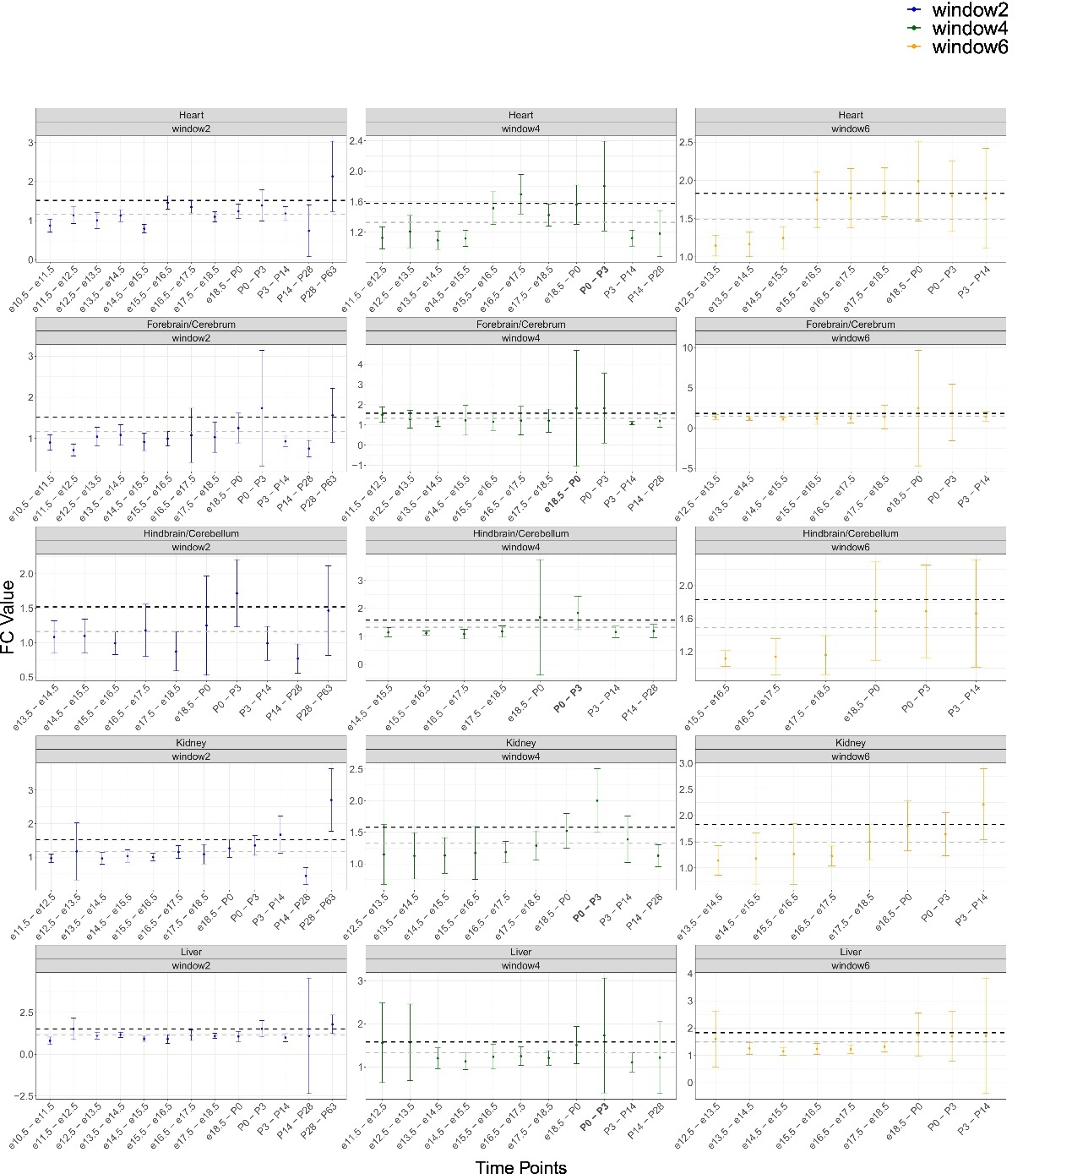
Figure S23. Fold-change (FC) values of of gene expression of OXPHOS structural factors in five Mus musculus tissues across developmental time points. X-axis - the developmental time points. Y-axis - the average FC values with standard deviation. Color code for each panel: sliding window sizes of w=2 (blue), w=4 (green), and w=6 (yellow). The highest FC values according to the w=4 analysis are highlighted in bold. Horisontal dashed grey line - average FC across the time points. Black dashed line – standard deviation above the average.

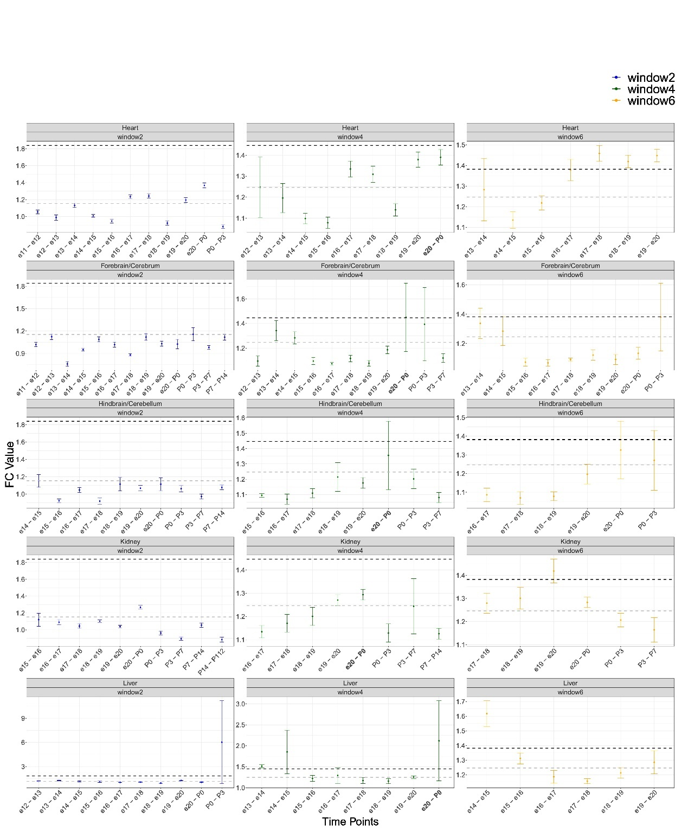
Figure S24. Fold-change (FC) values of of gene expression of OXPHOS structural factors in five Rattus norvegicus tissues across developmental time points. X-axis - the developmental time points. Y-axis - the average FC values with standard deviation. Color code for each panel: sliding window sizes of w=2 (blue), w=4 (green), and w=6 (yellow). The highest FC values according to the w=4 analysis are highlighted in bold. Horisontal dashed grey line - average FC across the time points. Black dashed line – standard deviation above the average.
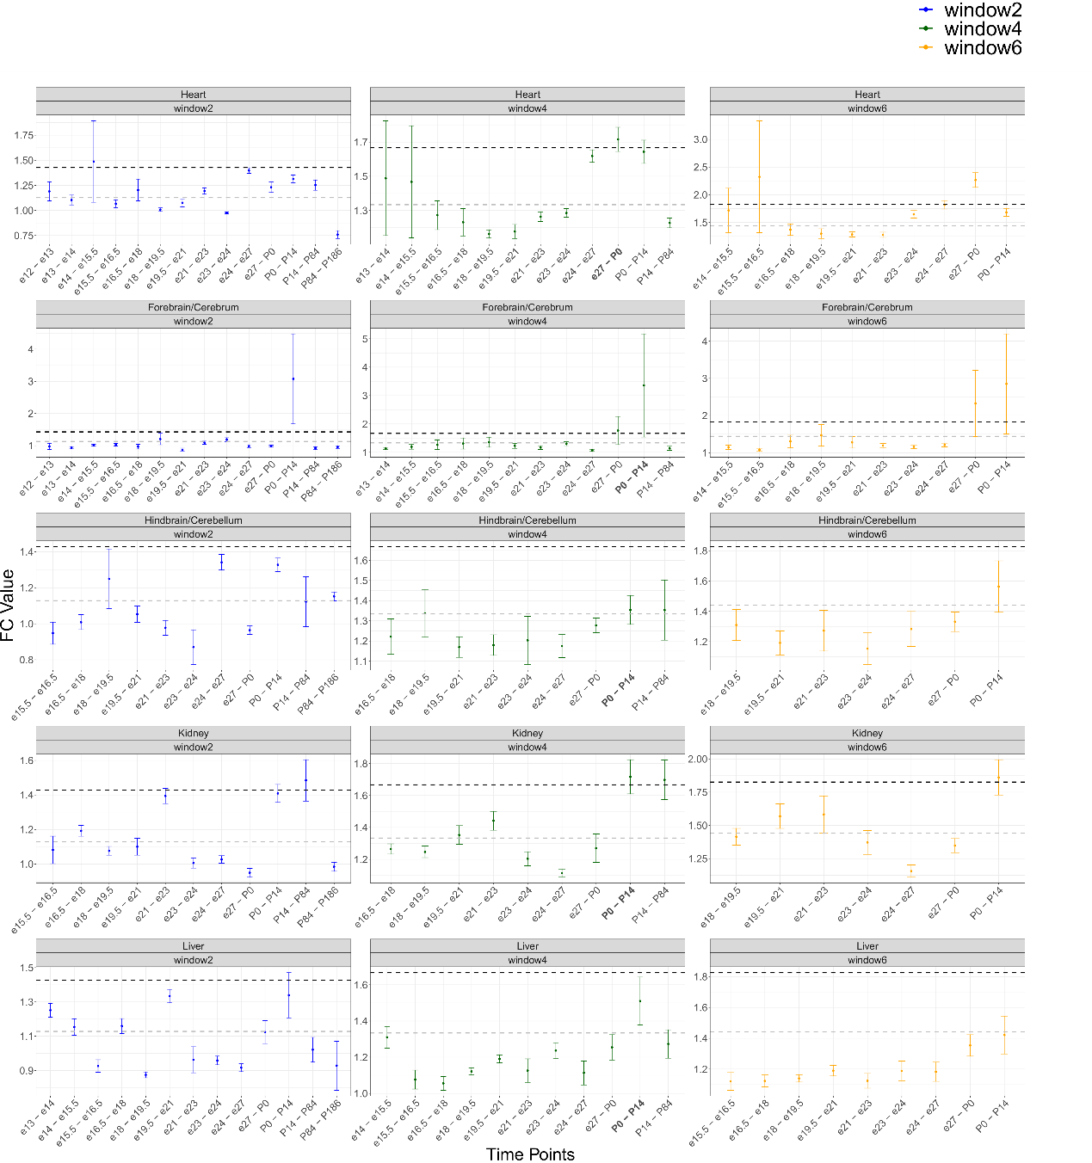
Figure S25. Fold-change (FC) values of of gene expression of OXPHOS structural factors in five Oryctolagus cuniculus tissues across developmental time points. X-axis - the developmental time points. Y-axis - the average FC values with standard deviation. Color code for each panel: sliding window sizes of w=2 (blue), w=4 (green), and w=6 (yellow). The highest FC values according to the w=4 analysis are highlighted in bold. Horisontal dashed grey line - average FC across the time points. Black dashed line – standard deviation above the average.
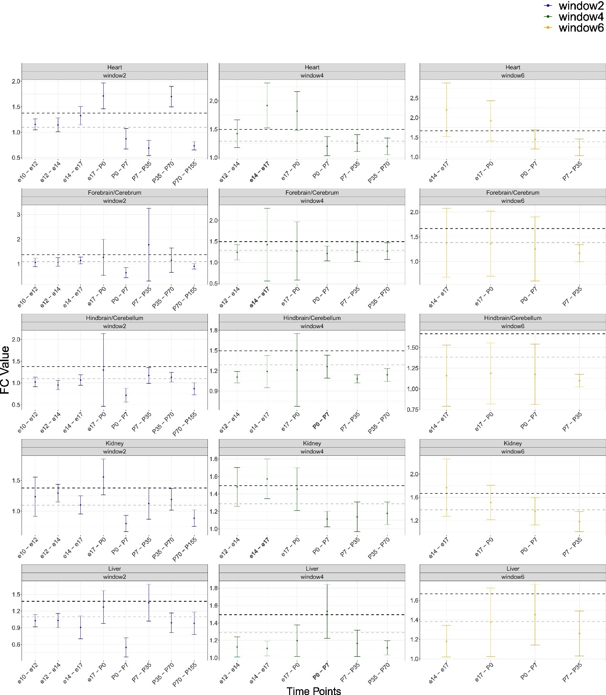
Figure S26. Fold-change (FC) values of of gene expression of OXPHOS structural factors in five Gallus gallus tissues across developmental time points. X-axis - the developmental time points. Y-axis - the average FC values with standard deviation. Color code for each panel: sliding window sizes of w=2 (blue), w=4 (green), and w=6 (yellow). The highest FC values according to the w=4 analysis are highlighted in bold. Horisontal dashed grey line - average FC across the time points. Black dashed line – standard deviation above the average.

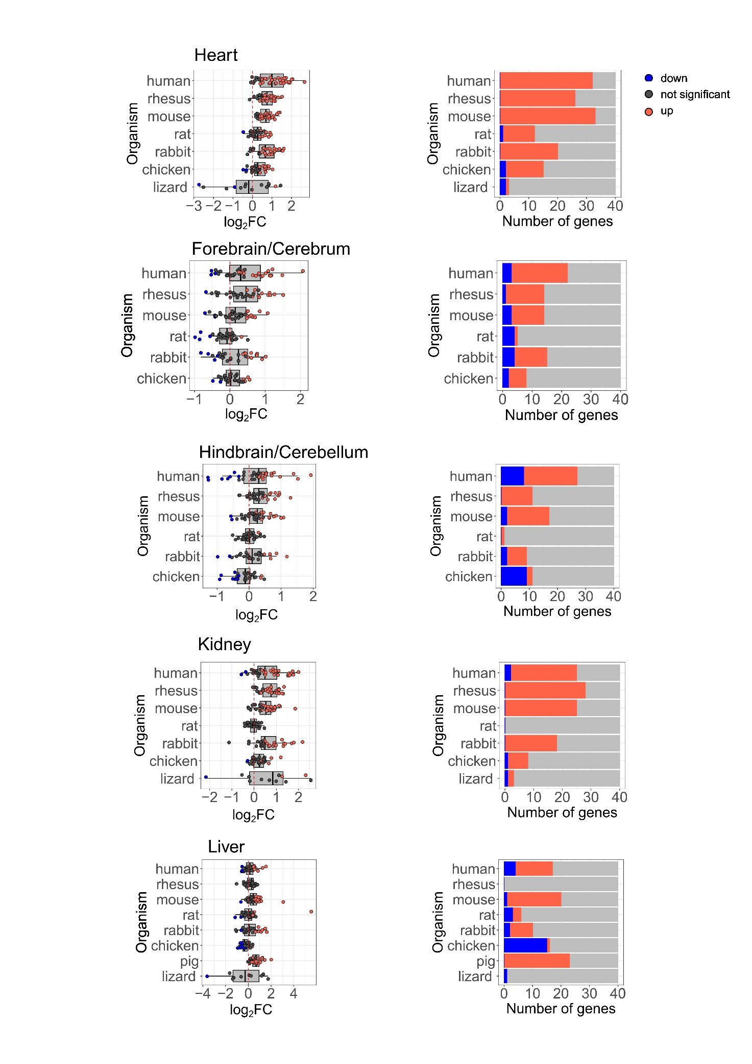
Figure S27. Expression of OXPHOS assembly factors display generally elevated gene expression in mammals and Gallus gallus. Left side panels: box plots indicating the log₂FC of nuclear DNA-encoded OXPHOS genes. X-axis: log₂FC. Y axis: the tested organisms. Color bar: blue dots- downregulation (log₂FC< -0.2, p-value<0.05), red dots- upregulation (log₂FC>0.2, p-value<0.05), black dots- non-significant. The dashed vertical red line displays the value of zero log₂FC on the X-axis (no change). Right side panels: bar plots represent the number of significant (indicated in red or blue) and non-significant (NS) nuclear OXPHOS genes expression (colored in grey). Blue: statistically significant genes with decreased expression between the time points (p<0.05); Red: number of genes with significantly increased expression. X-axis: Number of genes. Y axis: organisms.

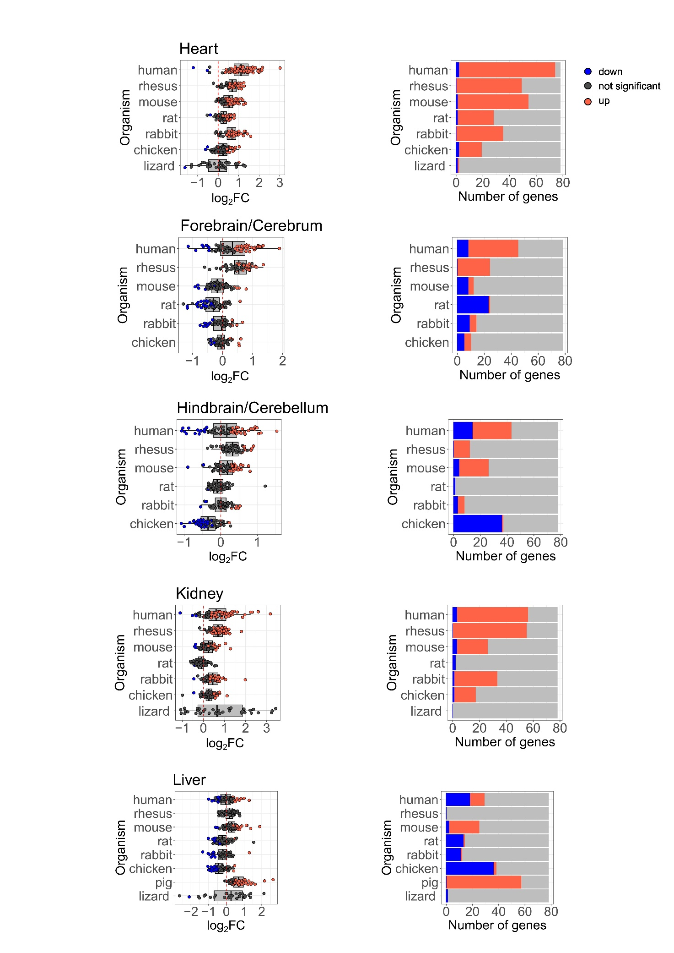
Figure S28. Mitochondrial ribosome nuclear DNA encoded genes show elevated gene expression in several tissues across vertebrates (Dataset I, Dataset II). Left side: box plots representing the log₂FC of mitochondrial ribosome genes. X-axis: log₂FC values, Y-axis: organisms. Color bar: blue: downregulated (log₂FC< -0.2, p-value<0.05), red: upregulated (log₂FC>0.2, p-value<0.05), black: non-significant. The dashed red line displays the value of zero log₂FC on the X-axis (no change). Right side: bar plots representing the number of significant (upregulated in red, downregulated in blue) or insignificant genes (in grey). X-axis: number of genes, Y-axis: organisms.

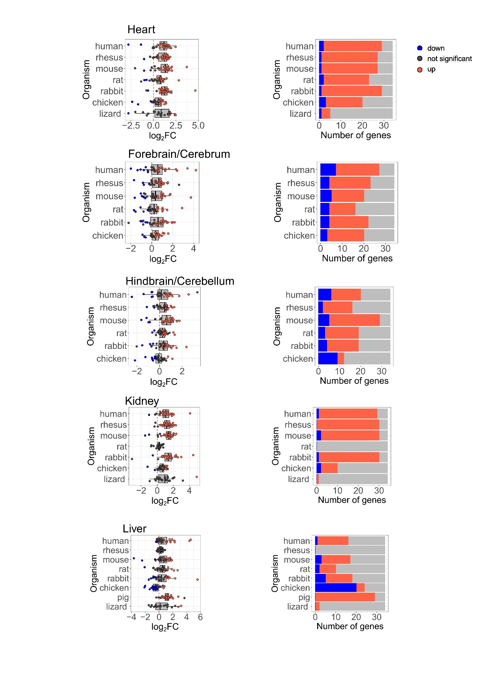
Figure S29. TCA genes display elevated gene expression in all tissues after birth across vertebrates, apart from Gallus gallus liver (Dataset I, Dataset II). left side panels: box plots representing the log₂FC of TCA genes. X axis: log₂FC values, Y axis: organisms. Color bar: blue: downregulated (log₂FC < -0.2, p-value<0.05), red: upregulated (log₂FC>0.2, p-value<0.05), black: non-significant. The dashed vertical red line displays the value of zero log₂FC on the X-axis (no change). Right side: bar plots representing the number of significant (upregulated in red, downregulated in blue) or insignificant genes (in grey). X axis: number of genes, Y axis: organisms.
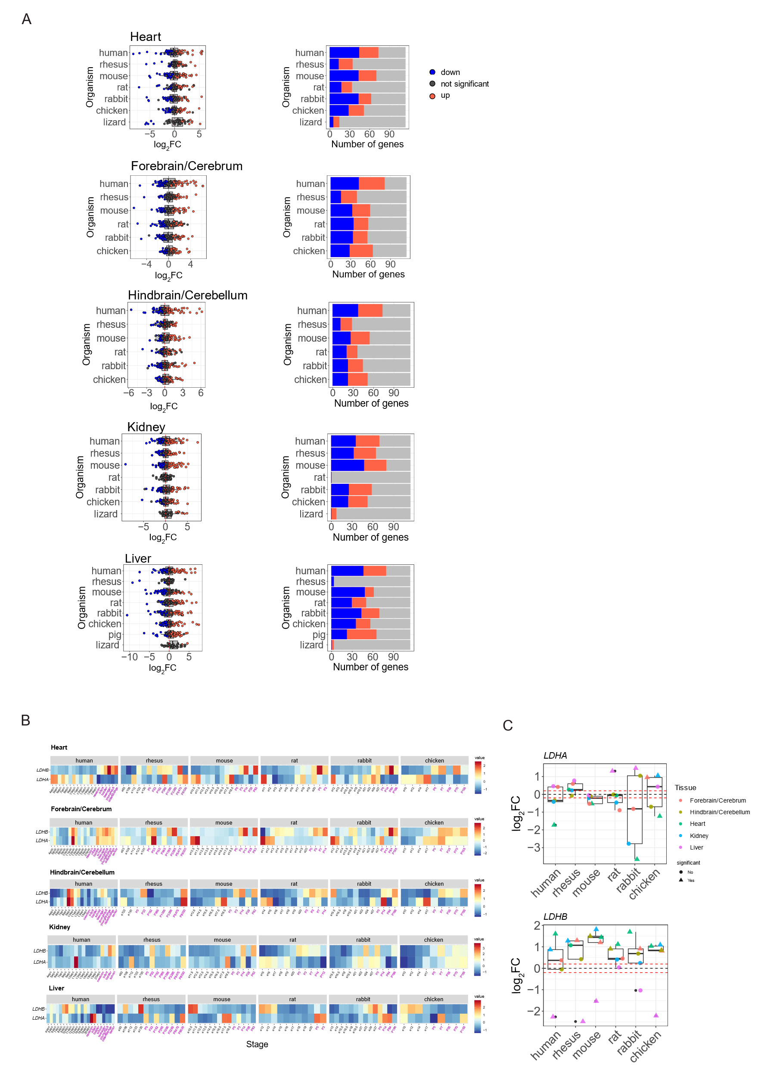
Figure S30. LDHB, but not the entire glycolysis pathway, show significant change in expression after birth (Dataset I, Dataset II). (A) Left side panels: box plots representing the log₂FC of glycolysis genes. X axis: log₂FC values, Y axis: organisms. Color bar: blue: downregulated (log₂FC< -0.2, p-value<0.05), red: upregulated (log₂FC>0.2, p-value<0.05), black: non-significant. Dashed vertical red line displayד the value of zero log₂FC on x axis (e.g., no change). Right side panels: bar plots representing the number of significant (upregulated in red, downregulated in blue) or insignificant genes (in grey). X axis: number of genes, Y axis: organisms. (B) Heatmaps showing LDHA and LDHB gene expression across vertebrates and across tissues. X axis: developmental stage, Y axis: genes. Prenatal stages are colored black, and postnatal stages are colored purple. (C) Box plots showing the log₂FC of LDHA and LDHB in each of the organisms and tissues. Color of dots represent tissue type, and shape indicates the statistical significance in the following manner: circle - non-significant, triangular - significant (p-value<0.05). Horizontal dashed red lines indicating 0.2 and -0.2 log₂FC values, respectively.
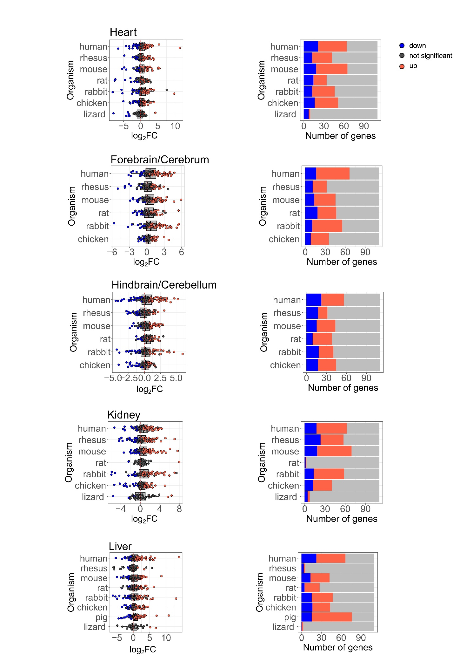
Figure S31. ROS genes did not show elevation of gene expression after birth (Dataset I, Dataset II). (A) left side: box plots representing the log₂FC of ROS genes. X axis: log₂FC values, Y axis: organisms. Color bar: blue: downregulated (log₂FC< -0.2, p-value<0.05), red: upregulated (log₂FC>0.2, p-value<0.05), black: non-significant. Dashed red line display the value of zero log₂FC on x axis (no change). Right side: bar plots representing the number of significant (upregulated in red, downregulated in blue) or insignificant genes (in grey). X axis: number of genes, Y axis: organisms. (B) Bar plots representing the number of significant (upregulated in red, downregulated in blue) or insignificant genes (in white). X axis: organisms and stage of division, Y axis: number of genes.

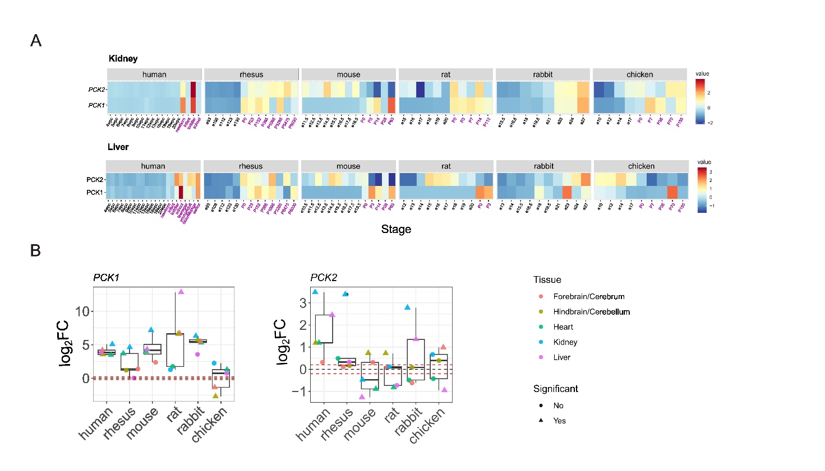
Figure S32. PCK1 expression is elevated after birth in mammalian tissues, but not after hatching in Gallus gallus. (A) Heatmaps showing PCK1 and PCK2 gene expression across vertebrates and across tissues. X axis: developmental stage, Y axis: genes. (B) box plots showing the log₂FC of PCK1 and PCK2 in each of the organisms and tissues. Dots colors representing tissue type, shape indicating the statistical significance: circle: non-significant, triangular: significant (p-value<0.05). Horizontal dashed red lines indicating 0.2 and -0.2 log₂FC values, respectively.
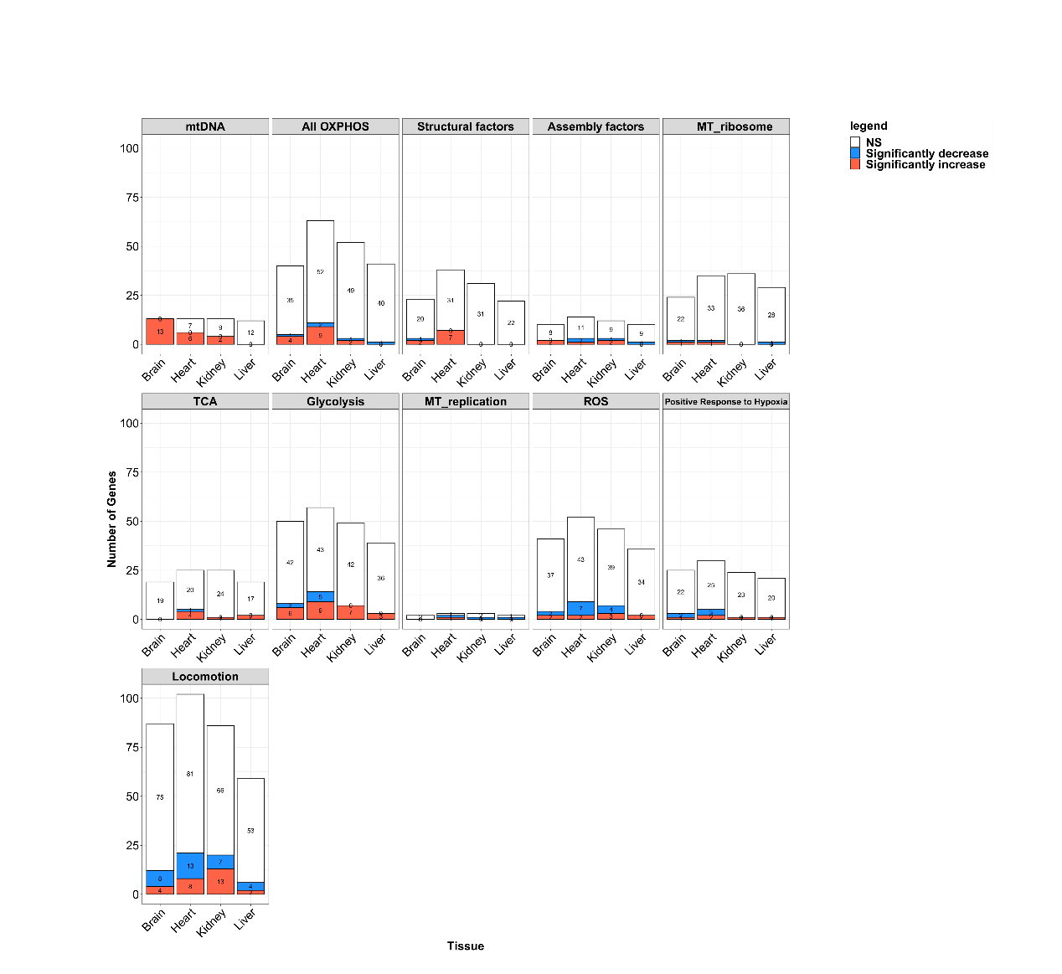
Figure S33. Number of significant genes per pathway for each of the tissues in Anolis carolinensis. Bar plots representing the number of the significant genes (upregulated in red, downregulated in blue) or insignificant genes (in white). X axis: organisms and stage of division, Y axis: number of genes.

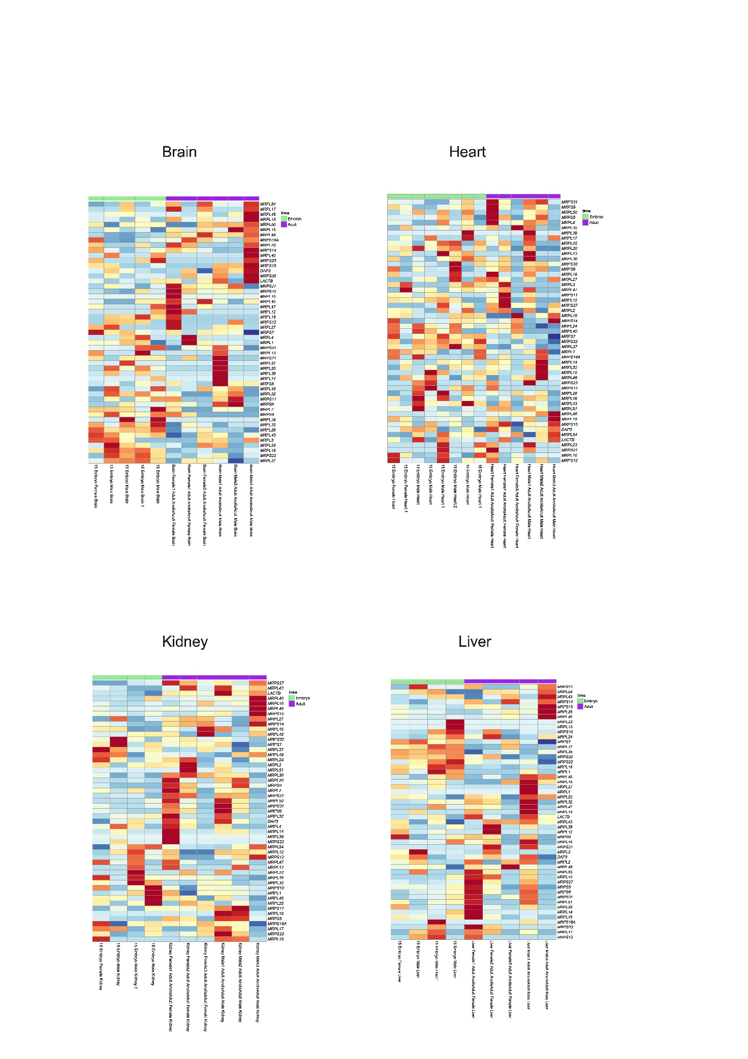
Figure S34. Anolis carolinensis mitochondrial ribosome pathway analysis did not show any significant change in expression. Heatmaps displaying mitochondrial ribosome gene expression from embryo and adult samples of Anolis carolinensis from four organs (brain, heart, kidney, liver) (Dataset V). Red: high expression, blue – low expression. Legend: pink: females, blue: males; green: embryo samples, purple: adult samples.

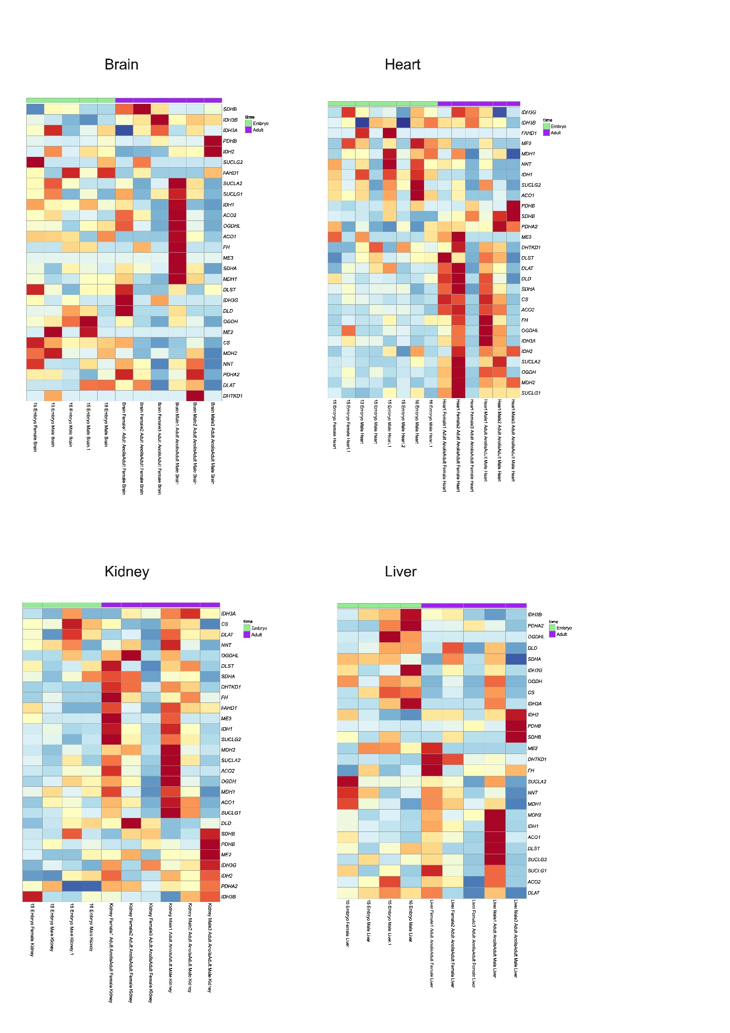
Figure S35. Anolis carolinensis TCA enzymes show a weakly significant postnatal expression change in the heart and kidney. Heatmaps displaying TCA gene expression from embryo and adult samples of Anolis carolinensis from four organs (brain, heart, kidney, liver) (Dataset V). Red: high expression, blue – low expression. Legend: pink: females, blue: males; green: embryo samples, purple: adult samples.

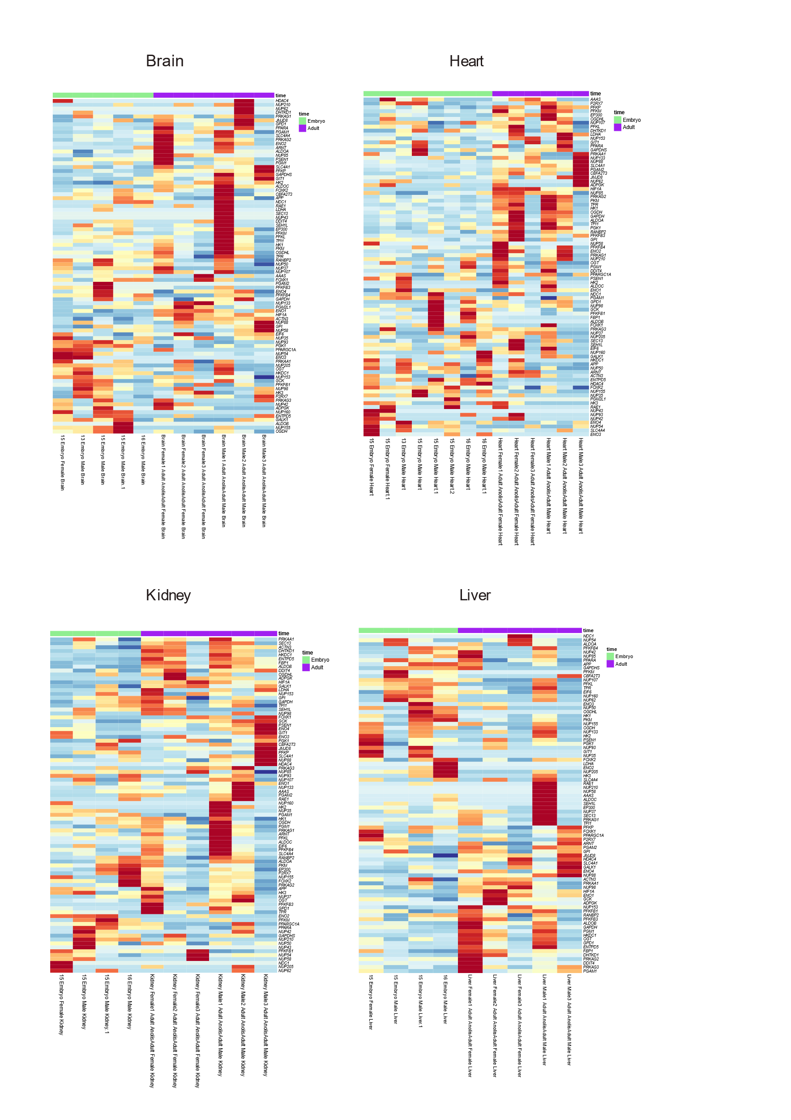
Figure S36. Glycolysis pathway analysis in Anolis carolinensis did not show any significant change in expression after birth. Heatmaps displaying Glycolysis gene expression from embryo and adult samples of Anolis carolinensis from four organs (brain, heart, kidney, liver) (Dataset V). Red: high expression, blue – low expression. Legend: pink: females, blue: males; green: embryo samples, purple: adult samples.
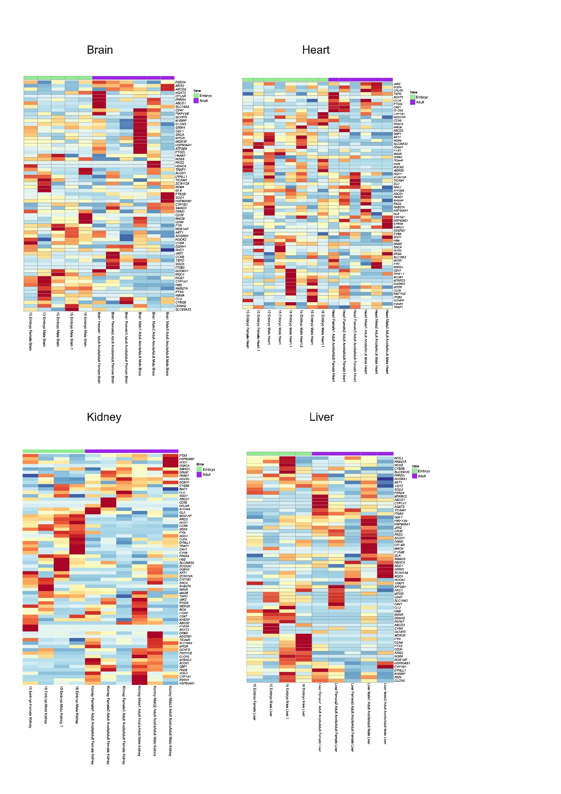
Figure S37. ROS pathway analysis in Anolis carolinensis did not show any significant change in expression after birth. Heatmaps displaying ROS gene expression from embryo and adult samples of Anolis carolinensis from four organs (brain, heart, kidney, liver) (Dataset V). Red: high expression, blue – low expression. Legend: pink: females, blue: males; green: embryo samples, purple: adult samples.

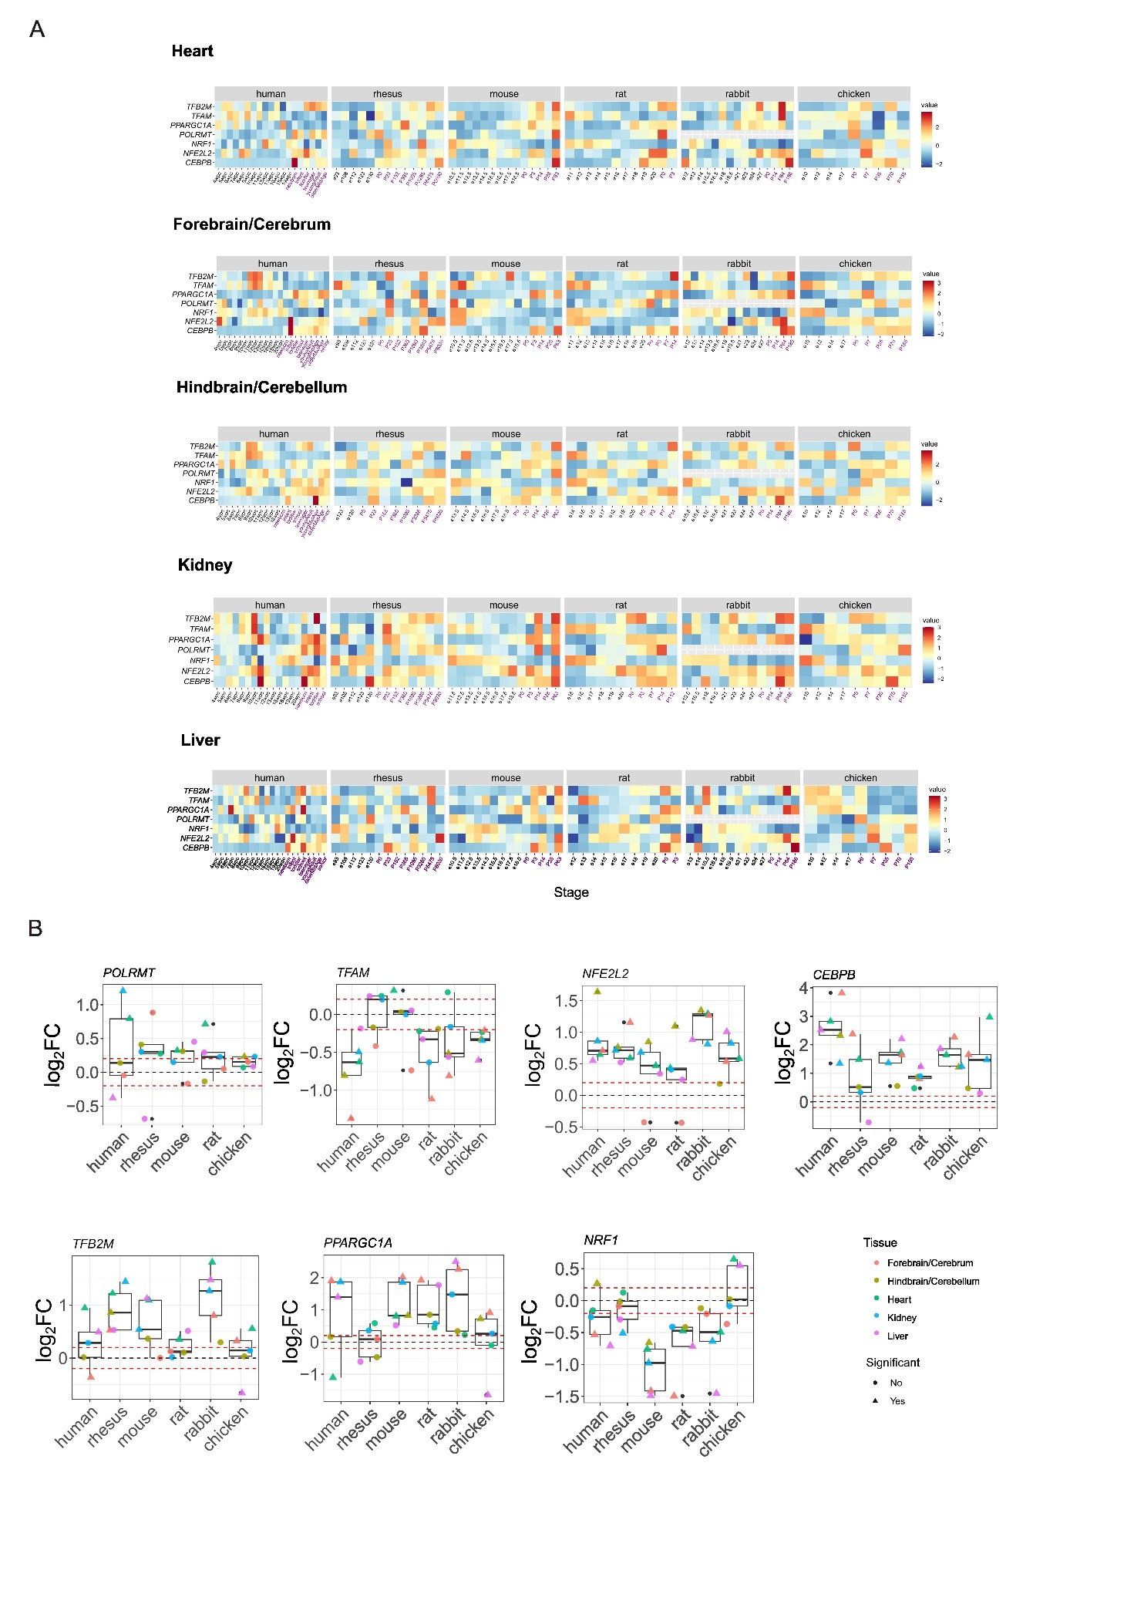
Figure S38 – Regulatory factors gene expression altered after birth. (A) Heatmaps showing expression patterns of TFAM, POLRMT, NFE2L2, C/EBPB, PPARGC1A (PGC1a), NRF1, and TFB2M across vertebrates and across tissues. X-axis: samples collected prenatal (black) or after birth (purple); Y axis: genes analyzed. (B) Box plots showing the log₂FC of all mentioned regulatory factors in (A) in each of the tested organisms and tissues. Notably, there was no clear annotation for rabbit POLRMT, and therefore it was not included in the analysis. Dots’ colors represent tissue type as indicated, shape indicates the statistical significance, as follows: circle - non-significant; triangular - significant (p-value<0.05). Horizontal dashed red lines indicate 0.2 and -0.2 log₂FC values, respectively.

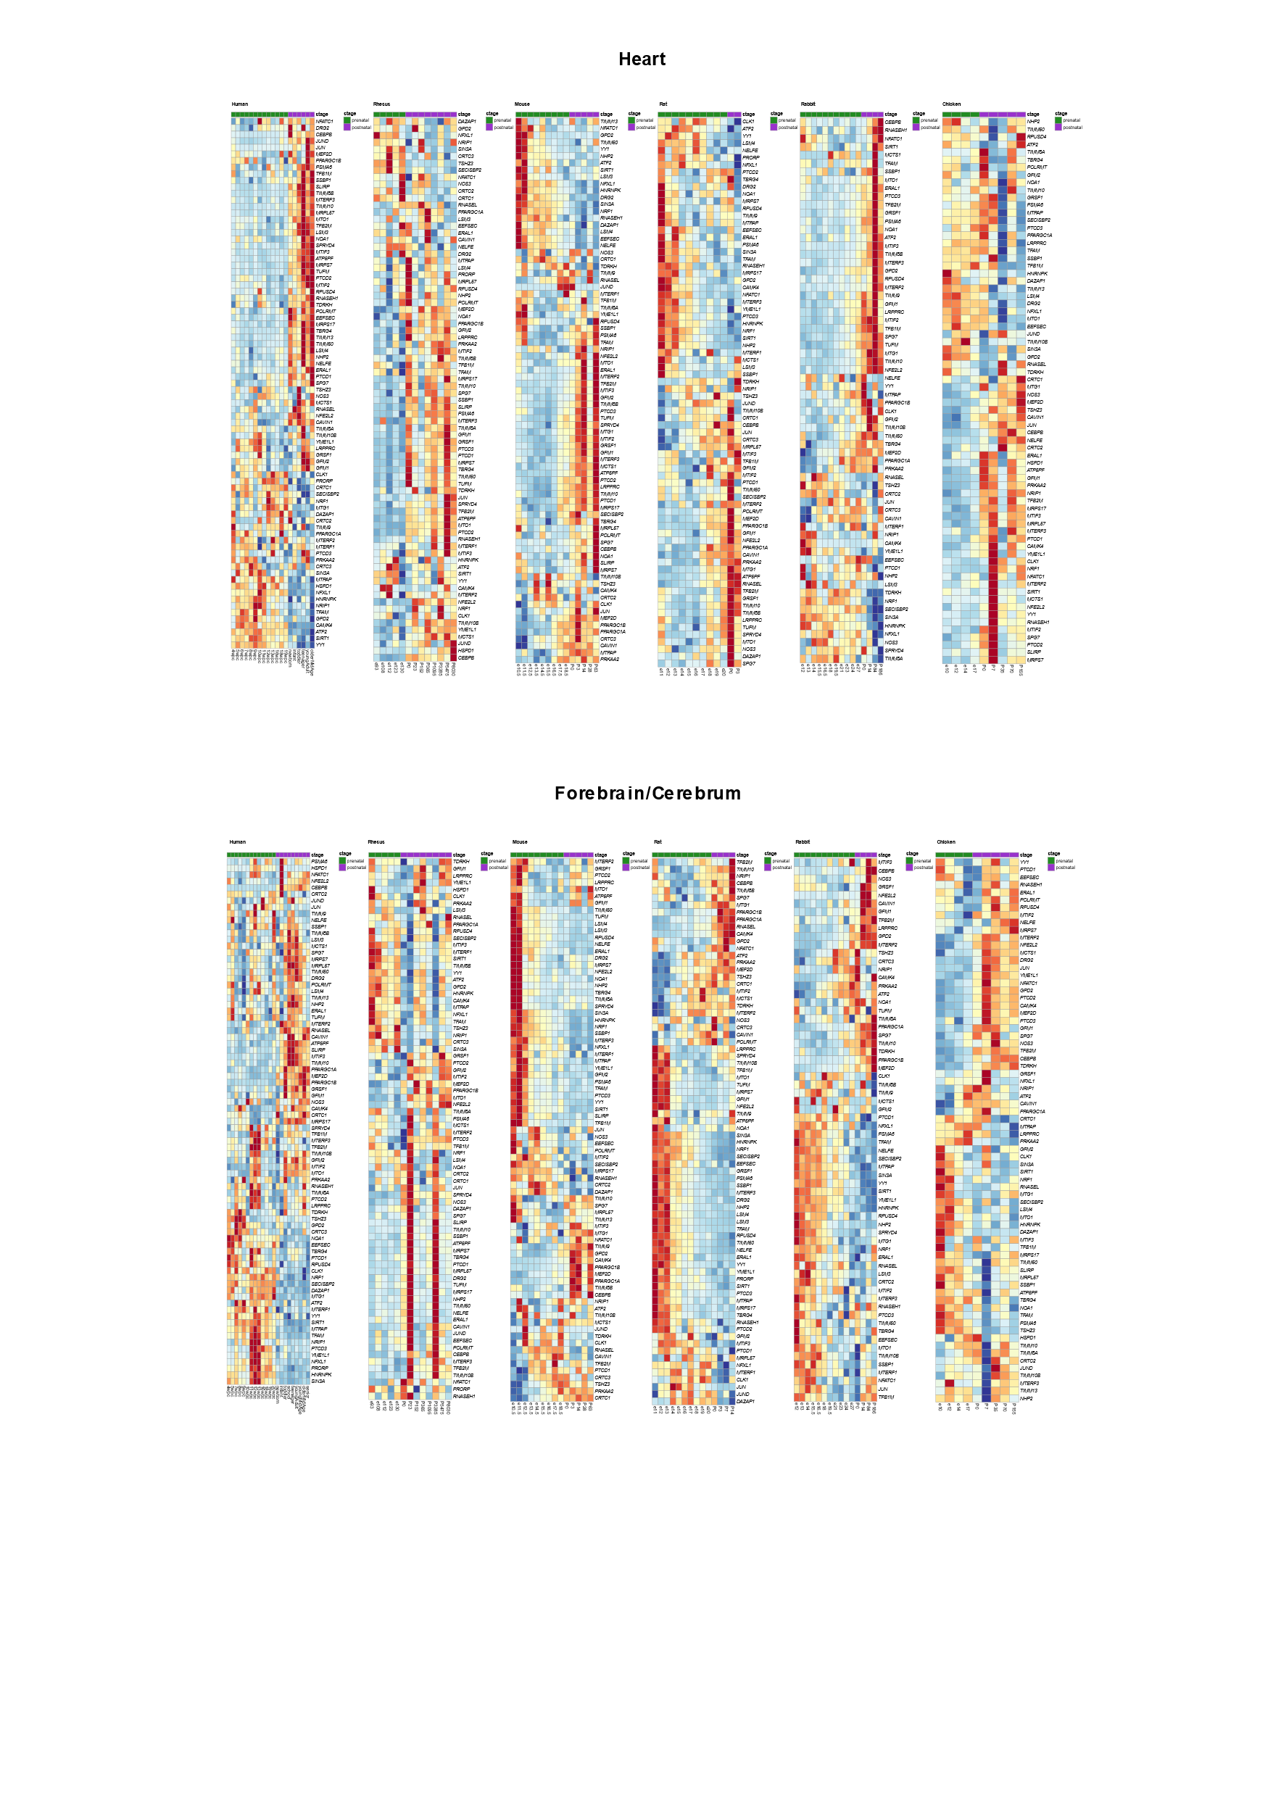
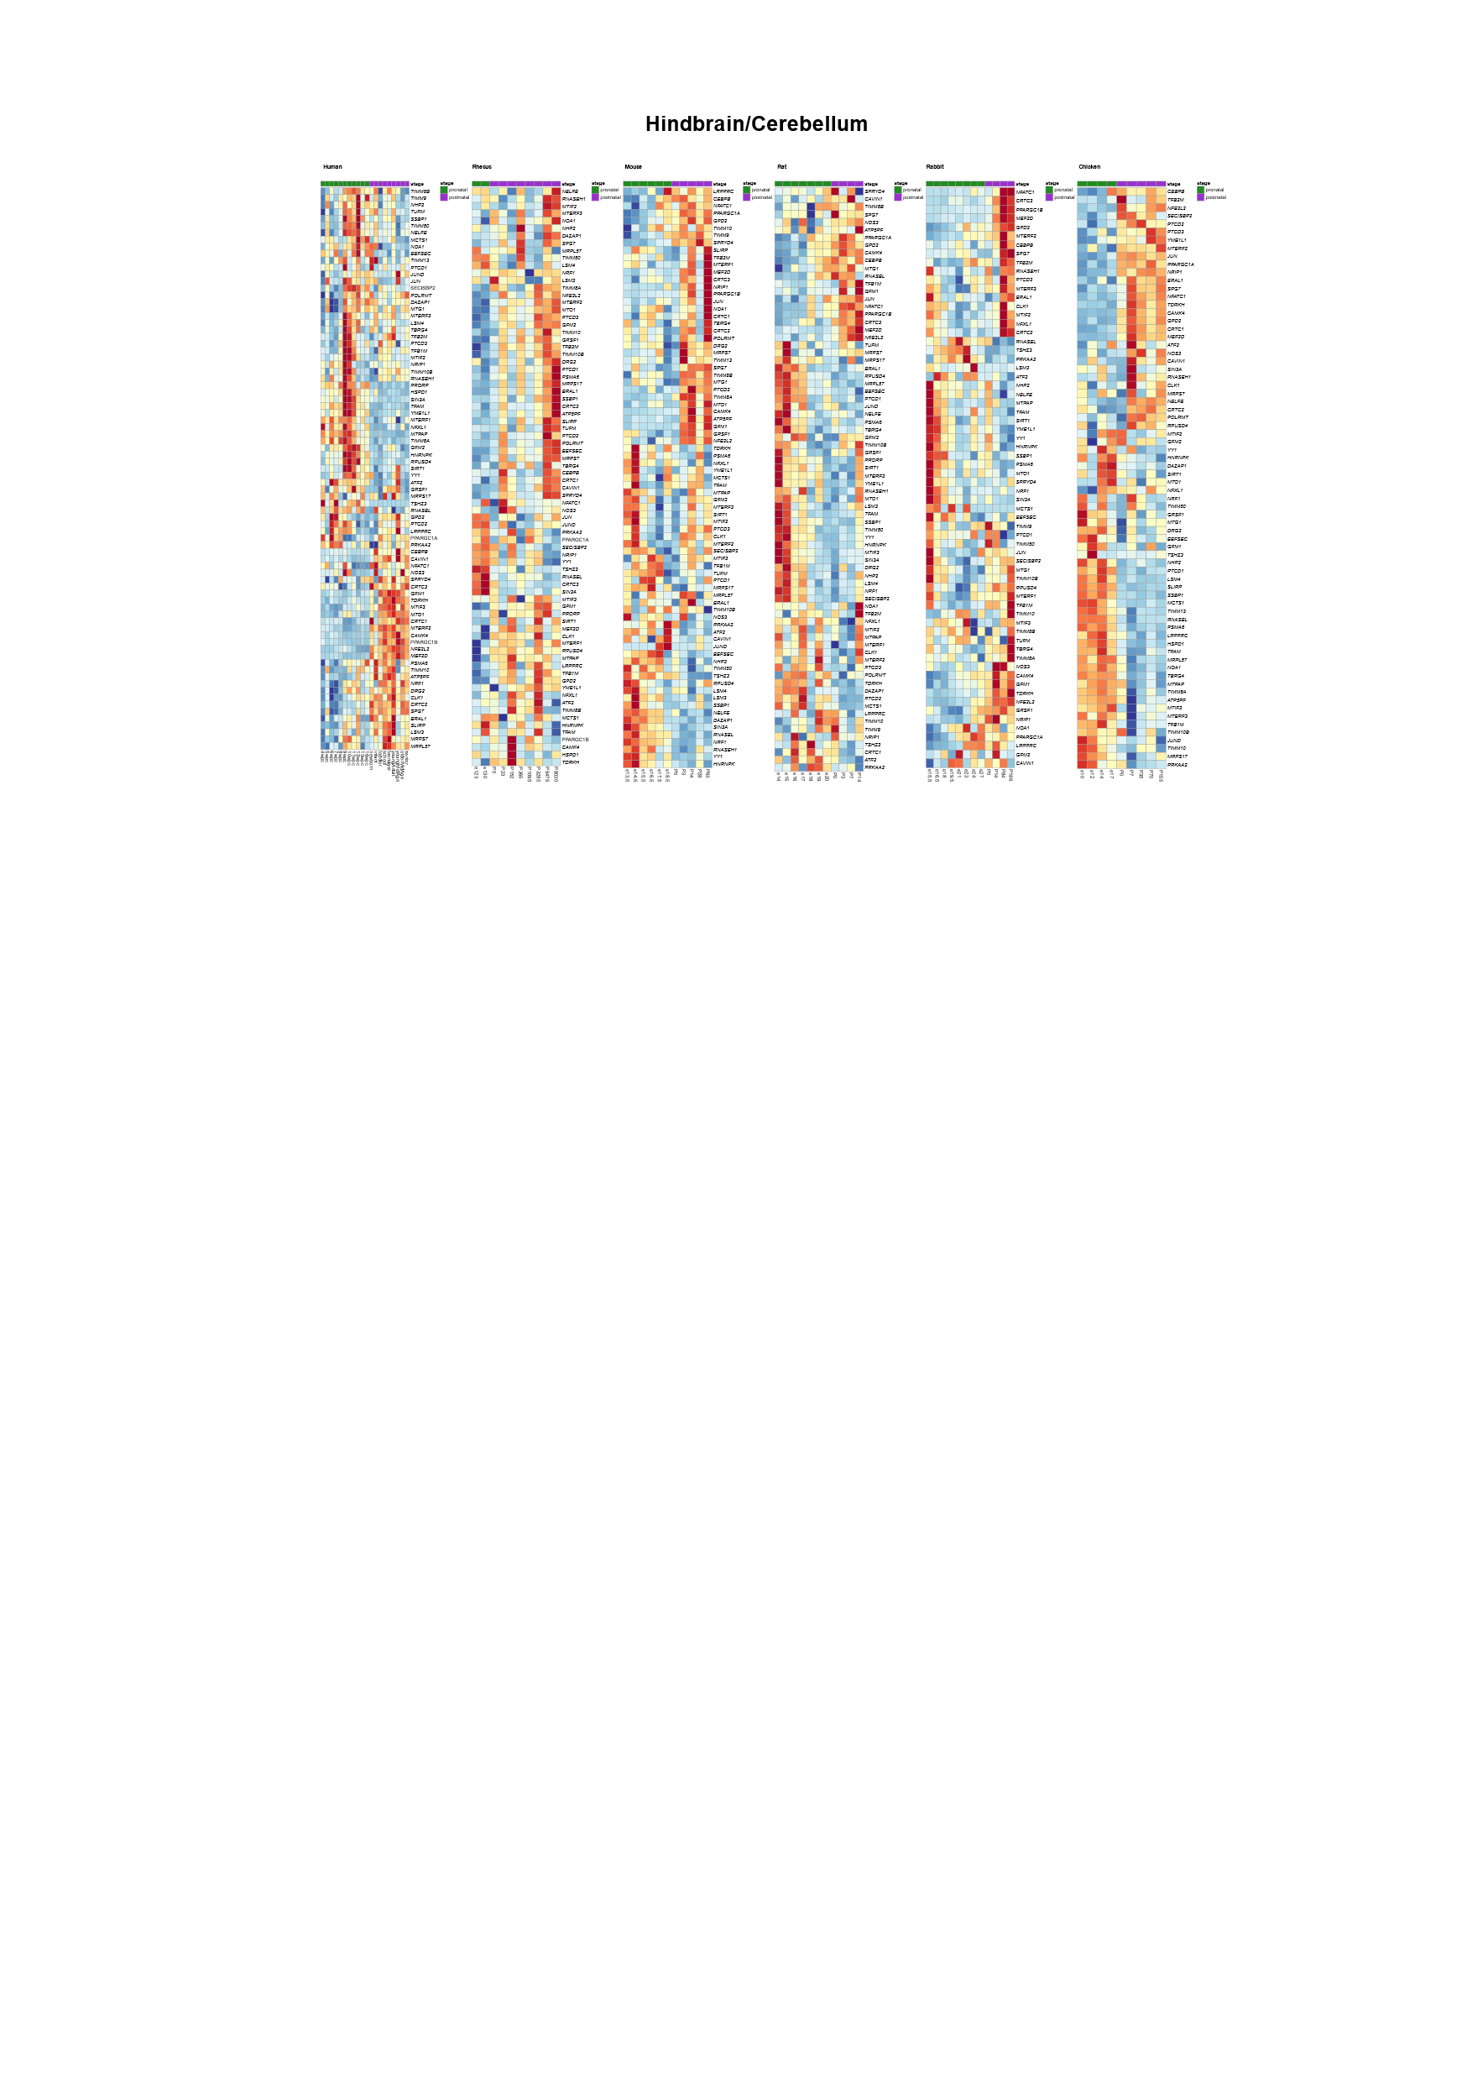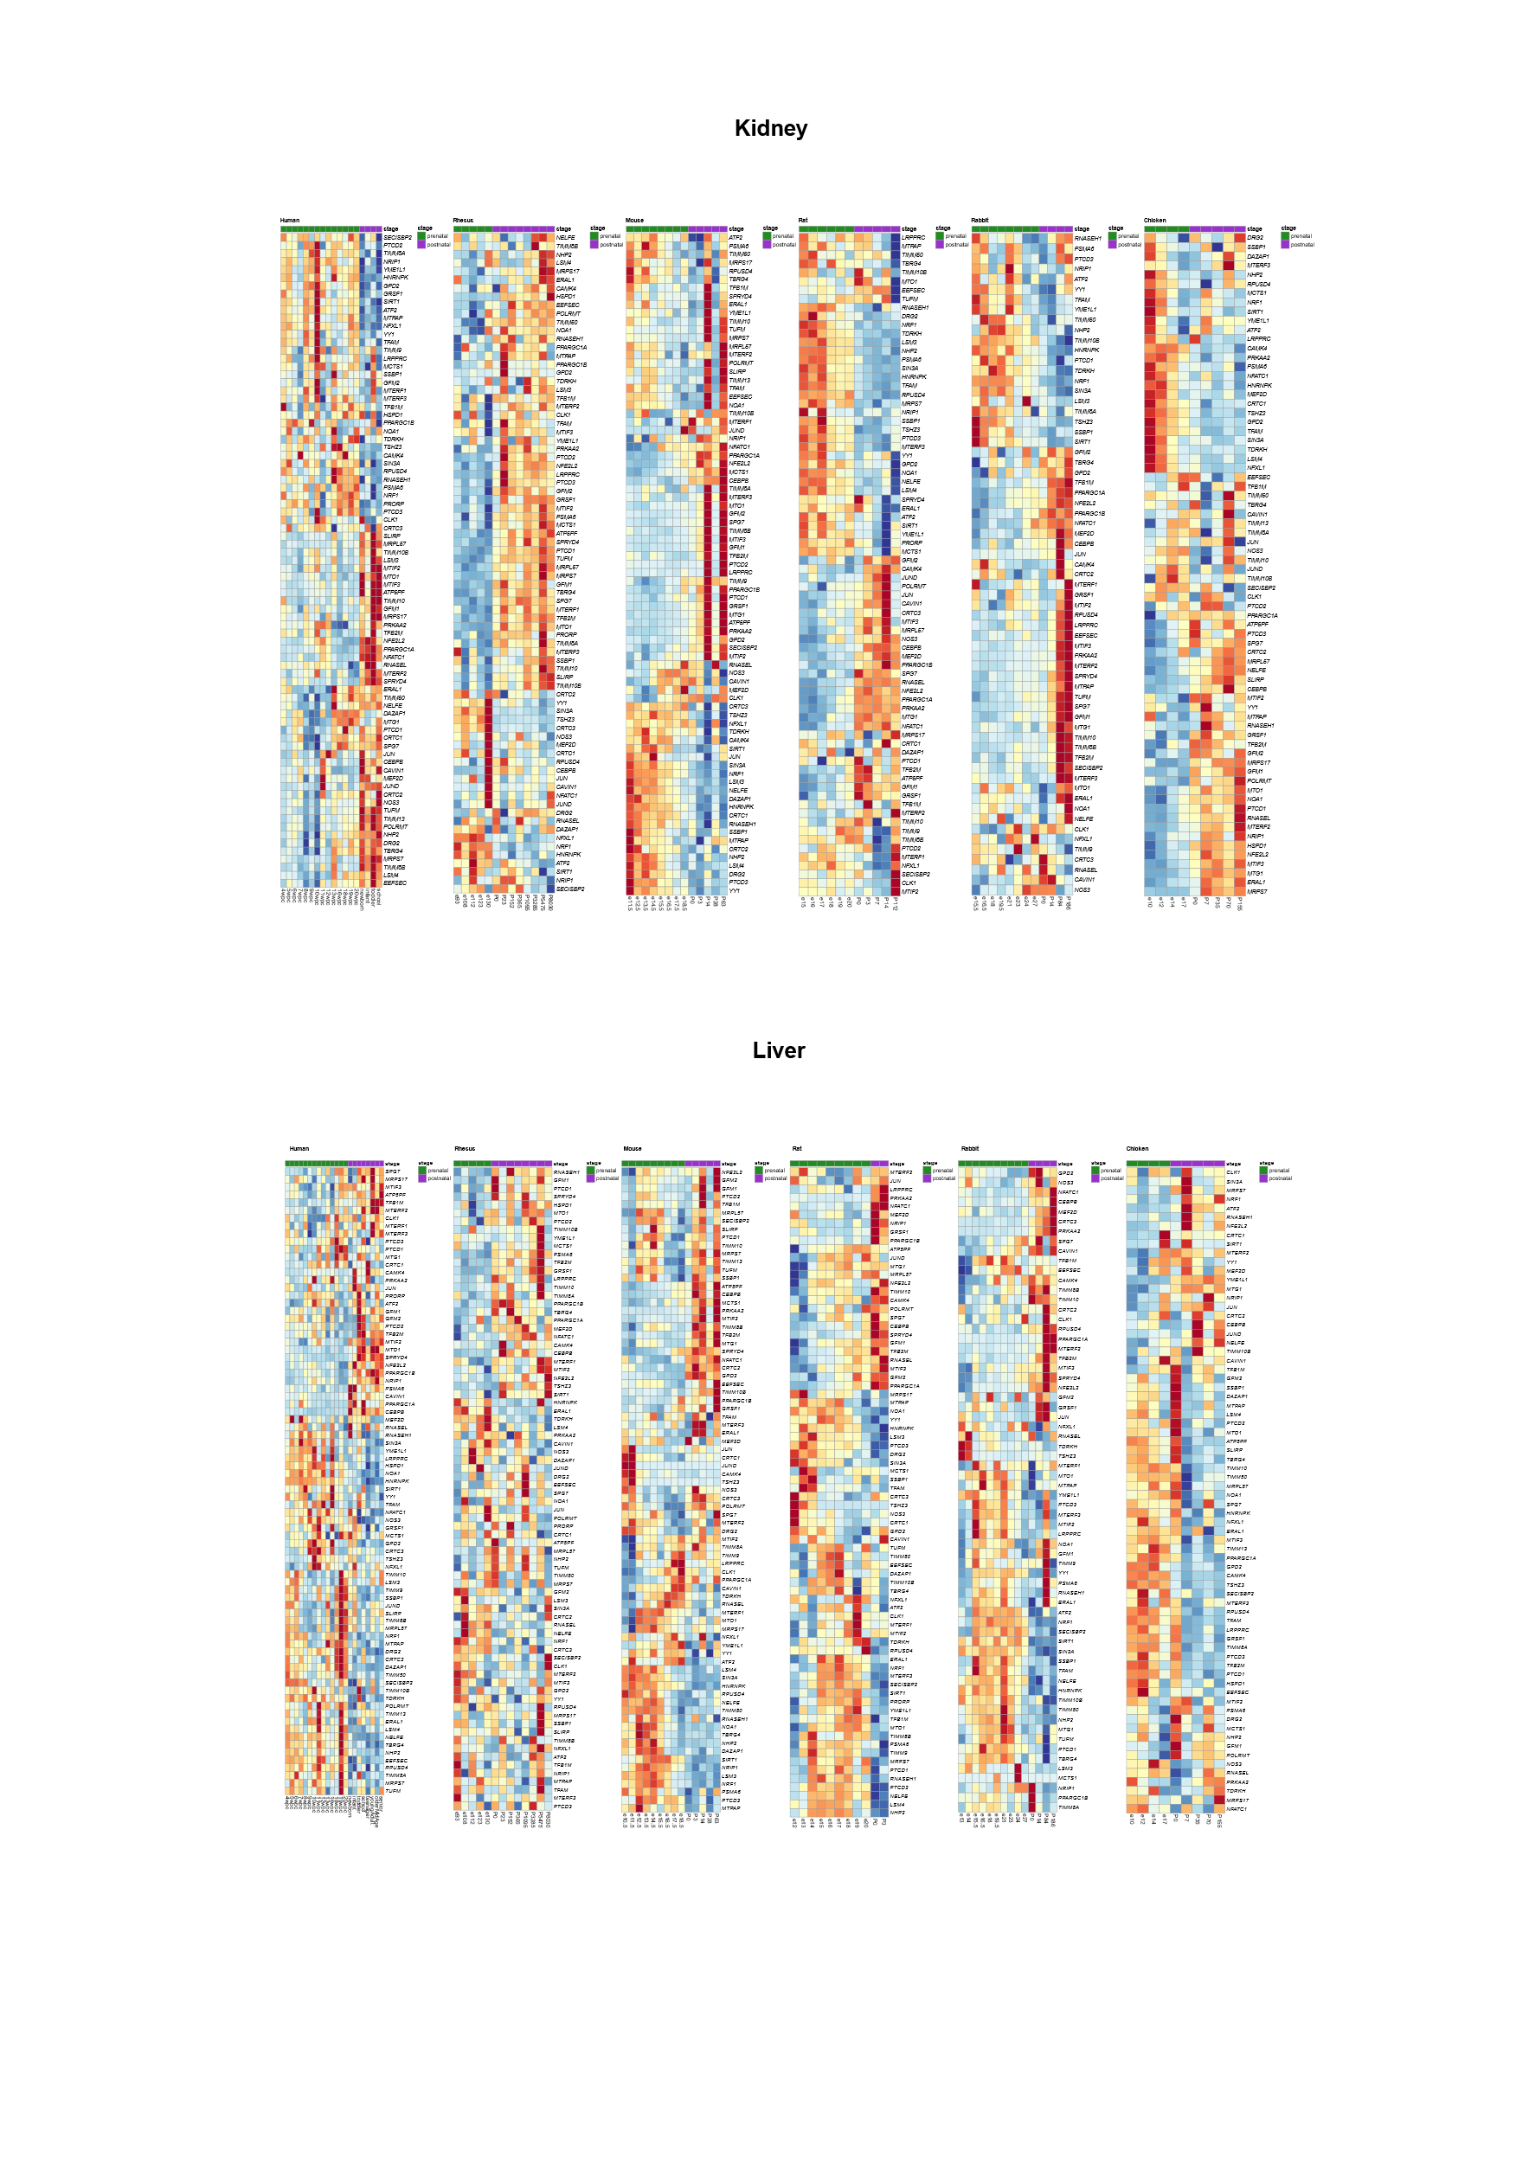

Figure S39. Changes in the expression of all tested mitochondrial regulatory factors and genes related to mitochondrial biogenesis after birth. Heatmaps presenting normalized expression levels of all known mitochondrial regulatory factors (transcription, post-transcription, and mitochondrial biogenesis) in six tissues from five mammals (six mammals in liver) and a non-mammalian vertebrate (chicken). Color bar: Red scale - elevated expression, blue scale: reduced expression. For each developmental stage the median expression of the relevant samples was used for calculation (Dataset I). Above each panel -horizontal green and purple bars span prenatal and postnatal samples, respectively. X axis: developmental stages. Y axis: genes.
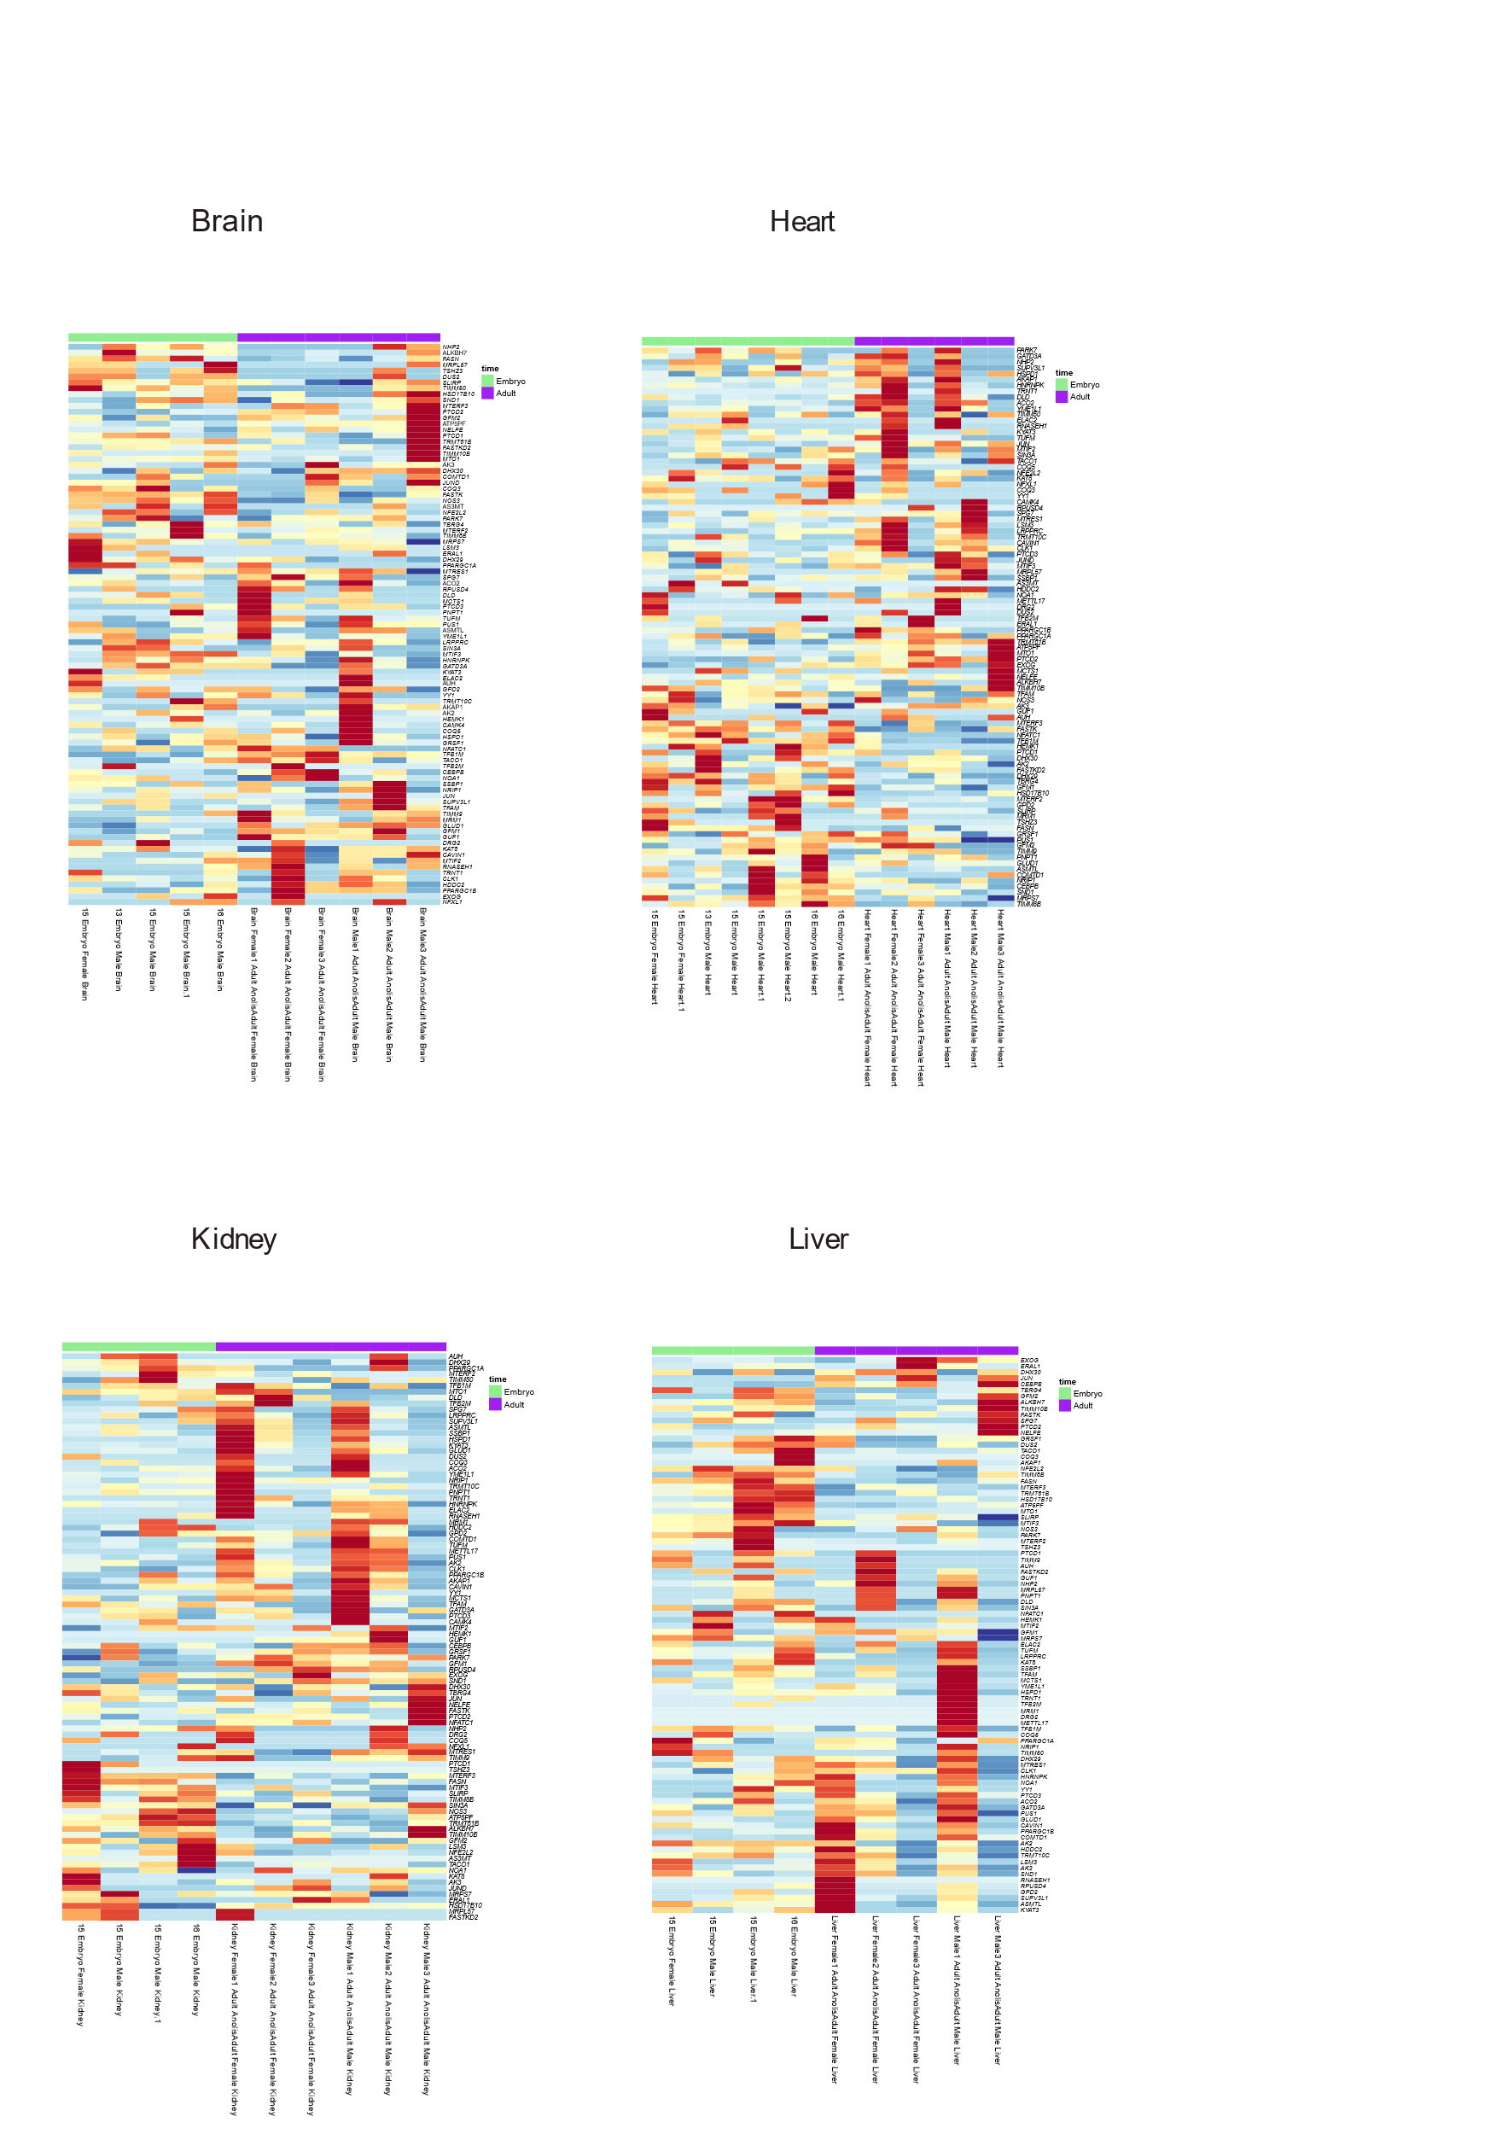
Figure S40. Analysis of mitochondrial regulatory gene expression in Anolis carolinensis in adults compared to embryos. Heatmaps displaying mitochondrial regulatory factors gene expression from embryo and adult samples of Anolis carolinensis from four organs (brain, heart, kidney, liver) (Dataset V). Red: high expression, blue – low expression. Legend: pink: females, blue: males; green: embryo samples, purple: adult samples.
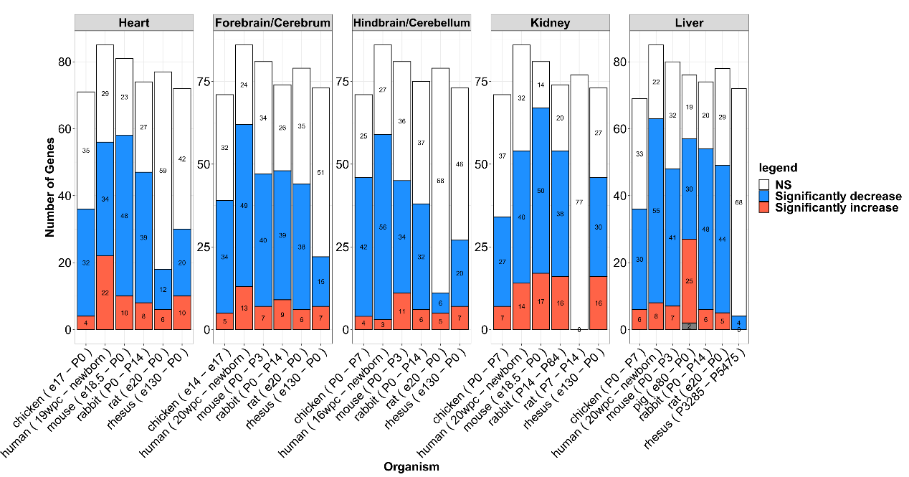
Figure S41. Expression changes after birth/hatching of genes within the Hypoxia response pathway (Dataset I, Dataset II). Bar plots representing the number of significant (upregulated in red, downregulated in blue) or insignificant changes in gene expression (in white). X axis: organisms, Y axis: number of genes.

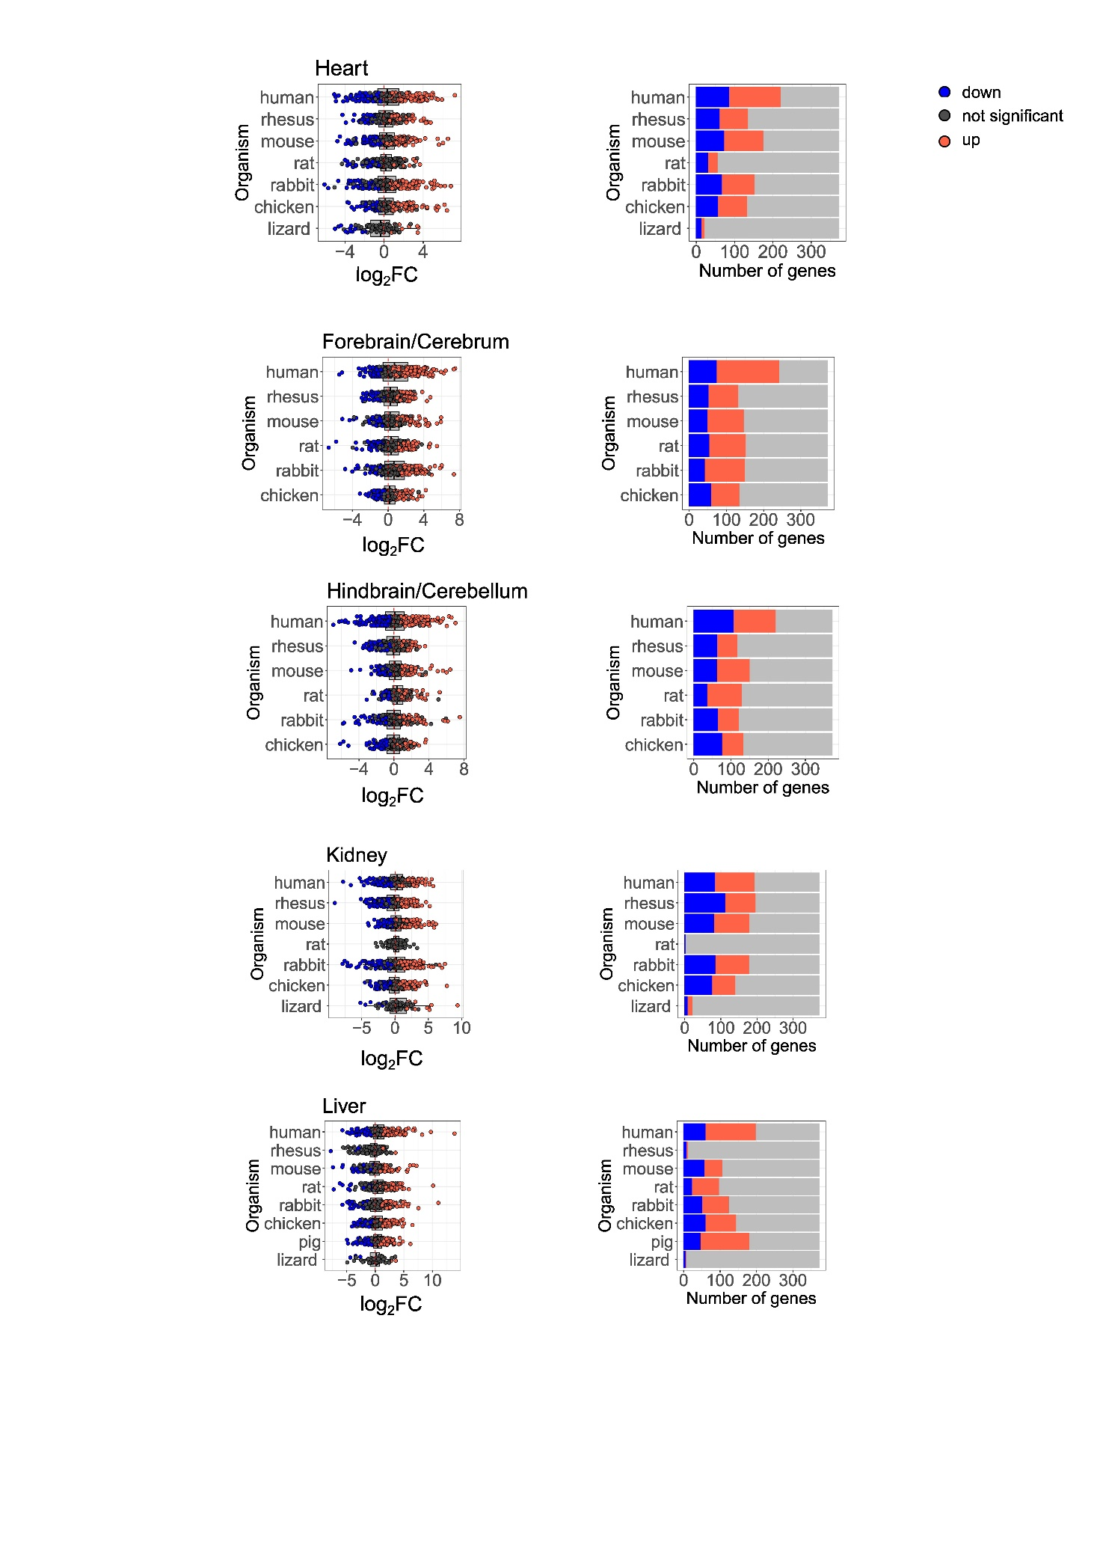
Figure S42. Locomotion genes did not show a significant change in expression (Dataset I, Dataset II). Left side panels: box plots representing the log₂FC of Locomotion genes. X axis: log₂FC values, Y axis: organisms. Color bar: blue: reduced expression (log₂FC< -0.2, p-value<0.05), red: elevated expression (log₂FC>0.2, p-value<0.05), black: non-significant. Vertical dashed red line indicates the value of zero log₂FC on the x axis (no change). Right side panels: bar plots representing the number of significant (upregulated in red, downregulated in blue) or insignificant changes in genes expression (in grey). X axis: number of genes, Y axis: organisms.

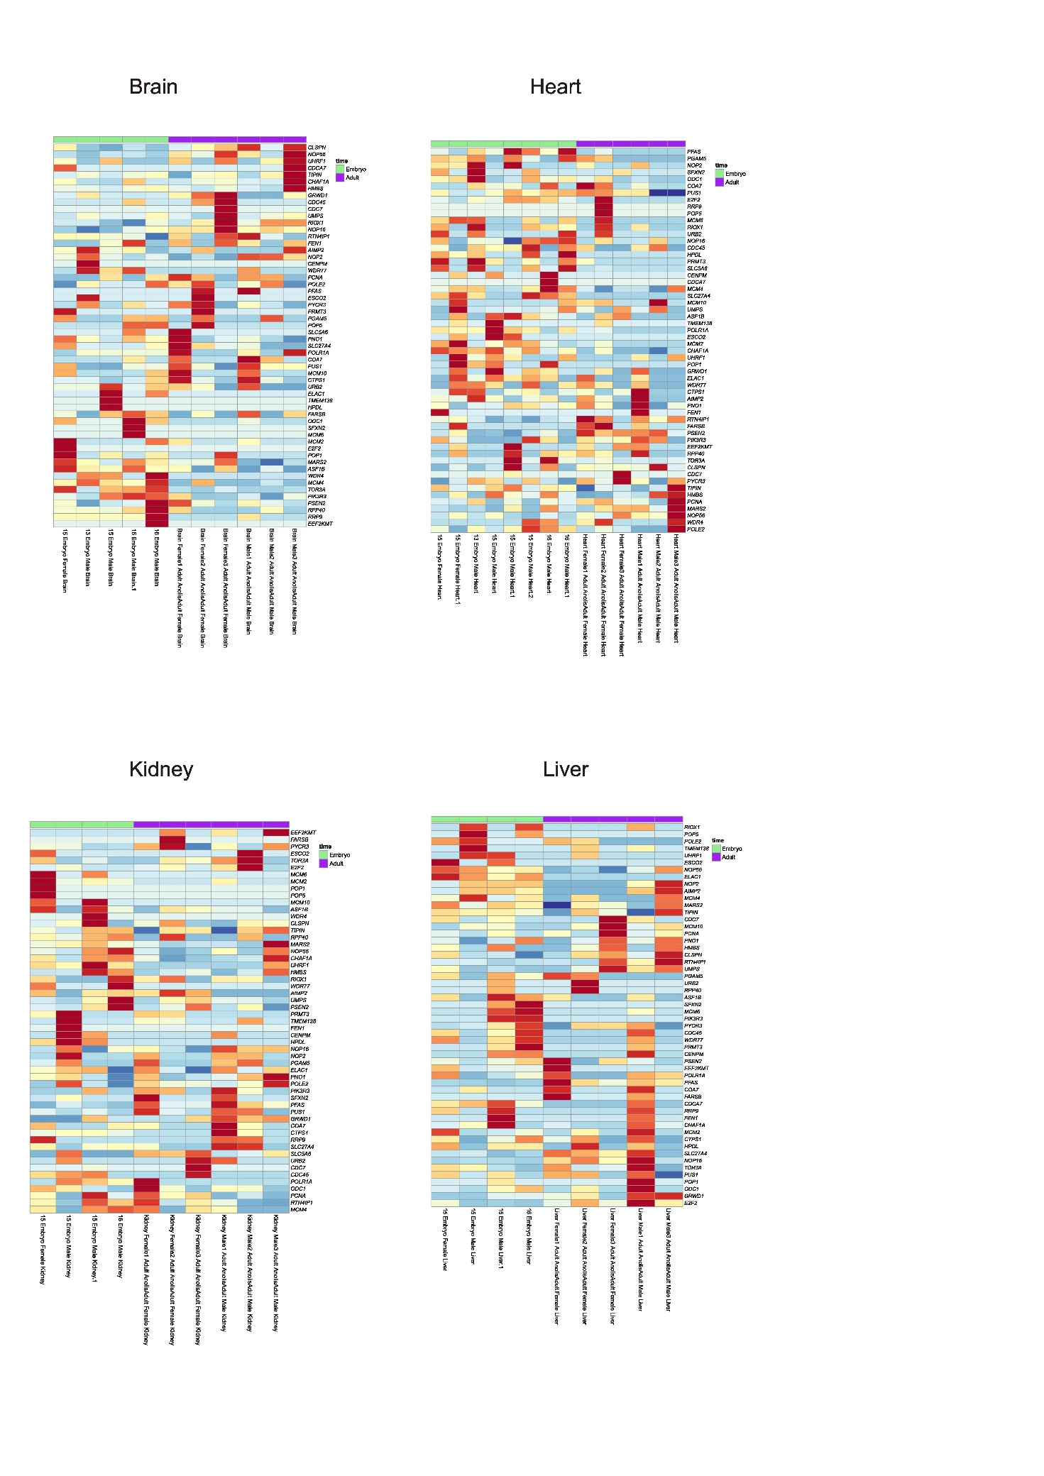
Figure S43. Anolis carolinensis positive regulation of hypoxia pathway analysis did not show a consistently significant change in expression in the adult. Heatmaps displaying positive regulation of hypoxia gene expression from embryo and adult samples of Anolis carolinensis from four organs (brain, heart, kidney, liver) (Dataset V). Red: high expression, blue – low expression. Legend: pink: females, blue: males; green: embryo samples, purple: adult samples.

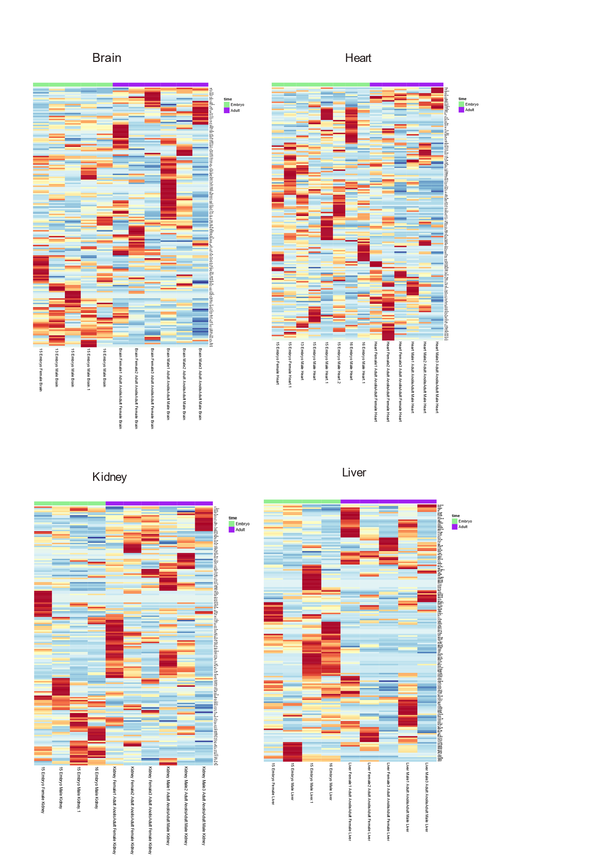
Figure S44. Anolis carolinensis locomotion pathway analysis did not show a consistently significant change in expression in the adult. Heatmaps displaying locomotion gene expression from embryo and adult samples of Anolis carolinensis from four organs (brain, heart, kidney, liver) (Dataset V). Red: high expression, blue – low expression. Legend: pink: females, blue: males; green: embryo samples, purple: adult samples.

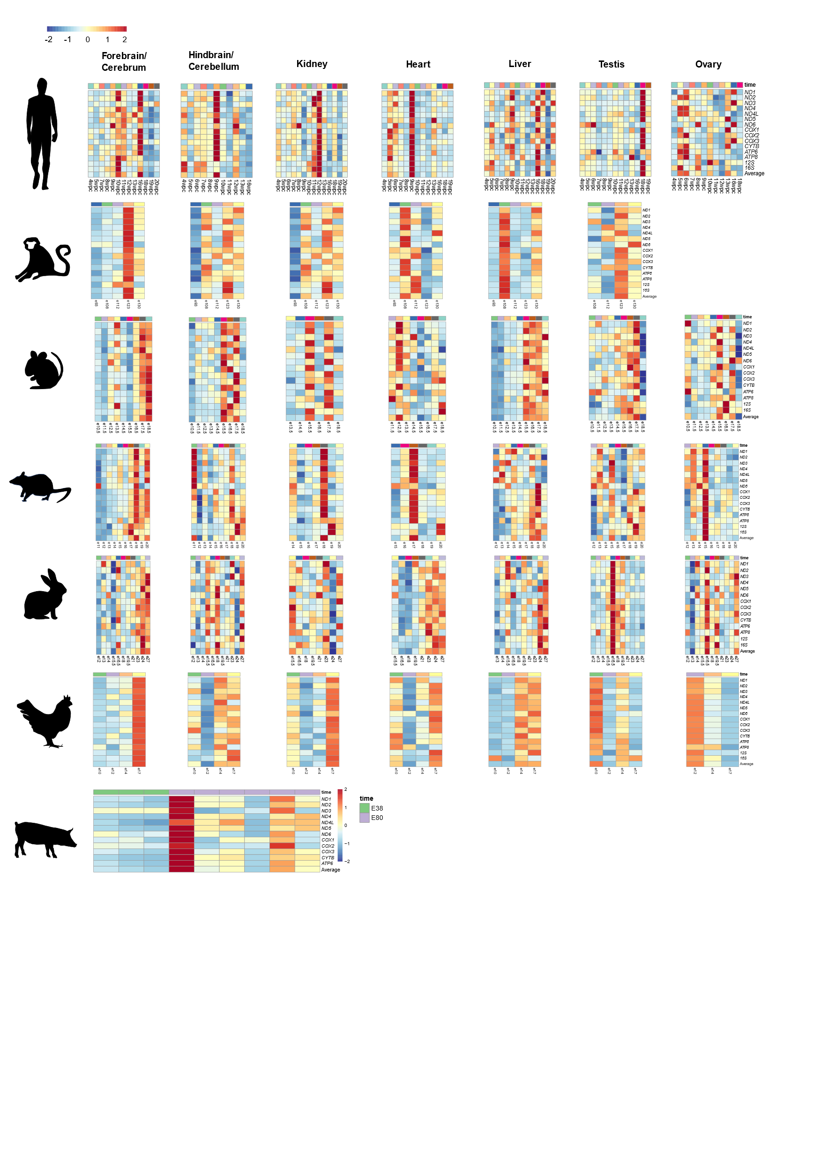
Figure S45. Expression of mtDNA genes only during prenatal development in mammals and Gallus gallus. Heatmaps representing mtDNA gene expression in six tissues from six mammals and a non-mammalian vertebrate (chicken). Color bar indicates the scaled expression. Red scale: elevated expression, blue scale: reduced expression. X axis: prenatal samples (colored in green) and postnatal samples (colored in purple) presenting the median expression of samples from the same stage of Dataset I. Y axis: mtDNA genes.

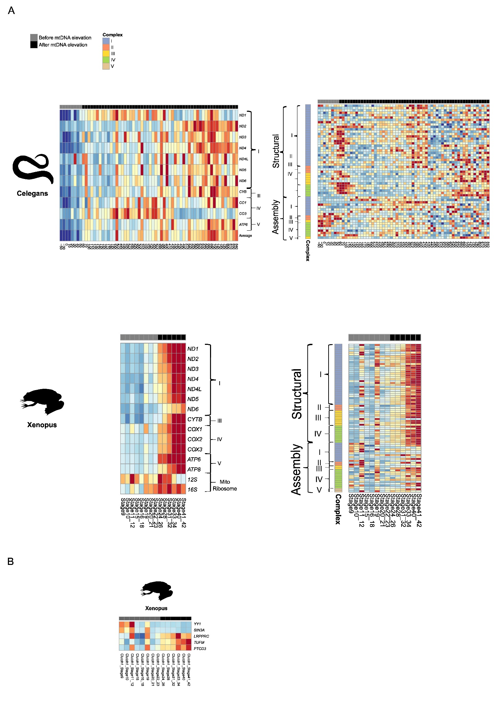
Figure S46. Mito-nuclear and regulatory factors gene expression during prenatal development. (A) Heatmaps of mtDNA (left panel) and nuclear DNA-encoded OXPHOS (right panel) gene expression from Caenorhabditis elegans and Xenopus tropicalis (one repeat). The color bar indicates the scaled expression. Red scale: elevated expression, blue scale: reduced expression. X axis: prenatal samples, Y axis: mtDNA/OXPHOS genes. Notice division into OXPHOS complexes and into structural and assembly genes of the OXPHOS. (B) Heatmaps of mitochondrial regulatory factors gene expression during the development of Xenopus tropicalis (one repeat). Color bar indicates the scaled expression. Red scale: elevated expression, blue scale: reduced expression. X axis: prenatal samples, Y axis: genes.
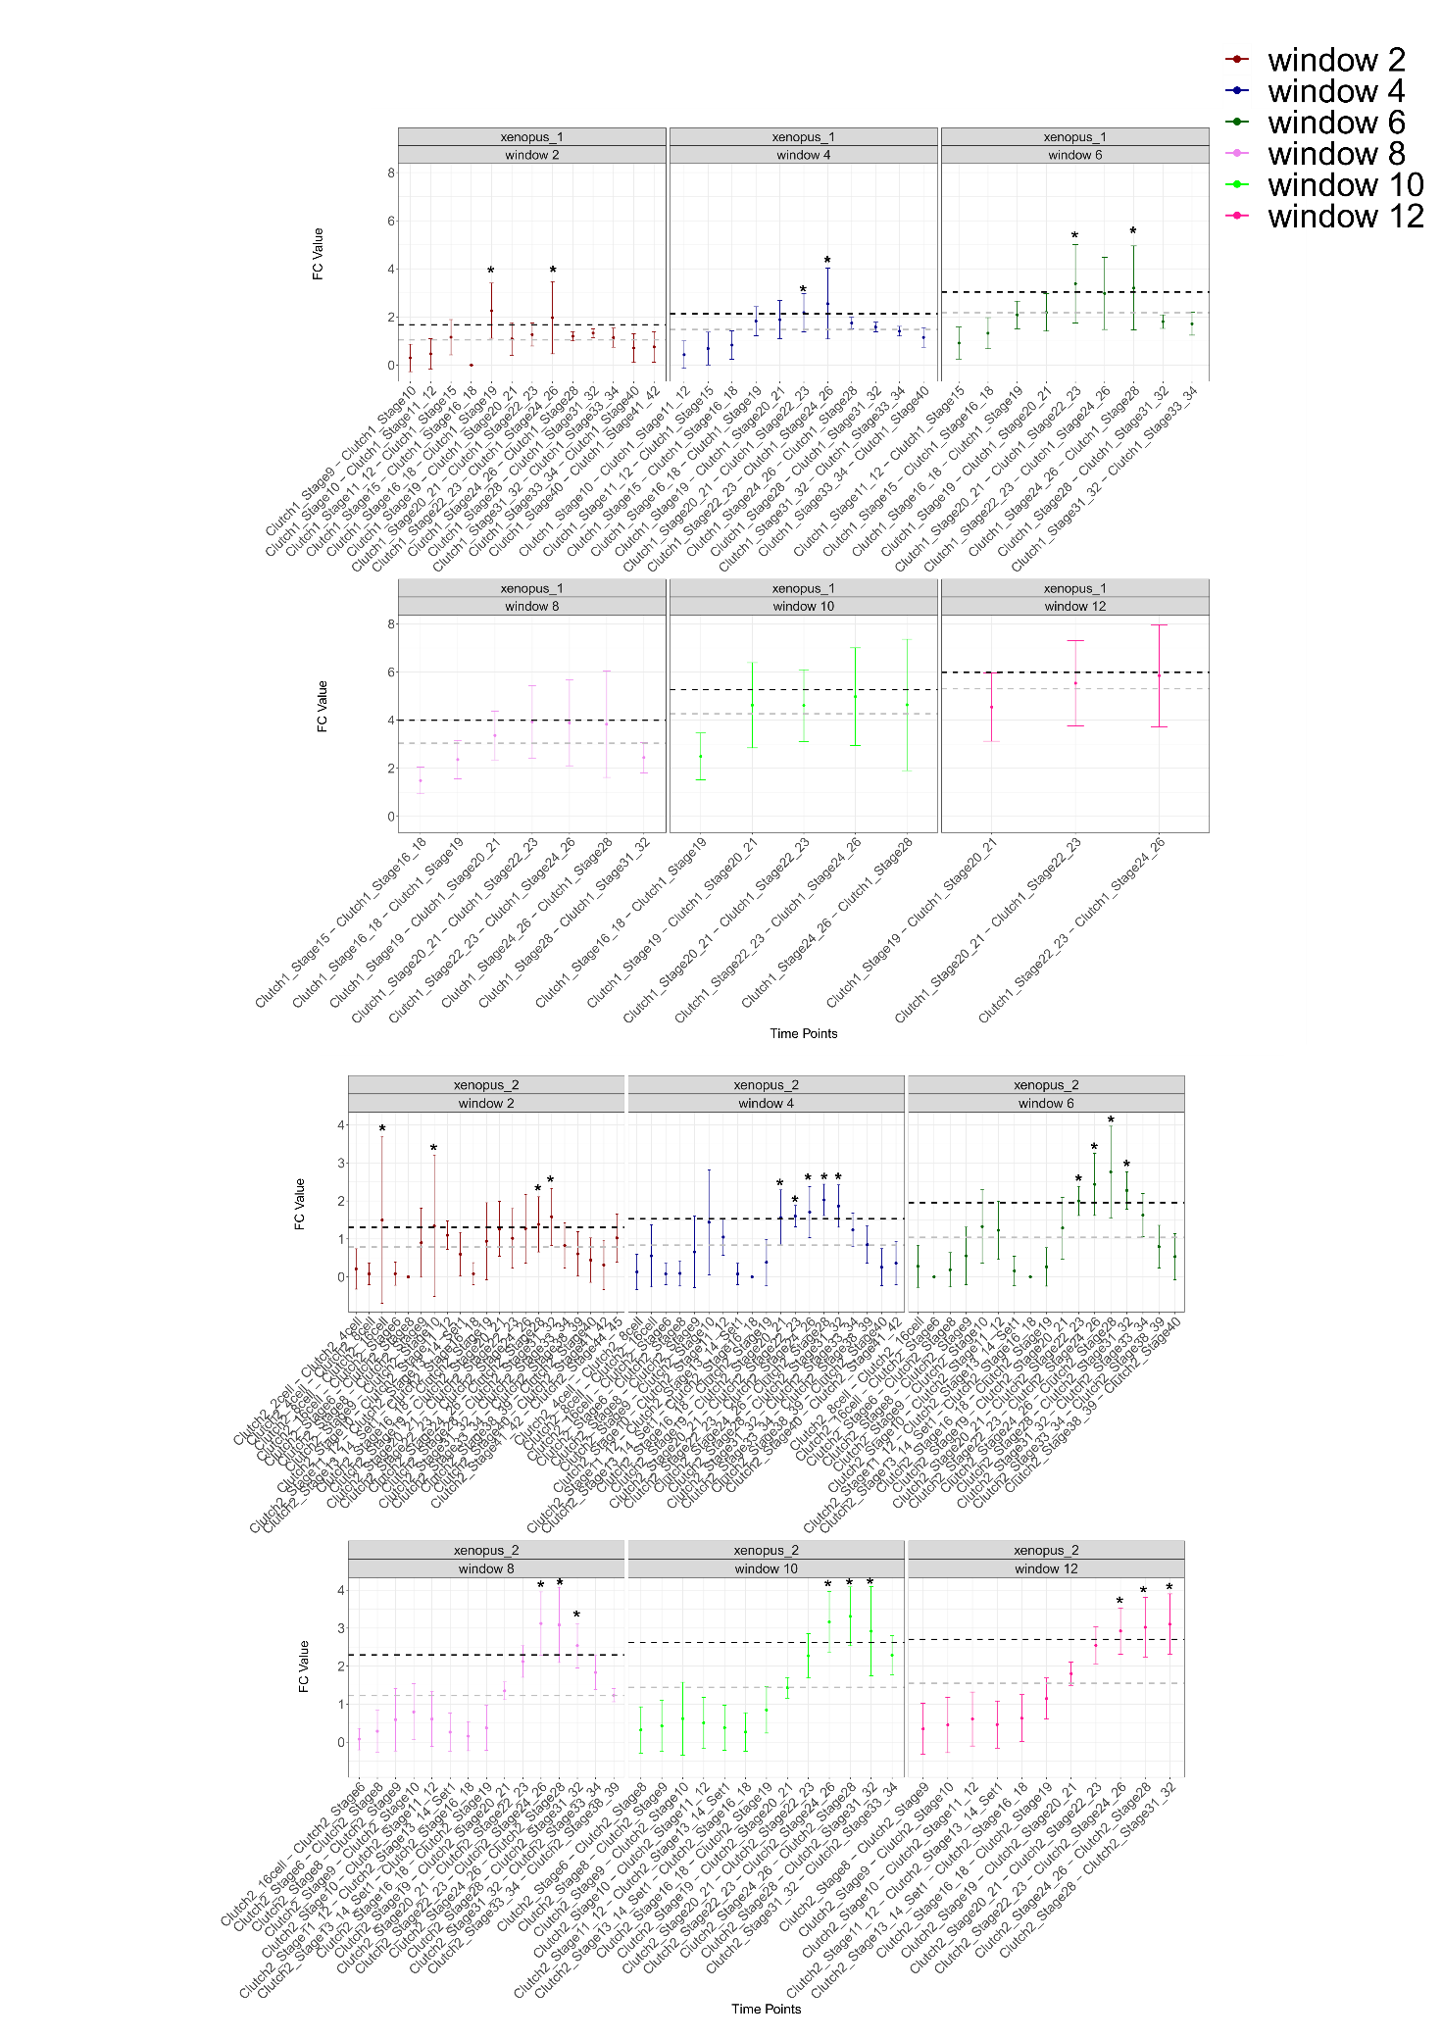
Figure S47. Fold-change (FC) values of mtDNA gene expression of Xenopus tropicalis at developmental time points collected from two experimental repeats. X-axis - the time points; Y-axis - average FC values with standard deviation (SD). Colors represent sliding window analyses with window sizes of w=2 through w=12. The highest FC values according to the w=4 analysis are highlighted in bold. Horisontal dashed grey line - average FC across the time points. Black dashed line – standard deviation above the average. *- indicate significance (above SD).

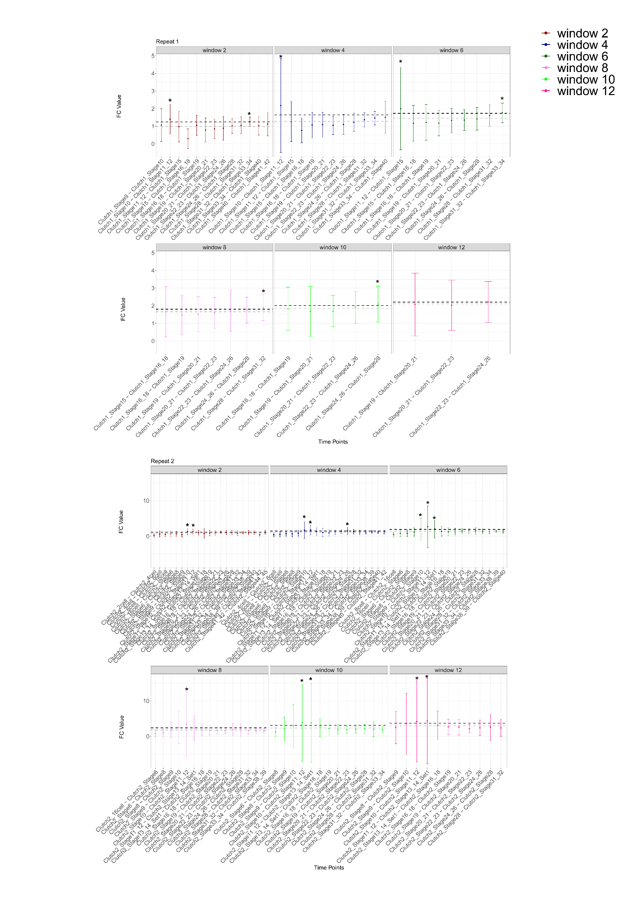
Figure S48. Fold-change (FC) values of expression of nuclear DNA-encoded OXPHOS structural subunits in Xenopus tropicalis across developmental points in two experimental repeats. X-axis - the time points; Y-axis - average FC values with standard deviation. Colors represent sliding window analyses with window sizes of w=2 through w=12. The highest FC values according to the w=4 analysis are highlighted in bold. Horisontal dashed grey line - average FC across the time points. Black dashed line – standard deviation above the average. *- indicate significance (above SD).

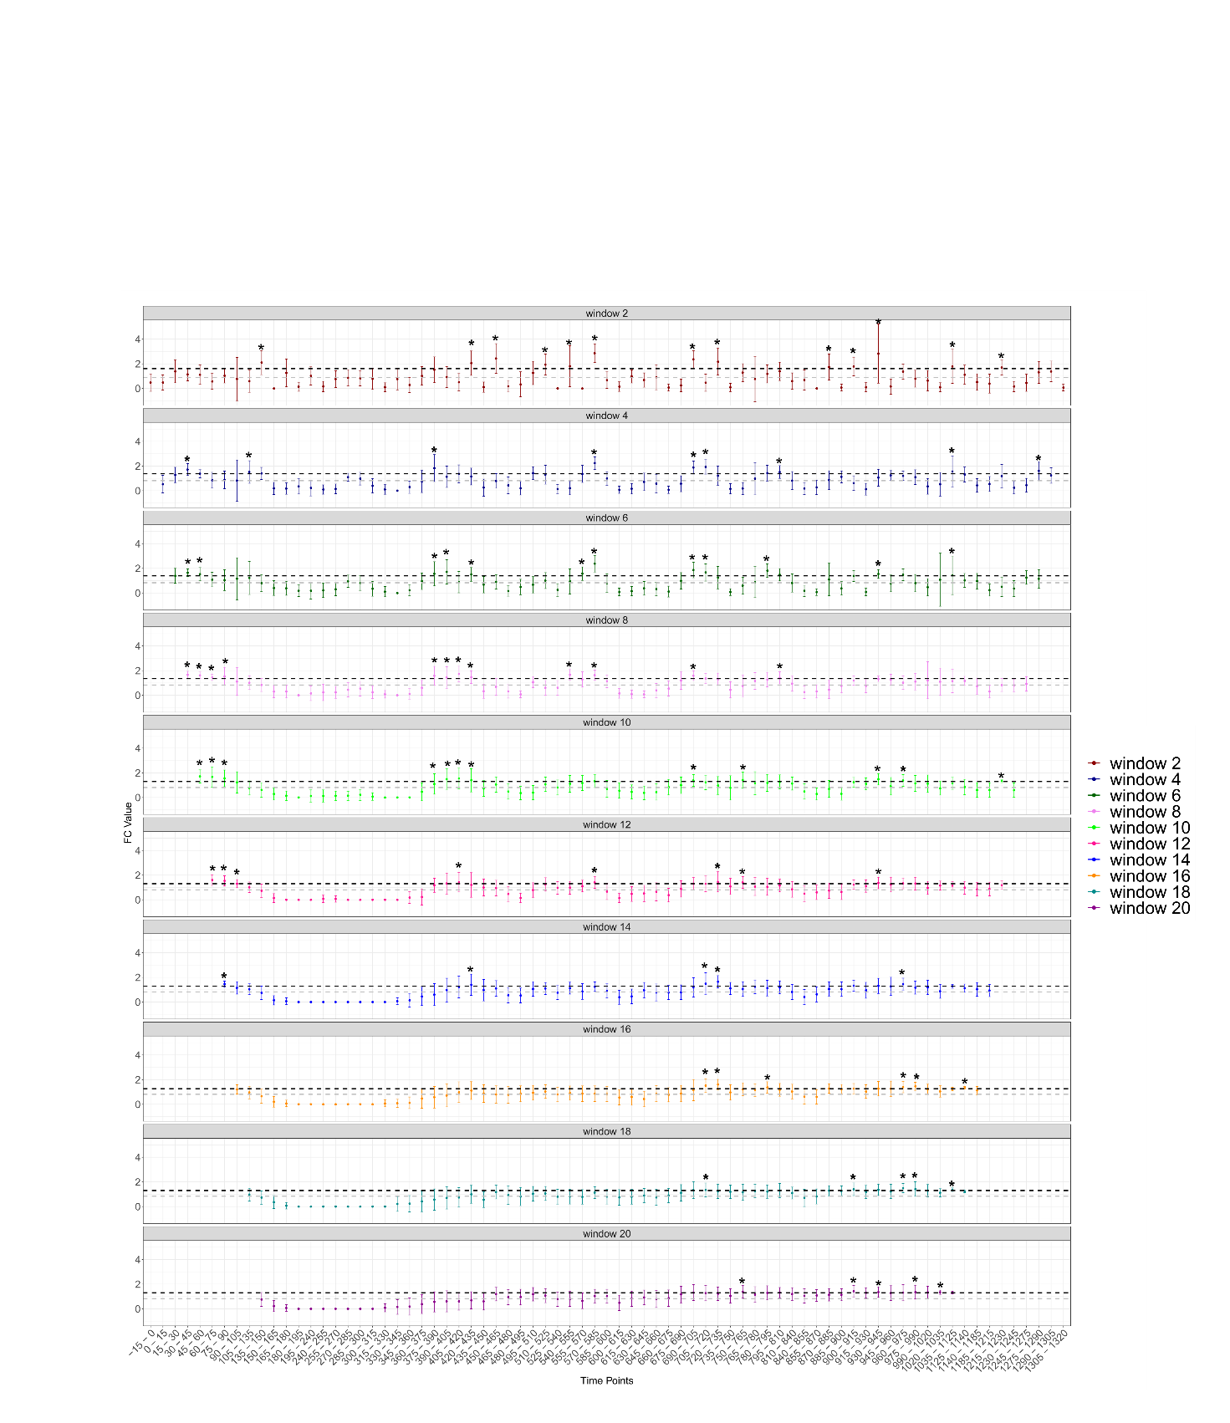

Figure S49. Fold-change (FC) values of mtDNA gene expression in Drosophila melanogaster across developmental time points in two experimental repeats. X-axis - the time points; Y-axis - average FC values with standard deviation. Colors represent sliding window analyses with window sizes of w=2 through w=12. The highest FC values according to the w=4 analysis are highlighted in bold. Horisontal dashed grey line - average FC across the time points. Black dashed line – standard deviation above the average. *- indicate significance (above SD).

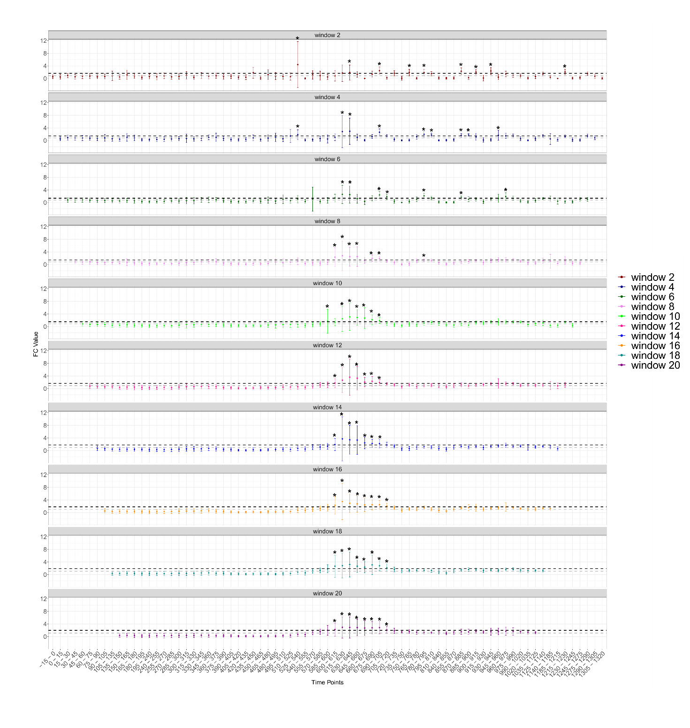
Figure S50. Fold-change (FC) values of expression of nuclear OXPHOS structural subunits in Drosophila melanogaster across developmental time points in two experimental repeats. X-axis - the time points; Y-axis - average FC values with standard deviation. Colors represent sliding window analyses with window sizes of w=2 through w=20. The highest FC values according to the w=4 analysis are highlighted in bold. Horisontal dashed grey line - average FC across the time points. Black dashed line – standard deviation above the average. *- indicate significance (above SD).
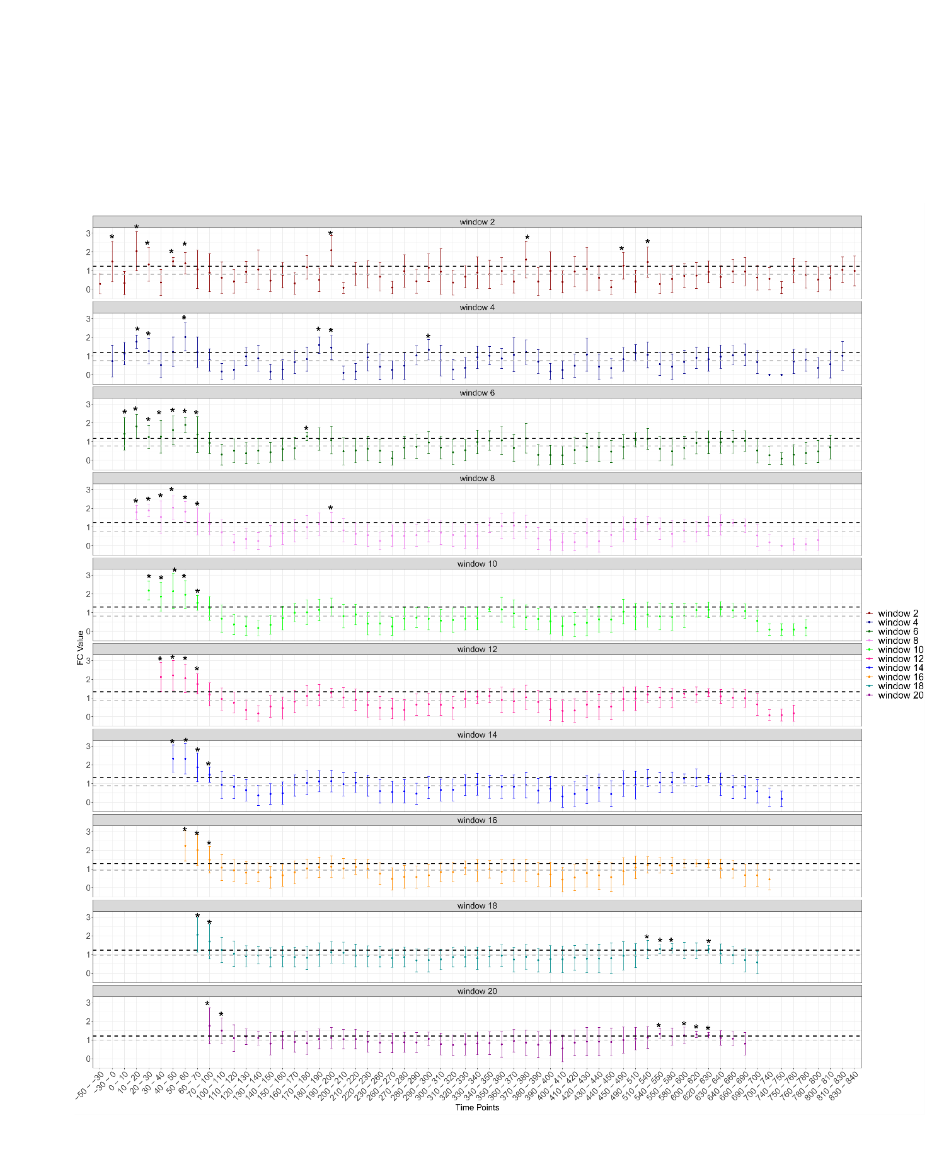
Figure S51. Fold-change (FC) values of mtDNA gene expression of Caenorhabditis elegans from developmental time points. X-axis - the time points; Y-axis - average FC values with standard deviation. Colors represent sliding window analyses with window sizes of w=2 through w=20. The highest FC values according to the w=4 analysis are highlighted in bold. Horisontal dashed grey line - average FC across the time points. Black dashed line – standard deviation above the average. *- indicate significance (above SD).

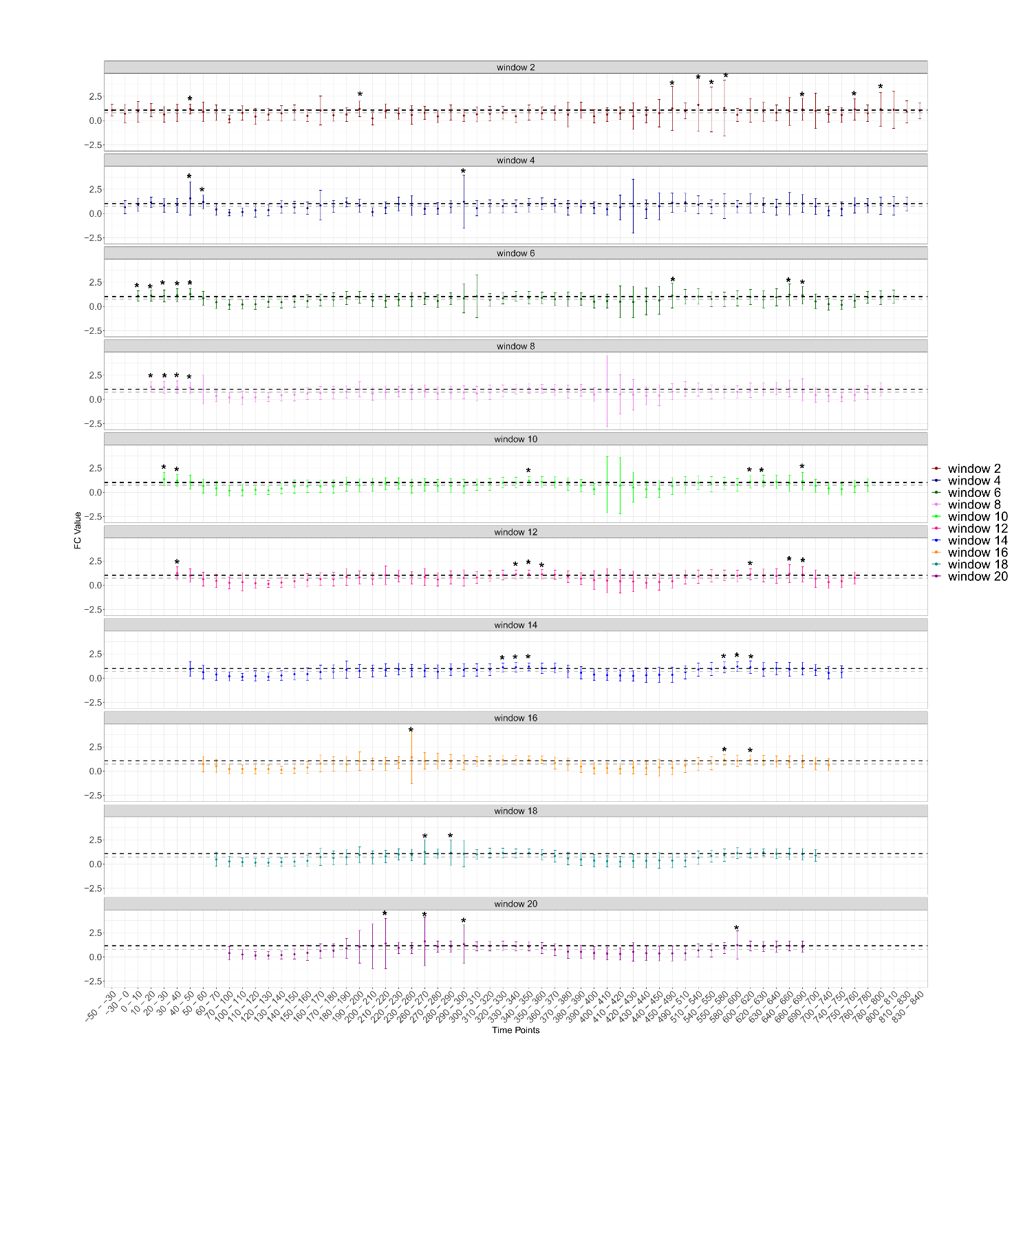
Figure S52. Fold-change (FC) expression values of nuclear DNA-encoded OXPHOS structural subunits in Caenorhabditis elegans across developmental time points. X-axis - the time points; Y-axis - average FC values with standard deviation. Colors represent sliding window analyses with window sizes of w=2 through w=20. The highest FC values according to the w=4 analysis are highlighted in bold. Horisontal dashed grey line - average FC across the time points. Black dashed line – standard deviation above the average. *- indicate significance (above SD).

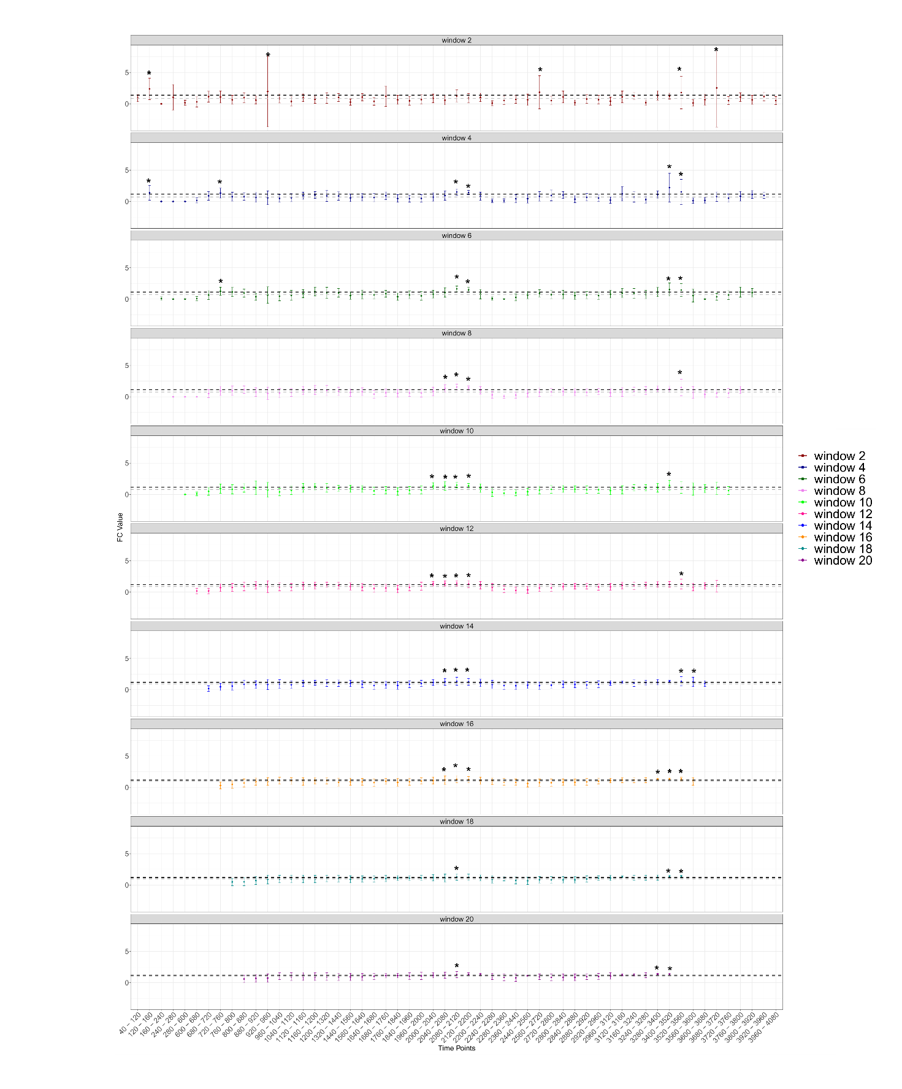
Figure S53. Fold-change (FC) values of mtDNA gene expression of Danio rerio (zebrafish) across developmental time points. X-axis - the time points; Y-axis - average FC values with standard deviation. Colors represent sliding window analyses with window sizes of w=2 through w=20. The highest FC values according to the w=4 analysis are highlighted in bold. Horisontal dashed grey line - average FC across the time points. Black dashed line – standard deviation above the average. *- indicate significance (above SD).

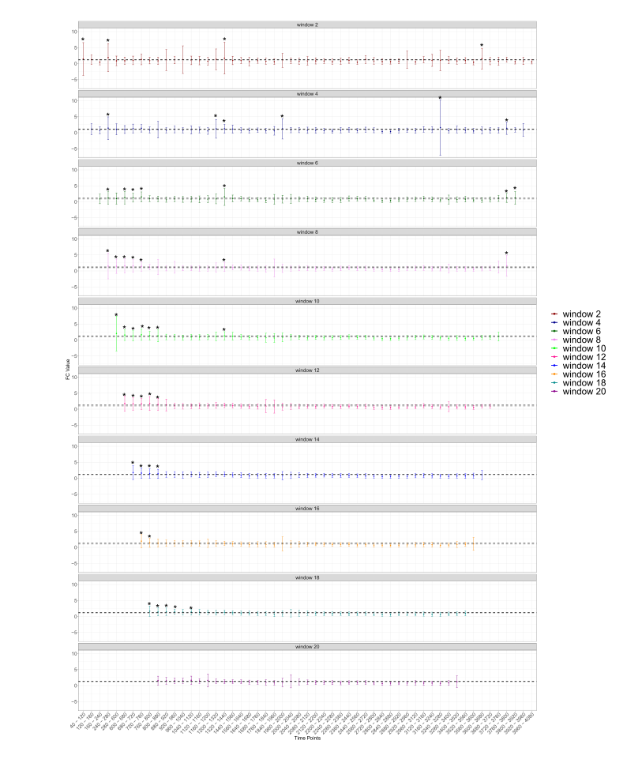
Figure S54. Fold-change (FC) expression values of nuclear DNA-encoded OXPHOS structural subunits in Danio rerio (zebrafish) across developmental time points. X-axis - the time points; Y-axis - average FC values with standard deviation. Colors represent sliding window analyses with window sizes of w=2 through w=20. The highest FC values according to the w=4 analysis are highlighted in bold. Horisontal dashed grey line - average FC across the time points. Black dashed line – standard deviation above the average. *- indicate significance (above SD).

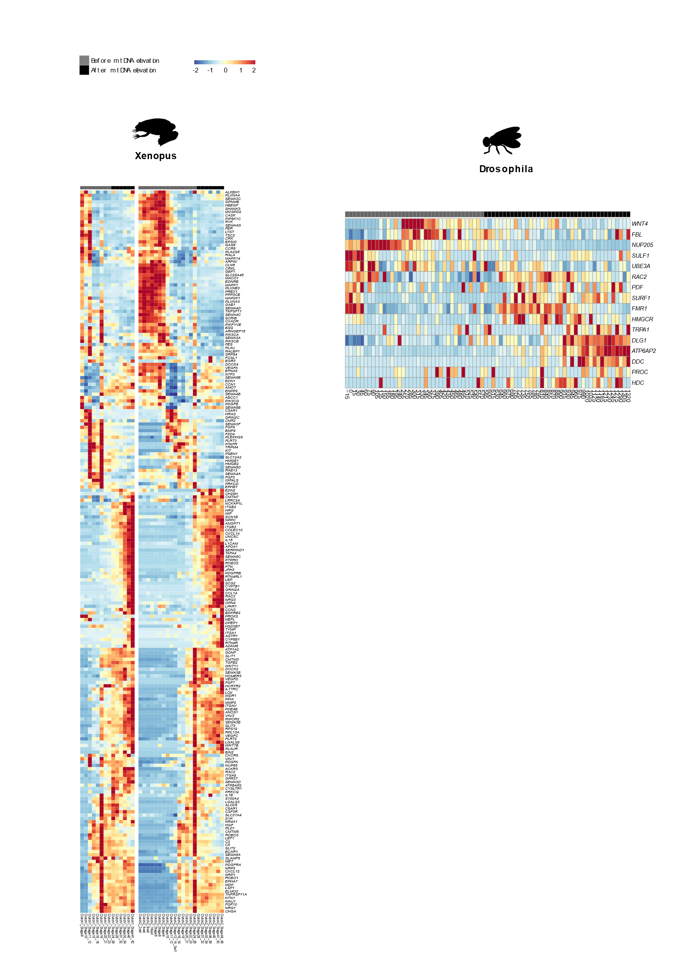
Figure S55. Expression of locomotion-related genes during prenatal development in Xenopus tropicalis and Drosophila melanogaster. Color bar indicates the scaled expression. Red scale: elevated expression, blue scale: reduced expression. X axis: prenatal samples, Y axis: Locomotion related genes.
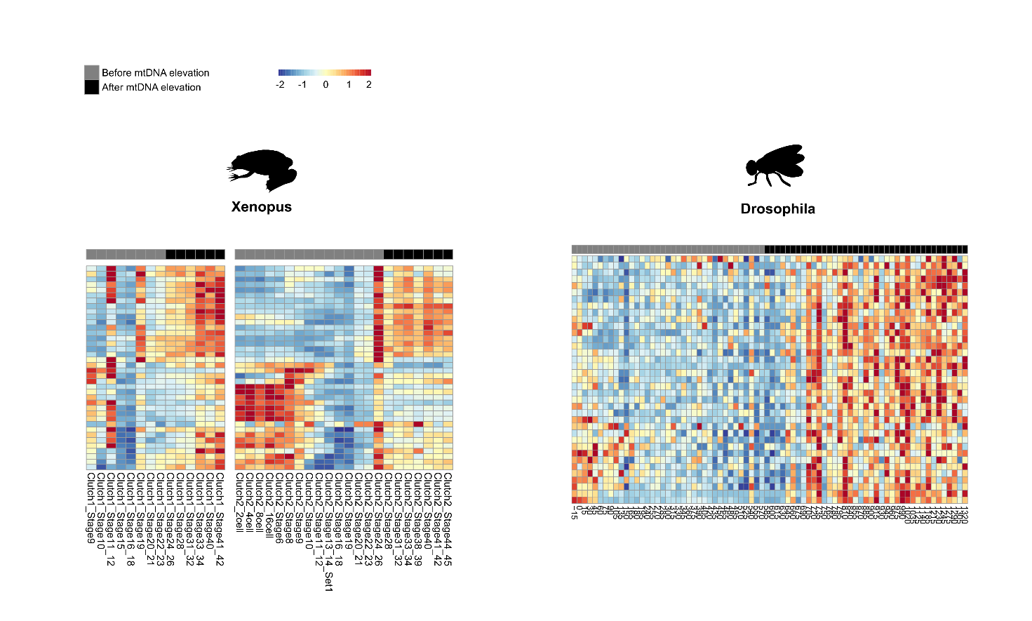
Figure S56. Gene expression analysis of mitochondrial-related pathways in Xenopus tropicalis and Drosophila melanogaster. Heatmaps of gene expression related to mitochondrial ribosome. Red indicates high expression, blue- reduced expression. X axis: embryo developmental time, Y axis: genes.
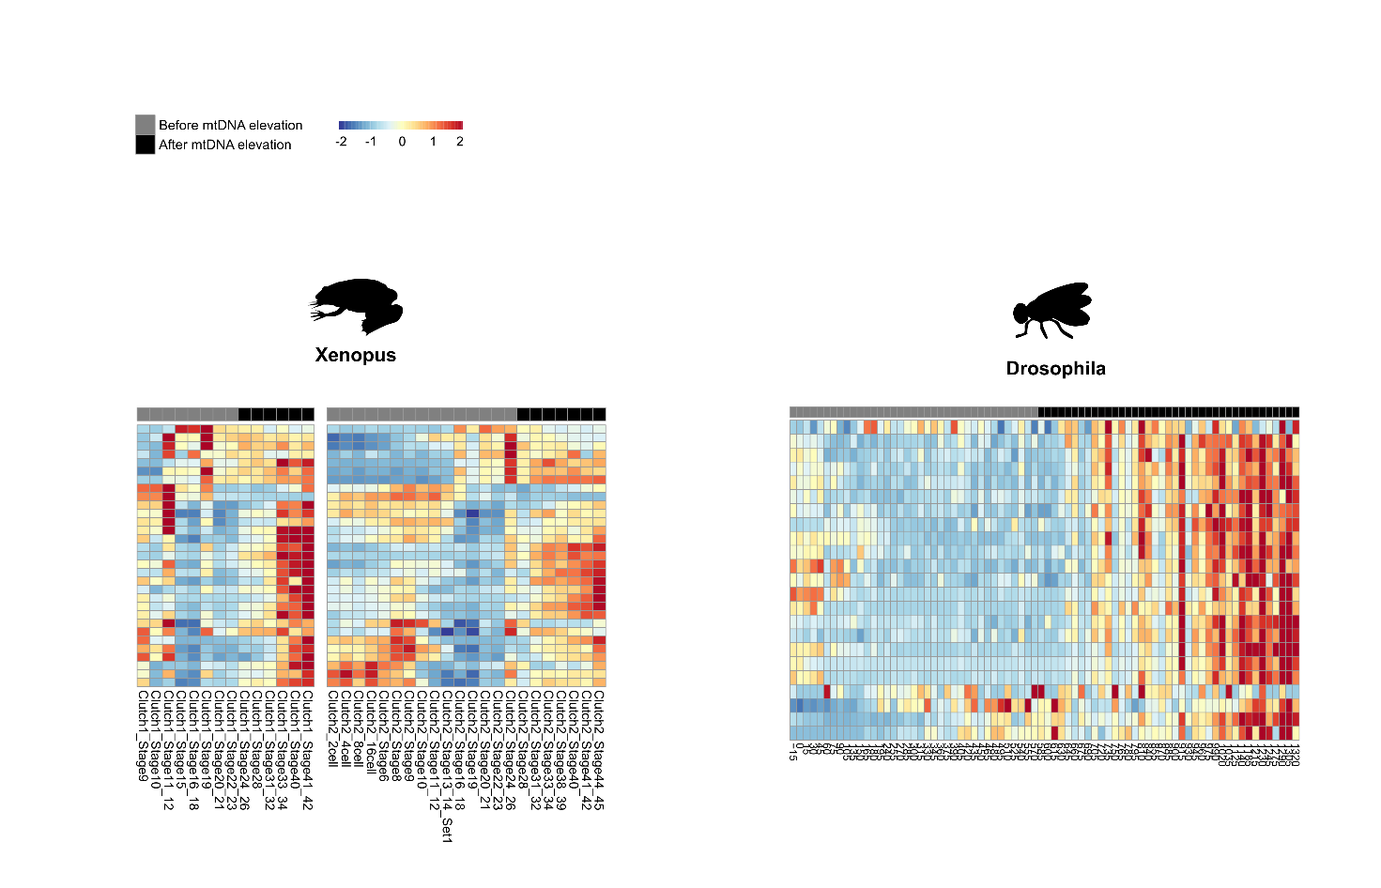
Figure S57. Gene expression analysis of mitochondrial-related pathways in Xenopus tropicalis and Drosophila melanogaster. Heatmaps of gene expression related to TCA. Red indicates high expression, blue- reduced expression. X axis: embryo developmental time, Y axis: genes.
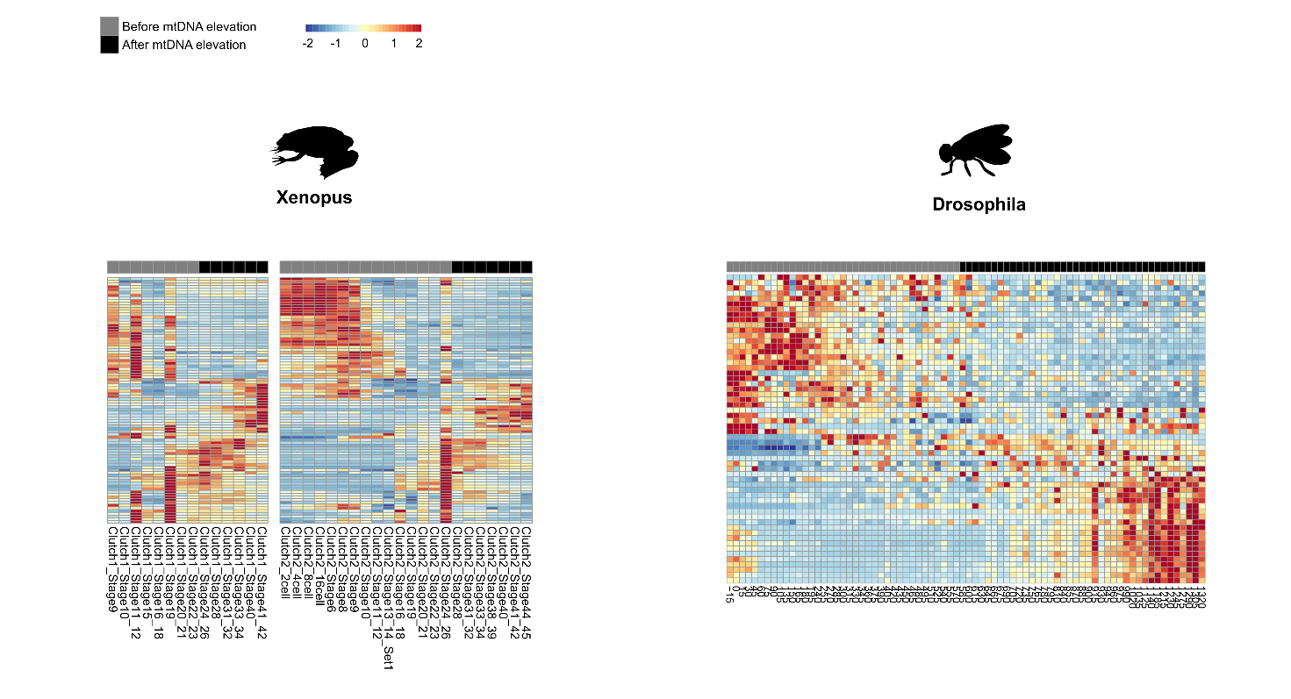
Figure S58. Gene expression analysis of mitochondrial-related pathways in Xenopus tropicalis and Drosophila melanogaster. Heatmaps of gene expression related to Glycolysis. Red indicates high expression, blue- reduced expression. X axis: embryo developmental time, Y axis: genes.
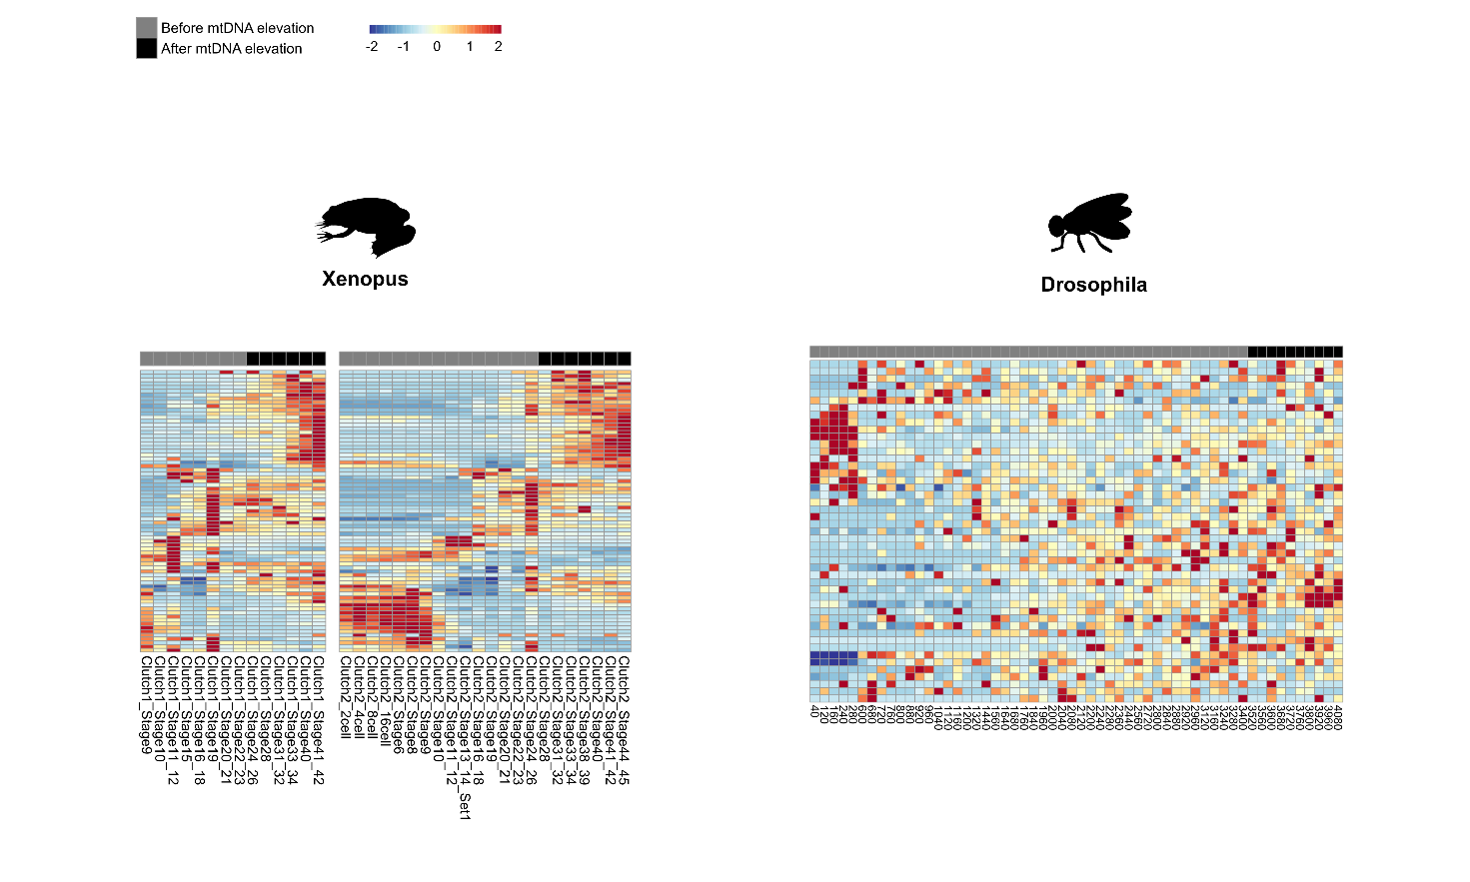
Figure S59. Mitochondrial-related pathways analysis in Xenopus tropicalis and Drosophila melanogaster. Heatmaps of gene expression related to ROS. Red indicates high expression, blue- reduced expression. X axis: embryo developmental time, Y axis: genes.

