Supplemental Information for:

Ancient dog introgression into the Iberian wolf genome may have facilitated adaptation to human-dominated landscapes

Diana Lobo^{1,2,3*}, Hernán E. Morales^{4,5}, Cock Van Oosterhout⁶, José Vicente López-Bao⁷, Pedro Silva^{1,3}, Luis Llaneza⁸, Carolina Pacheco^{1,2,3}, Diana Castro^{1,3}, Germán Hernández-Alonso⁴, George Pacheco⁴, John Archer^{1,3}, M. Thomas P. Gilbert^{4,9}, Nuno Ferrand^{1,2,3,10}, and Raquel Godinho^{1,2,3,10*}

¹CIBIO, Centro de Investigação em Biodiversidade e Recursos Genéticos, InBIO Laboratório Associado, Campus de Vairão, Universidade do Porto, 4485-661 Vairão, Portugal. ²Departamento de Biologia, Faculdade de Ciências, Universidade do Porto, 4169-007 Porto, Portugal. ³BIOPOLIS, Program in Genomics, Biodiversity and Land Planning, CIBIO, Campus de Vairão, 4485-661 Vairão, Portugal. ⁴Center for Evolutionary Hologenomics, The GLOBE Institute, University of Copenhagen, 1353 Copenhagen, Denmark. ⁵Section for Evolutionary Genomics, The GLOBE Institute, University of Copenhagen, 1353 Copenhagen, Denmark. ⁶School of Environmental Sciences, Norwich Research Park, University of East Anglia, NR4 7TJ Norwich, UK. ⁷Biodiversity Research Institute (CSIC - Oviedo University - Principality of Asturias) Oviedo University, E-33600 Mieres, Spain. ⁸A.RE.NA, Asesores en Recursos Naturales, 27003 Lugo, Spain. ⁹University Museum, Norwegian University of Science and Technology, 7012 Trondheim, Norway. ¹⁰Centre for Ecological Genomics and Wildlife Conservation, Department of Zoology, University of Johannesburg, 2006 South Africa

*Correspondence: diana.lobo@cibio.up.pt (Diana Lobo), rgodinho@cibio.up.pt (Raquel Godinho)

This PDF file includes:

Supplemental Figures S1 – S19
Supplemental Tables S1 – S5

Supplemental Figures

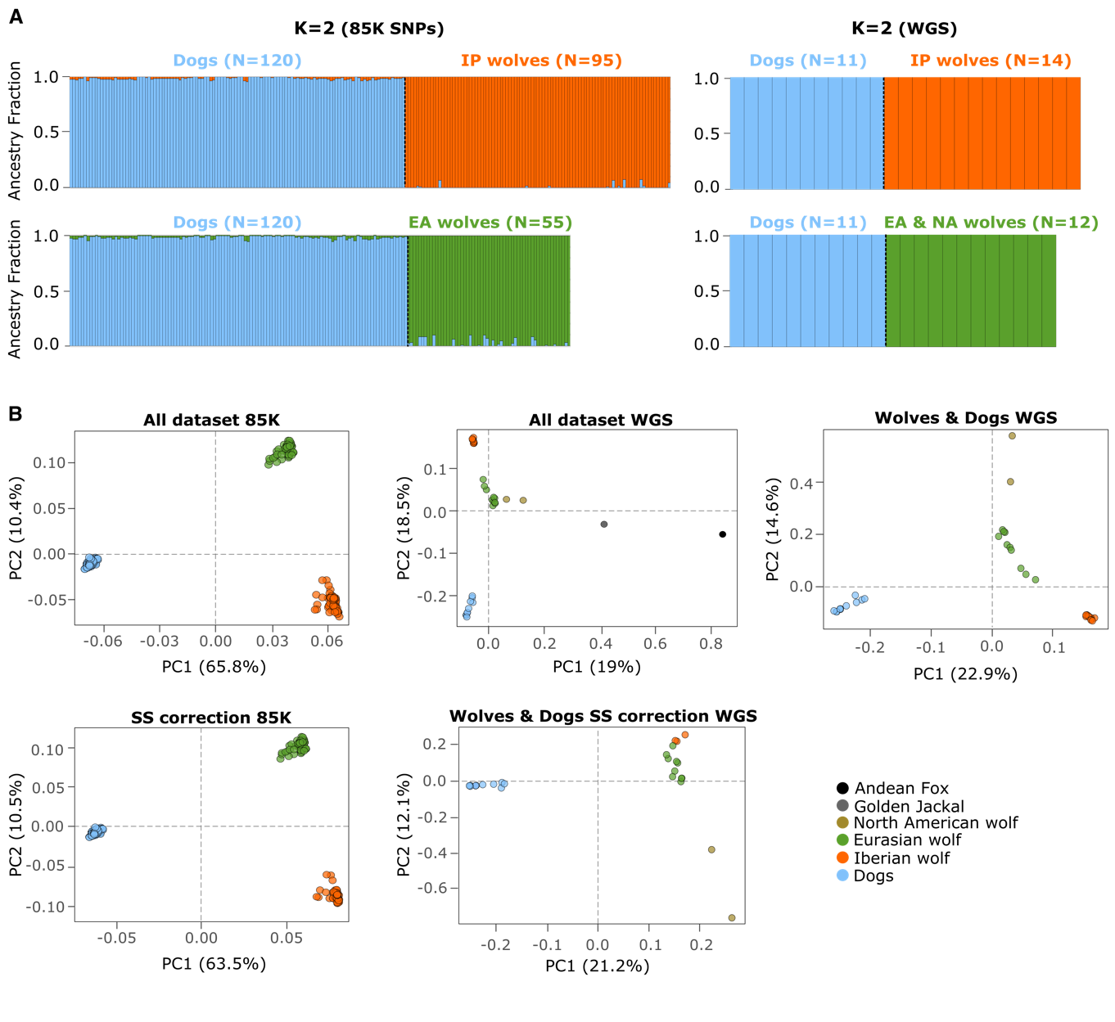
Supplemental Figure S1. Global ancestry analysis and PCA. (A) Ancestry fractions inferred using the 85K SNP panel and whole genome data (WGS; ~4 M variants) in ADMIXTURE for K = 2 for dogs and wolves. Individuals are identified by a single bar and different colors indicate the ancestry proportion attributed to each cluster. Sample sizes are indicated within brackets for each group. Iberian and Eurasian wolves were run independently in two separate datasets with dogs. (B) Principal component analysis (PCA) using the 85K SNP dataset and WGS data. The 85K SNP panel includes 95 Iberian wolves, 55 Eurasian wolves and 120 dogs, and a dataset with sample size correction (SS) with an equal number of Iberian and Eurasian wolves (N=55). WGS data includes 14 Iberian wolves, 10 Eurasian wolves, two North American wolves, 11 dogs, one Golden Jackal and one Andean fox, and a dataset with sample size correction, which includes only three Iberian wolves to balance the number of Eurasian wolves per population. Each dot denotes an individual.
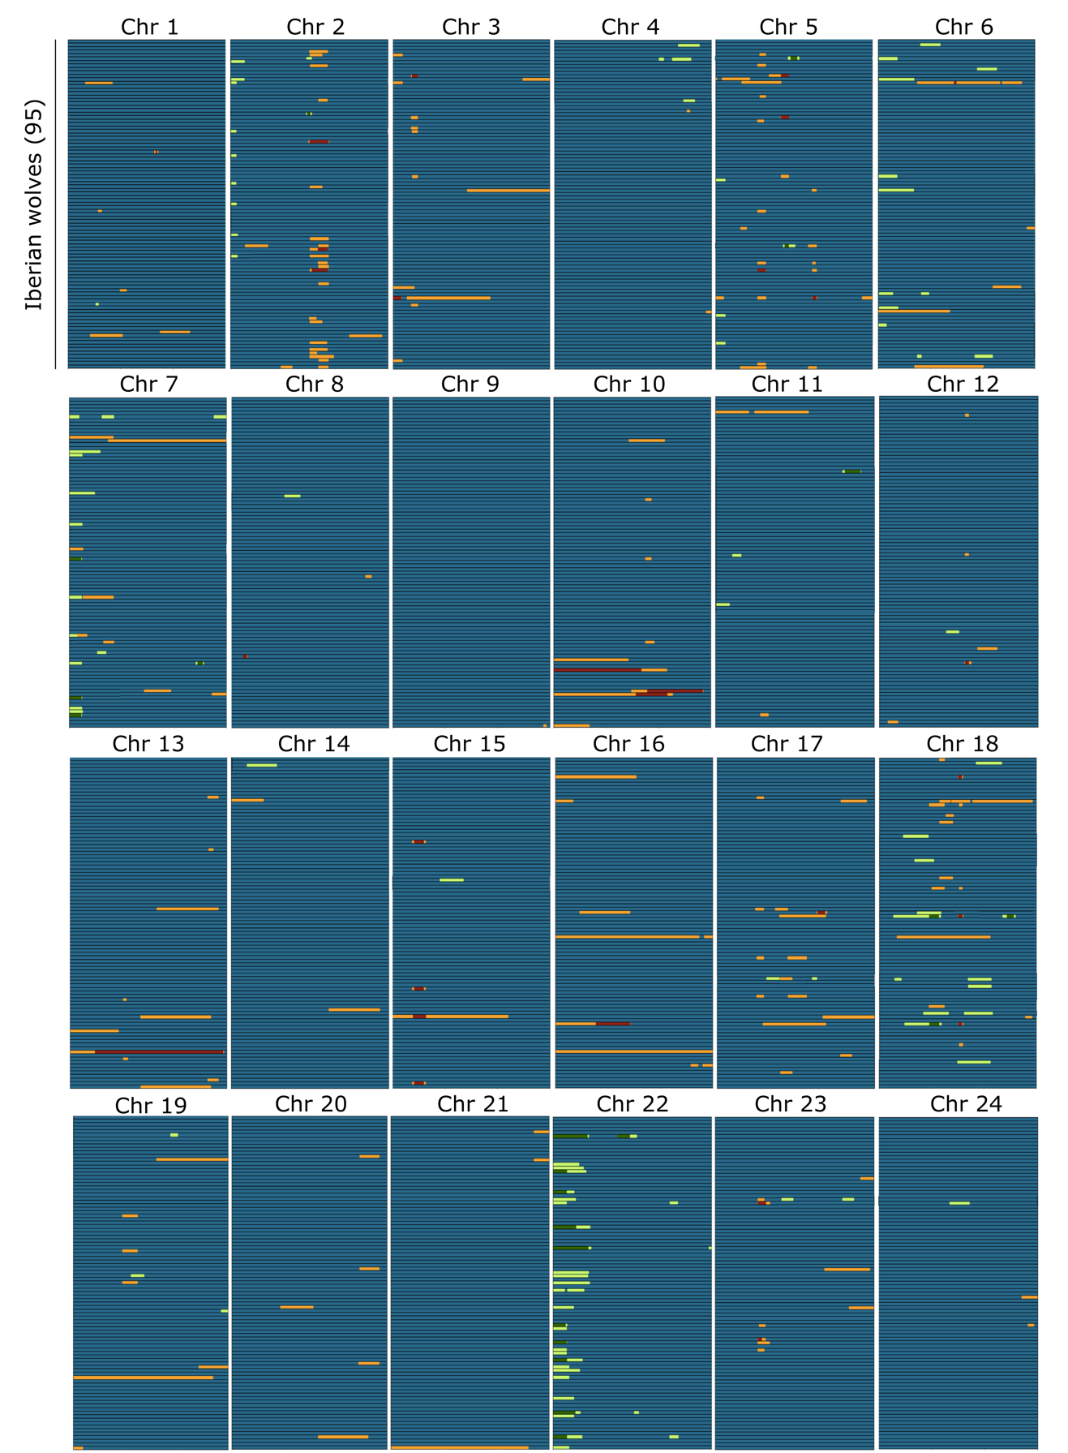

(Supplemental Fig. S2 continues next page)

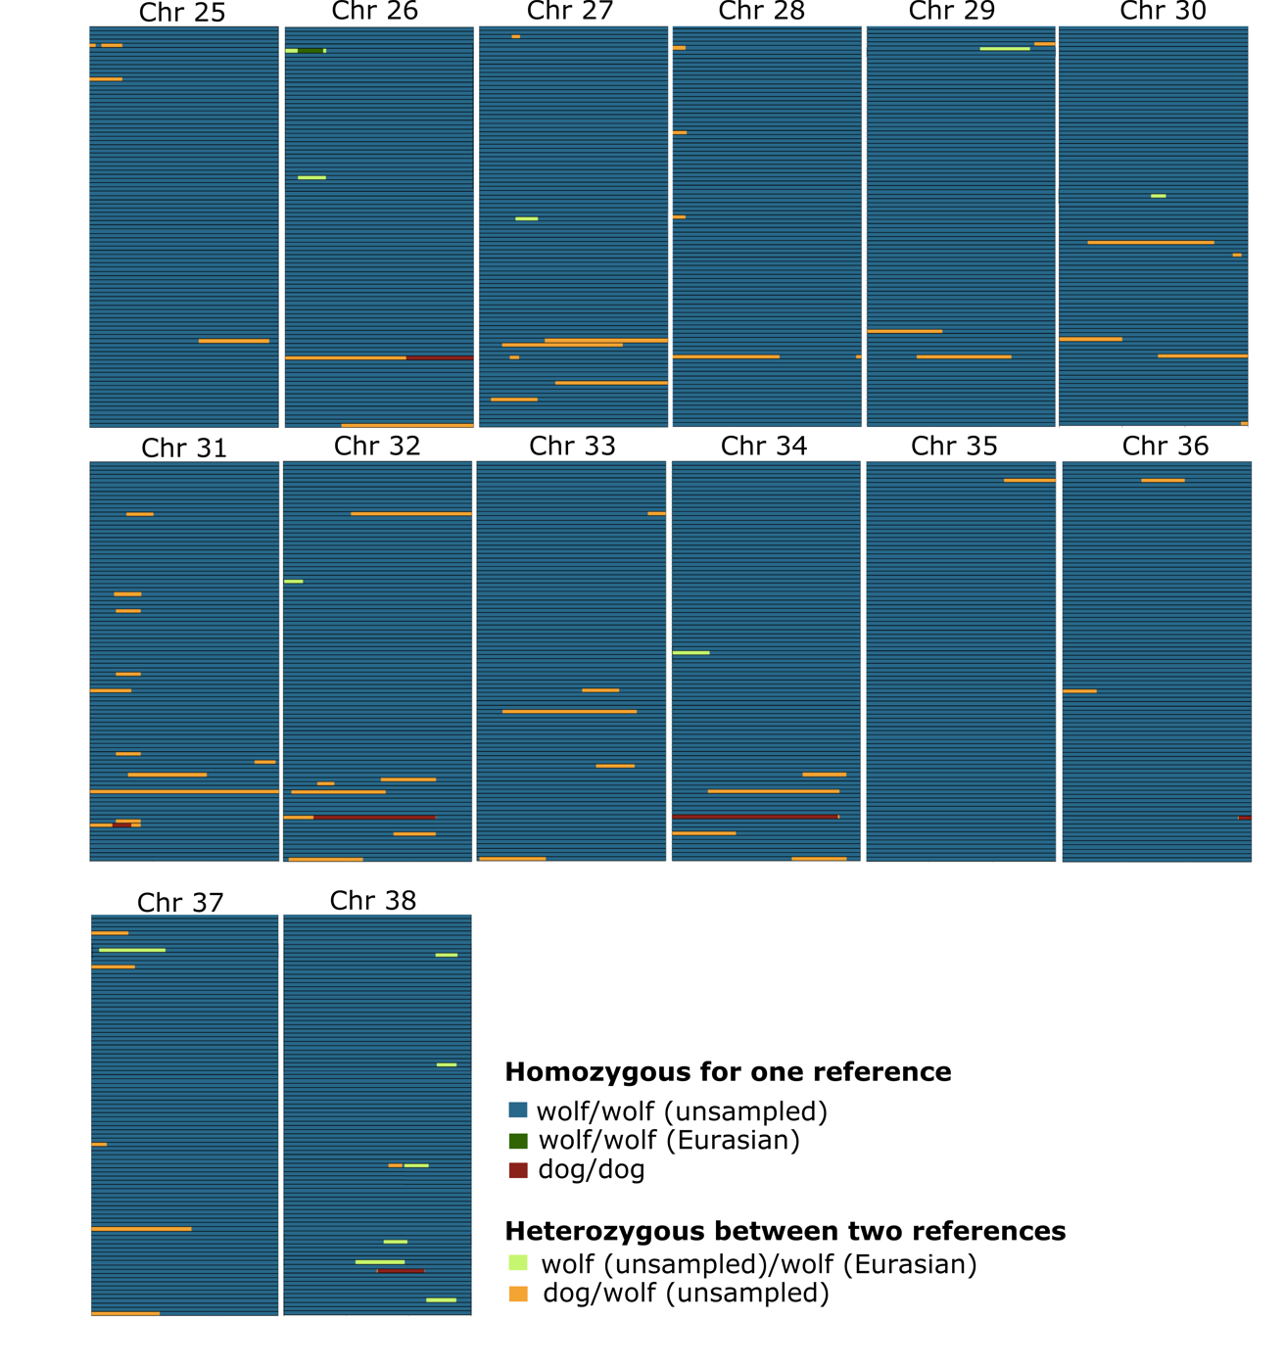
Supplemental Figure S2. Local ancestry analysis using ELAI. Results of local ancestry analysis in ELAI (10 mixture generations) based on 85K SNPs. Blocks were colored based on the attributed local ancestry: blue for the unsampled population (both chromosomes), dark green for Eurasian wolf (both chromosomes), red for dog (both chromosomes), light green and yellow represent a mixture of unsampled/Eurasian wolf and unsampled/dog (one chromosome of each), respectively. Each box identifies a chromosome, and every row represents an Iberian wolf sample (N = 95).

Supplemental Figure S3. Local ancestry analysis using LAMP. Results of local ancestry analysis in LAMP-ANC based on 85K SNPs. Blocks were colored based on the attributed local ancestry: yellow for wolf (both chromosomes), red for dog (both chromosomes), and a mixture of yellow and red for wolf/dog (one chromosome of each). Each box identifies a chromosome, and every row represents an Iberian wolf sample (N = 95).

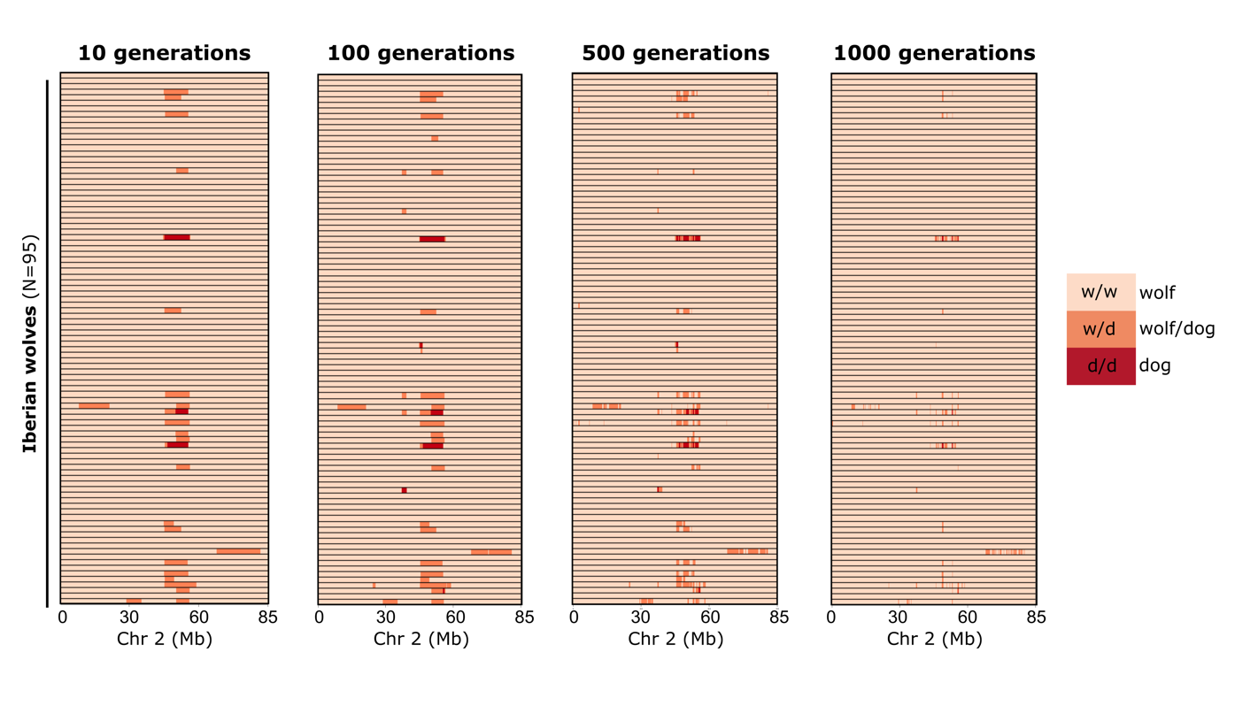
Supplemental Figure S4. Representation of the dog block considering distinct generation times. Representation of the dog block found in Chromosome 2 of Iberian wolves based on local ancestry analysis in ELAI (85K SNPs), considering several mixture generations (10, 100, 500, and 1000). Each row represents a single individual and different colors represent the attributed local ancestry: light orange for wolf (both chromosomes), red for dog (both chromosomes), and orange represents a mixture of wolf/dog (one chromosome of each).

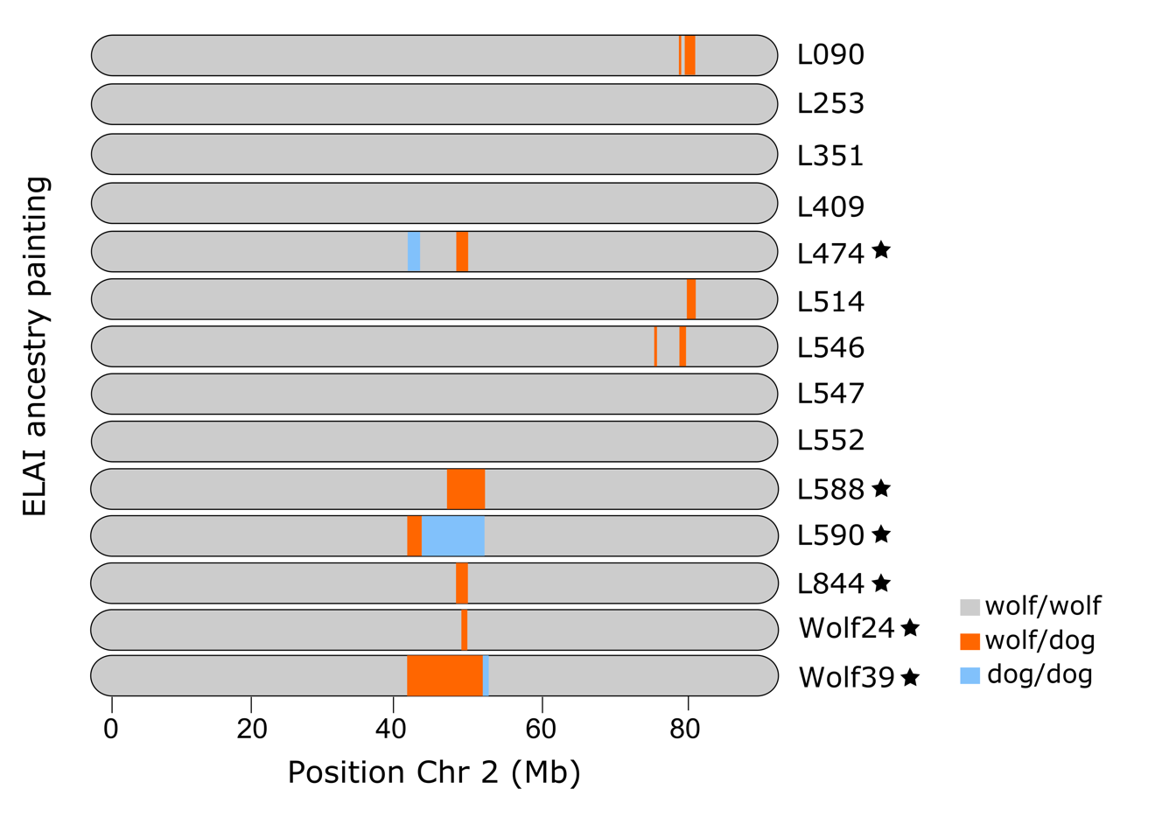
Supplemental Figure S5. Local ancestry analysis using WGS data. Representation of the ∆block on Chromosome 2 across all Iberian wolf genomes, based on ELAI results. Each row represents an individual and different colors represent the attributed local ancestry: gray for wolf (both chromosomes), blue for dog (both chromosomes), and orange represents a mixture of wolf/dog (one chromosome of each). Black stars denote the six individuals with the ∆block.

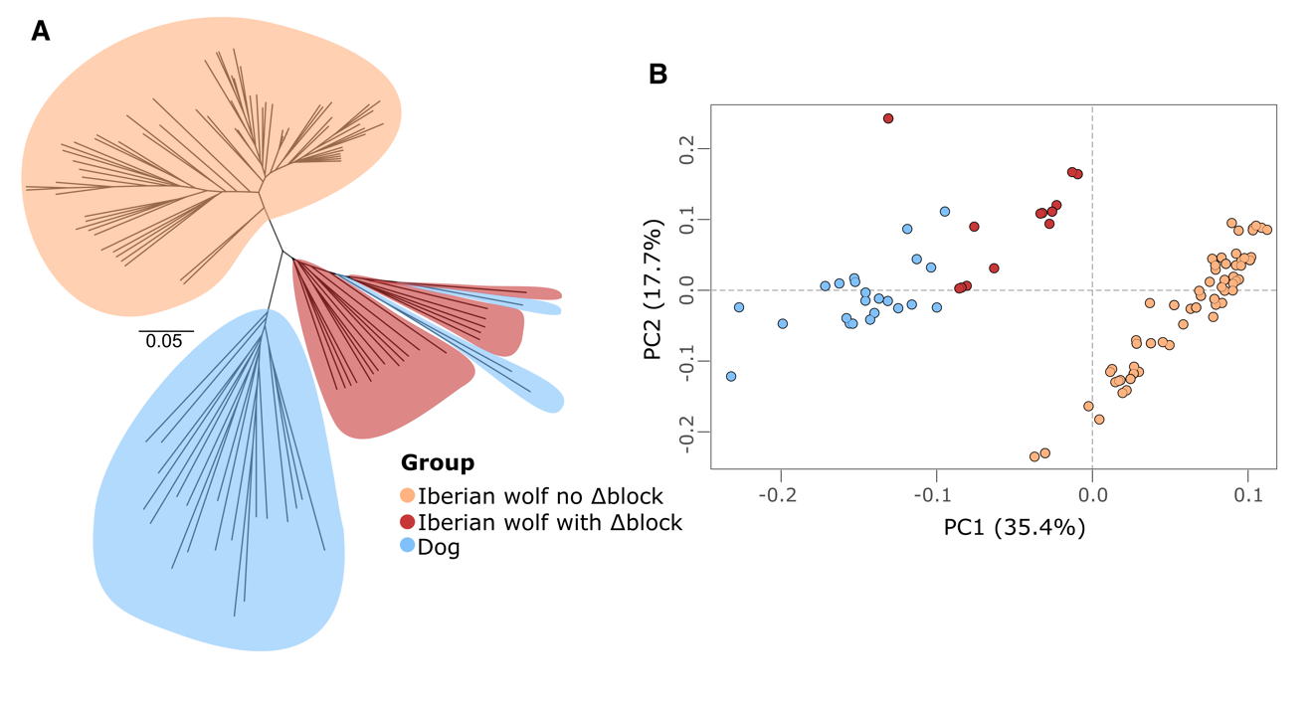
Supplemental Figure S6. Individual clustering within ∆block based on the 85K SNP dataset. Neighbor-joining (NJ) tree (A) and PCA (B) of Iberian wolves and village dogs from Iberia, constructed using the 78 SNPs spanning ∆block in Chromosome 2 (Chr 2: 50.02 – 52.62 Mb). Iberian wolves without the ∆block are represented in light orange, Iberian wolves with the ∆block in red, and village dogs in blue.

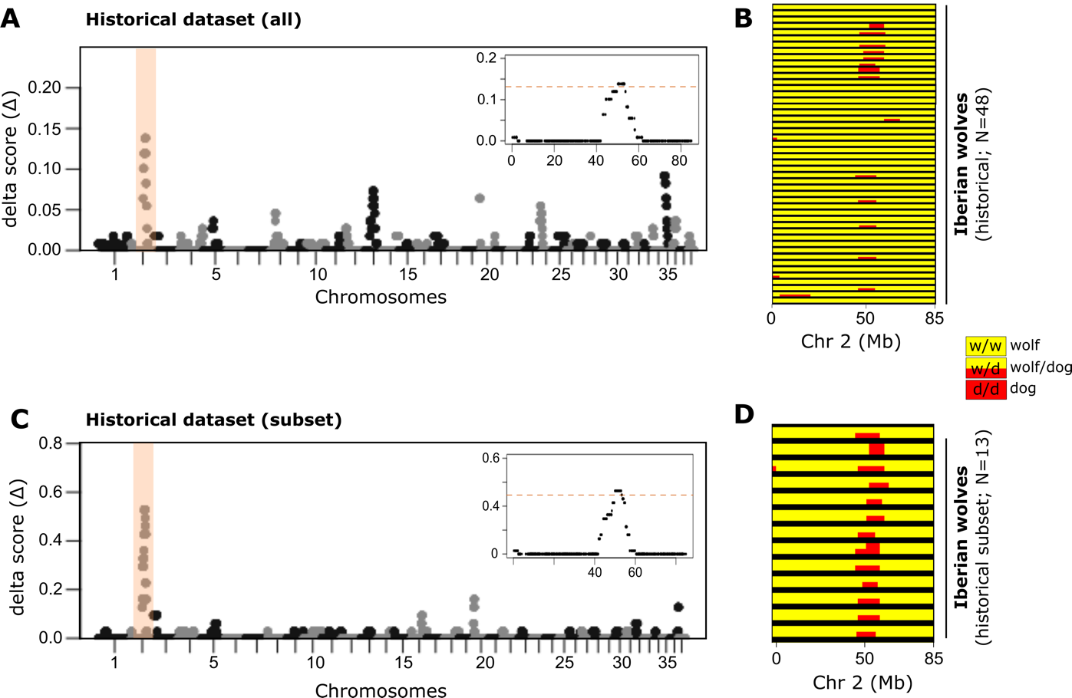

Supplemental Figure S7. Dog block in historical samples. (A) ∆ancestry scores indicating the excess of dog ancestry across the Iberian wolf genome (historical samples; N = 48). The position of ∆block on Chromosome 2 is highlighted in orange with a zoomed-in view at the right (orange line indicates the cut-off used for outliers’ detection). (B) Representation of the dog block found in Chromosome 2 of Iberian wolf historical samples, based on local ancestry analysis in LAMP. Each row represents a single individual and different colors represent the attributed local ancestry: yellow for wolf (both chromosomes), red for dog (both chromosomes), and a mixture of yellow and red for wolf/dog (one chromosome of each). (C) and (D) represent the same as (A) and (B), respectively, but with a subset of the Iberian wolf historical dataset (> 60K SNPs, N = 13).

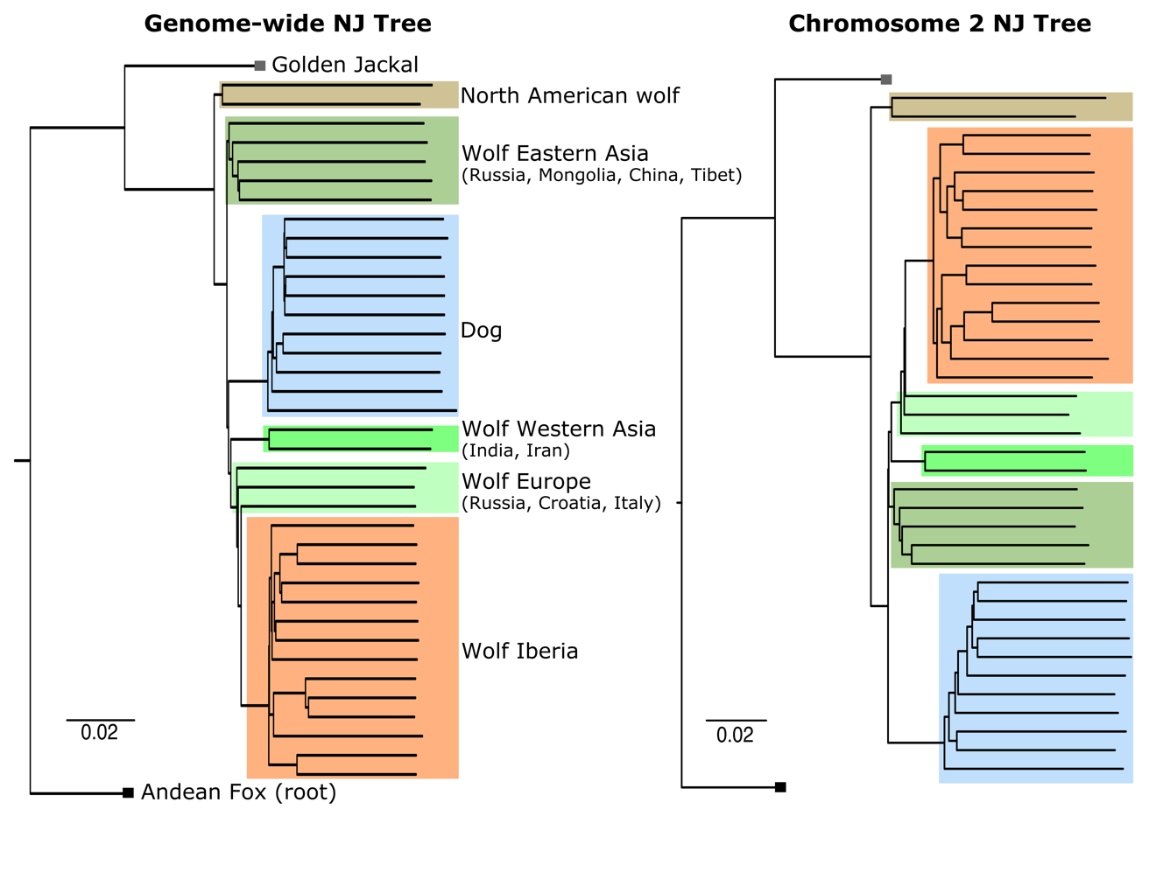
Supplemental Figure S8. Genome-wide phylogenetic relationships. Individual-based neighbor-joining trees estimated based on genetic distances for pseudo sequence alignments of 11.7 million genome-wide SNPs and 420K SNPs spanning Chromosome 2. Samples from Iberian, Eurasian and North American wolves are identified in orange, green shades and dark yellow, respectively. Dogs are represented in blue and outgroup canid species, Golden jackal and Andean fox, are identified in gray and black, respectively.

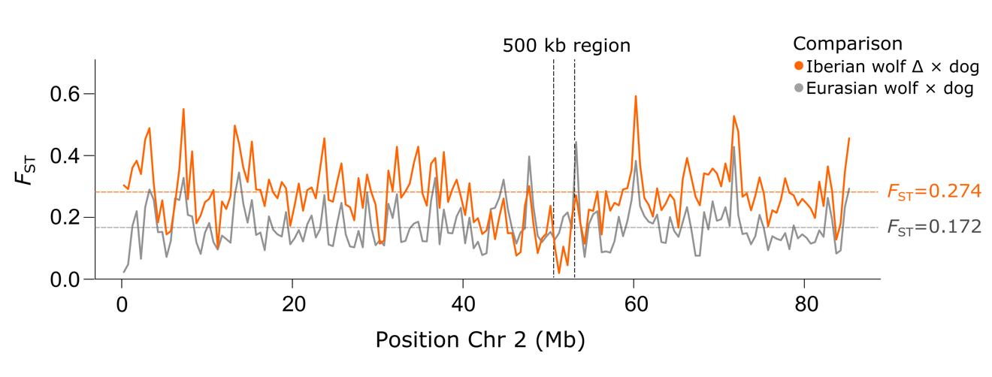
Supplemental Figure S9. Levels of genetic differentiation (F_{ST}) in chromosome 2 using WGS data. Weighted F_{ST} values estimated along Chromosome 2 in 500 kb windows between Iberian wolves with the ∆block (N = 6) and dogs (N = 11) (orange line), and Eurasian wolves (N = 10) and dogs (N = 11) (gray line). The vertical dotted black bar indicates the position of the 500 kb region with the highest fraction of introgression between Iberian wolves and dogs (Chr 2: 52-52.5 Mb). Average chromosome wide F_{ST} values are presented at the right for each comparison (horizontal dotted lines).

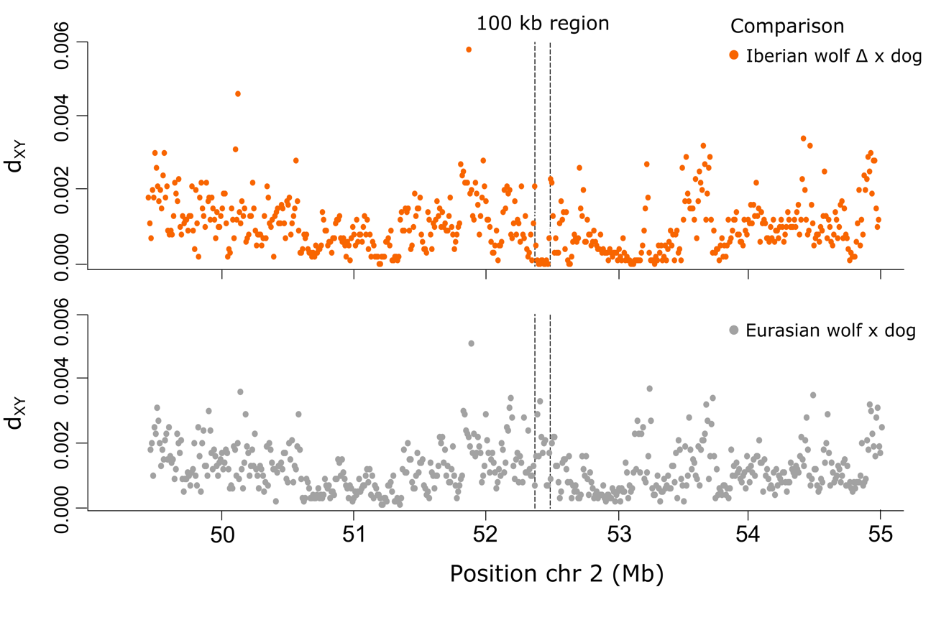
Supplemental Figure S10. Levels of genetic divergence (d_{XY}) in the introgressed ∆block. Mean pairwise sequence divergence (d_{XY}) between Iberian wolves with the ∆block (N = 6) and dogs (N = 11) (orange dots), and Eurasian wolves (N = 10) and dogs (N = 11) (gray dots), estimated in 10 kb non-overlapping windows for all sites within 6 Mb haplotypes surrounding ∆block. The dotted black bars indicate the position of the 100 kb introgressed haplotype. Each dot denotes a 10 kb window.

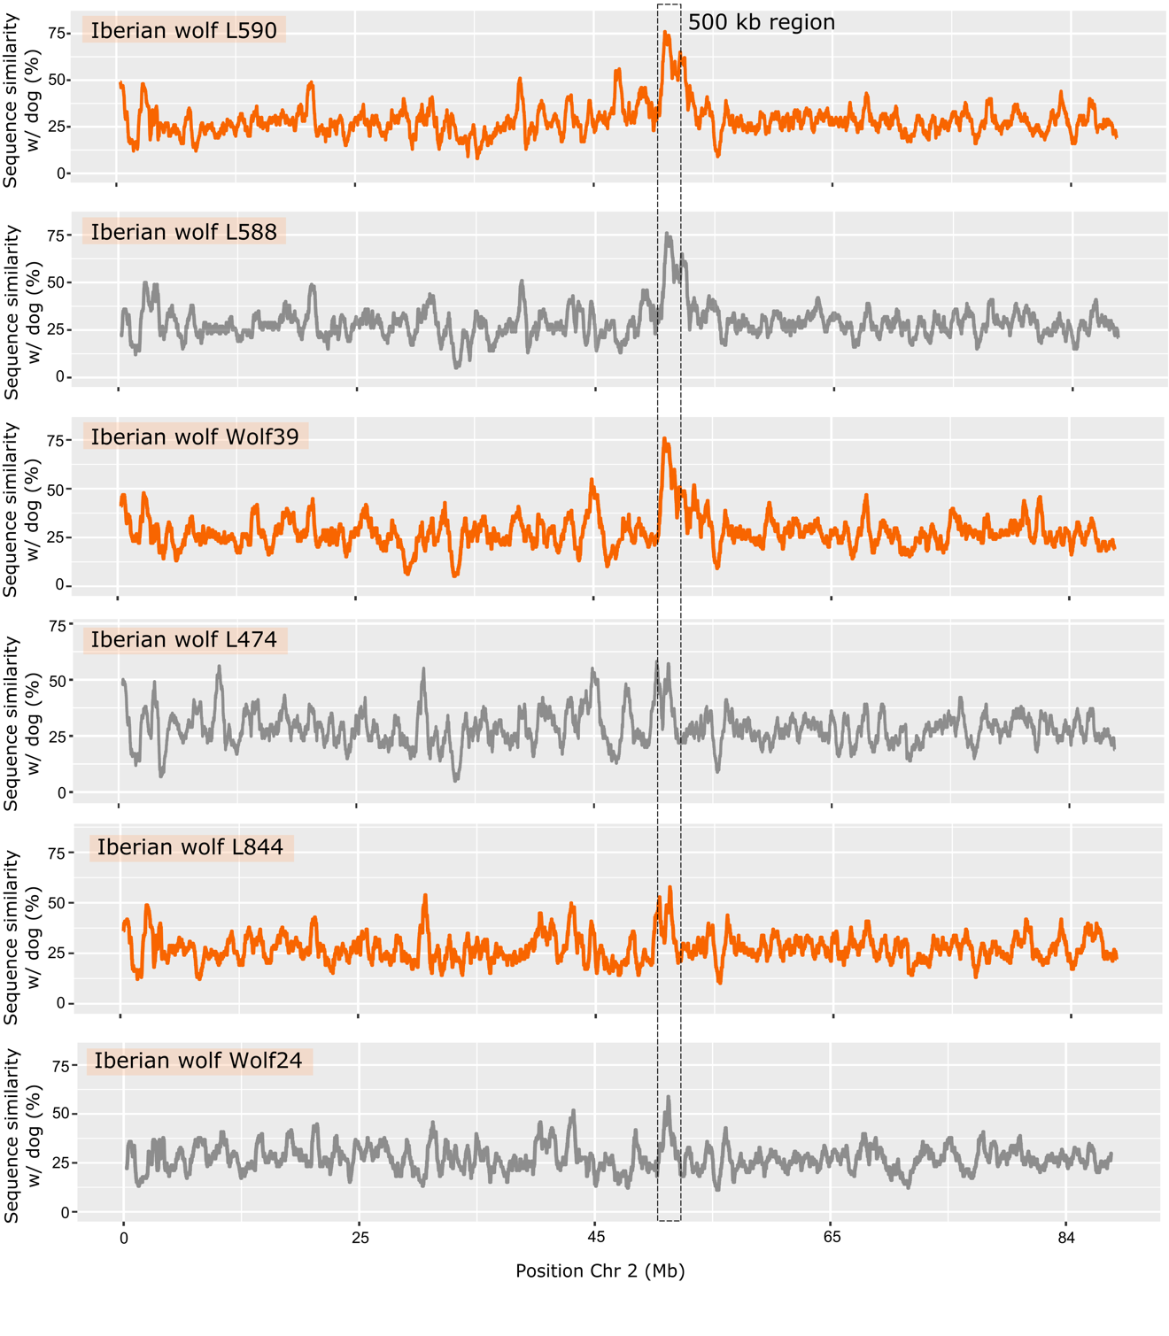
Supplemental Figure S11. Levels of genetic sequence similarity with HYBRIDCHECK. Pairwise sequence similarity (%) between Iberian wolves with the ∆block and a village dog from Portugal (“VillDog_PT01”), estimated in HYBRIDCHECK using pseudo haplotype sequence alignments of 420,699 concatenated SNPs spanning the entire Chromosome 2. The percentage of sequence similarity was estimated across the chromosome in 1 kb windows. The vertical dotted black bar indicates the position of the 500 kb region with the highest fraction of introgression between Iberian wolves and dogs (Chr 2: 52-52.5 Mb).

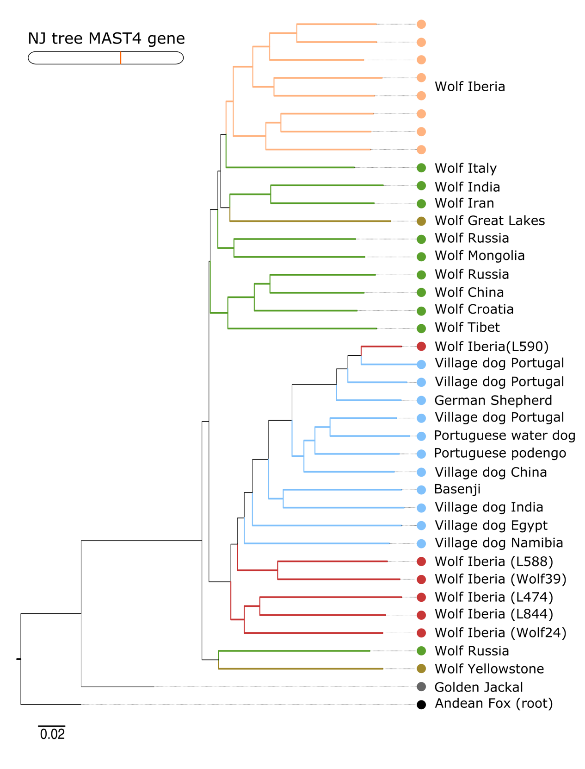

Supplemental Figure S12. Phylogenetic relationships in MAST4 gene. Neighbor-joining tree estimated based on genetic distances for a pseudo sequence alignment of 2,158 concatenated SNPs spanning the MAST4 gene (~447 kb). Samples from Iberian, Eurasian and North American wolves are identified in light orange, green and dark yellow, respectively. Dogs are represented in blue and Iberian wolves with the introgressed ∆ haplotype in red. Outgroup canid species are identified in gray and black colors.

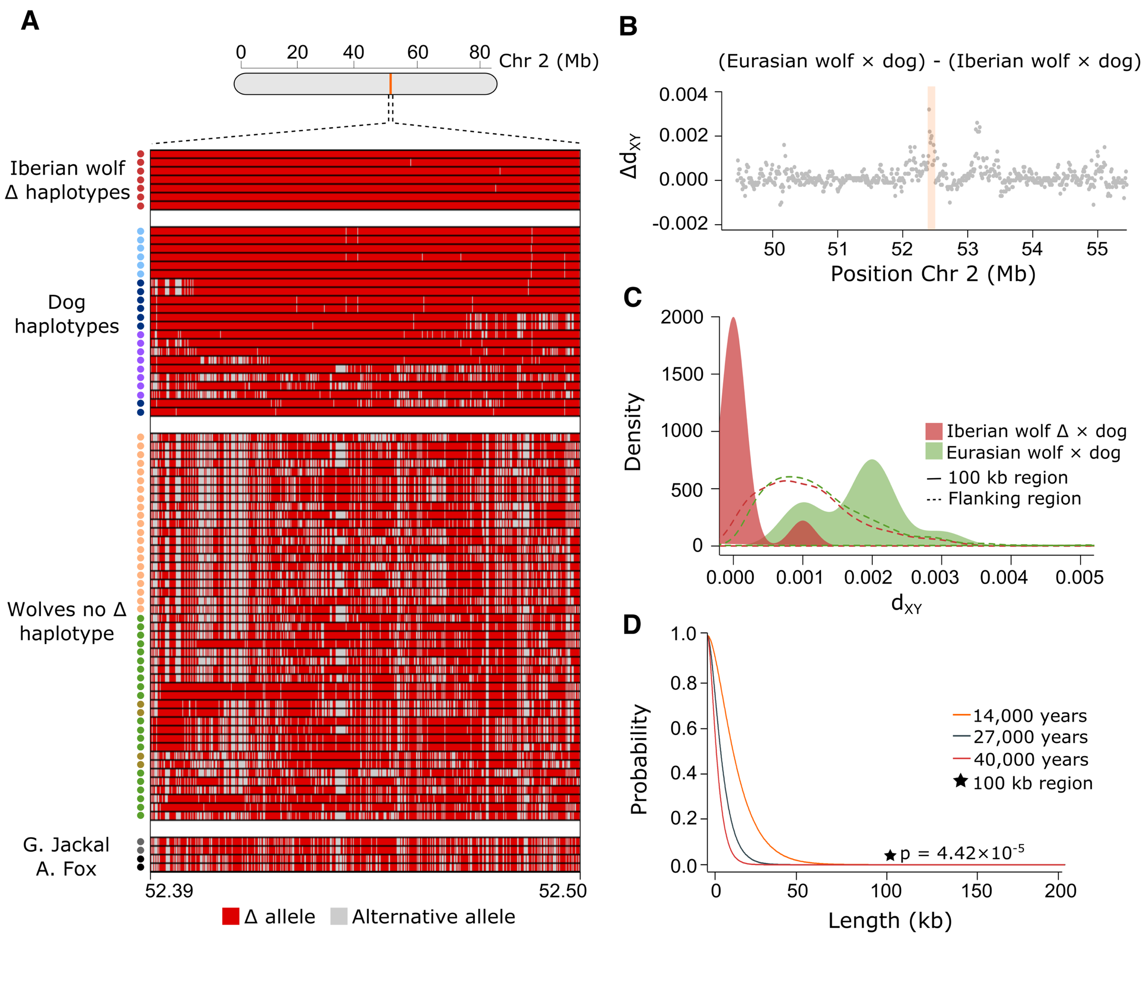

Supplemental Figure S13. Haplotype length probabilities. Probability distribution of maintaining a haplotype of 0-200 kb length due to ancestral shared variation, assuming the average Chromosome 2 recombination rate and three divergence time estimates between gray wolves and dogs (represented by distinct colors). The black star indicates the p-value associated with the introgressed haplotype (for 14 Kya).

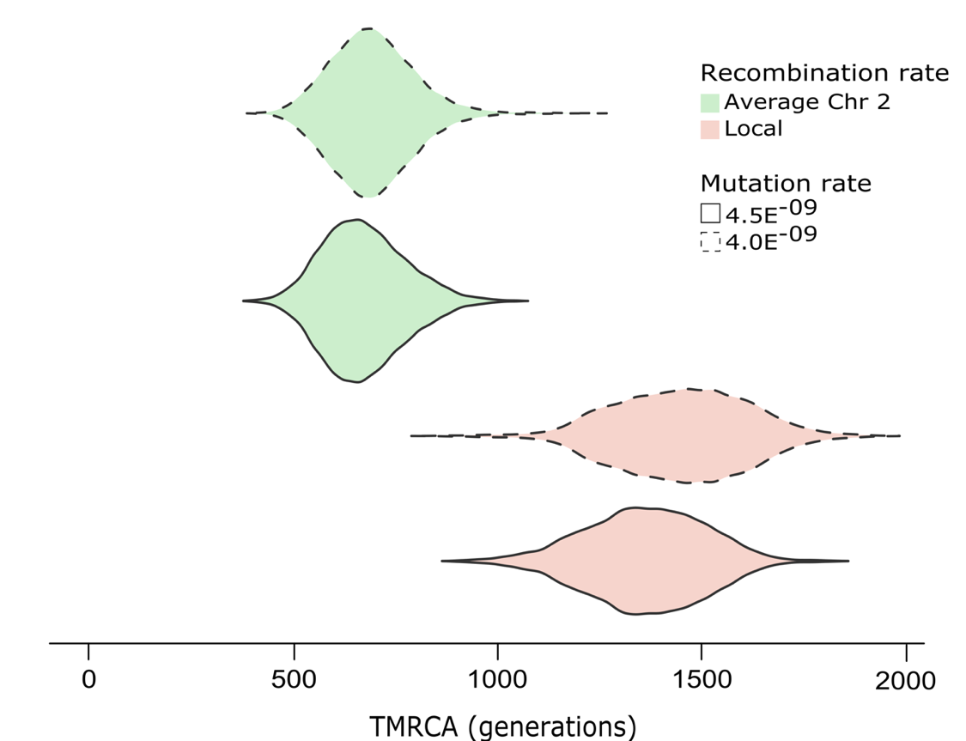

Supplemental Figure S14. Time distribution of the introgressed haplotype. Estimates of TMRCA of the 100 kb introgressed haplotype in Iberian wolves using STARTMRCA and considering two estimates of recombination and mutation rates. Violin plots represent the distribution of TMRCA from 10,000 MCMC iterations.

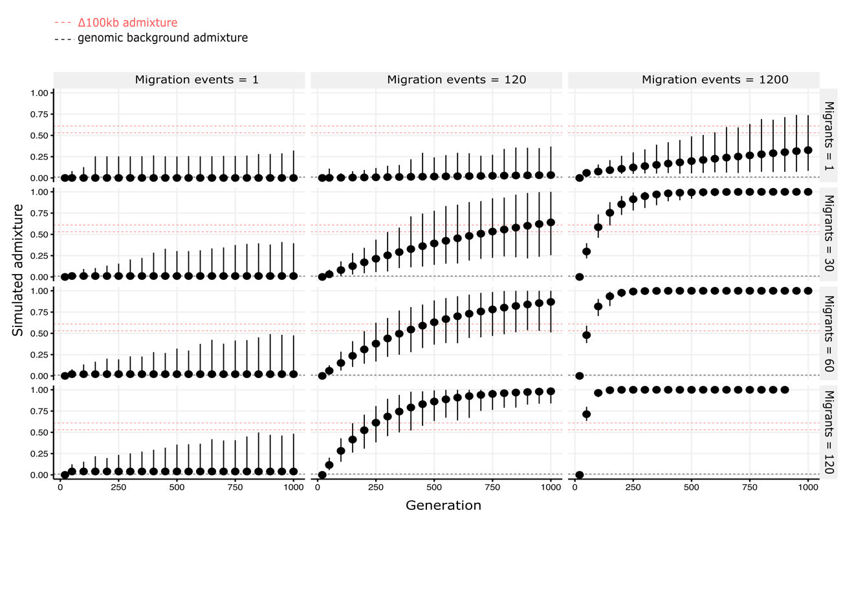

Supplemental Figure S15. Neutral simulations. Mean and standard deviation of 100 simulated replicates in SLiM for average chromosome-wide admixture per generation (0 represents the present time) across neutral models. A range of migration events and number of migrants were simulated. When few events of hybridization were simulated, we never reached the level of empirical admixture observed in the introgressed 100 kb region. Conversely, when multiple events were simulated, the wolf genomic background rapidly became highly admixed, a scenario inconsistent with the empirical levels of dog ancestry found in the Iberian wolf genome. Empirical estimates of dog admixture within the 100 kb region (0.53-0.60; 95% CI of ELAI average estimate) and genome-wide level (0.01) are shown in red and black dashed lines, respectively.

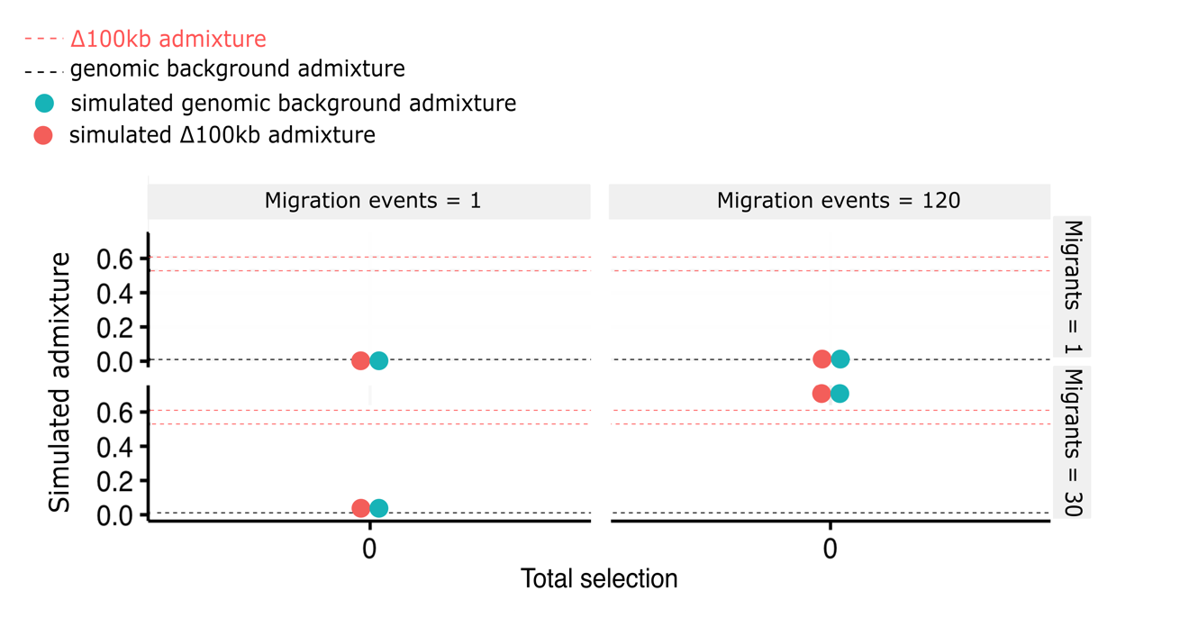
Supplemental Figure S16. Levels of admixture inside and outside the introgressed block in neutral simulations. Mean across 100 simulated replicates for average background admixture (outside 100 kb introgressed region; blue dots) and within the introgressed 100 kb region (red dots) across neutral models. Values were retrieved and summarized for the last generation in the simulations (1200 generations) and for the parameters that recovered likely scenarios in neutral models of the genomic background (1 and 120 migration events; 1 and 30 migrants). The simulated levels of dog ancestry in the introgressed 100 kb region mirrored those in the genomic background, contradicting our empirical observations (empirical estimates of dog admixture within the 100 kb region and at genome-wide level are shown in red and black dashed lines, respectively).

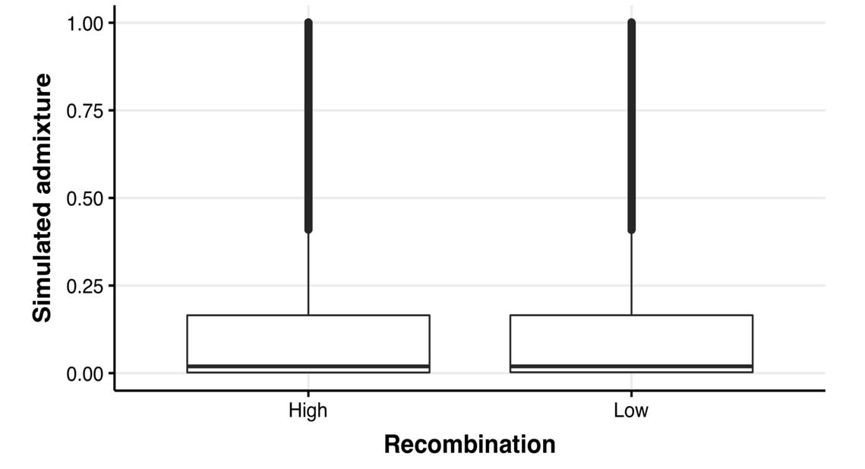

Supplemental Figure S17. Effects of distinct recombination rates on simulated admixture levels. Boxplots displaying the average simulated admixture in neutral simulations for genomic regions with the highest and lowest recombination rates found in Chromosome 2. Neutrality and distinct recombination rates did no not lead to variable levels of dog admixture, suggesting that low or suppressed recombination rate cannot account for the empirical patterns in the introgressed 100 kb region.

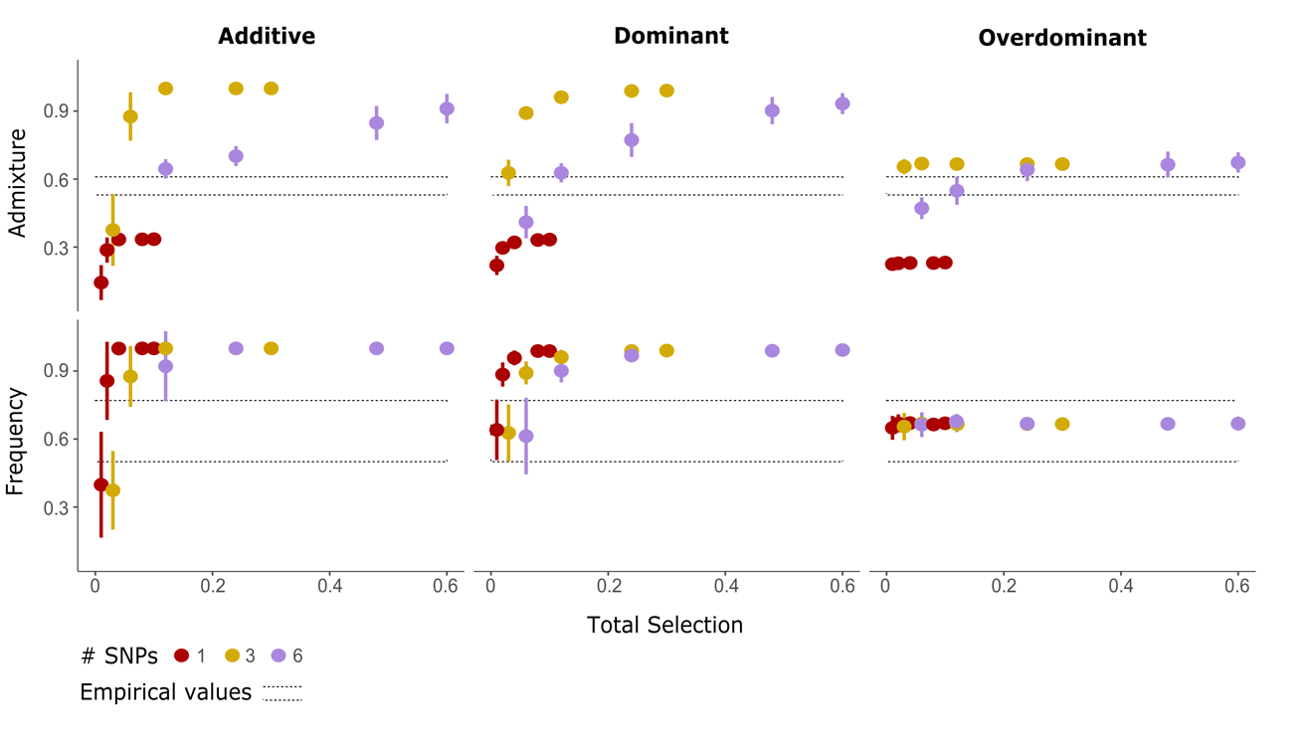
Supplemental Figure S18. Individual-based simulations of adaptive introgression. Mean and standard deviation of simulated admixture and frequency of introgressed alleles for the 100 kb introgressed region across 100 simulated replicates. The models considered one migrant and one migration event. Simulations explored neutral evolution (selection = 0), an additive model (h = 0.5), dominant model (h = 1), and overdominant model (h = 2), with a range of selection coefficients (s = 0-0.1) for 1, 3 or 6 introgressed SNPs (denoted with distinct colors), resulting in a total amount of selection ranging from 0 to 0.6 (x-axis). Empirical estimates of admixture (0.53-0.60; 95% CI of ELAI average estimate) and mean frequency of introgressed alleles (Supplemental Table S5) in the 100 kb region are represented by dashed lines.
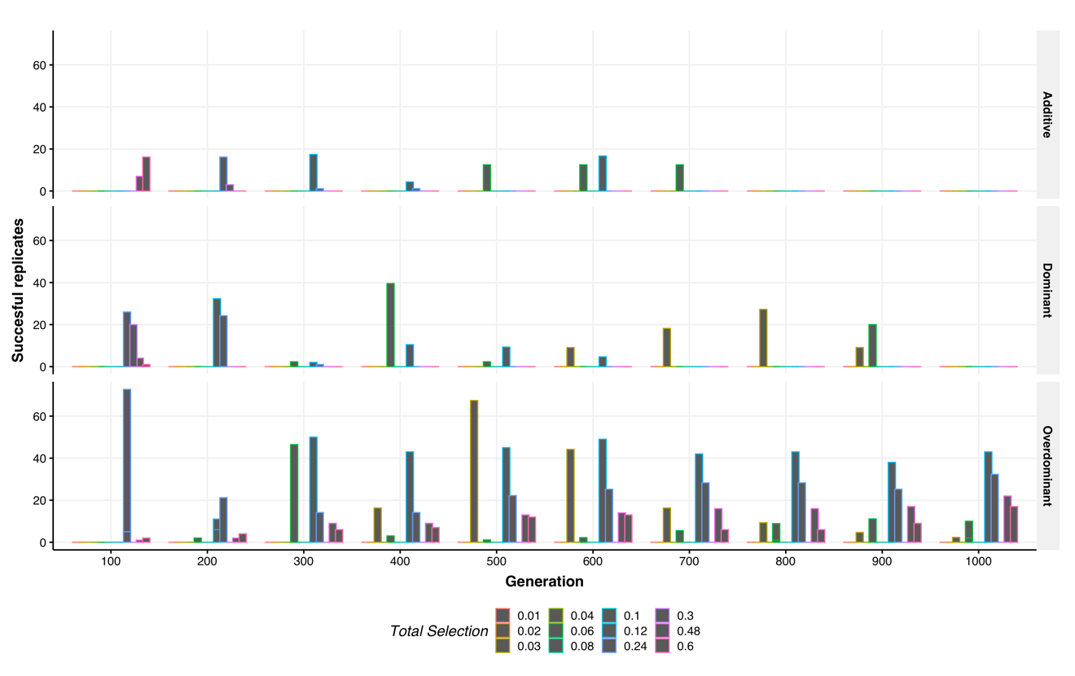
Supplemental Figure S19. Successful replicates across simulations. Number of replicates that successfully recovered the empirical patterns of admixture and allele frequencies per generation across 100 replicates for different models of selection. A range of simulated selection coefficients (s = 0-0.1) for 1, 3 or 6 introgressed SNPs resulted in a total amount of selection ranging from 0 to 0.6 (color gradient).

Supplemental Tables

Supplemental Table S1. Description of the SNP dataset used in this study. Information about sample ID, population, group, locality, and the study that generated data for each sample, are provided.

Sample ID | Population/Dog breed | Group | Locality | Study
1 | Maremma Sheepdog | Purebred dog | Italy | This study
2 | Maremma Sheepdog | Purebred dog | Italy | This study
1308 | Leonberger | Purebred dog | Germany | This study
1309 | Leonberger | Purebred dog | Germany | This study
DA172 | Great Dane | Purebred dog | Germany | This study
DA179 | Great Dane | Purebred dog | Germany | This study
Kom660 | Komondor | Purebred dog | Hungary | This study
SB513 | Saint Bernard | Purebred dog | Central Europe | This study
SB514 | Saint Bernard | Purebred dog | Central Europe | This study
CGT33 | Cão de Gado Transmontano | Purebred dog | Portugal | This study + [1]
CGT34 | Cão de Gado Transmontano | Purebred dog | Portugal | This study + [1]
CGT36 | Cão de Gado Transmontano | Purebred dog | Portugal | This study + [1]
CGT38 | Cão de Gado Transmontano | Purebred dog | Portugal | This study + [1]
CGT39 | Cão de Gado Transmontano | Purebred dog | Portugal | This study + [1]
CCL22 | Castro Laboreiro | Purebred dog | Portugal | This study + [1]
CCL32 | Castro Laboreiro | Purebred dog | Portugal | This study + [1]
CL04 | Castro Laboreiro | Purebred dog | Portugal | This study + [1]
CL5 | Castro Laboreiro | Purebred dog | Portugal | This study + [1]
CL11 | Castro Laboreiro | Purebred dog | Portugal | This study + [1]
ME134 | Mastin Español | Purebred dog | Spain | This study
ME_Leon11 | Mastin Español | Purebred dog | Spain | This study
ME257 | Mastin Español | Purebred dog | Spain | This study
ME259 | Mastin Español | Purebred dog | Spain | This study
ME_Avispado | Mastin Español | Purebred dog | Spain | This study
MoP361 | Montaña del Pirineo | Purebred dog | Spain | This study
MoP577 | Montaña del Pirineo | Purebred dog | Spain | This study
MoP579 | Montaña del Pirineo | Purebred dog | Spain | This study
MoP583 | Montaña del Pirineo | Purebred dog | Spain | This study
MoP581 | Montaña del Pirineo | Purebred dog | Spain | This study
RA01 | Rafeiro do Alentejo | Purebred dog | Portugal | This study + [1]
RA05 | Rafeiro do Alentejo | Purebred dog | Portugal | This study + [1]
RA16 | Rafeiro do Alentejo | Purebred dog | Portugal | This study + [1]
RA22 | Rafeiro do Alentejo | Purebred dog | Portugal | This study + [1]
RA23 | Rafeiro do Alentejo | Purebred dog | Portugal | This study + [1]
SE_EMD004 | Serra da Estrela | Purebred dog | Portugal | This study + [1]
SE_EMD009 | Serra da Estrela | Purebred dog | Portugal | This study + [1]
SE_EMD016 | Serra da Estrela | Purebred dog | Portugal | This study + [1]
SE_EMD021 | Serra da Estrela | Purebred dog | Portugal | This study + [1]
SE_EMD030 | Serra da Estrela | Purebred dog | Portugal | This study + [1]
ASh_LU1 | Australian Shepherd | Purebred dog | -- | [2,3]
BeT_GT25 | Belgian Tervuren | Purebred dog | -- | [2,3]
BeT_GT27 | Belgian Tervuren | Purebred dog | -- | [2,3]
Bgl_GT1 | Beagle | Purebred dog | -- | [2,3]
Bgl_GT5 | Beagle | Purebred dog | -- | [2,3]
BMD_GT30 | Bernese Mountain Dog | Purebred dog | -- | [2,3]
BMD_GT31 | Bernese Mountain Dog | Purebred dog | -- | [2,3]
BoC_GT55 | Border Collie | Purebred dog | -- | [2,3]
BoC_GT56 | Border Collie | Purebred dog | -- | [2,3]
BrS_GT76 | Brittany Spaniel | Purebred dog | -- | [2,3]
BrS_GT83 | Brittany Spaniel | Purebred dog | -- | [2,3]
Chi_LU135 | Chihuahua | Purebred dog | -- | [2,3]
Chi_LU136 | Chihuahua | Purebred dog | -- | [2,3]
CKC_GT88 | Cavalier King Charles Spaniel | Purebred dog | -- | [2,3]
CKC_LU138 | Cavalier King Charles Spaniel | Purebred dog | -- | [2,3]
CoS_GT91 | Cocker Spaniel | Purebred dog | -- | [2,3]
CoS_GT93 | Cocker Spaniel | Purebred dog | -- | [2,3]
Dac_GT111 | Dachshund | Purebred dog | -- | [2,3]
Dac_GT117 | Dachshund | Purebred dog | -- | [2,3]
Dal_GT122 | Dalmatian | Purebred dog | -- | [2,3]
Dal_GT123 | Dalmatian | Purebred dog | -- | [2,3]
ECS_LU437 | English Cocker Spaniel | Purebred dog | -- | [2,3]
ECS_LU438 | English Cocker Spaniel | Purebred dog | -- | [2,3]
Elk_GT128 | Elkhound | Purebred dog | -- | [2,3]
Elk_GT129 | Elkhound | Purebred dog | -- | [2,3]
ESS_LU598 | English Springer Spaniel | Purebred dog | -- | [2,3]
ESS_LU600 | English Springer Spaniel | Purebred dog | -- | [2,3]
ESt_GT162 | English Setter | Purebred dog | -- | [2,3]
ESt_GT163 | English Setter | Purebred dog | -- | [2,3]
FcR_GT198 | Flatcoated Retriever | Purebred dog | -- | [2,3]
FcR_GT199 | Flatcoated Retriever | Purebred dog | -- | [2,3]
GoS_LU604 | Gordon Setter | Purebred dog | -- | [2,3]
GoS_LU606 | Gordon Setter | Purebred dog | -- | [2,3]
GRe_GT214 | Golden Retriever | Purebred dog | -- | [2,3]
GRe_GT217 | Golden Retriever | Purebred dog | -- | [2,3]
Gry_GT239 | Greyhound | Purebred dog | -- | [2,3]
Gry_GT240 | Greyhound | Purebred dog | -- | [2,3]
GSh_GT200 | German Shepherd | Purebred dog | -- | [2,3]
GSh_GT201 | German Shepherd | Purebred dog | -- | [2,3]
IrW_LU1210 | Irish Wolfhound | Purebred dog | -- | [2,3]
IrW_LU1211 | Irish Wolfhound | Purebred dog | -- | [2,3]
JRT_GT250 | Jack Russell Terrier | Purebred dog | -- | [2,3]
JRT_GT251 | Jack Russell Terrier | Purebred dog | -- | [2,3]
LMu_GT279 | Large Munsterlander | Purebred dog | -- | [2,3]
LRe_GT264 | Labrador Retriever | Purebred dog | -- | [2,3]
LRe_GT266 | Labrador Retriever | Purebred dog | -- | [2,3]
Mop_GT280 | Mops | Purebred dog | -- | [2,3]
Mop_GT282 | Mops | Purebred dog | -- | [2,3]
Pdl_GT328 | Poodle | Purebred dog | -- | [2,3]
Pdl_GT345 | Poodle | Purebred dog | -- | [2,3]
Rtw_GT348 | Rottweiler | Purebred dog | -- | [2,3]
Rtw_GT349 | Rottweiler | Purebred dog | -- | [2,3]
Scn_LU1563 | Schnauzer | Purebred dog | -- | [2,3]
Scn_LU1565 | Schnauzer | Purebred dog | -- | [2,3]
StP_GT376 | Standard Poodle | Purebred dog | -- | [2,3]
StP_GT379 | Standard Poodle | Purebred dog | -- | [2,3]
TYo_GT388 | Yorkshire Terrier | Purebred dog | -- | [2,3]
TYo_GT390 | Yorkshire Terrier | Purebred dog | -- | [2,3]
CR2 | Village dog | Village dog | Portugal | This study + [1]
CR9 | Village dog | Village dog | Portugal | This study + [1]
CR11 | Village dog | Village dog | Portugal | This study + [1]
CR14 | Village dog | Village dog | Portugal | This study + [1]
CR35 | Village dog | Village dog | Portugal | This study + [1]
CR39 | Village dog | Village dog | Spain | This study + [1]
CR44 | Village dog | Village dog | Spain | This study + [1]
CR63 | Village dog | Village dog | Portugal | This study + [1]
CR64 | Village dog | Village dog | Portugal | This study + [1]
CR65 | Village dog | Village dog | Portugal | This study + [1]
CR67 | Village dog | Village dog | Portugal | This study + [1]
CR68 | Village dog | Village dog | Portugal | This study + [1]
CR77 | Village dog | Village dog | Portugal | This study + [1]
CR80 | Village dog | Village dog | Portugal | This study + [1]
CR97 | Village dog | Village dog | Portugal | This study + [1]
CR98 | Village dog | Village dog | Portugal | This study + [1]
CR104 | Village dog | Village dog | Portugal | This study + [1]
L400 | Village dog | Village dog | Portugal | This study + [1]
L501 | Village dog | Village dog | Portugal | This study + [1]
L624 | Village dog | Village dog | Spain | This study + [1]
L652 | Village dog | Village dog | Spain | This study + [1]
L744 | Village dog | Village dog | Spain | This study + [1]
L791 | Village dog | Village dog | Spain | This study + [1]
L005 | Iberian Wolf | Iberian Wolf | Bragança, Portugal | This study + [1]
L010 | Iberian Wolf | Iberian Wolf | Bragança, Portugal | This study + [1]
L029 | Iberian Wolf | Iberian Wolf | Vila Real, Portugal | This study + [1]
L053 | Iberian Wolf | Iberian Wolf | Bragança, Portugal | This study
L063 | Iberian Wolf | Iberian Wolf | Asturias, Spain | This study + [1]
L086 | Iberian Wolf | Iberian Wolf | Viseu, Portugal | This study + [1]
L090 | Iberian Wolf | Iberian Wolf | Bragança, Portugal | This study
L091 | Iberian Wolf | Iberian Wolf | Bragança, Portugal | This study
L102 | Iberian Wolf | Iberian Wolf | Bragança, Portugal | This study + [1]
L116 | Iberian Wolf | Iberian Wolf | Galicia, Spain | This study + [1]
L125 | Iberian Wolf | Iberian Wolf | Viana do Castelo, Portugal | This study + [1]
L180 | Iberian Wolf | Iberian Wolf | Asturias, Spain | This study + [1]
L186 | Iberian Wolf | Iberian Wolf | Asturias, Spain | This study + [1]
L188 | Iberian Wolf | Iberian Wolf | Asturias, Spain | This study + [1]
L190 | Iberian Wolf | Iberian Wolf | Asturias, Spain | This study + [1]
L195 | Iberian Wolf | Iberian Wolf | Asturias, Spain | This study
L200 | Iberian Wolf | Iberian Wolf | Asturias, Spain | This study
L212 | Iberian Wolf | Iberian Wolf | Asturias, Spain | This study + [1]
L253 | Iberian Wolf | Iberian Wolf | Galicia, Spain | This study + [1]
L262 | Iberian Wolf | Iberian Wolf | Galicia, Spain | This study + [1]
L286 | Iberian Wolf | Iberian Wolf | Castilla y Leon, Spain | This study
L298 | Iberian Wolf | Iberian Wolf | Vila Real, Portugal | This study
L316 | Iberian Wolf | Iberian Wolf | Viana do Castelo, Portugal | This study + [1]
L319 | Iberian Wolf | Iberian Wolf | Castilla y Leon, Spain | This study + [1]
L320 | Iberian Wolf | Iberian Wolf | Castilla y Leon, Spain | This study + [1]
L322 | Iberian Wolf | Iberian Wolf | Viana do Castelo, Portugal | This study
L337 | Iberian Wolf | Iberian Wolf | Viana do Castelo, Portugal | This study + [1]
L338 | Iberian Wolf | Iberian Wolf | Galicia, Spain | This study + [1]
L351 | Iberian Wolf | Iberian Wolf | Asturias, Spain | This study + [1]
L357 | Iberian Wolf | Iberian Wolf | Asturias, Spain | This study + [1]
L360 | Iberian Wolf | Iberian Wolf | Galicia, Spain | This study + [1]
L363 | Iberian Wolf | Iberian Wolf | Galicia, Spain | This study
L364 | Iberian Wolf | Iberian Wolf | Galicia, Spain | This study + [1]
L365 | Iberian Wolf | Iberian Wolf | Galicia, Spain | This study
L367 | Iberian Wolf | Iberian Wolf | Galicia, Spain | This study
L370 | Iberian Wolf | Iberian Wolf | Galicia, Spain | This study
L382 | Iberian Wolf | Iberian Wolf | Asturias, Spain | This study + [1]
L384 | Iberian Wolf | Iberian Wolf | Asturias, Spain | This study
L387 | Iberian Wolf | Iberian Wolf | Asturias, Spain | This study + [1]
L392 | Iberian Wolf | Iberian Wolf | Viana do Castelo, Portugal | This study + [1]
L401 | Iberian Wolf | Iberian Wolf | Galicia, Spain | This study + [1]
L409 | Iberian Wolf | Iberian Wolf | Galicia, Spain | This study
L410 | Iberian Wolf | Iberian Wolf | Galicia, Spain | This study
L419 | Iberian Wolf | Iberian Wolf | Asturias, Spain | This study
L422 | Iberian Wolf | Iberian Wolf | Viseu, Portugal | This study + [1]
L429 | Iberian Wolf | Iberian Wolf | Guarda, Portugal | This study
L431 | Iberian Wolf | Iberian Wolf | Asturias, Spain | This study + [1]
L446 | Iberian Wolf | Iberian Wolf | Asturias, Spain | This study + [1]
L474 | Iberian Wolf | Iberian Wolf | Bragança, Portugal | [4]
L475 | Iberian Wolf | Iberian Wolf | Guarda, Portugal | This study
L502 | Iberian Wolf | Iberian Wolf | Galicia, Spain | This study + [1]
L509 | Iberian Wolf | Iberian Wolf | Galicia, Spain | This study + [1]
L511 | Iberian Wolf | Iberian Wolf | Galicia, Spain | This study
L514 | Iberian Wolf | Iberian Wolf | Galicia, Spain | This study + [1]
L546 | Iberian Wolf | Iberian Wolf | Galicia, Spain | This study + [1]
L547 | Iberian Wolf | Iberian Wolf | Galicia, Spain | This study + [1]
L552 | Iberian Wolf | Iberian Wolf | Asturias, Spain | This study
L556 | Iberian Wolf | Iberian Wolf | Asturias, Spain | This study
L577 | Iberian Wolf | Iberian Wolf | Castilla y Leon, Spain | This study + [1]
L580 | Iberian Wolf | Iberian Wolf | Castilla y Leon, Spain | This study + [1]
L582 | Iberian Wolf | Iberian Wolf | Castilla y Leon, Spain | This study
L583 | Iberian Wolf | Iberian Wolf | Castilla y Leon, Spain | This study
L585 | Iberian Wolf | Iberian Wolf | Castilla y Leon, Spain | [4]
L586 | Iberian Wolf | Iberian Wolf | Castilla y Leon, Spain | This study
L588 | Iberian Wolf | Iberian Wolf | Castilla y Leon, Spain | This study
L589 | Iberian Wolf | Iberian Wolf | Castilla y Leon, Spain | This study
L590 | Iberian Wolf | Iberian Wolf | Castilla y Leon, Spain | This study
L596 | Iberian Wolf | Iberian Wolf | Vila Real, Portugal | This study + [1]
L619 | Iberian Wolf | Iberian Wolf | Asturias, Spain | This study
L625 | Iberian Wolf | Iberian Wolf | Galicia, Spain | This study + [1]
L639 | Iberian Wolf | Iberian Wolf | Asturias, Spain | This study
L649 | Iberian Wolf | Iberian Wolf | Asturias, Spain | This study + [1]
L650 | Iberian Wolf | Iberian Wolf | Asturias, Spain | This study
L679 | Iberian Wolf | Iberian Wolf | Vila Real, Portugal | This study
L713 | Iberian Wolf | Iberian Wolf | Castilla y Leon, Spain | This study + [1]
L768 | Iberian Wolf | Iberian Wolf | Galicia, Spain | This study + [1]
L772 | Iberian Wolf | Iberian Wolf | Viseu, Portugal | This study + [1]
L780 | Iberian Wolf | Iberian Wolf | Viana do Castelo, Portugal | This study + [1]
L781 | Iberian Wolf | Iberian Wolf | Galicia, Spain | This study + [1]
L783 | Iberian Wolf | Iberian Wolf | Galicia, Spain | This study + [1]
L788 | Iberian Wolf | Iberian Wolf | Galicia, Spain | This study + [1]
L790 | Iberian Wolf | Iberian Wolf | Galicia, Spain | This study + [1]
L795 | Iberian Wolf | Iberian Wolf | Viana do Castelo, Portugal | This study + [1]
L798 | Iberian Wolf | Iberian Wolf | Galicia, Spain | This study + [1]
L800 | Iberian Wolf | Iberian Wolf | Galicia, Spain | This study + [1]
L801 | Iberian Wolf | Iberian Wolf | Galicia, Spain | This study + [1]
L802 | Iberian Wolf | Iberian Wolf | Galicia, Spain | This study
L804 | Iberian Wolf | Iberian Wolf | Galicia, Spain | This study
L805 | Iberian Wolf | Iberian Wolf | Galicia, Spain | This study + [1]
L806 | Iberian Wolf | Iberian Wolf | Asturias, Spain | This study + [1]
L819 | Iberian Wolf | Iberian Wolf | Castilla y Leon, Spain | This study + [1]
L820 | Iberian Wolf | Iberian Wolf | Castilla y Leon, Spain | This study
L825 | Iberian Wolf | Iberian Wolf | Asturias, Spain | This study + [1]
L844 | Iberian Wolf | Iberian Wolf | Castilla y Leon, Spain | This study
L845 | Iberian Wolf | Iberian Wolf | Castilla La Mancha, Spain | This study + [1]
5 | European Wolf | Eurasian Wolf | Poland | [5]
15 | European Wolf | Eurasian Wolf | Belarus | [5]
L112 | European Wolf | Eurasian Wolf | Romania | This study
L114 | European Wolf | Eurasian Wolf | Romania | This study
L525 | European Wolf | Eurasian Wolf | Slovenia | This study
L527 | European Wolf | Eurasian Wolf | Slovenia | This study
L743 | Western Asian Wolf | Eurasian Wolf | Iran | This study
27 | European Wolf | Eurasian Wolf | Belarus | [5]
52 | European Wolf | Eurasian Wolf | Belarus | [5]
57 | European Wolf | Eurasian Wolf | Belarus | [5]
62 | European Wolf | Eurasian Wolf | Latvia | [5]
103 | European Wolf | Eurasian Wolf | Belarus | [5]
112 | European Wolf | Eurasian Wolf | Belarus | [5]
128 | European Wolf | Eurasian Wolf | Latvia | [5]
132 | European Wolf | Eurasian Wolf | Latvia | [5]
133 | European Wolf | Eurasian Wolf | Belarus | [5]
163 | European Wolf | Eurasian Wolf | Russia | [5]
203 | European Wolf | Eurasian Wolf | Belarus | [5]
206 | European Wolf | Eurasian Wolf | Belarus | [5]
378 | European Wolf | Eurasian Wolf | Ukraine | [5]
424 | European Wolf | Eurasian Wolf | Russia | [5]
444 | European Wolf | Eurasian Wolf | Russia | [5]
527 | European Wolf | Eurasian Wolf | Ukraine | [5]
548 | European Wolf | Eurasian Wolf | Ukraine | [5]
562 | European Wolf | Eurasian Wolf | Ukraine | [5]
563 | European Wolf | Eurasian Wolf | Ukraine | [5]
689 | European Wolf | Eurasian Wolf | Poland | [5]
846 | European Wolf | Eurasian Wolf | Poland | [5]
987 | European Wolf | Eurasian Wolf | Poland | [5]
988 | European Wolf | Eurasian Wolf | Poland | [5]
1003 | European Wolf | Eurasian Wolf | Bulgaria | [5]
1135 | European Wolf | Eurasian Wolf | Latvia | [5]
1148 | European Wolf | Eurasian Wolf | Latvia | [5]
1150 | European Wolf | Eurasian Wolf | Latvia | [5]
1174 | European Wolf | Eurasian Wolf | Croatia | [5]
1219 | European Wolf | Eurasian Wolf | Croatia | [5]
1262 | European Wolf | Eurasian Wolf | Finland | [5]
1263 | European Wolf | Eurasian Wolf | Finland | [5]
1267 | European Wolf | Eurasian Wolf | Finland | [5]
1271 | European Wolf | Eurasian Wolf | Finland | [5]
1282 | European Wolf | Eurasian Wolf | Finland | [5]
1344 | European Wolf | Eurasian Wolf | Ukraine | [5]
1345 | European Wolf | Eurasian Wolf | Ukraine | [5]
1382 | European Wolf | Eurasian Wolf | Greece | [5]
1387 | European Wolf | Eurasian Wolf | Greece | [5]
895 | European Wolf | Eurasian Wolf | Bulgaria | [5]
1032 | European Wolf | Eurasian Wolf | Bulgaria | [5]
1224 | European Wolf | Eurasian Wolf | Croatia | [5]
833 | European Wolf | Eurasian Wolf | Poland | [5]
897 | European Wolf | Eurasian Wolf | Poland | [5]
1381 | European Wolf | Eurasian Wolf | Poland | [5]
574 | European Wolf | Eurasian Wolf | Russia | [5]
584 | European Wolf | Eurasian Wolf | Russia | [5]
553 | European Wolf | Eurasian Wolf | Ukraine | [5]
347 | European Wolf | Eurasian Wolf | Slovakia | [5]

[1] – Lobo et al. 2023. We used some samples genotyped in parallel in study [1] but increased the number of SNPs (data available on OSF with DOI 10.17605/OSF.IO/N3CDR).
[2] – Lequarré et al. 2011
[3] – Vaysse et al. 2011
[4] – Pacheco, Lobo et al. 2022
[5] – Stronen et al. 2015

Supplemental Table S2. Genes within ∆block. Description of the 22 protein-coding genes located within ∆block in chromosome 2. This information is accordingly to the CanFam3.1 Ensembl annotation.

Gene ID | Gene Description | Start | End
HTR1A | 5-hydroxytryptamine receptor 1A | 50,002,740 | 50,006,548
RNF180 | Ring finger protein 180 | 50,197,137 | 50,352,946
RGS7BP | Regulator of G protein signaling 7 binding protein | 50,430,844 | 50,528,673
SHISAL2B | SHISA like 2B | 50,590,487 | 50,606,452
SREK1IP1 | SREK1 interacting protein 1 | 50,612,272 | 50,654,746
CWC27 | CWC27 spliceosome associated cyclophillin | 50,655,037 | 50,846,604
ENSCAFG00000042469 | -- | 50,828,607 | 50,831,060
ADAMTS6 | ADAM metallopeptidase with thrombospondin type 1 motif 6 | 50,955481 | 51,236,421
CENPK | Centromere protein K | 51,263,185 | 51,292,425
PPWD1 | Peptidylpropyl isomerase domain and WD repeat containing 1 | 51,300,182 | 51,320,989
TRIM23 | Tripartite motif containing 23 | 51,325,038 | 51,360,117
TRAPPC13 | Trafficking protein particle complex 13 | 51,360,593 | 51,398,210
SGTB | Small glutamine rich tetratricopeptide repeat | 51,402,856 | 51,445,278
NLN | Neurolysin | 51,444,566 | 51,538,028
ERBIN | ERBB2 interacting protein | 51,613,230 | 51,729,021
ENSCAFG00000043906 | -- | 51,670,843 | 51,671,704
SREK1 | Splicing regulatory glutamic acid and lysine rich protein 1 | 51,761,763 | 51,802,694
MAST4 | Microtubule associated serine threonine kinase family member 4 | 52,185,407 | 52,633,243
ENSCAFG00000042414 | -- | 52,307,006 | 52,285,621
ENSCAFG00000046880 | -- | 52,432,389 | 52,459,478
CD180 | CD180 molecule | 52,645,766 | 53,660,790
ENSCAFG00000049004 | -- | 52,910,756 | 52,912,978

Supplemental Table S3. Description of the whole-genome sequencing dataset used in this study. Information about sample ID, population, accession numbers for SRA and BioSample, mean depth and missing data across the 11.7 M SNPs, and the study that generated data for each sample, are provided. Genotypes for published WGS data were extracted from a vcf file created by Plassais et al. (2019), accessible on NCBI (PRJNA448733).

Sample ID | Population | SRA | BioSample | Study | Mean Depth | Missing (%)
L090 | Wolf Portugal |  | XX | This study + [6] | 14.60 | 0.25
L253 | Wolf Spain | SRS20496639 | SAMN39993575 | This study | 13.11 | 0.07
L351 | Wolf Spain | SRS20496374 | SAMN39993576 | This study | 11.30 | 0.07
L409 | Wolf Spain | SRS20496376 | SAMN39993577 | This study | 14.24 | 0.04
L474 | Wolf Portugal |  | XX | This study + [6] | 11.14 | 0.07
L514 | Wolf Spain | SRS20496375 | SAMN39993578 | This study | 13.40 | 0.05
L546 | Wolf Spain |  | XX | This study + [6] | 14.79 | 0.03
L547 | Wolf Spain | SRS20496644 | SAMN39993579 | This study | 14.21 | 0.05
L552 | Wolf Spain | SRS20496456 | SAMN39993580 | This study | 13.35 | 0.04
L588 | Wolf Spain | SRS20496377 | SAMN39993581 | This study | 15.66 | 0.04
L590 | Wolf Spain |  | XX | This study + [6] | 13.88 | 0.04
L844 | Wolf Spain | SRS20496641 | SAMN39993582 | This study | 12.35 | 0.26
Wolf01 | Wolf Altai, Russia | SRS402038 | SAMN01974486 | [7] | 11.74 | 1.33
Wolf02 | Wolf Chukotka, Russia | SRS402061 | SAMN01974487 | [7] | 9.27 | 1.94
Wolf03 | Wolf Bryansk, Russia | SRS402066 | SAMN01974488 | [7] | 12.04 | 0.59
Wolf04 | Wolf Inner Mongolia | SRS401789 | SAMN01974489 | [7] | 8.48 | 1.91
Wolf05 | Wolf China | SRS1025418 | SAMN03366711 | [8] | 28.29 | 0.10
Wolf06 | Wolf Perković, Croatia | SRS1025420 | SAMN03366712 | [8] | 6.73 | 4.17
Wolf18 | Wolf Great Lakes | SRS661486 | SAMN02921310 | [9] | 26.71 | 0.11
Wolf19 | Wolf India | SRS661487 | SAMN02921311 | [9] | 27.27 | 0.08
Wolf20 | Wolf Iran | SRS661488 | SAMN02921312 | [9] | 28.40 | 0.19
Wolf21 | Wolf Italy | SRS661489 | SAMN02921313 | [9] | 6.06 | 2.83
Wolf24 | Wolf Portugal | SRS661492 | SAMN02921316 | [9] | 26.36 | 0.41
Wolf28 | Wolf Yellowstone | SRS661496 | SAMN02921320 | [9] | 27.69 | 0.11
Wolf39 | Wolf Spain | SRS1397562 | SAMN04851099 | [11] | 38.05 | 0.07
WolfTibetan | Wolf Tibet | SRS933421 | SAMN03653004 | [10] | 24.06 | 0.38
PT49 | Village dog Portugal | SRS1397563 | SAMN04851101 | [12] | 14.81 | 0.27
VillDogPT1 | Village dog Portugal | SRS520079 | SAMN02485604 | [12] | 15.31 | 0.28
VillDogPT2 | Village dog Portugal | SRS520080 | SAMN02485605 | [12] | 13.90 | 0.39
Podengo | Podengo dog Portugal | SRS932163 | SAMN03580388 | [13] | 28.12 | 0.05
WaterDog | Water dog Portugal | SRS3259328 | SAMN08873219 | [14] | 42.85 | 0.04
CFA.118003 | Basenji | SRS1867907 | SAMN06159689 | [13] | 40.14 | 0.07
VillDogChina | Village dog China | SRS402070 | SAMN01974490 | [7] | 18.08 | 5.98
VillDogEgypt | Village dog Egypt | SRS520057 | SAMN02485582 | [12] | 6.92 | 1.74
VillDogIndia | Village dog India | SRS520061 | SAMN02485586 | [12] | 12.89 | 0.84
VillDogNamb | Village dog Namibia | SRS520073 | SAMN02485598 | [12] | 7.71 | 2.22
GShepherd | German Shepherd dog | SRS402078 | SAMN01974494 | [7] | 9.68 | 0.72
G_Jackal | Golden Jackal Israel | SRS1025419 | SAMN03366713 | [8] | 4.85 | 5.88
A_Fox | Andean Fox | SRS523207 | SAMN02487034 | [12] | 14.18 | 3.09

[6] – Ciucani et al. 2023. WGS data for 4 Iberian wolves was generated in parallel through a collaboration with [6] (data available on ENA with accession number PRJEB57290).
[7] – Wang et al. 2013 [8] – Freedman et al. 2014
[9] – Fan et al. 2016 [10] – Zhang et al. 2014
[11] – Botigue et al. 2017 [12] – Auton et al. 2013
[13] – Marsden et al. 2016 [14] – Plassais et al. 2019
Supplemental Table S4. Description of the Iberian wolf historical dataset used in this study. Information about sample ID, population, collection date (year of the original collection), locality within the Iberian Peninsula, and the study that generated data for each sample, are provided.

Sample ID | Population | Collection date | Locality | Study
CL-H010 | Iberian Wolf | 1975 | Castilla y Leon, Spain | [1] [4]
CL-H017 | Iberian Wolf | 1972 | Castilla y Leon, Spain | [1] [4]
CL-H020 | Iberian Wolf | 1974 | Castilla y Leon, Spain | [4]
CL-H022 | Iberian Wolf | 1976 | Castilla y Leon, Spain | [1] [4]
CL-H027 | Iberian Wolf | 1983 | Castilla y Leon, Spain | [1] [4]
CL-H029 | Iberian Wolf | 1983 | Castilla y Leon, Spain | [1] [4]
CL-H034 | Iberian Wolf | 1984 | Castilla y Leon, Spain | [1] [4]
CL-H035 | Iberian Wolf | 1986 | Castilla y Leon, Spain | [1] [4]
CL-H036 | Iberian Wolf | 1984 | Castilla y Leon, Spain | [1] [4]
CL-H038 | Iberian Wolf | 1984 | Castilla y Leon, Spain | [1] [4]
CL-H040 | Iberian Wolf | 1983 | Castilla y Leon, Spain | [1] [4]
CL-H042 | Iberian Wolf | 1982 | Castilla y Leon, Spain | [1] [4]
CL-H052 | Iberian Wolf | 1979 | Guarda, Portugal | [1] [4]
CL-H083 | Iberian Wolf | 1972 | Castelo Branco, Portugal | [1] [4]
CL-H084 | Iberian Wolf | 1972 | Castelo Branco, Portugal | [1] [4]
CL-H086 | Iberian Wolf | 1912 | Castelo Branco, Portugal | [1] [4]
CL-H093 | Iberian Wolf | 1930 | Castelo Branco, Portugal | [1] [4]
CL-H100 | Iberian Wolf | 1962 | Beja, Portugal | [1] [4]
CL-H103 | Iberian Wolf | 1959 | Beja, Portugal | [1] [4]
CL-H105 | Iberian Wolf | 1959 | Portalegre, Portugal | [1] [4]
CL-H116 | Iberian Wolf | 1927 | Jaén, Spain | [1] [4]
CL-H117 | Iberian Wolf | 1970 | Castilla la Mancha, Spain | [1] [4]
CL-H119 | Iberian Wolf | 1944 | Extremadura, Spain | [1] [4]
CL-H126 | Iberian Wolf | 1973 | Setubal, Portugal | [1] [4]
CL-H129 | Iberian Wolf | 1991 | Braga, Portugal | [1] [4]
CL-H131 | Iberian Wolf | 1987 | Viana do Castelo, Portugal | [1] [4]
CL-H132 | Iberian Wolf | 1955 | Braga, Portugal | [1] [4]
CL-H135 | Iberian Wolf | 1945 | Vila Real, Portugal | [1] [4]
CL-H137 | Iberian Wolf | NA | Vila Real, Portugal | [1] [4]
CL-H139 | Iberian Wolf | 1980 | Bragança, Portugal | [1] [4]
CL-H140 | Iberian Wolf | 1980 | Bragança, Portugal | [1] [4]
CL-H142 | Iberian Wolf | 1960 | Bragança, Portugal | [1] [4]
CL-H143 | Iberian Wolf | 1970 | Bragança, Portugal | [1] [4]
CL-H145 | Iberian Wolf | 1980 | Bragança, Portugal | [1] [4]
CL-H146 | Iberian Wolf | 1980 | Bragança, Portugal | [1] [4]
CL-H148 | Iberian Wolf | 1980 | Bragança, Portugal | [1] [4]
CL-H149 | Iberian Wolf | 1970 | Braga, Portugal | [1] [4]
CL-H177 | Iberian Wolf | 1984 | Castilla y Leon, Spain | [1] [4]
CL-H182 | Iberian Wolf | 1964 | Jaén, Spain | [1] [4]
CL-H188 | Iberian Wolf | 1970 | Asturias, Spain | [1] [4]
CL-H197 | Iberian Wolf | 1969 | Castilla y Leon, Spain | [1] [4]
CL-H200 | Iberian Wolf | 1974 | Galicia, Spain | [1] [4]
CL-H220 | Iberian Wolf | 1976 | Castilla y Leon, Spain | [1] [4]
CL-H234 | Iberian Wolf | 1969 | Galicia, Spain | [1] [4]
CL-H241 | Iberian Wolf | 1967 | Castilla y Leon, Spain | [1] [4]
CL-H261 | Iberian Wolf | 1991 | Sevilla, Spain | [1] [4]
CL-H268 | Iberian Wolf | 1989 | Castilla y Leon, Spain | [1] [4]
CL-H272 | Iberian Wolf | 2005 | Castilla y Leon, Spain | [4]

[1] – Lobo et al. 2023
[4] – Pacheco, Lobo et al. 2022

Supplemental Table S5. SNPs with high allele sharing between Iberian wolves with the ∆block and dogs. SNPs presenting increased allele sharing between Iberian wolves with the ∆block and dogs within the 100 kb introgressed haplotype (Chr 2: 52.4-52.5 Mb). The position of each SNP is provided as the allele found in high frequency in dogs and Iberian wolves carrying the ∆block (designated “∆ allele”). The alternative allele is also described. Frequencies for ∆ allele are presented.

Position | ∆ allele (dog) | Alternative allele |  | Frequency dogs (N=11) | Frequency Iberian wolves ∆ (N=6) | Frequency wolves no ∆ (N=20)
52,410,241 | A | G | 0.86 |  | 0.58 | 0
52,412,955 | C | T | 0.91 |  | 0.67 | 0
52,415,653 | A | G | 0.86 |  | 0.58 | 0
52,439,949 | T | C | 0.91 |  | 0.67 | 0
52,439,986 | A | G | 0.91 |  | 0.67 | 0
52,442,711 | A | G | 0.82 |  | 0.58 | 0.025
52,444,107 | T | C | 0.82 |  | 0.58 | 0
52,449,886 | T | C | 0.77 |  | 0.58 | 0
52,458,657 | T | G | 0.64 |  | 0.58 | 0
52,465,058 | T | C | 0.64 |  | 0.58 | 0
52,465,071 | A | G | 0.64 |  | 0.58 | 0
52,470,773 | A | G | 0.68 |  | 0.58 | 0
52,474,634 | T | C | 0.68 |  | 0.67 | 0
52,474,659 | G | C | 0.68 |  | 0.58 | 0
52,474,724 | G | C | 0.73 |  | 0.58 | 0
52,474,727 | C | G | 0.73 |  | 0.58 | 0
52,478,735 | T | C | 0.50 |  | 0.58 | 0
52,486,200 | G | T | 0.77 |  | 0.58 | 0

Supplemental References

Auton A, Li YR, Kidd J, Oliveira K, Nadel J, Holloway JK, Hayward JJ, Cohen PE, Greally JM, Wang J, et al. 2013. Genetic Recombination Is Targeted towards Gene Promoter Regions in Dogs. PLoS Genet 9: e1003984.

Botigué LR, Song S, Scheu A, Gopalan S, Pendleton AL, Oetjens M, Taravella AM, Seregély T, Zeeb-Lanz A, Arbogast R-M, et al. 2017. Ancient European dog genomes reveal continuity since the Early Neolithic. Nat Commun 8: 16082

Ciucani MM, Ramos-Madrigal J, Hernández-Alonso G, Carmagnini A, Aninta SG, Sun X, Scharff-Olsen CH, Lanigan LT, Fracasso I, Clausen CG, et al. 2023. The extinct Sicilian wolf shows a complex history of isolation and admixture with ancient dogs. iScience 26: 107307.

Fan Z, Silva P, Gronau I, Wang S, Armero AS, Schweizer RM, Ramirez O, Pollinger J, Galaverni M, Ortega-Del Vecchyo D, et al. 2016. Worldwide patterns of genomic variation and admixture in gray wolves. Genome Res 26: 163–173.

Freedman AH, Gronau I, Schweizer RM, Ortega-Del Vecchyo D, Han E, Silva PM, Galaverni M, Fan Z, Marx P, Lorente-Galdos B, et al. 2014. Genome Sequencing Highlights the Dynamic Early History of Dogs. PLoS Genet 10: e1004016.

Lequarré A-S, Andersson L, André C, Fredholm M, Hitte C, Leeb T, Lohi H, Lindblad-Toh K, Georges M. 2011. LUPA: A European initiative taking advantage of the canine genome architecture for unravelling complex disorders in both human and dogs. Vet J 189: 155–159.

Lobo D, López‐Bao JV, Godinho R. 2023. The population bottleneck of the Iberian wolf impacted genetic diversity but not admixture with domestic dogs: A temporal genomic approach. Mol Ecol 32: 5986–5999.

Marsden CD, Ortega-Del Vecchyo D, O’Brien DP, Taylor JF, Ramirez O, Vilà C, Marques-Bonet T, Schnabel RD, Wayne RK, Lohmueller KE. 2016. Bottlenecks and selective sweeps during domestication have increased deleterious genetic variation in dogs. Proc Natl Acad Sci 113: 152–157.

Pacheco C, Lobo D, Silva P, Álvares F, García EJ, Castro D, Layna JF, López-Bao JV, Godinho R. 2022. Assessing the performance of historical skins and bones for museomics using wolf specimens as a case study. Front Ecol Evol 10: 970249.

Plassais J, Kim J, Davis BW, Karyadi DM, Hogan AN, Harris AC, Decker B, Parker HG, Ostrander EA. 2019. Whole genome sequencing of canids reveals genomic regions under selection and variants influencing morphology. Nat Commun 10: 1489.

Stronen AV, Jędrzejewska B, Pertoldi C, Demontis D, Randi E, Niedziałkowska M, Borowik T, Sidorovich VE, Kusak J, Kojola I, et al. 2015. Genome‐wide analyses suggest parallel selection for universal traits may eclipse local environmental selection in a highly mobile carnivore. Ecol Evol 5: 4410–4425.

Vaysse A, Ratnakumar A, Derrien T, Axelsson E, Rosengren PG, Sigurdsson S, Fall T, Seppälä EH, Hansen MST, Lawley CT, et al. 2011. Identification of Genomic Regions Associated with Phenotypic Variation between Dog Breeds using Selection Mapping. PLoS Genet 7:e1002316.

Wang G, Zhai W, Yang H, Fan R, Cao X, Zhong L, Wang L, Liu F, Wu H, Cheng L, et al. 2013. The genomics of selection in dogs and the parallel evolution between dogs and humans. Nat Commun 4:1860.

Zhang W, Fan Z, Han E, Hou R, Zhang L, Galaverni M, Huang J, Liu H, Silva P, Li P, et al. 2014. Hypoxia Adaptations in the Grey Wolf (Canis lupus chanco) from Qinghai-Tibet Plateau. PLoS Genet 10: e1004466.

