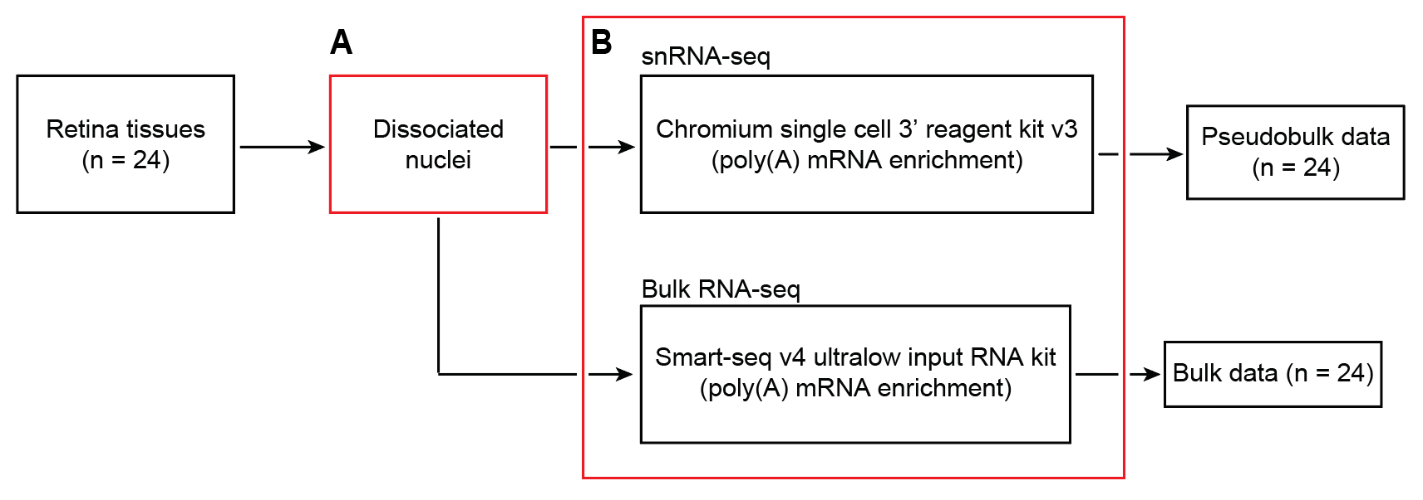
Supplemental Fig. S1. Workflow for generating matched bulk and snRNA-seq data for the retina benchmark data set.
There are two critical steps to ensure the matchness of the benchmark data set. A, For each retina tissue sample, it was dissociated into a single nuclei suspension. B, From the same nuclei suspension, one aliquot was utilized for bulk RNA-seq with poly(A) enrichment using the Smart-seq v4 Ultralow Input RNA kit, while another aliquot was used for snRNA-seq with poly(A) enrichment using the Chromium Single Cell 3' Reagent Kit v3. This approach ensures the matched bulk and snRNA-seq data originate from the same pool of dissociated nuclei and undergo the same poly(A) enrichment protocol for cDNA library preparation. The matched pseudobulk mixtures are generated by summing UMI counts across cells from all cell types
in each sample.

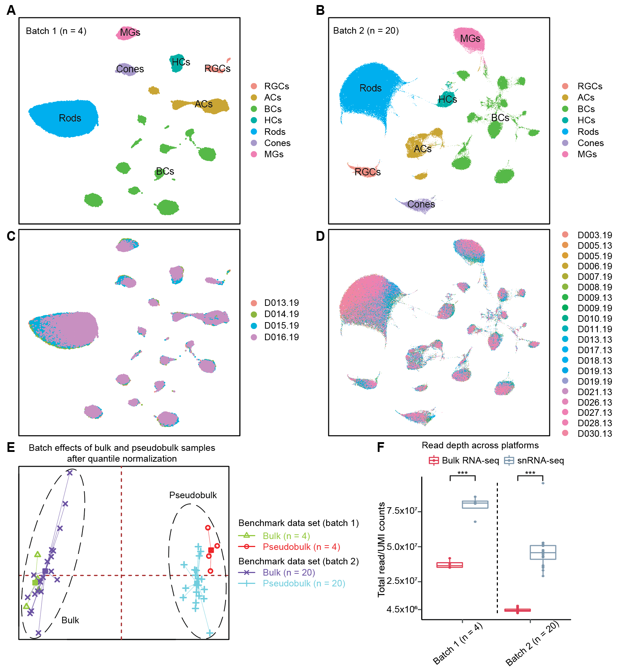
Supplemental Fig. S2. Overview of the matched bulk and snRNA-seq data of retinal samples.
A and B, UMAP projection of snRNA-seq data from 4 healthy retinal samples in batch-1 and 20 healthy retinal samples in batch-2, annotated by cell types. C and D, UMAP projection of snRNA-seq data from 4 healthy retinal samples in batch-1 and 20 healthy retinal samples in batch-2, annotated by sample IDs. Cells were clustered by their biological annotations instead of sample origins, suggesting negligible batch effects. E, Distribution of the first two principal components for the matched bulk and pseudobulk RNA-seq data in the benchmark data set after quantile normalization. F, Boxplot showing the raw read depth between bulk and pseudobulk RNA-seq data from batch-1 and batch-2. The P-values for Wilcoxon rank-sum tests comparing sequencing read depth between bulk and pseudobulk data are denoted as follows: *P-value ≤0.05; **P-value ≤0.01; and ***P-value ≤0.001.

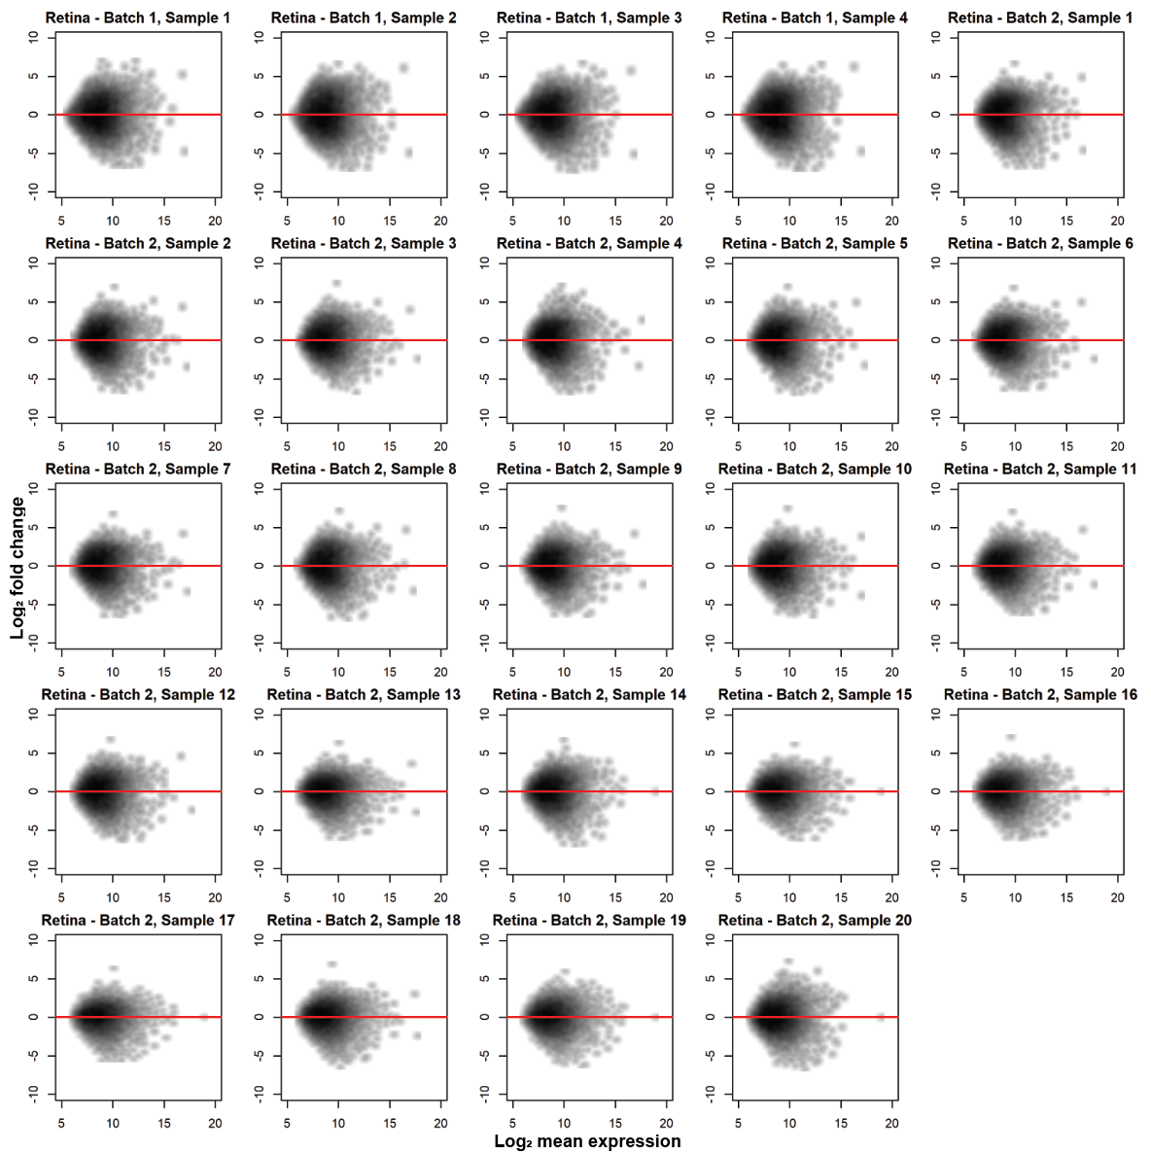
Supplemental Fig. S3. Comparison of bulk and pseudobulk RNA-seq data across 24 retinal samples.
Smooth scatter plots comparing bulk and pseudobulk RNA-seq data. Each plot corresponds to an individual sample. The x-axis represents the log₂ mean expression, and the y-axis represents the log₂ fold change. Red horizontal indicates y = 0. Each data point denotes an individual gene. Differences in gene expression levels between the paired samples are consistently observed across all pairs.
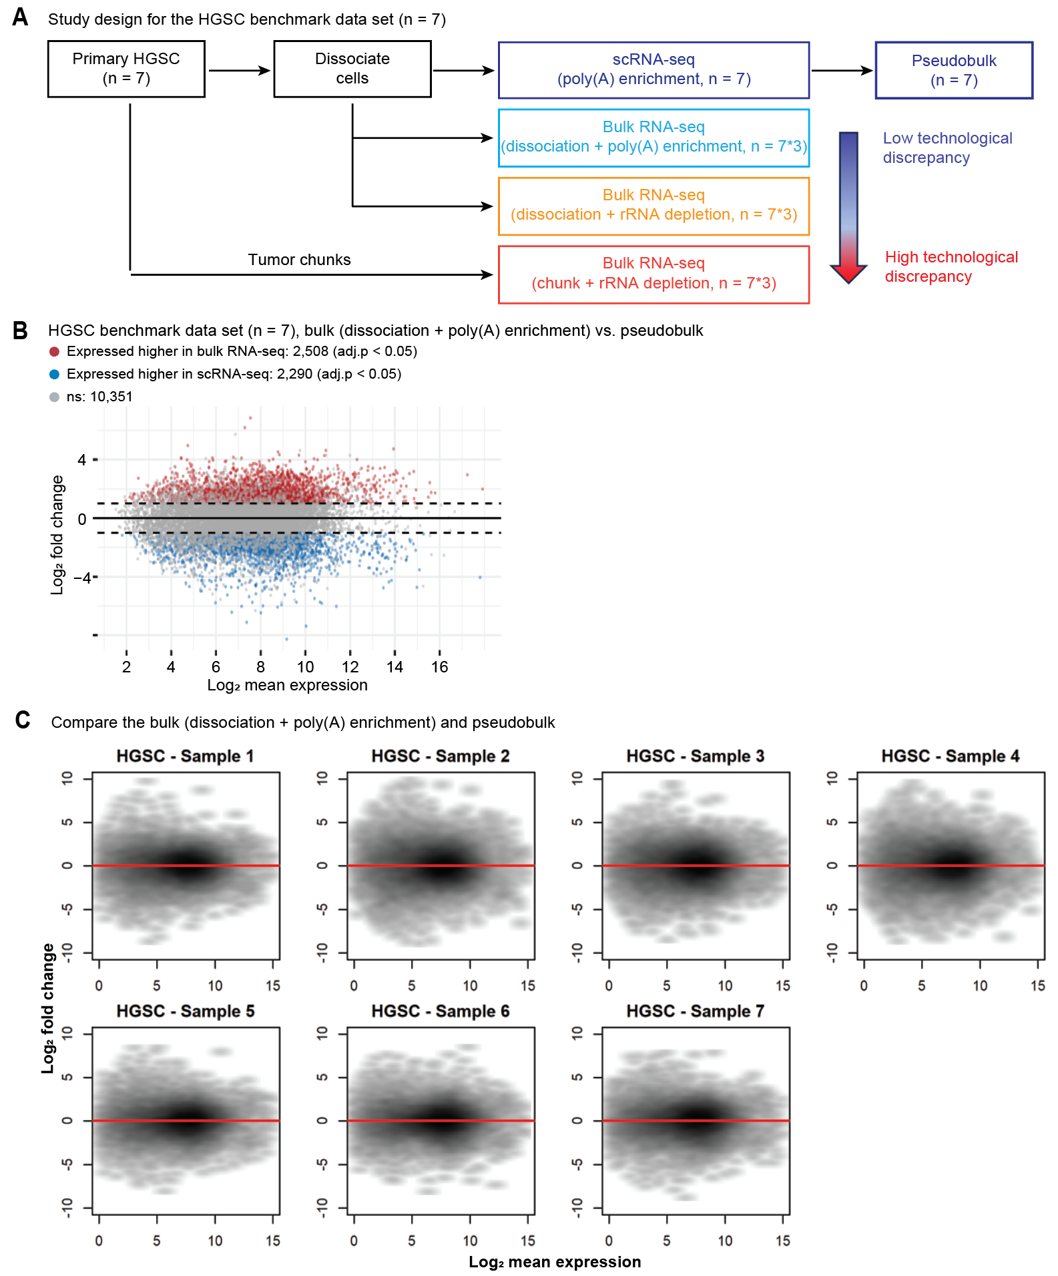
Supplemental Fig. S4. Assessing technological discrepancy between bulk and single-cell sequencing platforms using the HGSC benchmark data set.
A, Study design of the primary HGSC benchmark data set. B, MA-plots displaying the mean expression levels of all genes between bulk and pseudobulk data. DE genes are identified using the paired t-test with BH adjustment. Red represents genes expressed higher in the bulk, and blue represents genes expressed higher in the pseudobulk. The horizontal dotted lines denote a 2-fold change. adj.p: adjusted P-values. C, Smooth scatter plots showing the comparison between matched bulk (dissociation + poly(A) enrichment) and pseudobulk RNA-seq data for each individual sample. The bulk data represents raw counts and the pseudobulk data represents total UMI counts. The x-axis shows the log₂ mean expression, and the y-axis shows the log₂ fold change. Red horizontal indicates y = 0. Each data point is an individual gene.
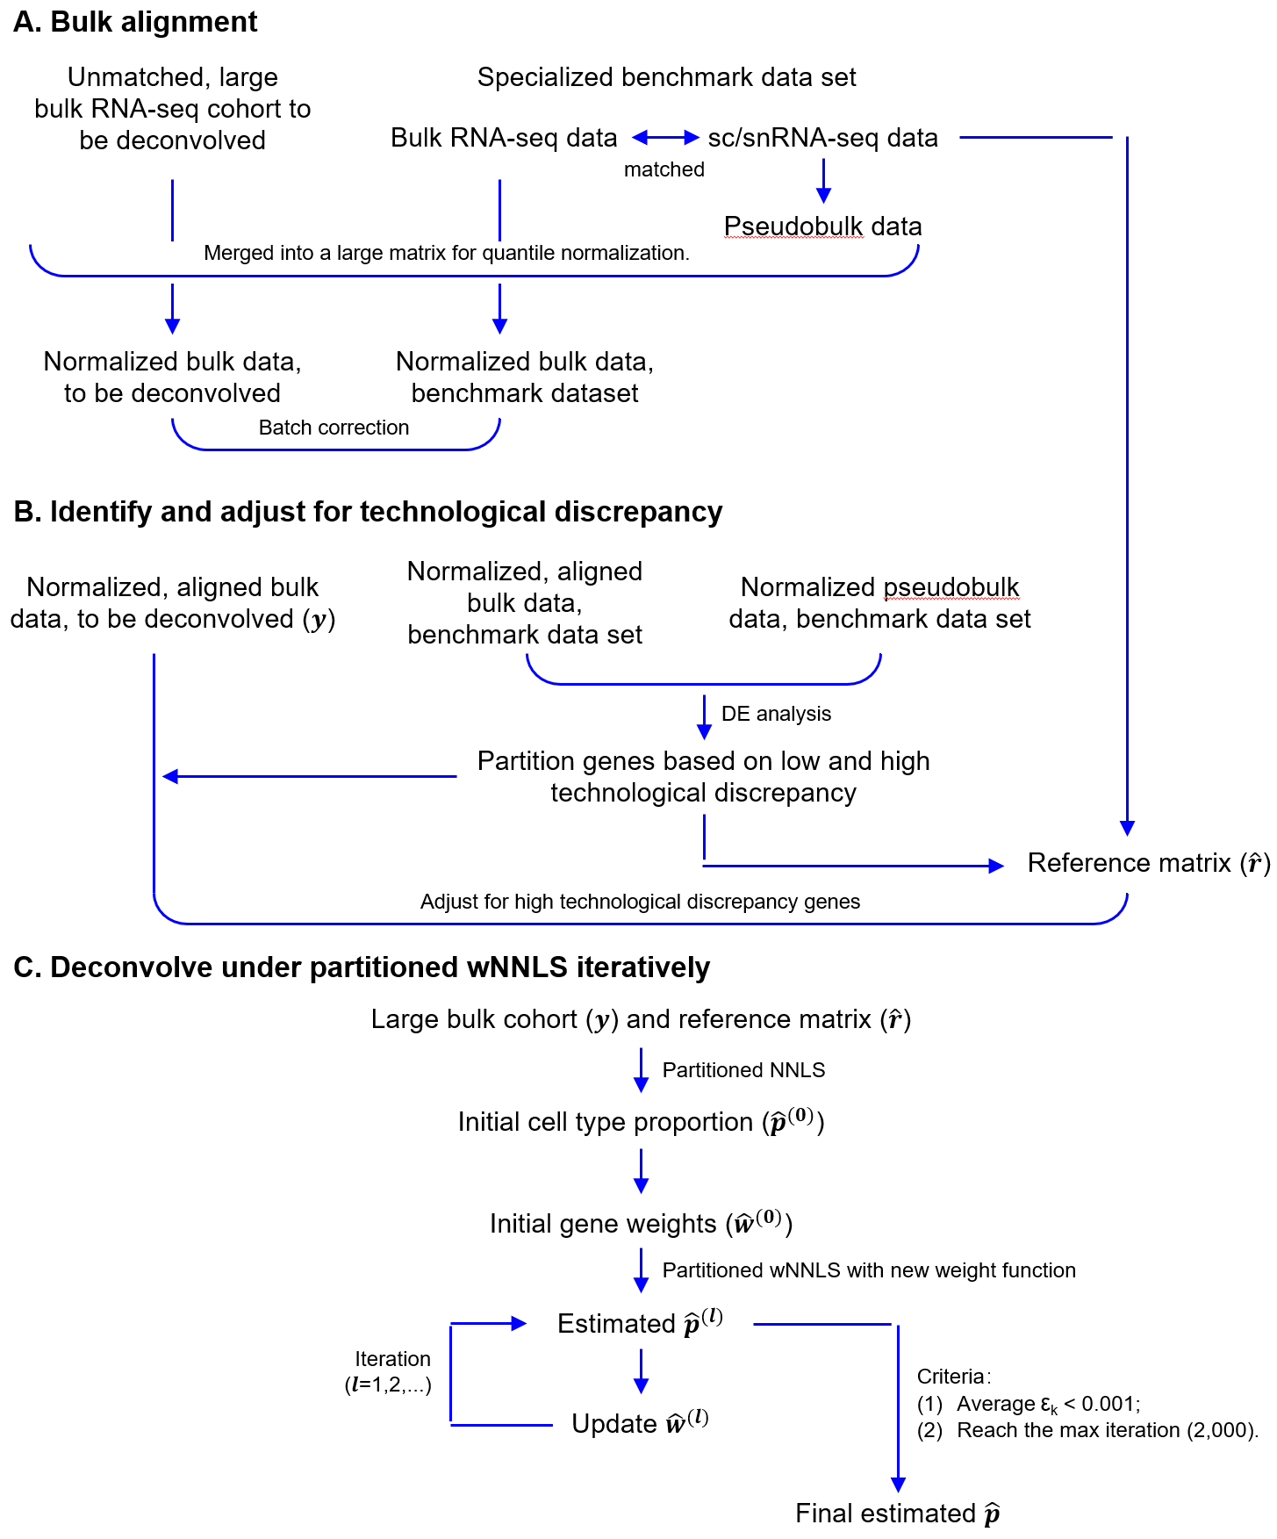
Supplemental Fig. S5. Workflow of DeMixSC.
This diagram outlines the three-step procedure for DeMixSC. A, The alignment of the unmatched bulk RNA-seq cohort to the bulk data from the benchmark data set. B, Identification and adjustment of genes with high technological discrepancy. C, Iterative estimation of cell type proportions with partitioned wNNLS framework and the new weight function. The final estimates are obtained when either the algorithm converges or reaches the prespecified maximum number of iterations. Here, $ε_{\text{k}}$ represents the difference between the current estimated cell type proportions and those from the previous iteration of cell type $\text{k}$.
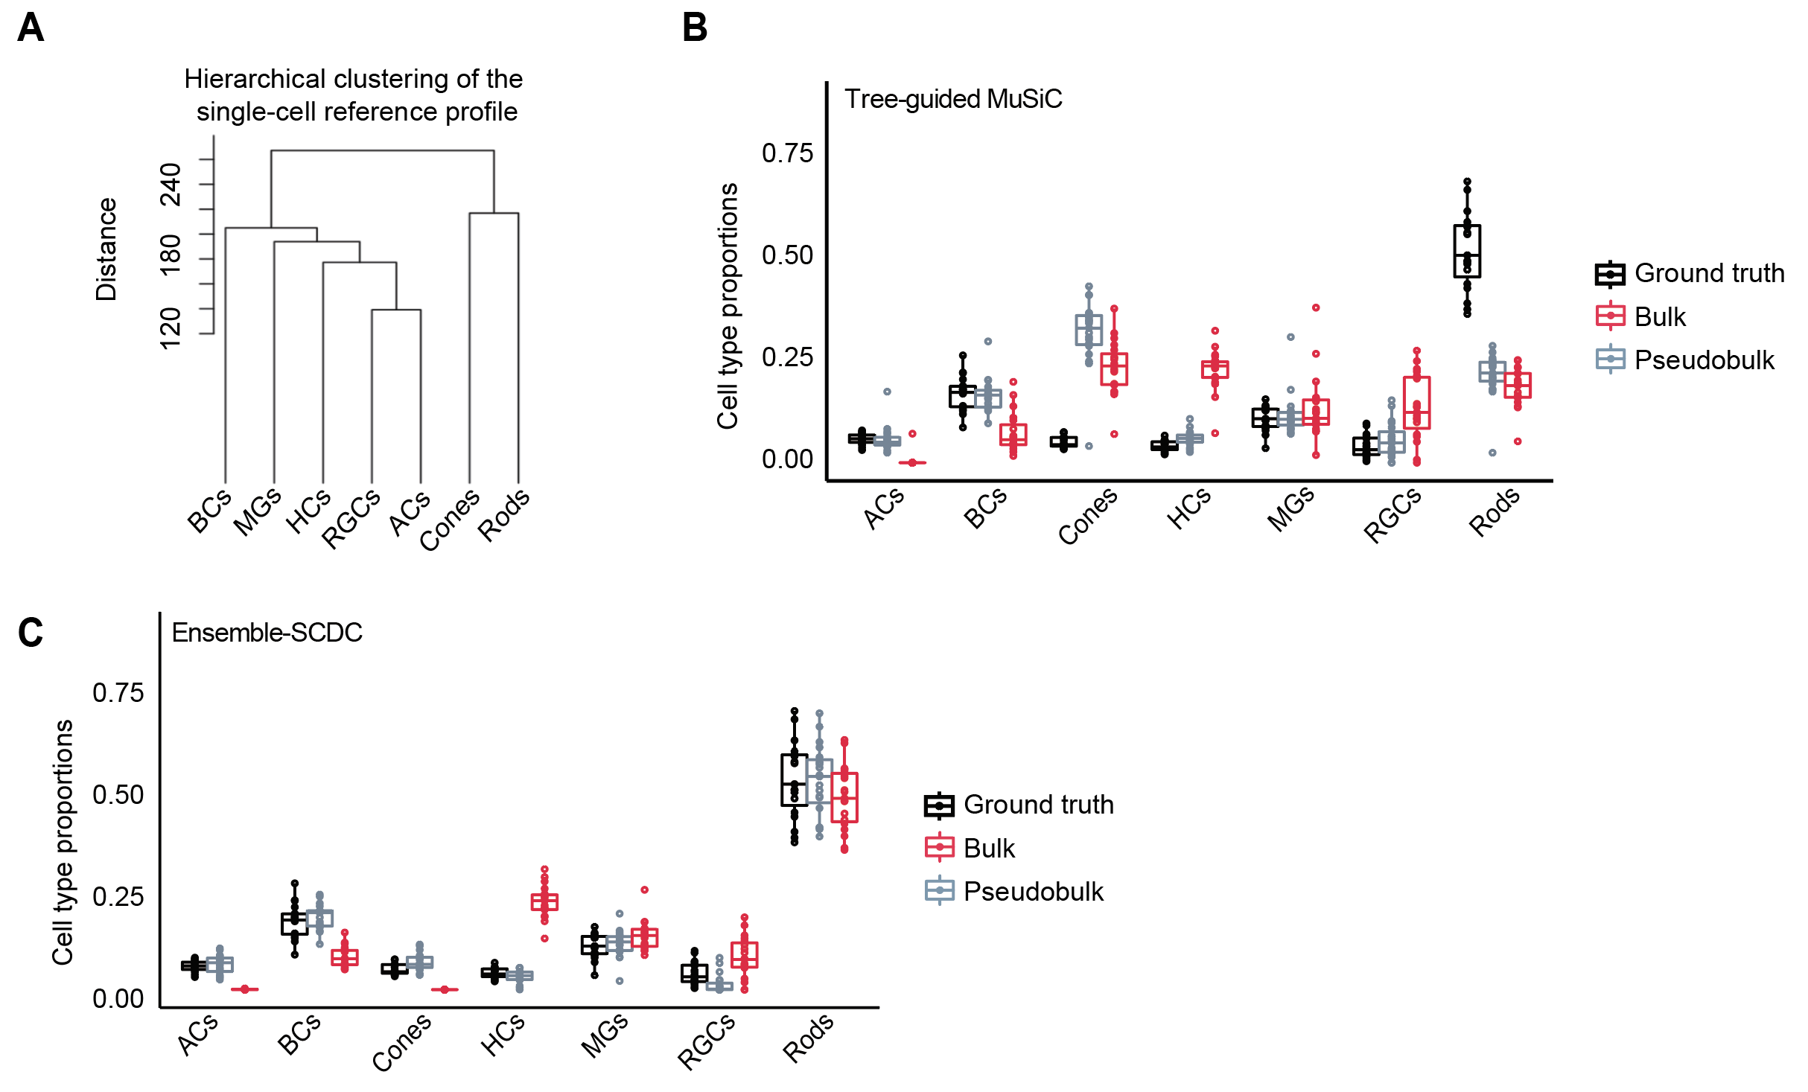
Supplemental Fig. S6. Deconvolution performance of the tree-guided MuSiC and Ensemble-SCDC.
A, Hierarchical clustering of the cell type-specific reference matrix. B, Boxplot showing the distributions of estimated cell type proportions from benchmark data using the tree-guided MuSiC. C, Boxplot showing the distributions of estimated cell type proportions from benchmark data using the SCDC ensemble mode. Black denotes the ground truth estimated using the snRNA-seq data. Gray denotes estimates from the pseudobulk RNA-seq data, and red denotes estimates from the matched bulk RNA-seq data.

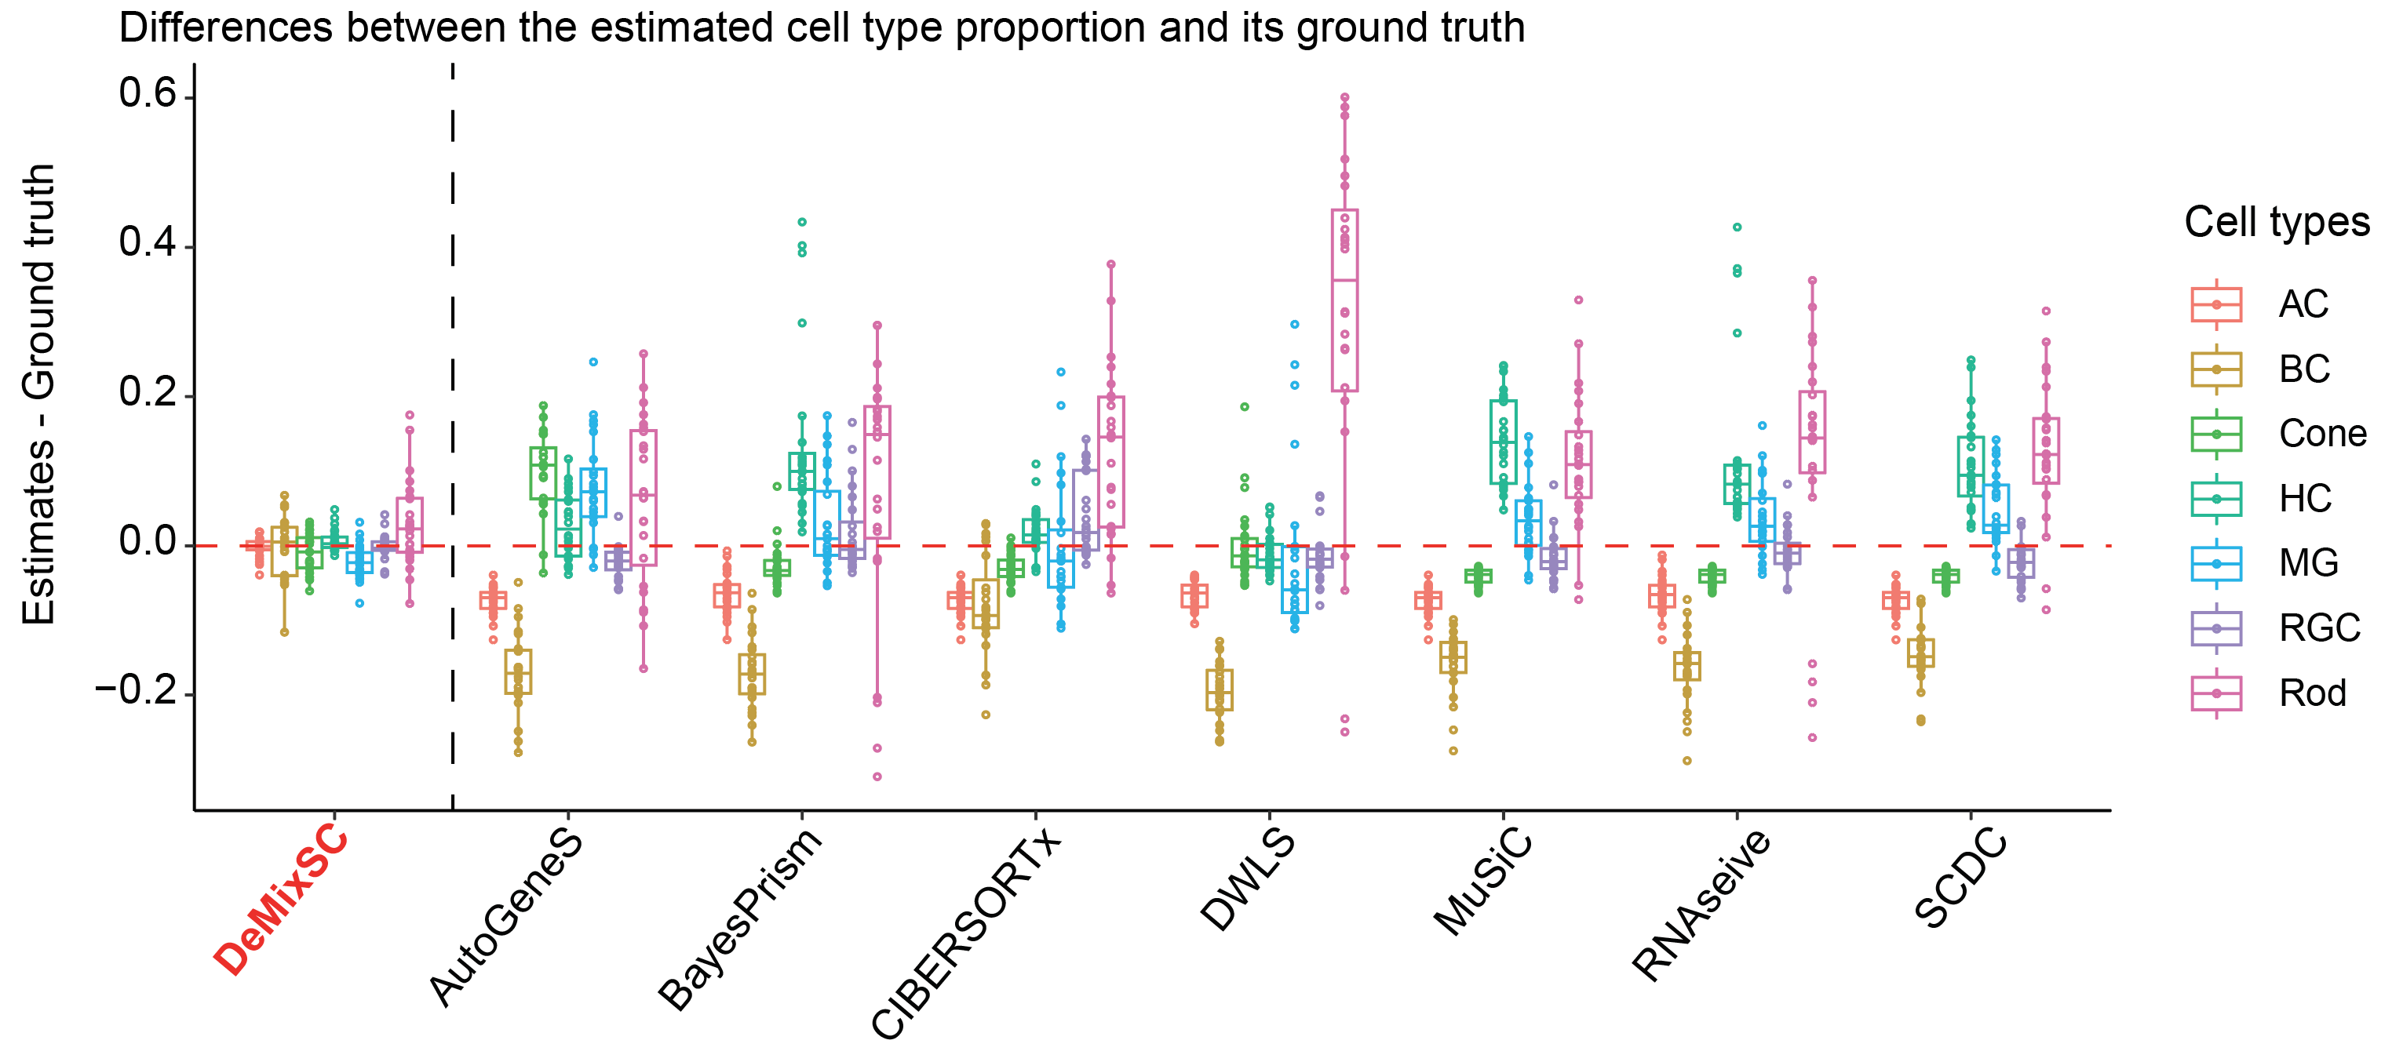
Supplemental Fig. S7. Comparing the deviation from ground truth for each method in the retina benchmark data.
Boxplots showing the difference between deconvolution estimates for the real bulk data and their true cell type proportions across eight deconvolution methods, stratified by the cell type. A score of 0 indicates perfect concordance, greater than 0 means overestimation, and less than 0 suggests underestimation.

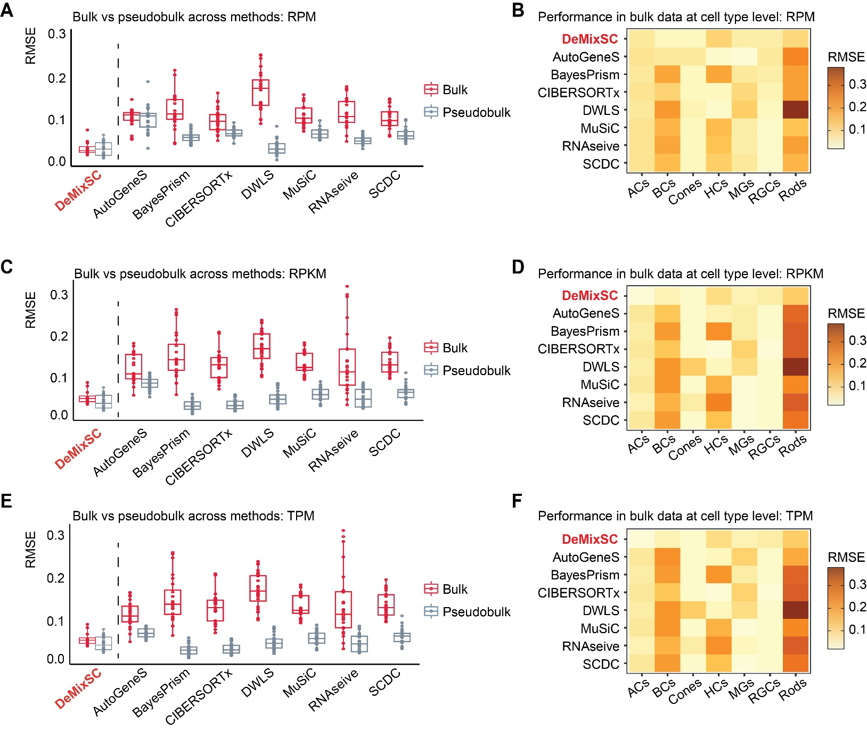
Supplemental Fig. S8. Impact of data normalization on the deconvolution performance.
A, C, and E, Boxplots showing the deconvolution performance across DeMixSC and seven current single-cell-based deconvolution methods for bulk and pseudobulk mixtures. RMSE values are calculated across seven major cell types for each sample, with gray denoting pseudobulk and red denoting bulk. Smaller values indicate higher accuracy in proportion estimation. B, D, and F, Heatmaps showing the deconvolution performance at the cell type level across the eight methods using RMSE. Lighter colors correspond to lower RMSE values. Each panel corresponds to a normalization strategy: RPM (B), RPKM (D), and TPM (F).

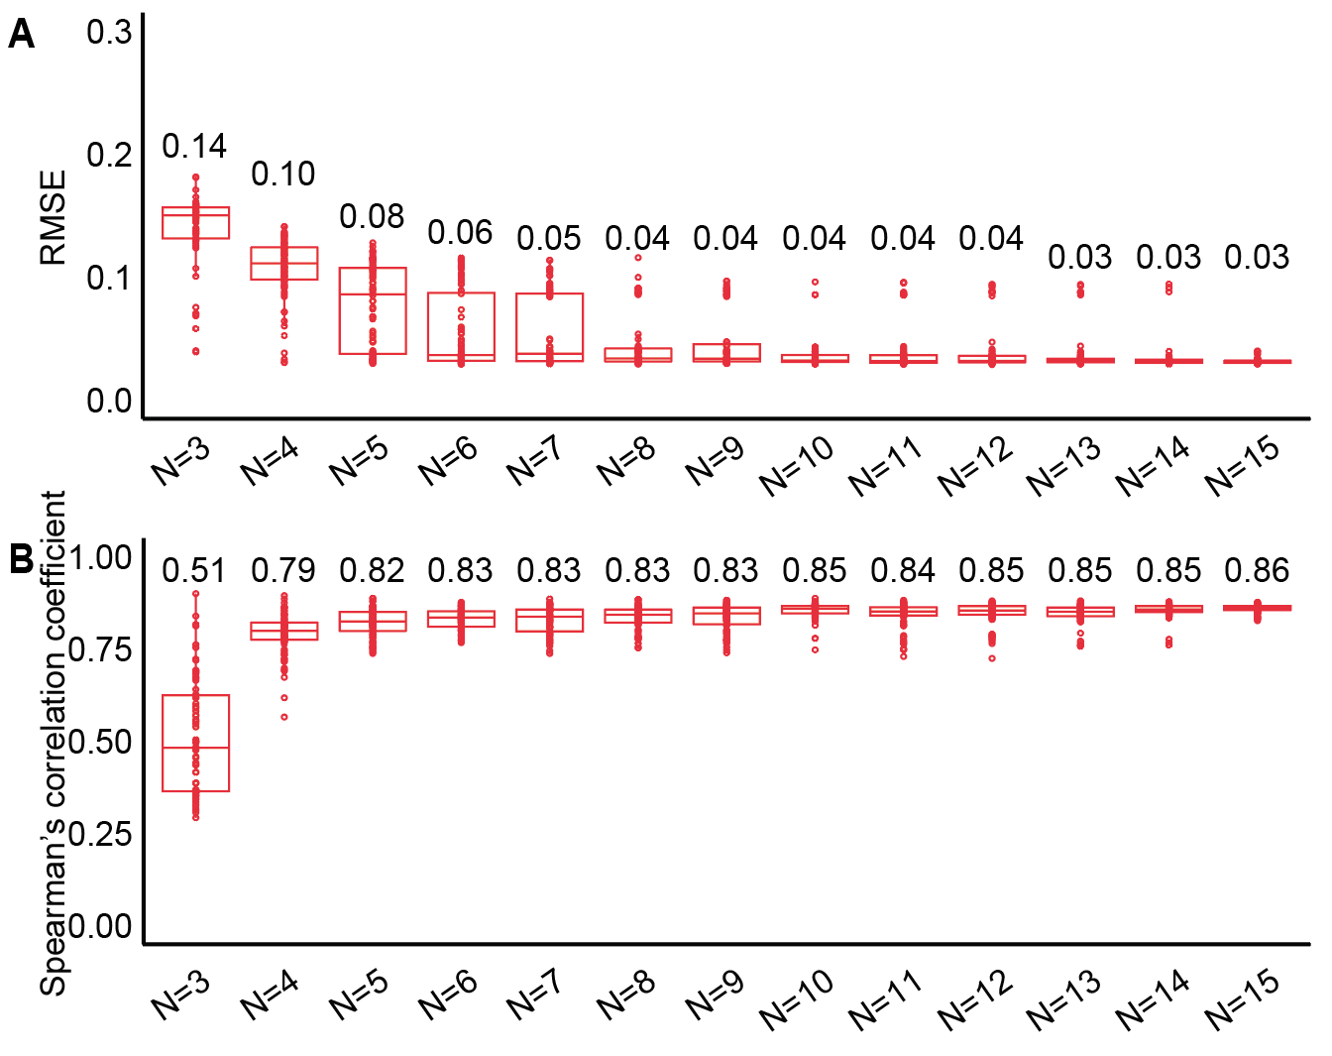
Supplemental Fig. S9. Estimation accuracy of DeMixSC using different sample sizes in the retina benchmark data.
To determine the requisite number of samples for a reliable deconvolution using DeMixSC, we conducted deconvolution on the benchmark data set using different sample sizes N. Namely, we randomly sampled N retina samples from the benchmark data set, where N∈{3,4,5,6,7,8,9,10,11,12,13,14,15}. The sampling for each candidate of N was replicated 100 times. Boxplot showing the DeMixSC’s performance on deconvolving the retina benchmark bulk data: RMSE (A) and Spearman’s correlation coefficient (B). Each dot corresponds to a single experiment where N samples were randomly sampled and used for deconvolution. The results indicate that the model's performance stabilizes with seven or more samples while remaining satisfactory with at least four samples. Therefore, we recommend that users include a minimum of seven samples in their benchmark data set to ensure a reliable performance of DeMixSC. The number on each box represents the mean value.

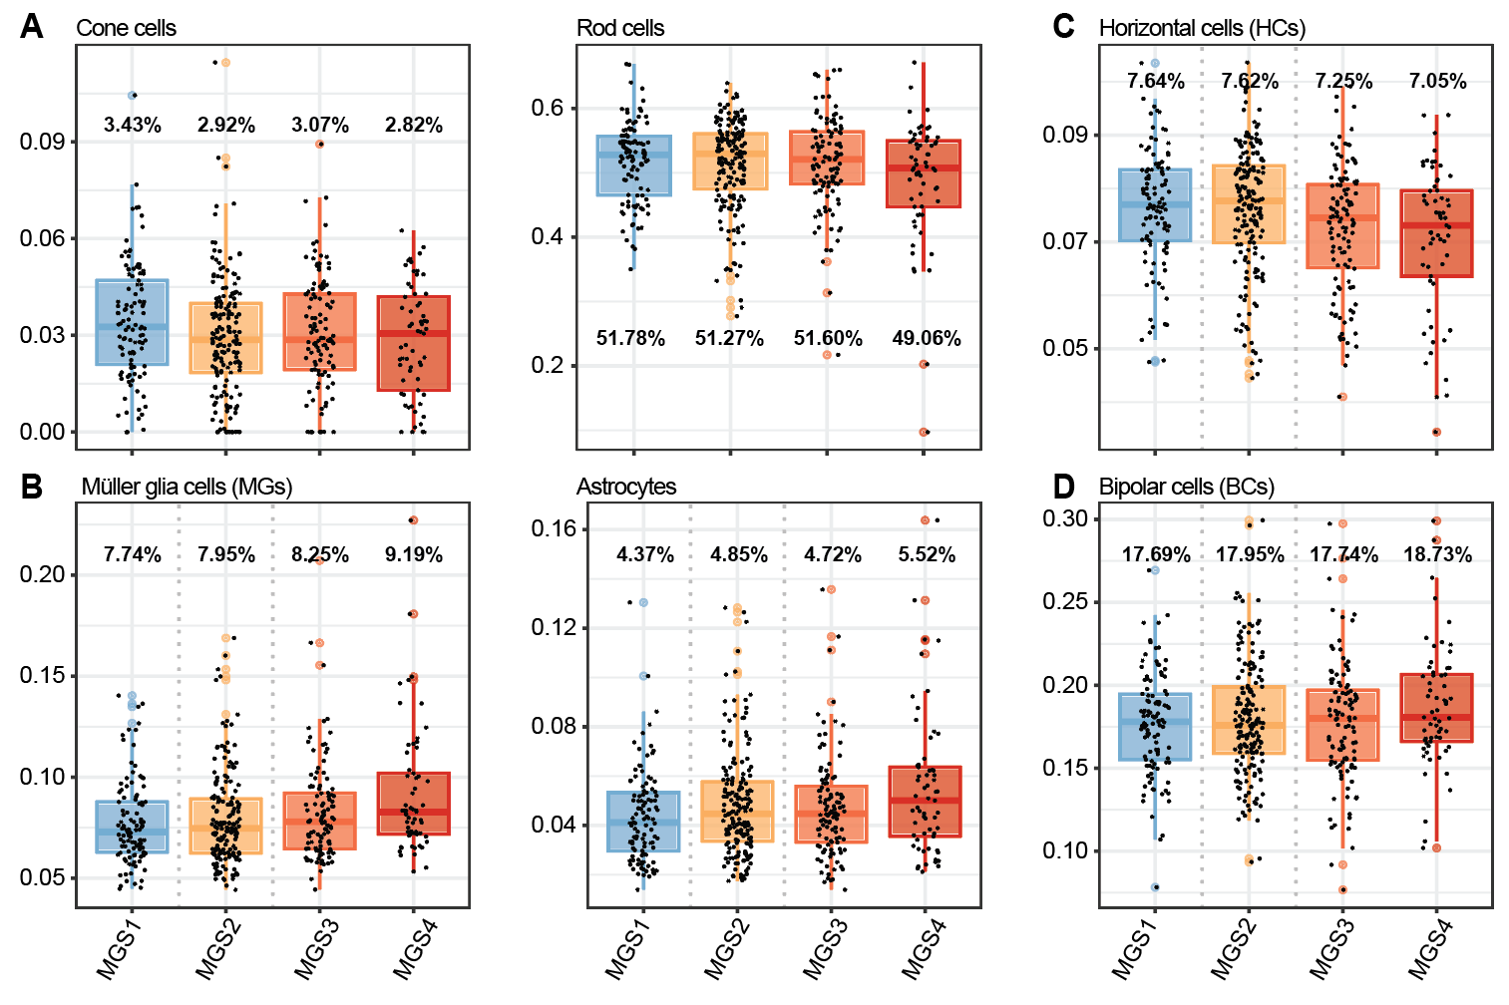
Supplemental Figure S10. A dynamic shift in cell type proportions revealed by DeMixSC during the AMD progression.
Boxplots showing the distributions of cell type proportion estimates across different MGS stages from MGS1 (non-AMD) to MGS4 (AMD). Each panel corresponds to a given cell type. (A) Photoreceptor cells, including Cone and Rod cells; (B) Glial cells, including MGs and Astrocytes; (C) HCs, and (D) BCs.

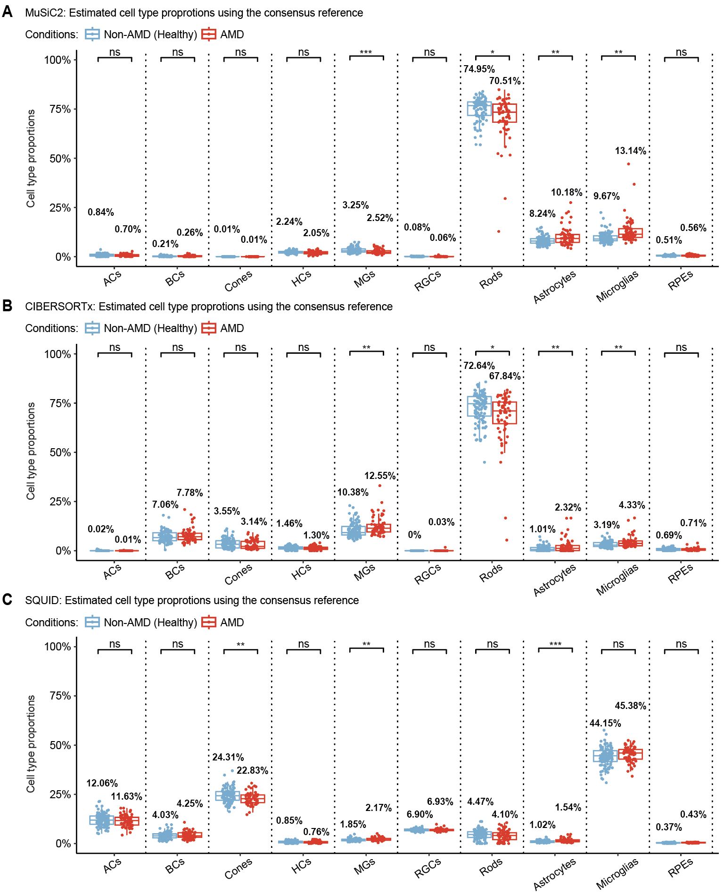
Supplemental Fig. S11. Cell type proportion estimates for the AMD cohort with existing methods.
A, B, and C, Boxplots showing the distributions of cell type proportion estimates for non-AMD healthy retina vs. AMD retina from MuSiC2 (A), CIBERSORTx (B), SQUID (C). The P-values for Student’s t-tests comparing the estimated cell type proportions between non-AMD (healthy) and AMD groups are denoted as follows: not significant (ns), P-value >0.05; *P-value ≤0.05; **P-value ≤0.01; and ***P-value ≤0.001.

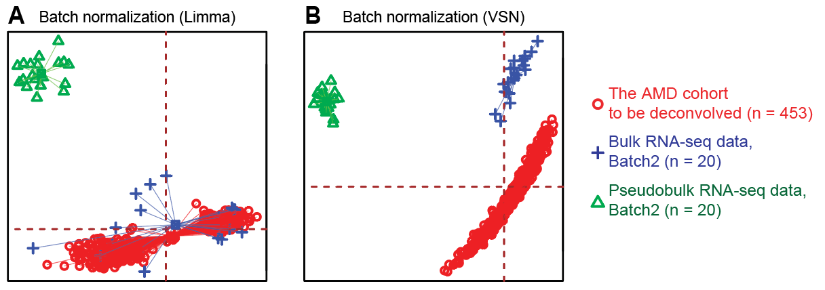
Supplemental Fig. S12. Comparison of the batch correction performance.
PCA plots of the AMD cohort and the benchmark data: Limma (A) and VSN (B). Limma effectively corrected batch effects while VSN showed inadequate batch effect correction.

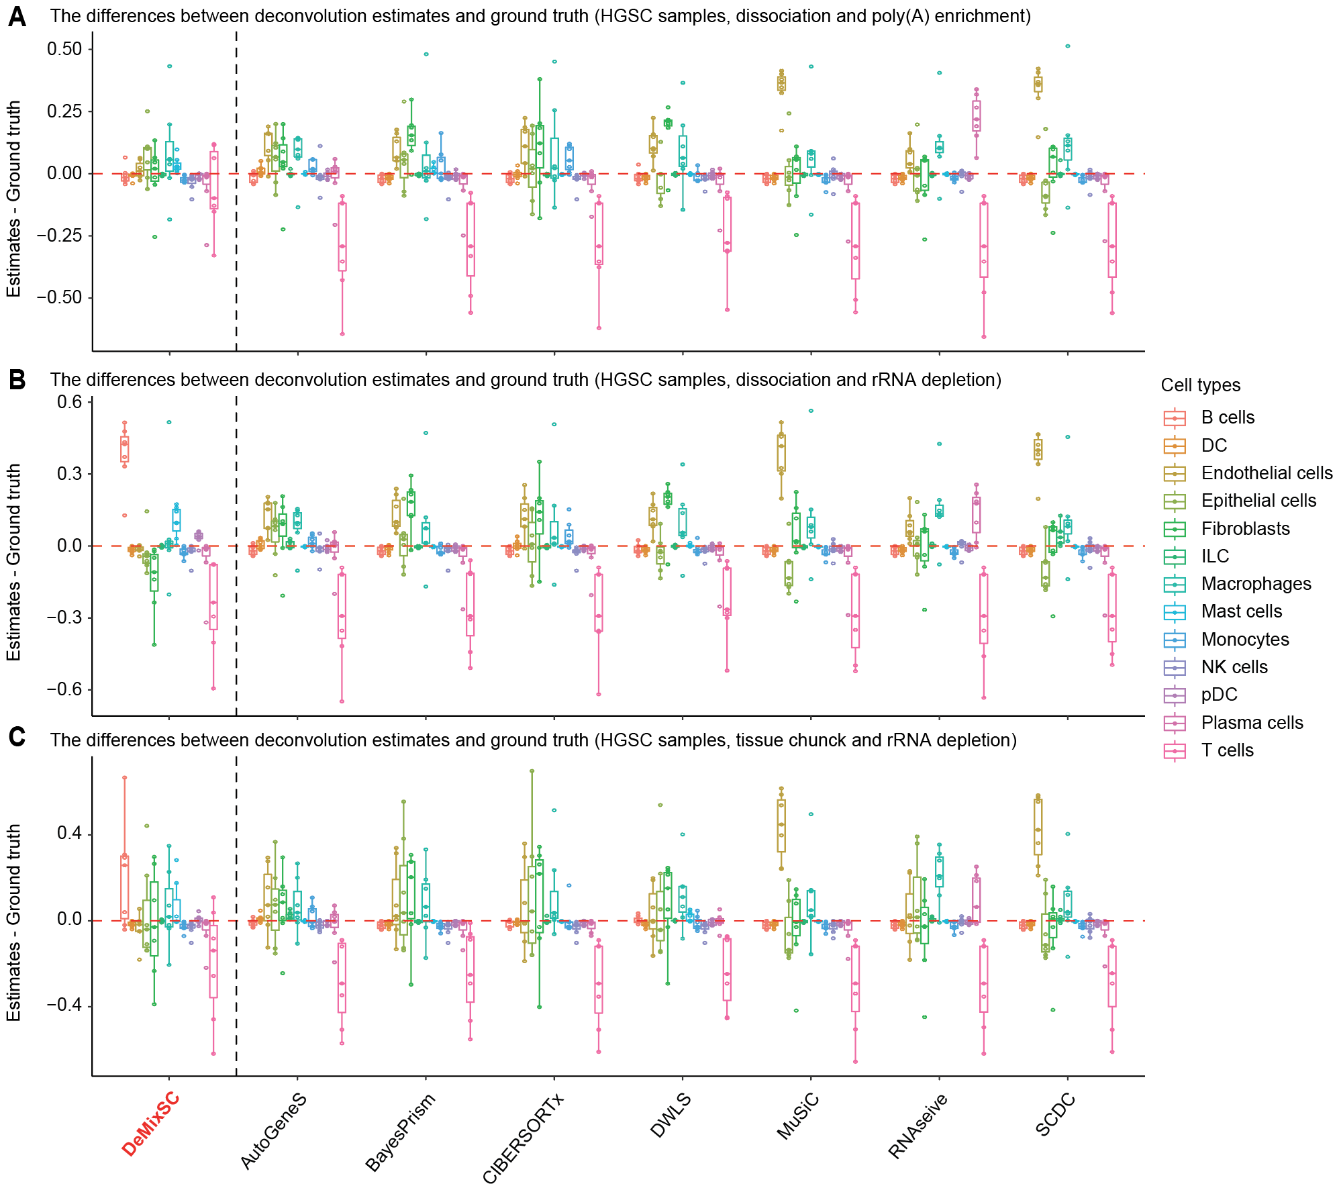
Supplemental Fig. S13. Comparing the deviation from ground truth for each method in the HGSC benchmark data.
Boxplots showing the differences between deconvolution estimates for the real bulk data and their true cell type proportions across eight deconvolution methods, stratified by the cell type. A, Dissociation with poly(A) enrichment; B, Dissociation with rRNA depletion; and C, Tissue chunk with rRNA depletion. A score of 0 indicates perfect concordance, greater than 0 means overestimation, and less than 0 suggests underestimation.

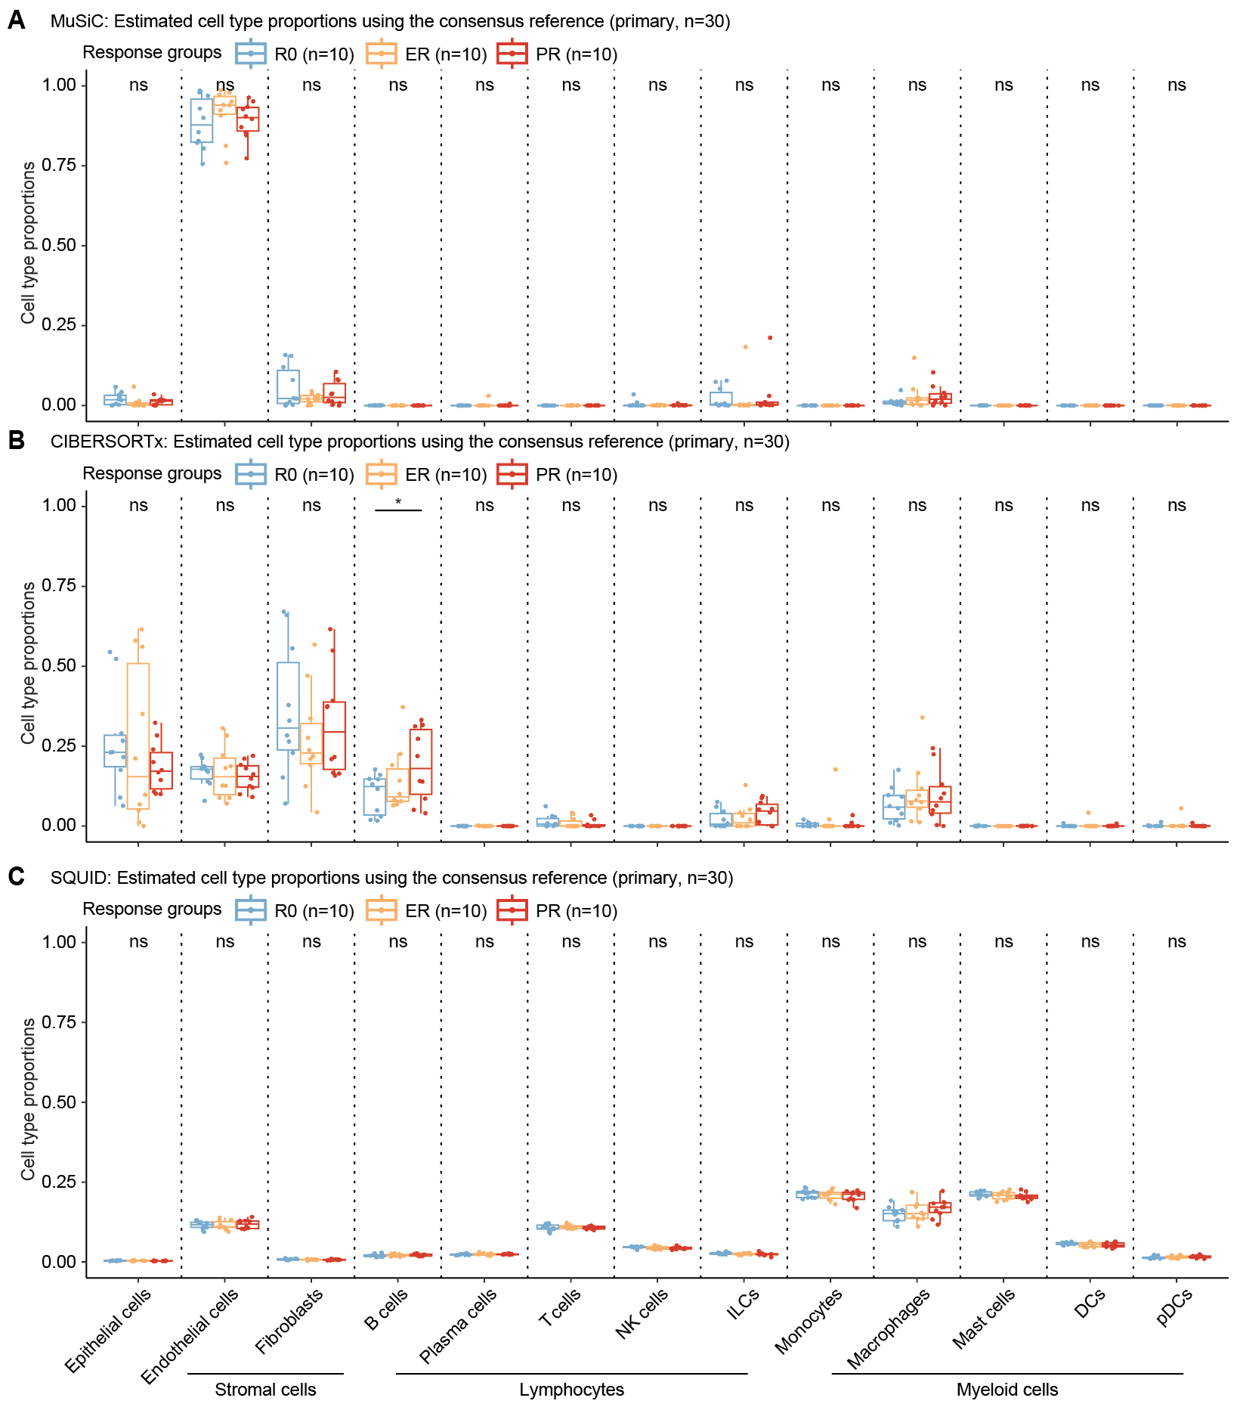
Supplemental Fig. S14. Cell type proportion estimates for the primary HGSC cohort with existing methods.
A, B, and C, Boxplots showing the distributions of cell type proportion estimates across different response groups from MuSiC (A), CIBERSORTx (B), SQUID (C). The P-values for Student’s t-tests comparing the estimated cell type proportions across R0, ER, and PR groups are denoted as follows: not significant (ns), P-value >0.05; *P-value ≤0.05; **P-value ≤0.01; and ***P-value ≤0.001.

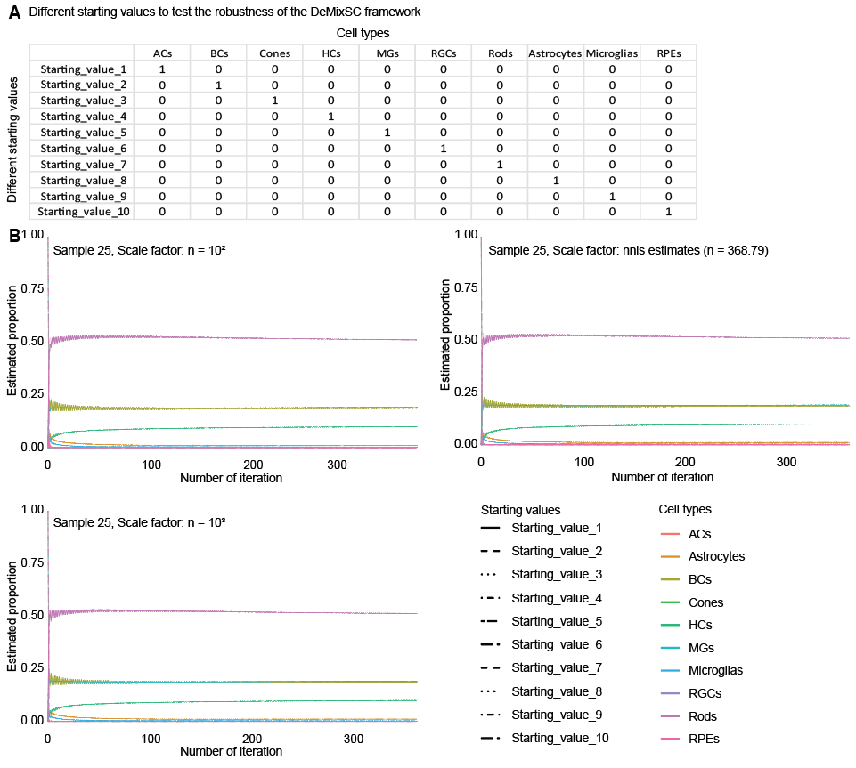
Supplemental Fig. S15. Convergence of DeMixSC with different starting values.
A, A list of different starting values across ten cell types. B, Trace plots of estimated cell type proportions over iterations.

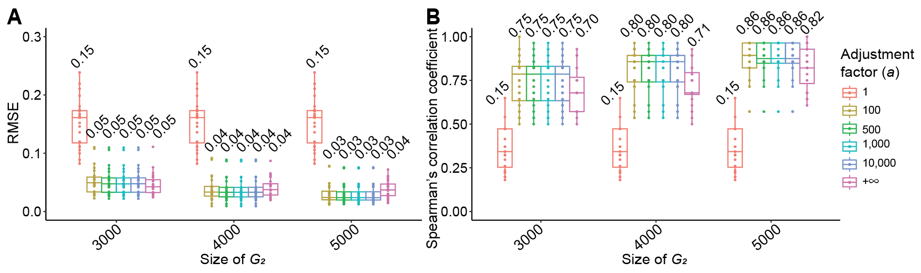
Supplemental Fig. S16. Performance comparison of DeMixSC with various ${\text{G}}_{\text{2}}$ gene selections and values of $\text{a}$
A and B, Boxplot showing the deconvolution performance of DeMixSC with different numbers of discrepancy genes and different values of adjustment factor $a$: RMSE (A) and Spearman’s correlation coefficient (B). We tested different numbers of top genes (3,000, 4,000, 5,000) and different values of $\text{a}$ (1, 100, 500, 1,000, 10,000, $\text{+∞}$) in the bulk RNA-seq data from the retina benchmark dataset (n=24). Here, $\text{a}$=$\text{+∞}$ is equivalent to remove all the technological discrepancy genes. We found that excluding these genes resulted in sub-optimal performance, verifying our reasoning that those discrepancy genes should be retained due to their inherent biological significance. Then, neglecting to adjust for technological discrepancy (i.e., $\text{a}$=1) significantly decreases the model’s accuracy. Any reasonable range of adjustment values (i.e., $\text{a}$ = 100, 500, 1,000, 10,000) are effective, yielding comparable deconvolution outcomes. The number on each box represents the mean value.

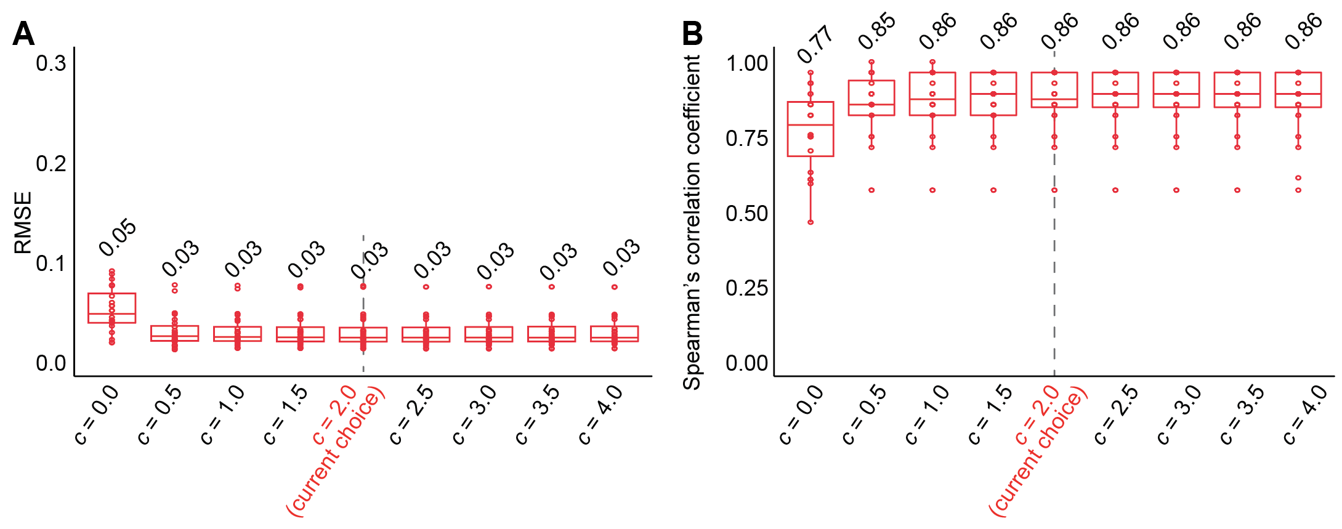
Supplemental Fig. S17. Comparing the estimation accuracy of DeMixSC with different constants in the weight function.
Boxplot comparing the deconvolution performance of DeMixSC with different constants in the weight function using the bulk RNA-seq data from the retina benchmark dataset (n=24): RMSE (A) and Spearman’s correlation coefficient (B). The number on each box represents the mean value.

