Supplemental Figure S1. MHC Assembly Pipeline Overview. Blue boxes represent steps in the assembly pipeline. Green cylinders represent a set of PacBio reads. Red boxes represent filtering steps. Yellow/Orange stacked files represent reference/contig sequences. A) PacBio reads were aligned to Hg38 plus a panel of MHC haplotypes. Reads that aligned to MHC-specific sequences were retained for further analysis. B) MHC-specific reads containing chimeras were edited by splitting reads at predicted chimeric junctions. C) Edited MHC-specific reads were assembled into collapsed contigs, which were used to further refine the chimeric reads. D) Heterozygous variants were called across the collapsed assembly and phased using edited MHC-specific reads. The local phase blocks were assigned phase across the MHC by intersecting with the trio phased or haplotype estimated reference-based SNP haplotype scaffold. Edited MHC-specific reads were assigned a haplotype if they contained phased variants. E) Each haplotype was assembled separately using a combination of haplotype-specific and homozygous reads. F) The haplotype-specific assembly was refined by re-editing reads at the haplotig edges.
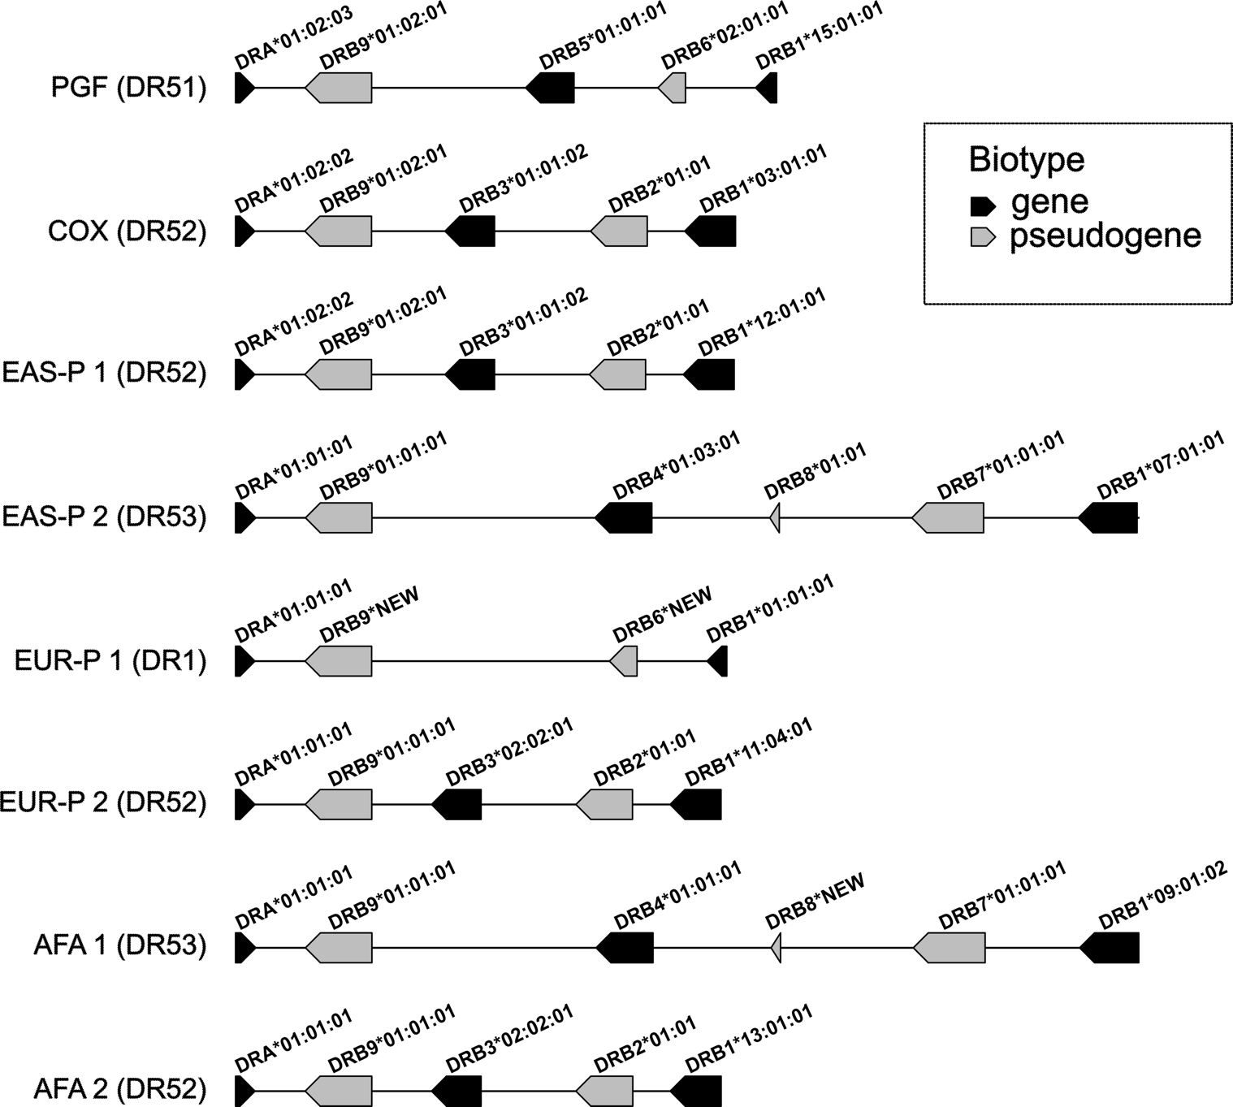
Supplemental Figure S2. DRB haplotype structure for each haplotype-resolved assembly. The spacing between each gene/pseudogene is based on our assembly. Allele names are generated using NGSEngine in PacBio consensus mode.

