Supplemental Material

Table of Contents

Supplemental Text
- ARF GTPase family functions
- Subcellular localization and structural predictions
- Structural alignments and phylogenetic analyses

Tables
Supplemental Table S1: Manually curated genomes for chromosomally integrated mobile
genetic elements and extrachromosomal elements.

Supplemental Table S11-B: Methylation patterns in Atabeyarchaeia and Freyarchaeia genomes
Based on PacBio data.

Supplemental Figures

Supplemental Figure S1: Distribution of MGE types colored by host for genomes ≤ 100000 bp

Supplemental Figure S2: Phylogenetic Analyses of ParB and Tyrosine-Recombinase-Like
proteins across archaeal mobile genetic elements

Supplemental Figure S3: Sequence Similarity Network (SSN) for representative phage
integrases

Supplemental Figure S4: Maximum likelihood phylogeny of a novel Type II-G Restriction
Modification protein fusion

Supplemental Figure S5: Cross-sample Atabeyarchaeia-1 plasmid integration

Supplemental Figure S6: Comparison of gene content of Yucahu-i and iMGE-xvi

Supplemental Figure S7: Genome diagram of Atabeyarchaeia-2 Putative plasmid Zemi-700

Supplemental Figure S8: Maximum Likelihood Phylogeny of CAAX Proteases Identified in
the Atabeyarchaeia-2 Plasmid_700

Supplemental Figure S9: Genomic organization of DISARM system from Freyarchaum

Supplemental Figure S10: Comparison of GTPases encoded within Atabeyarchaeia putative MGEs

Supplemental Figure S11: Evolutionary position of Atabeyarchaeia putative MGEs GTPases

Supplemental Figure S12: Conservation of G domain and switches

Supplemental Text
The ARF GTPase family is a multi-function group that may be involved in processes such as vesicle transport, lipid modification, organelle morphology (e.g., mitochondrial fusion), and adhesion. Phylogenetic analysis indicates that Atabeyarchaeia, Freyarchaeia, and iMGE-xii proteins belong to a group characterized mainly by unannotated Arf eukaryotic representatives. Thus to get insights into their potential function we determined i) their subcellular localization via (PSORTb v3.0 Archaea), ii) structural predictions (AlphaFold), and iii) structure-based phylogenies (Supplemental Figure S10-12, Supplemental Table S12). Similar to known eukaryotic proteins PSORT identified localization as cytoplasmic or unknown. From the ArfX cluster on the tree, we chose 5 proteins from Atabeyarchaeia (Atabeya-1, Atabeya-2, and Atabeya-3) and Freyarchaeia genomes, the 2 proteins from the MGEs, 4 proteins from Eukaryotes, and 4 additional Eukaryotic proteins from Arl2 and Arl8 as the outgroup for localization and structural analysis. Then, we searched the predicted GTPase structures of the iMGE-xii_6 and iMGE-xii_29 against the RCSB Protein Data Bank and aligned the predicted and validated structures to curate the structural phylogeny (Supplemental Figure S11). Predicted structures of the iMGE-xii proteins showed strong similarity to the predicted GTPase from Freya (RMSD: 1.606), predicted GTPase from Spironucleus salmonicida (single-cell flagellate) (RMSD: 2.476), and protein structures obtained by electron microscopy in a Homo sapien (RMSD: 2.252) (Supplemental Figure S11-B). Filtered structural alignments (>15% identity) of predicted iMGE GTPases to the RCSB Protein Data Bank (PDB) showed matches were >95% and >91% eukaryotic for iMGE-xii_6 and iMGE-xii_29, respectively (Supplemental Table S12) (Berman et al. 2000). The G domain region of the GTPase is composed of 5 α-helices and 6 β-sheets, and the main function is to bind and hydrolyze guanine nucleotides. The small proteins work as biotimers by differentiating between their active and inactive state. Regions called switches induce the conformational changes between the GTP-bound state (active form) and the GDP-bound state (inactive form) (Vetter and Wittinghofer 2001). The structural alignments showed a conserved G domain and switches of these GTPases (Supplemental Figure S12), suggesting these GTPases act as biotimers, initiating or terminating the associated protein complexes’ activity (Takai et al. 2001).

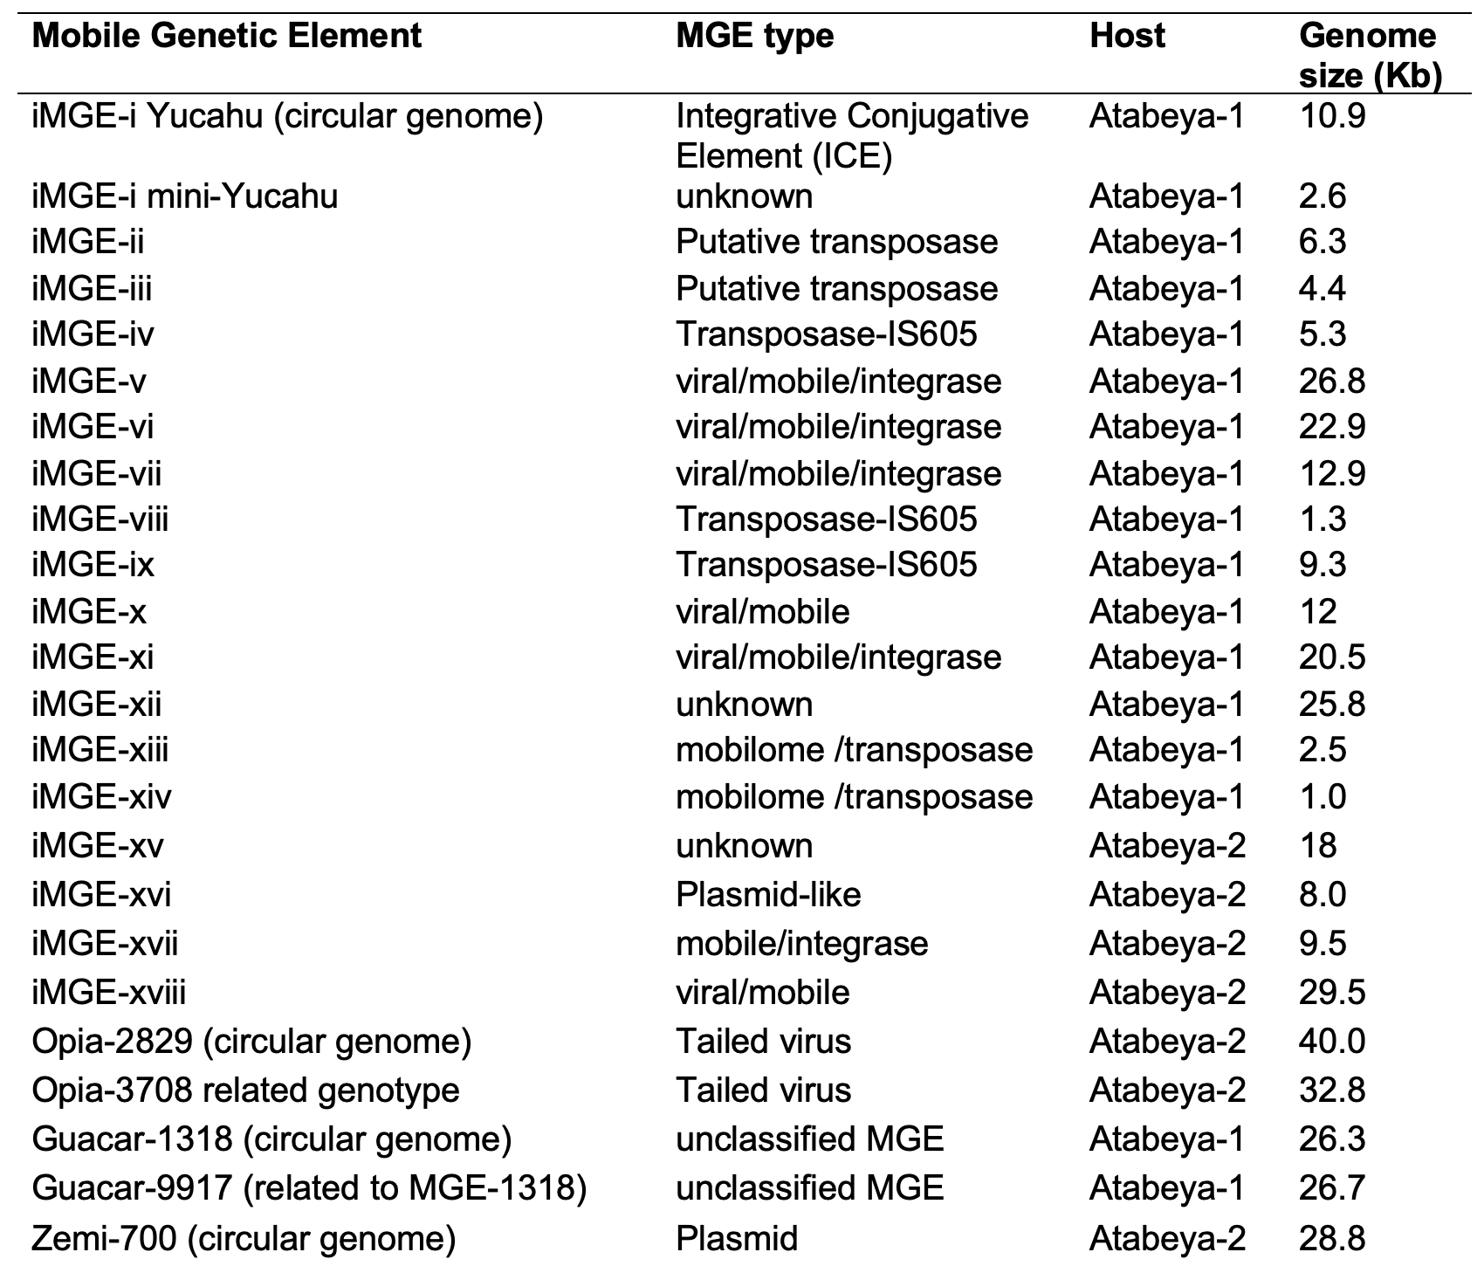
Supplemental Table S1 Manually curated genomes for chromosomally integrated mobile genetic elements and extrachromosomal elements. MGE type is the closest classification based on gene content and genome structure. The host was determined based on matches of the MGE sequences to spacers from the CRISPR systems. Ata-1 and Ata-2 are abbreviations for Atabeyarchaeia-1 and Atabeyarchaeia-2, respectively.

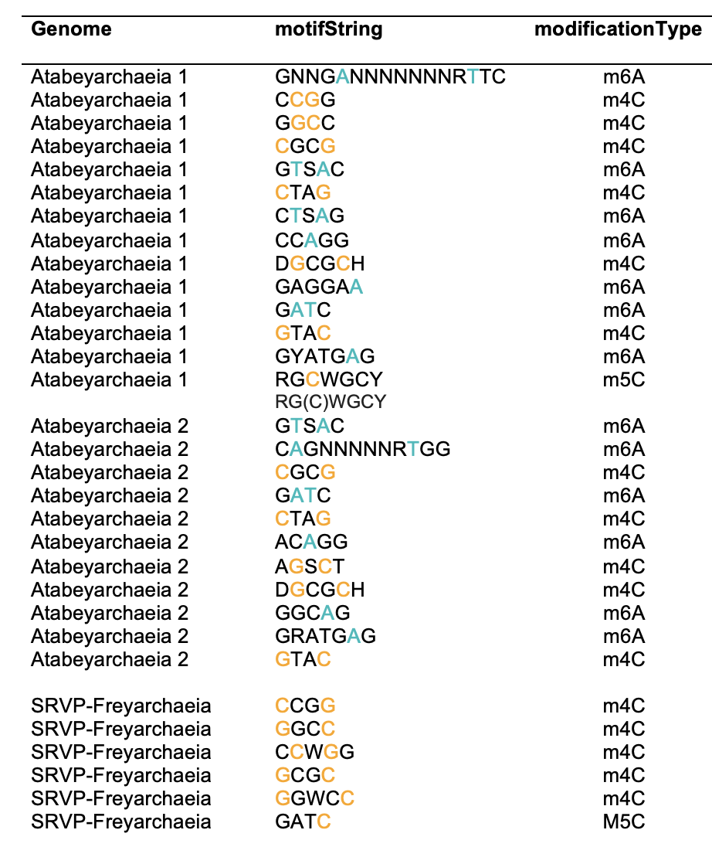
Supplemental Table S11-B Methylation patterns in Atabeyarchaeia and Freyarchaeia genomes based on PacBio and Nanopore data. Where Nanopore detected overlapping but non-identical m4C motifs, the PacBio version is used.

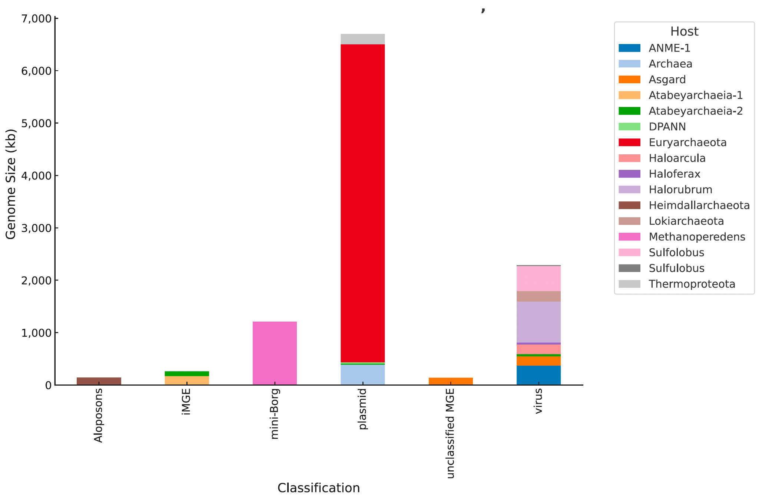
Supplemental Figure S1 Distribution of MGE types colored by host for genomes ≤ 100,000 bp. Overview of the distribution and contribution of different hosts to the genome sizes of various MGE classifications within the specified size range. Stacked bar plot showing the total genome size (in kilobases) for different types of mobile genetic elements (MGEs) categorized by their classification. The genome size is aggregated and displayed for MGEs with a size of 100,000 base pairs or less. Each bar represents a specific MGE classification, and the different colors within each bar indicate the various hosts. The hosts are listed in the legend to the right of the plot. 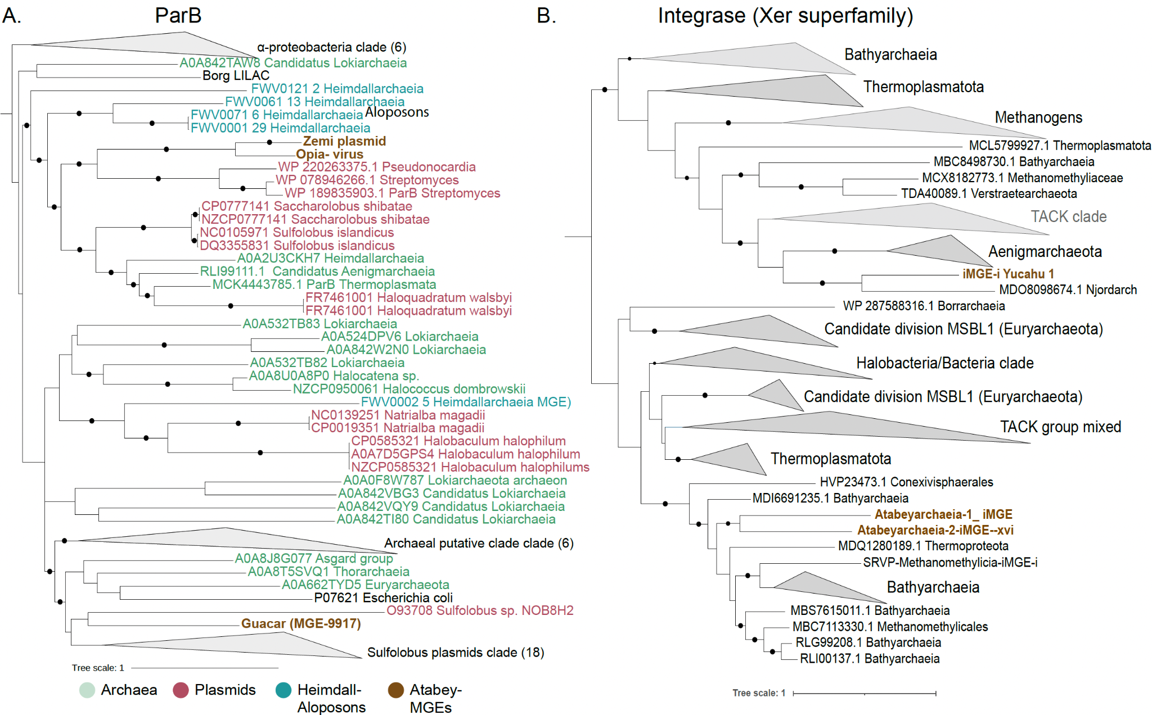 Supplemental Figure S2 Phylogenetic analyses of ParB and tyrosine-recombinase-like proteins across archaeal mobile genetic elements. A. Phylogenetic tree of ParB and ParB-like Proteins. Analysis incorporates reference sequences of E. coli ParB (Pfam08775) and Sulfolobus conjugative plasmid ParB (NOB8H2), alongside representative ParB-like domains from select archaeal and bacterial genomes. Selection criteria for inclusion involved a rigorous screening of the top 25 protein hits from the NCBI database. Sequence alignments were conducted using MAFFT (v7.310) in 'auto' mode, with subsequent optimization by trimAl (v1.4.rev15) applying a 0.7 gap threshold. Phylogenetic trees were inferred using IQ-TREE (v1.6.1) under the LG+FO+R model. B. Phylogeny of tyrosine-recombinase-like proteins within integrated mobile genetic elements of Atabeyarchaeia-1 and Atabeyarchaeia-2. The analysis selected the top 25 protein hits from the NCBI database, aligned with MAFFT (v 7.310) on 'auto' setting, and refined the alignment with trimAl (v 1.4.rev15) using a 0.7 gap threshold. The phylogenetic tree was constructed using IQ-TREE (v 1.6.1), adopting the LG+FO+R model.

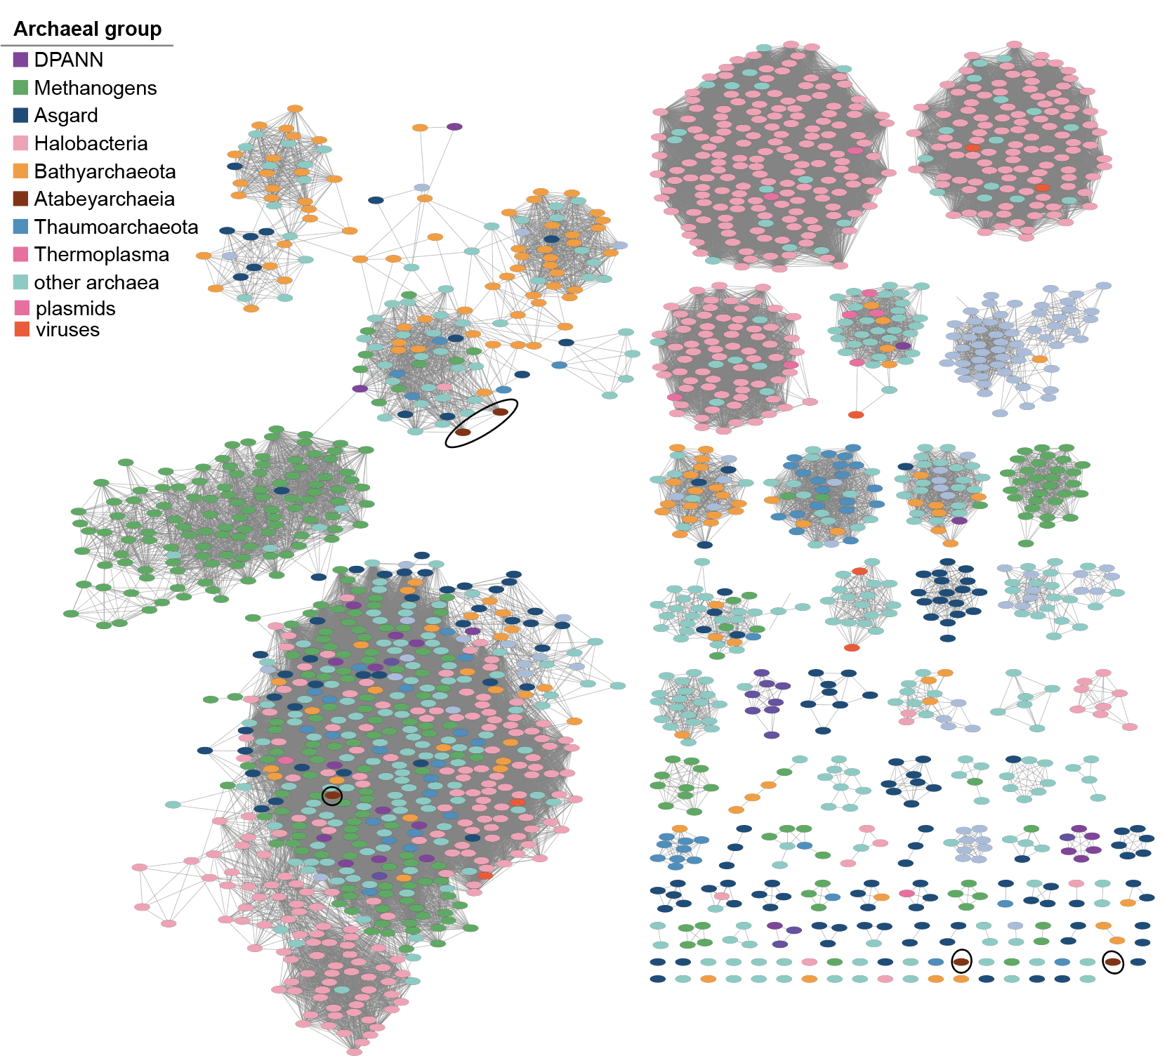
Supplemental Figure S3 Sequence similarity network (SSN) for representative viral Integrases database from dereplicated 6,200 amino acid sequences. The network was constructed from a curated database of integrase-like proteins across archaeal groups. Black circles in the network denote integrases from Atabeyarchaeota genomes. The singletons from Atabeyarchaeia are from the plasmid and Yucahu integrases.
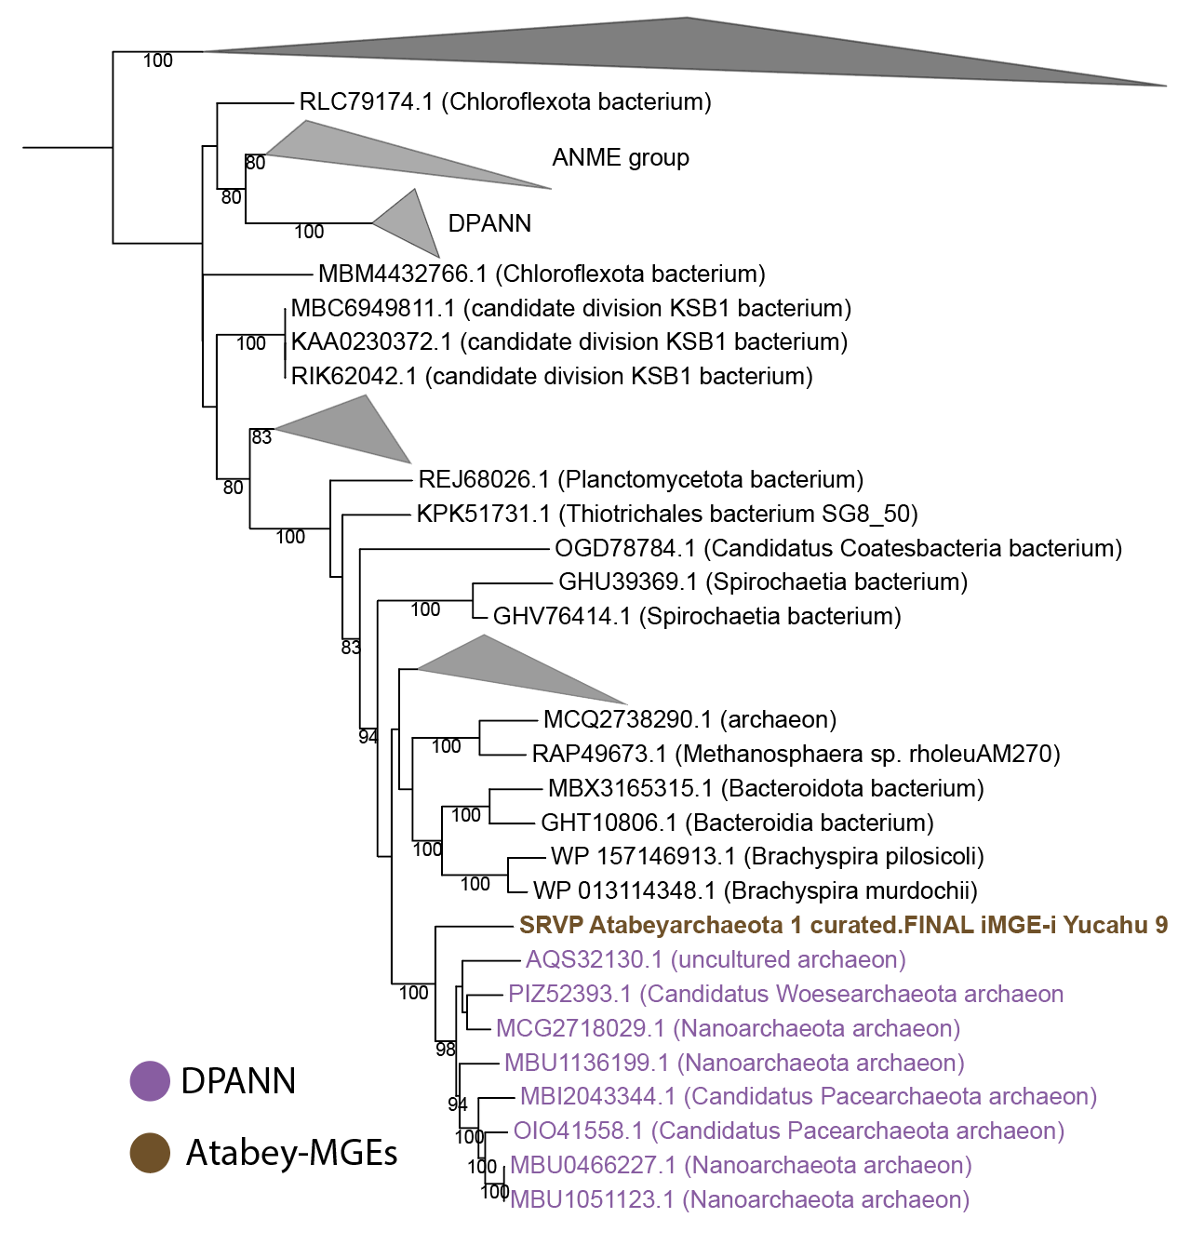

Supplemental Figure S4 Maximum likelihood phylogeny of a novel Type II-G restriction-modification (IIG RM) protein fusion that combines endonuclease and methyltransferase present in Yucahu MGE The phylogenetic tree was constructed with IQ-TREE (v 1.6.1) LG+FO+R model.

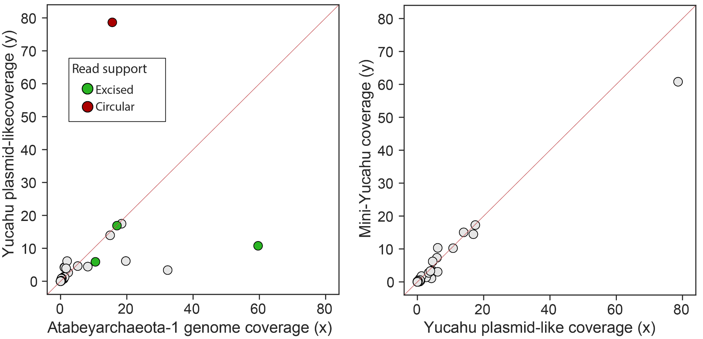

Supplemental Figure S5 Cross-sample Atabeyarchaeia-1 plasmid integration A. Correlations of the genome coverages between integrated plasmid Yucahu and Atabeyarchaeia B. Correlations of the Yucahu plasmid genome and the mini-Yucahu element

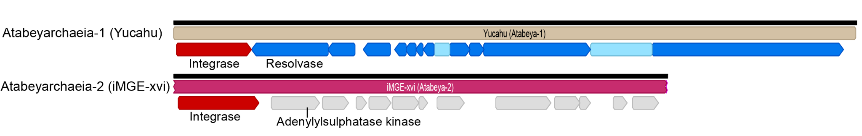
Supplemental Figure S6 Comparison of gene content of Yucahu-i (Atabeyarchaeia-1), top. and iMGE-xvi (Atabeyarchaeia-2), bottom. Annotated proteins of Yucahu-i include a tyrosine recombinase and a protein with similarity to adenylylsulfate kinases. The iMGE-xvi has 12 open reading frames, most encoding hypothetical proteins or proteins of unknown function. Three proteins are predicted to have 5 - 8 transmembrane domains. One is a putative membrane-bound serine protease of the ClpP class involved in the proteolysis of misfolded and defective proteins (Moreno-Cinos et al. 2019). Genes in gray represent hypothetical proteins with no known homologous sequences or functional domains in databases.

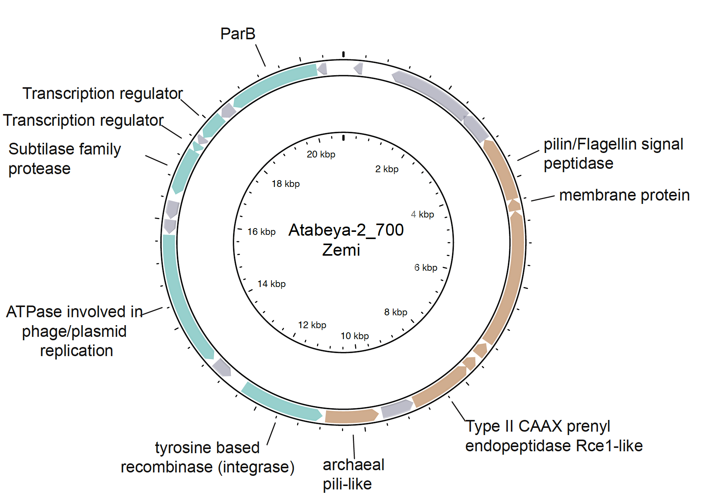 Supplemental Figure S7 Genome diagram of Atabeyarchaeia-2 putative plasmid Zemi-700. The plasmid has 23 open reading frames and gray-colored genes are hypothetical. Genes colored brown have transmembrane domains and are predicted to be extracellular.
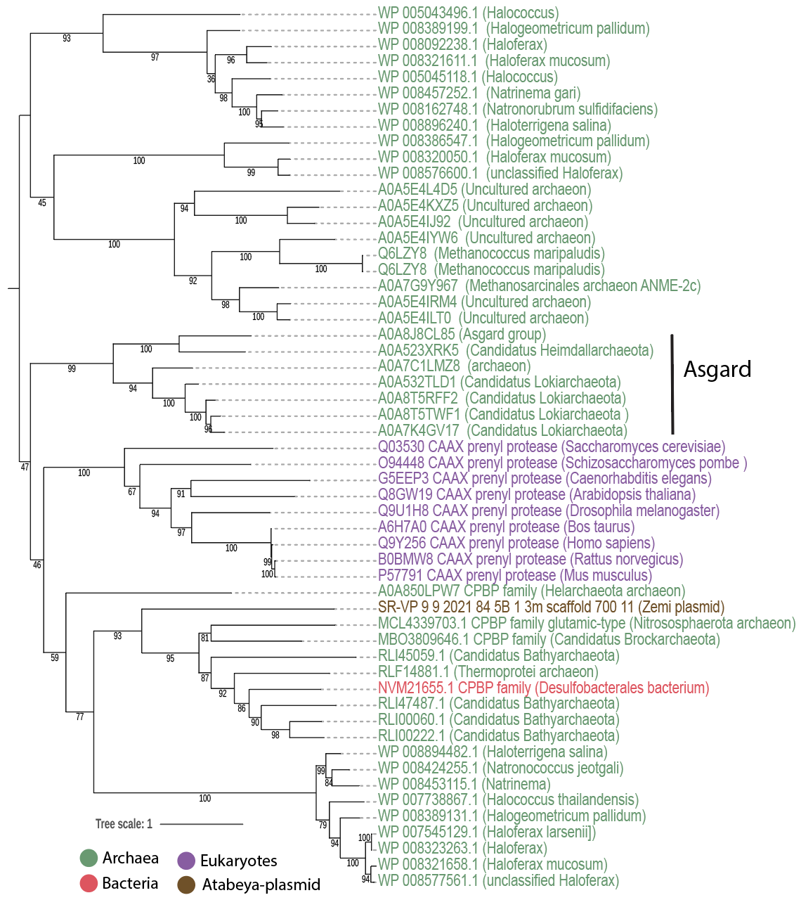
Supplemental Figure S8 Maximum likelihood phylogeny of CAAX proteases identified in the Atabeyarchaeia-2 plasmid_700. For this analysis, the top 50 protein hits from the NCBI against the non redundant database were selected. Sequence alignment was performed using MAFFT (v 7.310) with the 'auto' setting, and the alignment was subsequently trimmed with trimAl (v 1.4.rev15) using a gap threshold of 0.7 (-gt 0.7). The phylogenetic tree was constructed with IQ-TREE (v 1.6.1) employing the LG+FO+R model.

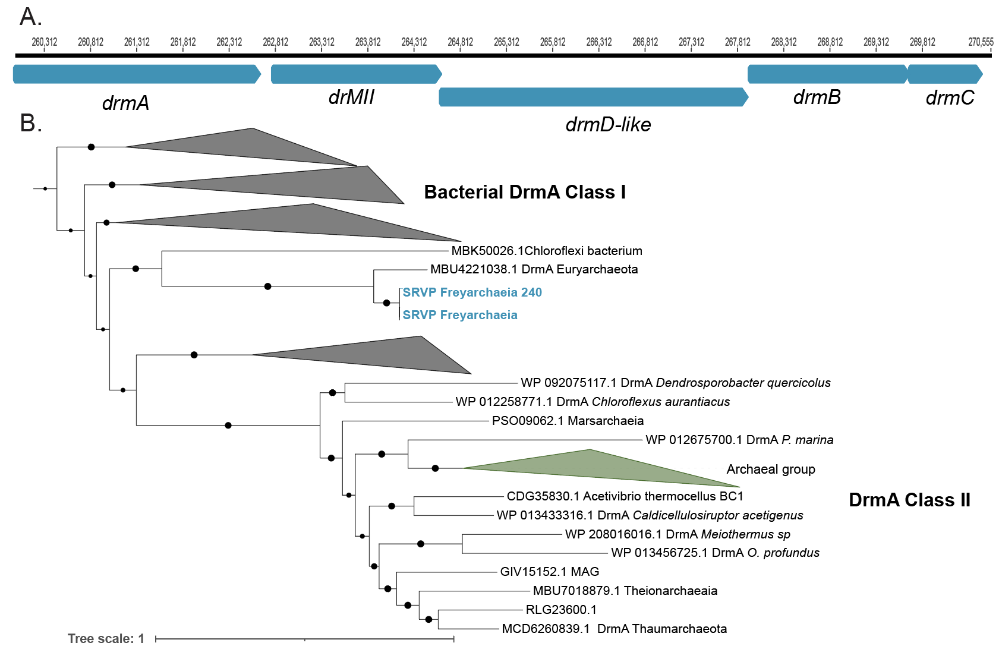 Supplemental Figure S9 Genomic organization of DISARM (Defense Island System Associated with Restriction-Modification) system from Freyarchaeia and phylogenetic placement of the DrmA within the whole superfamily. A. DrmA, DrmMII, DrmA’, DrmB and DrmC gene locus. B. Phylogenetic analysis of the DrmA protein found within the Freyarchaeia genome and reference sequences. The phylogenetic tree was initially constructed with IQ-TREE (v 1.6.1) using the LG+FO+R model.

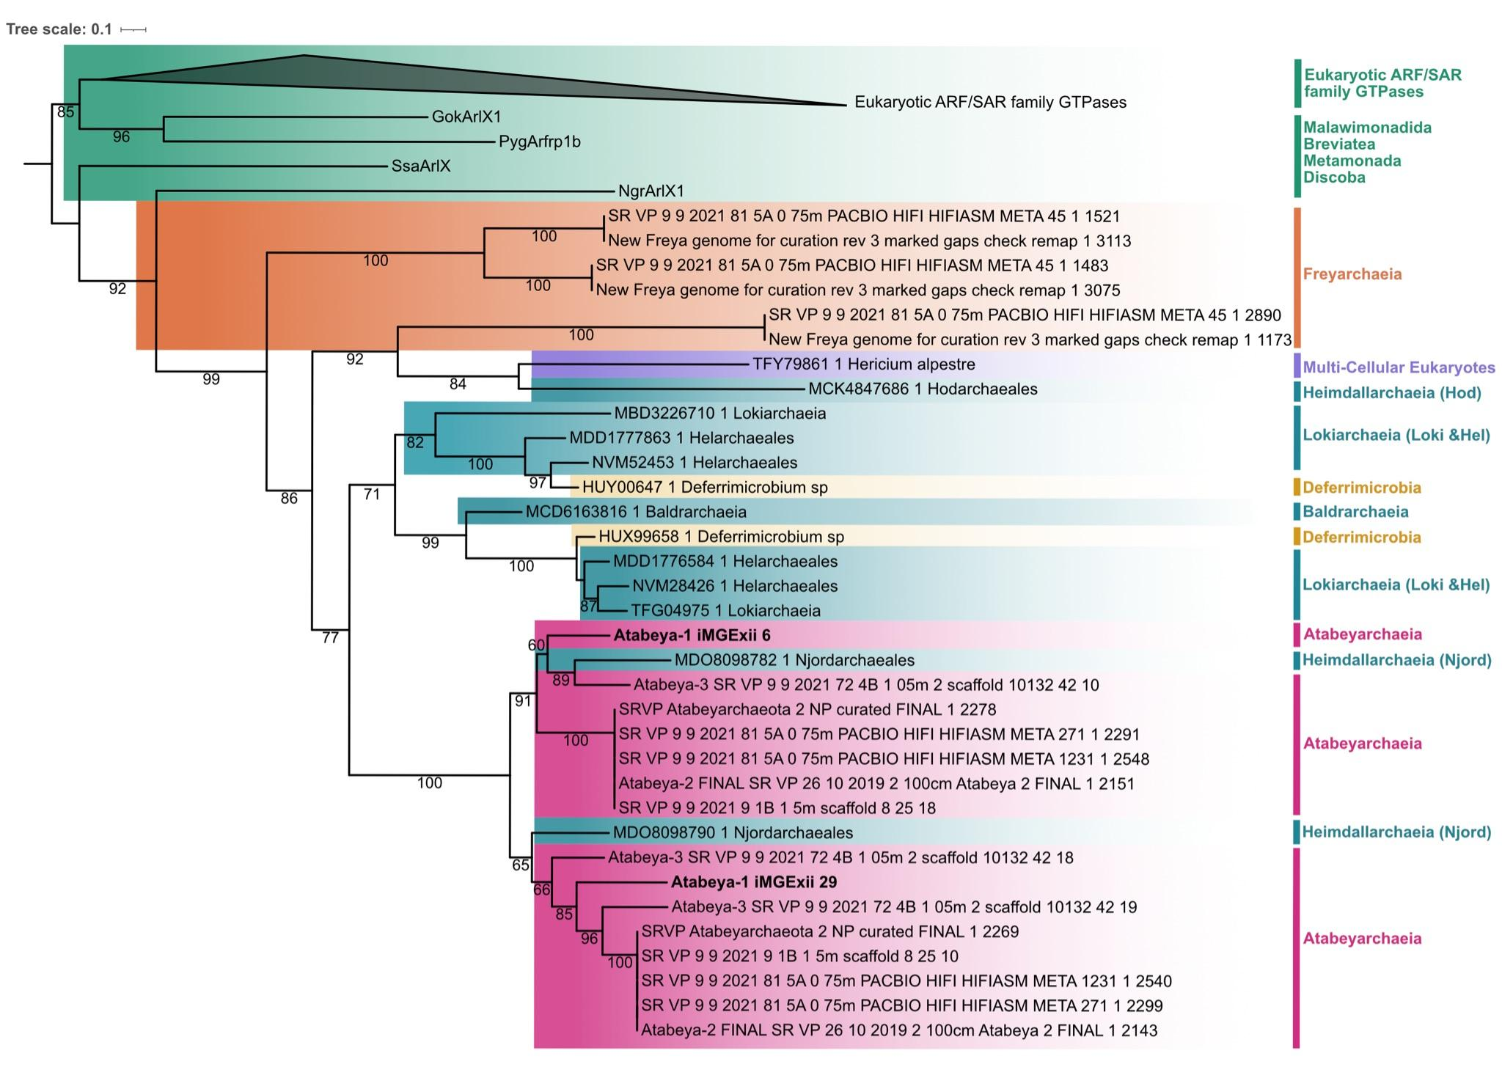
Supplemental Figure S10 Evolutionary position of Atabeyarchaeia putative MGEs GTPases across the three domains. Maximum likelihood tree of eukaryotic ARF family GTPases and Asgard archaea and bacterial GTPase sequences. GTPases identified on the putative iMGE-xii are highlighted in bold. Blasting the MGE GTPases against the NCBI non redundant database (June 19, 2024), we added hits with percent identity greater than or equal to 35% with more than 71% query coverage. Our expanded reference set includes 10 Asgardarchaeota (1 Baldrarchaeaia (previously misidentified as Odindarchaeia), 6 Lokiarchaeia, and 3 Heimdallarchaiea) and two grassland soil-associated Deferrimicrobium sp. sequences. We also added one eukaryotic sequence from a multicellular fungi, Hericium alpestre, collected from deadwood that had high query coverage (70-71%) and percent identity (33.33%-34.92%) to both MGE GTPases. Sequences were aligned with MAFFT auto (v7.490), trimmed with trimAl -gt 0.5 (v1.4.rev22), and used to create a maximum likelihood tree with iqtree (v1.6.12). LG+R7 was the best-fit model chosen according to BIC. Bootstrap values greater than or equal to 60 are shown.
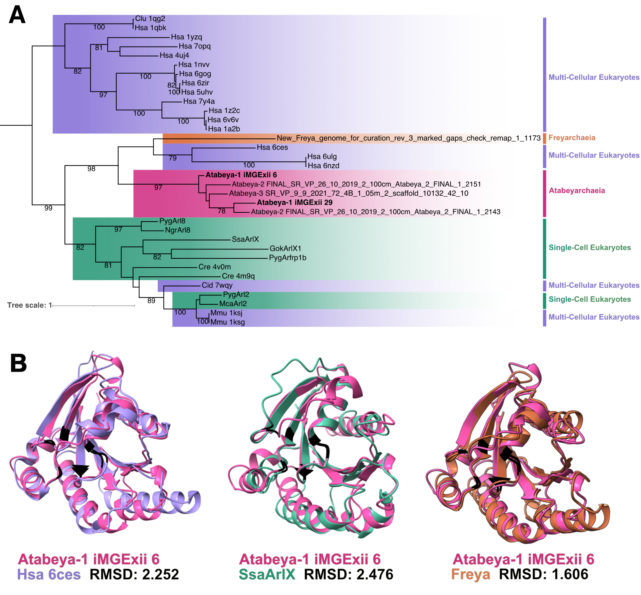

Supplemental Figure S11 Structural similarity between Atabeyarchaeia MGE-encoded and eukaryotic GTPases. A. Structural phylogeny including a subset of the proteins with the sequence phylogeny and confirmed structural homologues in the RCSB Protein Data Bank (See “Methods”). The first three letters of the references in sequence and structural phylogenies are the first letter of the genus followed by the first two letters of the species (i.e., Hsa abbreviated for Homo sapien). B. Atabeya-1 iMGE-xii_6 GTPase structural model (pink) superimposed on a H. sapien GTPase predicted by electron microscopy (purple), Spironucleus salmonicida GTPase structural model (green), and Freyarchaeia GTPase structural model (orange) (from left to right).

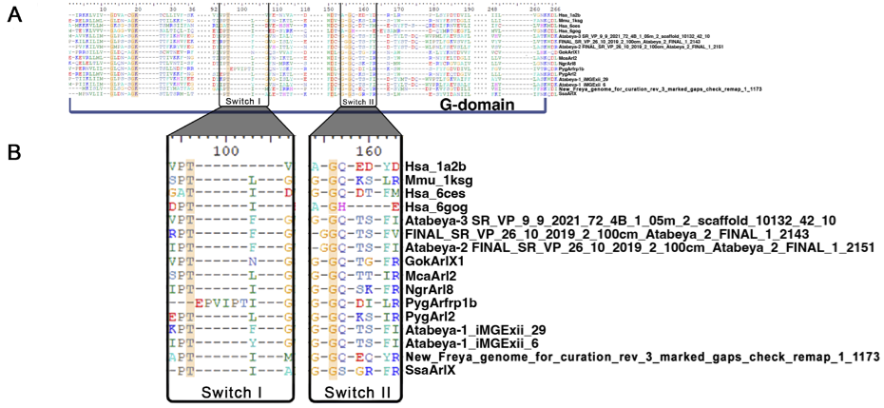

Supplemental Figure S12 Conservation of G domain and switches. A. Multi-sequence structural alignment, highlighting the conserved amino acids (yellow) in the G domain and B. the position of the switches.

