Supplemental Material

Global characterization of somatic mutations and DNA methylation changes during vegetative propagation in strawberries

Shaoqiang Hu, Xiangguo Zeng*, Yuguo Liu, Yongping Li, Minghao Qu, Wen-Biao Jiao, Yongchao Han*, Chunying Kang*

*Corresponding author:
Chunying Kang, ckang@mail.hzau.edu.cn
Yongchao Han, hyc660@126.com
Xiangguo Zeng, 382687178@qq.com

This PDF file includes:
Supplemental Figures 1-15
Supplemental Tables 1-15 legends
Supplemental Data 1-6 legends

The materials presented as separate files include:
Supplemental Tables 1-15 (in Supplemental_Tables.xlsx)
Supplemental Data 1-6 (in Supplemental_Data.zip)

Supplemental Figures
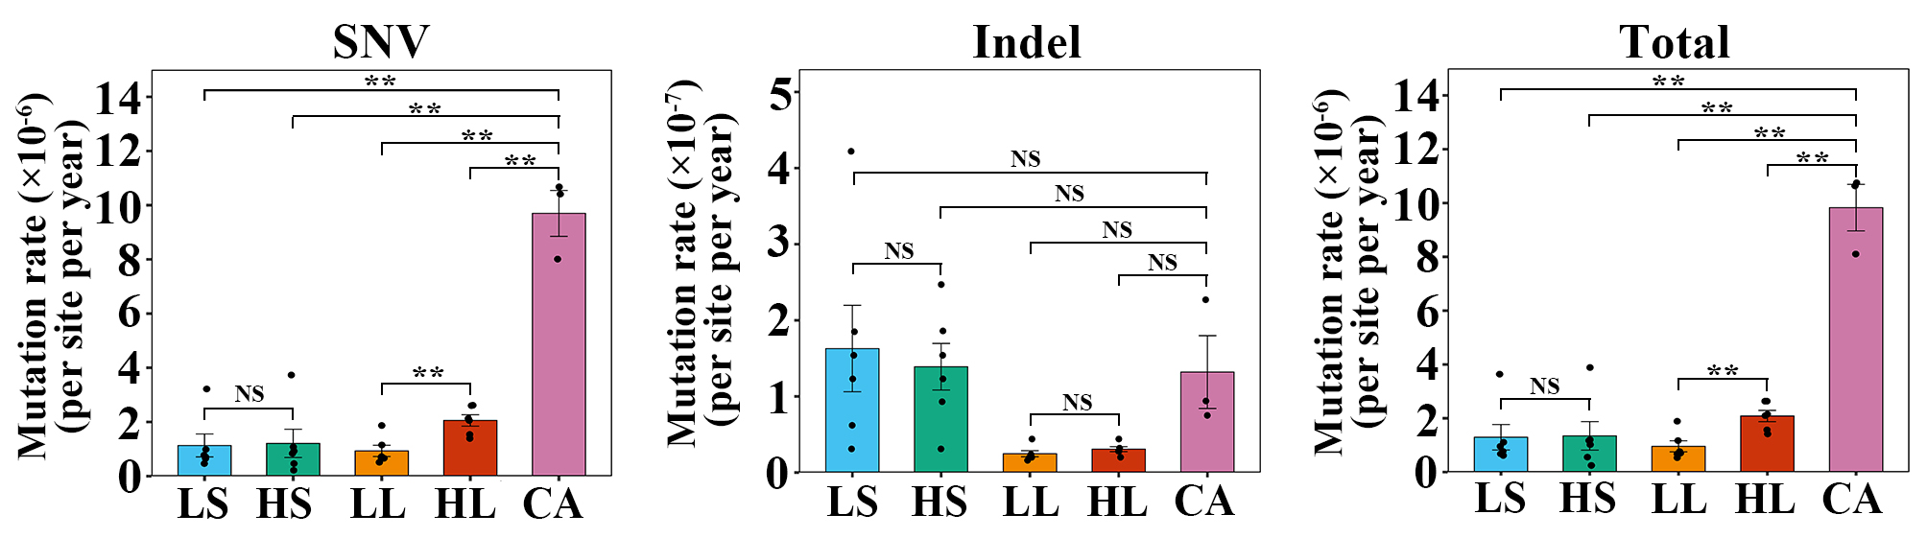
Supplemental Figure 1. SNV, indel, and total mutation rates in each sample.
The mutation rate in this figure indicates the number of mutations per site per year. Data are the mean ± SEM. **, P < 0.01; NS, not significant; Student’s t-test.

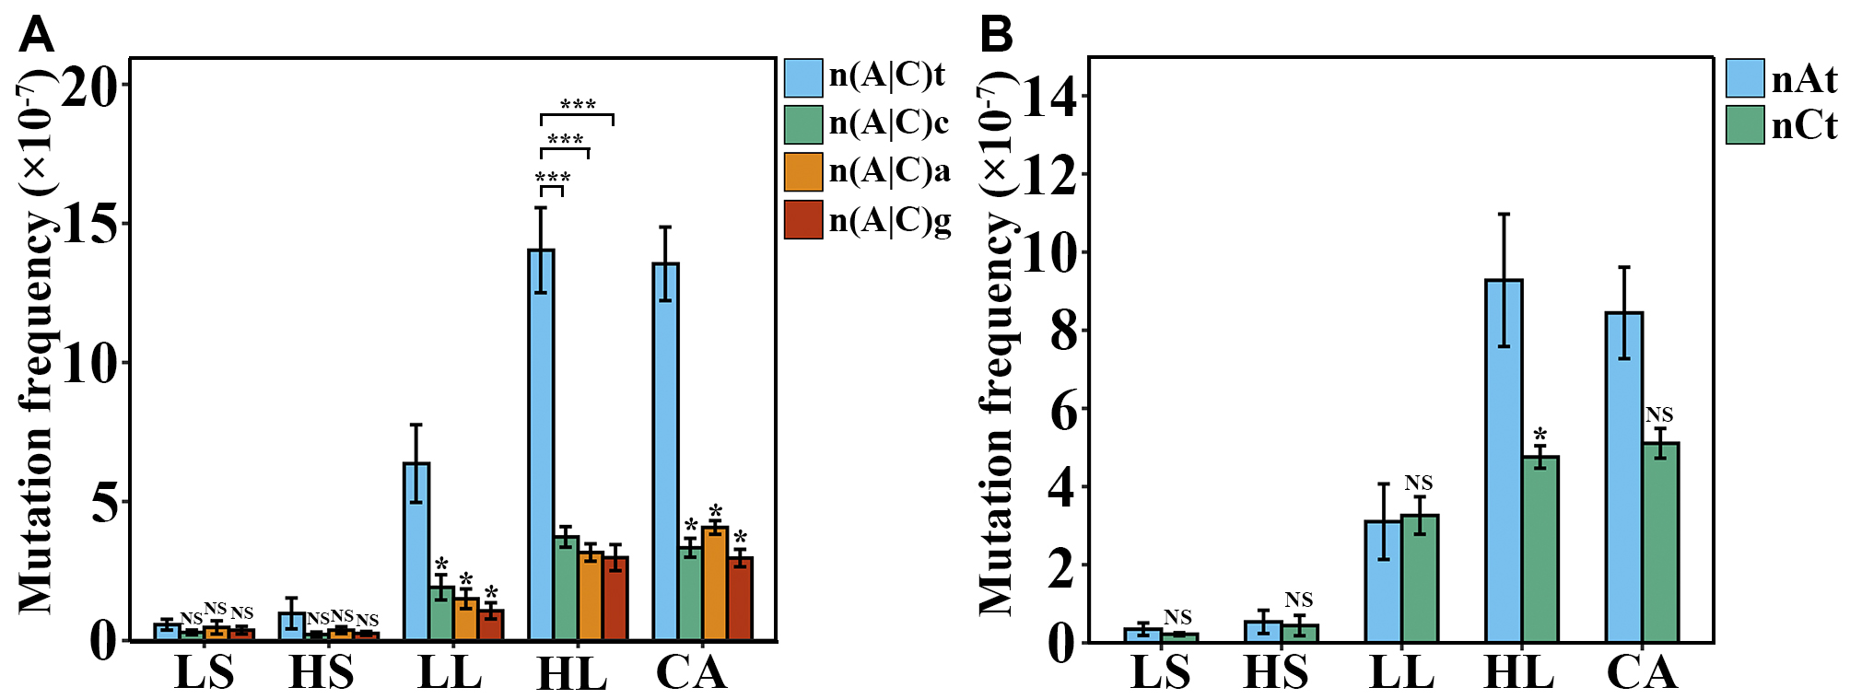
Supplemental Figure 2. Neighbor-dependent mutation frequencies at AT and GC bases estimated in regenerated woodland strawberry plants.
(A) Mutation frequencies of n(A|C)t, n(A|C)c, n(A|C)a and n(A|C)g in each sample. (B) Mutation frequencies of nAt and nCt in each sample. Data are the mean ± SEM. *, P < 0.05; ***, P < 0.001; NS, not significant; Student’s t-test.

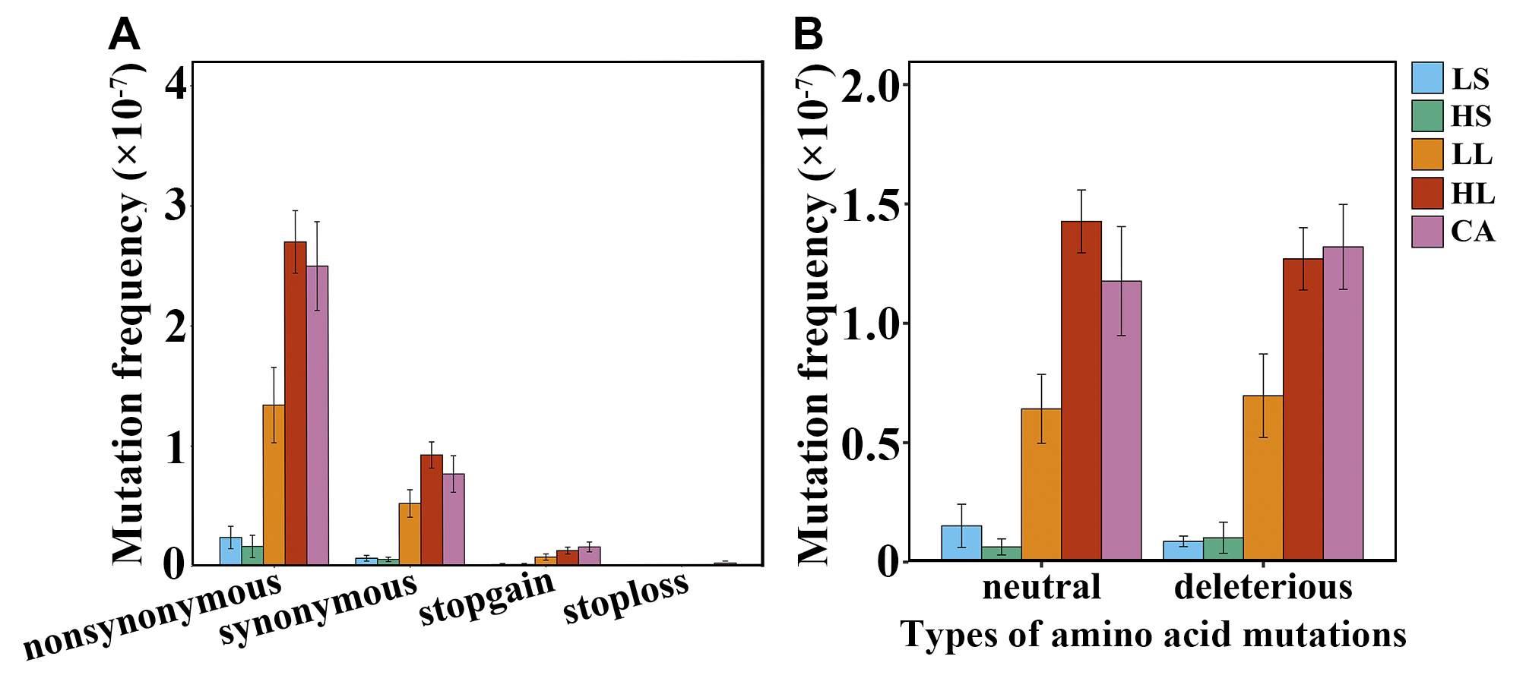
Supplemental Figure 3. Mutation frequencies of different SNV types in regenerated woodland strawberry plants.
(A) Mutation frequencies of different SNV types in the coding regions based on amino acid change in each sample. (B) Mutation frequencies of neutral and deleterious SNVs of the nonsynonymous type in each sample. Data are the mean ± SEM.

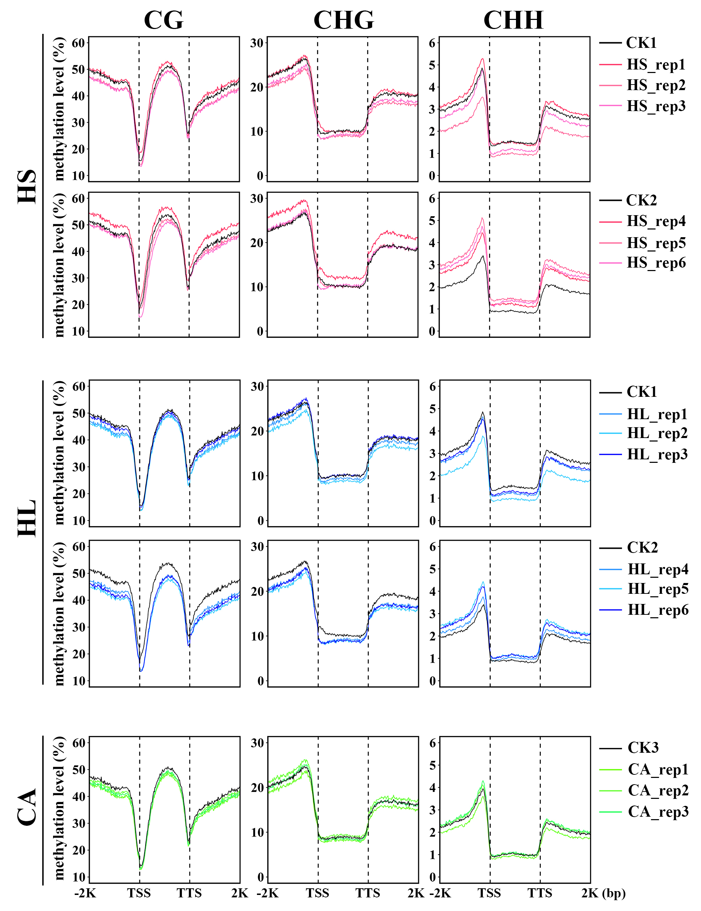
Supplemental Figure 4. Average methylation levels at the CG, CHG, and CHH contexts for the protein-coding genes in the regenerated woodland strawberry plants.
The original plants (CK1-3) were used as controls. The flanking regions from 2-kb upstream of the transcription start site (TSS) to 2-kb downstream of the transcription termination site (TTS) were included.

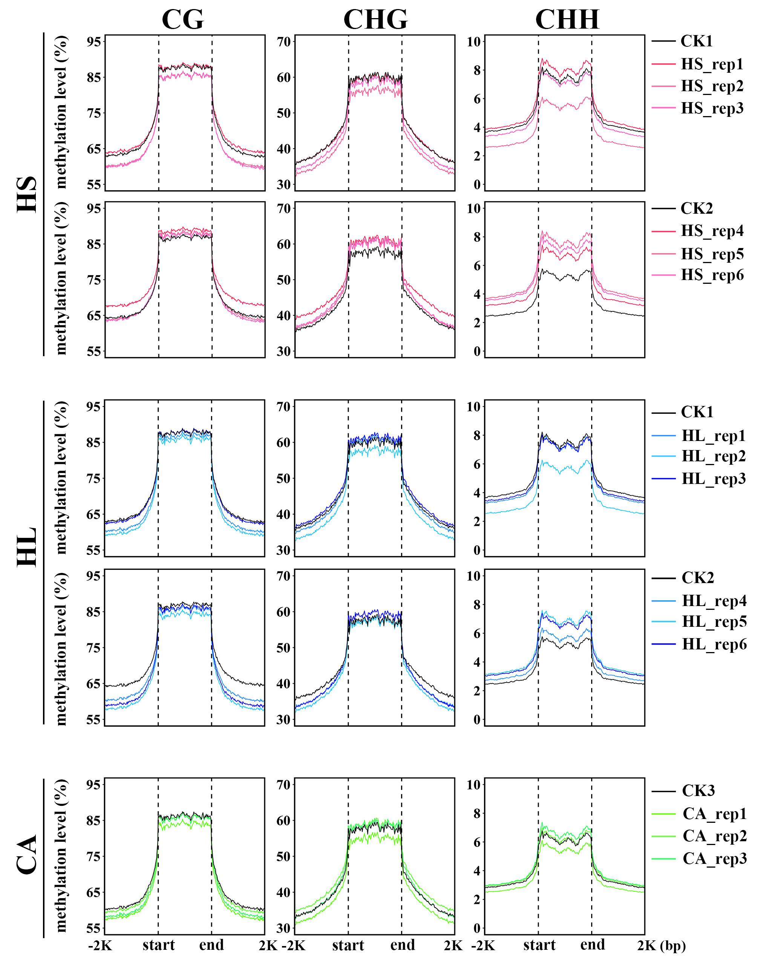
Supplemental Figure 5. Average methylation levels at the CG, CHG, and CHH contexts for the transposons in the regenerated woodland strawberry plants.
The original plants (CK1-3) were used as controls. The flanking regions from 2-kb upstream of the start site to 2-kb downstream of the end site were included.

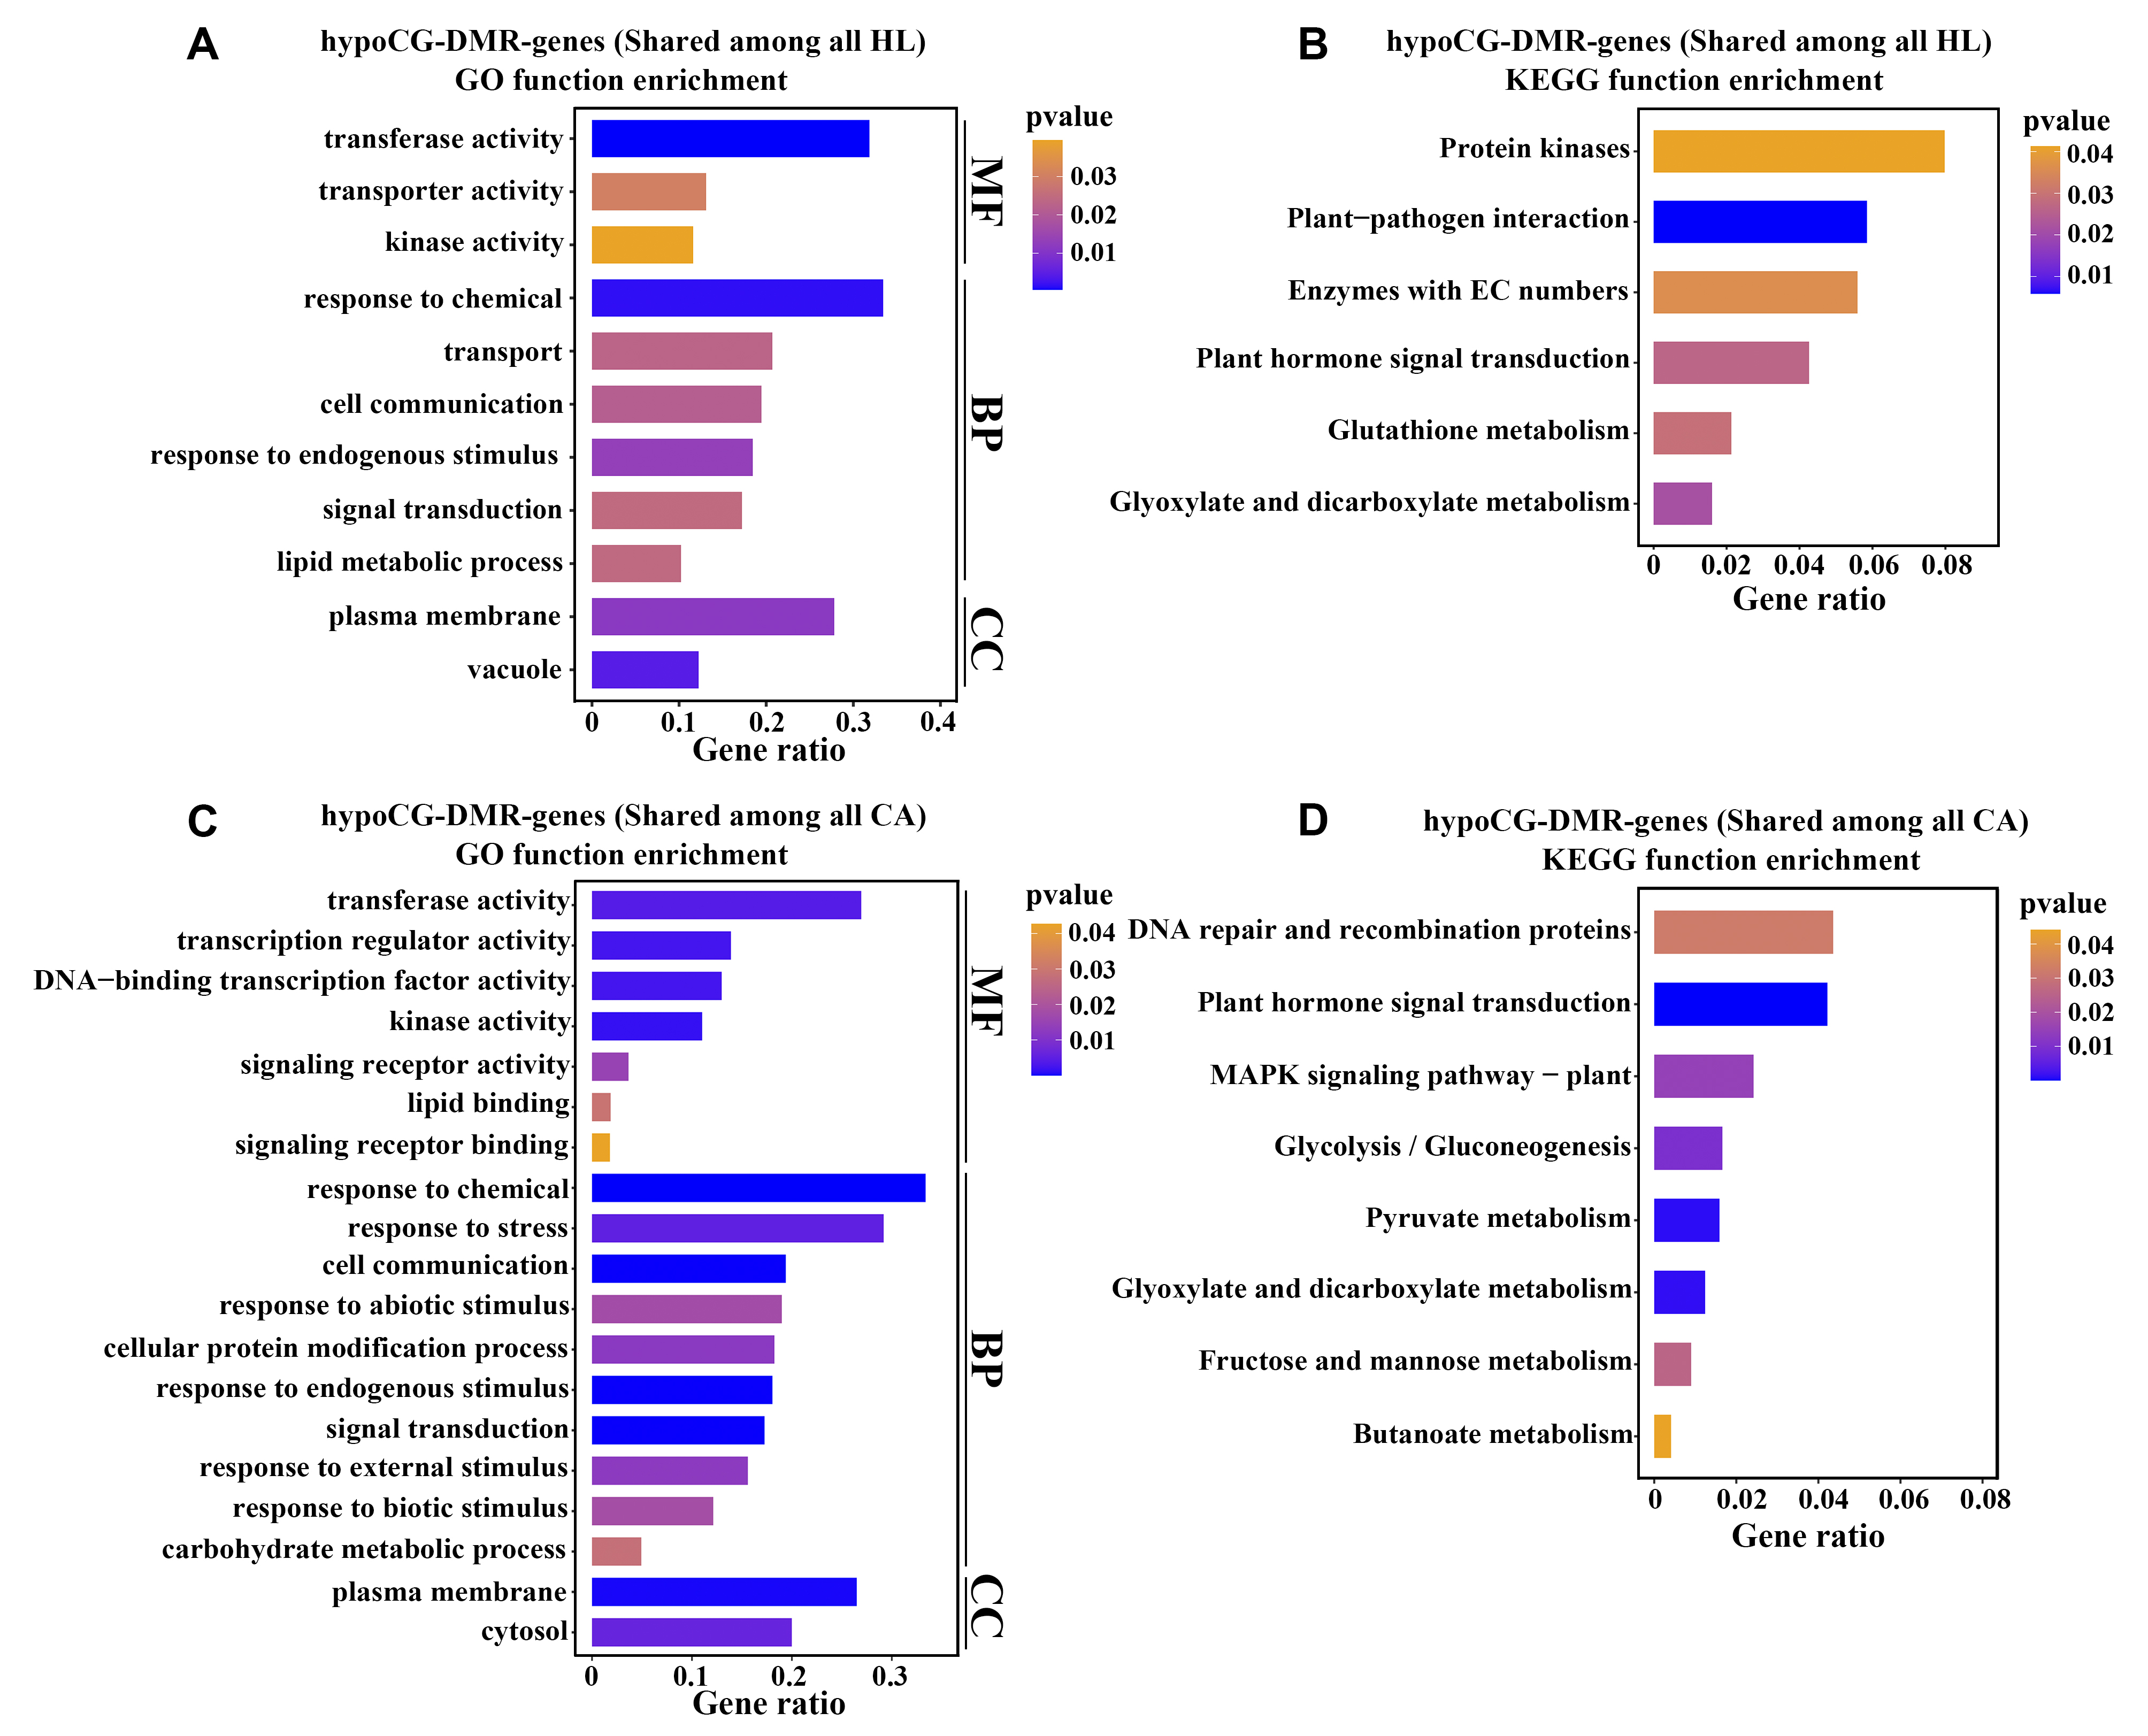
Supplemental Figure 6. Functional enrichment of genes with hypoCG-DMRs shared by HL and CA samples.
(A) GO enrichment of genes with hypoCG-DMRs shared by HL samples. (B) KEGG enrichment of genes with hypoCG-DMRs shared by HL samples. (C) GO enrichment of genes with hypoCG-DMRs shared by CA samples. (D) KEGG enrichment of genes with hypoCG-DMRs shared by CA samples.

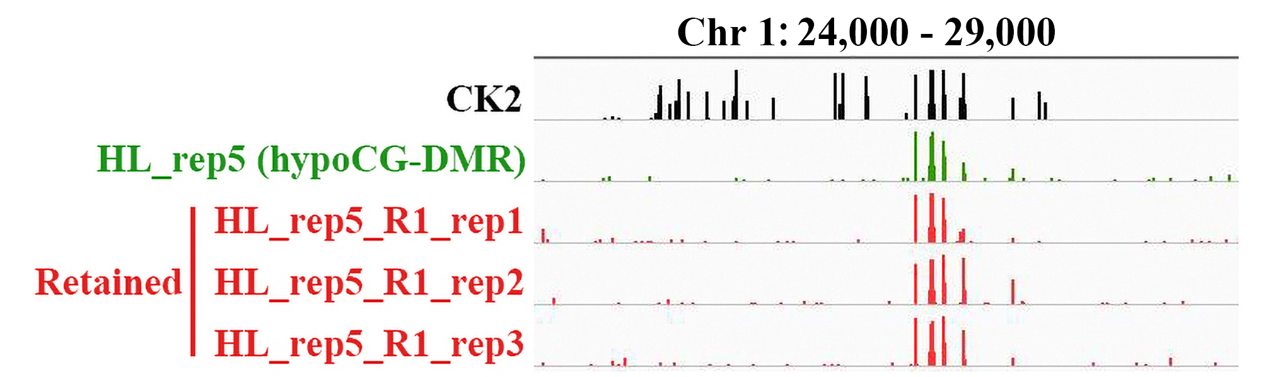
Supplemental Figure 7. IGV (Integrated Genome Viewer) view of a retained hypoCG-DMR region in the next generation. This region is located on Chromosome 1. The column height indicates the relative methylation levels at individual cytosine positions.
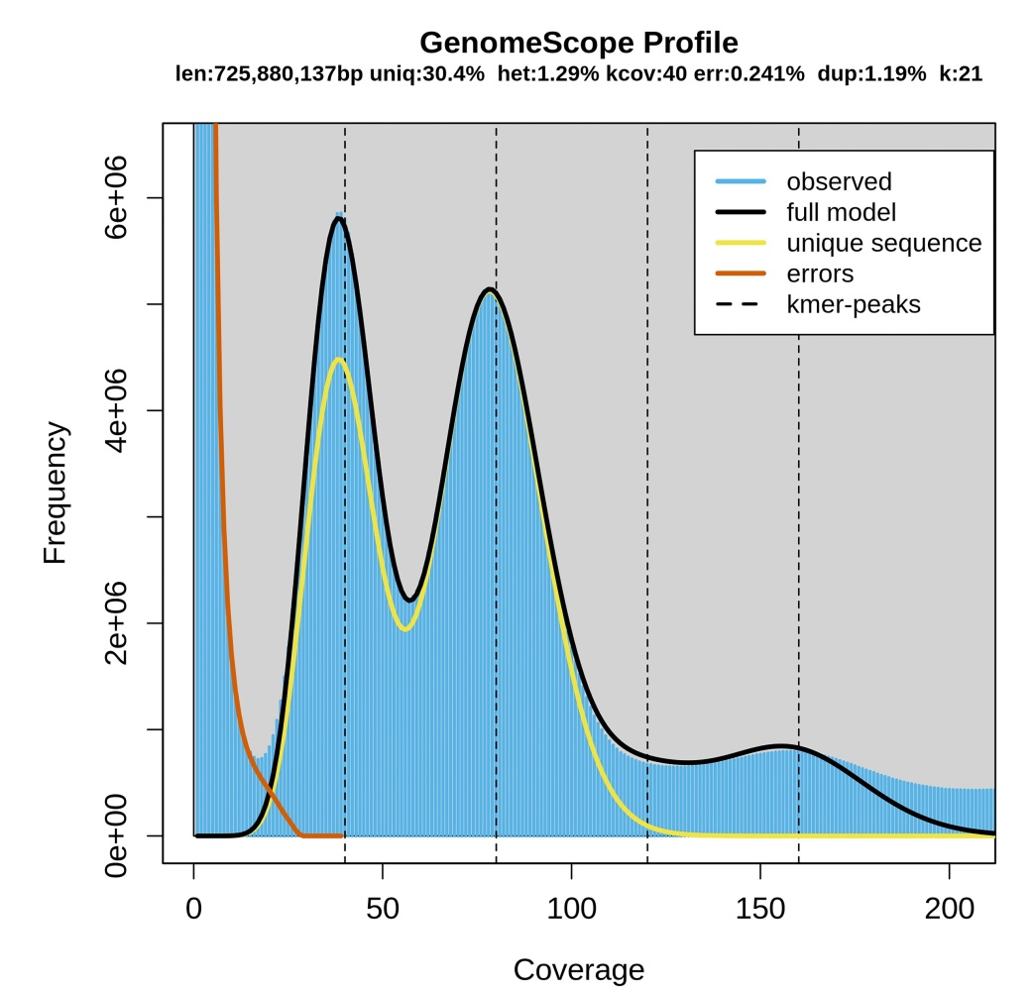
Supplemental Figure 8. Genome size estimates of ‘Beni hoppe’ by kmer (21-mer) analysis.

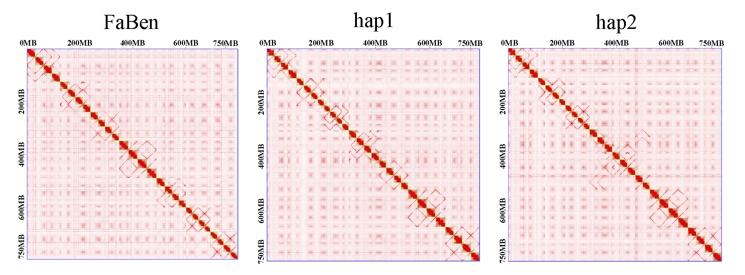
Supplemental Figure 9. Whole-genome Hi-C heatmap of the FaBen, hap1 and hap2 genomes.
The heatmap shows genome-wide all-by-all interactions under a resolution of 1 Mb.

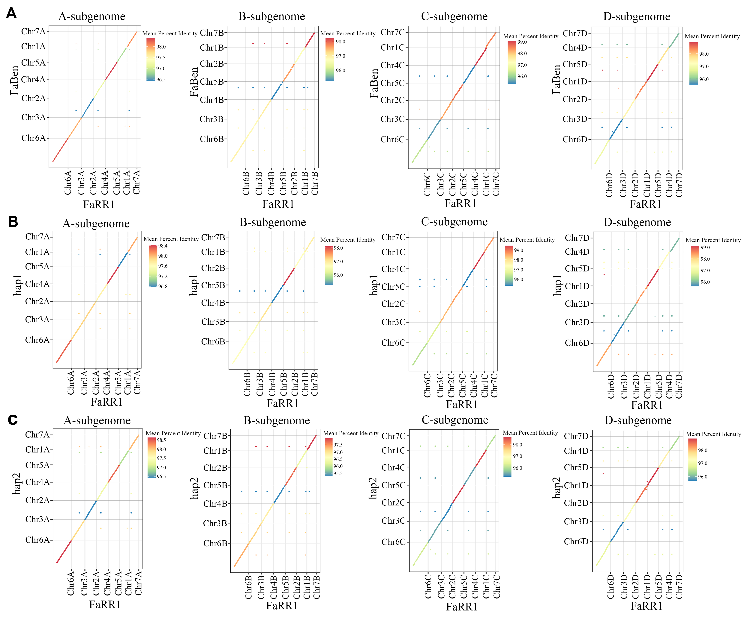
Supplemental Figure 10. Collinearity analysis of the ‘Beni hoppe’ and ‘Royal Royce’ genomes.
(A) Macrosyntenic comparison of the FaBen and ‘Royal Royce’ genomes. (B) Macrosyntenic comparison of the hap1 and ‘Royal Royce’ genomes. (C) Macrosyntenic comparison of the hap2 and ‘Royal Royce’ genomes.

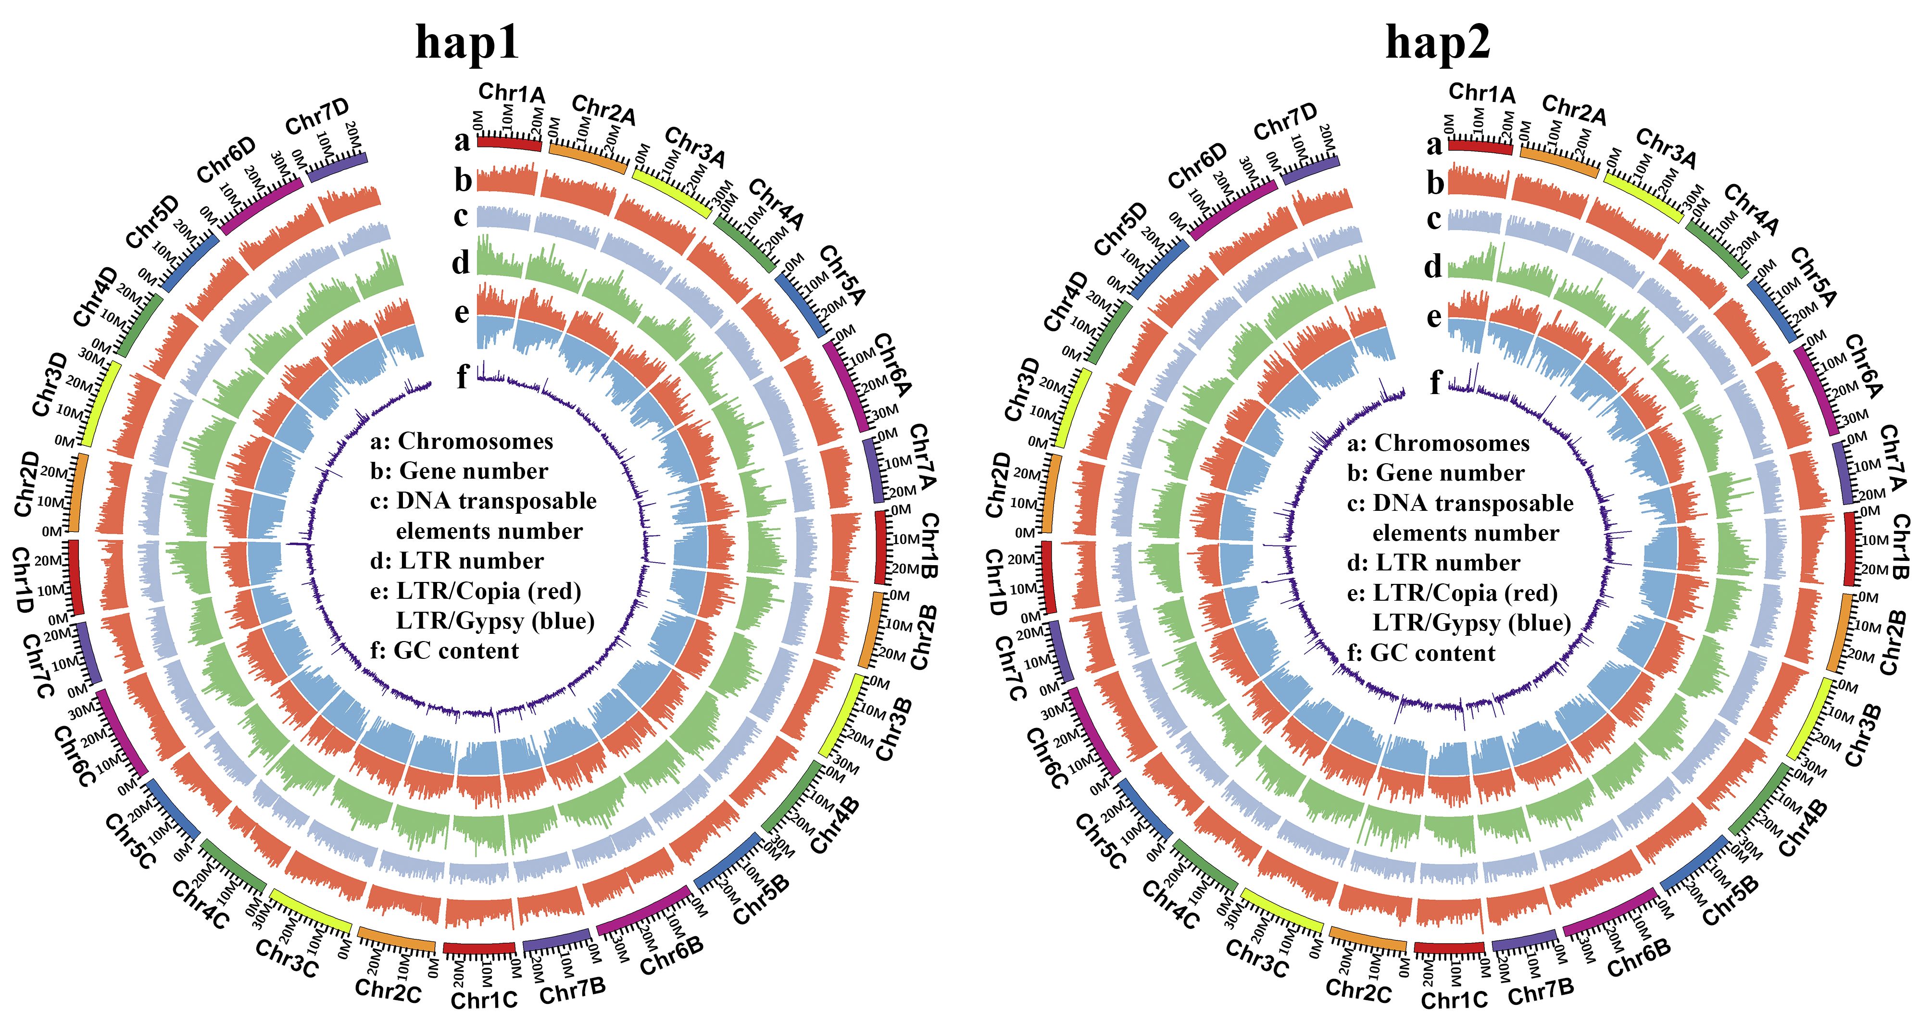
Supplemental Figure 11. Genomic features of the hap1 and hap2 assembly of the ‘Beni hoppe’ genome. All statistics were computed for windows of 100 kb.

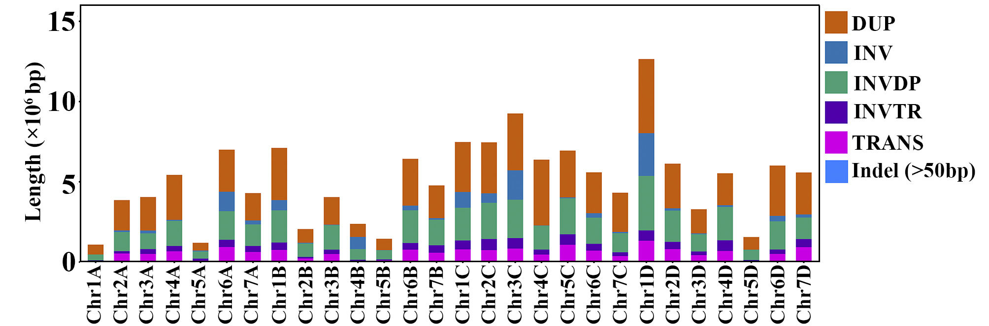
Supplemental Figure 12. Length of structural variations in the same chromosome pair between hap1 and hap2. DUP: duplicated region. INV: inverted region. INVDP: inverted duplicated region. INVTR: inverted translocated region. TRANS: translocated region.

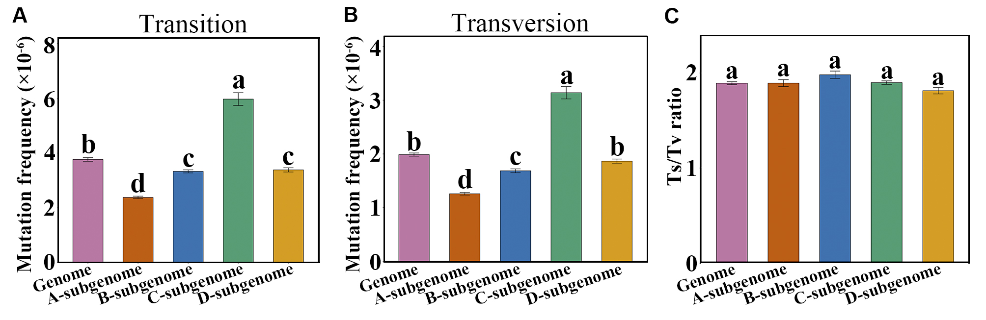
Supplemental Figure 13. Mutation frequencies of transitions and transversions among the 12 ‘Beni hoppe’ individuals.
(A) Mutation frequencies of all transitions among the 12 ‘Beni hoppe’ individuals. (B) Mutation frequencies of all transversions among the 12 ‘Beni hoppe’ individuals. (C) Transition/transversion ratios (Ts/Tv) among the 12 ‘Beni hoppe’ individuals. Data are the mean ± SEM. Different letters indicate significant difference at P < 0.05 using Tukey’s test.

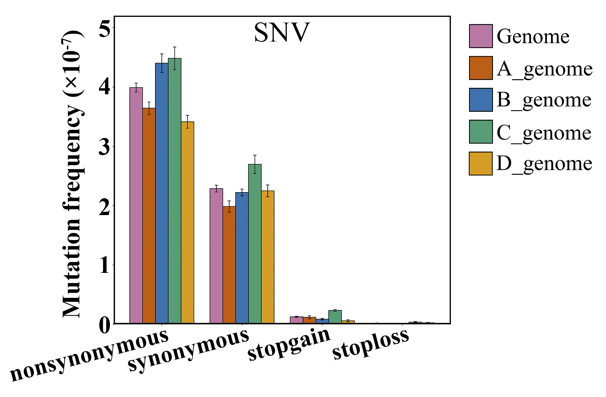
Supplemental Figure 14. Mutation frequencies of different SNV types in the protein-coding regions among the 12 ‘Beni hoppe’ individuals.
Data are the mean ± SEM.
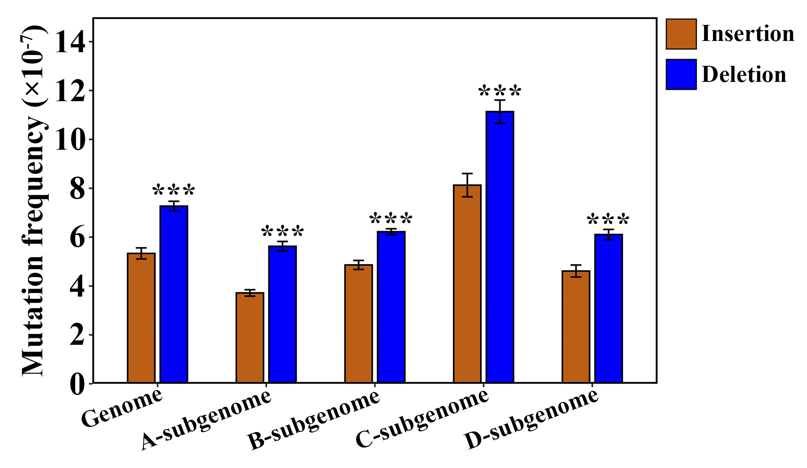
Supplemental Figure 15. Mutation frequencies of insertions and deletions among the 12 ‘Beni hoppe’ individuals. Data are the mean ± SEM. ***, P < 0.001; Student’s t-test.

Supplemental Tables
Supplemental Table 1 Summary of read statistics for all samples.
Supplemental Table 2 Number of mutation sites identified in the regenerated woodland strawberry plants and 12 ‘Beni hoppe’ individuals.
Supplemental Table 3 Validation of identified SNVs and indels by Sanger sequencing.
Supplemental Table 4 Summary of read statistics for all Whole-Genome Bisulfite Sequencing (WGBS) samples.
Supplemental Table 5 Average methylation levels at the CG, CHG and CHH contexts in the regenerated woodland strawberry plants.
Supplemental Table 6 Number of the CG-DMR, CHG-DMR and CHH-DMR regions in the regenerated woodland strawberry plants.
Supplemental Table 7 Summary of sequencing data used for ‘Beni hoppe’ genome assembly.
Supplemental Table 8 Genome size and heterozygosity (H) estimation by k-mer analysis.
Supplemental Table 9 Summary of the FaBen, hap1 and hap2 genome assemblies.
Supplemental Table 10 Predicted telomeres in the FaBen, hap1 and hap2 genome assemblies.
Supplemental Table 11 Predicted centromeres in the FaBen, hap1 and hap2 genome assemblies.
Supplemental Table 12 Genome quality assessed by the LAI index.
Supplemental Table 13 Transposons and repeats in the FaBen, hap1 and hap2 genome assemblies.
Supplemental Table 14 Statistics of the protein-coding gene models in the FaBen, hap1 and hap2 genome assemblies.
Supplemental Table 15 Summary of RNA-Seq datasets used for genome annotation.

Supplemental Data
Supplemental Data 1 Information about the different mutation types in all samples.
Supplemental Data 2 Information about the mutation sites in regenerated woodland strawberry plants.
Supplemental Data 3 Information about the mutation sites among the 12 ‘Beni hoppe’ individuals.
Supplemental Data 4 The list of DMRs at the CG contexts in the regenerated woodland strawberry plants.
Supplemental Data 5 The list of DMRs at the CHG contexts in the regenerated woodland strawberry plants.
Supplemental Data 6 The list of DMRs at the CHH contexts in the regenerated woodland strawberry plants.

