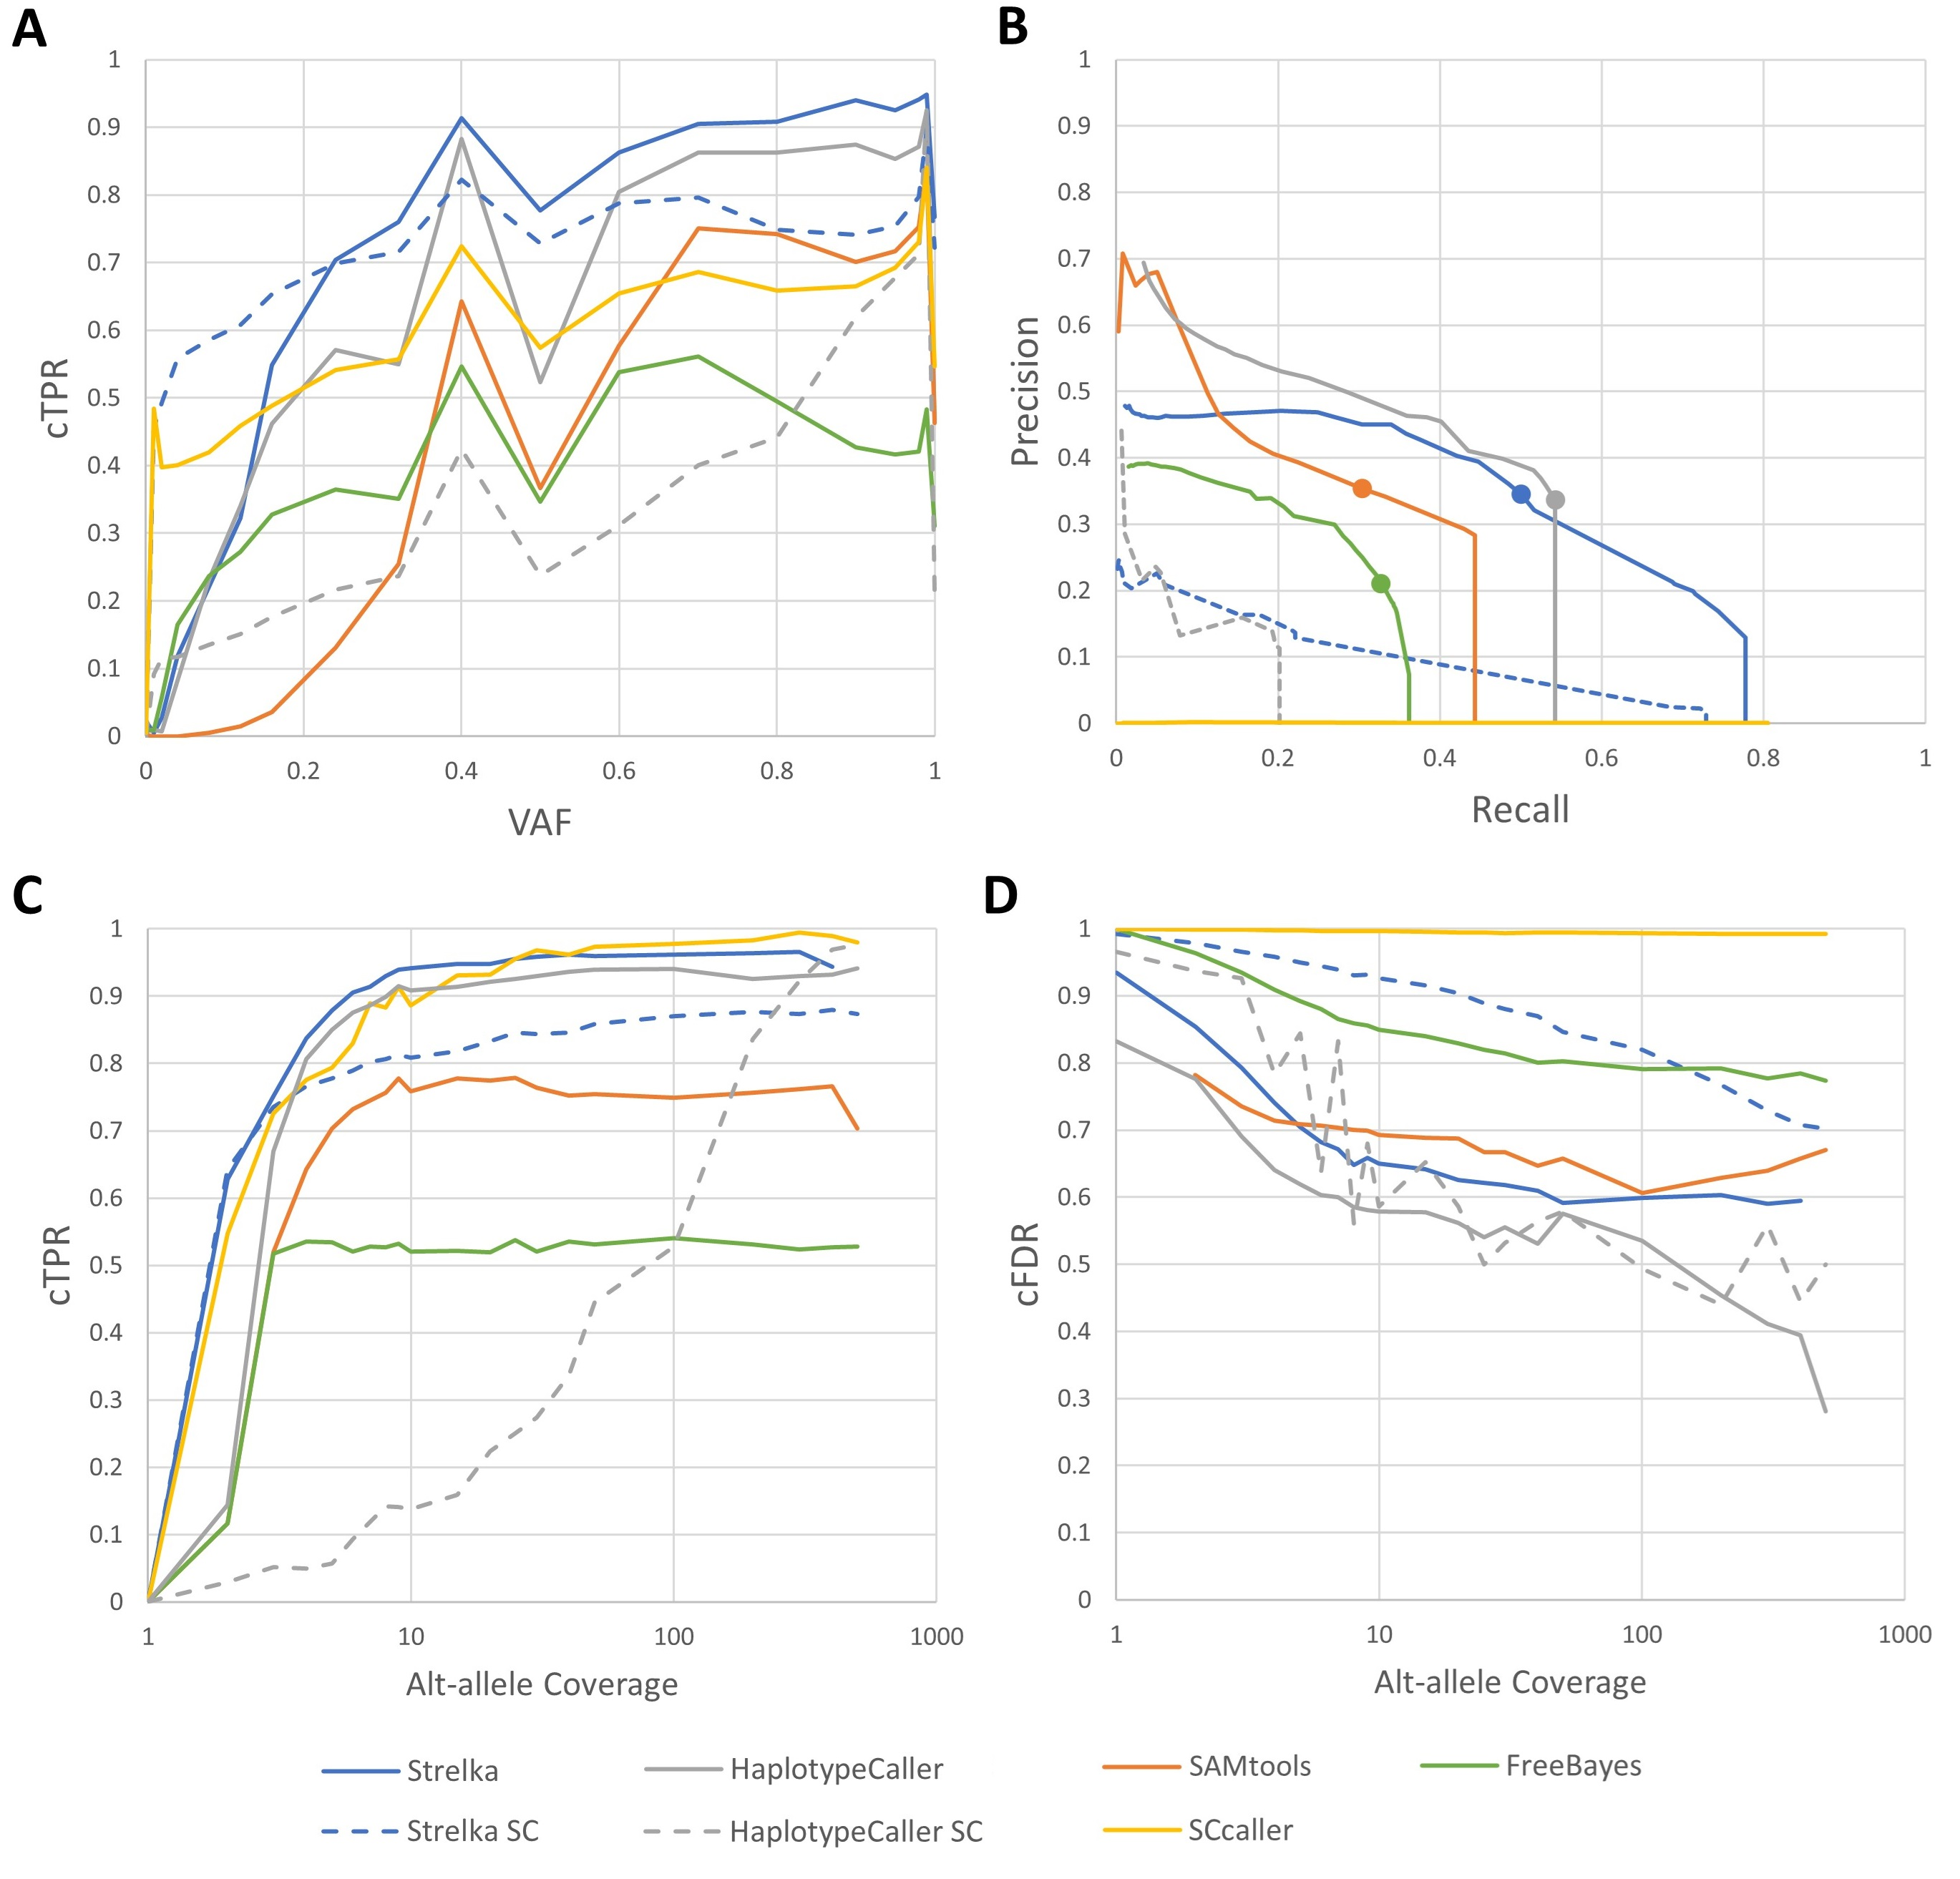
Supplementary Figure S2: Analysis of all scRNA-seq-derived variants (including non-exonic) generated by different variant calling approaches used; (a) common true positive rates (cTPR) by variant allele frequency (VAF); (b) precision-Recall curves averaged over samples for different variant-calling approaches used; average over samples of common true positive rate (cTPR) (c) and common false discovery rate (cFDR) (d) versus alternate allele coverage

