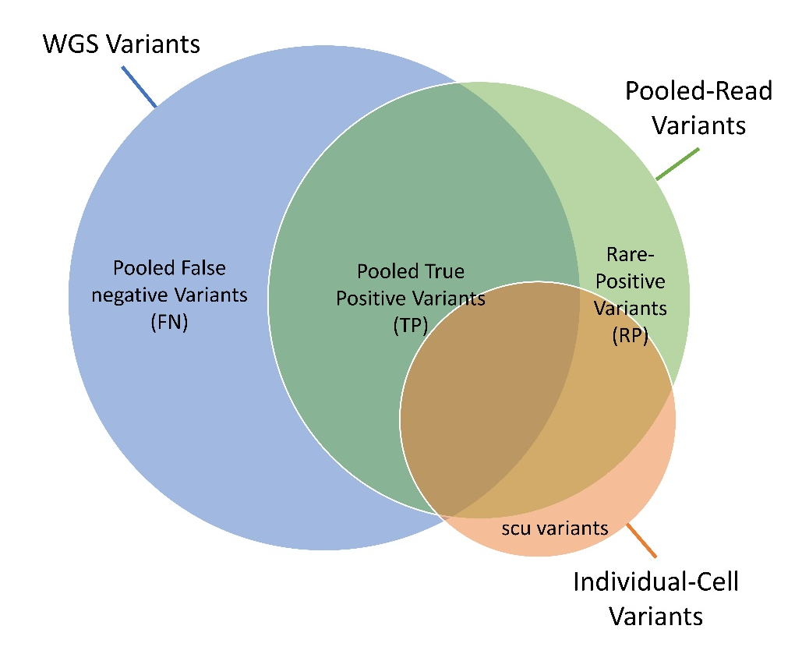
Supplementary Figure S1: Venn diagram visualizing the definition of various variant-category definitions, as defined in table 1. The three circles represent the types of variant calling sources (WGS calling, pooled read calling, and individual-cell calling), with labels in the circles defining types of variant classes.

