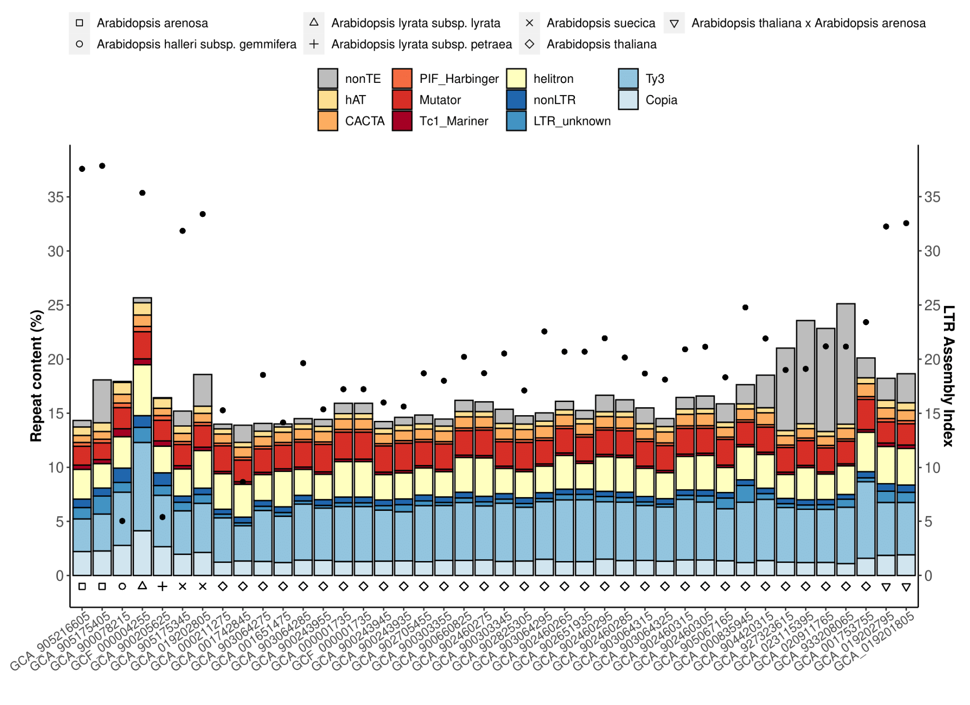
Supplemental Figure S1. panEDTA annotation of Arabidopsis genomes. Assemblies of the same species were arranged from small to large on the x-axis. The LTR Assembly Index (LAI) was used to access the repeat assembly quality of each assembly indicated by a black dot. Variation within species likely reflects assembly quality differences due to variation in sequencing methods and assembly algorithms.

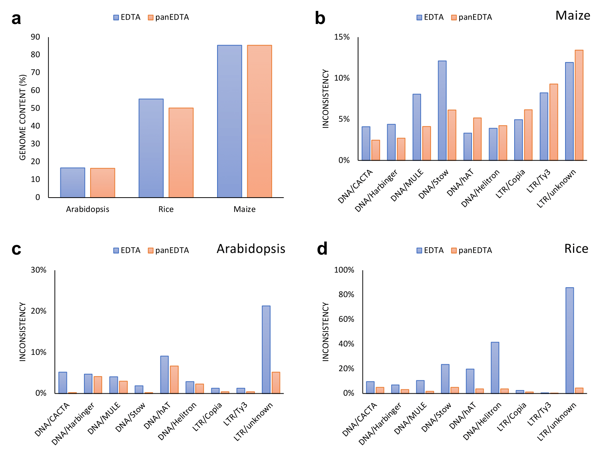
Supplemental Figure S2. Summary of EDTA and panEDTA performance. a. Repeat content percentage is consistent between EDTA and panEDTA annotations. Annotation inconsistency of EDTA and panEDTA in maize (b), Arabidopsis (c), and rice (d).
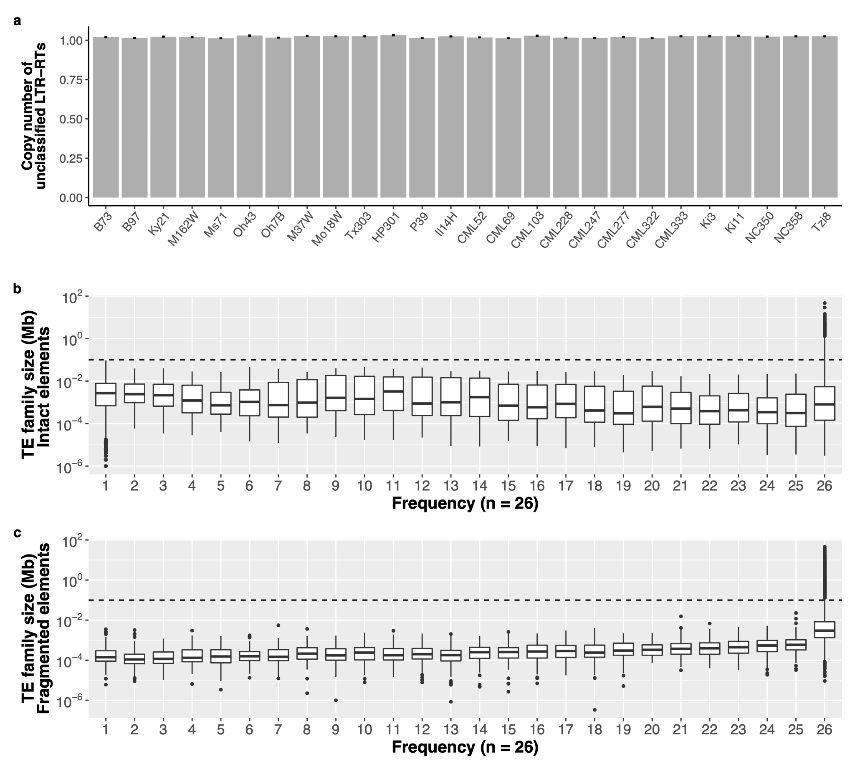
Supplemental Figure S3. Pan-genome summary of TE annotations. a. Average copy number of single-copy intact LTR-RTs in each maize line. These elements did not satisfy the 80-80-80 rule to be classified into pan-genome TE families. Error bars indicate standard deviation. A total of 269,847 single-copy intact TEs were found across all 26 NAM genomes, with each genome having an average of 46.25 Mb of single-copy intact TEs. The relaxed 50-70-70 rule was used to estimate the copy number of these rare LTR-RTs (Methods). The average size of each TE family (including LTR retrotransposons, TIR transposons, Helitrons, and LINEs) for (b) structurally intact elements and (c) fragmented elements and their frequency in the 26 NAM founder lines. The black-dashed line indicates 0.1 Mb. In b and c, y axes were log10 scaled. Each box shows the median, upper, and lower quartiles. Whiskers indicate the 1.5× interquartile range. Black dots indicate outliers.

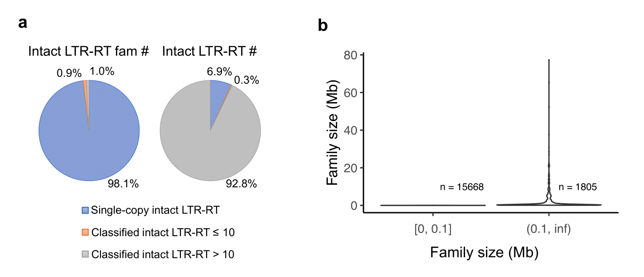
Supplemental Figure S4. Summary of TE family size in maize NAM founders. a. Number of LTR families and copy number of intact LTR-RTs. Single-copy intact LTR-RTs did not satisfy the 80-80-80 rule to be classified into pan-genome TE families and presented as standalone families. b. Family size (including both intact and fragmented TEs) distribution of all pan-genome TE families in NAM founder lines which were categorized based on a family size of 0.1 Mb.

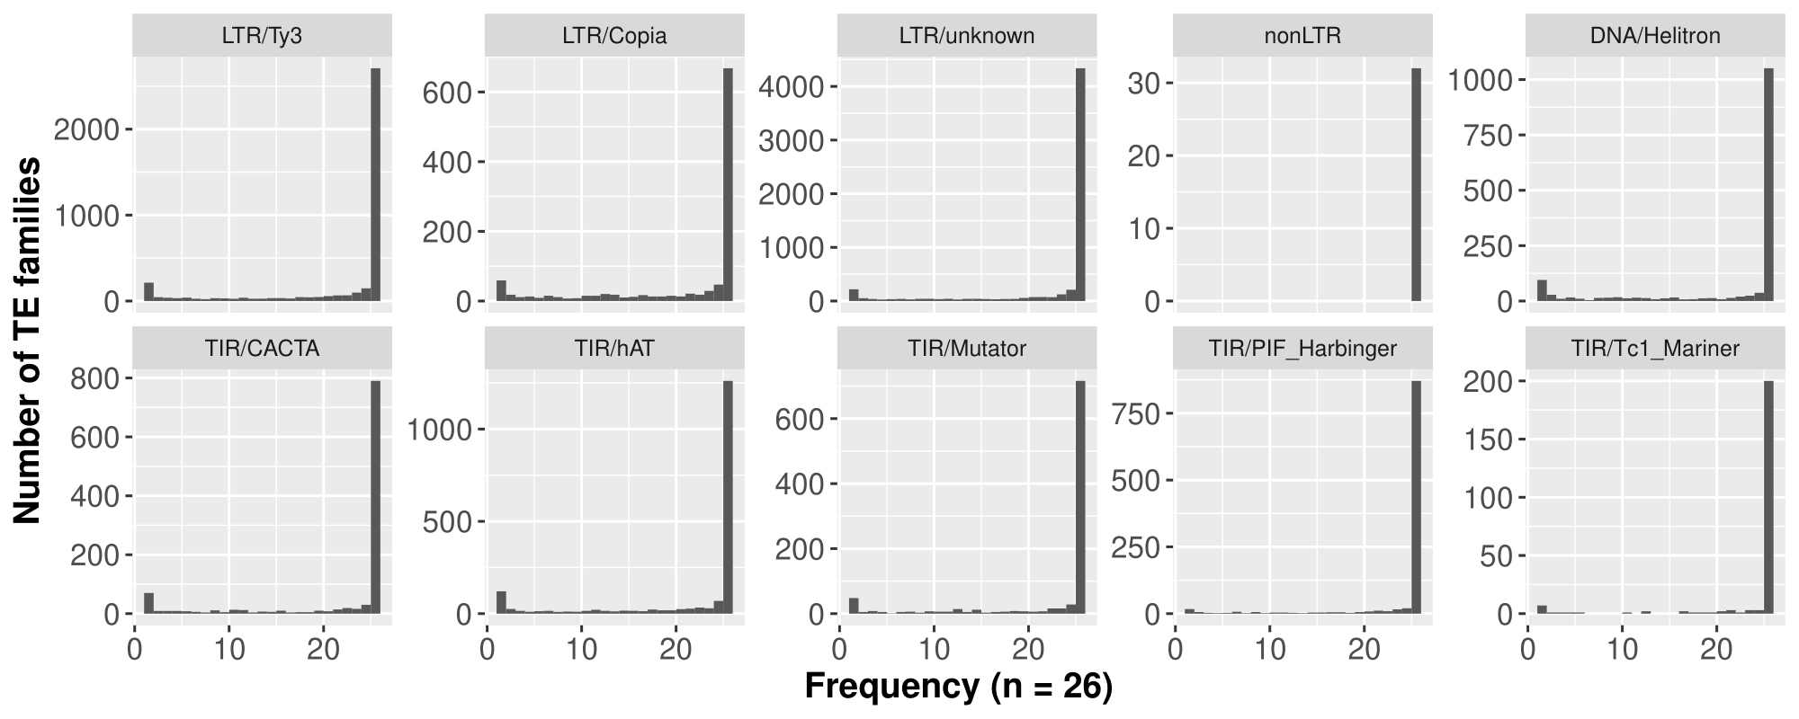
Supplemental Figure S5. Frequency of TE families in the 26 NAM founder lines for different TE superfamilies.

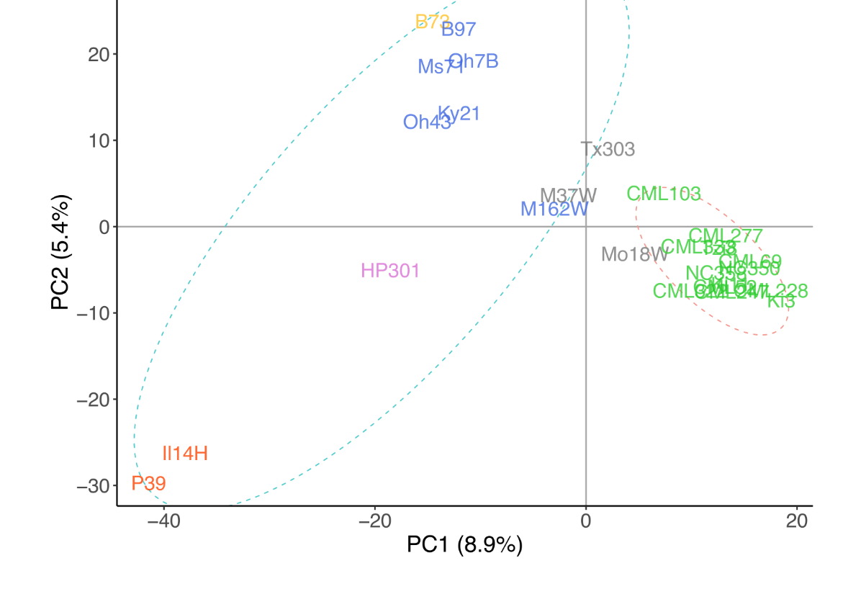
Supplemental Figure S6. Genetic relationships between the 26 NAM founders based on single nucleotide polymorphisms (SNPs). Principal component analysis of the NAM founder genomes using 25,000 random homozygous SNPs with no missing data. Dashed ellipses indicate tropical (pink) and temperate (blue) genomes.

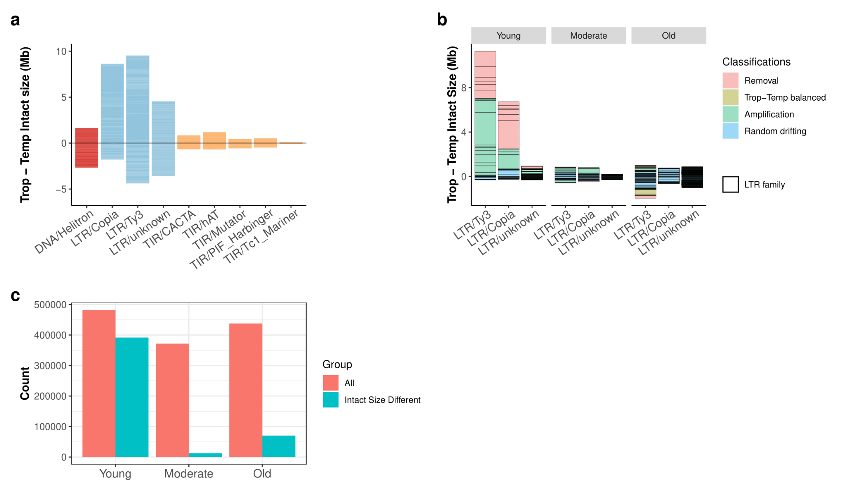
Supplemental Figure S7. Summary of structurally intact TE differences between temperate and tropical genomes. a. TE family size difference of intact elements between tropical and temperate lines in TE superfamilies. Positive values represent intact elements in families that are larger in tropical genomes and negative values represent intact elements in families that are larger in temperate genomes. b. The accumulated TE size differentiation contributed by intact elements from different LTR superfamilies (Ty3, Copia/Ty1, and unknown) in different age groups (Young, Moderate, and Old). Each box represents the contribution of an LTR family. c. Number of intact LTR elements in different age groups. The “All” category contains all intact LTR elements identified from temperate and tropical genomes that can be classified into age categories on the x-axis (n = 1,291,173). “Intact Size Different” are intact LTR elements coming from families that have intact LTR sizes significantly different between temperate and tropical genomes (n = 474,713).

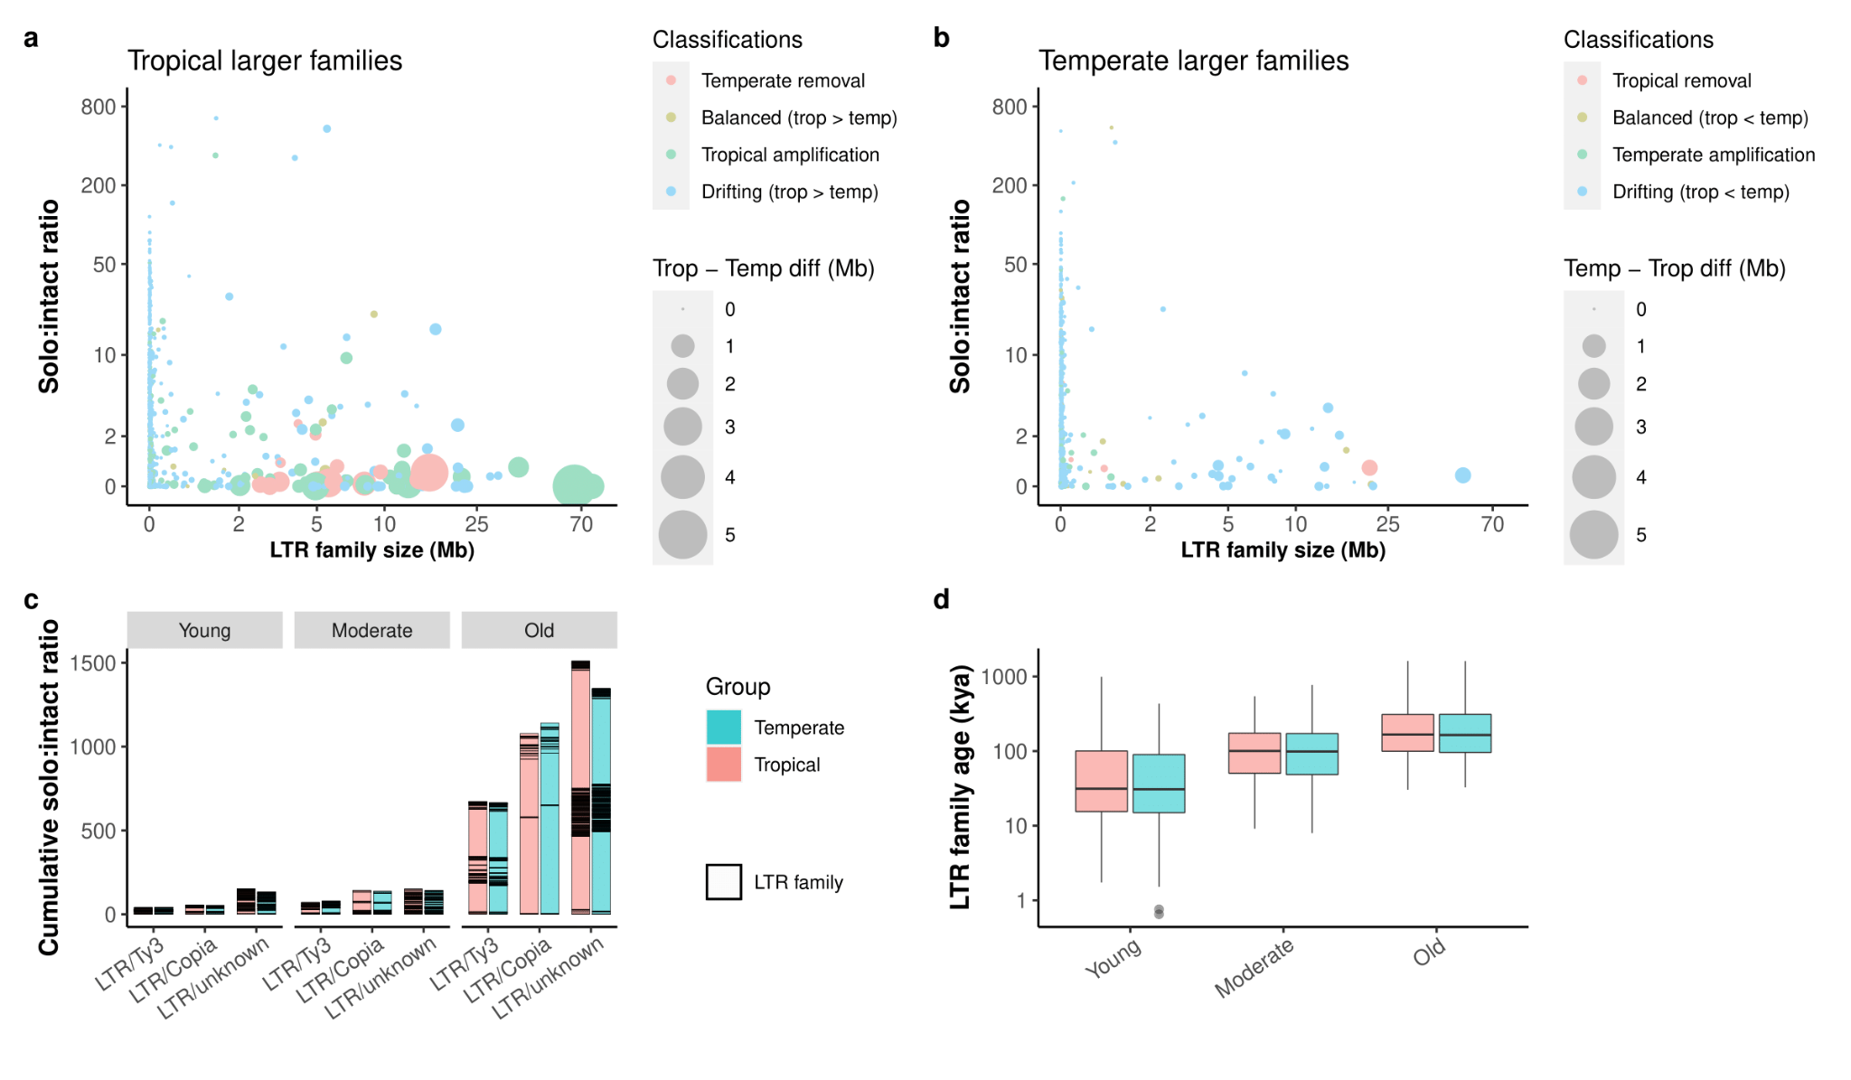
Supplemental Figure S8. LTR family characterization in temperate and tropical maize genomes. a. Classification of LTR families that are larger in tropical genomes. b, Classification of LTR families that are larger in temperate genomes. In a and b, each dot represents an LTR family, the size of each dot scales to the absolute family size difference, and x and y axes were pseudo-log scaled. c. Cumulative solo:intact LTR ratios of temperate and tropical genomes. Each box shows the difference of one family. d. Mean family age per family for all classified families. The y-axis is log10 scaled. Each box shows the median, upper, and lower quartiles of the group. Whiskers indicate the 1.5× interquartile range. Black dots indicate outliers.

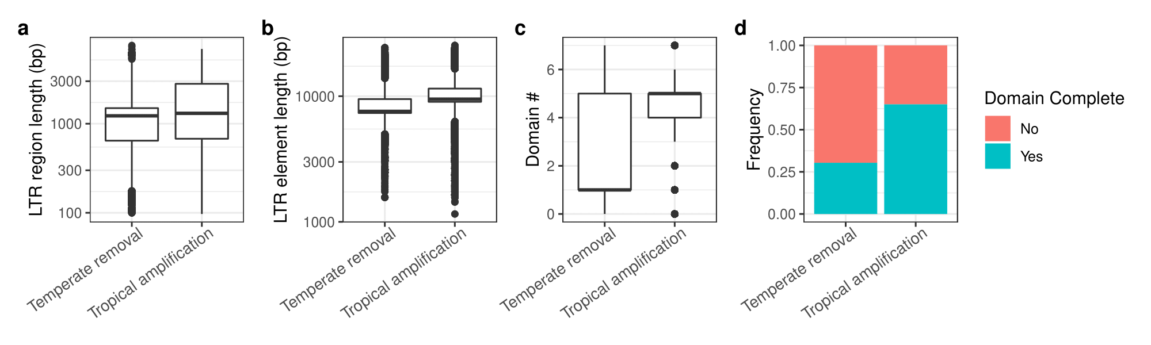
Supplemental Figure S9. Summary of structurally intact LTR retrotransposons in NAM founders. (a) LTR region length, (b) LTR element length, (c) coding domain count, and (d) domain completeness for temperate removal and tropical amplifying LTR families. Number of coding domains were identified in structurally intact LTR elements. For Ty3 LTRs, the complete domains (n = 6) are GAG, PROT, RT, RH, INT, and CHD. For Copia/Ty1 LTRs, the complete domains (n = 5) are GAG, PROT, INT, RT, and RH. In a and b, the y-axis was log10 scaled.

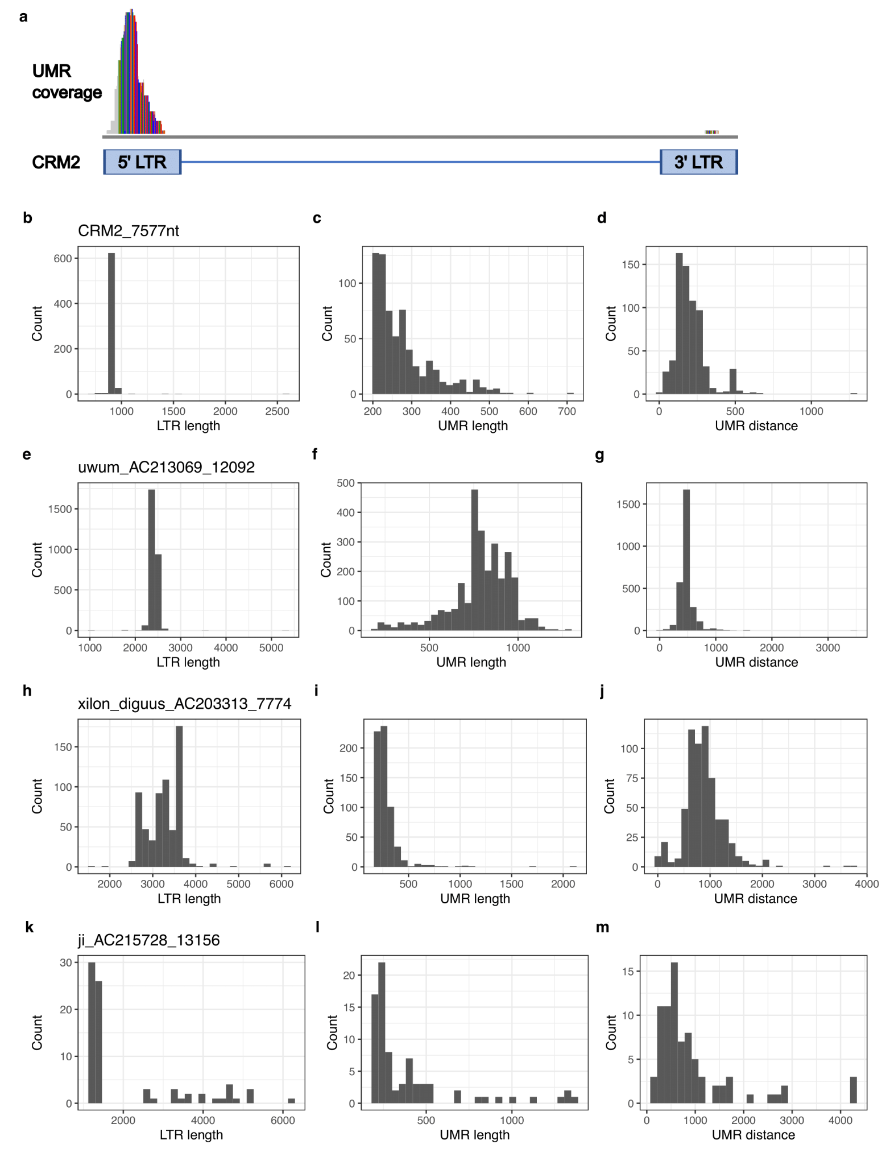
Supplemental Figure S10. Unmethylated regions in LTR families. a. Mapping unmethylated regions (UMR) of the CRM2_7577nt family on a representing CRM2_7577nt element. The peak represents high coverage of UMR regions. (b-m) Each row shows a representative LTR family with family names indicated. The CRM2_7577nt family belongs to the Ty3 superfamily and is located in active centromeric regions and is actively transcribed (Topp, Zhong, and Dawe, 2004 PNAS). The uwum_AC213069_12092 family belongs to the Ty3 superfamily, was classified as a tropical amplification family and harbors the most unmethylated intact copies (n = 3,069, Table S2). The xilon_diguus_AC203313_7774 family belongs to the Ty3 superfamily and contributed the largest size differentiation between tropical and temperate genomes in tropical amplification families. The ji_AC215728_13156 family belongs to the Copia/Ty1 superfamily and contributed the largest size differentiation between tropical and temperate genomes in temperate removal families. (b-m) Columns from left to right show distributions of LTR region length, UMR length, and the distance from the 5’ start of the LTR element to the 5’ start of the most upstream UMR, respectively. These plots show that UMRs of these families are mostly located in the 5’ LTR region, especially the first half of the 5’ LTR region where LTR promoters and enhancers are located.

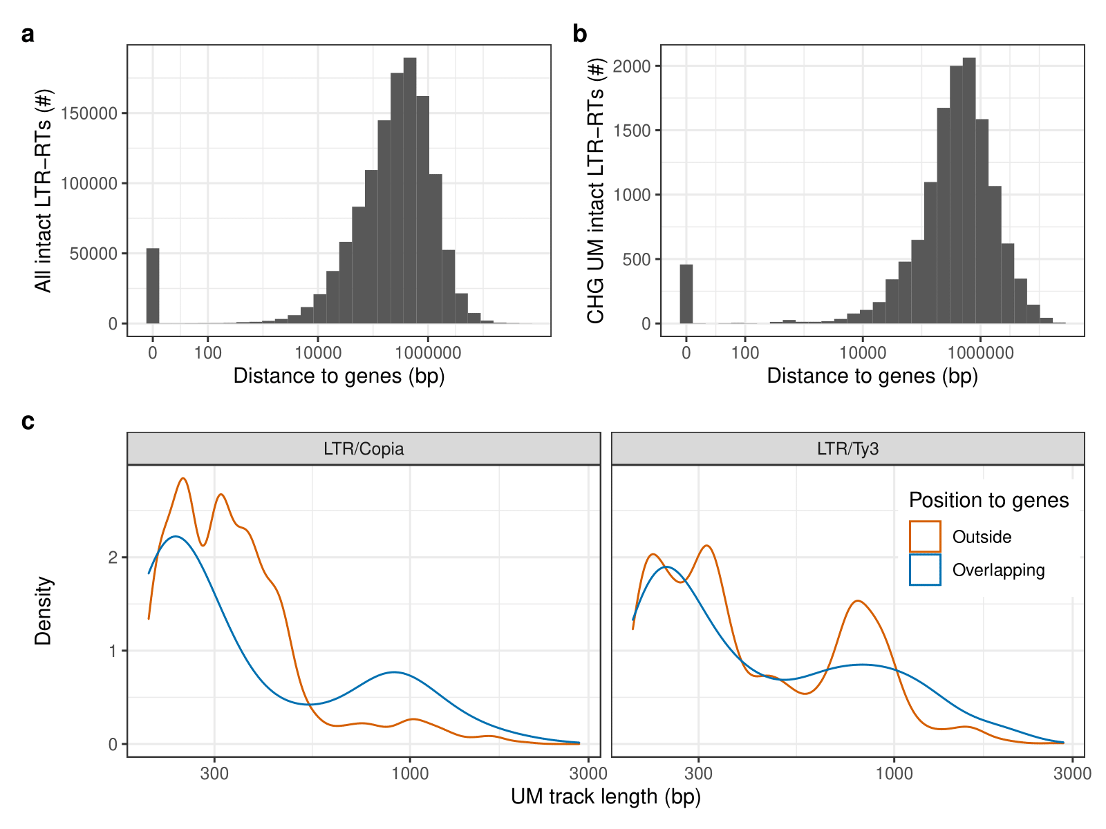
Supplemental Figure S11. Characterization of unmethylated intact LTR retrotransposons. Distance from the nearest downstream non-TE gene for (a) all intact LTR elements and (b) intact LTR elements carrying unmethylated regions. 0 means the LTR element is overlapping with a non-TE gene. The average distance between intact LTR elements and the downstream gene is 60 kb. c. Density plots are shown for region length distributions of unmethylated intact LTR elements. LTR elements overlapping or located outside of genes were plotted in blue and orange lines, respectively. X-axes were log10 scaled.

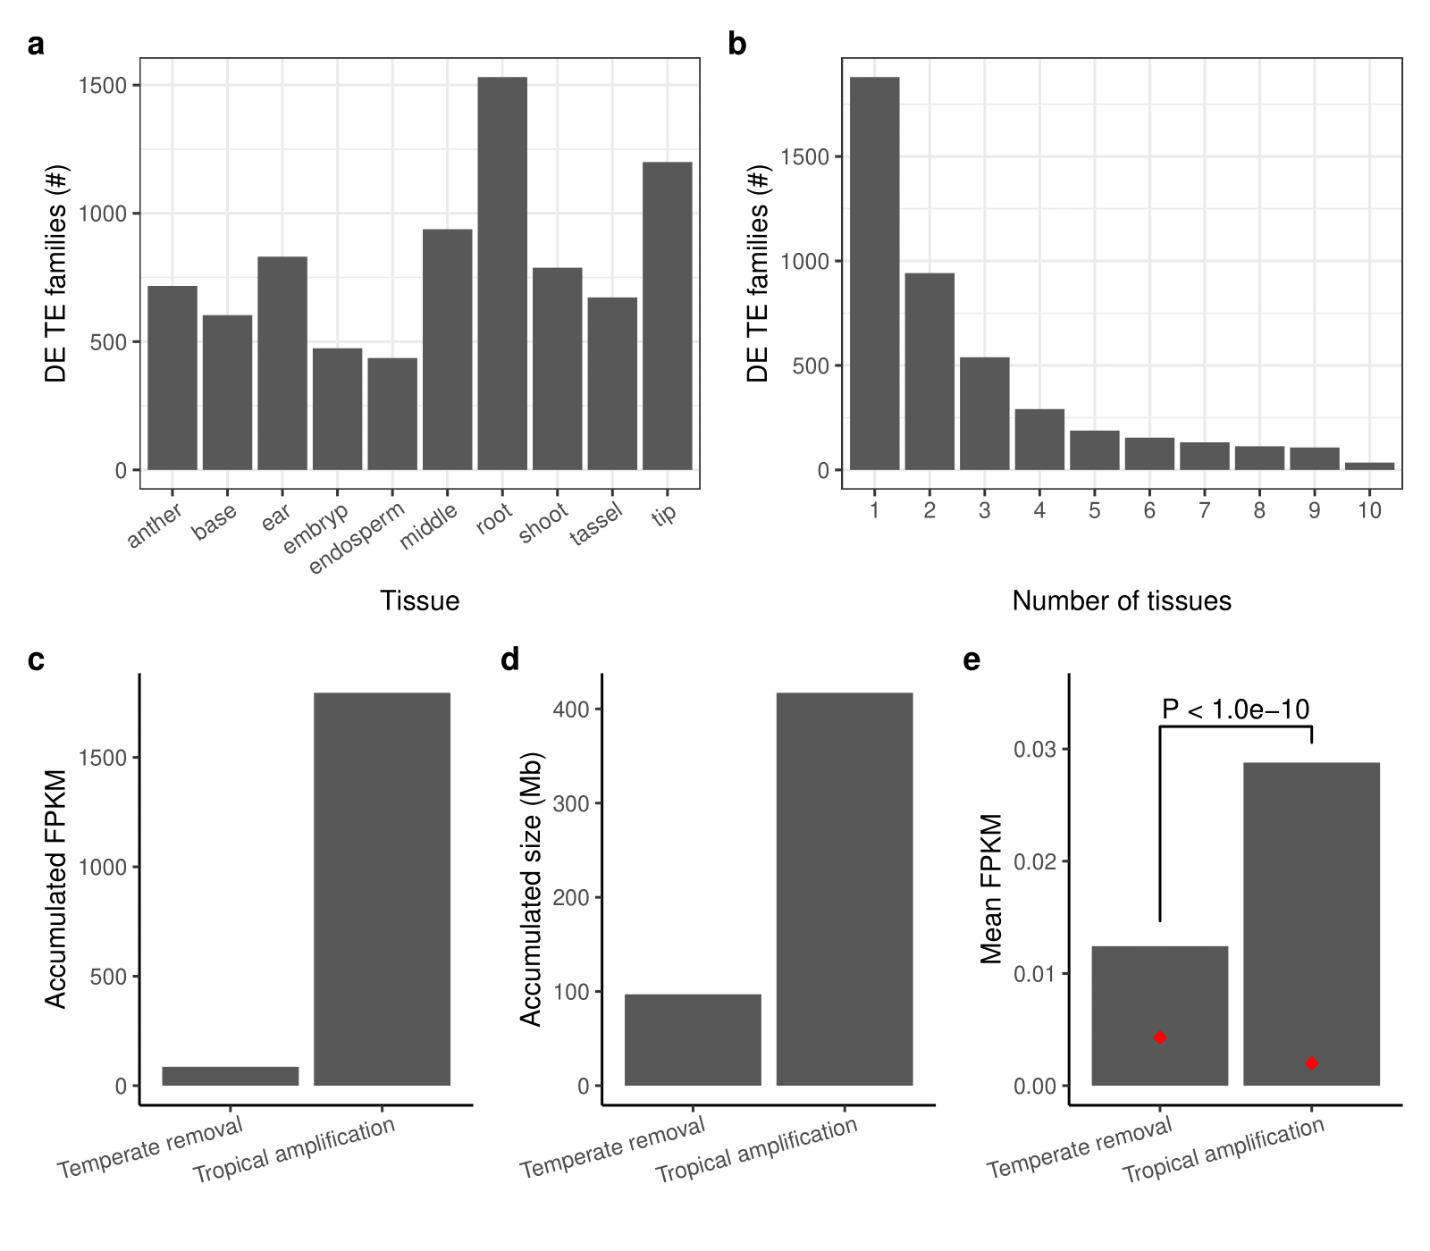
Supplemental Figure S12. TE transcript abundance estimates at the family level using 10 tissues collected throughout development. a. Number of TE families that were differentially expressed (DE) between tropical and temperate maize genomes in each tissue. Root tissues had larger numbers of differentially expressed families compared to other tissues (Grubbs test, P = 0.04). b. The number of TE families that were differentially expressed between tropical and temperate genomes in a given number of tissues. c. Accumulated FPKM across all tissues, (d) accumulated sequence size, and (e) mean FPKM for temperate removal and tropical amplification LTR families. Red diamonds represent medians.

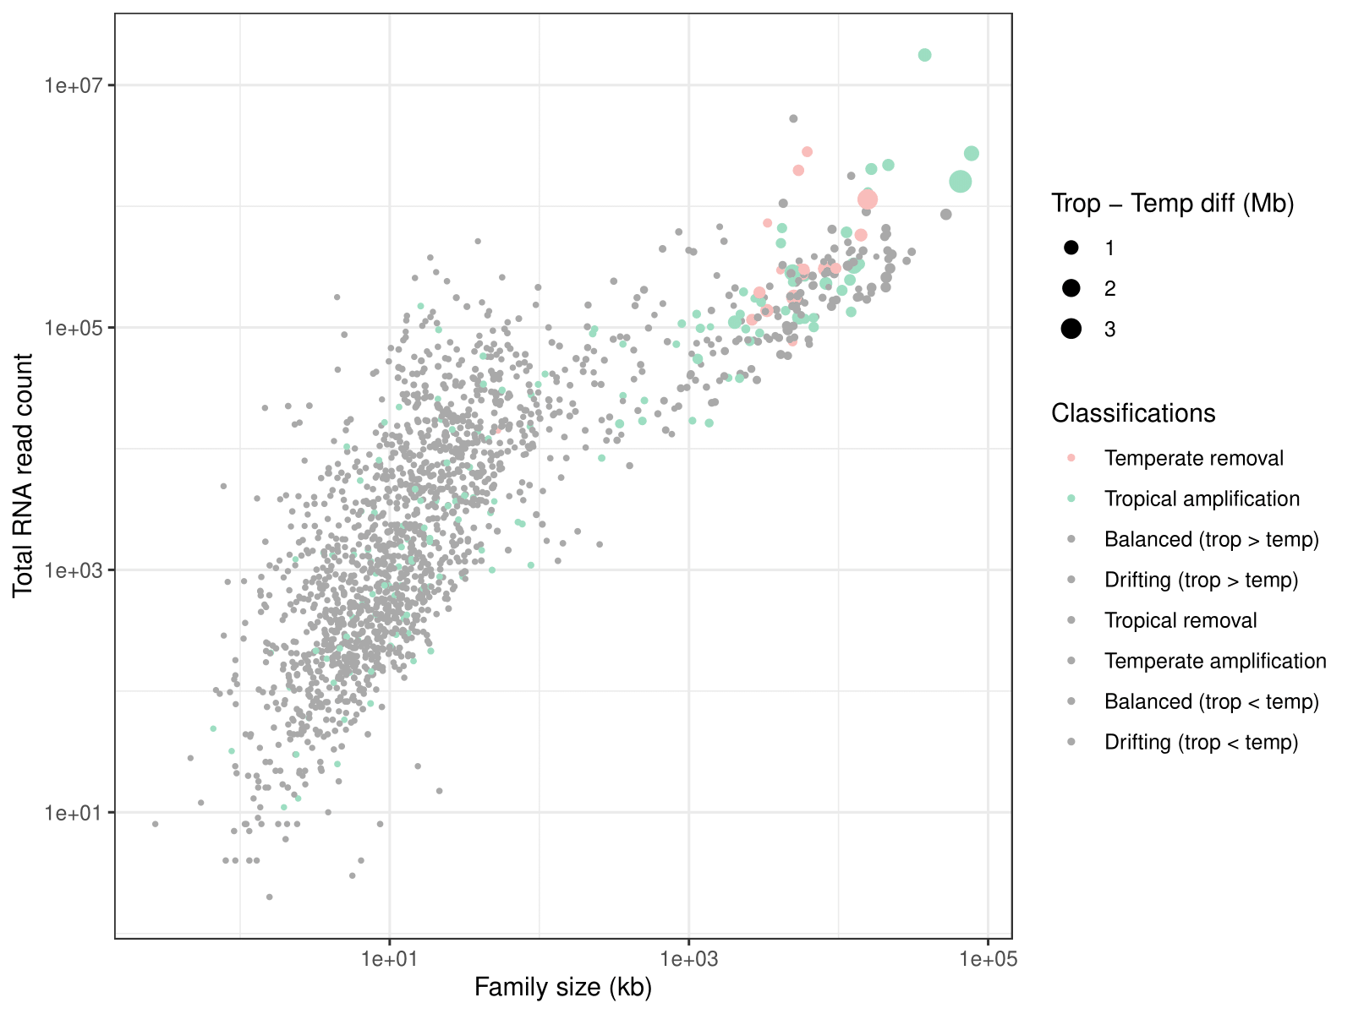
Supplemental Figure S13. Total raw read counts from RNAseq of 10 tissues from the 23 tropical and temperate maize genomes. Each dot represents one pan-genome TE family, and the radius of the dot corresponds to the family size difference between tropical and temperate genomes. The x-axis represents the mean size of TE families across all genomes. Both x- and y-axes are log10 scaled.

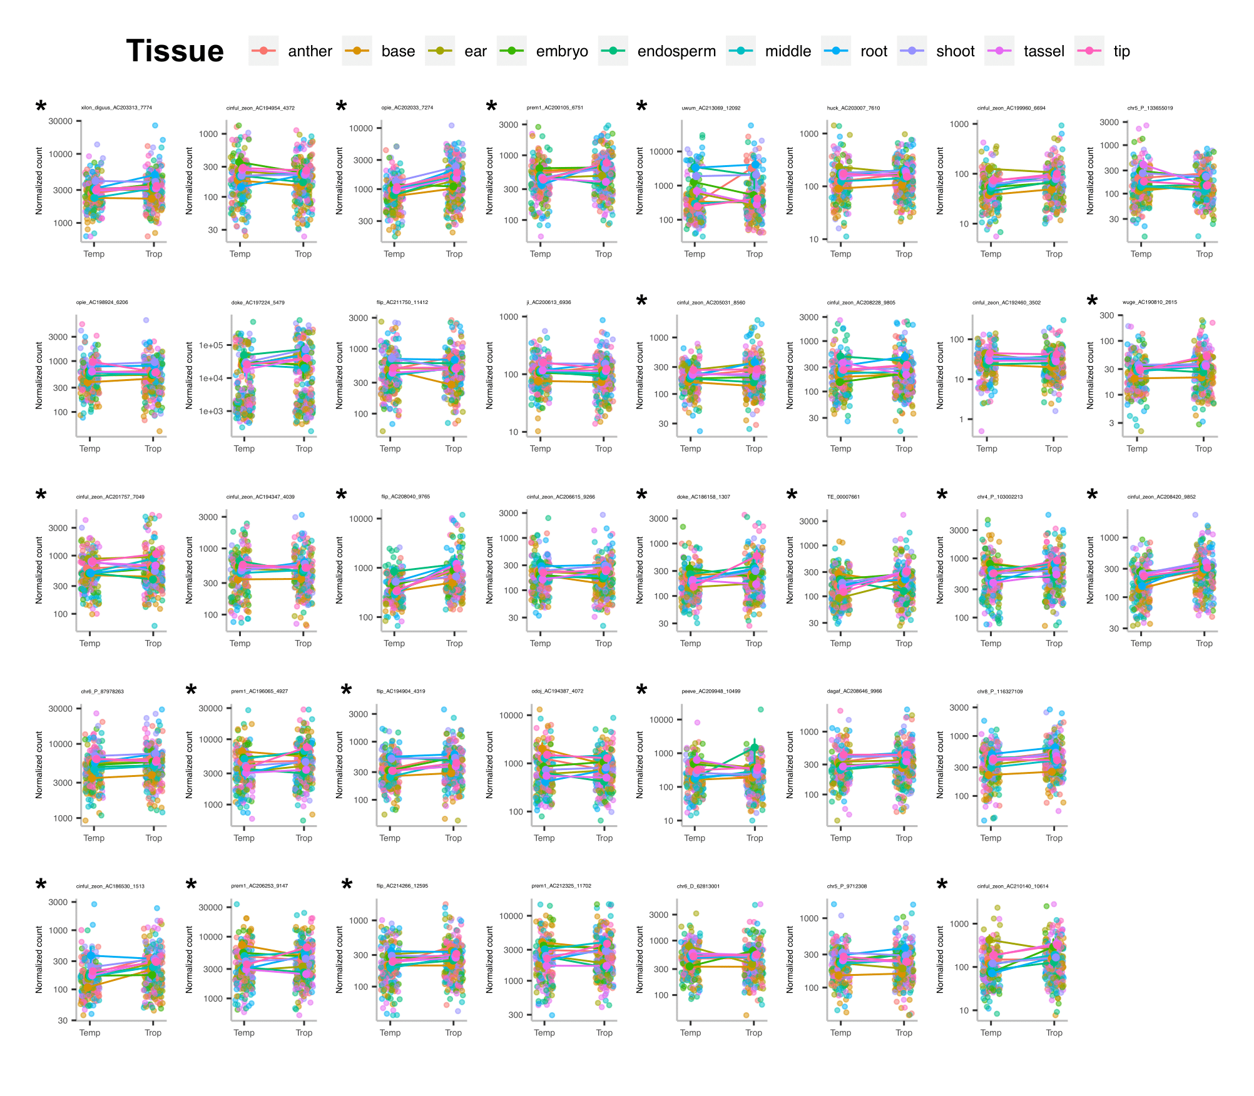
Supplemental Figure S14. Expression norms for tropical amplification families that have tropical–temperate family size difference ≥ 0.1 Mb (n = 38). Families were ordered with size differences from large to small (top to bottom, left to right). Each dot represents one RNA library with different colors corresponding to different tissues. Each line represents the mean of normalized counts for each tissue linked between tropical and temperate genomes. Y-axes are normalized read count and log10 scaled. Asterisks indicate families that have differentially expressed tissues that were consistently higher expressed in tropical genomes.

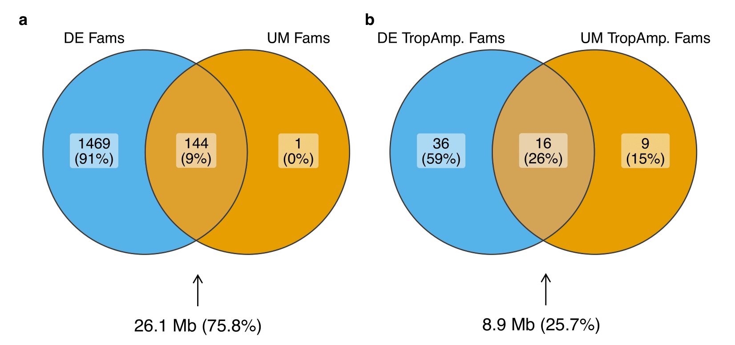
Supplemental Figure S15. Overlap between differentially expressed (DE) LTR families and families carrying at least one UM-5’LTR. a. The number of DE LTR families overlapping with the number of families carrying UM-5’LTRs. The arrow indicates the size of family differences between tropical and temperate lines and the percentage of total TE family differences contributed by overlapping families. b. The number of DE tropical amplifying LTR families that are consistently higher expressed in tropical lines overlapping with the number of tropical amplifying families having at least one UM-5’LTRs in tropical genomes. The arrow indicates the size of tropical amplifying family differences between tropical and temperate lines and the percentage of total TE family differences contributed by overlapping families.

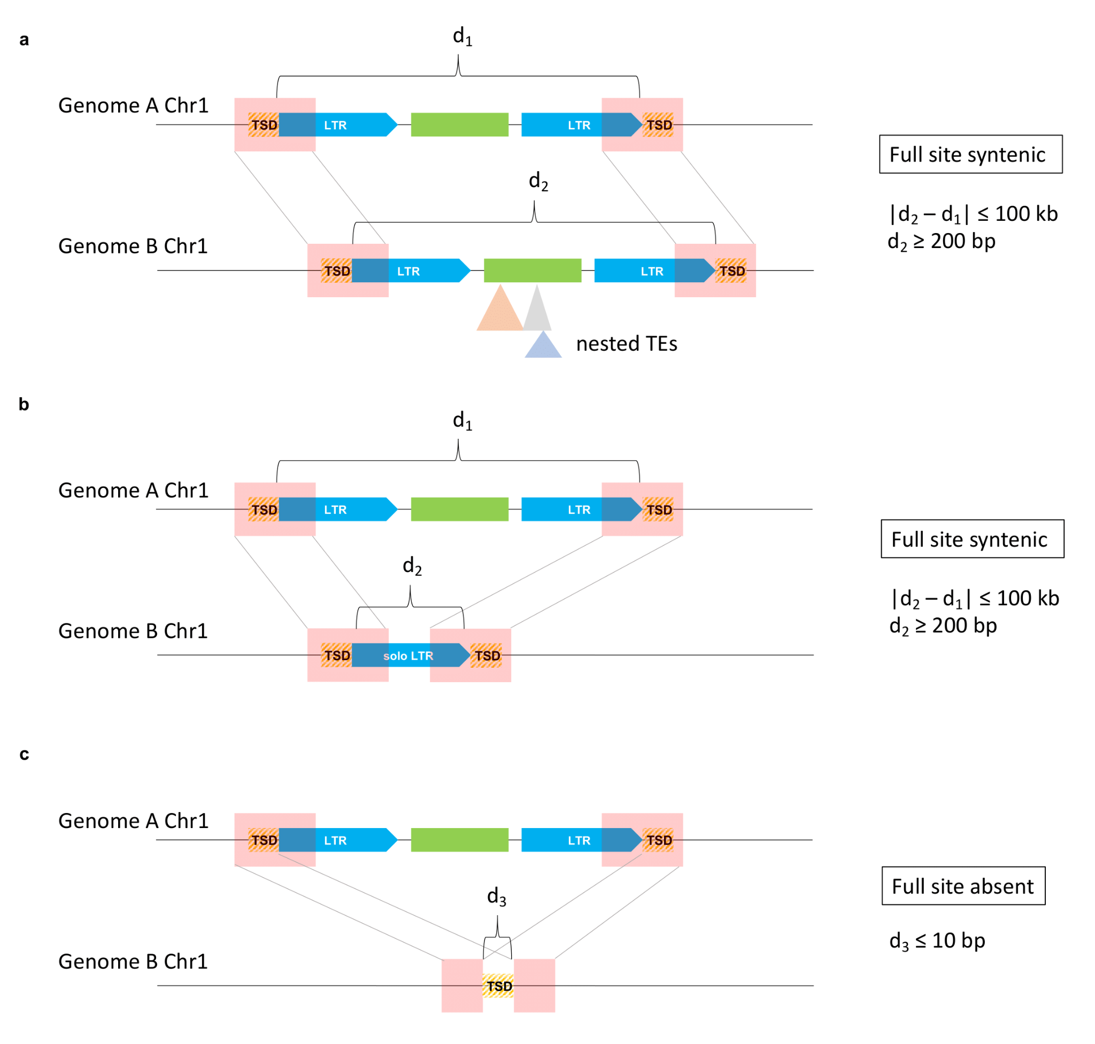
Supplemental Figure S16. Identifying syntenic LTR retrotransposons between two genomes. Two 1-kb sequences centered on the 5’ start and 3’ end of an intact LTR element (pink boxes) were extracted and blasted to the opposite genome. Only matches from the orthologous chromosome (e.g., Chr1) of the other genome were retained. a. If full matches were found for both 1-kb sequences from the LTR-RT in the same direction and the hits were ≥ 200 bp apart (non-empty sites) and ≤ the length of the intact LTR-RT + 100 kb, then the locus was recorded as the syntenic full site of the intact LTR-RT. The size difference between syntenic LTR elements was set to ≤ 100 kb to allow for cases of nested insertions. b. Solo LTRs were identified as full site syntenic if the distance between full matches was ≥ 200 bp. c. If the flanking site distance was less than 10 bp (target site duplication (TSD) sequence is ~5 bp), this pair of flanking sites was kept as full site absent. If an LTR-RT was not identified as a full site or a null site in the paired genome based on these criteria, it was recorded as missing data (NA). If more than one full site or null site on the orthologous chromosome were observed, the LTR-RT was recorded as missing data in the paired genome.

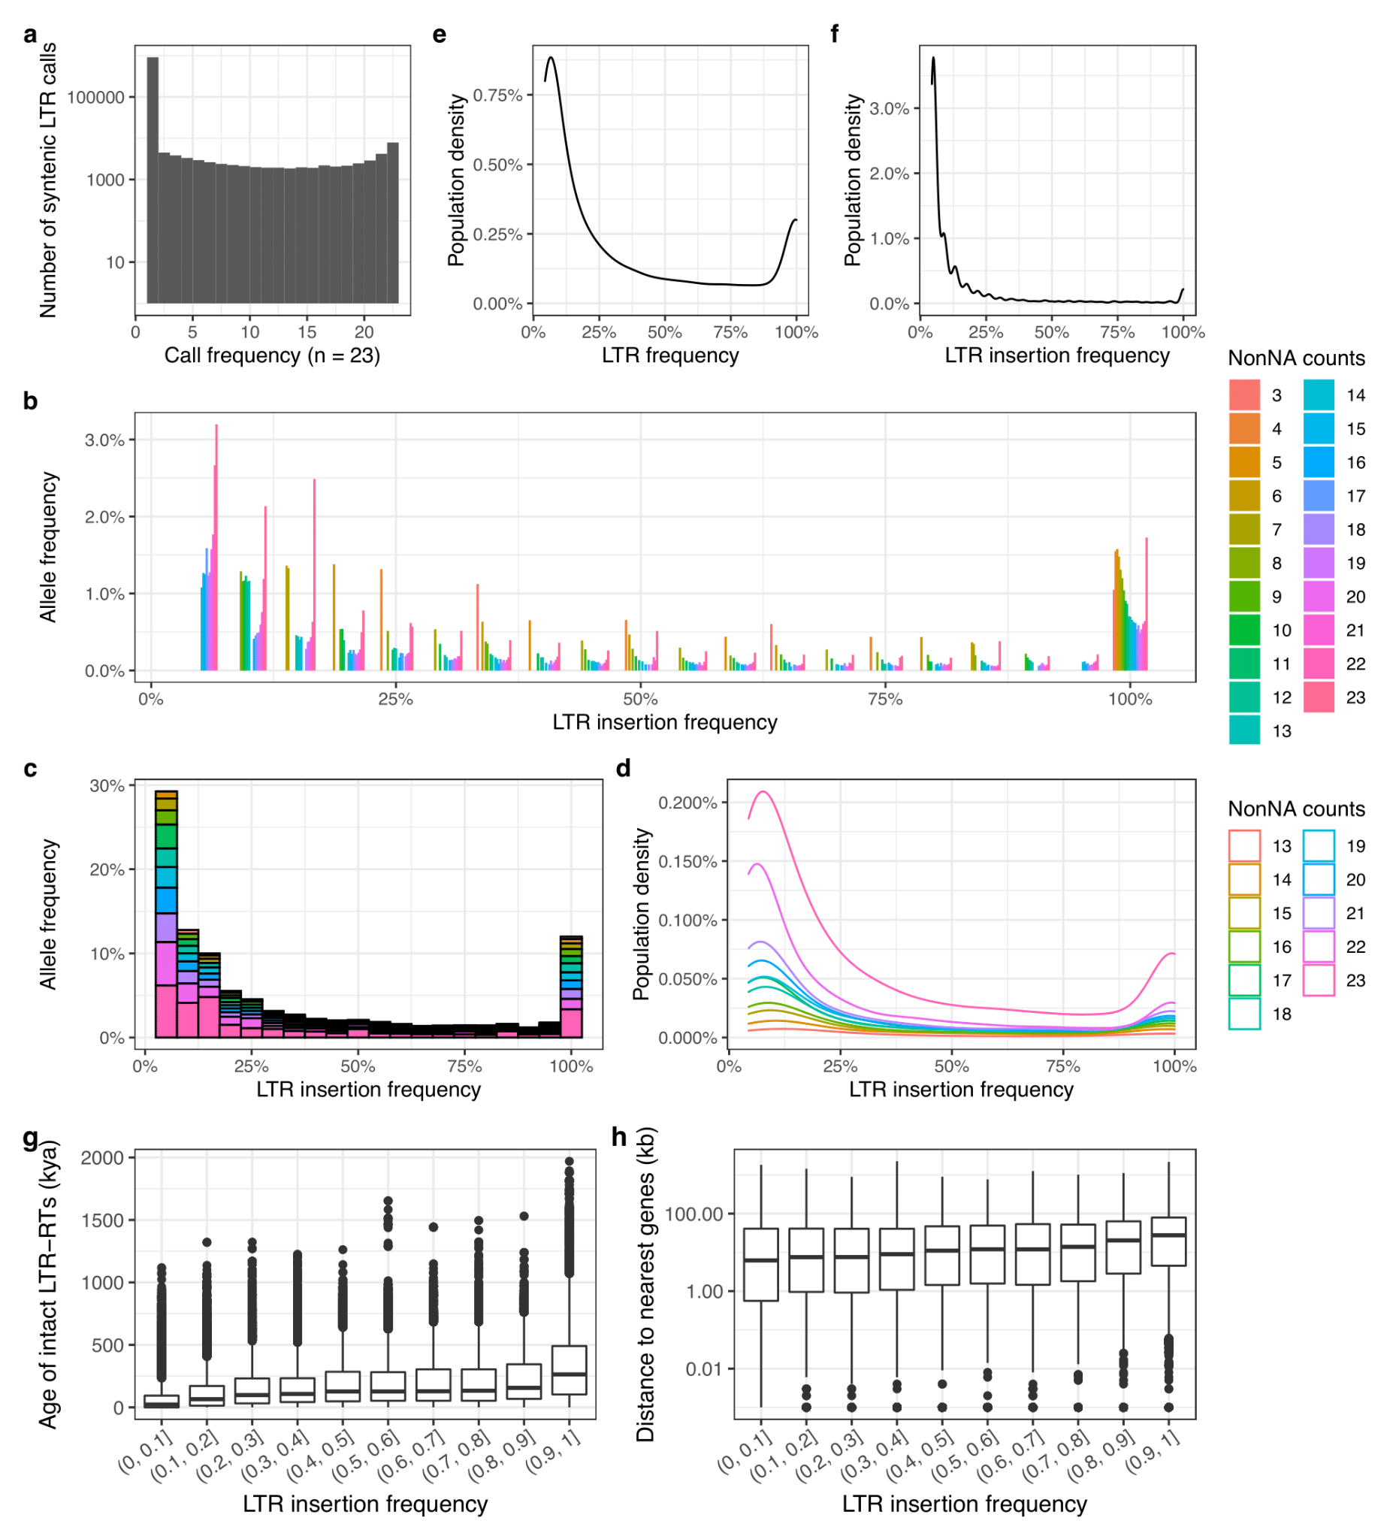
Supplemental Figure S17. Population genetics of LTR retrotransposons. a. The call frequency of syntenic LTR elements among tropical and temperate maize genomes. The y axis is log10 scaled. b. LTR insertion frequency spectrums for call frequency ranging from 3 to 23 genomes. c-d. LTR insertion frequency spectrums for call frequency ranging from 13 to 23 genomes. e. The LTR insertion frequency spectrum after retaining sites with more than 50% call rate. f. The LTR insertion frequency spectrum after further removing sites younger than 20 kya. g. Age of syntenic LTR elements and (h) their distance from the nearest downstream genes for different LTR insertion frequency brackets. The correlation of the median age or gene distance to insertion frequency is 0.89 (P < 0.0005) or 0.90 (P < 0.0004), respectively. The box shows the median, upper, and lower quartiles. Whiskers indicate the 1.5× interquartile range. Black dots indicate outliers.

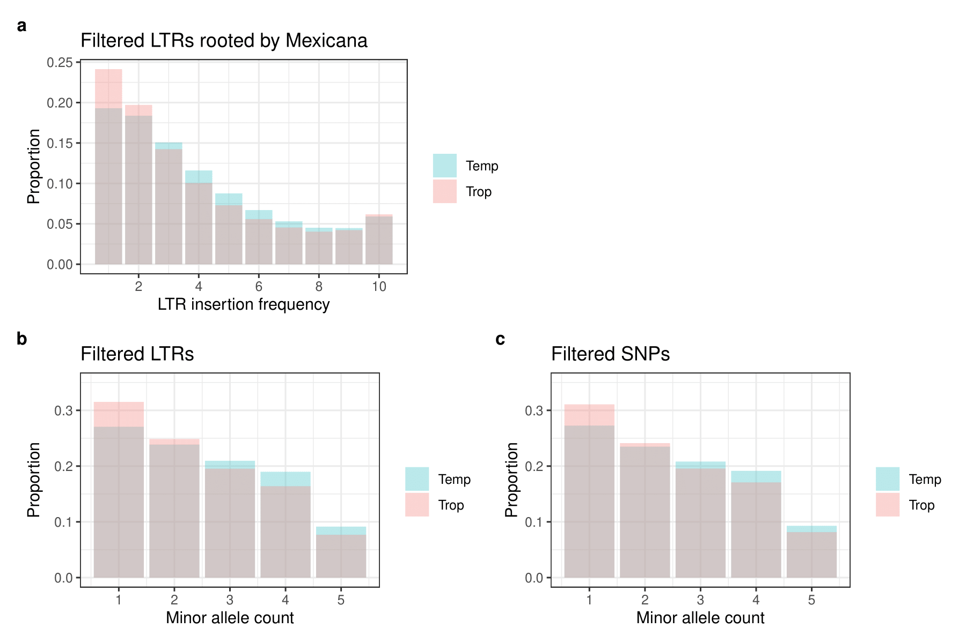
Supplemental Figure S18. Allele frequency spectrum in tropical (pink) and temperate (blue) genomes. a. LTR insertion frequency spectrum of syntenic LTR loci that were filtered by the presence of null sites in the Zea mays ssp. mexicana genome. Minor allele frequency (folded SFS) of (b) filtered syntenic LTR loci and (c) filtered SNP loci. Filtered syntenic LTR loci (n = 27,279) and SNP loci (n = 10.4M) have missing data rate ≤ 50%. Syntenic LTRs with missing data rates higher than 50% were filtered out, and SNPs were filtered for having the same missing data profile as those retained syntenic LTR loci.

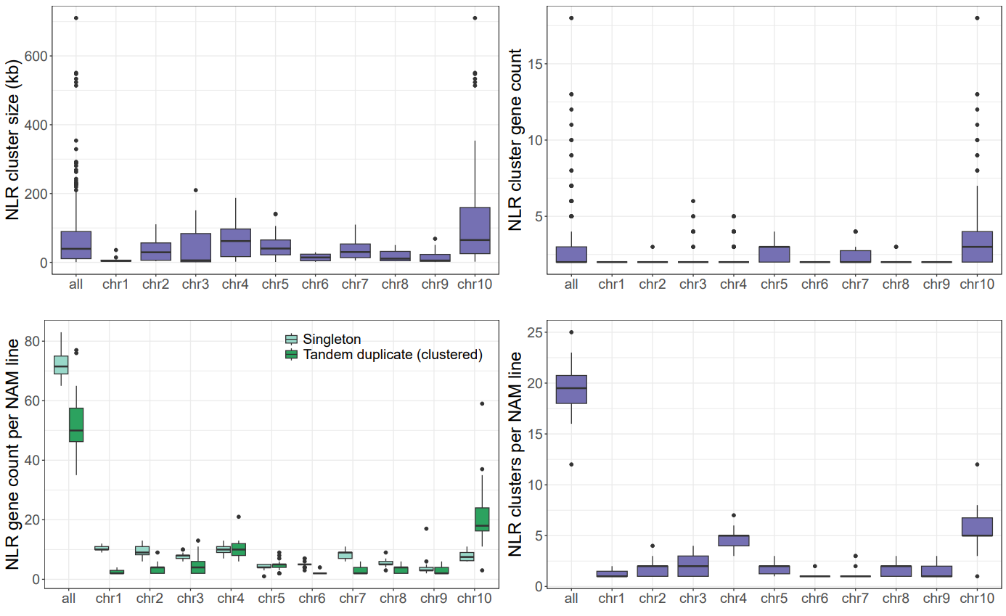
Supplemental Figure S19. Summary statistics for the NLR annotation and clustering in NAM founder lines. The box shows the median, upper, and lower quartiles. Whiskers indicate the 1.5× interquartile range. Black dots indicate outliers.

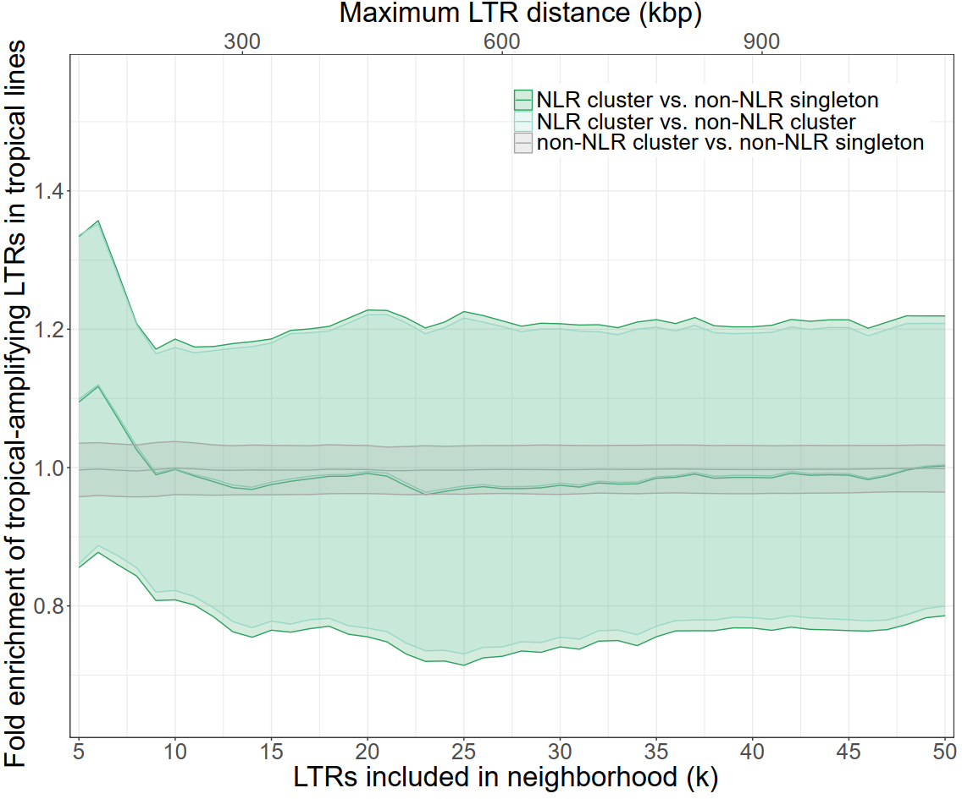
Supplemental Figure S20. Tropical amplifying LTR families in the neighborhood of NLR clusters are not significantly enriched in tropical lines compared to temperate lines. Lines indicate the mean values for all NAM lines, and the ribbon indicates the standard deviation within the population.

Supplemental Table S1 (separate file). The number of intact LTR and LTR clades found in dynamic categories.
Supplemental Table S2 (separate file). Supplemental Table S2. Classification of major LTR families based on age distribution.
Supplemental Table S3 (separate file). The number of unmethylated intact LTR elements.
Supplemental Table S4 (separate file). Distribution of intact LTR elements in relation to genes.
Supplemental Table S5 (separate file). Genes having intact LTR retrotransposons inserted into at least one of their coding regions.
Supplemental Table S6 (separate file). NAM line NLR gene annotation and clustering statistics.
Supplemental Table S7 (separate file). Summary of Fisher's exact test for enrichment of TE families in the TE neighborhood of NLR clusters in tropical lines.
Supplemental Dataset S1 (separate file). The 50 Arabidopsis assemblies used in this study.
Supplemental Dataset S2 (separate file). Maize pan-genome metadata containing information for each TE family.
Supplemental Dataset S3 (separate file). Raw read count of each TE family in each maize genome.
Supplemental Dataset S4 (separate file). Normalized read count of each TE family in each maize genome.

