Supplementary Figures

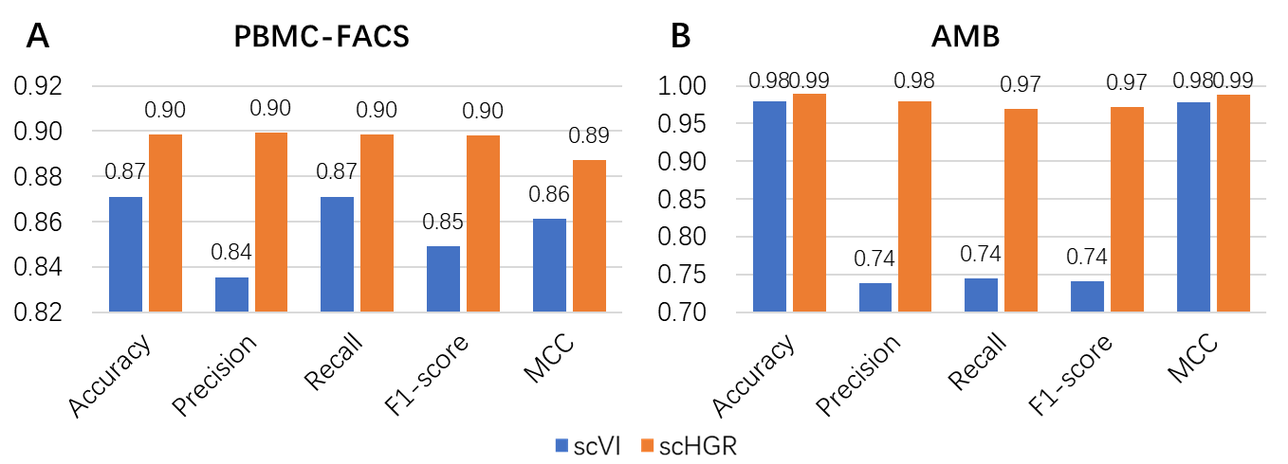
Supplemental_Fig_S1. Performance comparison of scHGR and scVI on PBMC-FACS and AMB. The specific values are marked above the corresponding bars.

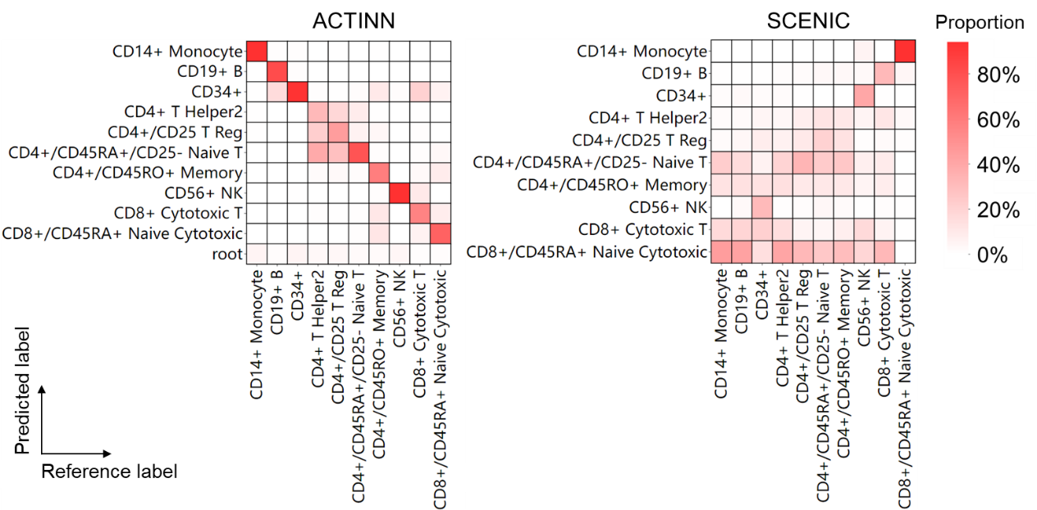
Supplemental_Fig_S2. Heatmap of the confusion matrix derived from ACTINN and SCENIC for PBMC-FACS. The rows denote predicted labels and columns denote labels provided by reference datasets.

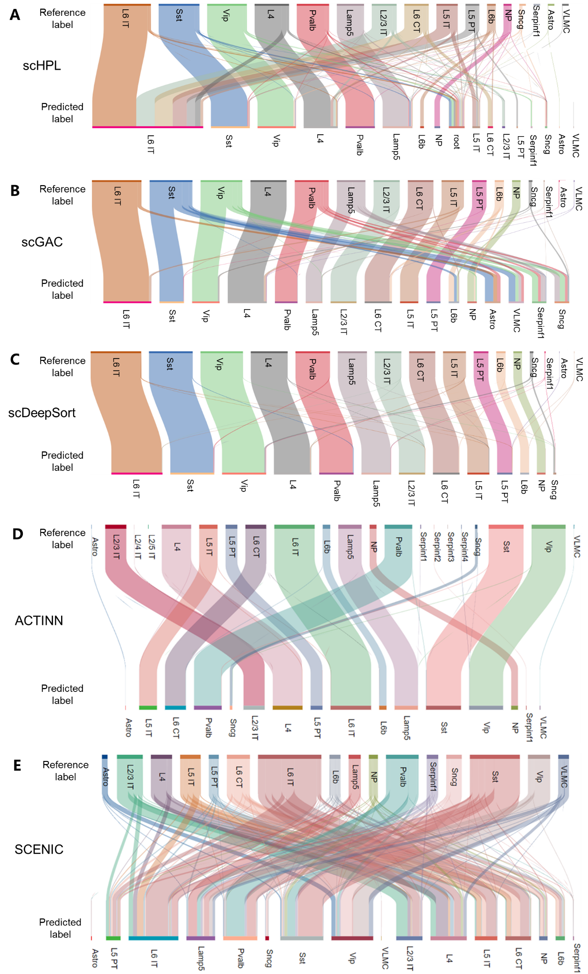
Supplemental_Fig_S3. Sankey plots of cell assignment derived from scHPL, scGAC, scDeepSort, ACTINN and SCENIC for AMB. In each plot, the top indicates the label provided by reference datasets and the bottom indicates the type assigned by annotation tools. Each color represents a cell type.

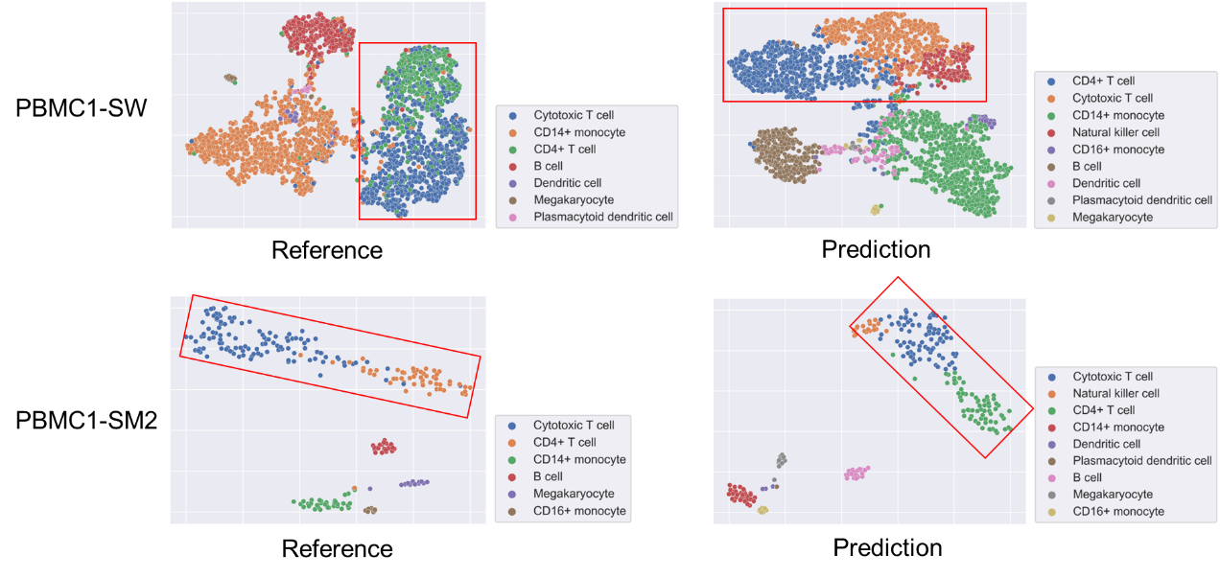
Supplemental_Fig_S4. T-SNE visualization of novel cell subpopulations revealed by scHGR. Based on the cell embedding optimized by scHGR, the coordinates of each cell in two-dimensional space are generated by t-SNE algorithm. New cell subtypes are annotated in PBMC1-D (Figure 3D), PBMC1-SW and PBMC1-SM2. The corresponding regions are shown in red rectangles. The left plots are colored by labels provide by reference datasets and the right plots are colored by labels predicted by scHGR.

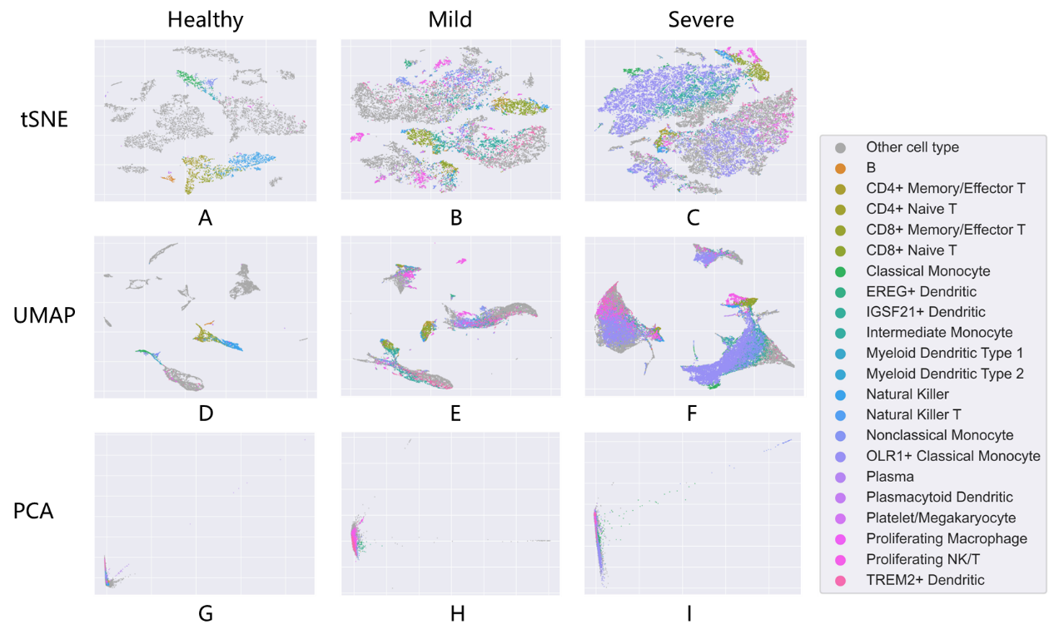
Supplemental_Fig_S5. The scatter plots of cell embedding based on tSNE (A, B, C), UMAP (D, E, F) and PCA (G, H, I). Each column represents different datasets. The first column refers to the health dataset (A, D, G), the second column refers to the COVID-19 mild patient dataset (B, E, H), and the third column refers to the COVID-19 severe patient dataset (C, F, I). Points in the scatterplot are colored depending on the cell types.

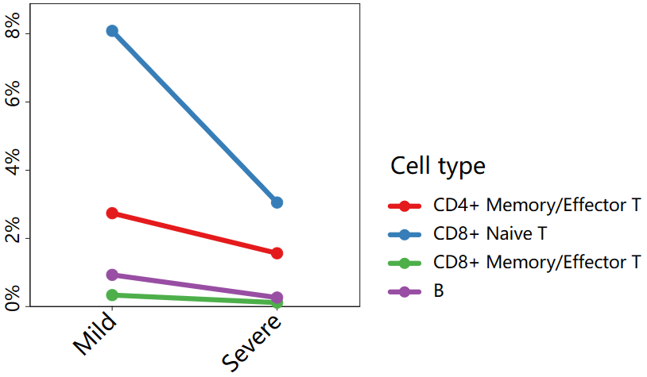
Supplemental_Fig_S6. Line chart of the proportional differences of CD4+ Memory/Effector T, CD8+ Naive T, CD8+ Memory/Effector T and B between Mild and Severe. Line charts exhibit the ratio of cell populations consisting of CD4+ Memory/Effector T, CD8+ Naive T, CD8+ Memory/Effector T and B. The x-axis denotes samples and y-axis denotes the proportion of each type.

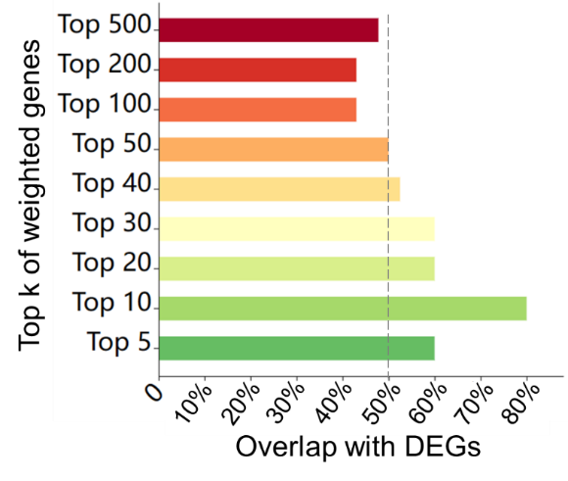
Supplemental_Fig_S7. Horizontal bar chart of the overlap between Top k genes selected by scHGR and DEGs. Bar chart compares the overlap of Top k genes selected by scHGR with HVGs in mild patients.

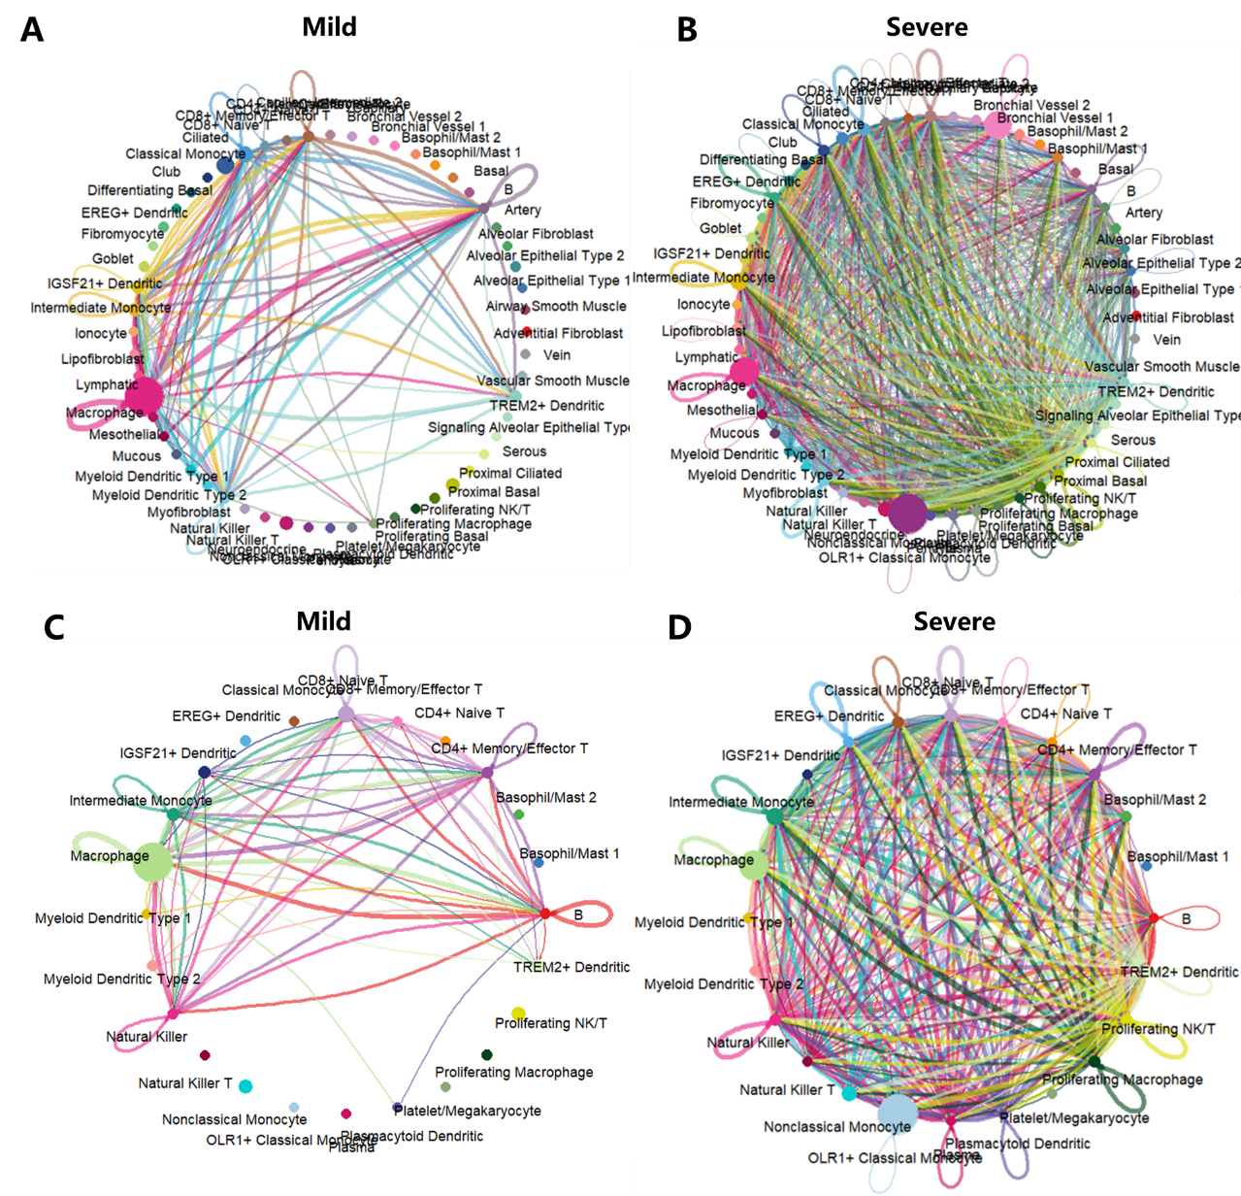
Supplemental_Fig_S8. Cell communication network visualization of mild and severe patients with COVID-19. (A-B) Cell communication networks covering all cell types for mild and severe patients, respectively. (C-D) Cell communication networks involving immune cell types for mild and severe patients, respectively. Circle sizes are proportional to the number of cells in each cell type and edge width represents the communication number. Edge colors are consistent with the source cell type.

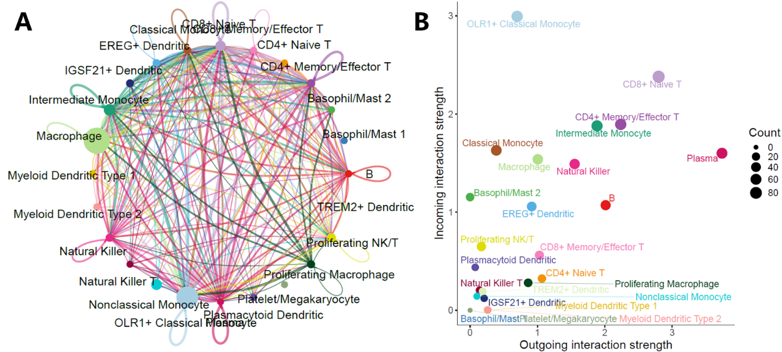
Supplemental_Fig_S9. Analysis of immune cell signal interactions. (A) Cell communication network of immune cell types based on mild and severe integrated data. (B) Total incoming and outgoing signaling strengths in different cell types. The size of points matches the count of interactions.

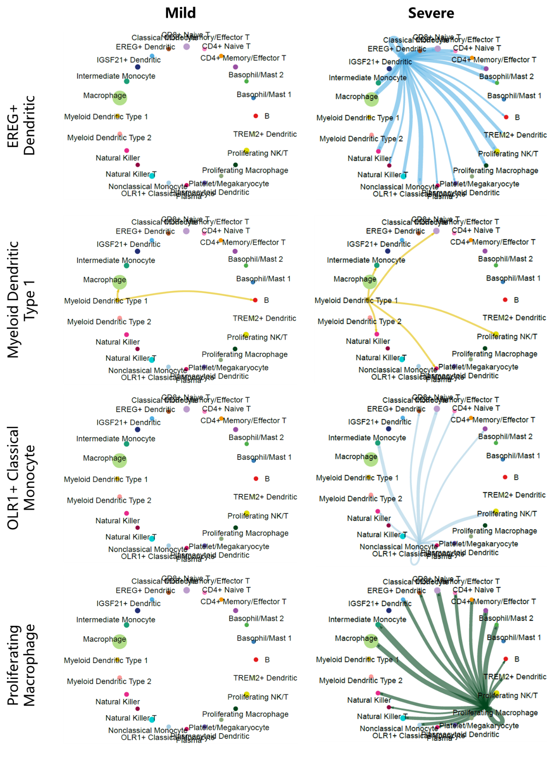
Supplemental_Fig_S10. Comparison of signaling pathway networks of different cell types in mild and severe patients. Each row represents one cell type. The first and second columns represent mild and severe patients, respectively. Each network visualizes the signaling pathways sending from the corresponding cell type.

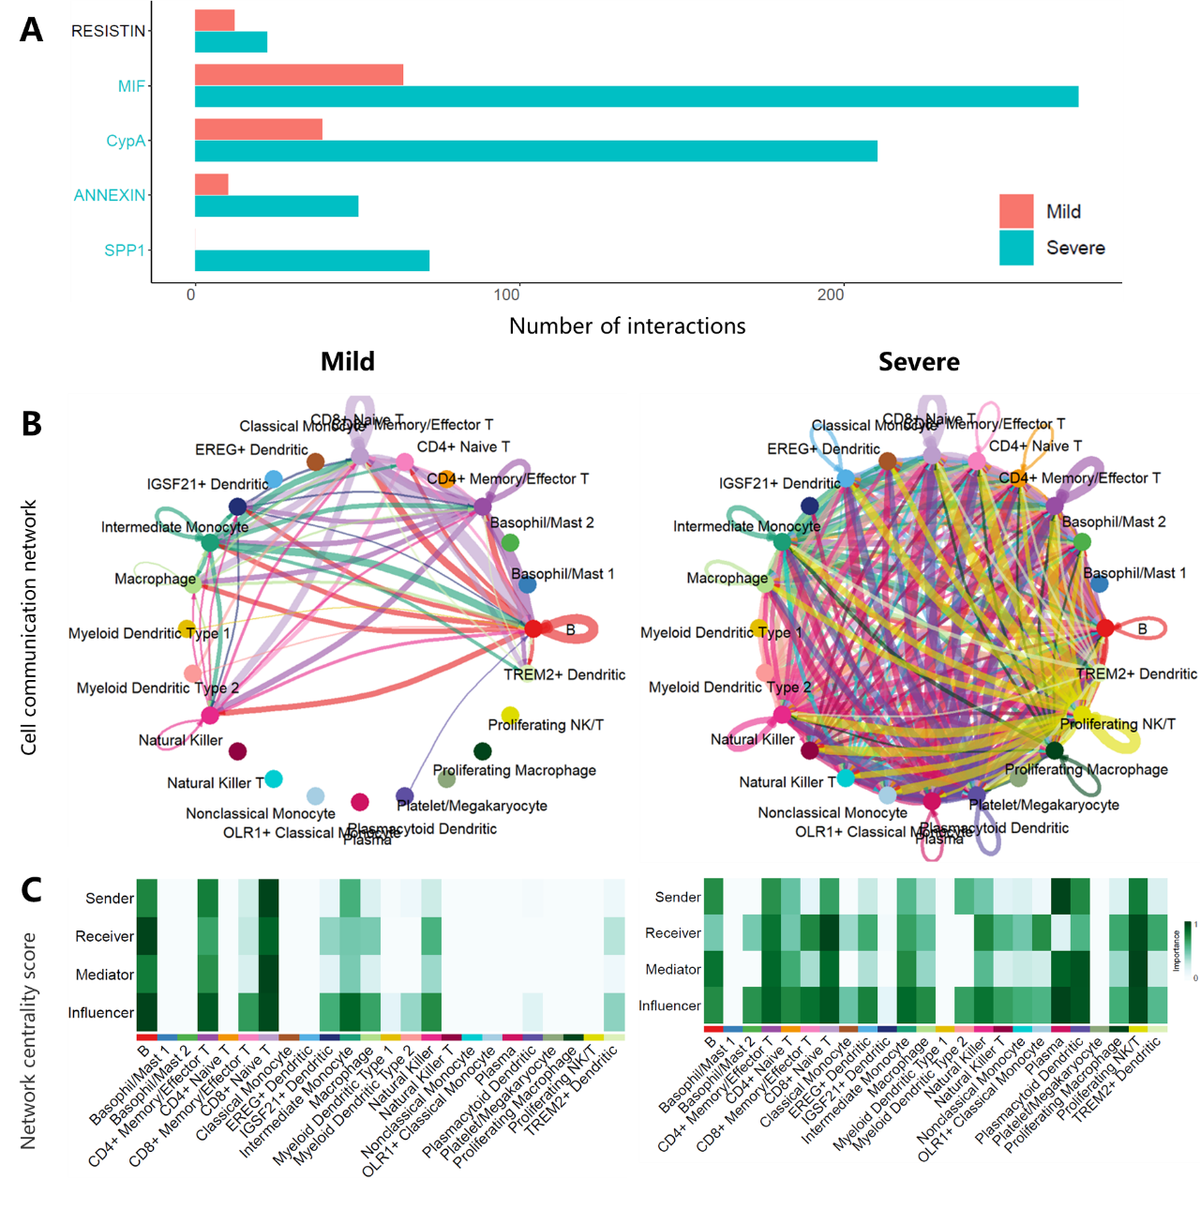
Supplemental_Fig_S11. Interaction network analysis of MIF signaling among immune cells. (A) Information flow (total interaction numbers) of each pathway. (B) Cell communication network of MIF signaling pathway on immune cell types. Circle sizes are proportional to the number of cells in each cell type and edge width represents the communication number. Edge colors are consistent with the source cell type. (C) Heatmap of the relative importance of each cell type based on the four network centrality measures of MIF signaling pathway. Specifically, the out-degree, in-degree, flow betweenesss and information centrality for each node to respectively identify dominant senders, receivers, mediators and influencers for the cell communications.

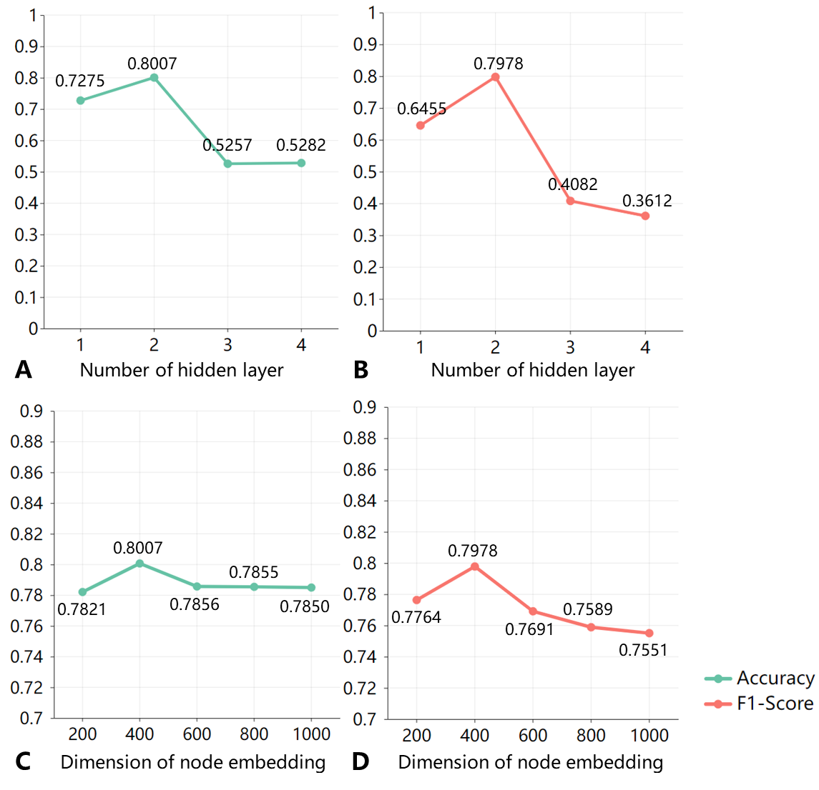
Supplemental_Fig_S12. The performance comparison of variants of scHGR including different number of hidden layers (A-B) and different dimension of node embeddings (C-D). The PBMC1-10X2 and PBMC1-10X3 are jointly used as reference datasets, and the query datasets including PBMC1-SM2, PBMC1-CS2, PBMC1-DS, PBMC1-D, PBMC1-SW and PBMC2-10X2. The average accuracy (green line chart) and average F1-Score (red line chart) on these test sets are employed to measure the performance of different architectures.

Supplementary Notes
Supplemental_Note_S1. Review of benchmark methods
scHPL [1] adopts classication tree which learns hierarchical relationships among cells and accurately describes cell types through dynamic updating.
scGAC [2] transfers cell knowledge by Graph Convolutional Net-work (GCN) which measures cell similarity within reference or query datasets and between reference and query datasets. To overcome the large span batch effect, neural networks are used to identify nonlinear relationships between cells.
scDeepSort [3] utilizes improved Graph Neural Networks (GNN) to generate information flows between genes and cells, which allows it to capture similar expression patterns within the same type of cells.
scVI [4] integrates raw sequencing reads to a low-dimensional latent space through nonlinear transformation, and trains the optimal representation of cells by variational inference and stochastic optimization.
SCENIC [5] is a computational method for simultaneous gene regulatory network construction and cell state recognition from single-cell RNA-seq data. SCENIC's workflow mainly consists of the following steps: Using GENIE3 or GRNBoost to infer gene regulatory networks from gene expression matrix; RcisTarget is used to enrich transcription factor binding sites and identify direct target genes; AUCell is taken to calculate the activity score of regulators for each cell, and using binary activity matrices to hierarchically cluster cells.
CellAssign [6] is a probabilistic model that leverages cell-type marker genes to annotate single-cell RNA sequencing data. CellAssign automates the process of annotation by computing a probabilistic assignment for each cell to a cell type—defined by a set of marker genes—or to an ‘unassigned’ class. CellAssign requires marker genes for cell types in addition to gene expression profiles. We use literature-based expert knowledge, CellMarker, PanglaoDB, and other public databases to extract the required marker gene sets.

Garnett [7] is a tool for rapidly annotating cell types in single-cell transcriptional profiling and single-cell chromatin accessibility datasets, based on an interpretable, hierarchical markup language of cell type-specific genes. Once a classifier is trained for a tissue/sample type, it can be applied to classify future datasets from similar tissues. To train the classifier, Garnett parses a marker file, which describes the marker genes corresponding to each cell type.

ACTINN [8] consists of a neural network including 3 hidden layers. Similar to scHGR proposed in this paper, ACTINN also adopts a strategy of first training the model using a reference dataset, and then classifying cells on new datasets. We took the same reference-query datasets setting for ACTINN as for scHGR.
We compared the annotation accuracy of SCENIC, CellAssign, Garnett, ACTINN with scHGR on all datasets. The results are shown in Table 1. PBMC-FACS and AMB correspond to annotation scenarios on intra-datasets, using a 5-fold cross validation strategy. PBMC corresponds to annotation scenarios on inter-datasets, including 6 datasets (PBMC1-SM2, PBMC1-CS2, PBMC1-DS, PBMC1-D, PBMC1-SW, PBMC2-10X2). Human and Mouse correspond to annotation tasks on cross-species scenarios, where Human contains 3 datasets and Mouse contains 2 datasets. The value in Supplemental Table S9 represents the average accuracy.
Both scHGR and SCENIC utilize relationships between genes to determine cell identity. The difference lies in the fact that scHGR employs validated gene relationships collected from databases including TRRUST, RegNetwork, BioGRID, and GREDB, whereas SCENIC utilizes GENIE3 or GRNBoost to infer gene relationships. It can be observed that scHGR outperforms SCENIC. While scHGR aims to achieve cell type annotation for single cells, SCENIC focuses more on the construction of gene regulatory networks, identification and clustering of cell states. SCENIC does not specifically target cell classification tasks, thus resulting in suboptimal performance when applied to classification tasks.
CellAssign and Garnett performed poorly compared to scHGR. There are three main reasons. (1) The advantages of CellAssign focus on simulating and analyzing the tumor microenvironment of advanced serous ovarian cancer and follicular lymphoma. However, the datasets used in this study involved different tissues and species, such as human pancreatic tissue, PBMC cells, mouse PBMC cells, and mouse cortical cells. (2) Since CellAssign and Garnett depend on cell type marker genes, we constructed marker gene set by collecting known marker genes from various sources, including literature, CellMarker, PanglaoDB, and other public databases. However, there's a possibility that these markers may not highly express in the cell type. Additionally, some cell types may belong to subtypes without available marker genes in the public databases. Mismatches between marker gene sets and gene expression data also affect the accuracy. (3) CellAssign and Garnett allow predictions to belong to an unknown class, which does not belong to any label when calculating accuracy. (4) Garnett requires at least one marker gene for each cell type, but insufficient marker genes for cell subtypes and missing markers for certain cell types led to PBMC-FACS and AMB not being compared with scHGR.
ACTINN outperforms CellAssign and Garnett. This is because ACTINN, as well as scHGR, leverages the detailed annotation of reference datasets. ACTINN performs inferiorly to scHGR because it is modeled as a neural network that includes 3 hidden layers. In contrast to the graph neural network of scHGR, ACTINN does not take into account the relationships between genes, and struggles to recognize more complex nonlinear correlations between cells.

Supplemental_Note_S2. Assessing the feasibility of using different genetic relationships for each specific query dataset
Since the reference dataset and the query dataset may originate from different batches, sequencing technologies and tissues, the noise, batch effects and biological heterogeneity make scRNA-seq data highly variable, hindering the accuracy of cell type identification on query datasets. Therefore, scHGR introduces genomic relations that are not interfered by these factors, fueling knowledge transfer from reference datasets to query datasets. Specifically, scHGR integrates gene relationships from the GREDB, BioGRID, TRRUST and Regnetwork databases that are prevalent within the same species, rather than cell type-specific gene regulations. Cell type-specific regulatory relationships and condition-specific regulatory relationships are not conducive to easing data discrepancies in scRNA-seq data.
We also attempted to employ different gene regulatory relationships for each specific query dataset, and the following limitations emerged when the reference and query datasets were from different tissues.
(1) The cell nodes in HGNN include both reference and query cells. If the regulatory relationships corresponding to query tissue are applied, it is illogical to use them to bridge the reference cells in graph topology. It’s difficult for scHGR to learn the relation between reference transcriptome data and cell types based on query-specific gene relationships. On the contrary, if applying reference tissue-specific regulatory relationships, it is illogical to use them to bridge the query cells. Meanwhile, the relations between reference transcriptomic data and cell types learned by scHGR based on reference-specific regulatory relationships is not suitable to directly apply in identifying cell types from query transcriptomic data.
(2) If we simultaneously use the regulatory relationships of reference and query organizations for the construction of a mixed graph, it is difficult to determine which regulatory relationship should be used for each gene pair. Meanwhile, the differences in regulatory relationships between reference and query organizations are not conducive to alleviate the differences between scRNA-seq data from various sources.
Therefore, using gene relationships commonly found in query and reference datasets can alleviate data differences introduced from different sources, facilitate information transfer from reference to query datasets, and improve the stability of scHGR in a wide range of cell annotation scenarios.

Reference
- Michielsen, L., Reinders, M.J.T. & Mahfouz, A. 2021. Hierarchical progressive learning of cell identities in single-cell data. Nat Commun 12, 2799.
- Cheng Y, Ma X. 2022. scGAC: a graph attentional architecture for clustering single-cell RNA-seq data. Bioinformatics (Oxford, England): btac099-btac099.
- Shao X, Yang H, Zhuang X, Liao J, Yang P, Cheng J, Lu X, Chen H, Fan X. 2021. scDeepSort: a pre-trained cell-type annotation method for single-cell transcriptomics using deep learning with a weighted graph neural network. Nucleic Acids Research 49: e122-e122.
- Lopez R, Regier J, Cole MB, Jordan MI, Yosef N. 2018. Deep generative modeling for single-cell transcriptomics. Nature Methods 15: 1053–1058-1053–1058.
- Aibar S, González-Blas CB, Moerman T, Huynh-Thu VA, Imrichova H, Hulselmans G, Rambow F, Marine J-C, Geurts P, Aerts J et al. 2017. SCENIC: single-cell regulatory network inference and clustering. Nature Methods 14: 1083-1086.
- Zhang AW, O’Flanagan C, Chavez EA, Lim JLP, Ceglia N, McPherson A, Wiens M, Walters P, Chan T, Hewitson B et al. 2019. Probabilistic cell-type assignment of single-cell RNA-seq for tumor microenvironment profiling. Nature Methods 16: 1007-1015.
- Pliner HA, Shendure J, Trapnell C. 2019. Supervised classification enables rapid annotation of cell atlases. Nature Methods 16: 983-986.
- Ma, F. & Pellegrini, M. ACTINN: automated identification of cell types in single cell RNA sequencing. Bioinformatics 36, 533–538 (2020).

