Description of supplementary figures

Supplemental Fig S1. Satellite distribution along chromosomes in the migratory locust genome.

Supplemental Fig S2. Genomic features along migratory locust chromosomes. a, gene density, GC content, nucleotide diversity, recombination rate; b, TE profile including LINE, DNA, LTR, Helitron transposons and simple repeat.

Supplemental Fig S3. Density plot for gene density between X Chromosome and autosomes.

Supplemental Fig S4. Boxplot for recombination rate form each chromosome.

Supplemental Fig S5. TE percentage and K2P profile. According to the size, chromosomes were classified into four categories: Large, Medium, Small and X.

Supplemental Fig S6. Functional enrichment of conservative X-linked genes. Left is GO terms, right is KEGG terms.

Supplemental Fig S7. d_{N}/d_{S} analysis in true bugs. P values were calculated between X-Sfur and others by 1000 replicates bootstrapping.

Supplemental Fig S8. Regression analysis between Rho and dn/ds. a: All genes. b: X chromosome genes alone.

Supplemental Fig S9. The distribution of X-X and X-Lmig genes along the X chromosome.

Supplemental Fig S10. The dosage compensation along each chromosome.

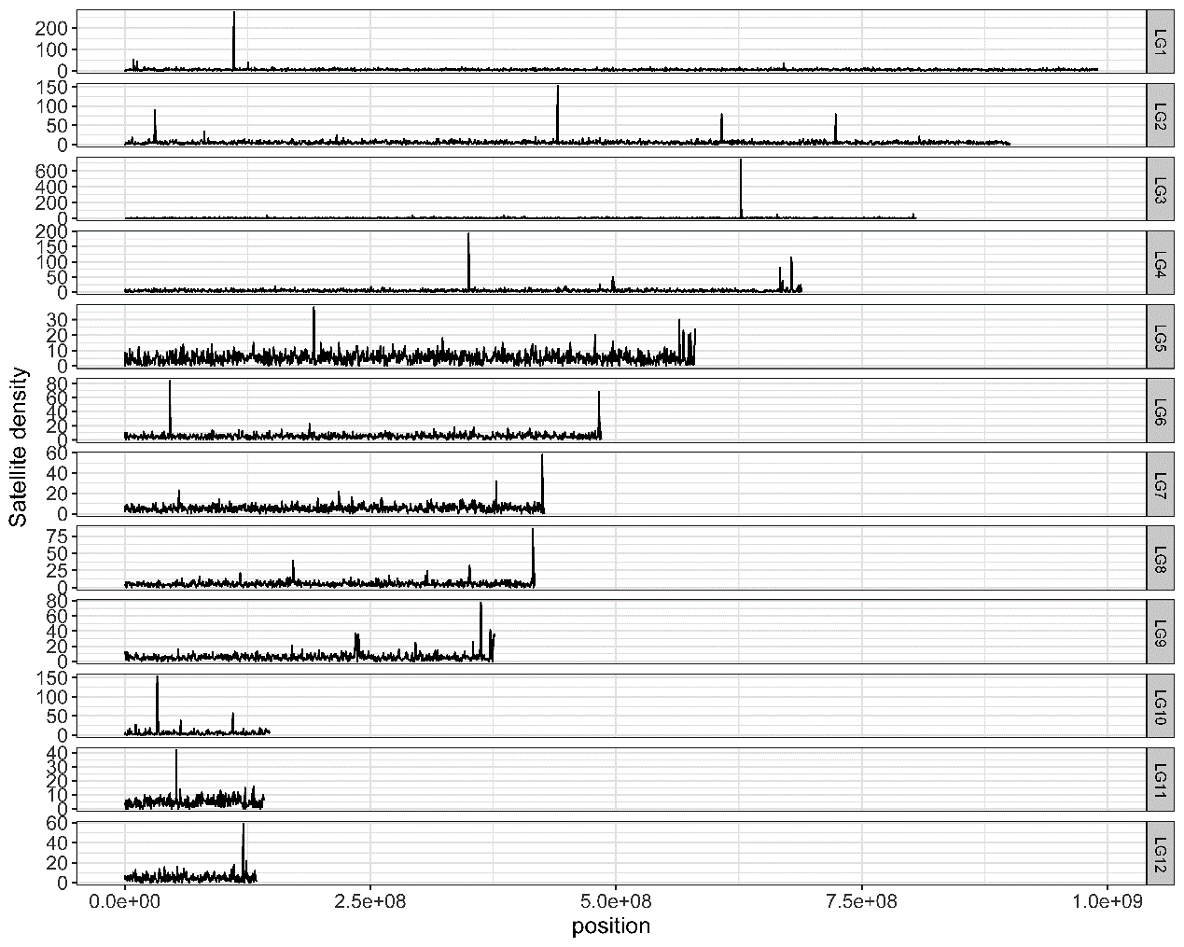
Supplemental Fig S1. Satellite distribution along chromosomes in the migratory locust genome.

a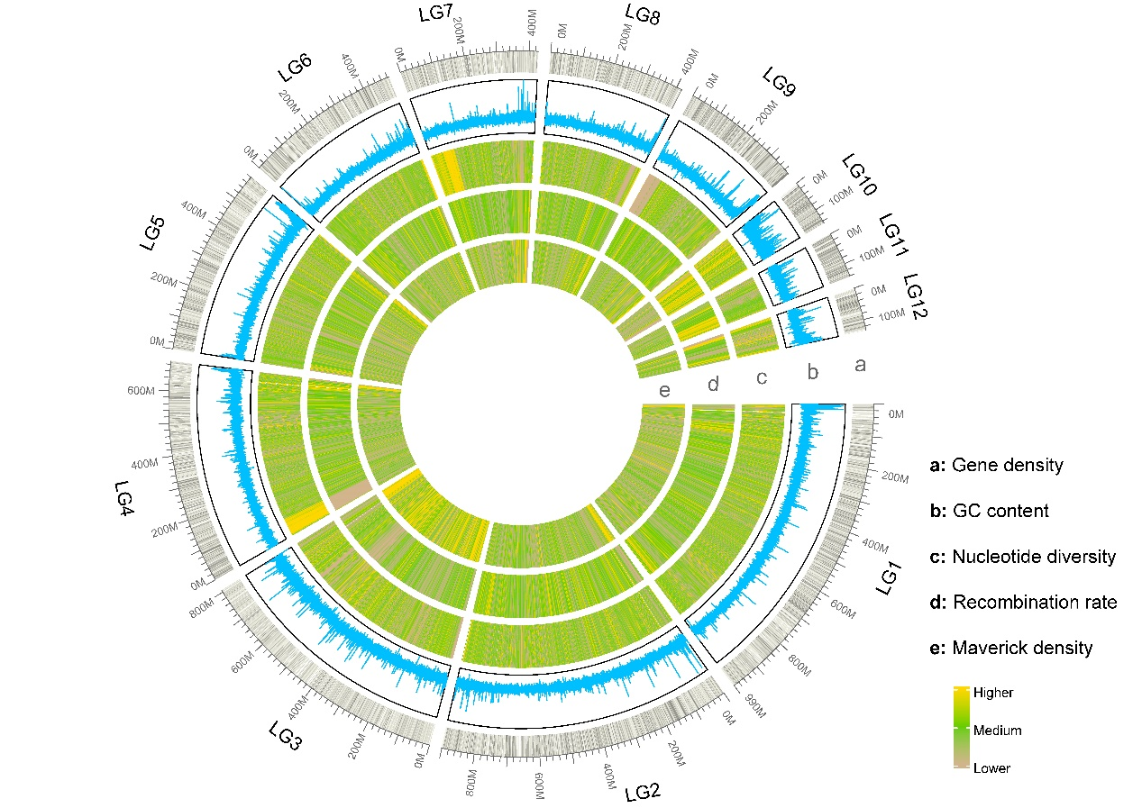
b
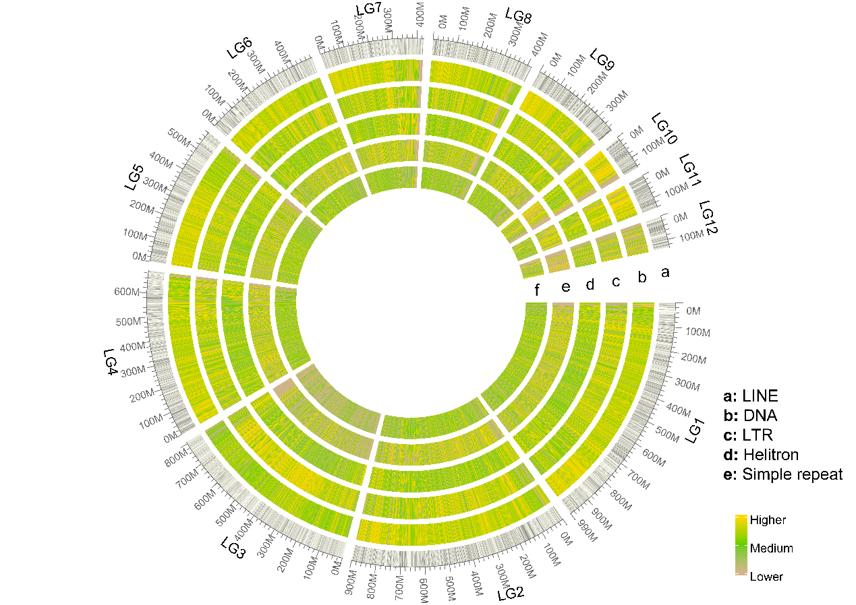

Supplemental Fig S2. Genomic features along migratory locust chromosomes. a, gene density, GC content, nucleotide diversity, recombination rate; b, TE profile including LINE, DNA, LTR, Helitron transposons and simple repeat.
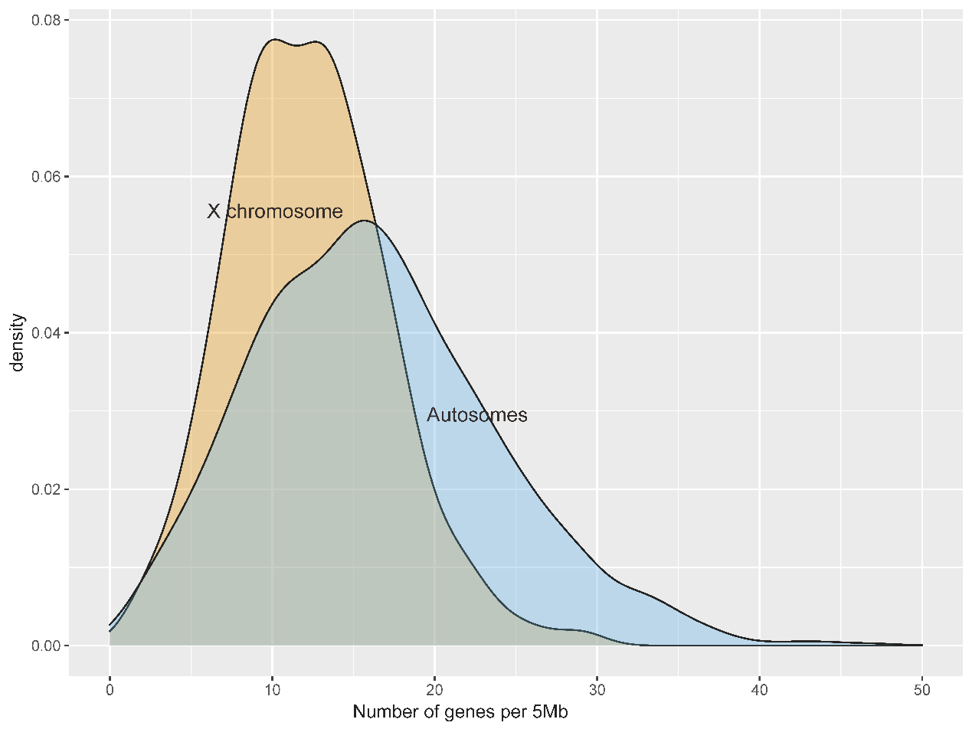
Supplemental Fig S3. Density plot for gene density between X Chromosome and autosomes.

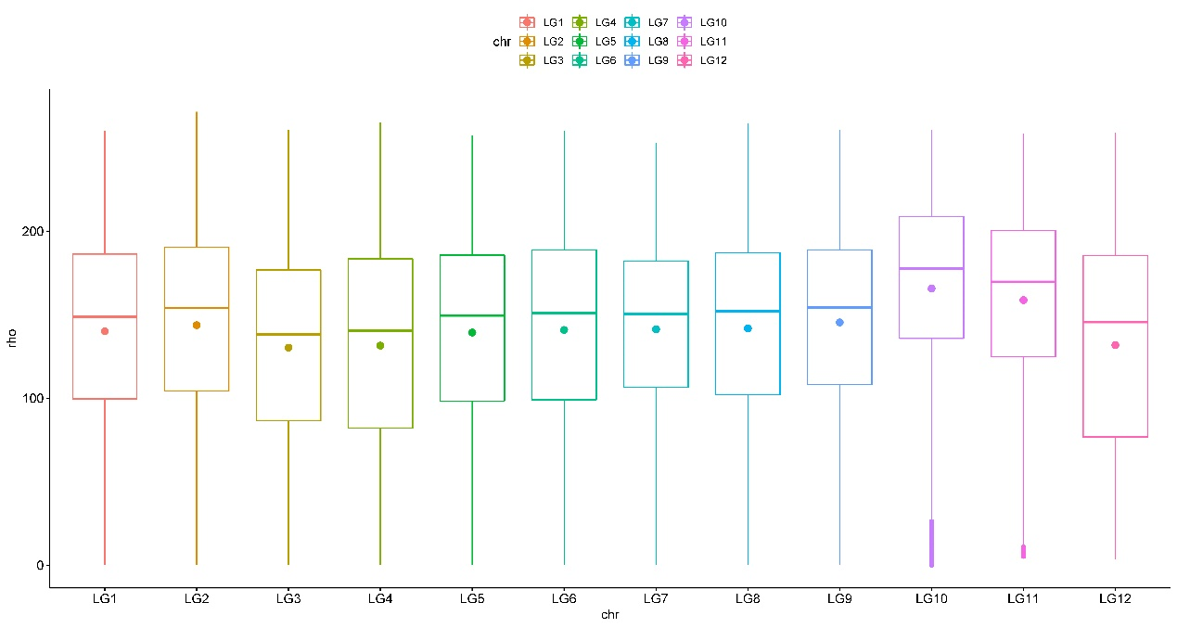
Supplemental Fig S4. Boxplot for recombination rate for each chromosome. Recombination rate for the X (LG3) is lower than all autosomes (P<0.001) except for LG4 and LG12 (P>0.05).

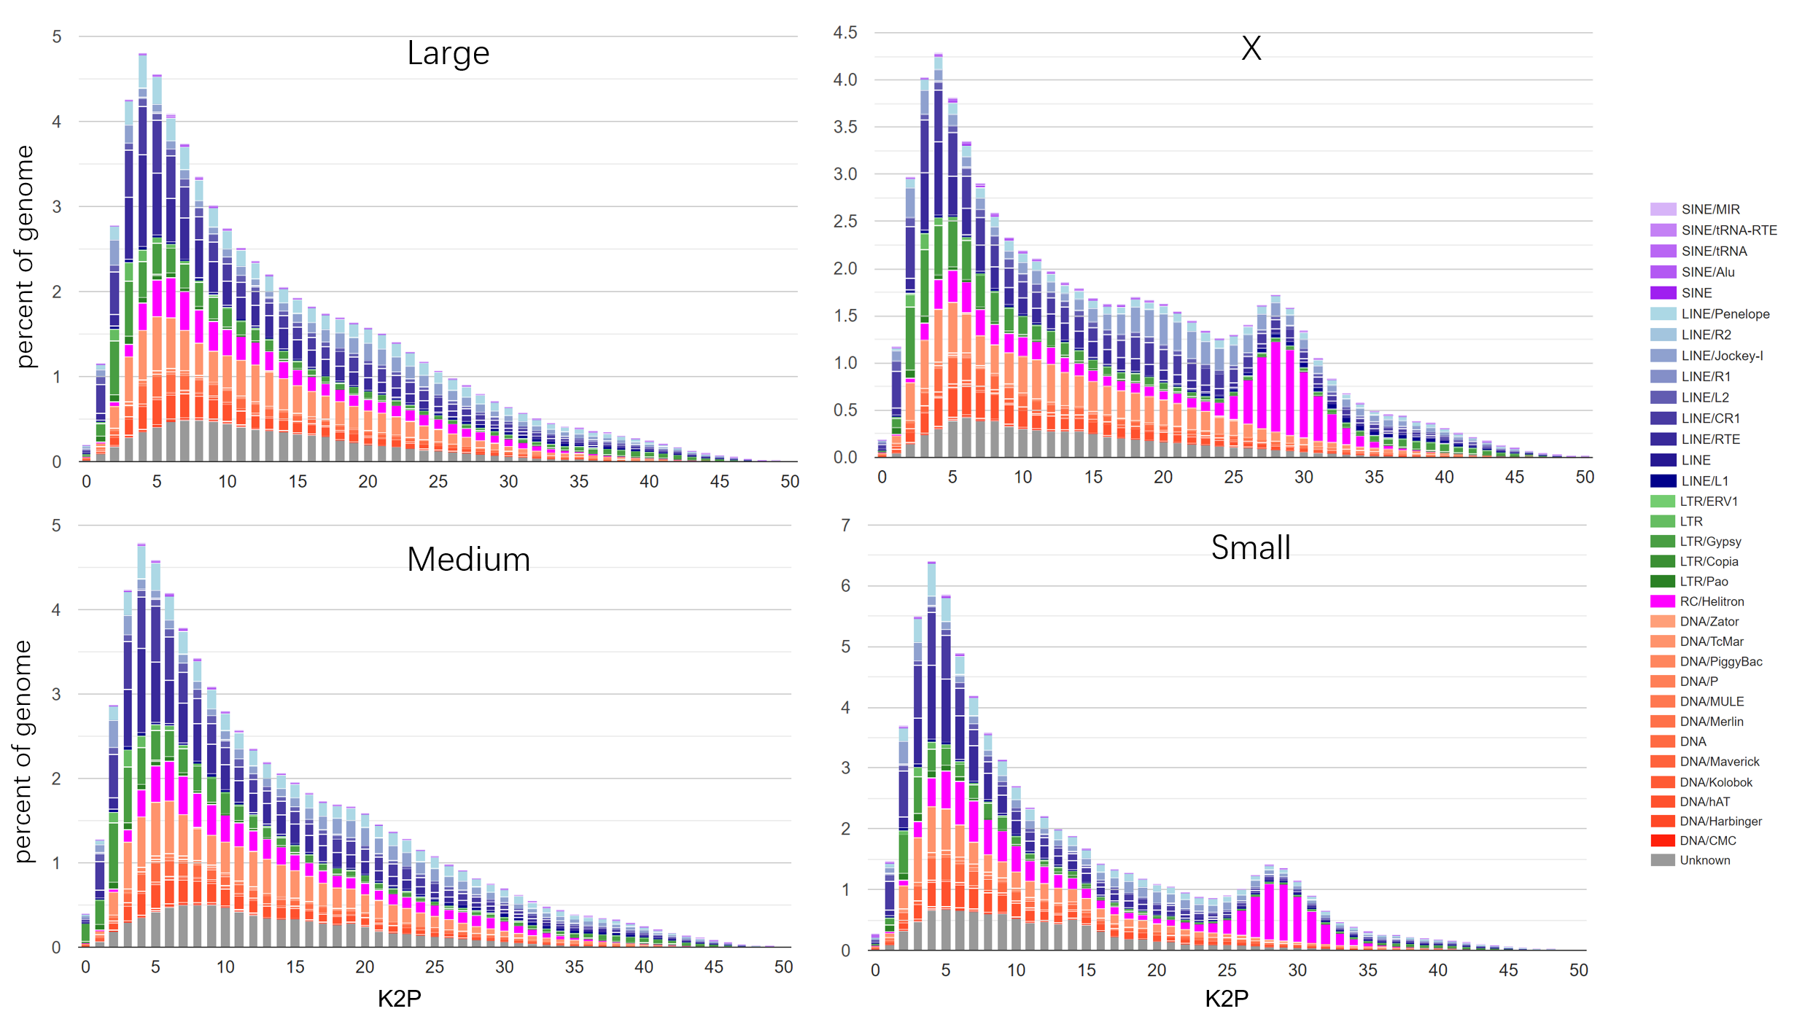
Supplemental Fig S5. TE percentage and K2P profile. According to the size, chromosomes were classified into four categories: Large, Medium, Small and X.

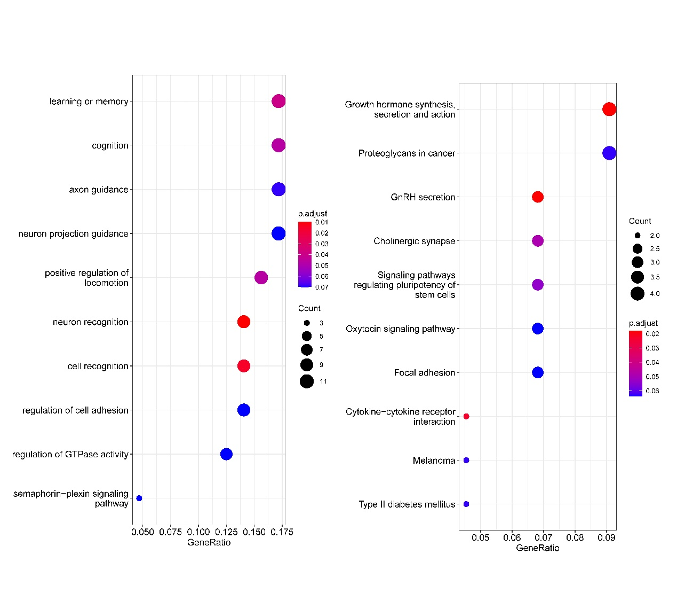
Supplemental Fig S6. Functional enrichment of conservative X-linked genes. GO terms on the left, KEGG terms on the right.

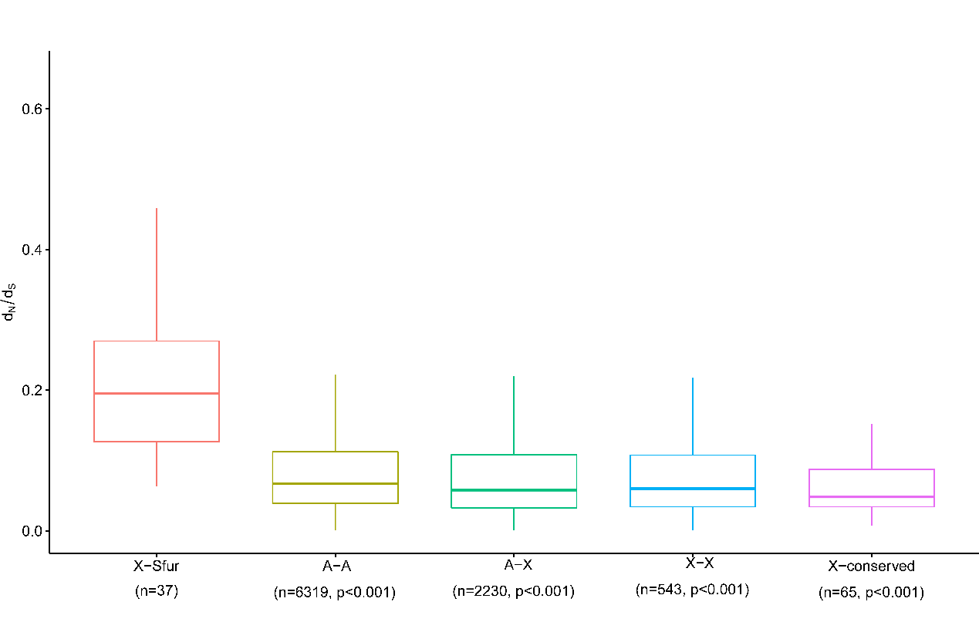
Supplemental Fig S7. d_{N}/d_{S} analysis in true bugs. d_{N}/d_{S} values were calculated between Sogatella furcifera (Sfur) and Nilaparvata lugens. P values were calculated between X-Sfur and other categories with 1000 bootstrap replicates.

Supplemental Fig S8. Regression analysis between Rho and d_{N}/d_{S}. a: All genes. b: X chromosome genes alone. Regression equations were calculated by R package ggpubr in a linear model.

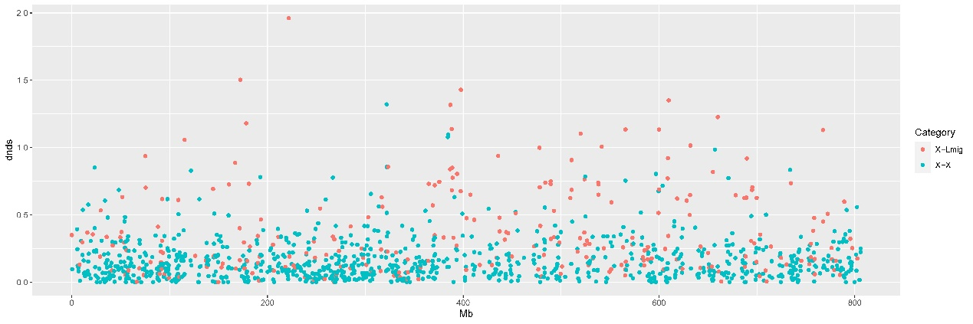
Supplemental Fig S9. The distribution of X-X and X-Lmig genes along the X chromosome.
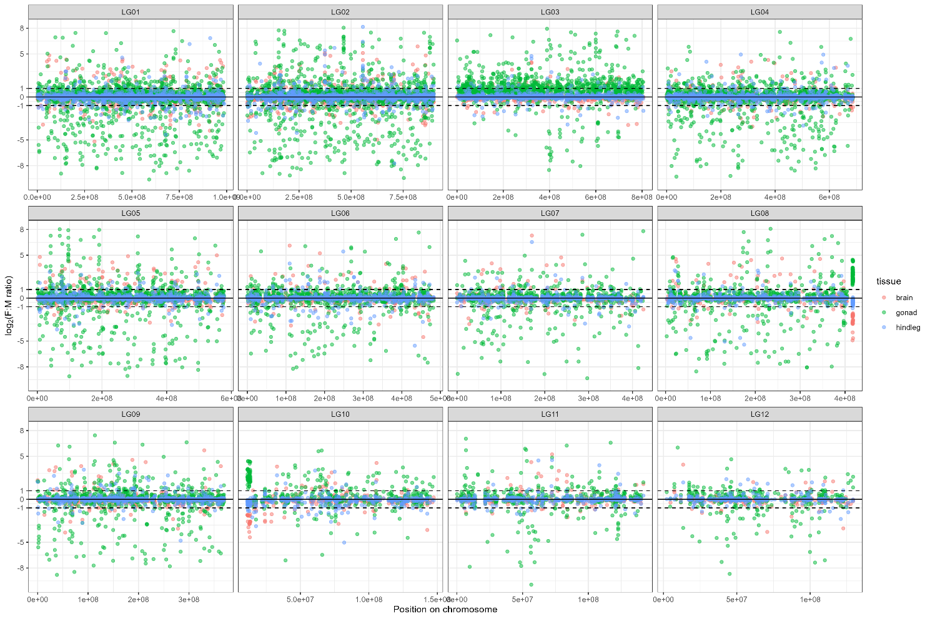
Supplemental Fig S10. The dosage compensation along each chromosome.

