m6A sites E-YTHmut
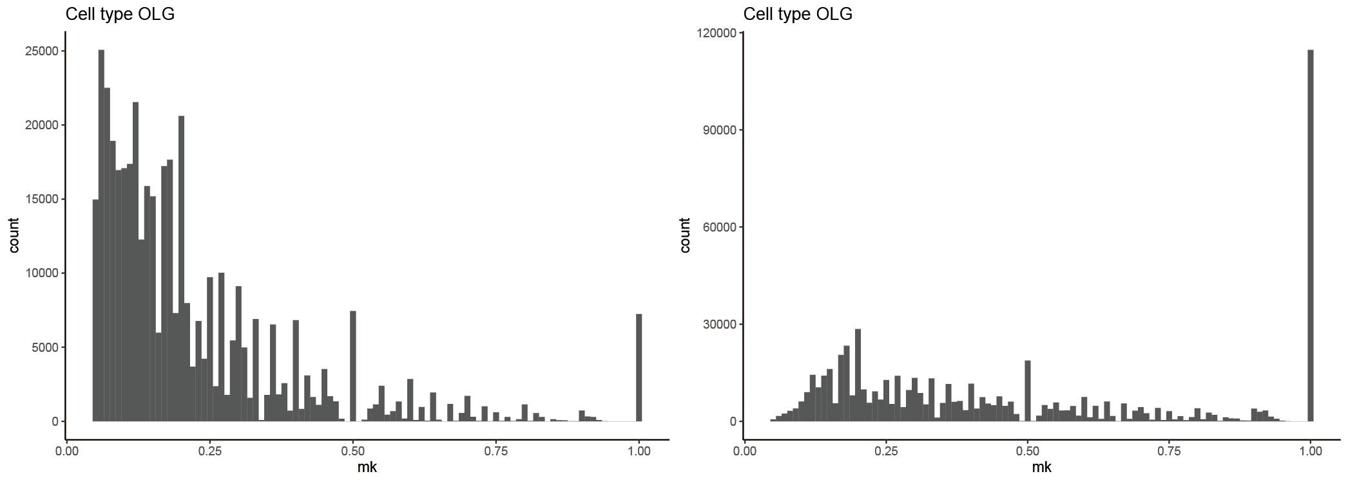

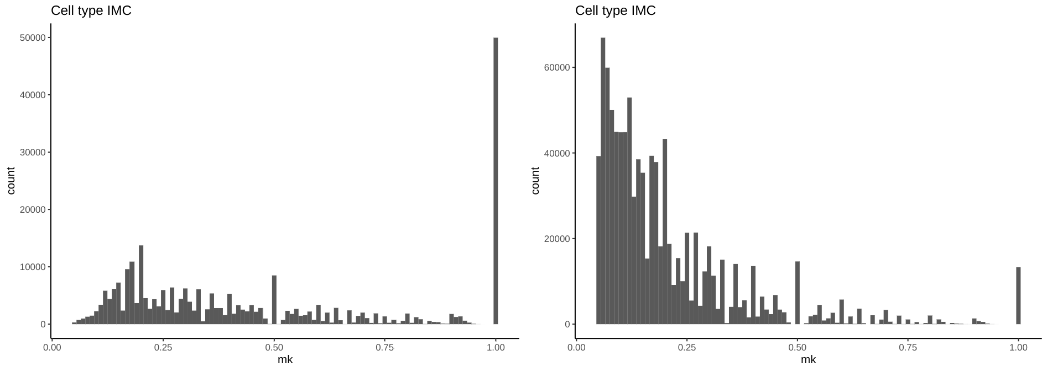
m6A sites E-YTHmut

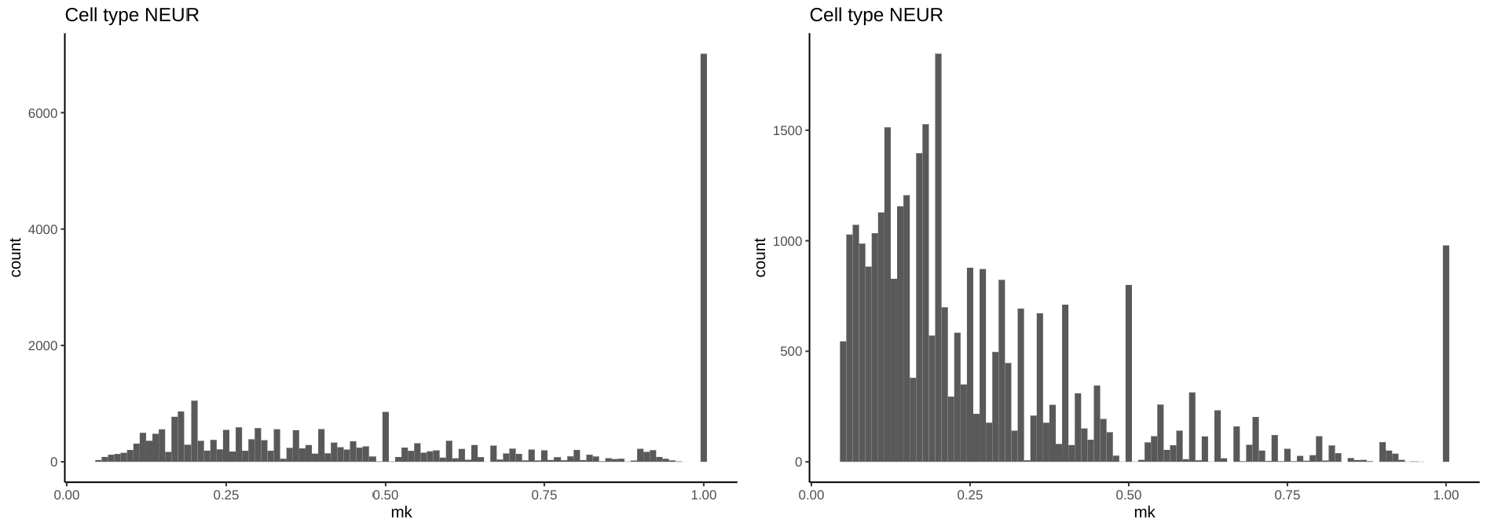
m6A sites E-YTHmut

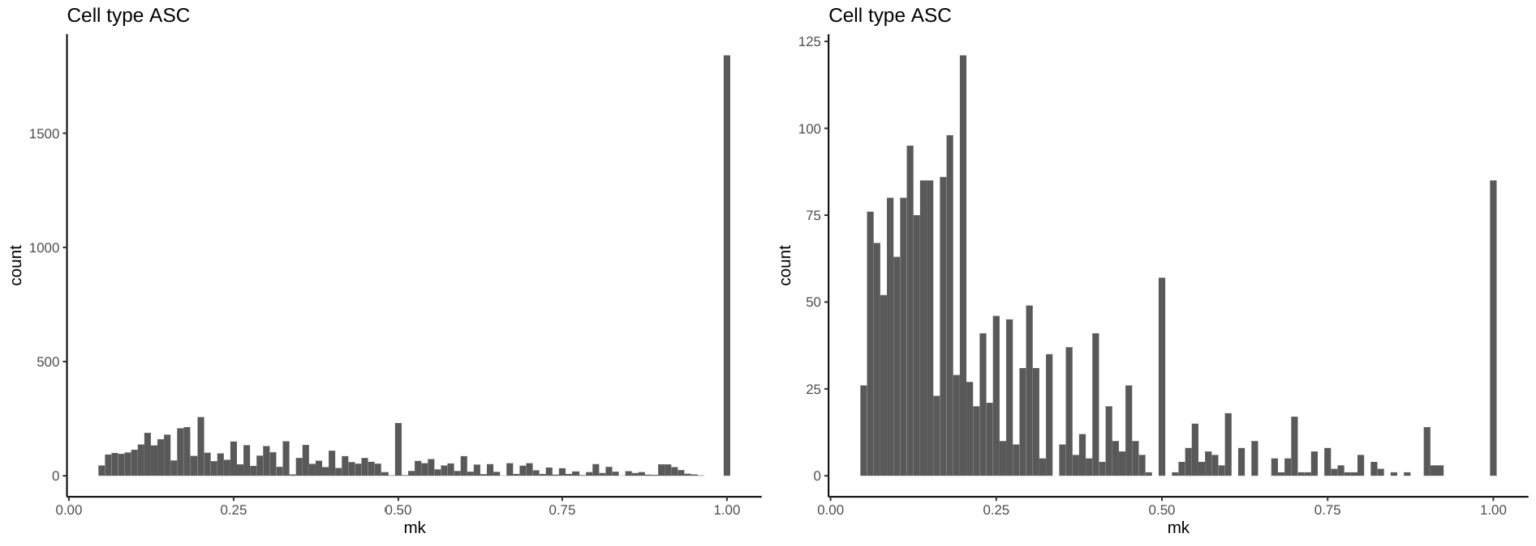
m6A sites E-YTHmut

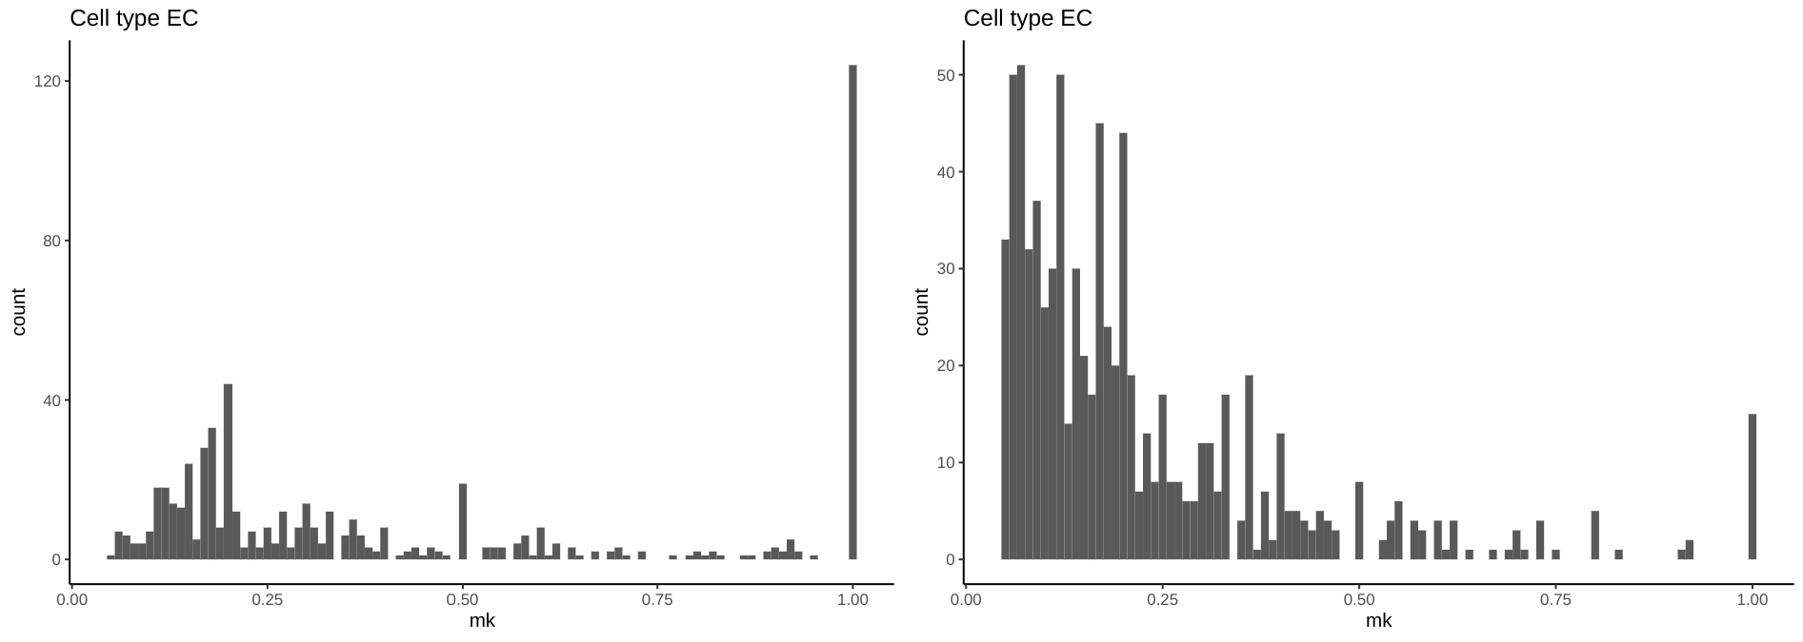
m6A sites E-YTHmut

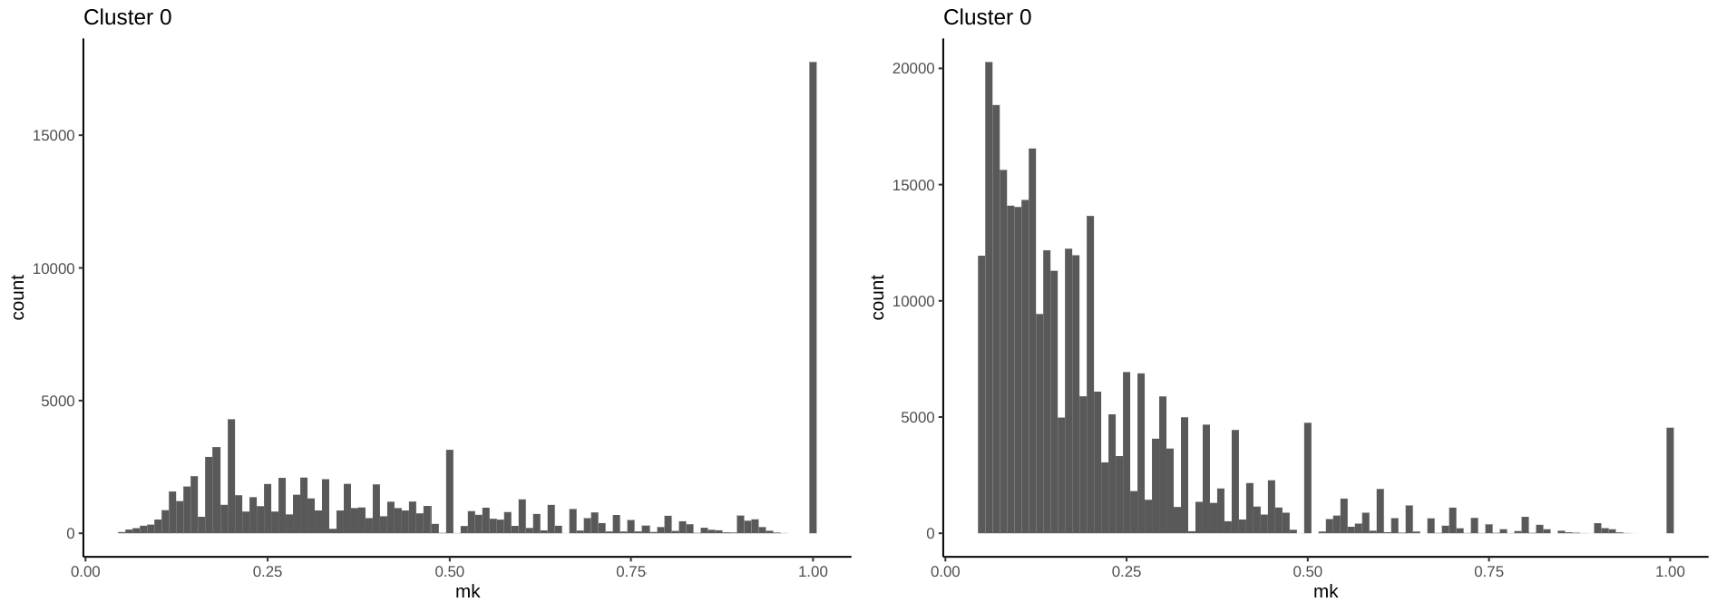
m6A sites E-YTHmut

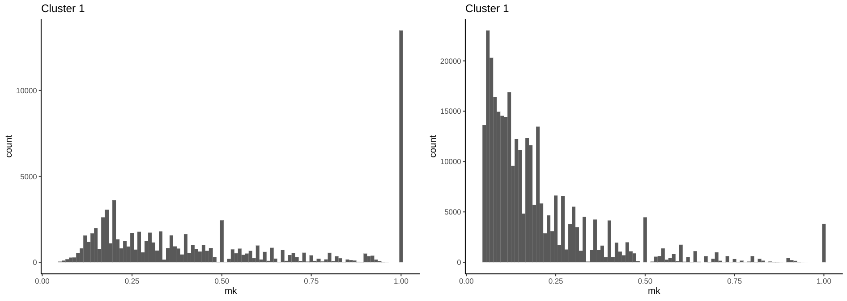
m6A sites E-YTHmut

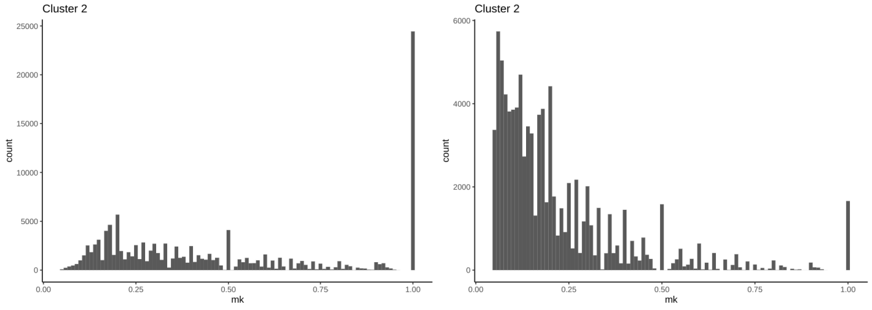
m6A sites E-YTHmut

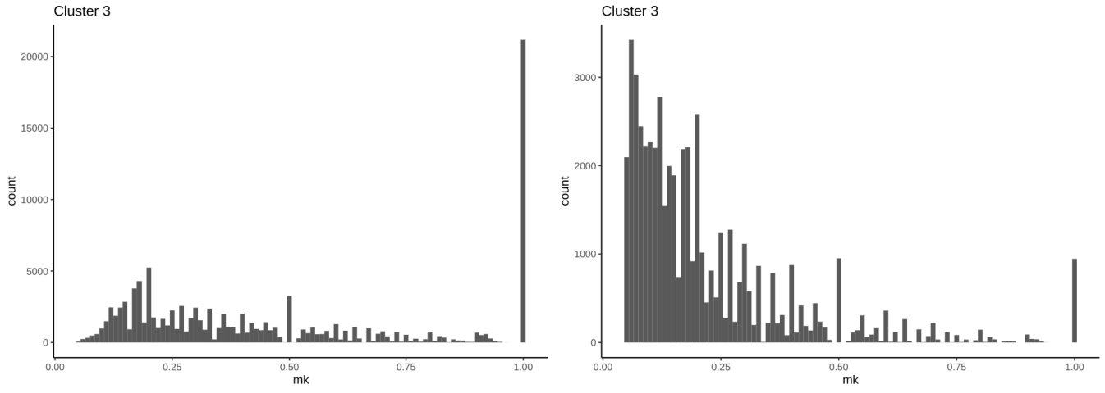
m6A sites E-YTHmut

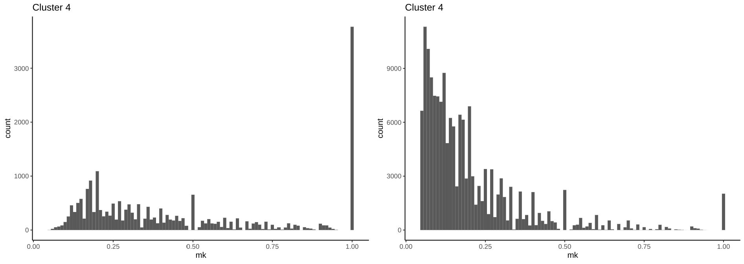
m6A sites E-YTHmut

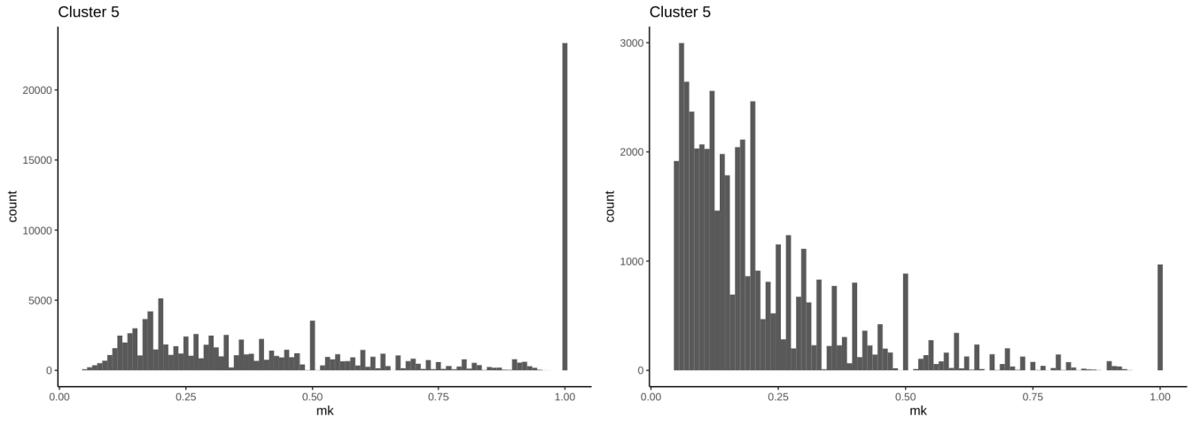
m6A sites E-YTHmut

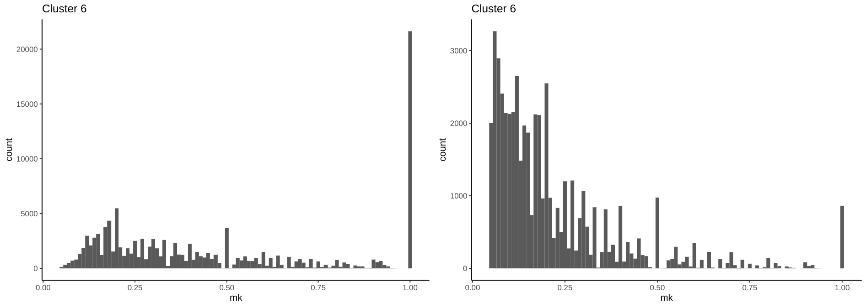
m6A sites E-YTHmut

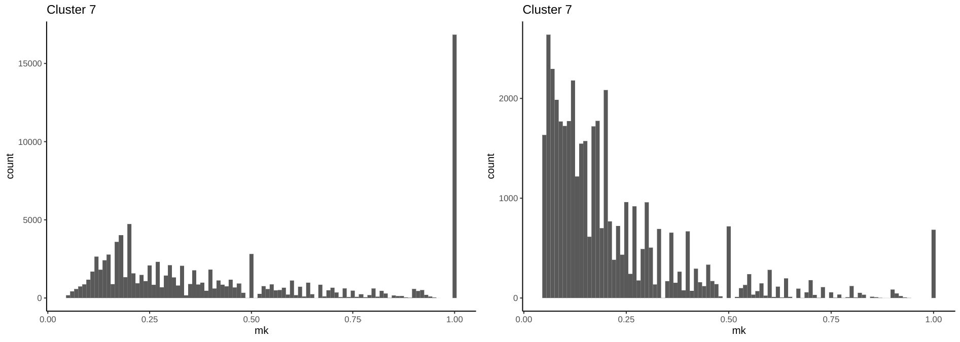
m6A sites E-YTHmut

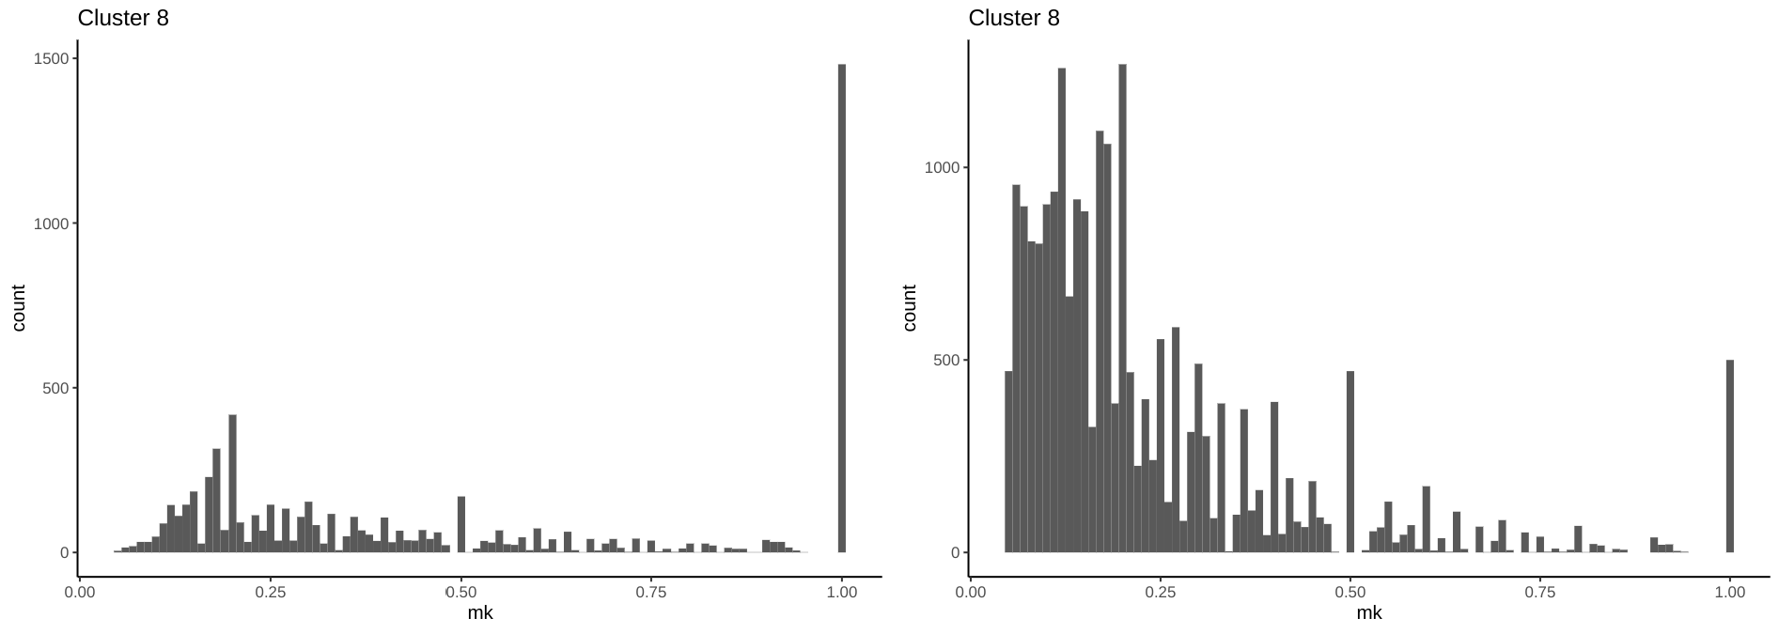
m6A sites E-YTHmut

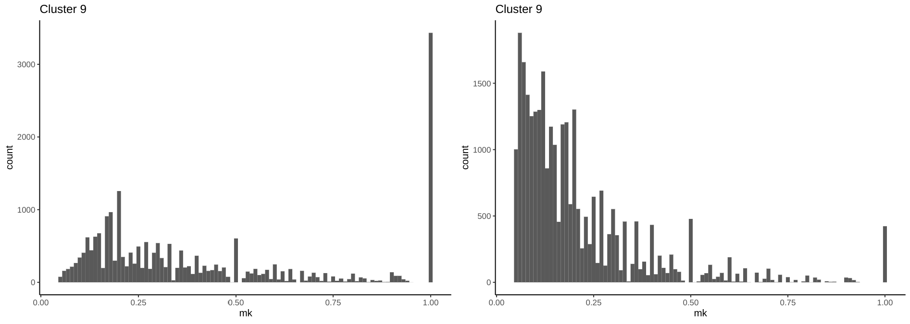
m6A sites E-YTHmut

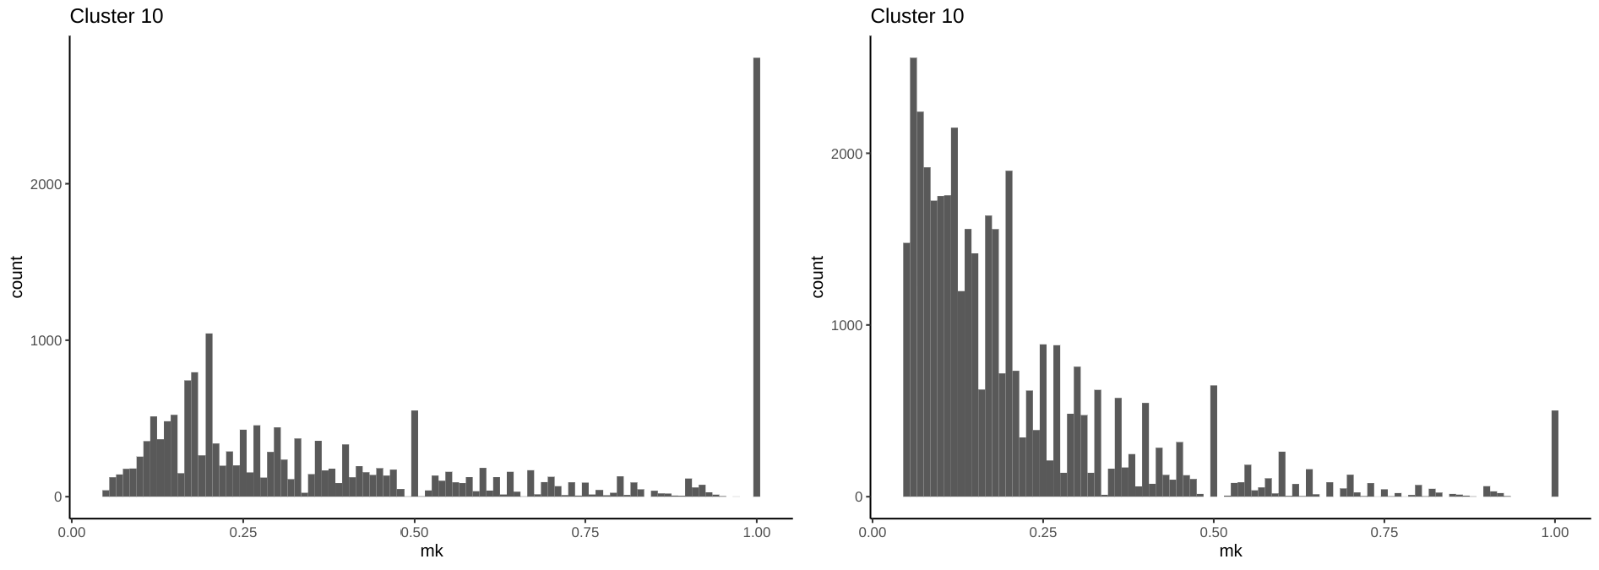
m6A sites E-YTHmut

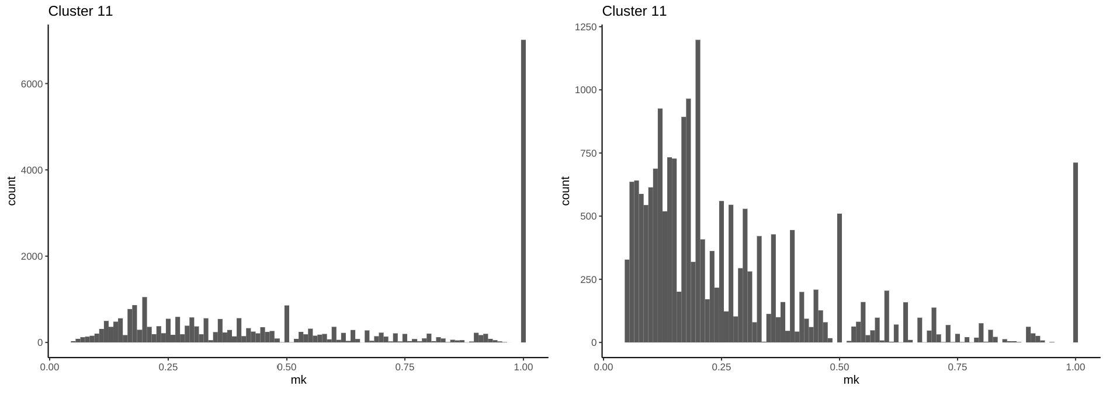
m6A sites E-YTHmut

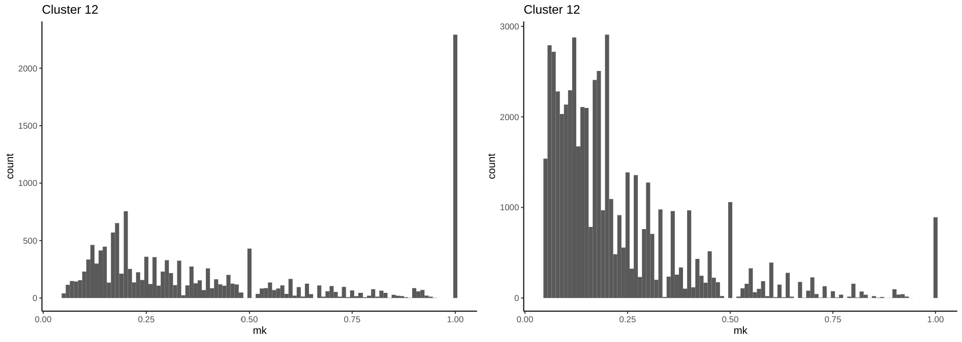
m6A sites E-YTHmut

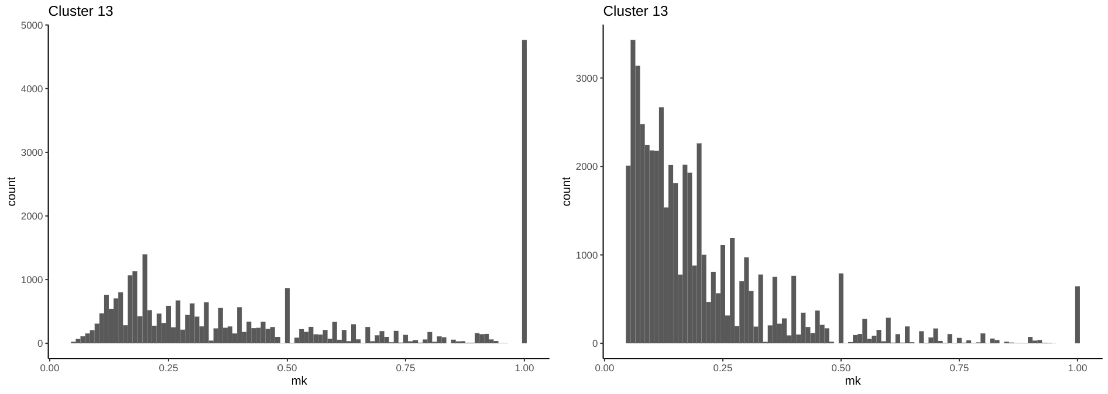
m6A sites E-YTHmut

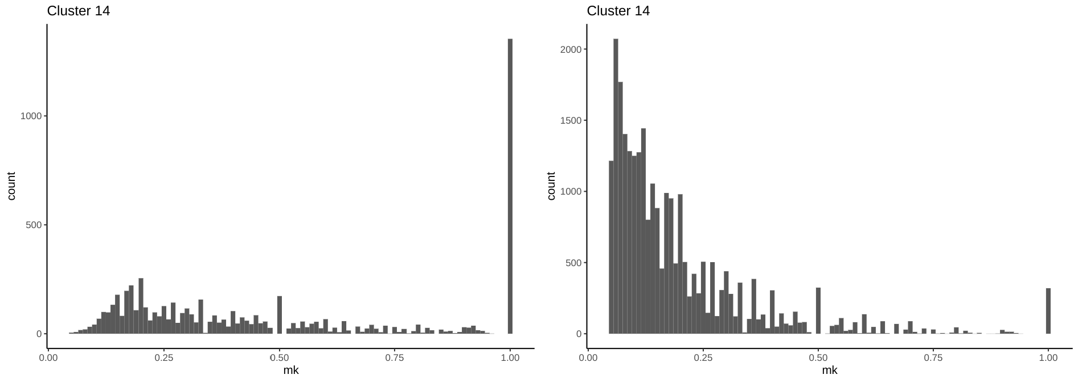
m6A sites E-YTHmut

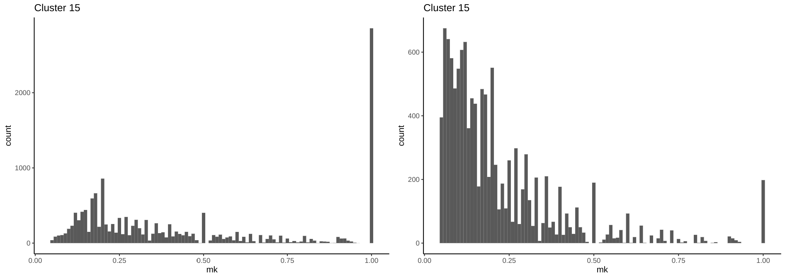
m6A sites E-YTHmut

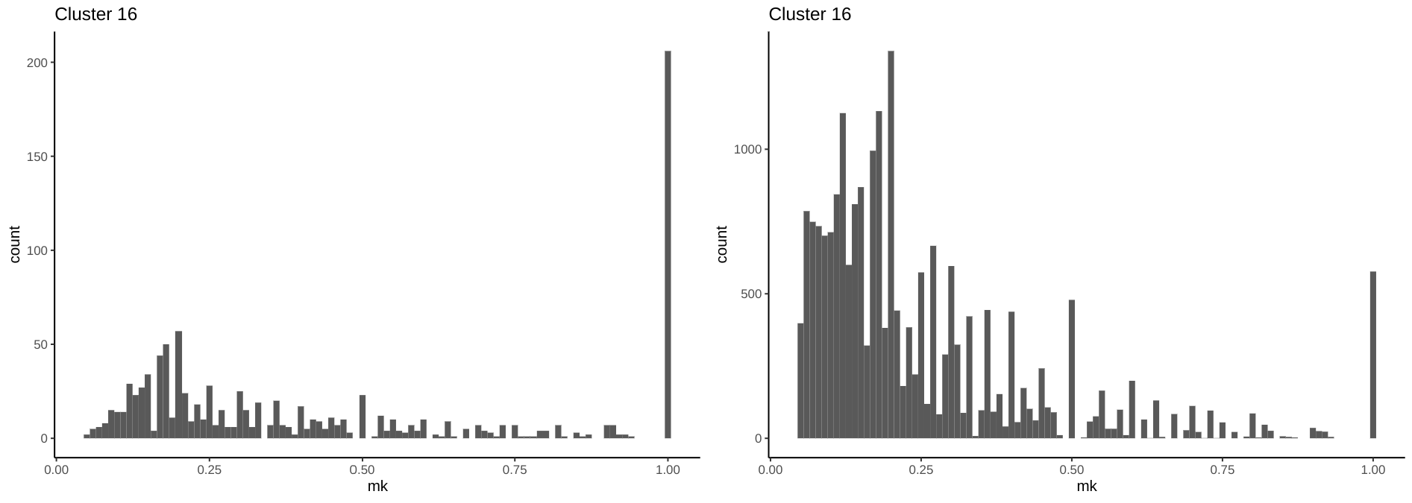
m6A sites E-YTHmut

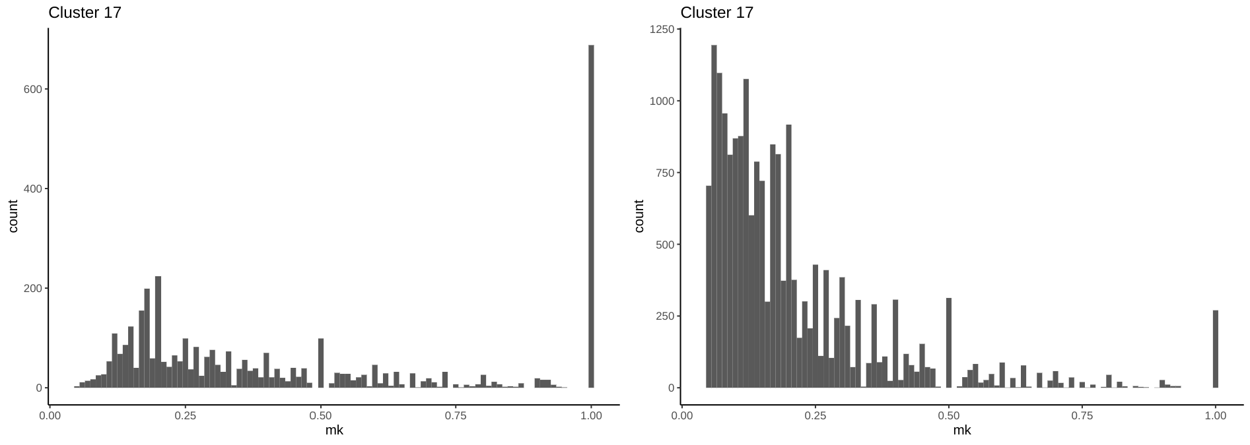
m6A sites E-YTHmut

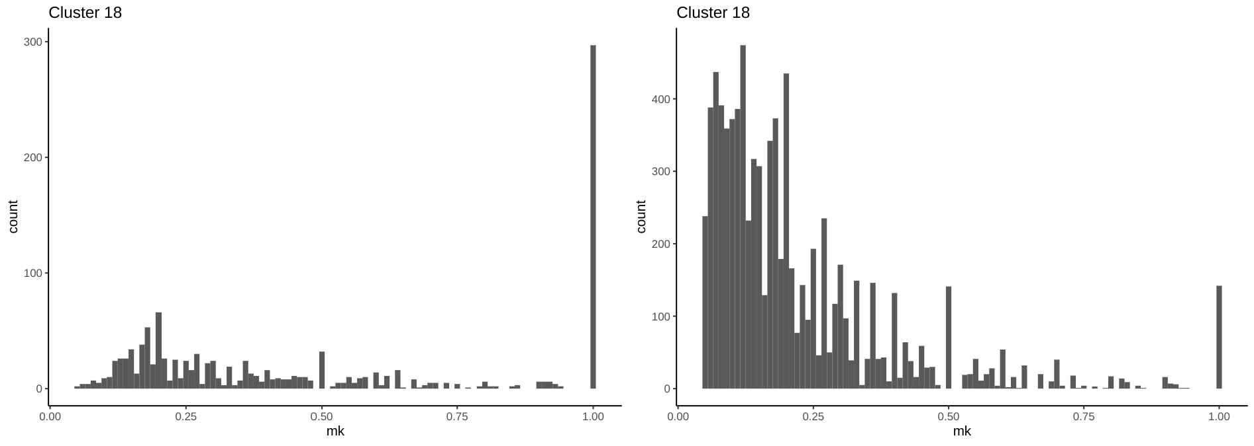
m6A sites E-YTHmut

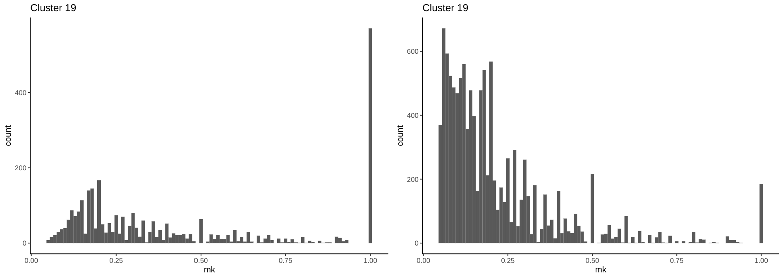
m6A sites E-YTHmut

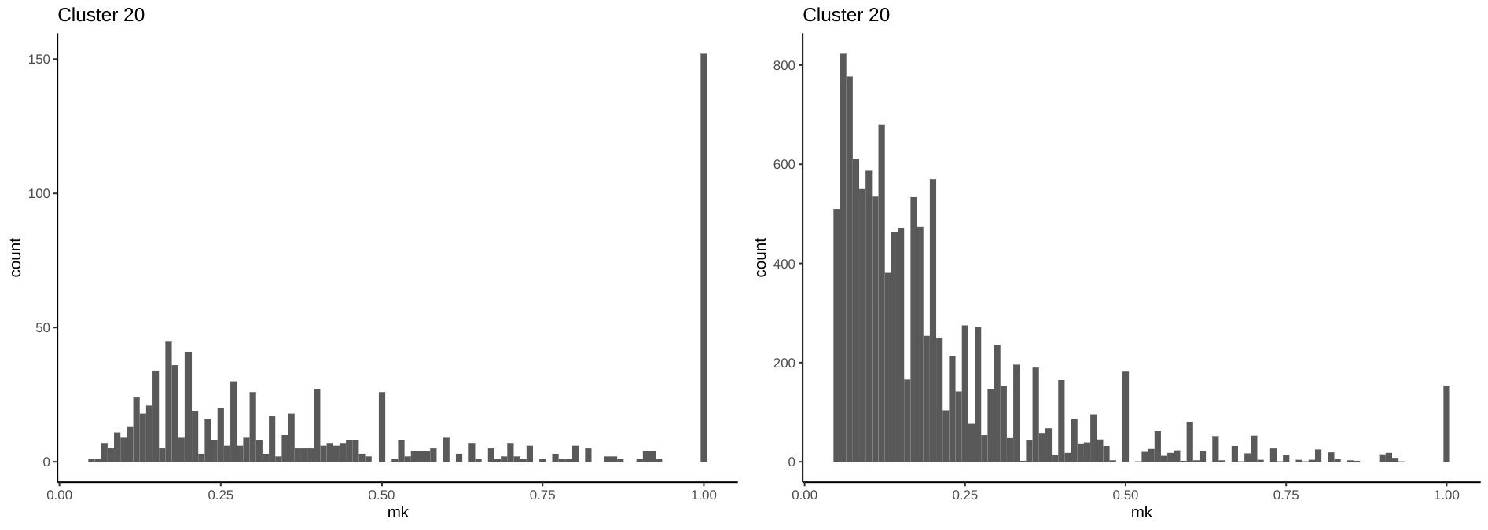
m6A sites E-YTHmut

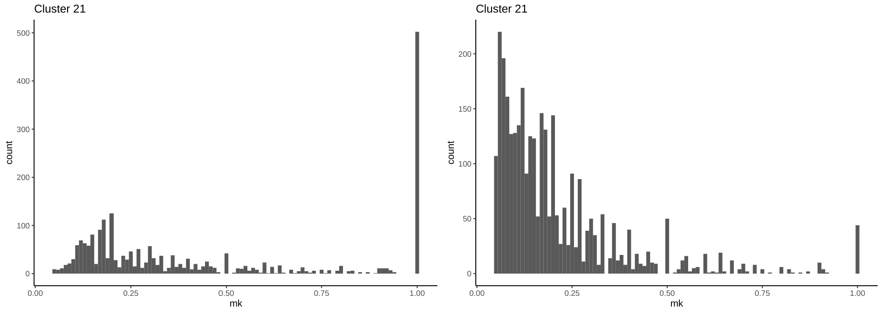
m6A sites E-YTHmut

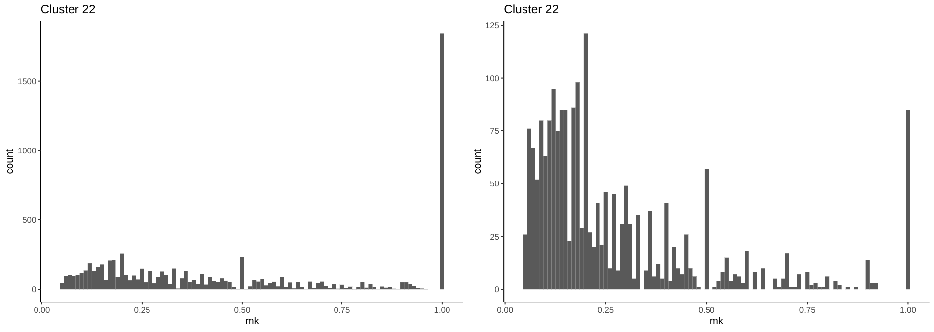
m6A sites E-YTHmut

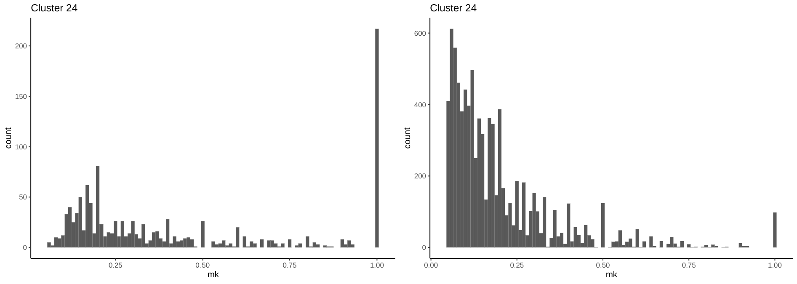
m6A sites E-YTHmut

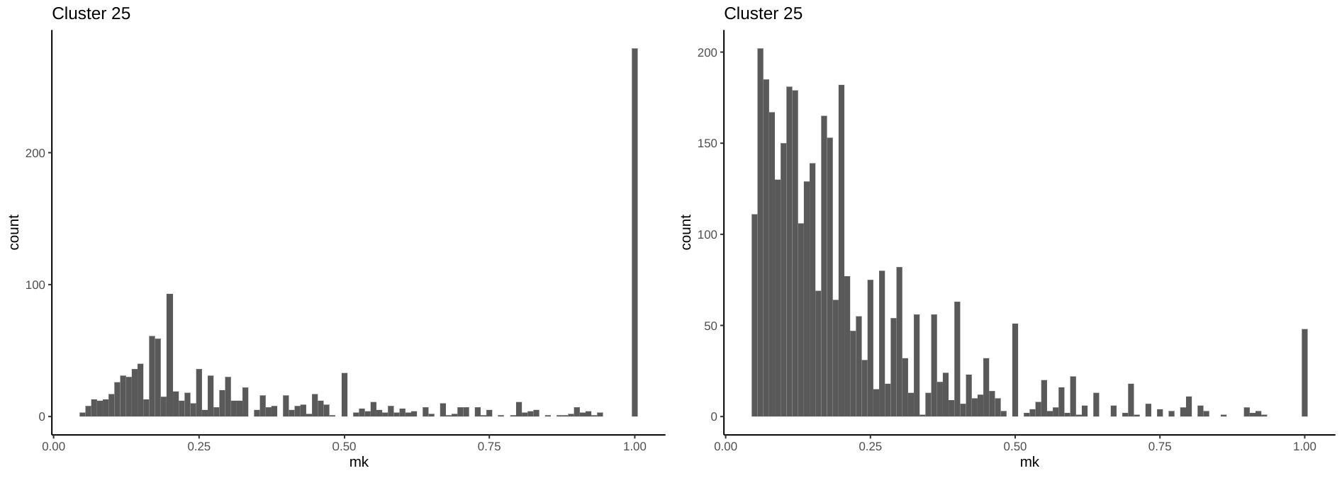
m6A sites E-YTHmut

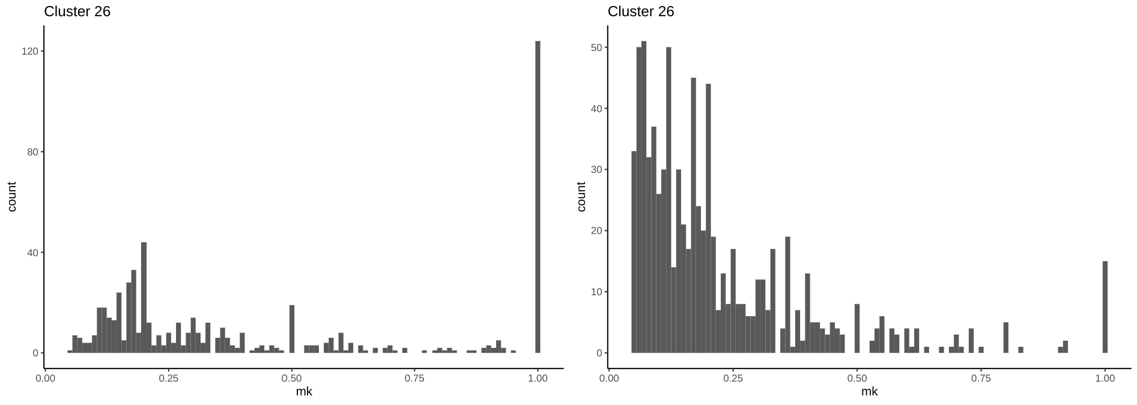
m6A sites E-YTHmut

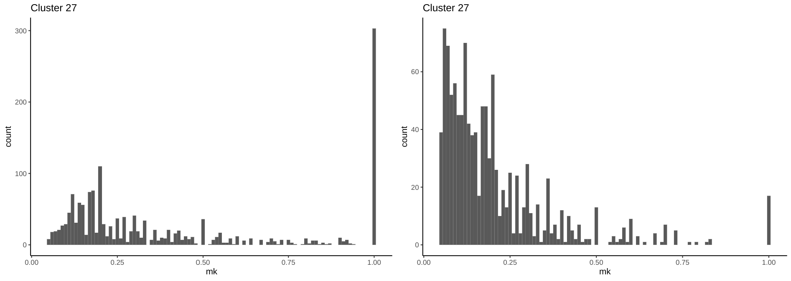
m6A sites E-YTHmut
Supplemental Fig S7. m⁶A and C-to-U edit counts over mutation per read ratio.
Histogram of m⁶A site counts over mutation per read (m/k) ratio (left) and histogram of C-to-U edit E-YTH^{mut} background over mutation per read (m/k) ratio (right). The data represents single cell data for OLG, IMC, NEUR, ASC, EC cell lineage cells and for each cluster. OLG: oligodendrocyte cell lineage; IMC: immune cell lineage; NEUR: neuronal cell lineage; ASC: astrocyte cell lineage, EC: endothelial cell lineage. A minimum threshold of 5% was applied.

