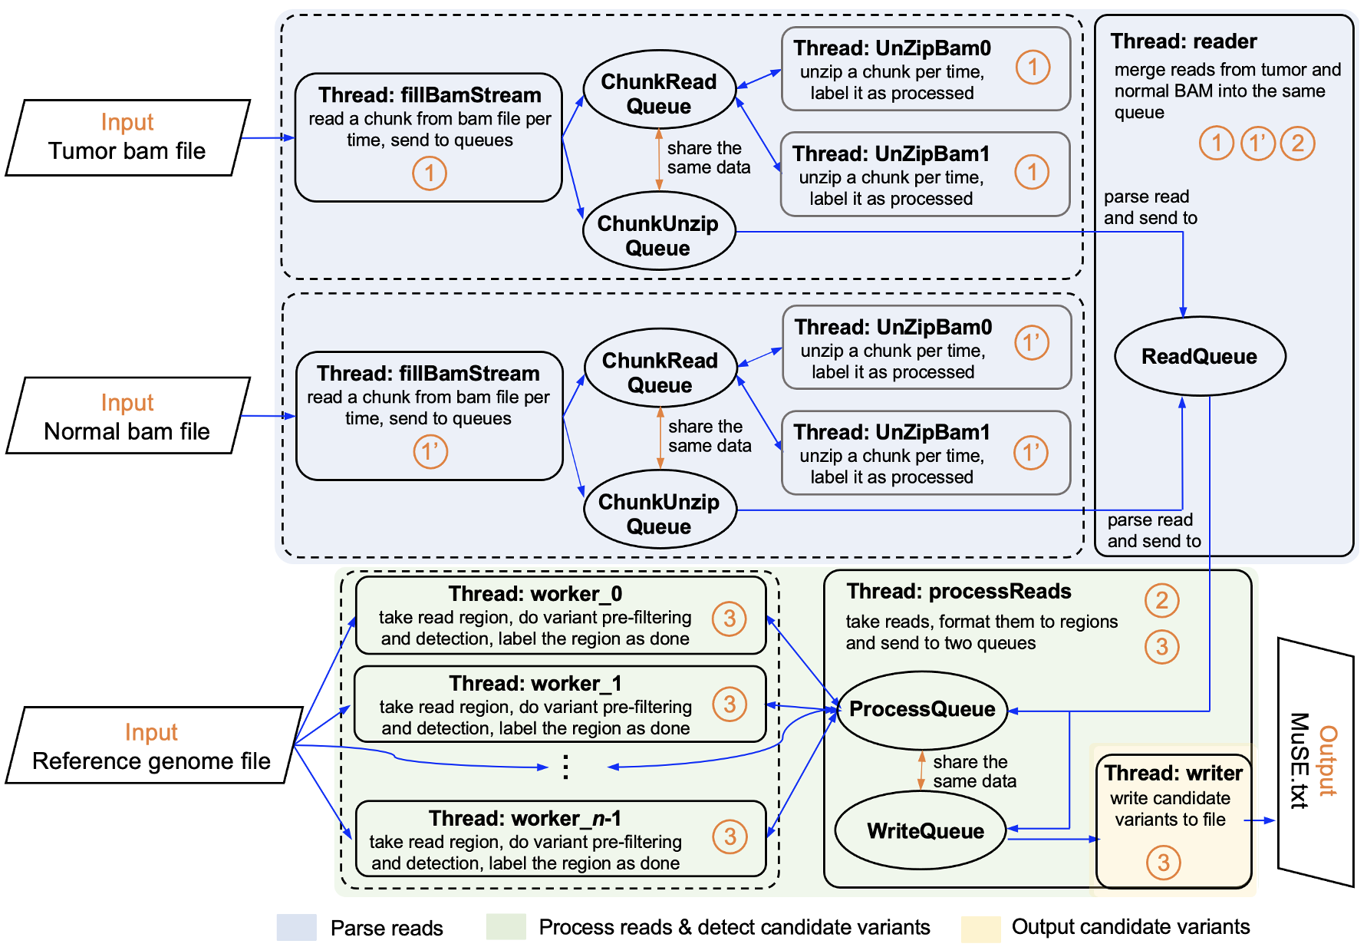
Supplemental Fig. S6 | Diagram of the parallelization implementation of the ‘call‘ step in MuSE 2. Diamonds indicate input and output; rectangles indicate threads created for a task described in the box; blue arrows denote data flow. Ellipses are queues exchanging data between the connected threads; orange double-headed arrows denote that the two connected queues sharing the same data; the threads and queues are divided into three groups by their functions as indicated by the shades; circled numbers represent the communication variables between an upstream thread and a downstream thread(s) by which the latter knows if the former completes its jobs; n is the number of threads specified for running MuSE 2.

