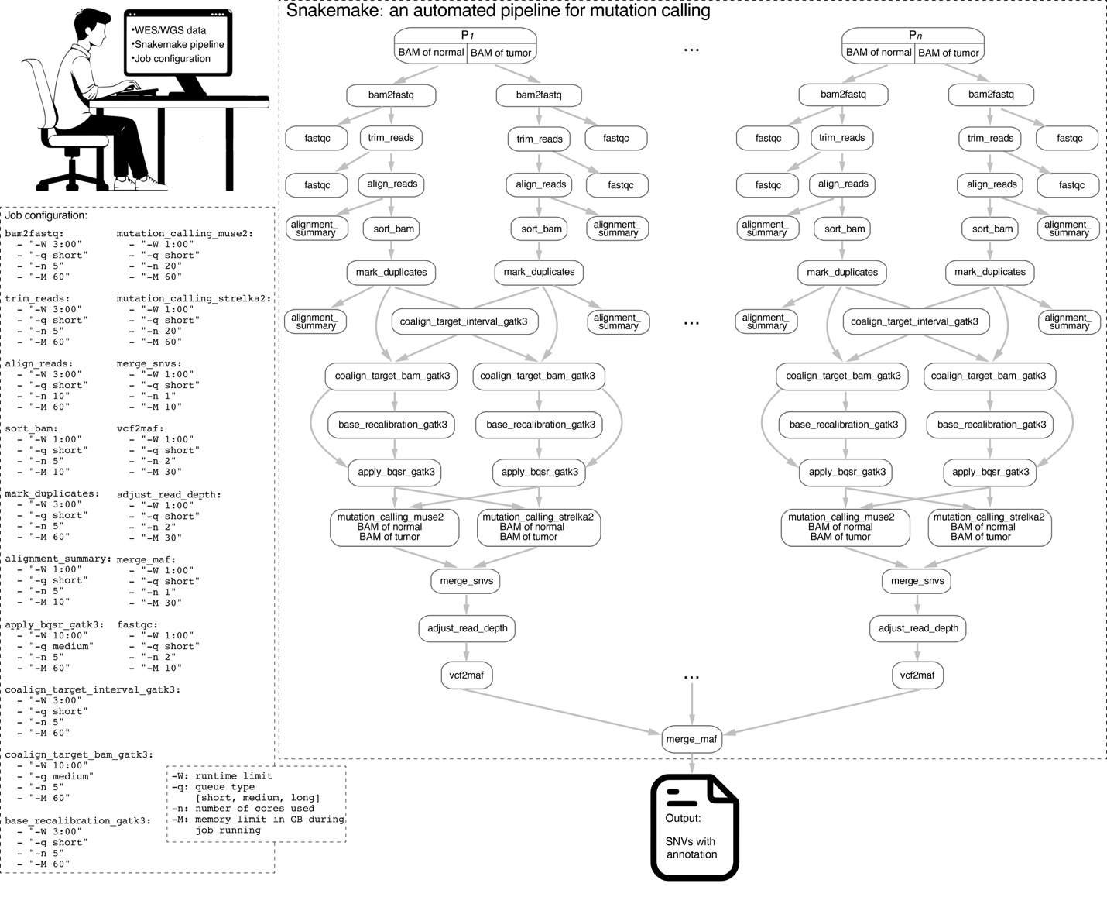Supplemental Fig. S5 | Illustration of running the Snakemake automated pipeline to call somatic SNVs for WES/WGS data from a patient cohort on a High Performance Computing cluster.

