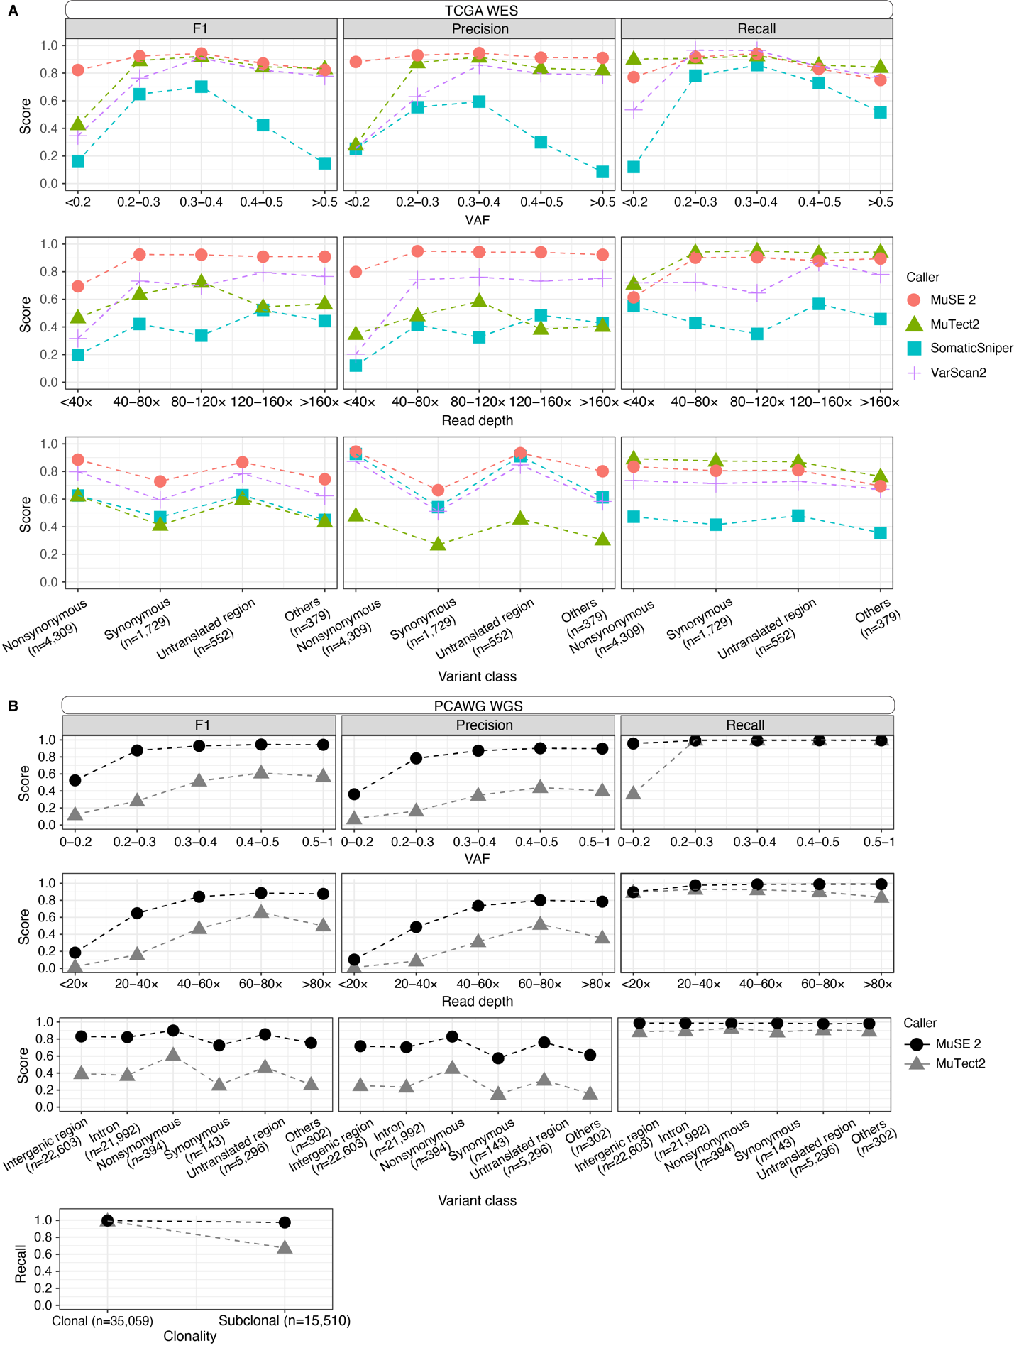Supplemental Fig. S4 | Accuracy benchmarking of MuSE 2 and other callers used for consensus calls within bins of variant allele frequency (VAF, first row) or sequencing read depth (second row), variant classes (third row) for TCGA WES (A) or PCAWG WGS data (B). Comparison of recall between MuSE 2 and MuTect2 within different clonality for PCAWG WGS data is shown in the last row of (B). The calls of each method, and the consensus calls, which are used as a truth set, are pooled from the WES data of 5 patient samples from TCGA (A), or the WGS data of 5 patient samples from PCAWG (B). The number of consensus calls for a SNV category is included in the x-axis labels.

