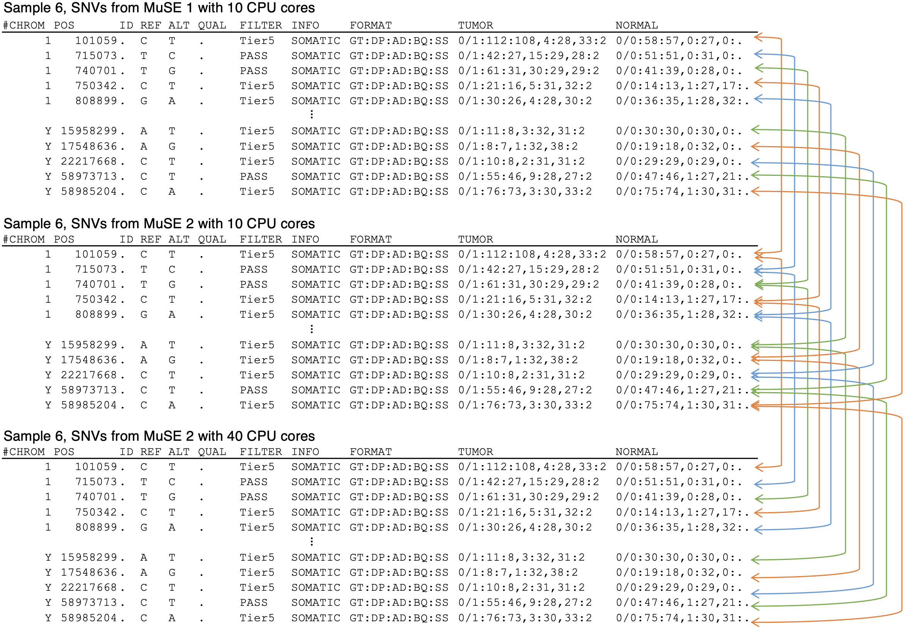
Supplemental Fig. S3 | Illustration of SNV calling results from MuSE 1 and MuSE 2. A total of 10 positions in Sample 6 are shown with identical results from running the two versions with different numbers of CPU cores.

