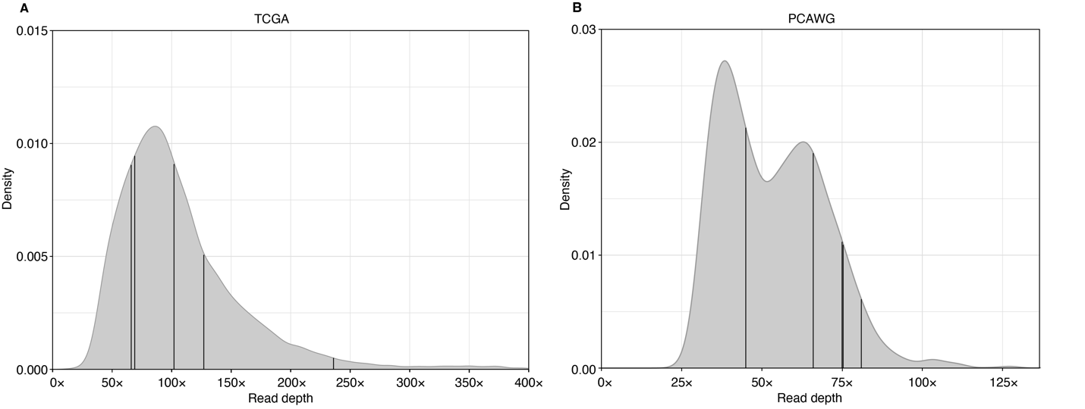
Supplemental Fig. S2 | Distributions of the average read depths of (A) TCGA WES, (B) PCAWG WGS data of tumor samples are shown by the curves. Vertical lines represent the selected tumor samples used in this study.

