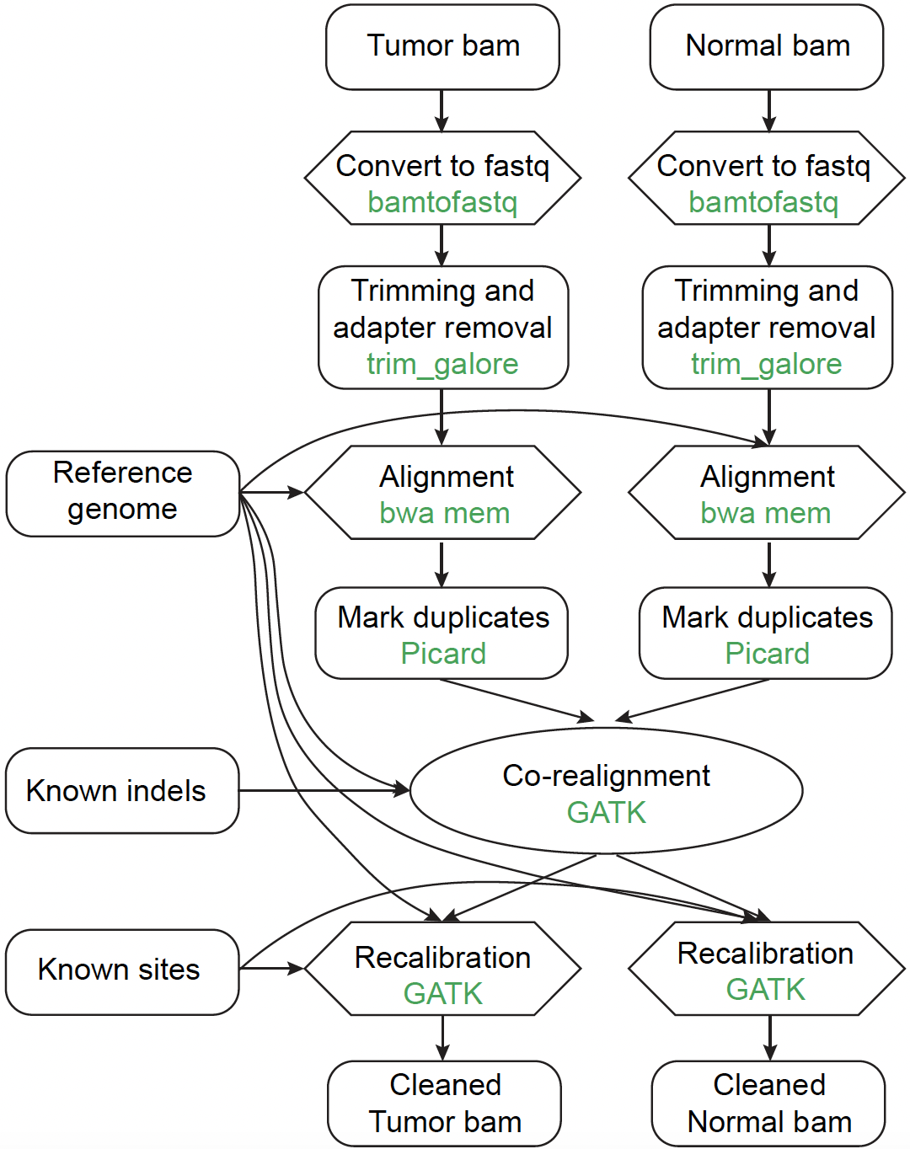
Supplemental Fig. S1 | Flowchart of sequencing read pre-processing before running a mutation calling method in the benchmarking study.

