Supplementary Figures and Tables

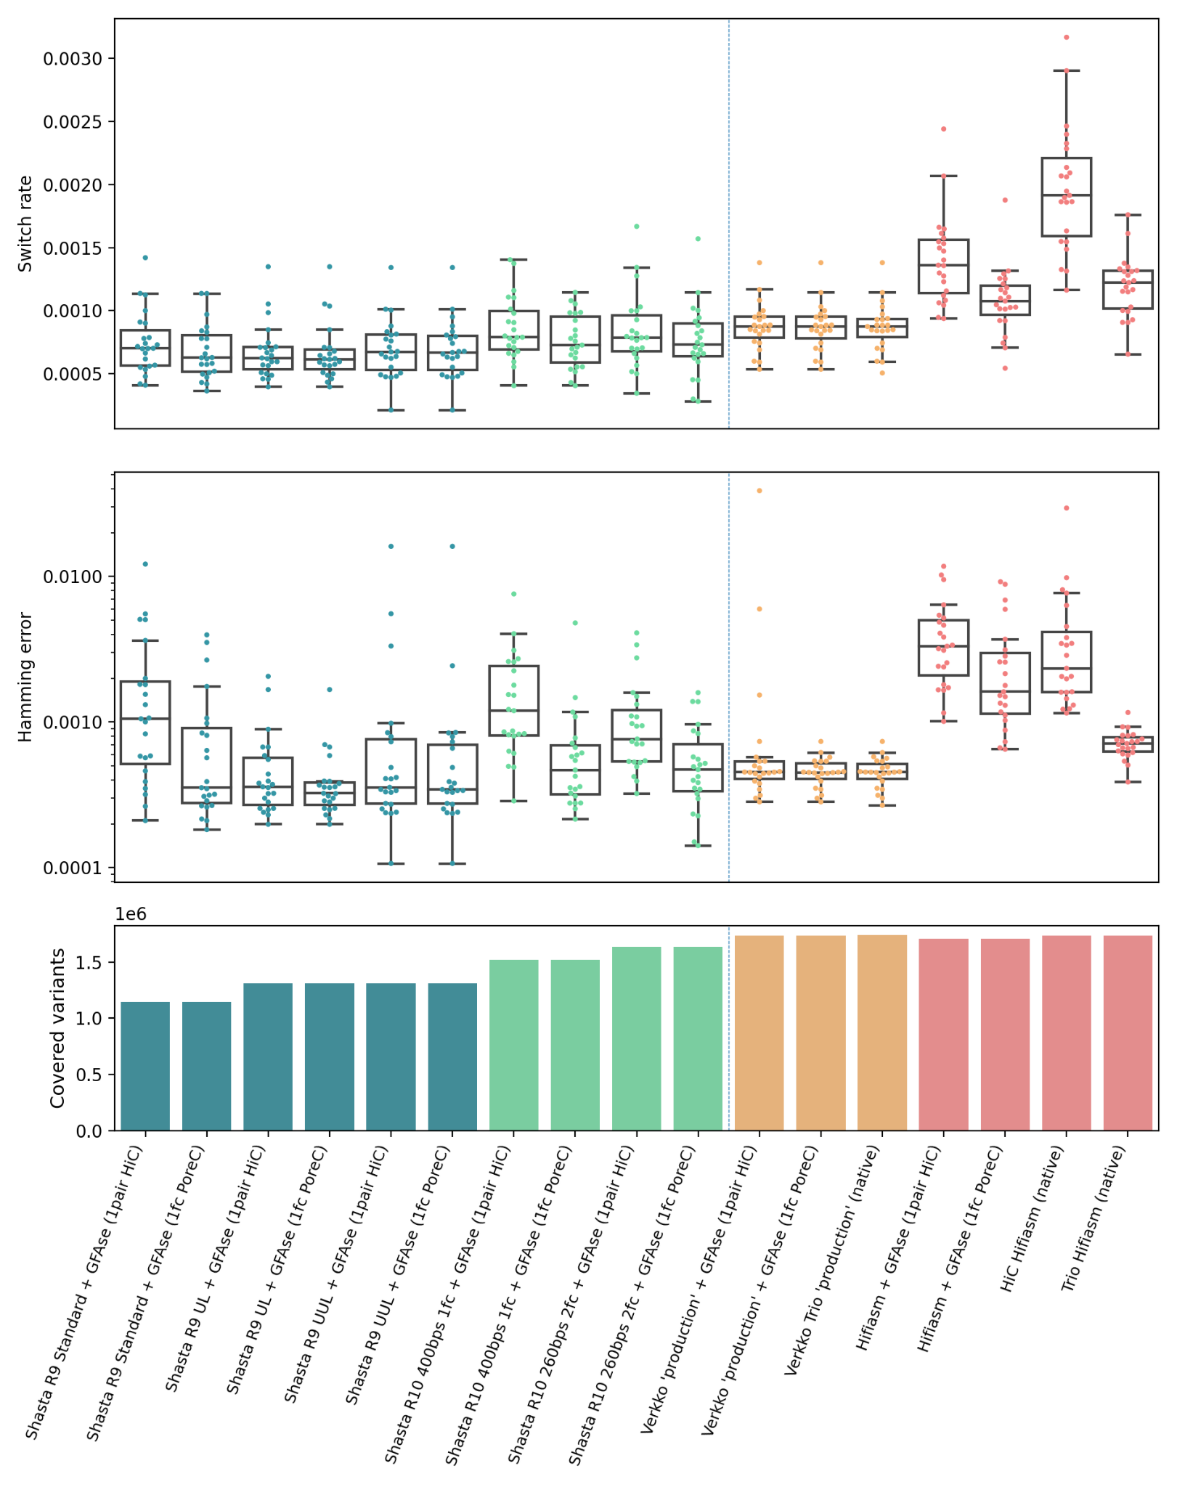
Supplementary Figure 1: Comparison of single pair HiC vs single flowcell PoreC (using GIAB StrandSeqANDTrio v4.2.1). Note that this truth set has fewer variants than that used in the main text.

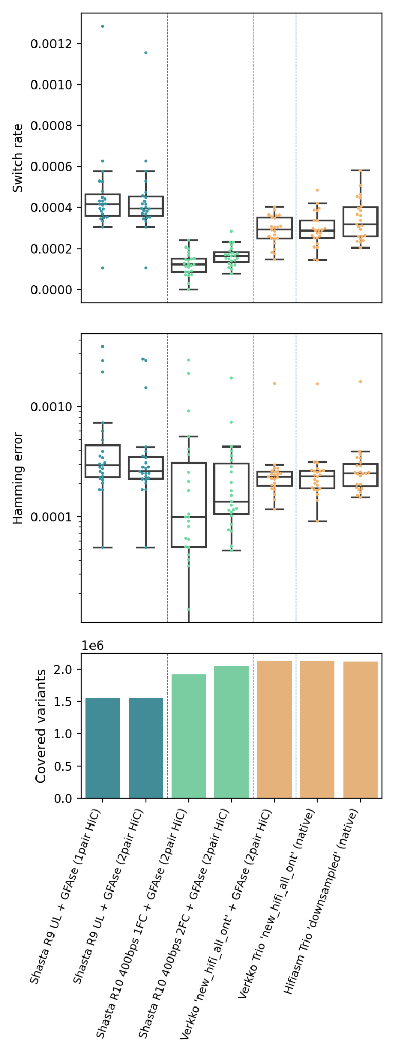
Supplementary Figure 2: HG005 evaluation using StrandSeq integrative phasing as a truth set.

 |  | ONT |  | CCS |  | HiC
Assembler | Label | Coverage | N50 (kbp) | Coverage | N50 (kbp) | Coverage
Shasta v0.10.0 | R9 UL | 57.1 | 111 |  |  | 30
Shasta v0.11.1 | R10 1FC | 34.0 | 32 |  |  | 30
Shasta v0.11.1 | R10 2FC | 57.2 | 34 |  |  | 30
Verkko v1.1 Trio | new_hifi_all_ont | 185.8 | 81.2 | 33.7 | 16.06 | 30

Supplementary Table 1: HG005 assembly input data

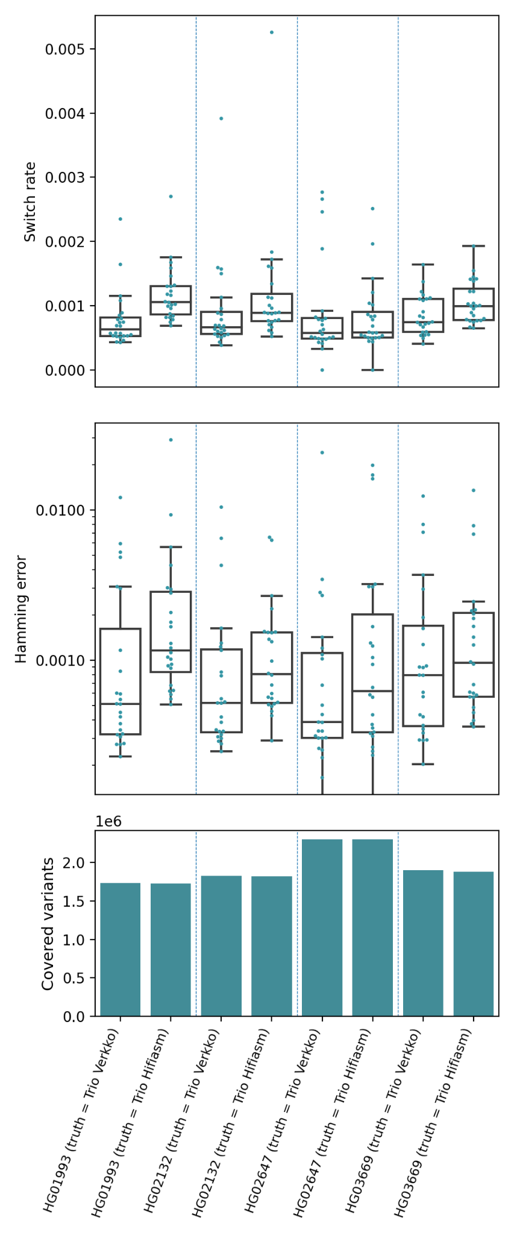
Supplementary Figure 3: HPRC evaluation using Trio Hifiasm and Trio Verkko aligned to HG38 as truth.

assembly | switch_rate | hamming_rate
hapdup_HG002_dual | 0.0418 | 0.24119
shasta_hic_gfase_HG002_standard | 0.11606 | 0.10936
shasta_trio_gfase_HG002_standard | 0.1161 | 0.10727
shasta_hic_gfase_HG002_UL | 0.09252 | 0.07675
shasta_trio_gfase_HG002_UL | 0.09146 | 0.07736
shasta_hic_gfase_HG002_UUL | 0.08471 | 0.07109
shasta_trio_gfase_HG002_UUL | 0.08604 | 0.07304
shasta_hic_gfase_HG002_r10_1fc | 0.05196 | 0.0537
shasta_trio_gfase_HG002_r10_1fc | 0.05061 | 0.04522
shasta_hic_gfase_HG002_r10_ul_4fc | 0.03234 | 0.0241
shasta_trio_gfase_HG002_r10_ul_4fc | 0.03353 | 0.02557
shasta_hic_gfase_HG002_r10_uul_11fc | 0.0336 | 0.0269
shasta_trio_gfase_HG002_r10_uul_11fc | 0.03594 | 0.0285
verkko_gfase_HG002_full_coverage_v1_1 | 0.00639 | 0.00553
verkko_gfase_HG002_production_v1_1 | 0.00621 | 0.00521
verkko_trio_HG002_full_coverage | 0.00846 | 0.00645
verkko_trio_HG002_production | 0.00909 | 0.00639
hifiasm_gfase_HG002_r366 | 0.00643 | 0.0064
hifiasm_hic_HG002_v016 | 0.01105 | 0.01421
hifiasm_trio_HG002_v016 | 0.00822 | 0.00748

Supplementary Table 2: Evaluation of assemblies using yak Trio eval, comparing existing hybrid and trio assemblers to the HiC phased assemblies presented in this paper.
Variant Type | Shasta  Confident  Bed Variants | Verkko  Confident  Bed Variants | Shared  Shasta  Loci | Shared  Verkko  Loci | Shasta  Only | Verkko  Only | Shasta  Indel | Shasta  Indel  Rate | Verkko  Indel | Verkko  Indel  Rate | WhatsHap  Covered Variants | WhatsHap Switch  Rate | Whatshap Hamming  Rate
0|1 | 1282348 | 1397762 | 1257356 | 1262499 | 24985 | 135255
1|0 | 1283631 | 1399130 | 1258035 | 1263396 | 25593 | 135729
1|2 | 42310 | 67573 | 38106 | 32437 | 4204 | 35136
2|1 | 41251 | 67426 | 37137 | 31605 | 4114 | 35820
Total Hets | 2649540 | 2931891 | 2590634 | 2589937 | 58896 | 341940 | 34364 | 0.01297 | 256474 | 0.0869 | 2,483,238 | 0.000431 | 0.000347
Total Homs | 2046423 | 1749922 | 1665743 | 1666205 | 380680 | 83717 | 342224 | 0.16723 | 30621 | 0.0172

Supplementary Table 3: Investigation of Dipcall variants for the shasta_trio_gfase_HG002_r10_ul_4fc and verkko_trio_HG002_production assemblies. The assemblies share similar numbers of heterozygous and homozygous variant loci. However, compared to Shasta Dipcall variants the Verkko assembly has more variants, five times more assembly specific heterozygous variants, and seven times as many assembly specific heterozygous Indel variants. While the Shasta assembly has 4.5 times as many assembly specific homozygous variants, and 11 times as many assembly specific homozygous Indel variants compared to Verkko.
We ran WhatsHap Compare with the Verkko assembly as the truth set and Shasta as the query, the last three columns in the table. WhatsHap reports a blockwise hamming rate of 0.00035 for the 2.48 million Verkko heterozygous variants that agree in genotype with heterozygous Shasta Dipcall variants at the same loci.

a) 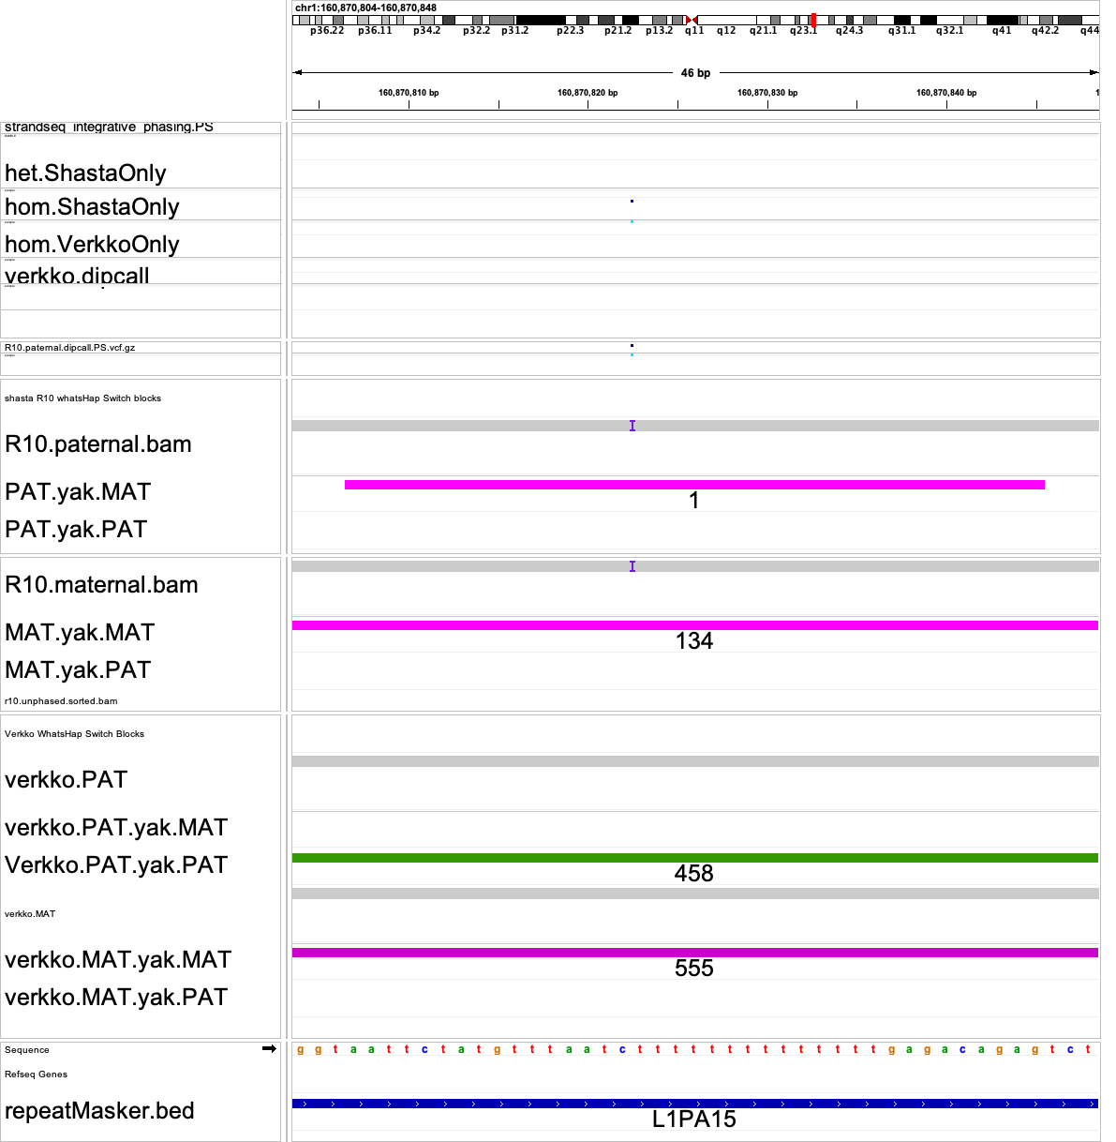
b)
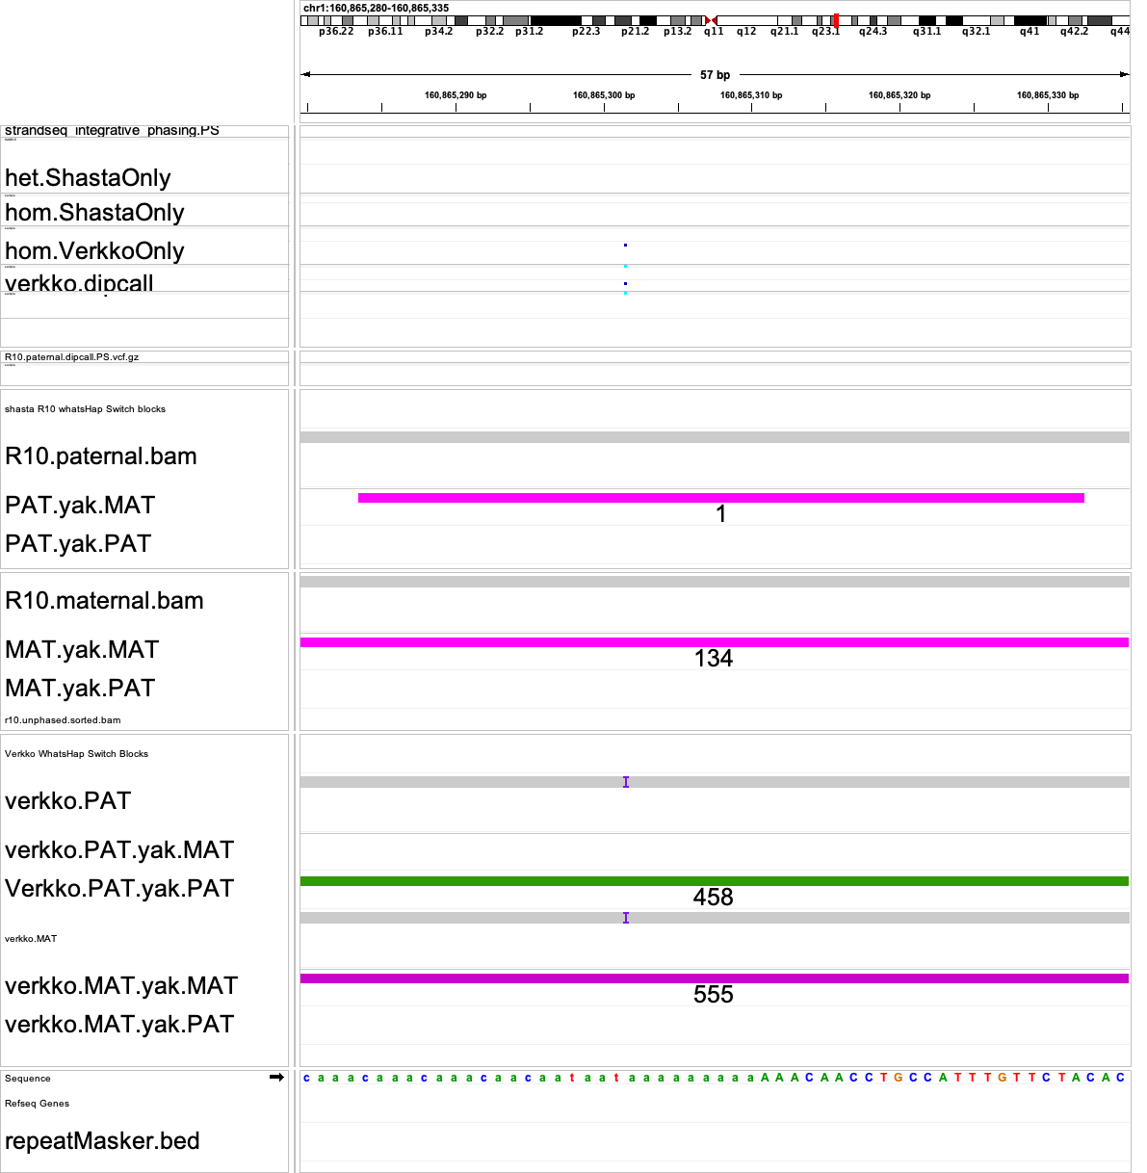c)
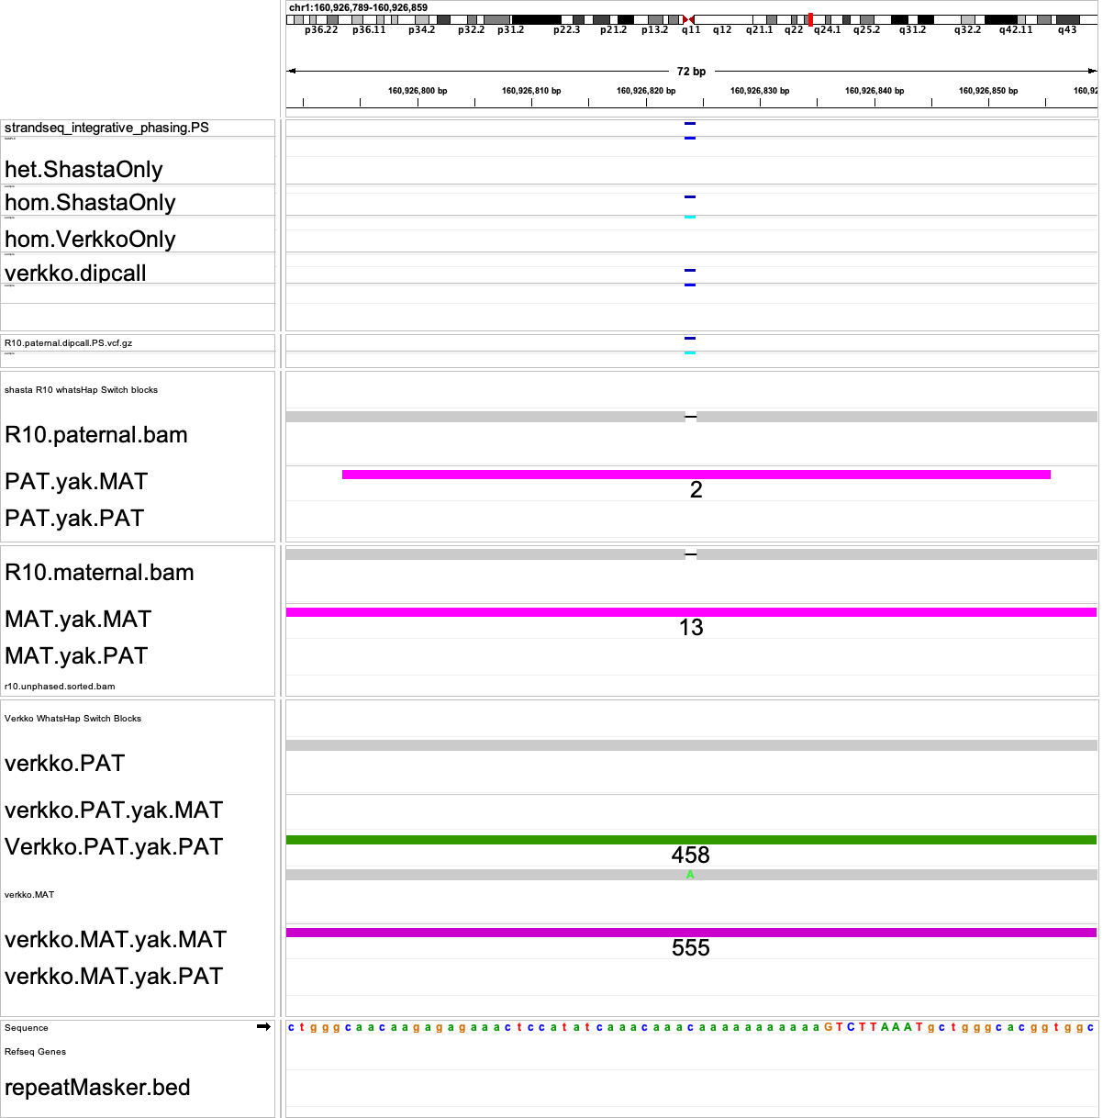
d)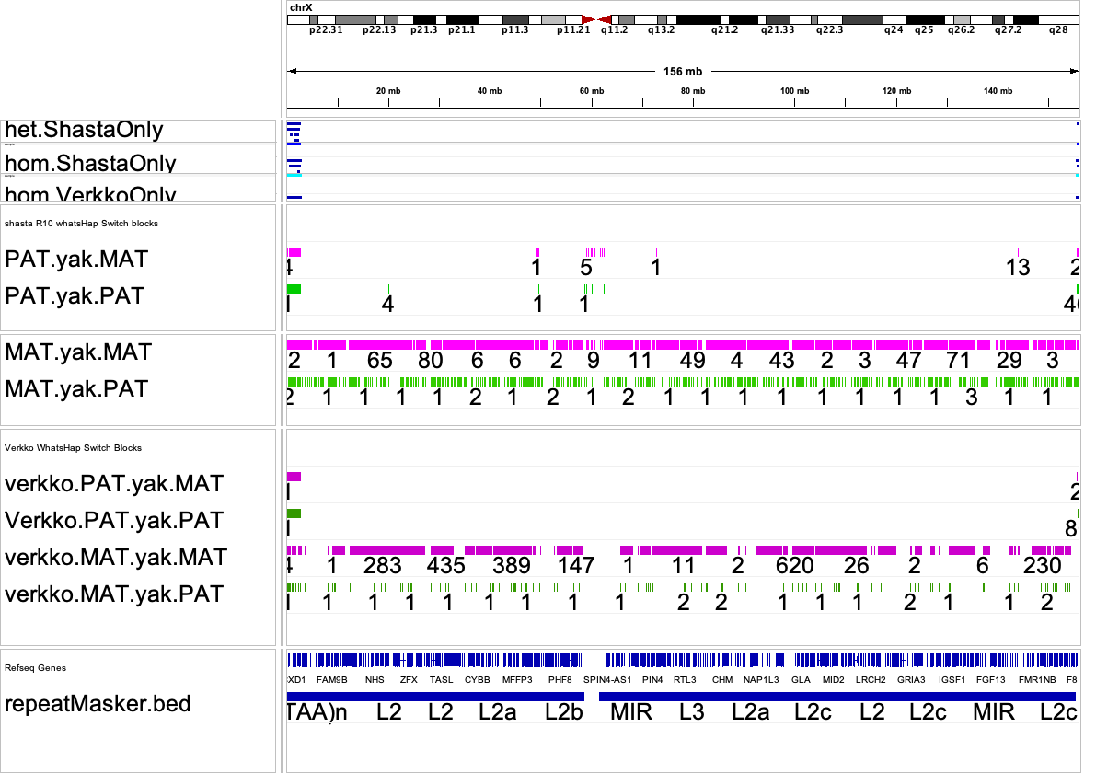
Supplementary Figure 4: IGV screenshots of k-mer block locations where homopolymer Indel variants are matching with parental illumina k-mers, as reported by yak on and off target k-mer blocks. Shasta Assembly is shasta_trio_gfase_HG002_r10_ul_4fc, Verkko Assembly is verkko_trio_HG002_production. Magenta bed tracks are maternal yak k-mer blocks labeled with k-mer counts per block. Green bed tracks are paternal k-mer blocks with their respective k-mer counts labeled. a. Shasta specific homozygous “T” insertion in a homopolymer region creates a single maternal k-mer yak switch block in the paternal assembly. b. Verkko homozygous “A” insertion in a homopolymer region creates a single maternal k-mer yak switch block in the paternal assembly. c. A single maternal k-mer yak switch block in the paternal assembly is located at a truth variant. However, the genotypes between assemblies don’t match ( homozygous “CA” deletion in Shasta, C-A SNP in Verkko ) and as such wouldn’t be assessed by WhatsHap. d. Chromosome X illustrates a thicker lawn of off target green paternal k-mer matches in the Shasta yak blocks compared to the Verkko paternal yak k-mer blocks.

