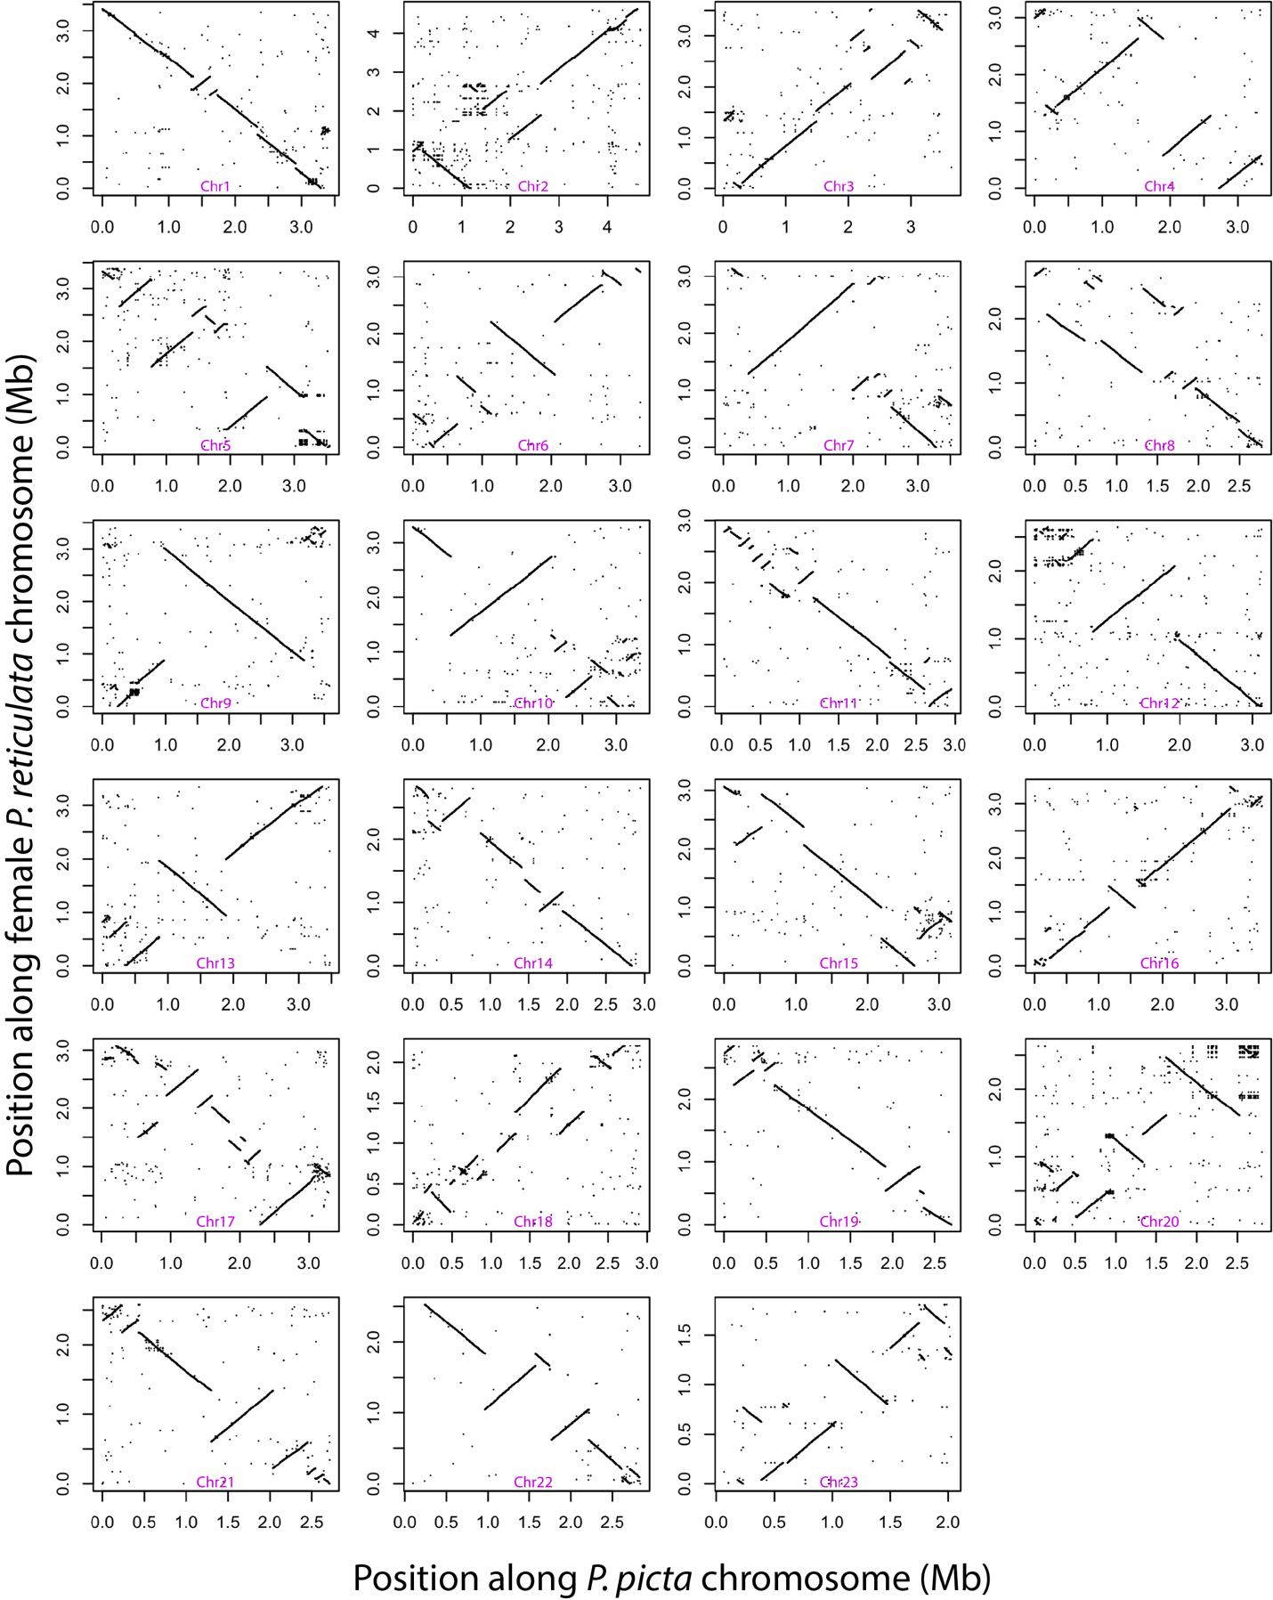

Supplemental Figure 1. Whole genome alignment between the P. picta female and the P. reticulata female genome assemblies. Dot-plots depicting synteny between P. picta and P. reticulata female genomes. Whole genome alignments were conducted using satusuma2 with default settings (window = 4096 bp). Each box depicts an individual chromosome. Chromosome names based on synteny with the P. reticulata genome. The X chromosome is Chr12.

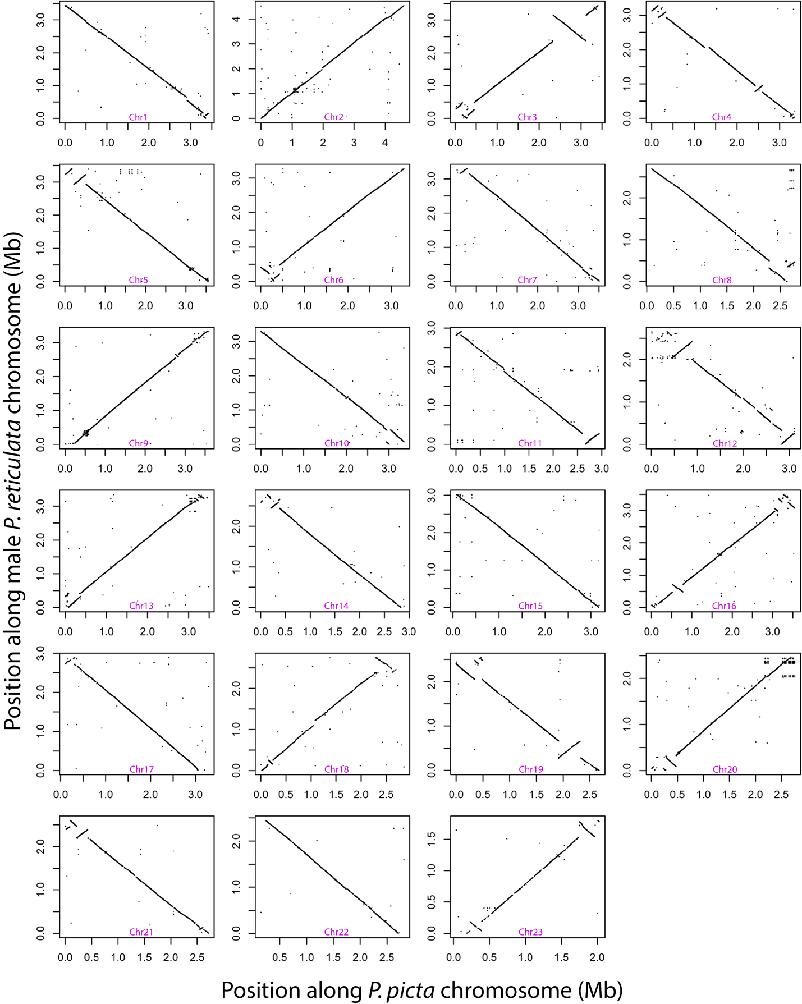
Supplemental Figure 2. Whole genome alignment between the P. picta female and the P. reticulata male genome assemblies. Dot-plots depicting synteny between P. picta female and P. reticulata male genome. Whole genome alignments were conducted using satusuma2 with default settings (window = 4096 bp). Each box depicts an individual chromosome. Chromosome names based on synteny with the P. reticulata genome. The X chromosome is Chr12.

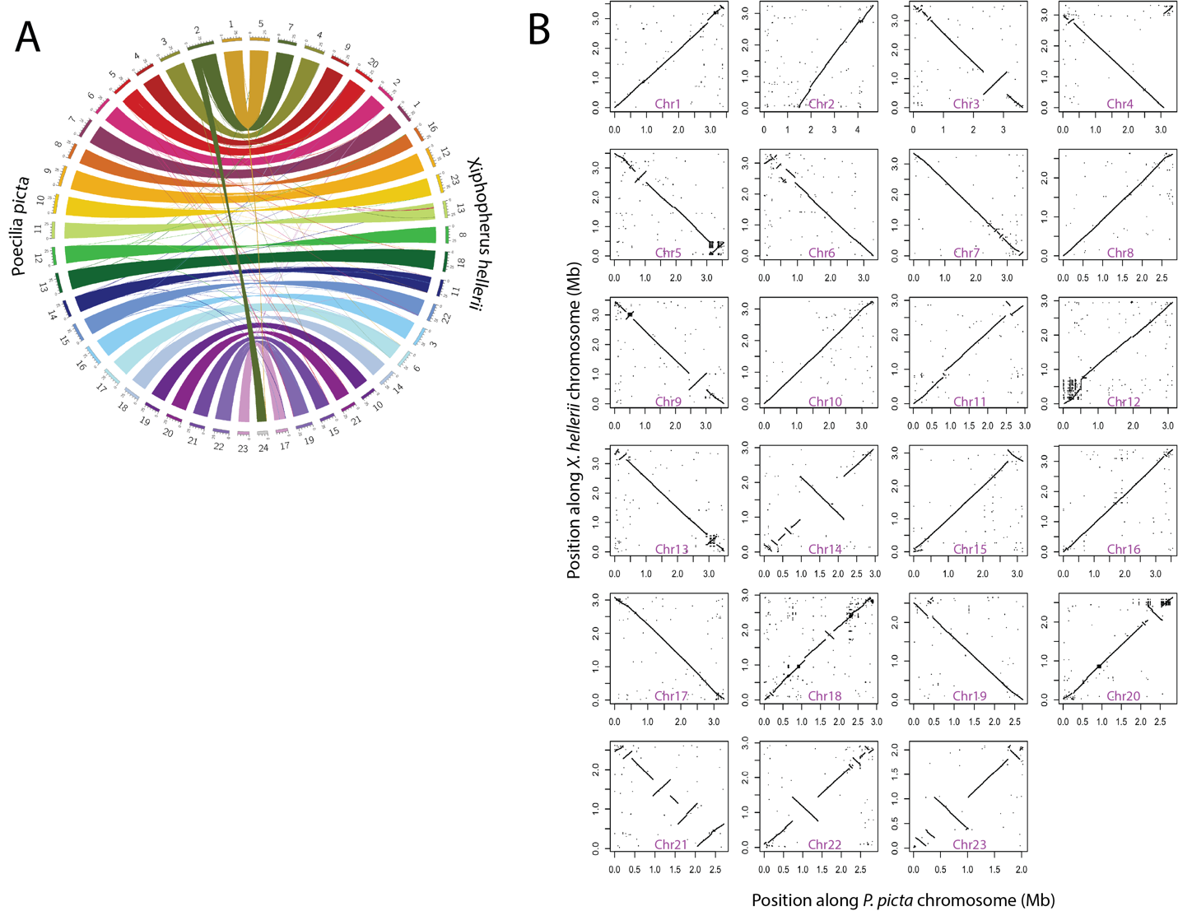

Supplemental Figure3: Sequence comparison between our P. picta genome and the X. hellerii genome. A) Sequence synteny between the female P. picta and the female X. helleri genomes presented as a Circos plot. Chromosomes are labeled 1-23 and are differentiated by colour around the outer ring with P. picta chromosomes on the left and X. helleri chromosomes on the right (numbered 1-24). Synteny alignments were conducted using Satusma2 with default settings (window = 4096 bp). The colour of the connecting lines indicates the chromosomal origin of the sequence from the P. picta genome. B) Synteny dot-plots between P. picta and X. helleri chromosomes. Each plot is a separate chromosome with the P. picta chromosome indicated on each plot. The P. picta X chromosome is Chr12.

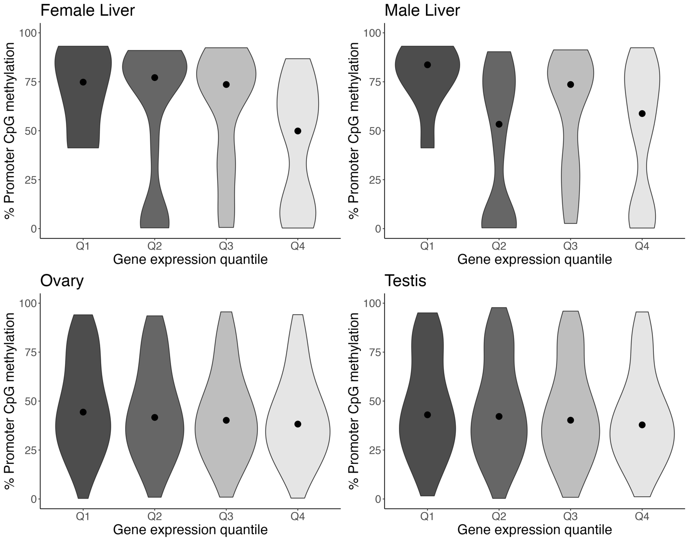
Supplemental Figure 4. Association of DNA methylation and genes ranked by gene expression level in P. picta. Violin plots depticting DNA methylation values of promoter regions for genes in different expression quantiles (Q1 < Q2 < Q3 < Q4). In somatic tissue, genes with high levels of DNA methylation in their promoter regions have lower expression while genes with lower levels of DNA methylation in their promoter regions have higher expression. There is no clear relationship between promoter DNA methylation and gene expression in gonad tissues.

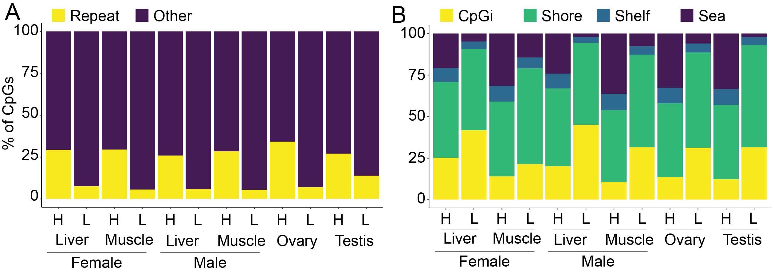

Supplemental Figure 5: Distribution of high and low methylation in the genome.
Panels A and B depict the distribution of highly methylated (>90%, H) and lowly methylated (<10%, L) CpG loci in relation to repetitive elements (A) or CpG island features (B).

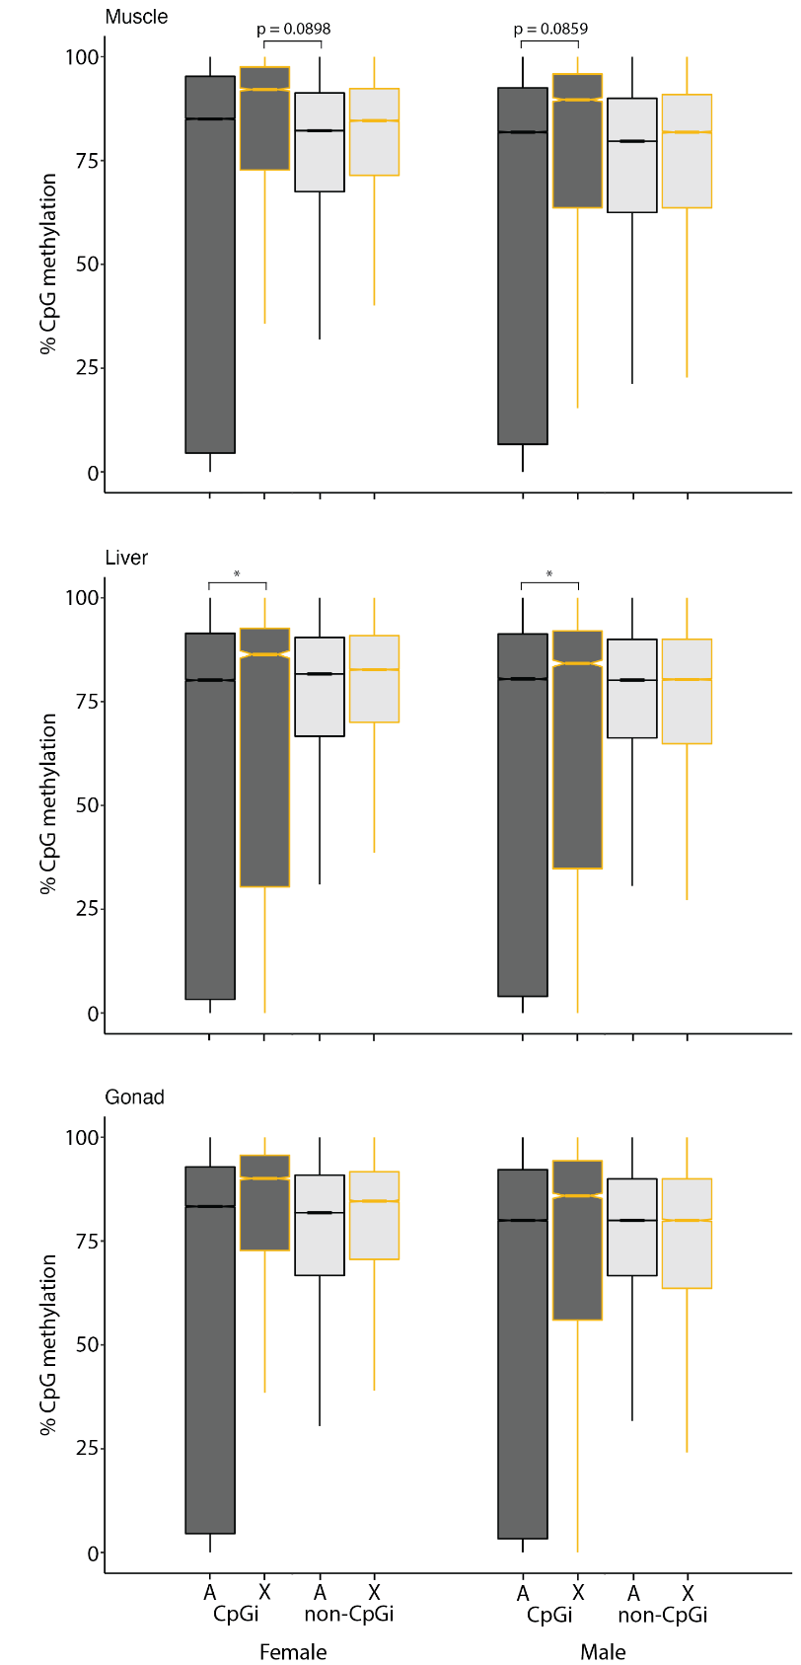

Supplemental Figure 6. CpG loci located in islands are more highly methylated on the X chromosome compared to other CpG loci in liver. P. picta DNA methylation values of individual CpG located in CpG islands (dark grey) or outside of CpG islands (light grey) on the sex chromosome (orange outline) or autosomes (black outline). Asterix (*) denotes significant
difference in median value (Dunn’s post-hoc FDR adjust p-value < 0.05).

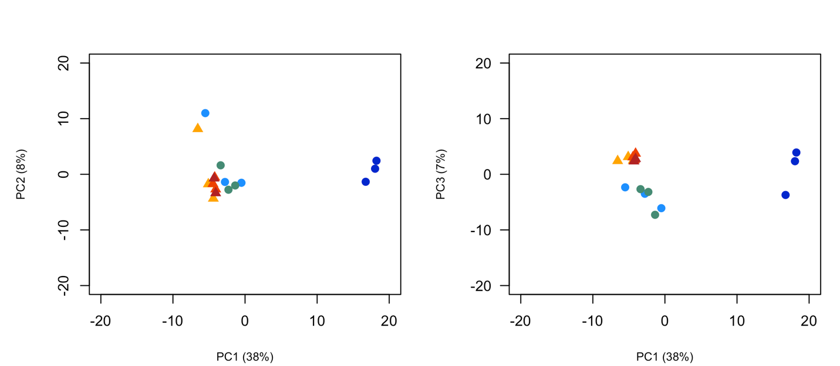
Supplemental Figure 7. Testis is a DNA methylation outlier. Principle component (PC) analysis of P. picta DNA methylation data calculated from whole genome bisulfite sequencing data of testis (dark blue), ovary (dark red), male muscle (light blue), female muscle (yellow), male liver (green), and female liver (orange) tissue. Circles represent samples from male tissue. Triangles represent samples from female tissue. The left plot shows PCs 1 vs 2. The plot on the right shows PCs 1 vs 3. PC analysis was performed on methylation data for individual CpG loci and only loci that were covered by a minimum read depth of 10 reads in each tissue were included in the analysis.

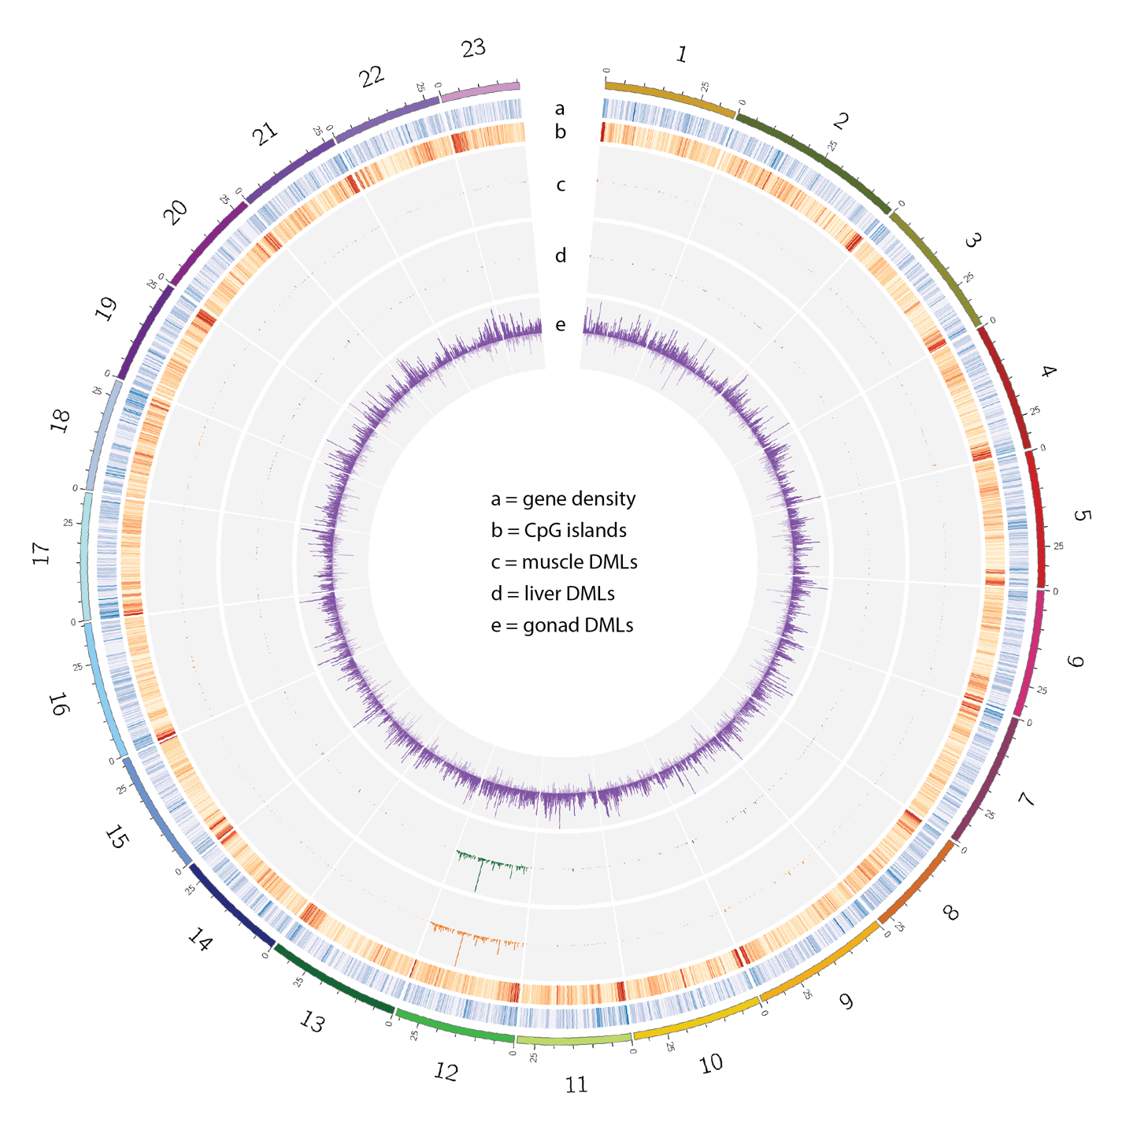
Supplemental Figure 8. The distribution of differentially methylated loci (DMLs) in the P. picta genome. Chromosome 12, the X Chromosome, is hypomethylated in P. picta male somatic tissues. Circos plot depicting sex-specific DNA methylation patterns in P. picta. Outer ring indicates the chromosome number and position in Mb. Chromosome colours are the same as in Figure 1. Tracks a & b are heatmaps depicting gene (blue) and CpG island (Red) densities respectively, in 100kb bins. Darker colors in the heatmap depict higher counts. Tracks c-e depict histograms of the number of differentially methylated CpG loci (DMLs) in 100kb bins in muscle (orange), liver (green), and gonad (purple) tissues respectively. Histogram bars extending outward represent DMLs that are hypomethylated in males while bars that extend towards the center of the plot represent DMLs that are hypomethylated in females.
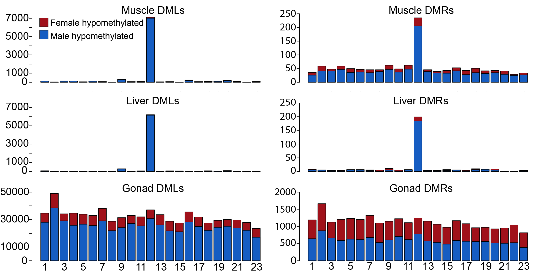

Supplemental Figure 9. The X chromosome is hypomethylated in P. picta males. Chromosomal distribution of differentially methylated loci (DMLs) and differentially methylated regions (DMRs) in muscle, liver, and gonad tissue presented as stacked bar plots where the height is the total number of DMLs or DMRs identified on an individual chromosome. Red shaded regions are DMLs or DMRs that are hypomethylated in female tissue. Blue shaded regions are DMLS or DMRs that are hypomethylated in male tissue.

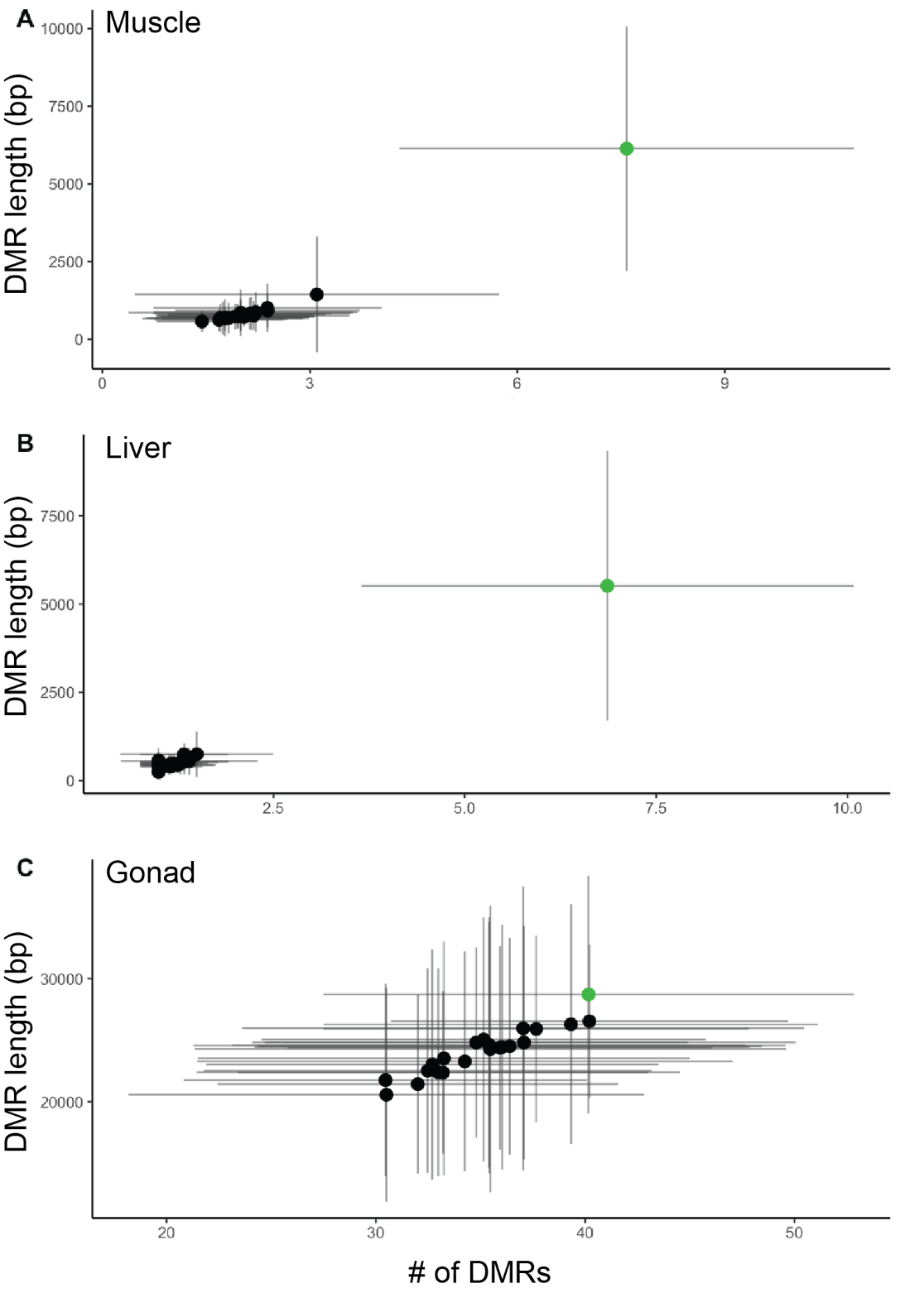
Supplemental Figure 10. Sex-biased DMRS are enriched on the P. picta sex chromosome in somatic tissue. Mean length and count of sex-biased DMRs in 1Mb sliding windows in muscle (A), liver (B), and gonad (C) tissue. The sex chromosome is highlighted in green. Error bars represent standard deviation.

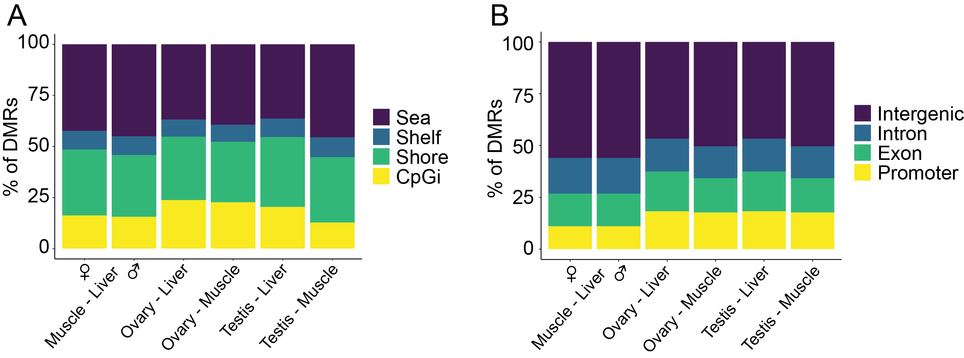

Supplemental Figure 11. Genomic distribution of sex-biased differentially methylated regions (DMRs). Panels A and B depict the distribution of DMRs in relation CpG island features (A) or genic features (B). The majority of DMRs are located in CpG island shores and open sea and in intergenic regions.

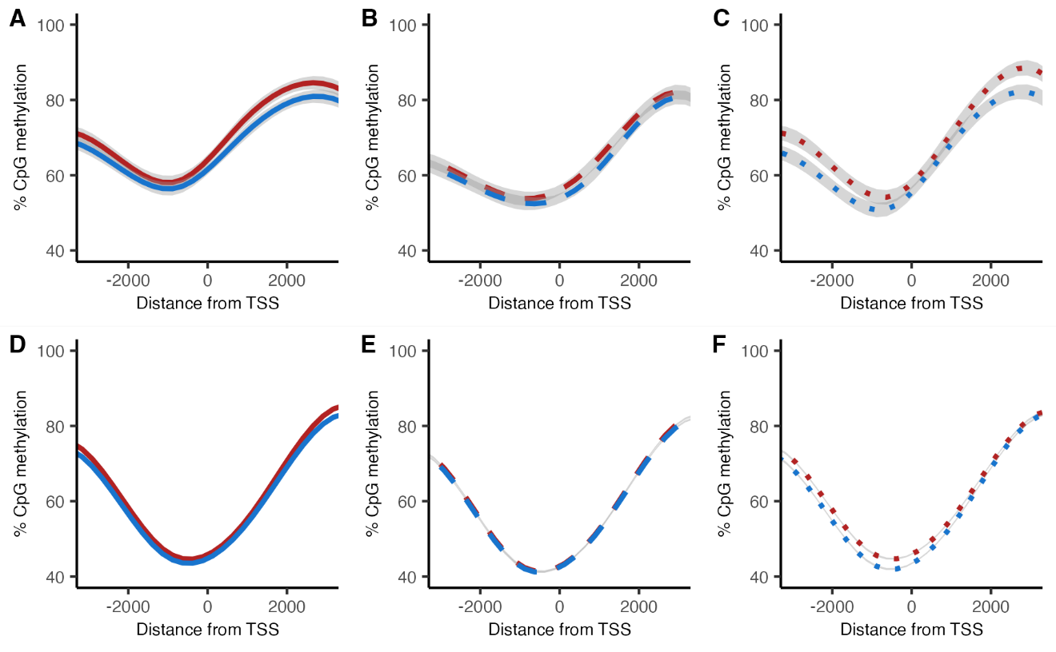

Supplemental Figure 12. CpG islands in gene promoters on the X do not exhibit sex-biased differential methylation. DNA methylation values of CpG loci in islands near transcription start sites (TSS) for genes on the X chromosome (A-C) and autosomes (D-F) in male (blue) and female (red) muscle (A/D), liver (B/E), and gonad tissue (C/F). Negative values on the x-axis are loci upstream (5’) of the TSS and positive values are downstream (3’) of the TSS. Shaded grey regions denote 95% confidence intervals.

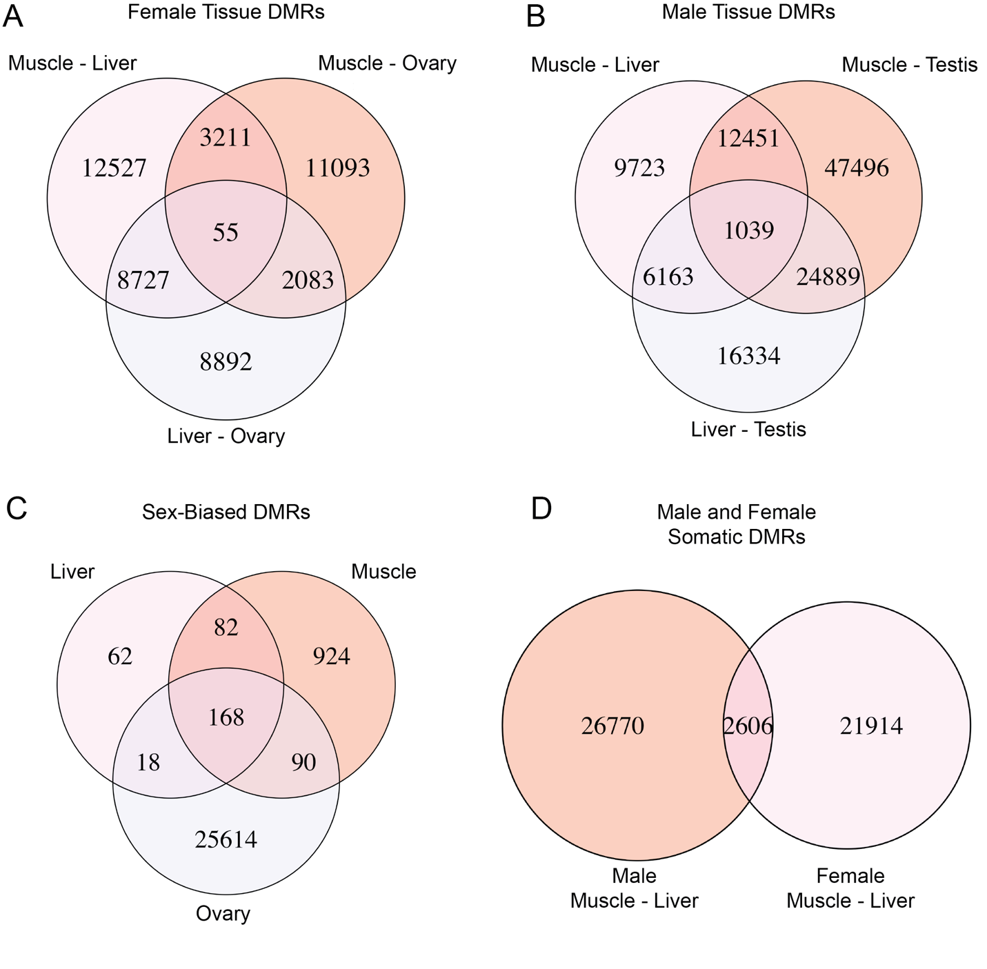
Supplemental Figure 13. Venn diagrams depicting similarities in tissue specific DMRs. A. Overlapping DMR regions between female tissues. B. Overlapping DMRs between male tissues. C. Overlapping sex-biased DMRs in different tissues. D. Overlapping DMRs between male and female somatic tissues.

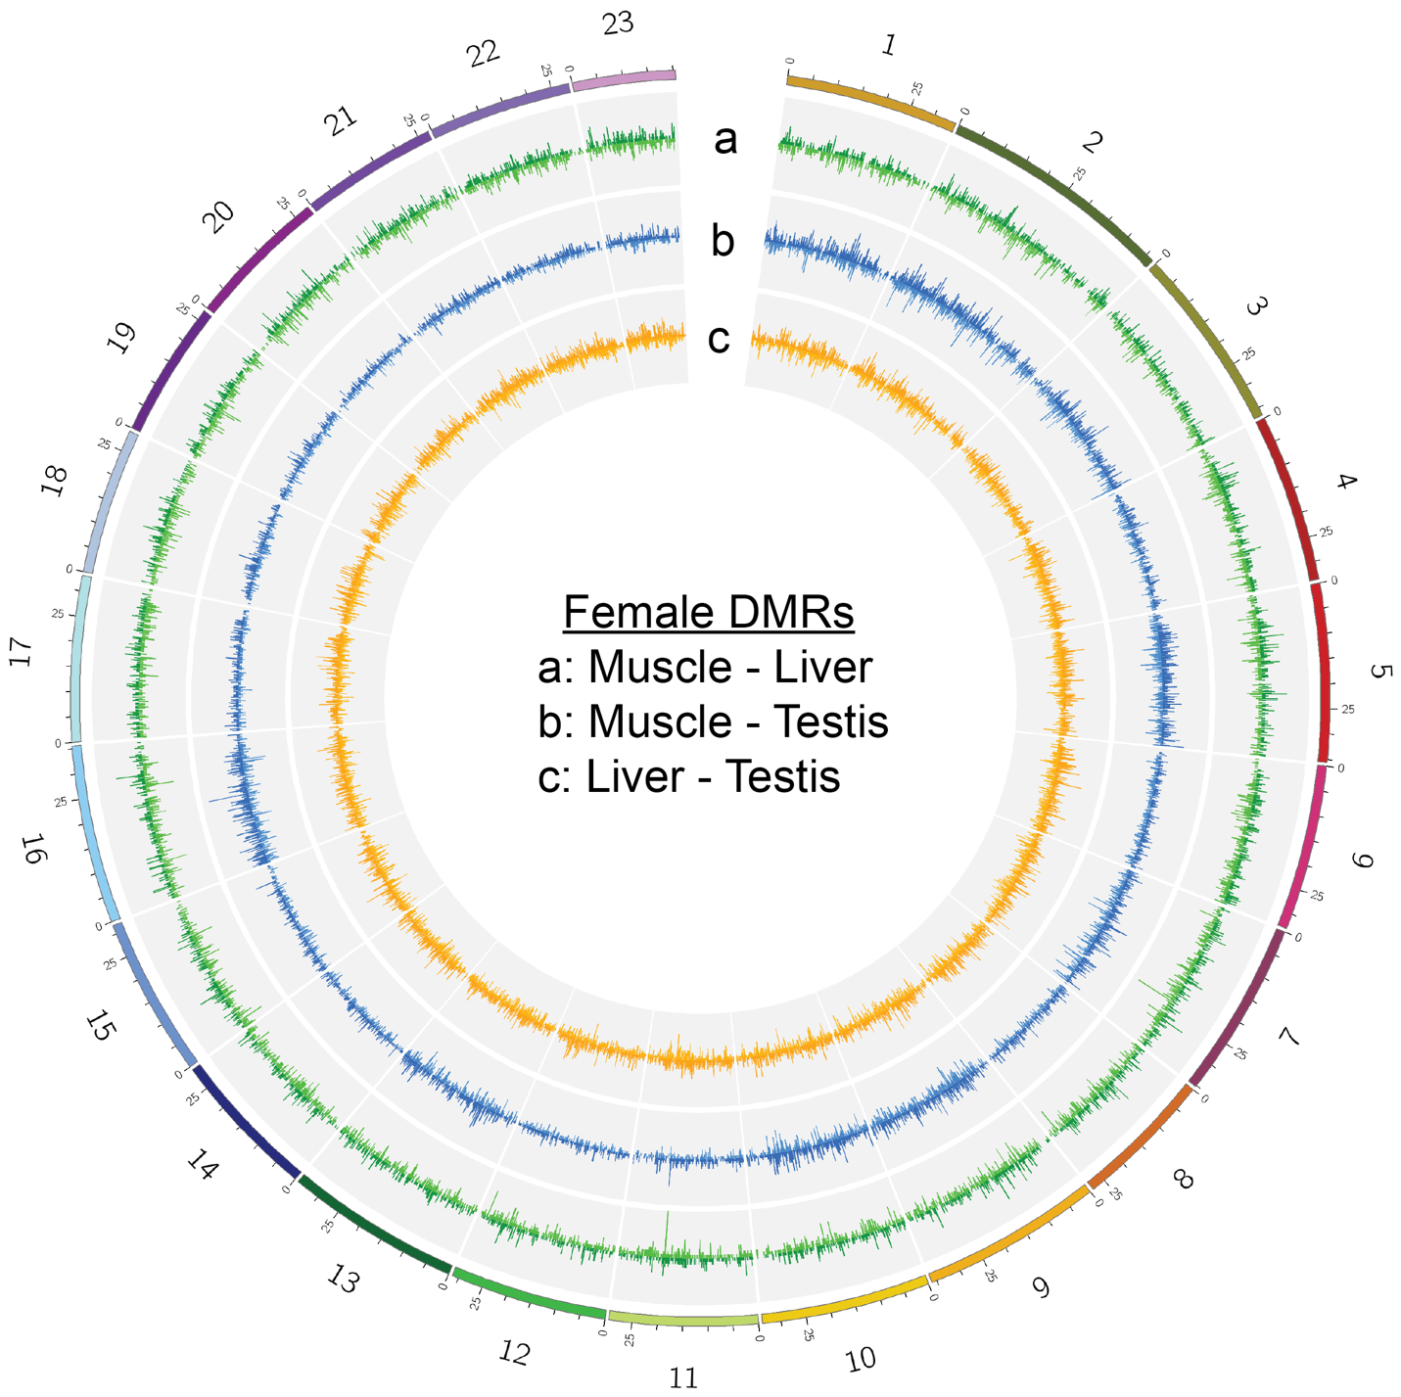

Supplemental Figure 14: The distribtuion of tissue specific differentially methylated regions (DMRs) in female P. picta. Circos plot depicting tissue-specific DNA methylation patterns in P. picta females. Chromosome colours are the same as in Figure 1. Tracks a-c depict histograms of the number of DMRs in 100kb bins in between muscle and liver (green), muscle and ovary (blue), and liver and ovary (orange) tissues respectively. Histogram bars extending outward represent DMRs that are hypomethylated in the tissue listed first in the comparison and bars that extend toward the center are DMRs that are hypomethylated in the second tissue listed in the comparison.

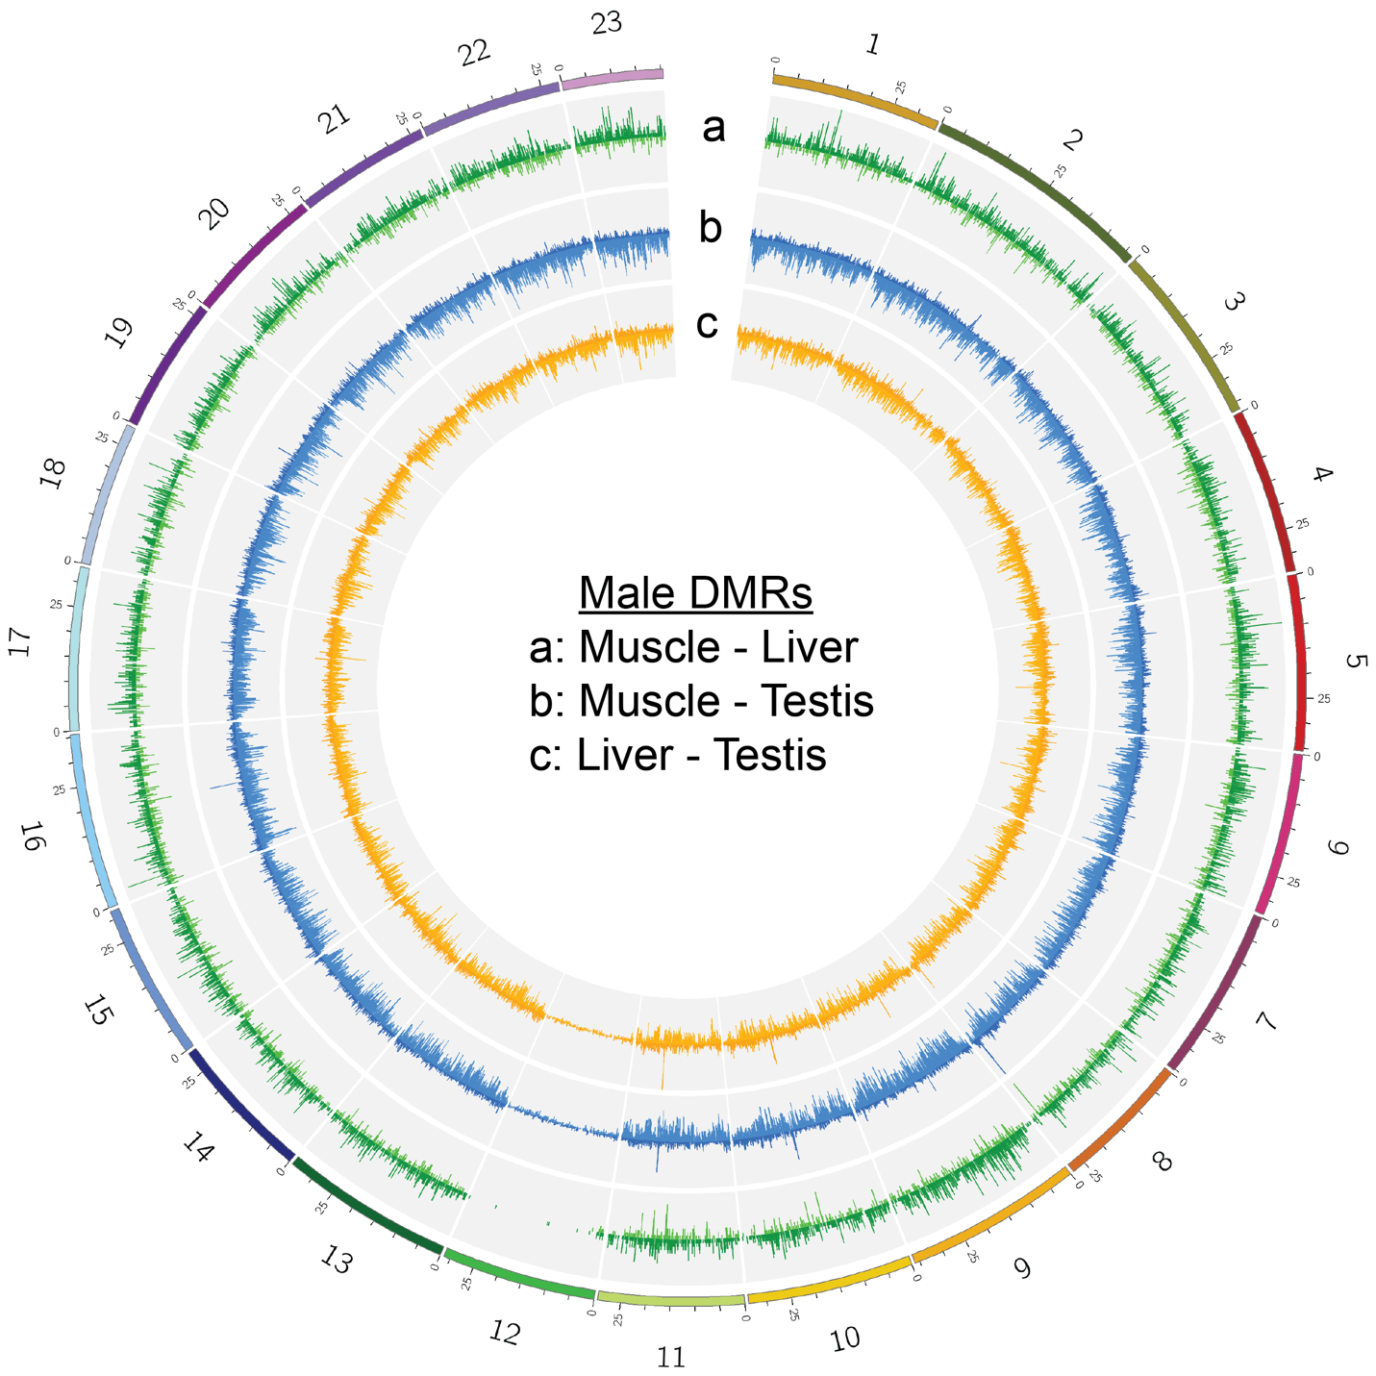

Supplemental Figure 15: The distribtuion of tissue specific differentially methylated regions (DMRs) in Male P. picta. Circos plot depicting tissue-specific DNA methylation patterns in P. picta males. Chromosome colours are the same as in Figure 1. Tracks a-c depict histograms of the number of DMRs in 100kb bins in between muscle and liver (green), muscle and testis (blue), and liver and testis (orange) tissues respectively. Histogram bars extending outward represent DMRs that are hypomethylated in the tissue listed first in the comparison and bars that extend toward the center are DMRs that are hypomethylated in the second tissue listed in the comparison.

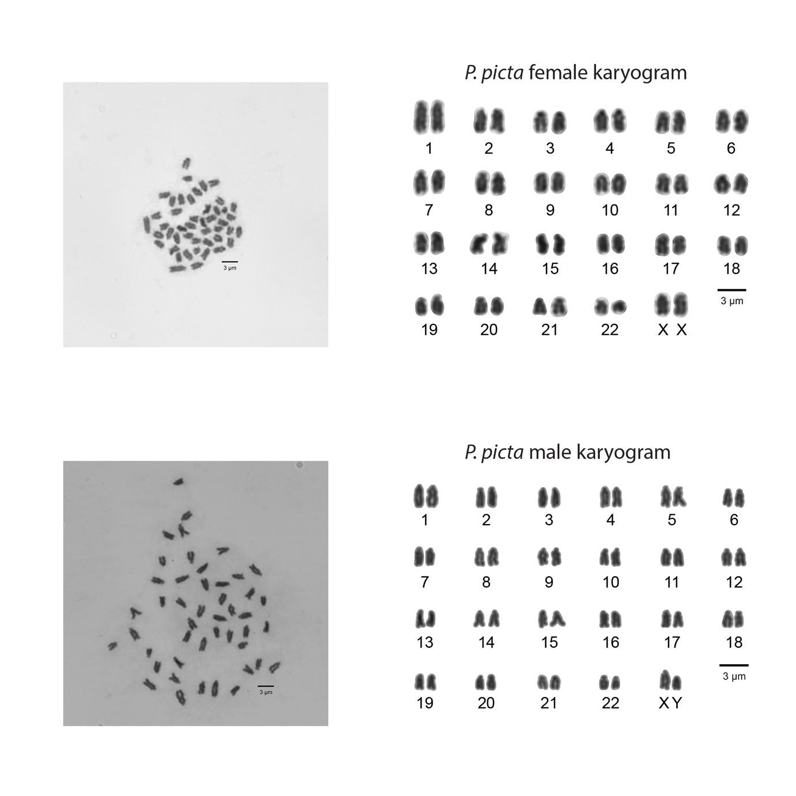
Supplemental Figure 16. Male and female X Chromosome appear similar in size. Karyograms from male and female P. picta chromosome spreads from our laboratory population originally sourced from Suriname. The Y Chromsome appears degenerated compared to the X, while the X Chromsomes in males and females are similar in size at this resolution. The left panel shows the chromosome spreads that the karyograms were sourced from.

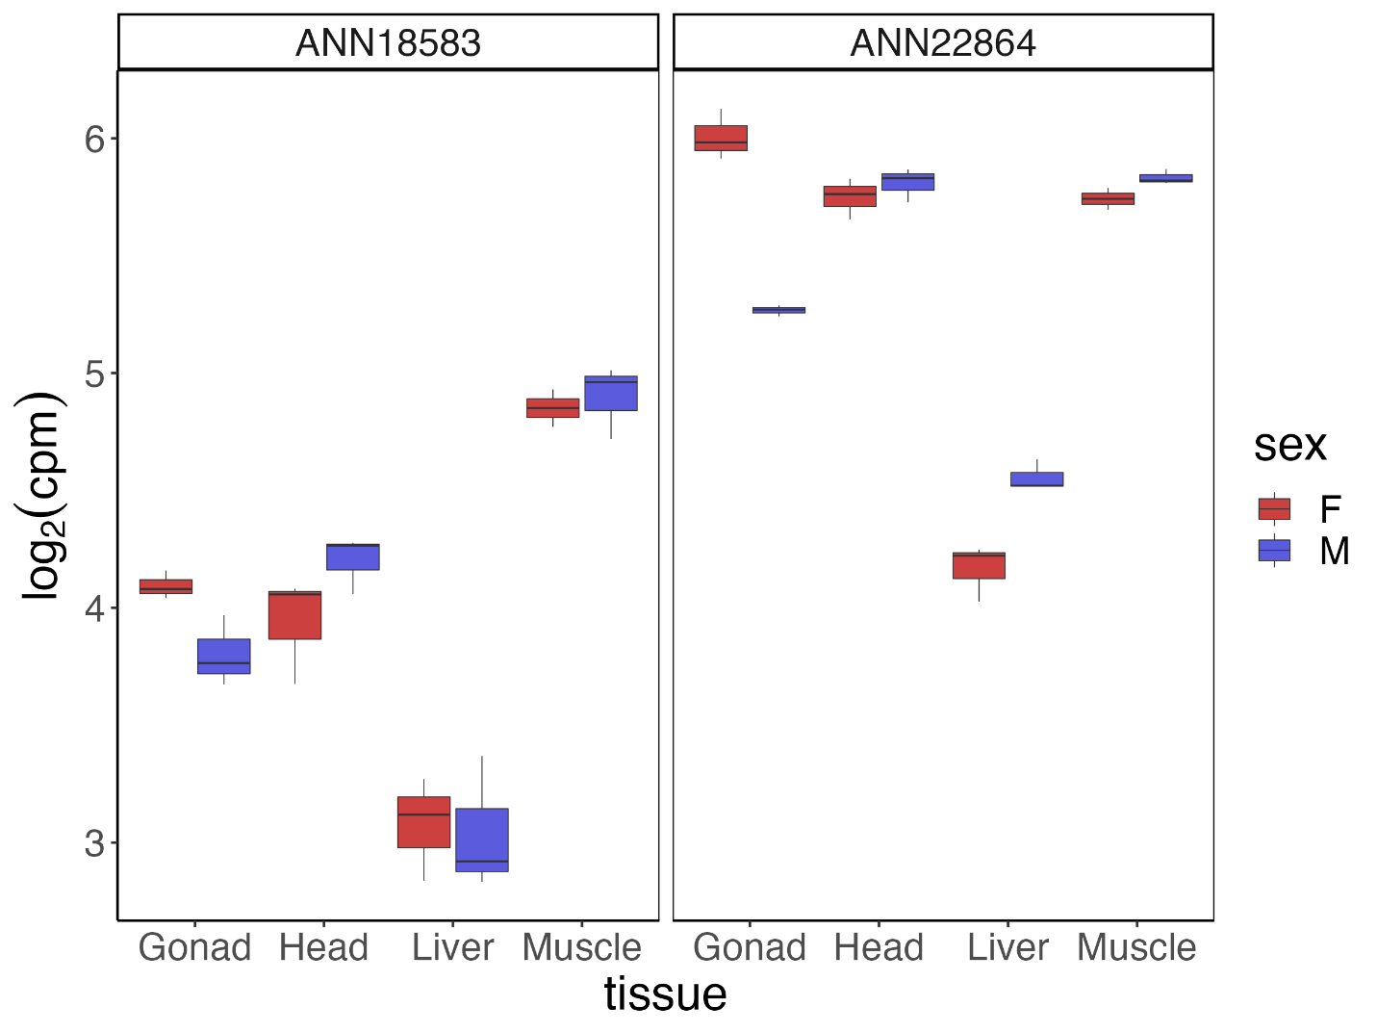

Supplemental Figure 17. YY1 orthologs are ubiquitously expressed in head, muscle, liver, and gonad tissues. Gene expression values for two YY1 orthologs (ANN18583 and ANN22864) in the P. picta genome for female (F, red), and male (M, blue) gonad, head, liver, and muscle tissue. Data is presented as log₂ counts per million normalized for library size as box and whisker plots. The horizontal line of the box and whisker plot is the median, the box denotes the 25th and 75th percentile, and “whiskers” are 1.5 times the interquartile range.

Supplemental Figure 18 The DNA binding domain of the YY1 protein is conserved between mammals and fishes. Alignment of amino acid sequences from human, mouse, pig, stickleback, medaka, and two isoforms from P. picta. Coloured amino acid residues depict mismatches between sequences. Purple ZF blocks indicate the four C2H2-type zinc finger domains of the YY1 DNA binding domain.

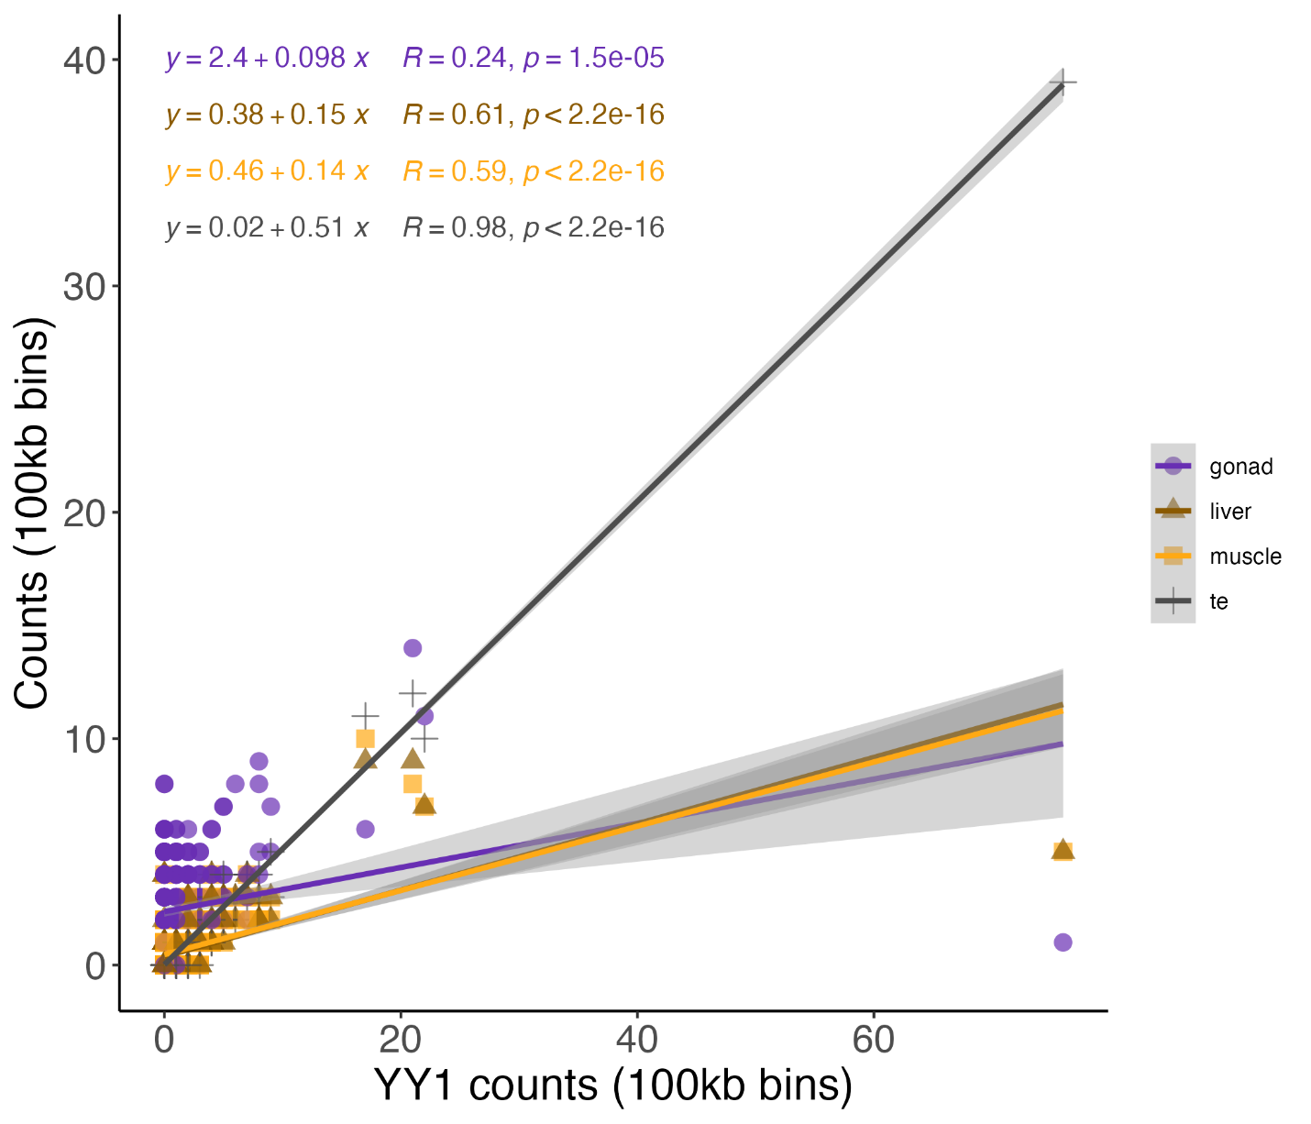

Supplemental Figure 19: The abundance of YY1 DNA binding motifs is significantly correlated with TE abundance and the abundance of sex-biased DMRs in muscle, liver, and gonad tissue. Scatter plot depicting the total number of YY1 motifs in 100kb non-overlapping bins on the sex chromosome of P. picta comapred to the number of TEs or sex-biased DMRs in gonad, liver, and muscle tissue. Each point corresponds to an individual 100kb bin. Lines represent the linear regression of the designated comparison. Colors of the regression lines, equations, and summary statistics are consistent with the color of the points with purple = gonad DMRs, brown = liver DMRs, orange = muscle DMRs, and grey = TEs. Shaded grey regions represent the standard error of the regression.

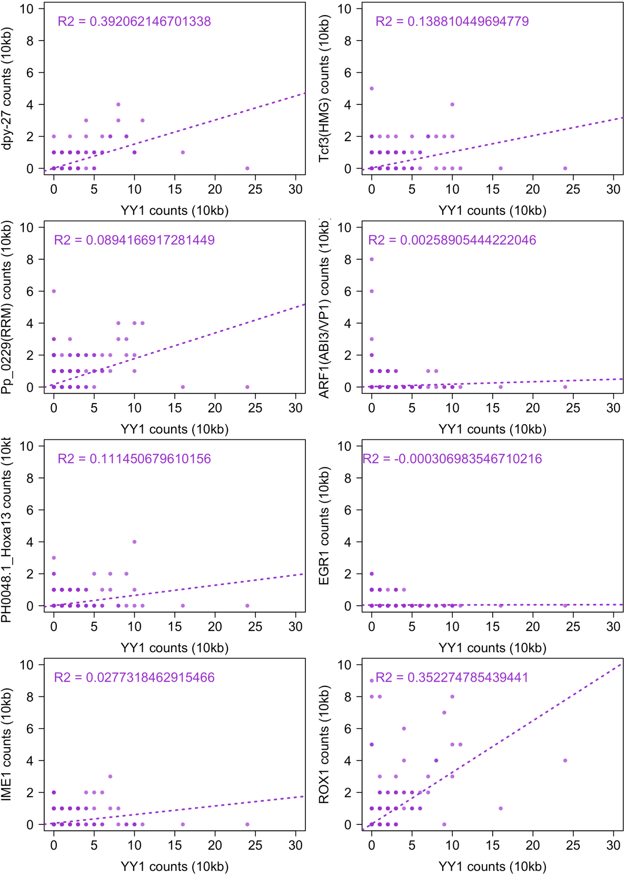
Supplemental Figure 20. The abundance of YY1 motifs are moderately correlated with the C. elegans dpy-27 and the yeast ROX1 DNA binding motifs. Scatter plot depicting the total number of YY1 motifs in 10kb non-overlapping sliding windows on the X chromosome of P. picta compared to other DNA binding motifs enriched in DMRs on the X chromosome. Only motifs that contain a CG motif and that are significantly enriched on the X chromosome are presented. Each point corresponds to an individual 10kb window. Dashed lines represent the linear regression of the designated comparison.

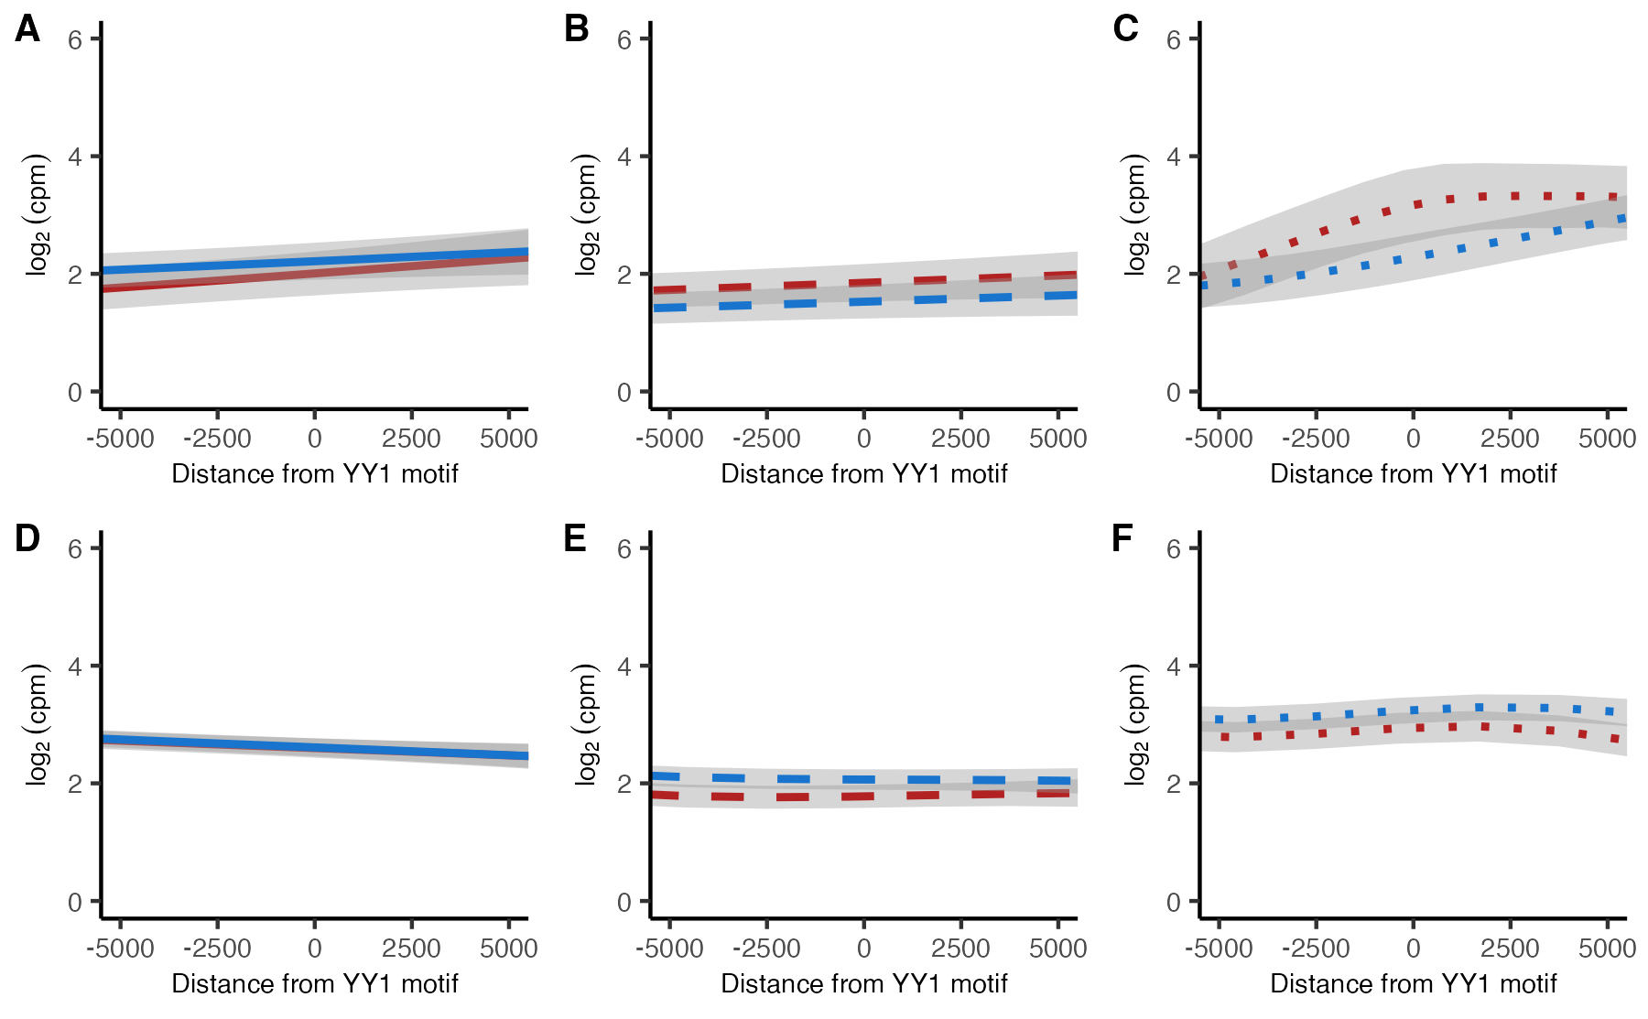

Supplemental Figure 21. Proximity to YY1 motifs is not associated with sex-biased gene expression. Gene expression values (log₂ (cpm)) for genes near YY1 DNA binding motifs on the sex chromosome (A-C) or on autosomes (D-F) in female (red) and male (blue) muscle (A/D), liver (B/E), and gonad tissue (C/F). A negative value on the X-axis is the distance in basepairs upstream (5’) of a YY1 DNA binding motif and positive value is the distance downstream (3’) of the YY1 DNA binding motif. Shaded grey areas represent 95% confidence intervals.

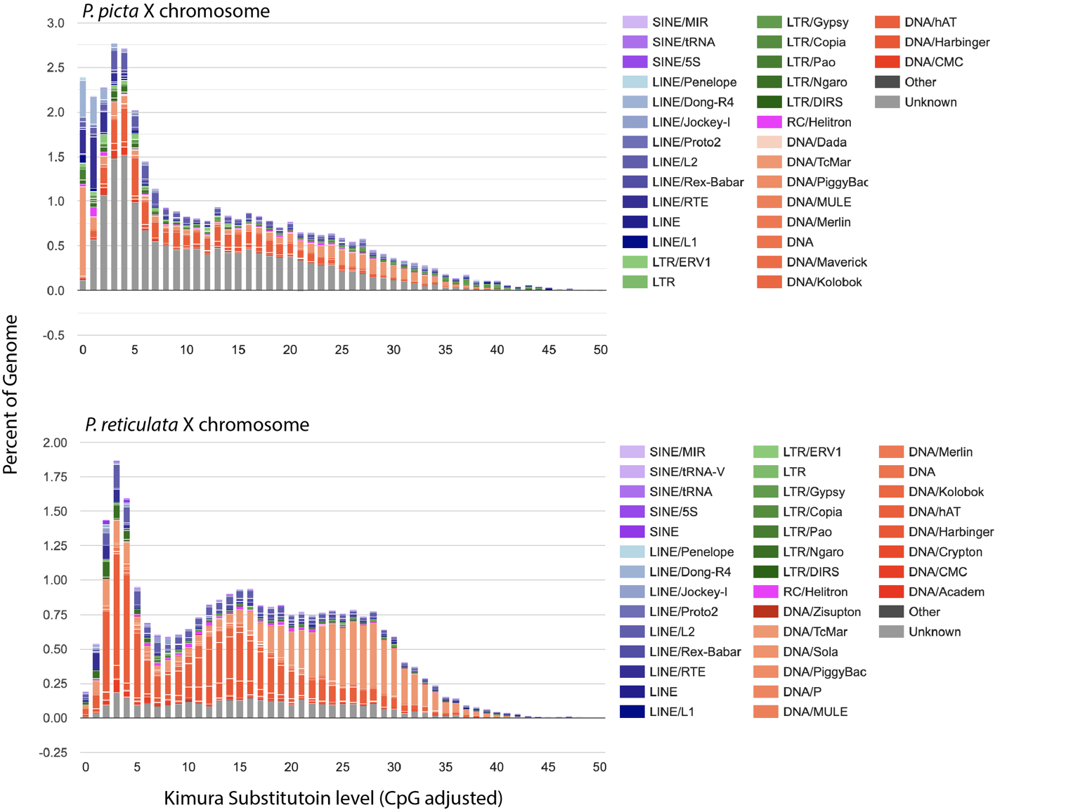

Supplemental Figure 22. The P. picta genome contains a group of recently derived repetitive elements compared to P. reticulata. Kimura substitution values used as a proxy for the expansion history of repetitive elements for the P. picta (upper panel) and P. reticulata (lower panel) X Chromosomes. Bargraph depicts the proportion of the X Chromosome that contains repetitive elements for a given Kimura substitution level. Colors indicate RE annotations. The older the repetitive element expansion the higher the Kimura substitution level indicating more sequence divergence from the consensus.

clade1 ATGCAGTCGCTGCCCGCCCCGTGGCGGGCTGACRTCATGCATGTAAAAGGCTTCTGTAT- 59
clade3 ATGCAGTCGCTGCCCGCCCCGTGGCGGGCTGACATCATGCATGTAAAAGGCTTCTGTAT- 59
clade2 ----AGTCACTGCCCGCCCTGTGGCGGGMTGACATCATGCATGTAAAAGGTTTCTGTATA 56
**** ********** ******** **** **************** ********

clade1 -AAAAAAAGACGGCATGAGGAGTGTGCATTTCAAGTCCTGTTGGACACCAGAGACCTCAA 118
clade3 -AAAAAAAGACGGCATGAGGAGTGTGCATTTCAAGTCCTGTTGGACACCAGAGACCTCAA 118
clade2 TGAAAAAAGACGGTATGAGGAGTGTGCATTTCAAGTCCTGTKGGACACCAGATACCTCAA 116
*********** *************************** ********** *******

clade1 ACTTTATAAAAGTAGTGGTTTTATATTGATTTTGTTTCATATTTACTTCCAAATAAAACC 178
clade3 ACTTTATAAAAGTAGTGGTTTTATATTGATTTTGTTTCATATTTACTTCCAAATAAAACC 178
clade2 ACTTTATAAAARTAGTAGTTTTATATTGATTTTGYTTAATATTTACTTCCAAATAAAACC 176
*********** **** ***************** ** **********************

clade1 AGAAATATGATCGATCATGTCCGCCATATTGTTTTGCGCATGTACTGCGCAATCCGGGAA 238
clade3 AGAAATATGATCGATCATGTCCGCCATATTGTTTTGCGCATGTACTGCGCAATCCGGGAA 238
clade2 AGAAATATGATCGATCATGTCCACCATTTTGTTTTTCGCATGTACTGCGCAATCTGGGAA 236
********************** **** ******* ****************** *****

clade1 TGTTTTATGACCAAAAAGTGAATGAATGCAACATGAAGTCCATTTTTCCYGATTTCCTCA 298
clade3 TGTTTTATGACCAAAAAGTGAATGAATGCAACATGAAGTCCATTTTTCCYGATTTCCTCA 298
clade2 TGTTTTATGACCAAAAAGTGAATGAATGCAACATGAAGTCCATTTGTTCCGATTTCTTCA 296
********************************************* * * ****** ***

clade1 AACGTACCACATTTCTGAAGCAACCAATCAGAAAGCATTKTCGGCCATTTTGTTTGAGCT 358
clade3 AACGTACCACATTTCTGAAGCAACCAATCAGAAAGCATTKTCGSCCATTTTGTTTGAGCT 358
clade2 AACGTACCACATTTCTGAAGCAACCAATCAGAAAGCATTTTCGGCCATTTTGTTTGAGCT 356
*************************************** *** ****************

clade1 CSTAACKGGAGA--TTTCTATGCAGACCTCGGCTGRCAGCCATTTTGTAAATAGTTGAAA 416
clade3 CGTAACGGGAGA--TTTCTATGCAGACCTCGGCTGRCAGCCATTTTGTAAATAGTTGAAA 416
clade2 CCTAACTGGAGAGATTTCTATACAGACCTTTGCTGACAGCCATTTTGTAAATAGTTGAAA 416
* **** ***** ******* ******* **** ************************

clade1 GGGGTAGGGGGACGGAGGAGGAAATGAATTTGTGATGGAAACATCGTCAAACATTTTGTA 476
clade3 GGGGTWGGGGGACGGAGGAGGAAATGAATTTGTGATGGAAACATCGTCAAACATTTTGTA 476
clade2 GGGGTTGGGGGACAGAGGA----------------------------------------- 435
***** ******* *****

clade1 AATAGTTGTAAAAAAACATGAGTCTTGTGGTGTTGGAGAGAATTTGTGATGGAGATATTG 536
clade3 AATAGTTGTAAAAAACATGAGTCT-TGTGTG------GAGAATTTG-----TGATGAGAT 524
clade2 ------------------------------------------------------------ 435

clade1 TGACACATTTATAAATTGTTGTAAAAATACGCCTGGGAAATTGCCCACAATGTGATGTAA 596
clade3 ATTCACATTTATAAATTGTTGTAAAAATACGCCTGGGAAATTGCCCACAATGTGATGTAA 584
clade2 ------------------------------------------------------------ 435

clade1 AAATATGCAT 606
clade3 AAATATGYA- 593
clade2 ---------- 435

Supplemental Figure 23. Consensus sequences of repetititve elements from the X Chromosome are conserved among the three distinct clades containing YY1 motifs.
ClusalW alignment of consensus sequences generated from the manual curration of MUSCLE alignments from the repetitive elements that form three distince clades of sequences derrived from the X chromosome. Regions highlighted in yellow represent putative YY1 motifs.

Supplemental Table 1. P. picta genome assembly statistics

HiRise assembly size (bp) | 743,972,568
Number of Scaffolds | 301
N50 | 33,053,486
L50 | 11
N90 | 27,142,806
L90 | 21
Largest scaffold | 46,707,787
Genome completeness (BUSCO) | 97.65 %
Total number of genes | 27,764
Total coding region | 46,815,666
Repeat % | 29.55 %

Supplemental Table 2. Comparison of average expression between the sex chromosome and autosomes across tissues and sex.

Tissue | X | Y | p-value*
Gonad | Male X genes | Male Autosomal genes | 4.915e-12
Gonad | Male X genes | Female X genes | 6.443e-07
Gonad | Male X genes | Female Autosomal genes | 1.036e-07
Muscle | Male X genes | Male Autosomal genes | 0.6724
Muscle | Male X genes | Female X genes | 0.7923
Muscle | Male X genes | Female Autosomal genes | 0.2407
Liver | Male X genes | Male Autosomal genes | 0.9855
Liver | Male X genes | Female X genes | 0.6603
Liver | Male X genes | Female Autosomal genes | 0.1029
Head | Male X genes | Male Autosomal genes | 0.94
Head | Male X genes | Female X genes | 0.3903
Head | Male X genes | Female Autosomal genes | 0.8463

*p-values calculated using Wilcoxon rank sum test between data in column X and data in column Y

Supplemental Table 3. Wilcoxon rank sum test statistics for dosage compensation as a function of expression level.
Tissue | Quantile | X | Y | p-value*
Gonad | Quantile 1 | Male X genes | Male Autosomal genes | 3.503e-04
Gonad | Quantile 1 | Male X genes | Female X genes | 1.919e-07
Gonad | Quantile 1 | Male X genes | Female Autosomal genes | 2.9e-15
Gonad | Quantile 2 | Male X genes | Male Autosomal genes | 0.002124088
Gonad | Quantile 2 | Male X genes | Female X genes | 1
Gonad | Quantile 2 | Male X genes | Female Autosomal genes | 0.02179697
Gonad | Quantile 3 | Male X genes | Male Autosomal genes | 0.01034029
Gonad | Quantile 3 | Male X genes | Female X genes | 4.166e-08
Gonad | Quantile 3 | Male X genes | Female Autosomal genes | 1.44e-05
Gonad | Quantile 4 | Male X genes | Male Autosomal genes | 3.305e-07
Gonad | Quantile 4 | Male X genes | Female X genes | 1.892e-11
Gonad | Quantile 4 | Male X genes | Female Autosomal genes | 5.725e-10
Muscle | Quantile 1 | Male X genes | Male Autosomal genes | 0.8039929
Muscle | Quantile 1 | Male X genes | Female X genes | 0.3912101
Muscle | Quantile 1 | Male X genes | Female Autosomal genes | 1
Muscle | Quantile 2 | Male X genes | Male Autosomal genes | 1
Muscle | Quantile 2 | Male X genes | Female X genes | 1
Muscle | Quantile 2 | Male X genes | Female Autosomal genes | 1
Muscle | Quantile 3 | Male X genes | Male Autosomal genes | 1
Muscle | Quantile 3 | Male X genes | Female X genes | 1
Muscle | Quantile 3 | Male X genes | Female Autosomal genes | 0.6628782
Muscle | Quantile 4 | Male X genes | Male Autosomal genes | 1
Muscle | Quantile 4 | Male X genes | Female X genes | 0.8554198
Muscle | Quantile 4 | Male X genes | Female Autosomal genes | 1
Liver | Quantile 1 | Male X genes | Male Autosomal genes | 0.2517831
Liver | Quantile 1 | Male X genes | Female X genes | 0.0006019065
Liver | Quantile 1 | Male X genes | Female Autosomal genes | 0.00002378624
Liver | Quantile 2 | Male X genes | Male Autosomal genes | 1
Liver | Quantile 2 | Male X genes | Female X genes | 1
Liver | Quantile 2 | Male X genes | Female Autosomal genes | 0.02162681
Liver | Quantile 3 | Male X genes | Male Autosomal genes | 1
Liver | Quantile 3 | Male X genes | Female X genes | 1
Liver | Quantile 3 | Male X genes | Female Autosomal genes | 0.1268024
Liver | Quantile 4 | Male X genes | Male Autosomal genes | 1
Liver | Quantile 4 | Male X genes | Female X genes | 0.6283786
Liver | Quantile 4 | Male X genes | Female Autosomal genes | 1
Head | Quantile 1 | Male X genes | Male Autosomal genes | 0.008493841
Head | Quantile 1 | Male X genes | Female X genes | 1
Head | Quantile 1 | Male X genes | Female Autosomal genes | 0.9011067
Head | Quantile 2 | Male X genes | Male Autosomal genes | 1
Head | Quantile 2 | Male X genes | Female X genes | 1
Head | Quantile 2 | Male X genes | Female Autosomal genes | 1
Head | Quantile 3 | Male X genes | Male Autosomal genes | 1
Head | Quantile 3 | Male X genes | Female X genes | 1
Head | Quantile 3 | Male X genes | Female Autosomal genes | 1
Head | Quantile 4 | Male X genes | Male Autosomal genes | 0.5104976
Head | Quantile 4 | Male X genes | Female X genes | 0.7668176
Head | Quantile 4 | Male X genes | Female Autosomal genes | 0.2904713

* Bonferroni corrected p-value results from Wilcoxon rank sum test between data in column X and data in column Y

Supplemental Table 4: Average DNA methylation levels at CG, CHG, and CHH motifs in P. picta muscle, liver, ovary, and testis tissue.

Supplemental Table 5: Percent of gene promoters containing CpG island features

Supplemental Table 6: Summary of sex-biased differentially methylated loci (DMLs) and differentially methylated regions (DMRs) in gonad, muscle, and liver tissue.

Supplemental Table 7: Summary of sex-biased DMRs containing YY1 DNA binding motifs.

Supplemental Table 8. RNA-Seq data for P. picta.

Tissue | Sex | Biological  Replicate | # reads | # reads mapped as pairs | % reads mapped
Muscle | Male | 1 | 144636107 | 118061726 | 88.28%
Muscle | Male | 2 | 169476423 | 138122808 | 89.86%
Muscle | Male | 3 | 194995685 | 158505438 | 90.33%
Muscle | Female | 1 | 148583536 | 120583282 | 91.11%
Muscle | Female | 2 | 165442661 | 130740620 | 89.83%
Liver | Male | 1 | 42653690 | 42602048 | 99.88%
Liver | Male | 2 | 46358957 | 46311114 | 99.90%
Liver | Male | 3 | 42446289 | 42401986 | 99.90%
Liver | Female | 1 | 41777391 | 41741864 | 99.91%
Liver | Female | 2 | 43934472 | 43895938 | 99.91%
Liver | Female | 3 | 42383097 | 42341376 | 99.90%
Head | Male | 1 | 51631056 | 51544142 | 99.83%
Head | Male | 2 | 46551675 | 46479572 | 99.85%
Head | Male | 3 | 38206399 | 38148536 | 99.85%
Head | Female | 1 | 54132041 | 54053660 | 99.86%
Head | Female | 2 | 60580208 | 60497298 | 99.86%
Head | Female | 3 | 46450145 | 46377666 | 99.84%
Testis | Male | 1 | 45585537 | 45535708 | 99.89%
Testis | Male | 2 | 59703504 | 59643374 | 99.90%
Testis | Male | 3 | 51146625 | 51079088 | 99.87%
Ovary | Female | 1 | 53248762 | 53146800 | 99.81%
Ovary | Female | 2 | 51869747 | 51785328 | 99.84%
Ovary | Female | 3 | 57592595 | 57497696 | 99.84%

Supplemental Table 9. WGBS data for P. picta.

Tissue | Sex | Biological  Replicate | # reads | # reads mapped as pairs | % reads mapped
Muscle | Male | 1 | 184771950 | 125246074 | 89.75%
Muscle | Male | 2 | 160032514 | 112189848 | 88.53%
Muscle | Male | 3 | 160032514 | 112189848 | 88.53%
Muscle | Female | 1 | 173524325 | 113572030 | 89.81%
Muscle | Female | 2 | 143912326 | 110264156 | 91.91%
Muscle | Female | 3 | 166238590 | 119300796 | 91.08%
Liver | Male | 1 | 151693943 | 101210542 | 87.24%
Liver | Male | 2 | 175369447 | 103025500 | 80.21%
Liver | Male | 3 | 173169280 | 115526270 | 87.01%
Liver | Female | 1 | 177598077 | 113951140 | 91.27%
Liver | Female | 2 | 158676444 | 110121160 | 90.81%
Liver | Female | 3 | 133363848 | 92716046 | 90.58%
Testis | Male | 1 | 165429956 | 87663290 | 71.92%
Testis | Male | 2 | 143549255 | 76288622 | 72.66%
Testis | Male | 3 | 130382202 | 68272628 | 76.52%
Ovary | Female | 1 | 172253818 | 121325294 | 90.46%
Ovary | Female | 2 | 156043172 | 113553024 | 91.51%

*DNA binding motifs that contain CpG dinucleotides
Bold denotes CpG containing motifs that are significantly enriched on the X chromosome (LG12)
Supplemental Table 10. X chromosome enrichment analysis for putative DNA binding motifs enriched in DMRs.

