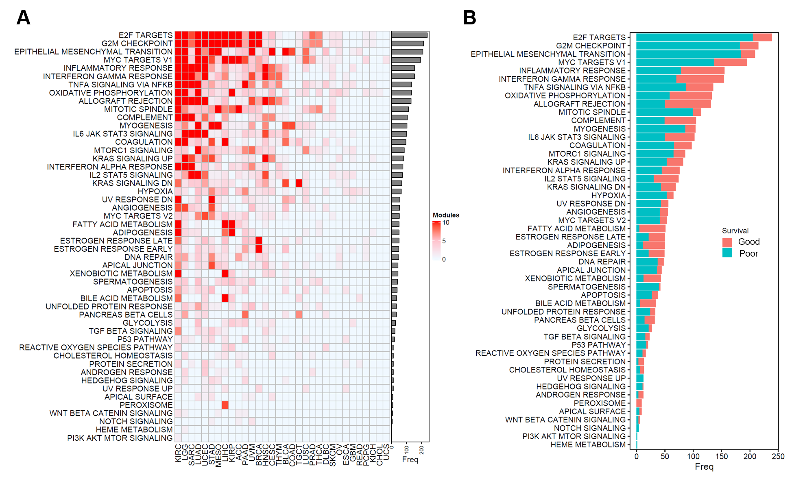

Supplemental Fig. S1 The biological functions of the prognostic modules in 32 cancer types. A) Heatmap showing the number of prognostic modules enriched for the 50 MsigDB hallmark pathways in each cancer type. The color intensity is proportional to the number of enriched modules. B) Bar plot showing the number of prognostic modules associated with different survival outcomes in each MsigDB hallmark pathway. The colors indicate different types of survival outcomes (pink: good outcome; green: poor outcome).

