Loss of epigenetic suppression of retrotransposons with oncogenic potential in aging mammary luminal epithelial cells
Parijat Senapati^{1,6}, Masaru Miyano², Rosalyn W. Sayaman^{2,3}, Mudaser Basam^{1,2}, Amy Leung¹, Mark A. LaBarge^{2,4,5}, Dustin E. Schones^{1,4}

¹Department of Diabetes Complications and Metabolism, Beckman Research Institute, City of Hope, Duarte, CA, 91010, USA
²Department of Population Sciences, Beckman Research Institute, City of Hope, Duarte, CA, 91010, USA
³Department of Laboratory Medicine, Helen Diller Family Comprehensive Cancer Center, University of California, San Francisco, San Francisco, CA, USA
⁴Irell & Manella Graduate School of Biological Sciences, City of Hope, Duarte, CA, USA
⁵Center for Cancer Biomarker Research, University of Bergen, Norway
⁶Present address: Rajiv Gandhi Centre for Biotechnology, Thiruvananthapuram, 695014, Kerala, India

Corresponding Author:
Dustin E. Schones, Ph.D.
Department of Diabetes Complications and Metabolism
City of Hope
Duarte, CA, 91010
Email: dschones@coh.org

Phone: 626-218-1319

Table of Contents:
Supplemental Methods 3
Supplemental Figures 6 Supplemental Figure S1 6
Supplemental Figure S2 7
Supplemental Figure S3 8
Supplemental Figure S4 10
Supplemental Figure S5 12
Supplemental Figure S6 13
Supplemental Figure S7 14
Supplemental Figure S8 15
Supplemental Tables 16
References 18

Supplemental Methods
Power Analysis
We used previously generated RRBS data from LEps derived from tissue of young (n=6) and old (n=4) women for determining sample size for WGBS. We used MethylSeqDesign (Liu et al. 2021) to determine sample size needed for different discovery rates. We found that a sample size of 5 per group allows 74.82% power for detecting differences in methylation (FDR < 0.05). A post-hoc analysis of our WGBS data using n=3 as pilot data on chromosome 1 also showed that we have 75% power with n=5 per age group.

Multiple sequence alignments and display of DMRs and hypomethylated region
The fasta sequence for TEs of each subfamily were retrieved using BEDTools getfasta (Quinlan and Hall 2010). Multiple sequence alignment (MSA) was done using MAFFT (Katoh et al. 2002). The MSA was converted into a matrix of 0s and 1s with 0s corresponding to gaps in alignment. The positions of DMRs, hypomethylated regions and TF binding sites was overlaid onto the MSA and loaded as an R object. pheatmap (Kolde 2018) was used to display the overlay of the sites on the MSA.

Characterization of DMRs
Kernel smoothed plots were made using the BSSeq package with default smoothing parameters and CpG sites with greater than 3× coverage (Hansen et al. 2012). Heatmaps were made using the pheatmap package (Kolde 2018).

Identification of variably methylated regions
Variably methylated regions were identified using the Systematic Interindividual Variation (SIV) approach (Gunasekara et al. 2019). Briefly, the human genome was divided into 100 bp non-overlapping windows containing at least 1 CpG site. About 14.4 million such windows were obtained. The coverage and methylation values were calculated for each sample across these 100bp windows using Methpipe (Song et al. 2013). Windows were then filtered by coverage as follows to obtain informative bins: Windows with CpG <= 2 that had a coverage of at least 10 reads and windows with CpG > 2 that had a coverage of at least 10 reads at half the number of CpG sites. We obtained about 12.9 million bins that had sufficient coverage. Next, we calculated the Pearson correlation co-efficient for each bin with its adjacent bin. Adjacent bins that were within 100 bp of each other and a correlation >= 0.71 were merged into correlated blocks of methylation. The average methylation for each sample was calculated for the correlated blocks. Correlated blocks which had an interindividual range (IR) of >= 20% and at least 4 CpG sites were defined as variable regions. Old specific variable regions were defined as regions that had an IR of >= 20% across the five old samples and IR_{old} -IR_{young} >= 20%. Similarly, young specific variable regions were defined as regions that had an IR of >= 20% across the five young samples and IR_{young} -IR_{old} >= 20%. These regions were further filtered to retain those that have coverage of at least 3 CpGs in all 10 samples. To categorize variably methylated regions into variable loss or variable gain, the highest (old_{max}) and the lowest (old_{min}) methylation values among old samples were compared to the methylation average in young (avg_{y}). The absolute values of differences in methylation between avg_{y} and old_{max,} old_{min} were compared. If the difference in methylation between the avg_{y} and old_{min} were higher than that between avg_{y} and old_{max}, that region was assigned as a variable region with methylation loss.
We identified 23,921 regions that were variably methylated only in old LEps and 25,585 regions specific to the young LEps. The variable regions were ~150p-450bp in length, with some spanning 2-2.5kb (Supplemental Fig. S5B and S5C). We noted that most of the variably methylated regions in old LEps (17,780 of 23,921; 74.3%) showed lower methylation levels compared to young LEps. We then examined whether variable regions contained TEs. 68.7% of the variable regions in young LEps overlapped TEs compared to 67.59% of control non-variable regions. Among variable regions in old LEps, 71.4% overlapped with TEs compared to 67.65% of control non-variable regions (Supplemental Fig. S5D). In addition, most variably methylated TEs lost methylation (76.9%) in old LEps (Supplemental Fig. S5E). We ensured that variable methylation at TEs was not due to mapping issues (Supplemental Fig. S5F).
RNA-seq analysis
RNA-seq data from FACS sorted young (n = 10) and old LEps (n = 8) and young (n = 6) MEps were generated for a parallel study (GSE182338). Raw sequences were aligned to the hg19 reference genome using HISAT2 (version 2.1.0) (Kim et al. 2015) with the --dta parameter. Stringtie (version 1.3.4) (Pertea et al. 2015) was used with default parameters to assemble transcripts using the Gencode v19 transcript annotation. Assembled transcripts from all libraries were further merged using --merge option in Stringtie. Merged transcript abundances were measured using bedtools coverage.

Methylation entropy analysis
Normalized methylation entropy (NME) and mean methylation levels (MML) were calculated on 150bp non-overlapping windows across the genome using informME (Jenkinson et al. 2018). Hyper-entropic regions were defined as windows with difference in NME (dNME)> 0.1 between at least 13 out of 25 young and old comparisons and methylation levels > 0.9 or < 0.05 in all young samples.

Additional data analysis and external data
The evolutionary age of TEs was calculated as described previously using the Jukes-Cantor correction (Bourque et al. 2008). CpG scores for individual TE copies were calculated as previously described (Gardiner-Garden and Frommer 1987). CpG score is defined as the ratio of observed and expected CpG frequency where observed CpG (o) = Number of CpGs $×$ length of the region (N) and expected CpG frequency (e) = Number of Cs $×$Number of Gs. Mappability of 100bp bisulfite converted kmers for the hg19 genome generated using Bismap (Karimzadeh et al. 2018) were downloaded from the UCSC Genome Browser (Kent et al. 2002). Bedgraph files were used to obtain the mappability score of individual CpGs within TEs. Normalized counts for TCGA-BRCA cancer specific ATAC-seq peaks and RNA-seq counts were downloaded from the Genomic Data Commons (GDC) Portal. The clinical information and PAM50 subtypes for these samples were accessed using TCGAbiolinks (Colaprico et al. 2016). Primary breast tumor WGBS data generated as part of the International Cancer Genome Consortium (Brinkman et al. 2019) was obtained from European Genome-phenome Archive after DACO approval. Figures were made in R (version 3.5.1) using the ggplot2 package (Wickham 2016) and assembled in Adobe Illustrator.

Usage of hg19 vs. GRCh38
In this manuscript, we used the hg19 reference genome rather than GRCh38 to compare our methylation data with previously published LEp methylation profiles (Pellacani et al. 2016). To examine the effects of the reference genome on our results, we examined the differences in TEs annotated in the GRCh38 genome by RepeatMasker (Smit 2013-2015). We found that 96.86% of the hg19 TEs lifted over to GRCh38 have complete overlaps with GRCh38 TEs. Additionally, the two reference genomes have less than a 4% difference in their TE content (see table). We, therefore, concluded that using the hg19 reference genome does not significantly alter our data and conclusions.
TE | GRCh38 | hg19 | Percent difference
LINE | 1609790 | 1569213 | 2.58
SINE | 1861488 | 1807002 | 3.01
LTR | 771683 | 750163 | 2.79
DNA | 540746 | 528865 | 2.25

Supplemental Figures
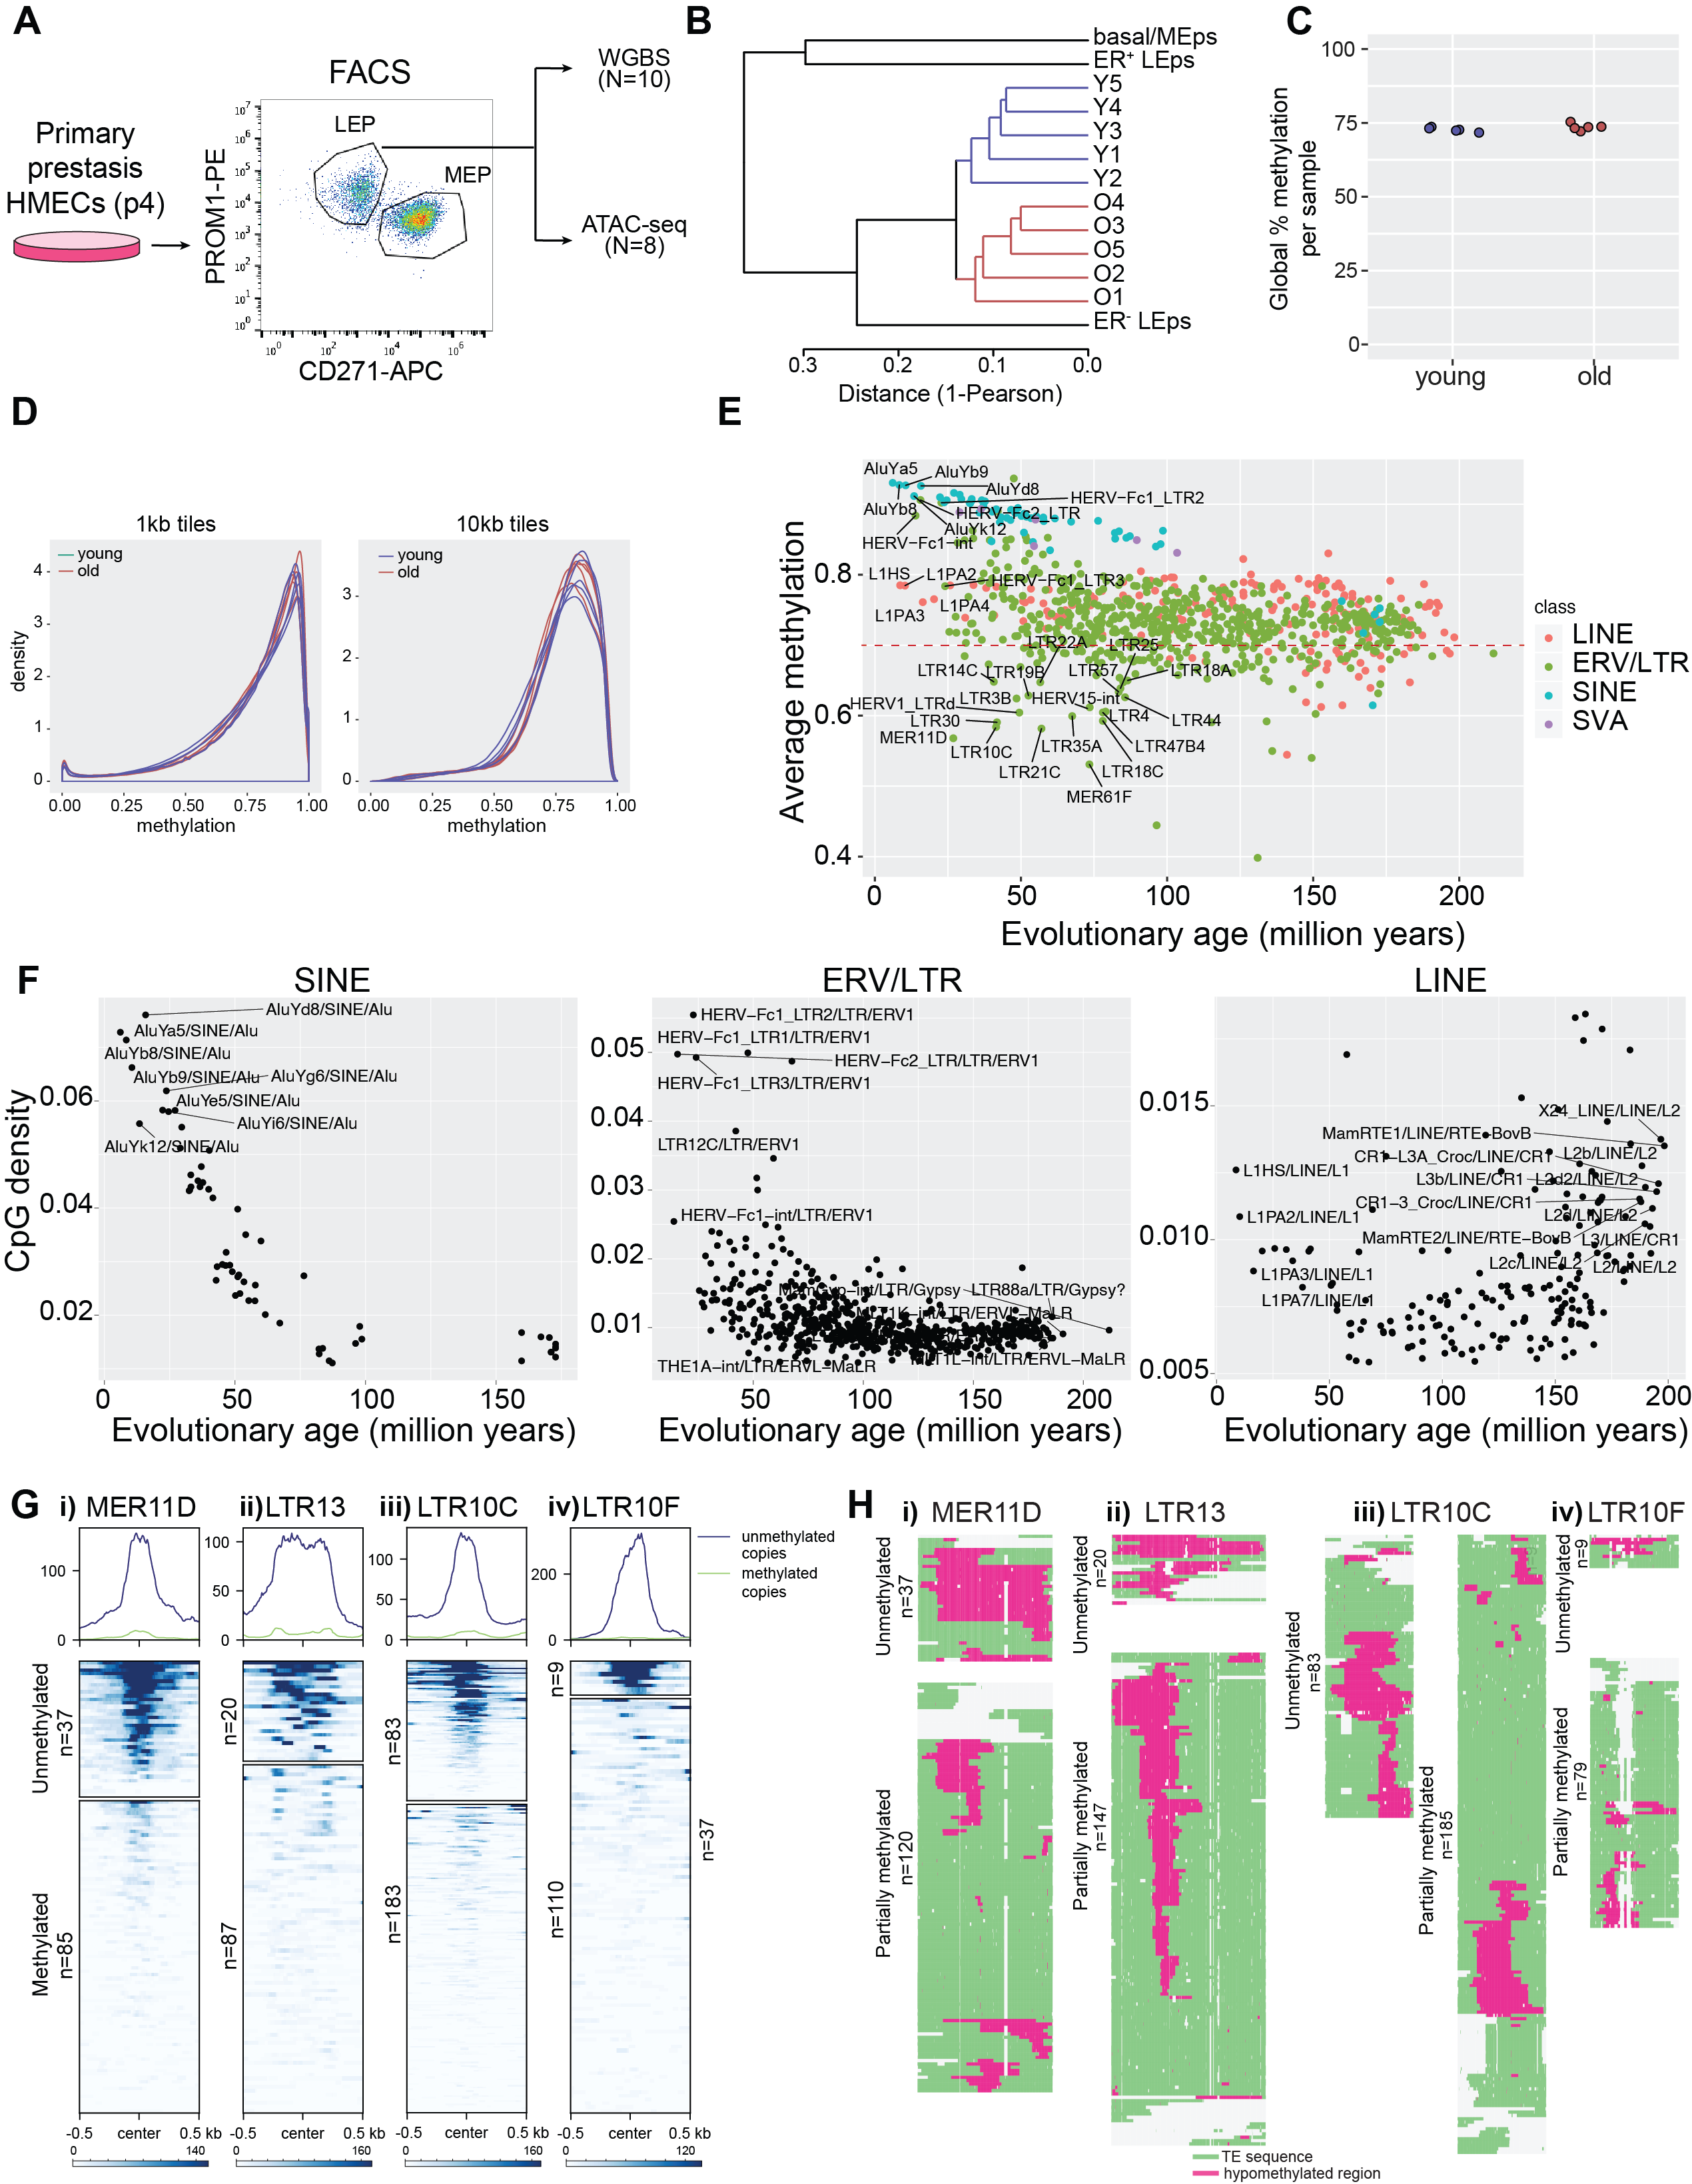
Figure S1: Characterization of whole genome methylation data. (A) Strategy for enrichment of the luminal and myoepithelial cell populations and design of study. (B) Unsupervised hierarchical clustering of young and old LEps and previously published mammary epithelial cell types using methylation levels at all covered CpG sites. (C) Global methylation percentage across all CpG sites in the genome in the ten samples. (D) Density distribution of average DNA methylation values within 1- and 10-kb windows across the genome in young and old LEPs. Only windows with 3 or more CpGs per 1 kb, or 10 or more CpGs per 10 kb, were considered for the analysis. (E) Comparison of average TE subfamily DNA methylation with evolutionary age among LINE, SINE, LTR and SVA elements in young luminal epithelial cells. Some subfamilies are indicated. (F) Comparison of average TE subfamily CpG density with evolutionary age among SINE, LTR and LINE elements in young luminal epithelial cells. Some subfamilies are indicated. (G) ATAC-seq profile across unmethylated copies (methylation < 30%) and methylated copies (methylation > 70%) of MER11D, LTR13, LTR10C, and LTR10F subfamilies in young luminal epithelial cells. Top panel shows aggregate signal of ATAC-seq over unmethylated and methylated copies. (H) Multiple sequence alignments (MSA) of unmethylated (methylation < 30%, upper panel) and partially methylated (30% < methylation < 70%, lower panel) copies of MER11D, LTR13, LTR10C, and LTR10F elements. The location of hypomethylated region (/CpGs) is indicated in pink.

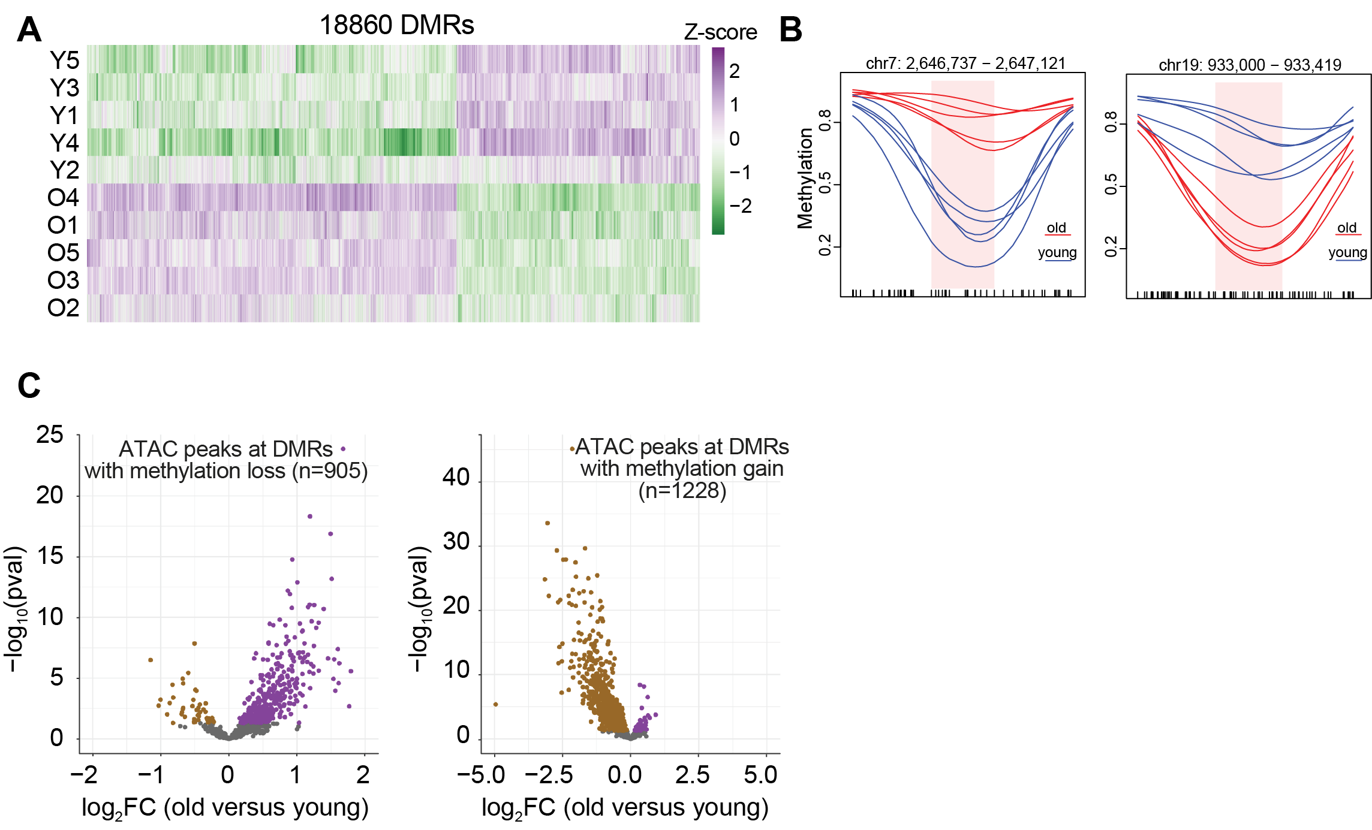
Figure S2: Identification and characterization of DMRs. (A) Methylation levels of identified DMRs across all samples. Samples are in rows, and DMRs are in columns. The color intensity represents the Z-score scaled from the mean. Values ranging from higher to lower methylation are shown as purple to green. (B) Kernel smoothed line plots of representative DMRs±500bp with methylation gain (left panel) and methylation loss (right panel). Blue and red lines respectively represent young and old samples. DMRs are highlighted in pink and black ticks mark each CpG position. (C) Left panel: Volcano plot showing log2 fold change (log₂fc) of ATAC-seq peaks overlapping DMRs with methylation loss in old versus young LEPs. Positive log2 fold change indicates increase in accessibility. Right panel: Volcano plot showing log2 fold change (log2fc) of ATAC-seq peaks overlapping DMRs with methylation gain in old versus young LEPs. Negative log2 fold change indicates decrease in accessibility.

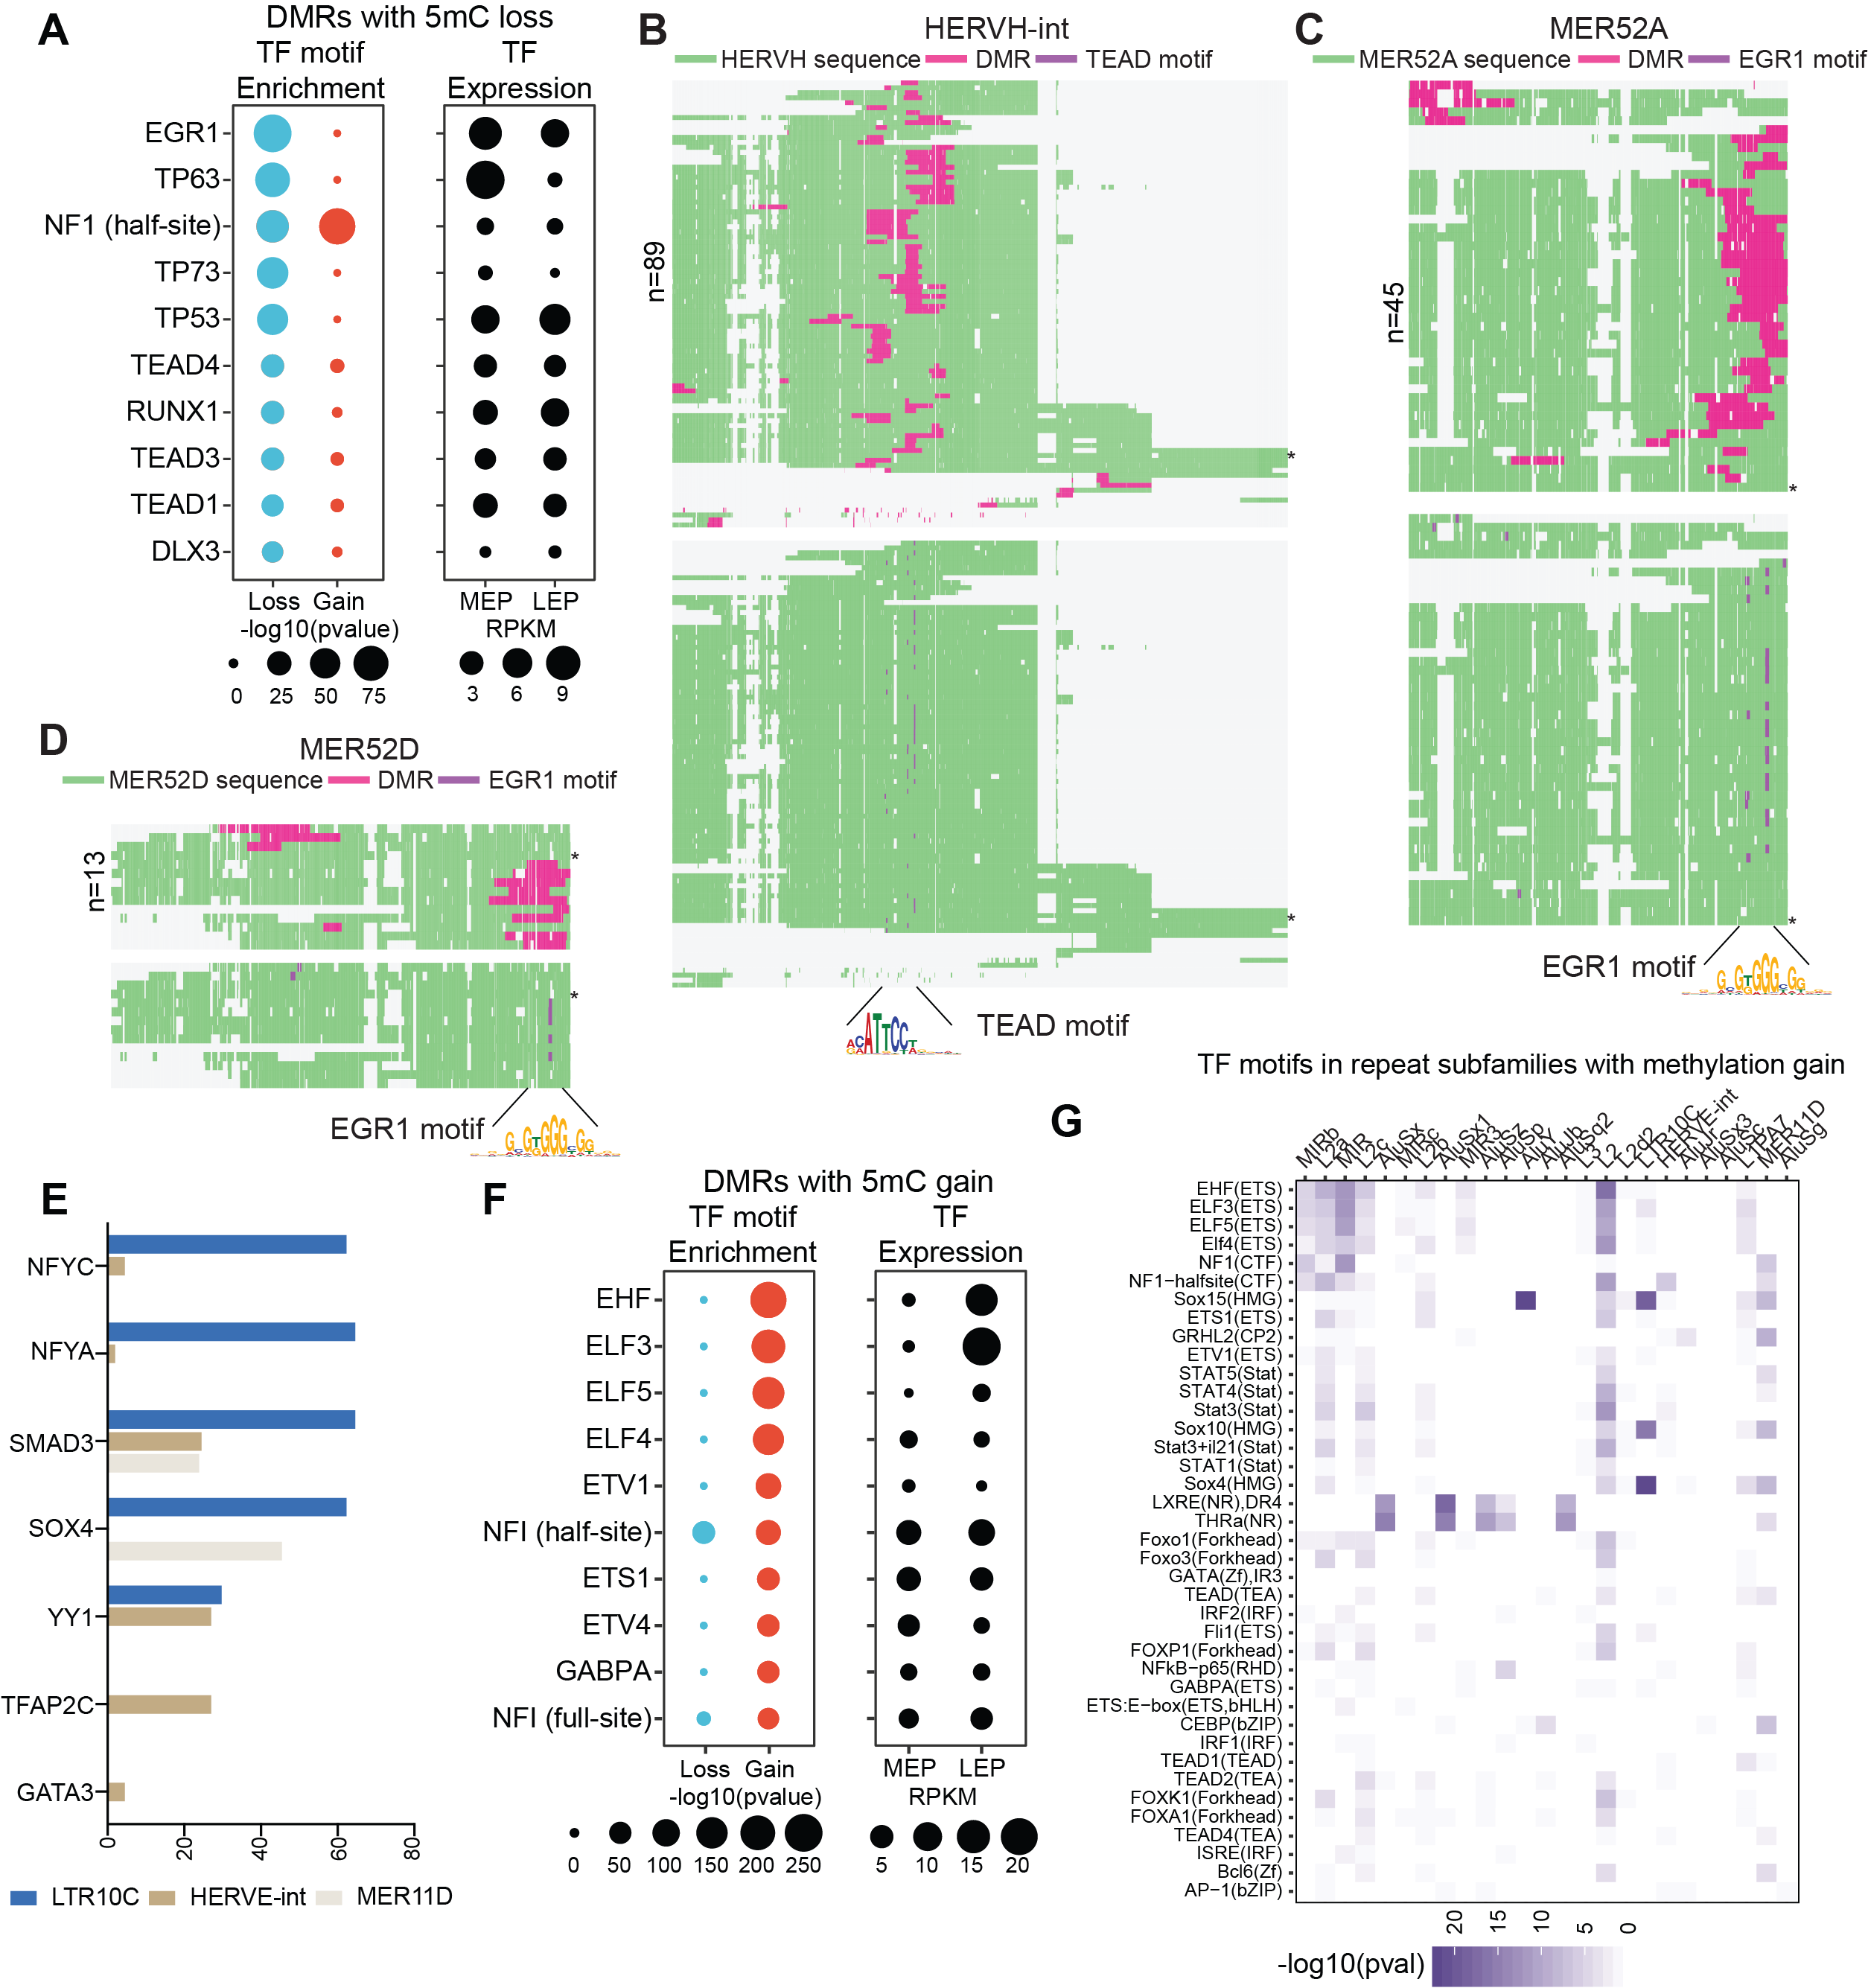
Figure S3: Age-dependent methylation changes occur at TE subfamilies that contain lineage-specific transcription factor binding sites. (A) Top ten TF binding sites enriched in the DMRs that lose methylation (left panel). Dots show -log₁₀(p-value) for the enrichment of the transcription factor binding site. (B) Multiple sequence alignments (MSA) of HERVH-int elements that lose methylation with age. The location of methylation loss (DMR) is indicated in pink in the upper panel. The lower panel indicates the location of the TEAD motif (purple) within the DMR in the same MSA. (C) MSA of MER52A and (D) MER52D copies that lose methylation with age. DMRs are indicated in pink in the upper panel and the EGR1 motif is indicated in purple color in the lower panel. (E) Percent number of elements containing indicated transcription factor motifs across TE subfamilies with methylation gain. (F) Top ten TF binding sites enriched in the DMRs that gain methylation (left panel) with age are shown. (G) Enrichment of TF binding site in each TE subfamily with methylation gain. Color scale is –log₁₀(p-value) of TF motif enrichment.

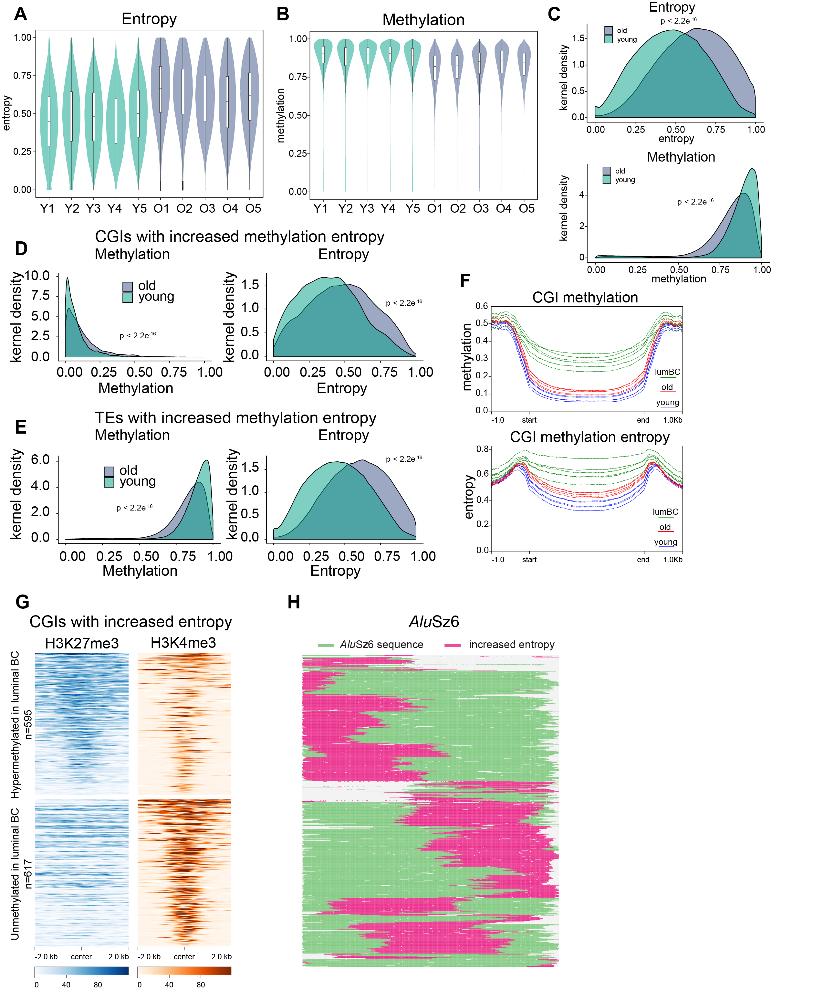
Figure S4: Increased methylation entropy with age in normal luminal epithelial cells predicts CGI methylation gain and Alu methylation loss in breast cancer. (A) Normalized methylation entropy (Entropy) levels and (B) methylation levels at regions with increased methylation entropy in old individuals. (C) Density plots showing entropy and methylation levels at regions with increased methylation entropy. (D) Density plots showing entropy and methylation levels at unmethylated regions with increased methylation entropy. (E) Density plots showing entropy and methylation levels at methylated regions with increased methylation entropy. (F) Aggregate plots show methylation levels at CGIs with increased entropy in old LEps. Methylation in young, old LEps and luminal breast tumors are shown. (G) Heatmaps show ChIP-seq signal for H3K27me3 (blue) and H3K4me3 (orange) at CGIs with increased entropy. ChIP-seq data is from ER- luminal cells. CGIs are separated into 2 groups; those that are hypermethylated in luminal breast cancer and those that remain unmethylated. (H) Multiple sequence alignments (MSA) of AluSz6 elements that show increased entropy with age. The location of increased entropy is indicated in pink.

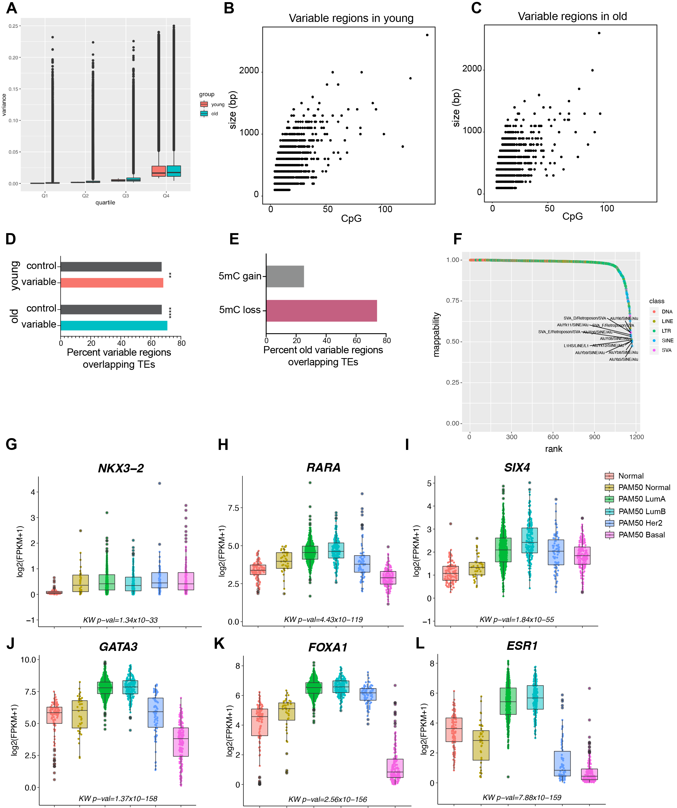
Figure S5: Characterization of variably methylated regions in luminal cells. (A) Boxplot shows variance of CpG methylation among young and old samples stratified by variance quartiles in young samples. (B) Scatterplot shows the genomic size of the young-specific variable regions versus no. of CpGs in the region. (C) Same as B but showing variable regions specific to old. (D) Percent of variable regions in young and old that overlap TEs. Overlap of shuffled control regions with TEs is shown in gray. P-value was calculated by comparing with control regions using Fisher’s exact test. **** p-val < 0.0001 and ** p-val < 0.01. (E) Percent of variable TE regions in old that lose or gain methylation. (F) Average mappability of 100bp bisufite converted reads within TE subfamilies. Indicated subfamilies have average mappability < 0.6. Mappability of 1 denotes unique mapping; 0.5 denotes multi-mapping at 2 sites. (G-L) Boxplots show expression of indicated transcription factors in normal and breast tumor tissue from the TCGA-BRCA RNA-seq data. Tumor Samples are grouped by PAM50 subtype.
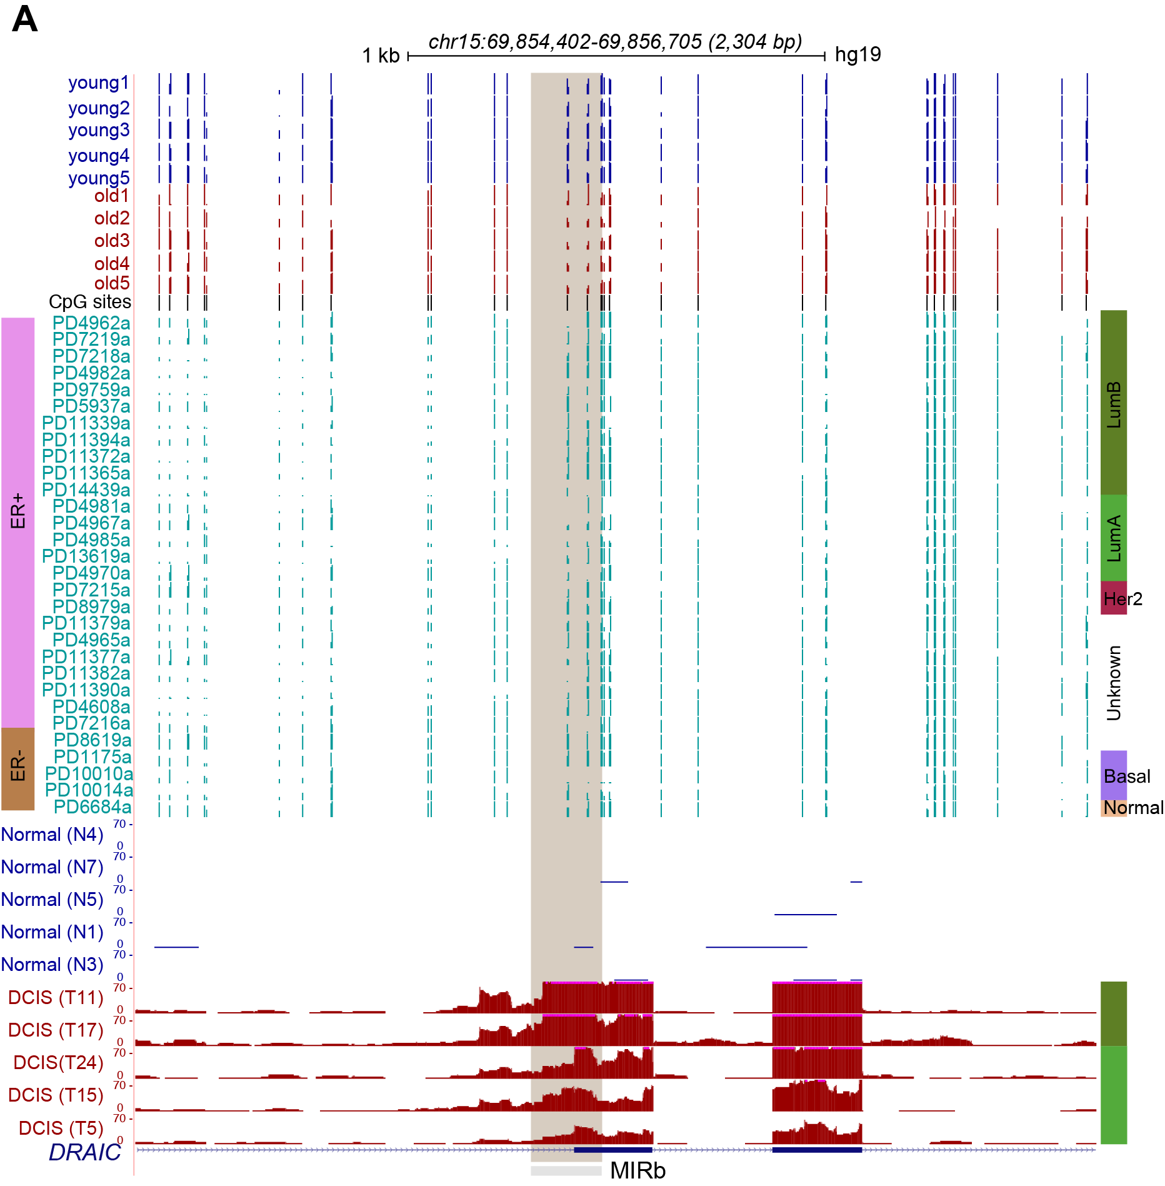
Figure S6: TEs are activated in DCIS samples. (A) A representative MIRb element showing methylation loss in old samples and in breast cancer (BC) samples. Bottom tracks are RNA-seq tracks from DCIS samples showing exonization of the MIRb element. All RNA-seq tracks are scaled to the same value.
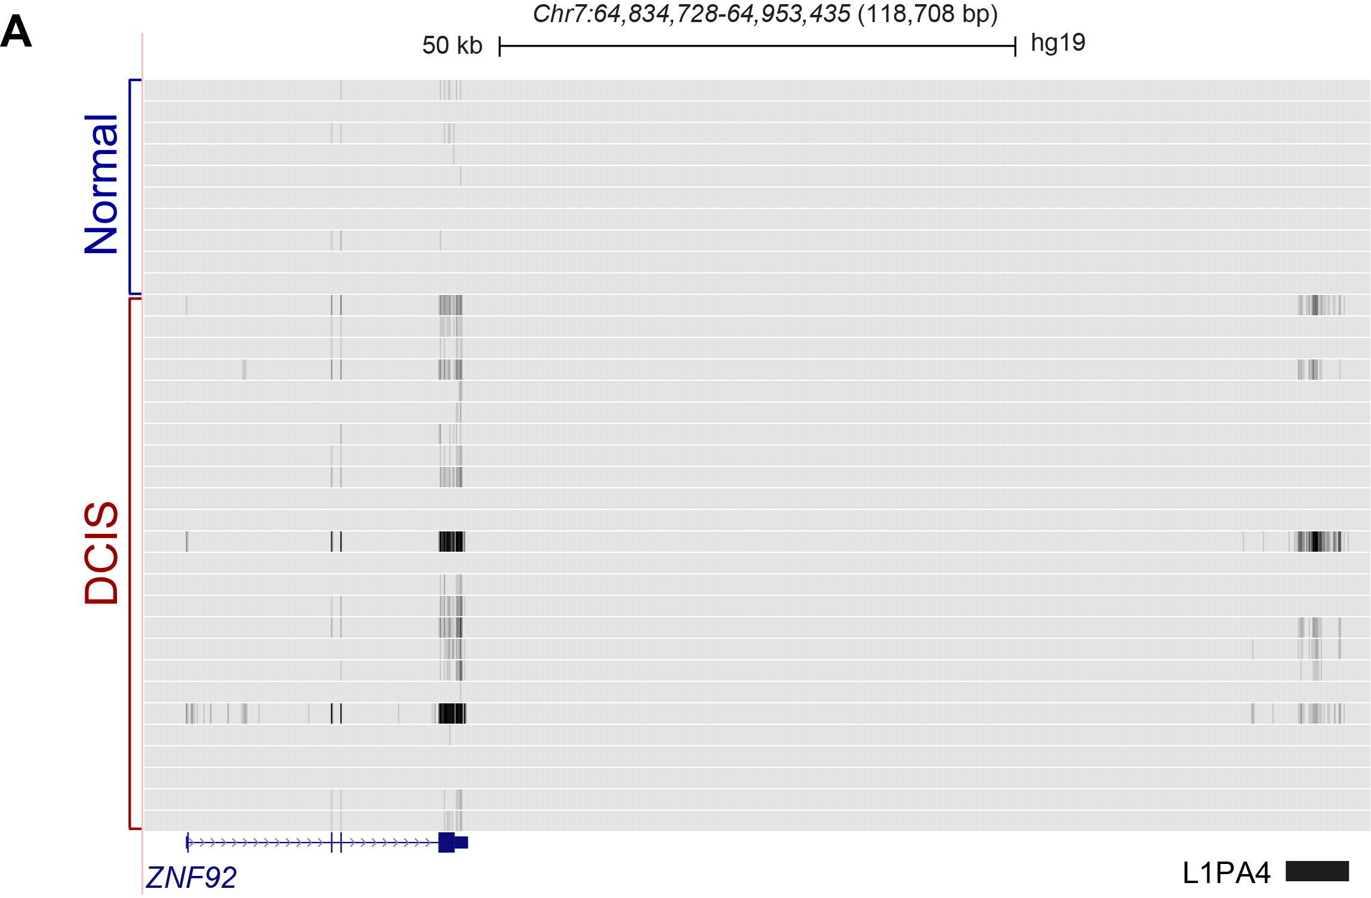
Figure S7: TEs regulate expression of nearby genes expressed in DCIS and luminal breast cancer. (A) RNA-seq tracks showing correlated expression of an L1PA4 element and a nearby ZNF92 gene. All tracks are scaled to the same value and displayed in the dense format.

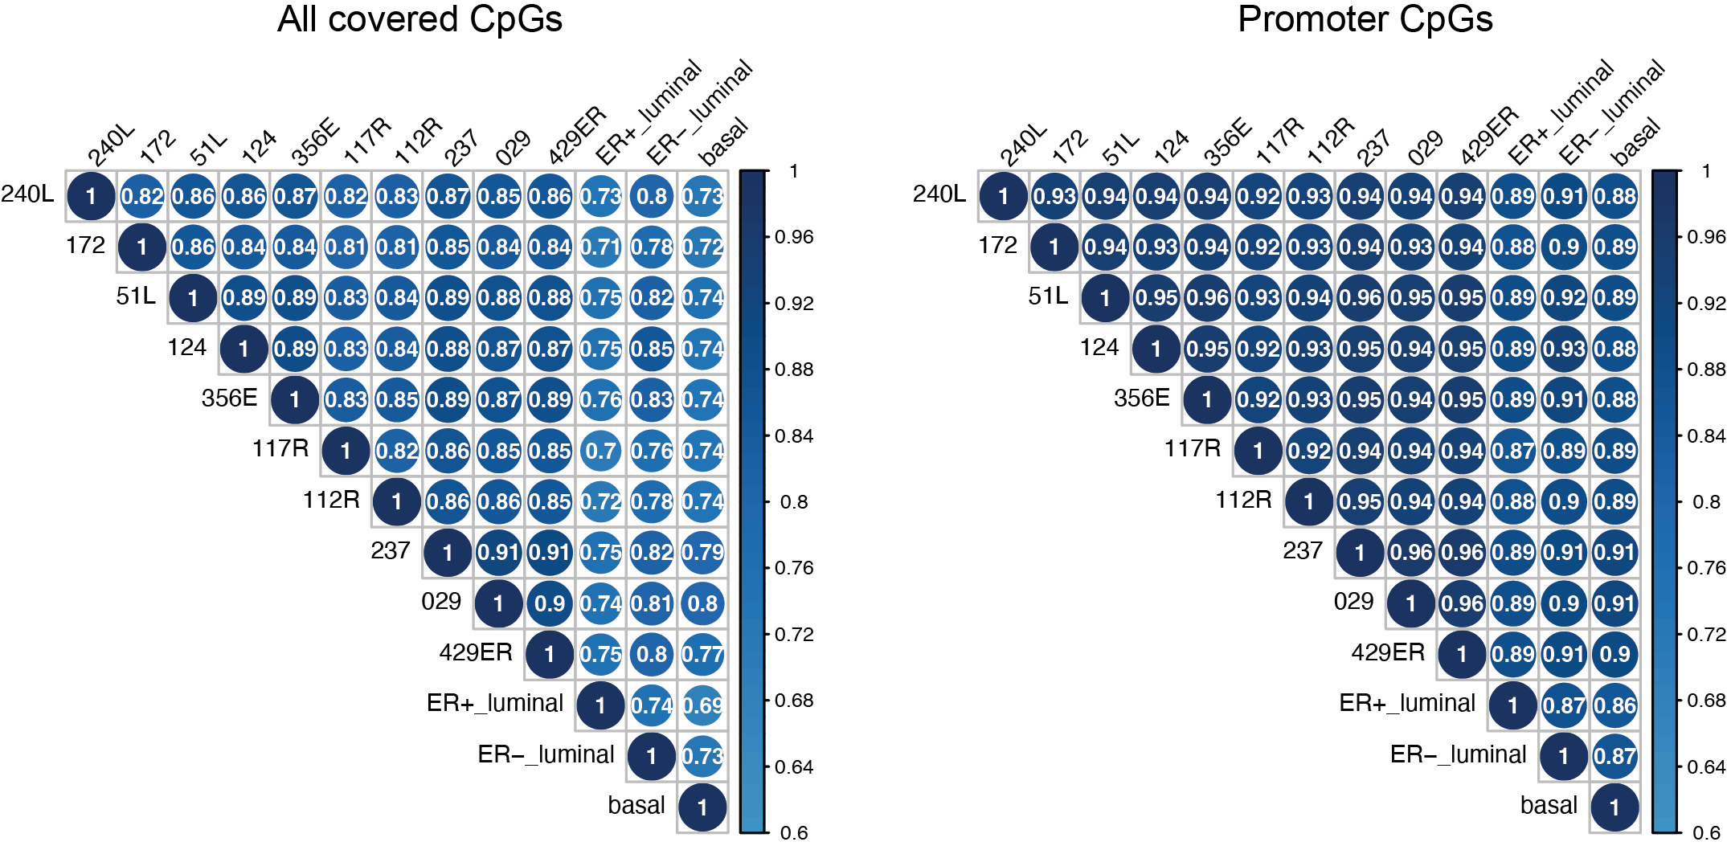
Figure S8: Correlation plot shows Pearson correlation coefficients for pairwise comparison of methylation levels of all CpGs (left panel) or promoter CpGs (right panel) of LEps in our dataset and with published WGBS datasets (Pellacani et al. 2016) from ER⁺ luminal, ER⁻ luminal cells and basal/myoepithelial cells.

Supplemental Tables
Sample name | Age | Sequencing | Sample IDs
Young1 | 19 | WGBS & ATAC-seq | 240L
Young2 | 28 | WGBS & ATAC-seq | 172L
Young3 | 27 | WGBS | 51L
Young4 | 29 | WGBS | 124
Young5 | 21 | WGBS | 356E
Young6 | 16 | ATAC-seq | 160
Young7 | 19 | ATAC-seq | 168R
Old1 | 56 | WGBS & ATAC-seq | 117R
Old2 | 61 | WGBS & ATAC-seq | 112R
Old3 | 66 | WGBS & ATAC-seq | 237
Old4 | 68 | WGBS | 029
Old5 | 72 | WGBS | 429ER
Old6 | 56 | ATAC-seq | 191L

Table S1: Information about HMEC strains used in this study. RM: Reduction Mammoplasty

Dataset | Total PE Reads | Uniquely aligned | Unaligned | Non-unique | Mapping Efficiency | % meth in CpG | % meth in CHG | % meth in CHH
young1 | 442,374,010 | 333,575,143 | 84,149,098 | 24,649,769 | 75.4% | 72.20% | 0.80% | 0.90%
young2 | 377,285,149 | 284,644,571 | 69,643,612 | 22,996,966 | 75.4% | 71.70% | 0.90% | 1.00%
old1 | 447,412,429 | 331,566,355 | 99,511,987 | 16,334,087 | 74.1% | 72.30% | 1.10% | 1.20%
old2 | 389,294,496 | 294,743,268 | 70,389,174 | 24,162,054 | 75.7% | 71.20% | 0.80% | 1.00%
young3 | 540,610,191 | 408,246,293 | 116,022,462 | 16,341,436 | 74.8% | 72.9% | 0.5% | 0.5%
young4 | 438,076,546 | 267,678,351 | 162,876,069 | 7,522,126 | 73.1% | 72.8% | 0.6% | 0.6%
young5 | 678,066,097 | 416,805,644 | 246,854,983 | 14,405,470 | 74.0% | 71.4% | 0.6% | 0.7%
old3 | 621,427,696 | 464,255,562 | 142,515,781 | 14,656,353 | 74.7% | 72.9% | 0.5% | 0.4%
old4 | 570,538,865 | 416,681,703 | 141,544,457 | 12,312,705 | 73.0% | 74.6% | 0.5% | 0.5%
old5 | 477,291,517 | 347,182,922 | 119,705,108 | 10,403,487 | 72.7% | 72.8% | 0.5% | 0.5%

Table S2: WGBS alignment statistics

Dataset | Total CpG sites covered | Fraction covered | Mean depth | Mean depth at covered sites | Mean methylation | Weighted mean methylation | Fractional methylation
young1 | 25846312 | 0.92 | 9.69 | 10.58 | 0.74 | 0.73 | 0.8
young2 | 25677175 | 0.91 | 8.95 | 9.84 | 0.74 | 0.73 | 0.8
old1 | 25561113 | 0.91 | 7.33 | 8.09 | 0.74 | 0.73 | 0.79
old2 | 25455720 | 0.9 | 8.2 | 9.09 | 0.74 | 0.72 | 0.8
young3 | 26967650 | 0.96 | 9.48 | 9.94 | 0.747 | 0.74 | 0.80
young4 | 27220228 | 0.97 | 18.56 | 19.24 | 0.744622 | 0.74 | 0.80
young5 | 27267663 | 0.97 | 24.45 | 25.30 | 0.734071 | 0.72 | 0.79
old3 | 27283872 | 0.97 | 27.86 | 28.81 | 0.749737 | 0.74 | 0.81
old4 | 27272794 | 0.97 | 23.78 | 24.60 | 0.76192 | 0.75 | 0.82
old5 | 27255122 | 0.97 | 19.96 | 20.67 | 0.7438 | 0.74 | 0.81

Table S3: WGBS CpG methylation statistics

Table S4-S9: Attached as excel files

Supplemental References
Bourque G, Leong B, Vega VB, Chen X, Lee YL, Srinivasan KG, Chew JL, Ruan Y, Wei CL, Ng HH et al. 2008. Evolution of the mammalian transcription factor binding repertoire via transposable elements. Genome Res 18: 1752-1762.
Brinkman AB, Nik-Zainal S, Simmer F, Rodriguez-Gonzalez FG, Smid M, Alexandrov LB, Butler A, Martin S, Davies H, Glodzik D et al. 2019. Partially methylated domains are hypervariable in breast cancer and fuel widespread CpG island hypermethylation. Nat Commun 10: 1749.
Colaprico A, Silva TC, Olsen C, Garofano L, Cava C, Garolini D, Sabedot TS, Malta TM, Pagnotta SM, Castiglioni I et al. 2016. TCGAbiolinks: an R/Bioconductor package for integrative analysis of TCGA data. Nucleic Acids Res 44: e71.
Gardiner-Garden M, Frommer M. 1987. CpG islands in vertebrate genomes. J Mol Biol 196: 261-282.
Gunasekara CJ, Scott CA, Laritsky E, Baker MS, MacKay H, Duryea JD, Kessler NJ, Hellenthal G, Wood AC, Hodges KR et al. 2019. A genomic atlas of systemic interindividual epigenetic variation in humans. Genome Biol 20: 105.
Hansen KD, Langmead B, Irizarry RA. 2012. BSmooth: from whole genome bisulfite sequencing reads to differentially methylated regions. Genome Biol 13: R83.
Jenkinson G, Abante J, Feinberg AP, Goutsias J. 2018. An information-theoretic approach to the modeling and analysis of whole-genome bisulfite sequencing data. BMC Bioinformatics 19: 87.
Karimzadeh M, Ernst C, Kundaje A, Hoffman MM. 2018. Umap and Bismap: quantifying genome and methylome mappability. Nucleic Acids Res 46: e120.
Katoh K, Misawa K, Kuma K, Miyata T. 2002. MAFFT: a novel method for rapid multiple sequence alignment based on fast Fourier transform. Nucleic Acids Res 30: 3059-3066.
Kent WJ, Sugnet CW, Furey TS, Roskin KM, Pringle TH, Zahler AM, Haussler D. 2002. The human genome browser at UCSC. Genome Res 12: 996-1006.
Kim D, Langmead B, Salzberg SL. 2015. HISAT: a fast spliced aligner with low memory requirements. Nat Methods 12: 357-360.
Kolde R. 2018. pheatmap: Pretty Heatmaps. R package version 1.0.10.
Liu P, Lin CW, Park Y, Tseng G. 2021. MethylSeqDesign: a framework for Methyl-Seq genome-wide power calculation and study design issues. Biostatistics 22: 35-50.
Pellacani D, Bilenky M, Kannan N, Heravi-Moussavi A, Knapp D, Gakkhar S, Moksa M, Carles A, Moore R, Mungall AJ et al. 2016. Analysis of Normal Human Mammary Epigenomes Reveals Cell-Specific Active Enhancer States and Associated Transcription Factor Networks. Cell Rep 17: 2060-2074.
Pertea M, Pertea GM, Antonescu CM, Chang TC, Mendell JT, Salzberg SL. 2015. StringTie enables improved reconstruction of a transcriptome from RNA-seq reads. Nat Biotechnol 33: 290-295.
Quinlan AR, Hall IM. 2010. BEDTools: a flexible suite of utilities for comparing genomic features. Bioinformatics 26: 841-842.
Smit A, Hubley, R & Green, P. . 2013-2015. RepeatMasker Open-4.0. http://www.repeatmasker.org.
Song Q, Decato B, Hong EE, Zhou M, Fang F, Qu J, Garvin T, Kessler M, Zhou J, Smith AD. 2013. A reference methylome database and analysis pipeline to facilitate integrative and comparative epigenomics. PLoS One 8: e81148.
Wickham H. 2016. ggplot2: elegant graphics for data analysis. Springer.

