Supplemental Material

Variation in mutation, recombination, and transposition rates in Drosophila melanogaster and Drosophila simulans

Yiguan Wang^{1*}, Paul McNeil¹, Rashidatu Abdulazeez², Marta Pascual³, Susan E. Johnston¹, Peter D. Keightley¹, Darren J. Obbard¹
- Institute of Ecology and Evolution, University of Edinburgh, Charlotte Auerbach Road, Edinburgh EH9 3FL, UK
- Department of Zoology, Ahmadu Bello University, Zaria, Nigeria
- Departament de Genètica, Microbiologia i Estadística and IRBio, Universitat de Barcelona, 08028 Barcelona, Spain

* Corresponding Author:
Email: yiguan.wang@ed.ac.uk

Table of Contents:
Supplemental methods | Page 2 - 11
Supplemental_Fig_S1 | Page 12
Supplemental_Fig_S2 | Page 13
Supplemental_Fig_S3 | Page 14
Supplemental_Fig_S4 | Page 15
Supplemental_Fig_S5 | Page 16
Supplemental_Fig_S6 | Page 17-18
Supplemental_Fig_S7 | Page 19
Supplemental_Fig_S8 | Page 20
Supplemental_Fig_S9 | Page 21
Supplemental_Fig_S10 | Page 22
Supplementary tables legends | Page 23
Reference | Page 23 -24

Supplemental methods
Fly Crosses and sequencing
West African D. melanogaster were netted by RA from fermented banana bait that had been exposed for 48 hours in Samaru market in Zaria, northern Nigeria (28th September 2020; 11.1611 N, 7.6471 E). European D. melanogaster were netted by DJO from yeasted banana bait that had been exposed for around 5 days in a rural garden in Sussex, southeast England (4th to 10th August 2020; 51.0998 N, 0.1644 E). European D. simulans were netted by MP from decomposing fallen fruit in an organic apple and pear orchard in Gimenells, Northern Spain (21st August 2020; 41.6564 N, 0.3885 E). In each case the landowner’s permission was obtained before collection, and this work was approved by the University of Edinburgh School of Biological Science ethics committee.
For the West African flies, we crossed the virgin male and female offspring from different wild-collected (i.e. wild-mated) females. For the European flies, we crossed virgin female offspring of wild-collected females with wild-collected males. All ‘parental’ flies for sequencing were therefore unrelated and genetically wild, i.e. no more inbred or related than naturally occurring flies. All progeny groups comprised outbred full-sibships. Once sufficient numbers of F1 offspring were available, we froze the parents at -80ºC until DNA extraction. All flies were maintained at 16:8 light:dark cycle at 20ºC on a modified ‘Lewis’ medium. In total, we sequenced six families comprising two parents and five F1 offspring (males) from each of the three populations (West African and European D. melanogaster, European D. simulans), giving 125 flies in total (36 parents and 89 offspring – one offspring individual failed sequencing).
DNA was extracted from single flies using Qiagen Blood and Tissue kits (Qiagen Ltd., UK) according to the manufacturer's protocol, and provided to the Centre for Genomic Research at the University of Liverpool (UK) for library preparation and sequencing. Libraries were prepared using NEBNext Ultra II FS Kits (New England Biolabs (UK) Ltd) with an insert size of approximately 350bp. Paired-end (2 x 150bp) sequencing was performed using Illumina NovaSeq with S4 chemistry, and raw FASTQ files were trimmed for adapter sequences using cutadapt-version 1.2.1 (Martin 2011). Reads were further trimmed for quality using Sickle (https://github.com/najoshi/sickle, version1.200), with a minimum window quality score of 20. After trimming, we retained only paired reads, giving an average of 38.3 million pairs for each sample, with a range from 20.0 to 81.1 million. The median coverages were all above 30-fold (except one with 28-fold) and the X Chromosome coverages in males were half of that in autosomes.

Read mapping and variant calling
We used BWA-MEM (version 0.7.17-r1188; Li 2013) to map the trimmed reads to the reference genomes of D. melanogaster (version r6.42, FlyBase.org) and D. simulans (version GCF_016746395.2_Prin_Dsim_3.1, NCBI) using default parameters. We used Picard MarkDuplicates (https://github.com/broadinstitute/picard, version 2.26.2) to identify and remove duplicate reads in the BAM files with parameters ‘REMOVE_DUPLICATES=true ASSUME_SORTED=true VALIDATION_STRINGENCY=LENIENT’. We used BCFtools-version 1.11 (Li 2011) to call variants for all the samples in each family with parameters ‘-a DP,AD,ADF,ADR --max-depth 250 --min-MQ 20’. Given the haploid state of the X and Y chromosomes in male samples, we configured a ploidy file using ‘--ploidy-file’ in BCFtools. Different chromosome arms were called separately and then concatenated using ‘bcftools concat’. We used GCTA (version 1.93.2; Yang et al. 2011) to examine the relatedness of the parental flies, calculating genetic relatedness matrix (GRM) between pairs of individuals j and k as:
$$A_{jk}= \frac{1}{N}\sum_{i=1}^{N}{\frac{(x_{ij}-2p_{i})(x_{ik}-2p_{i})}{2p_{i}(1-p_{i})}}$$

where N is the total number of SNPs, x_{ij} is the copy of reference allele for the i^{th} SNP in individual j, and p_{i} is the population allele frequency for the i^{th} SNP. We also used seqinr (version 4.2-5; Charif and Lobry 2007) to estimate the genome-wide synonymous and non-synonymous nucleotide diversity from the inferred parental haplotypes (π_{S} and π_{A}).

Filtering of candidate single-nucleotide and short indel mutations
The central challenge in calling rare heterozygous de novo mutations in highly diverse diploid genomes is to distinguish true mutations from read-mapping errors (Keightley et al. 2014; Bergeron et al. 2022). For each family, we used GATK-version 4.2.2 (McKenna et al. 2010) ‘SelectVariants’ to select single nucleotide variants (SNVs) in the VCF file and then used ‘VariantsToTable’ to extract relevant information for each SNV, including chromosomes (CHROM), positions (POS), reference allele (REF), alternative allele (ALT), genotype (GT), depth (DP), genotype quality (GQ), allele depth (AD), allele depth on forward reads (ADF) and allele depth on reverse reads (ADR). We then filtered the SNVs using the criteria in BOX 1A to identify sites of candidate de novo mutations.
We additionally tailored the filtering approach for SNVs on X and Y chromosomes in males, as follows. For the X Chromosome, we did not filter the father except to require that the site was ‘pure’ (i.e. no reads supporting the candidate mutation; AD = 0), the allelic balance (AB) for the focal (male) offspring was 1, and the read depth was 5-fold - 75-fold (i.e. half the range for diploid filtering). For the Y Chromosome, we required that the father was ‘pure’, with read depth 5 – 75-fold and that the focal offspring was AB = 1.
To filter candidate short indel mutations (those less than 50 bp), we re-called indels for each of the families using platypus-version 0.8.1.2 (Rimmer et al. 2014) with parameters ‘--genSNPs=0 --countOnlyExactIndelMatches=1’. Then we used VCFtools-version 0.1.16 (Danecek et al. 2011) to extract biallelic indels from the VCF files, and used GATK ‘VariantsToTable’ to extract chromosomes (CHROM), positions (POS), reference allele (REF), alternative allele (ALT), the number of reads covering variant location (NR), and the number of reads containing the variant in this sample (NV). We then used the criteria in BOX 1B to identify sites of candidate de novo short indels.
Similar to the filtering for SNVs above, we halved the required number of reads (NR) to filter candidate variants on X and Y chromosomes in male offspring, and we required that the allelic balance was above 0.5. We did not filter the number of reads (NR) in the father, but we did require NV to be 0 if the candidate variant were on the X Chromosome (i.e. the sample was ‘pure’).
Finally, for each family, we manually examined all of the candidate SNMs and short indel mutations using the Integrative Genomics Viewer (IGV; Robinson et al. 2011 ). To be accepted, a candidate mutation was required to fulfil the following criteria. First, we ensured the candidate mutation was absent from all parental reads, and satisfied the criteria described above in the non-focal offspring. Second, the candidate mutation and its surrounding genomic markers (such as SNP or indel alleles, if present) had to be phased into only two haplotypes if on autosomes, or one haplotype if on sex chromosomes in a male. This step also allowed us to trace the parent of origin for the majority of mutations. Third, if a read containing the candidate mutation was present in any non-focal offspring, and it carried some other genomic markers, then the association between the candidate mutation and these genomic markers was not identified in the focal offspring (Keightley et al. 2014). Last, although we didn’t exclude putative mutations in the close vicinity of indels in the automated pipeline outlined above, we did verify these manually, and candidates were excluded if they could be perfectly resolved by moving bases around the indels (Keightley et al. 2014). All scripts are available via GitHub:https://github.com/Yiguan/muDmelDsim.

BOX 1. Filtering strategies for SNMs (A) and indels (B)

A: To filter SNMs, we applied the following criteria:

For both parents we required that:
- The site was called homozygous for the reference allele (GT)
- The read depth (DP) was in the range 10X – 150X
- The genotype quality (GQ) was ≥ 50
- The site was ‘pure’, i.e. no reads supporting the candidate mutation (AD = 0)
For each focal offspring we required that:
- The site was called heterozygous (GT)
- The read depth (DP) was in the range 10X – 150X
- The genotype quality (GQ) was ≥ 50
- The proportion of reads supporting the alternative allele relative to the total depth at this site (allelic balance, AB) was in the range 0.2 – 0.8
- The number of reads supporting the candidate mutation was ≥ 5 (AD ≥ 5)
- The candidate mutation was supported by both forward (ADF > 0) and reverse (ADR > 0) reads
For non-focal offspring in the family, we required that:
- The site was called homozygous for the reference allele (GT)
- No offspring had more than one read supporting the candidate mutation
- No more than two offspring had any reads supporting the candidate mutation
For all other families in the same population, we required that:
- No individual was called heterozygous (GT)

B: To filter indels, we applied the following criteria:

For both parents we required that:
- The number of reads covering the indel location (NR) was between 10 - 150
- No read in either parent contained the candidate indel
For the focal offspring we required that:
- The number of reads covering the indel location (NR) was between 10 - 150
- The number of reads containing the indel (NV) was ≥ 5
- The allelic balance was between 0.15 - 0.85
For non-focal offspring:
- No read in any offspring contained the candidate indel
For the other families in the same population:
- No read in any individual contained the candidate indel

Simulation and defining ‘callable’ sites
Unevenness in mapped read depth, for example due to variation in ‘mappability’, means that some fraction of the genome will not be accessible to mutation detection. Most estimates of mutation rate account for this missing fraction by using only the ‘callable’ sites as the denominator when calculating per-site rates (i.e. the sites meeting the depth and quality threshold in all relevant individuals). However, the complex filtering required to achieve high specificity (Box 1) can reduce detection sensitivity in other ways that may be harder to capture, in part because they are contingent on the mutations that arise. For example, as mismatches can reduce the probability that a read maps successfully, especially in a high-diversity genome, the mapped read depth may itself depend on the presence of new mutations. Even more subtly, a ‘purity’ requirement means that a site called as reference homozygous AA, but which has a very small fraction of reads supporting a C allele, is ‘callable’ if the de novo mutation is A→G, but not if it is A→C. One solution to this has been to simulate ‘synthetic mutations’ in the empirical reads, and re-run the mapping and mutation-detection pipeline to estimate its overall sensitivity (Keightley et al. 2014). This sensitivity estimate can then be used to ‘correct’ the overall rate estimate. Here we take this approach one step further, and use these simulations to directly define the proportion of the genome that is ‘callable’, simply as the proportion of synthetic mutations that can be re-called by the whole pipeline.
To simulate SNMs, we randomly selected 100,000 ‘synthetic mutation’ sites across the combined genomes of the five offspring in each family, ensuring that sites were at least 500bp apart and setting the number of sites per chromosome in proportion to the chromosome length. We then extracted all of the reads covering each of these sites and edited the bases in these reads at each chosen site to create a synthetic mutation. To mimic the number of non-reference alleles and their linkage to true standing variation, we followed two rules. First, if there were SNP markers linked the chosen site that could be used to phase the reads, we randomly selected one parental haplotype and edited all reads belonging to this haplotype. Second, if there were no available SNP markers on the target reads, we randomly selected the number of reads to be edited based on the empirical distribution of read frequencies for true heterozygous sites, given the read depth. We then replaced the corresponding reads in the original BAM files with the reads that had been edited and used ‘samtools fastq’ to convert the edited BAM files to paired-end read files. Together with the original read files for the parents in each family we then re-ran our complete pipeline, including mapping, variant calling and filtering. If a synthetic mutation was successfully recovered by the full pipeline, then the synthetic mutation site was deemed callable. We then estimated the total callable sites as:
$$Callable sites=\sum_{i=1}^{k}{\frac{n_{i}}{N_{i}} ×L_{i} ×P_{i}×C }$$
where, k is the number of chromosomes; n_{i} is the number of callable sites in a total of N_{i} sites we simulated on the ith chromosome; L_{i} is the length of the reference genome for the ith chromosome; C is the number of offspring in the family; P_{i} is the number of ploidy for the ith chromosome in each offspring.
We also simulated synthetic short indels in our data, analogous to our approach for the simulation of SNMs. However, given the limits of short-read data, we confined the length of the synthetic indels to a maximum of 25bp. As above, we randomly selected 100,000 sites along the reference genome spaced at least 500bp apart, and at these sites we created short insertions or short deletions in the reads. Where possible, the read edits were made in phase with a parental allele, otherwise numbers were chosen to match the empirical distribution. We then used platypus to detect indels in the simulated data and used the same filtering strategies as we did on the original data. However, when we compared the filtered results with the synthetic indels we created, we relaxed the match conditions such that indel length need not be correctly inferred, and indel position could fall within 5bp of the expected position. The number of callable sites was then estimated as for SNMs above.
Finally, to further verify our approach to SNM detection, we applied our filtering pipeline to the rhesus macaque trio data analysed by the recent ‘Mutationathon’ study (Bergeron et al. 2022), and compared our results with those from five other research groups. As the candidate macaque mutations had been validated by PCR, they provide an opportunity to test the sensitivity of our pipeline. However, as only one F1 offspring was available in this test dataset, substantially reducing the power to distinguish false-positive mutations, we narrowed the acceptable allelic balance from (0.2 – 0.8) to (0.35 – 0.65).

Recombination detection
To infer crossover recombination in the parents, we used VCFtools to select biallelic SNPs with minimum genotype quality of 20 in each family and then applied ‘phase_by_transmission’ (window size = 100 heterozygous sites) from the Python package scikit-allel (version 1.3.5) to phase the two haplotypes in each offspring (Miles et al. 2017). We visualised the haplotypes of informative SNPs in the offspring using R, and manually examined them to identify potential phasing errors in the parents. For example, the maternal haplotypes on 2R in fam27 of D. simulans displayed multiple identical breakpoints, consistent with mis-phasing of the parent (Supplemental Fig. S6), as did maternal haplotypes on the X Chromosome in fam28 of D. simulans. We resolved a small number of such errors manually, by switching the parental phase at the shared breakpoint.
The resulting phased genomes should permit a direct count of crossover breakpoints, and thus an estimate of the recombination rate. However, substantial ‘noise’ was visible in the phasing at a scale of hundreds to thousands of bases (Supplemental Fig. S6). This noise could reflect sequencing errors, genotyping errors, or short phasing errors, but may also reflect gene-conversion events (Comeron et al. 2012), which are difficult to robustly infer using short-read data. In principle, they might also represent very close pairs of crossover events, but because crossover interference is likely to suppress very close crossovers (Miller et al. 2016), these can be excluded by setting a minimum threshold distance. To choose this threshold, we made use of the fact that recombination is generally absent in male Drosophila (Morgan 1912). As expected, we saw no compelling evidence of crossover recombination in males, but we did see a small number of short (i.e. ‘noisy’) recombinant haplotypes that could represent phasing errors or gene-conversion tracts. The longest tract was a region on 2L in a D. simulans individual that was supported by 1190 SNP markers. We therefore chose this as a threshold for the detection of true crossovers, on the basis that it was the longest (presumably erroneous) recombinant region detected in non-recombining males. When applied to the maternal haplotypes, this threshold allowed us to exclude 31,123 likely erroneous short haplotype blocks (median length 2 kbp, 95% quantile = 188 kbp).
Finally, given the potential for suppression of recombination by genomic inversions in heterozygotes, we used inversion-specific markers in D. melanogaster to detect cosmopolitan inversions in the parental samples and examined whether the inversions, if present, affect the occurrence of recombination (Kapun et al. 2014). The seven canonical inversions we examined were In(2L)t, In(2R)Ns, In(3L)P, In(3R)C, In(3R)K, In(3R)Mo, and In(3R)Payne.

Detection of transposable element insertions
The robust detection of TE insertions into repetitive regions is extremely challenging, and rarely possible using short-read data alone. However, a number of approaches can reliably detect TE insertions into low-complexity and gene-rich regions (Ewing 2015). We used TEFLoN (Adrion et al. 2017) to identify TE insertions in our data, and we detected new insertions by comparing the TE locations between parents and offspring. TEFLoN first creates a pseudo-reference genome with TE sequences removed, then maps paired reads to the pseudo-reference genome and known TE sequences, identifying breakpoints to classify the reads into three categories: ‘presence’ reads that are a soft clipped or have a mate aligning to a TE, ‘absence’ reads whose alignment spans the breakpoints, and ‘ambiguous’ reads that are uninformative. We provided TEFLoN with a TE database that integrated two recently published TE databases in Drosophila: ‘Manually Curated Transposable Elements’ (MCTE) for D. melanogaster (Rech 2021) and a D. simulans species complex database (Chakraborty et al. 2021). The MCTE database was originally created by running REPET (v.2.5) TE denovo pipeline on 13 genomes of natural D. melanogaster, followed by manual curation (Rech 2021). The D. simulans database was originally created by REPET and merged with Drosophila Repbase, and has been applied to detect TEs in D. simulans, D. sechellia, and D. mauritiana (Chakraborty et al. 2021).
To confidently identify novel TE insertions, we then followed a similar logic to our SNM and indel filtering above, using the following steps. First, all the samples in each family were required to have at least 10 informative reads at a putative insertion site (presence reads or absence reads). Second, there could be no ‘presence’ reads in either parent. Third, the allelic balance of ‘presence’ reads in the focal offspring had to be between 0.2 – 0.8 (i.e. heterozygous). Fourth, the number of ‘presence’ reads in non-focal offspring could be no greater than 1, and no more than two individuals could have any reads supporting the ‘presence’ of the insertion. Finally, the candidate insertion could not be present in other families. For the candidate insertions on the X and Y chromosome in males, we halved the required number of informative reads, and required that the frequency of presence reads was greater than 0.8. We manually verified all the candidate insertions using IGV as we did to the SNMs.
To estimate the transposition rate per parental element, we counted the number of TEs in both parents of each family, requiring that each parental copy should have at least 10 informative reads, including at least 2 presence reads. The candidate TE was considered heterozygous if its frequency was in the range 0.2 – 0.8, and homozygous if the frequency was greater than 0.8. TE insertions on the X and Y chromosomes in the father were counted as present if the proportion of reads supporting TE presence was greater than 0.8.

Statistical analyses
We used binomial generalised linear mixed models to test for rate differences between populations and sexes and to quantify potential rate variation among individuals, using the Bayesian mixed-model MCMCglmm (version 2.32; Hadfield 2010) in R (R Core Team 2021). To do this, we treated mutations (or recombination breakpoints, or insertions) as outcomes from a Bernoulli trial, with the estimated number of callable sites (or equivalent) as the number of trials. This approach naturally accounts for variation in power across the experiment (genome size, coverage, family size) and provides a robust and well-established framework for statistical testing. By transforming estimates of the latent rate parameter back on to the data scale, it also provides direct estimates of the rates and their credibility intervals.
To quantify differences in mutation rate among our three ‘populations’ (i.e. West African D. melanogaster, European D. melanogaster, D. simulans; termed ‘POPULATION’ in the model) and between the two parental sexes (‘SEX’), we fitted these terms as fixed effects. To quantify the variation among parents, we fitted parental id (‘PID’) as a random effect. MCMCglmm also fits a residual variance, such as might be caused by differences among observations of offspring that are not attributable to parents. A small number of mutations (or insertions) could not be assigned to their parent of origin, and we arbitrarily assigned half of these as maternal and half as paternal. This assignment will downwardly bias the difference between the sexes and the variance among parents, and in alternative models that are presented in supplementary material we separately explored the impact of (i) assigning the un-phased mutations differently, (ii) fitting chromosome arm as a fixed effect, and (iii) combining the parental and residual variance as a single term (Supplemental Fig. S5). For each model, we set the number of MCMC iterations to 50100000 with a thinning interval of 10000 and a burn-in of 100000 steps to allow the chain to reach stationarity. The MCMCglmm syntax for our full preferred model was:
MCMCglmm(cbind(mutation, callable_sites) ~ POPULATION + SEX, random = ~PID,
prior = prior, data = data, family = "multinomial2", nitt=50100000, thin=10000, burnin=100000)
To improve mixing, we used the following diffuse parameter-expanded prior (Hadfield 2014):
prior=list(R=list(V=1, nu=0.002), G=list(G1=list(V=1, nu=1, alpha.mu=0, alpha.V=100)))
We similarly used MCMCglmm to estimate the recombination rate and to quantify variation in the recombination rate, with the following differences. First, data from males was excluded and parental sex was not fitted, because recombination is absent in male D. melanogaster and D. simulans. Second, chromosomal arm identity was included as a fixed effect, as recombination rates are known to vary between chromosome arms in Drosophila (Comeron et al. 2012). Third, the number of Bernoulli trials was taken to be the genome length rather the number of ‘callable sites’, as recombination events would be detectable at any base within the spanned range, not just those at which sufficient coverage was available.
For transposable elements, we considered transposition rate in two contexts, transposition rate per base and transposition rate per parental element; the first used the length of host genome size that passed depth filtering as a proxy for ‘callable sites’, and the second used the inferred copy number of TEs in host genomes to characterise the transposition rate.

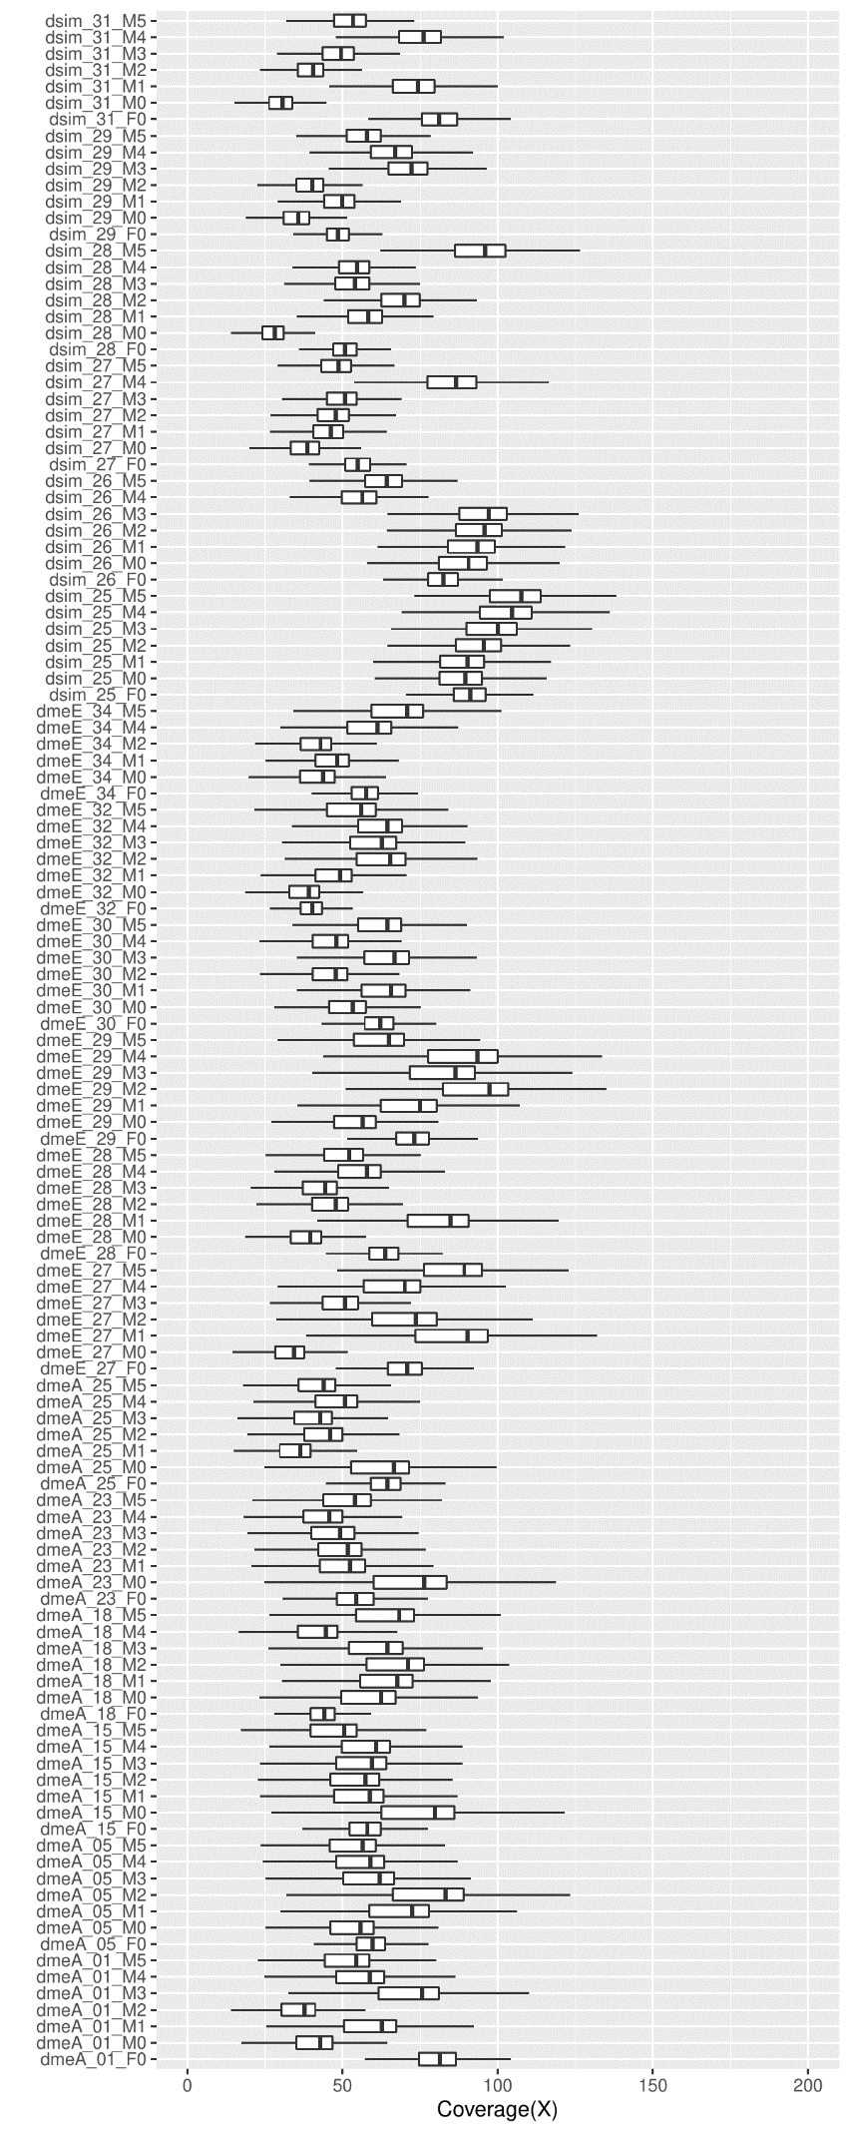
Supplemental_Fig_S1: Boxplots of sequencing coverage of all samples. Coverage was calculated as a mean value for each 1000bp window along the genome. Outliers are not shown in the figure. ‘dmeA’: the West African D. melanogaster; ‘dmeE’: the European D. melanogaster; ‘dsim’: the European D. simulans.

Supplemental_Fig_S1

Supplemental_Fig_S2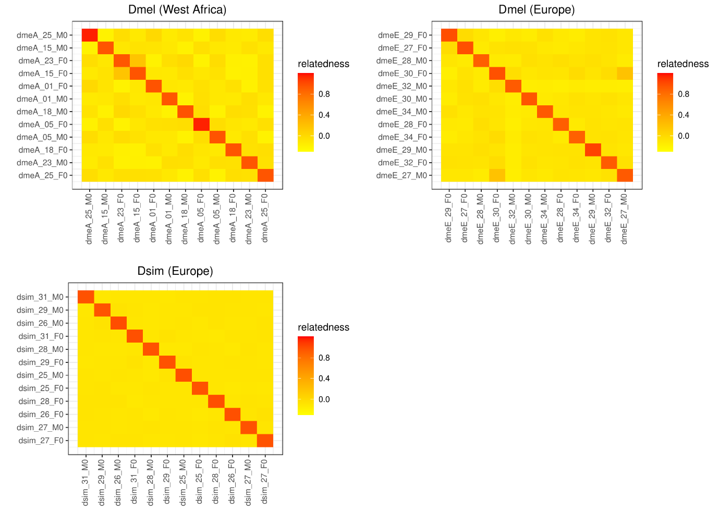

Supplemental_Fig_S2: The relatedness of the flies collected from the wild. For each population, we made 6 families by mating a female (‘F0’) and male (‘M0’). Two pairs in the D. melanogaster population (dmeA_15_F0 vs. dmeA_23_F0; dmeE_27_M0 vs. dmeE_30_F0) may be potentially 3rd degree relatives (e.g. first cousins).

Supplemental_Fig_S3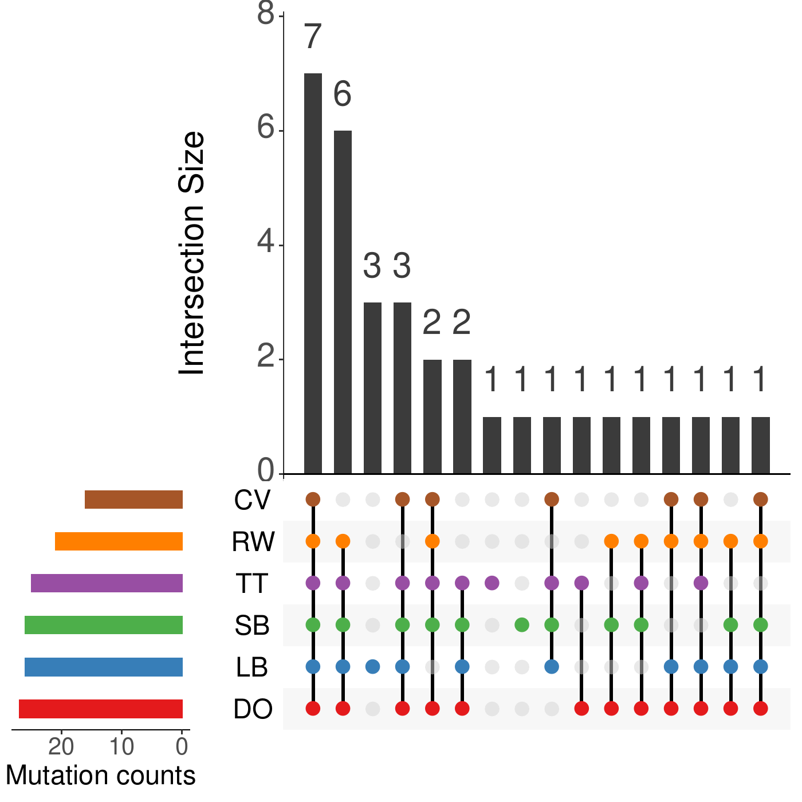
Supplemental_Fig_S3: The test of our SNMs pipeline on a trio dataset of rhesus macaques, which includes 33 PCR-confirmed de novo mutations of which we recovered 27 (here in red). The other research groups are - LB: Lucie Bergeron; SB: Søren Besenbacher; TT: Tychele Turner; RW: Richard Wang CV: Cyril Versoza.

Supplemental_Fig_S4

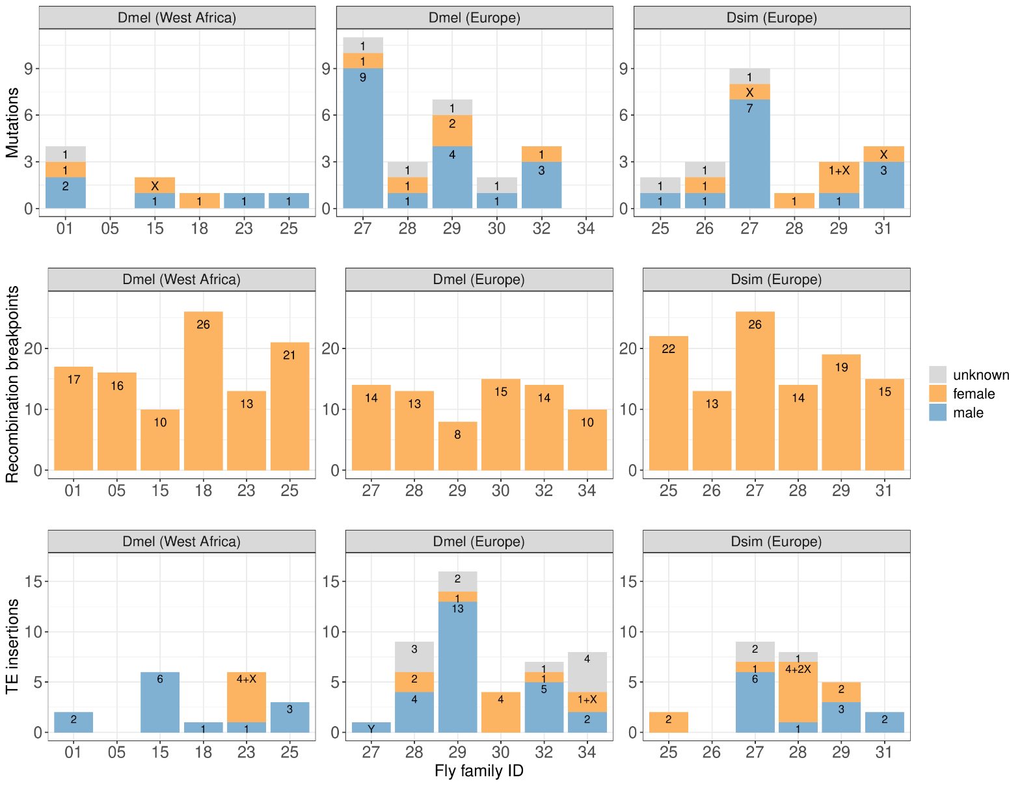
Supplemental_Fig_S4: The number of new variants in three Drosophila populations: the number of de novo SNMs (top panel), the number of recombination breakpoints (centre panel) and the number of TE insertions (bottom panel). For the SNMs and TEs, we used ‘X’ to indicate a new variant on the X chromosome and ‘Y’ on Y chromosome. Blue bars denote a variant originating in males; orange bars denote a variant originating in females; grey bars mean that the variation could not be assigned to one parent or the other due to lack of informative SNP markers.

Supplemental_Fig_S5
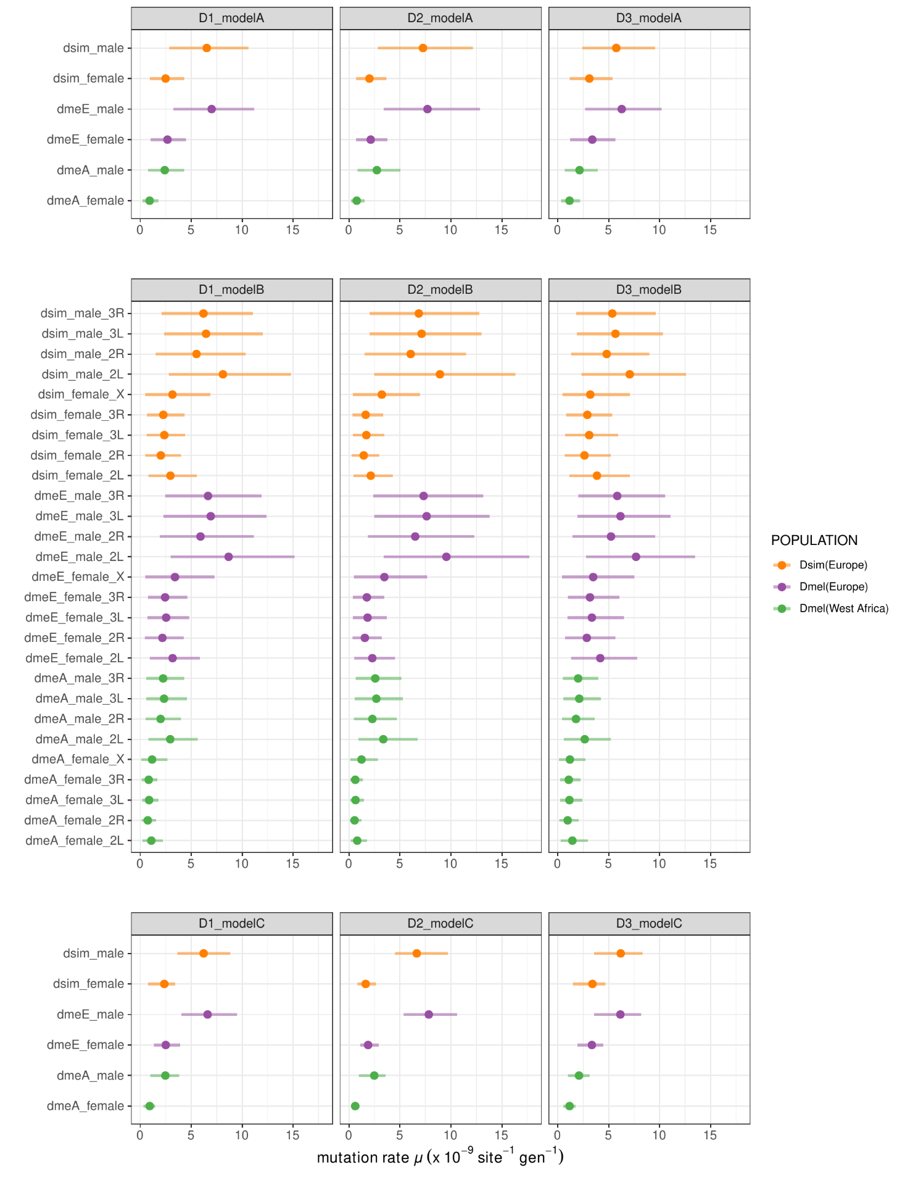
Supplemental_Fig_S5: The mutation rate and 95% CI estimated using different datasets and different models. Depending on how we assign the un-attributable mutations we created three datasets. ‘D1’: half of these mutations to the males and half to females; ‘D2’: all these mutations to males; ‘D3’: all these mutations to females. ‘modelA’ includes ‘POPULATION’ and ‘SEX as fixed effects and parental ID ‘PID’ as random effect; ‘modelB’ incorporates ‘CHROM’ as an additional fixed effect based on modelA; ‘modelC’ excludes random effect ‘PID’ from the modelA.

Supplemental_Fig_S6
(a)

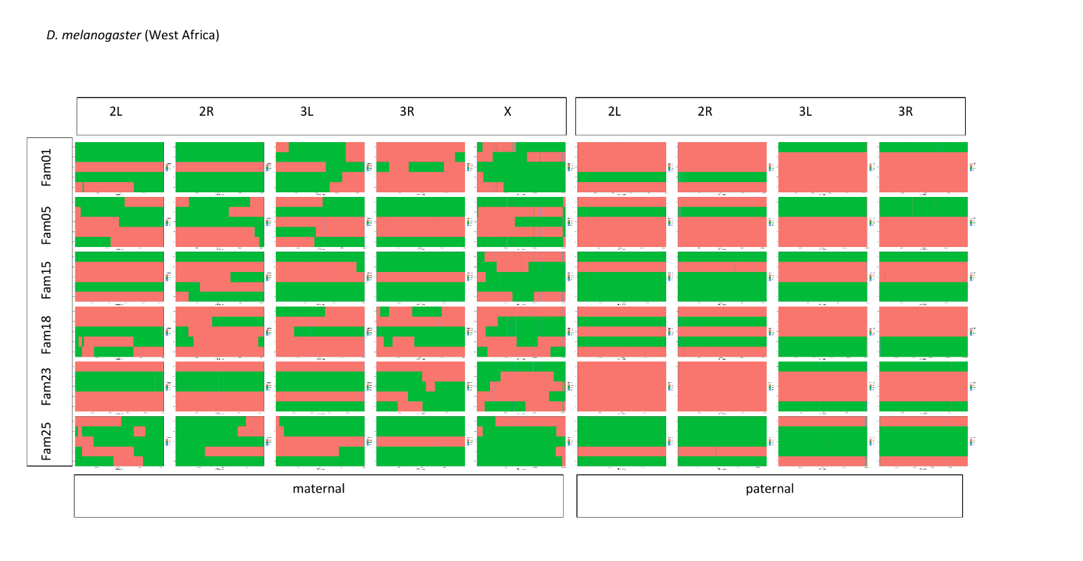
(b)
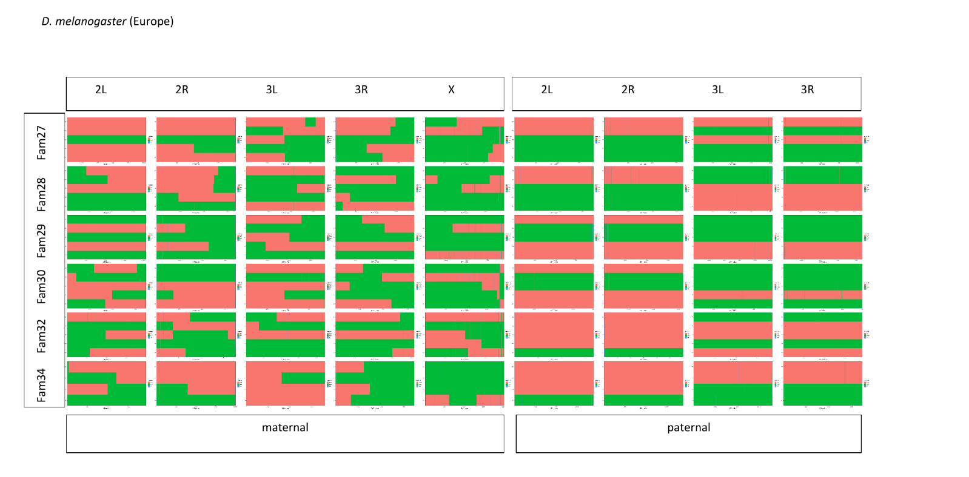

(c)
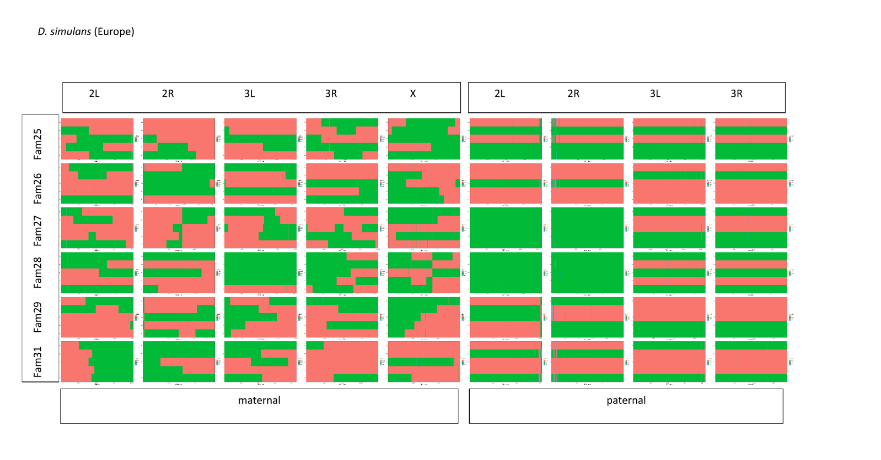

Supplemental_Fig_S6: The haplotypes phased using informative SNP markers for West African D. melanogaster (a), the European D. melanogaster (b) and the European D. simulans (c). The x-axis represents the SNP markers on chromosome arms. The y-axis represents the offspring in each family. Two colours are used to distinguish two different haplotypes in the mother or father.

Supplemental_Fig_S7
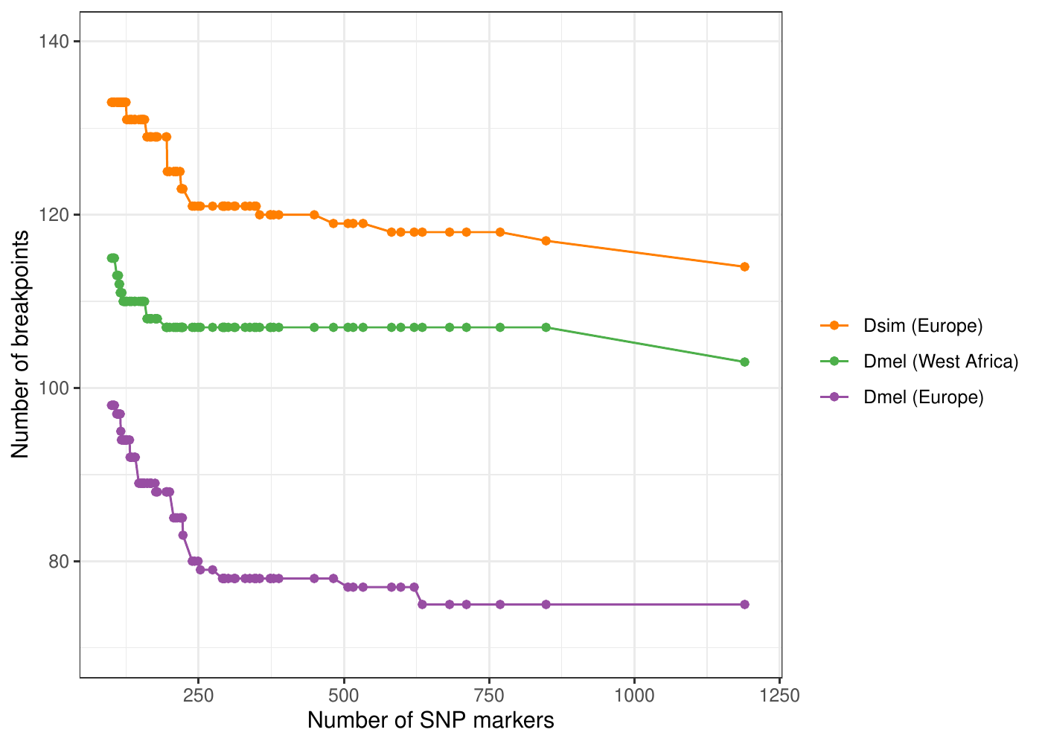
Supplemental_Fig_S7: The relationship between the threshold of SNP markers to infer a haplotype block and its resulting number of breakpoints. The x-axis is the threshold of SNP markers which we used to infer a haplotype block. Any haplotype block containing SNP markers less than the threshold will be considered as ‘noisy’. The y-axis represents the total number of inferred breakpoints across 5 families in each population given the threshold. We didn’t manually check and correct a few potentially phasing errors in this figure.

Supplemental_Fig_S8
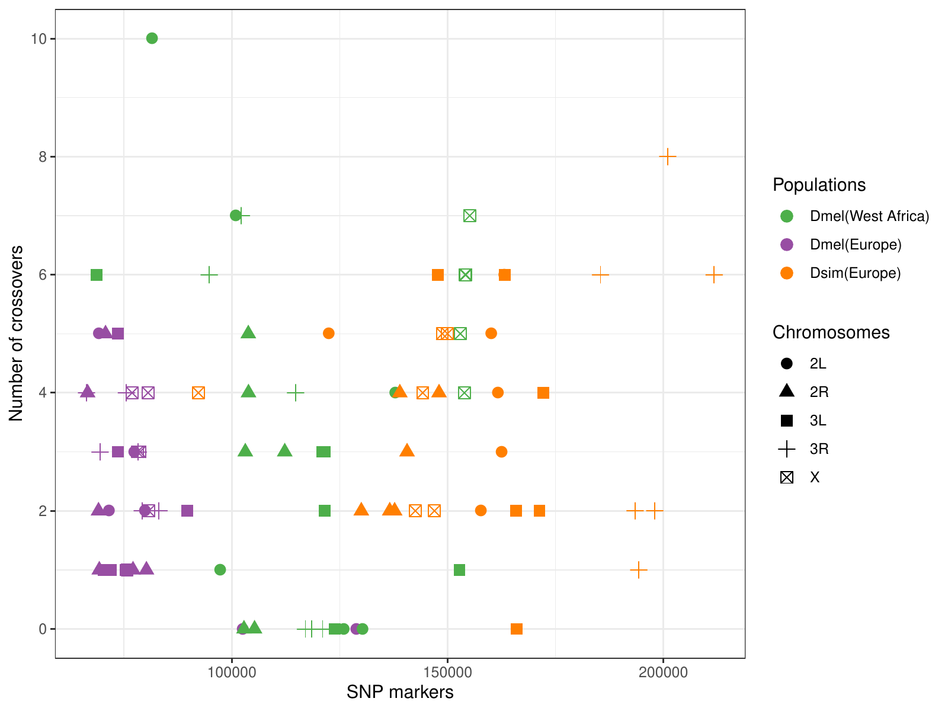
Supplemental_Fig_S8: The relationship between the number of SNP markers aggregated by family and the number of crossovers on different chromosomes.

Supplemental_Fig_S9
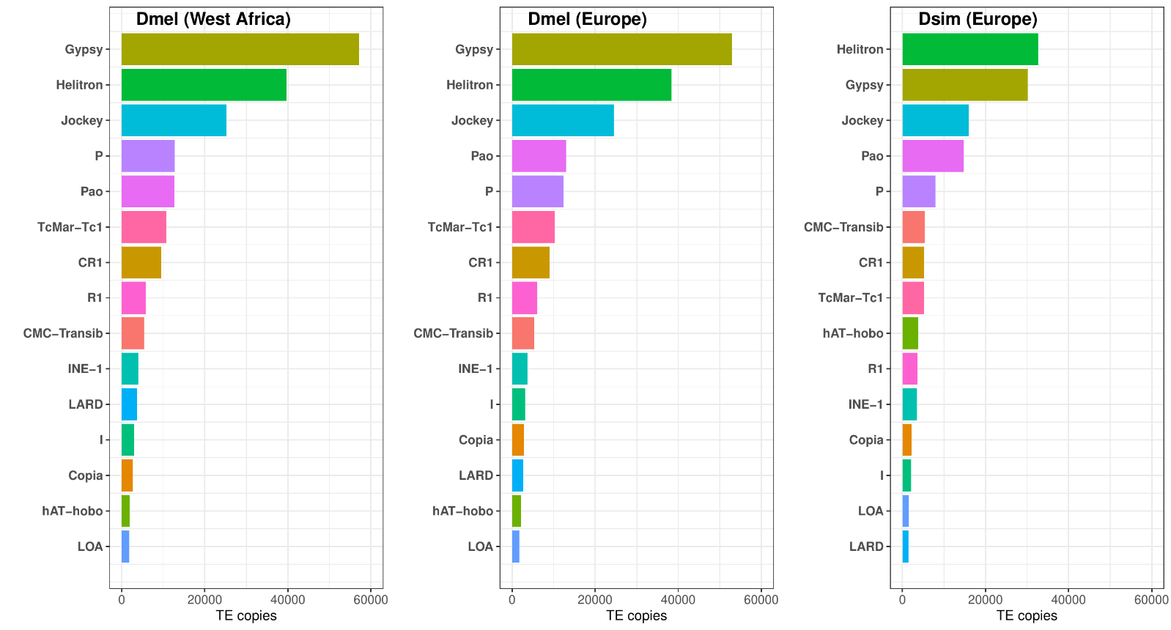
Figure S9: The total number of TE copies by TE super-family in 12 parental samples for each population. Only the top 15 most abundant TEs are shown.

Supplemental_Fig_S10
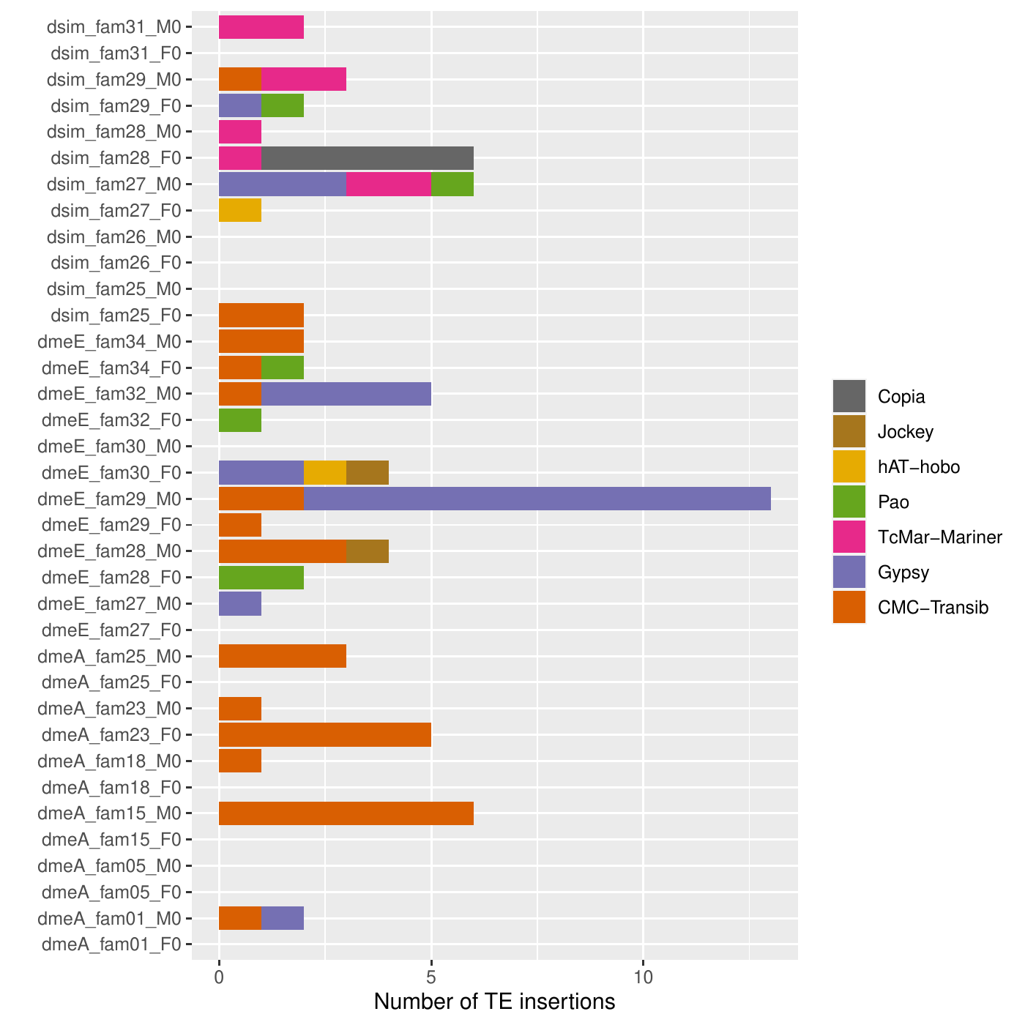
Supplemental_Fig_S10: The number of new TE insertions identified in each parental sample. We identified a total of 89 insertions and 13 of them were not attributable to the parents due to lack of informative SNP markers and not shown in the figure. ‘dmeA’: the West African D. melanogaster; ‘dmeE’: the European D. melanogaster; ‘dsim’: the European D. simulans. Sample names with ‘F0’ denote female (mother); ‘M0’ for male (father).

Supplementary tables
Supplemental_Table_S1: The number of SNMs and indel mutations in each family and their corresponding callable sites and estimated mutation rates.
Supplemental_Table_S2: The details of genomic inversions and recombination breakpoints.
Supplemental_Table_S3: The number of TE insertions and the corresponding insertion rate in each Drosophila family and TE superfamily.

Reference
Adrion JR, Song MJ, Schrider DR, Hahn MW, Schaack S. 2017. Genome-Wide Estimates of Transposable Element Insertion and Deletion Rates in Drosophila Melanogaster. Genome Biol Evol 9:1329-1340. doi: 10.1093/gbe/evx050.
Bergeron LA, Besenbacher S, Turner T, Versoza CJ, Wang RJ, Price AL, Armstrong E, Riera M, Carlson J, Chen HY, et al. 2022. The Mutationathon highlights the importance of reaching standardization in estimates of pedigree-based germline mutation rates. Elife 11:e73577. doi: 10.7554/eLife.73577.
Chakraborty M, Chang CH, Khost DE, Vedanayagam J, Adrion JR, Liao Y, Montooth KL, Meiklejohn CD, Larracuente AM, Emerson JJ. 2021. Evolution of genome structure in the Drosophila simulans species complex. Genome Res 31:380-396. doi: 10.1101/gr.263442.120.
Charif D, Lobry JR. 2007. SeqinR 1.0-2: a contributed package to the R project for statistical computing devoted to biological sequences retrieval and analysis. In Structural approaches to sequence evolution. pp. 207-232. Springer. Berlin, Heidelberg.
Comeron JM, Ratnappan R, Bailin S. 2012. The Many Landscapes of Recombination in Drosophila melanogaster. Plos Genet 8:e1002905. doi: 10.1371/journal.pgen.1002905.
Danecek P, Auton A, Abecasis G, Albers CA, Banks E, DePristo MA, Handsaker RE, Lunter G, Marth GT, Sherry ST, et al. 2011. The variant call format and VCFtools. Bioinformatics 27:2156-2158. doi: 10.1093/bioinformatics/btr330.
Ewing AD. 2015. Transposable element detection from whole genome sequence data. Mob DNA 6:1-9. doi: 10.1186/s13100-015-0055-3.
Hadfield J. 2010. MCMC Methods for Multi-Response Generalized Linear Mixed Models: The MCMCglmm R Package. J Stat Softw 33:1-22. doi: DOI 10.18637/jss.v033.i02.
Hadfield J. 2014. MCMCglmm course notes.[cited 23 Sept 2022]. Available from: https://cran.microsoft.com/snapshot/2018-07-12/web/packages/MCMCglmm/vignettes/CourseNotes.pdf
Kapun M, van Schalkwyk H, McAllister B, Flatt T, Schlotterer C. 2014. Inference of chromosomal inversion dynamics from Pool-Seq data in natural and laboratory populations of Drosophila melanogaster. Mol Ecol 23:1813-1827. doi: 10.1111/mec.12594.
Keightley PD, Ness RW, Halligan DL, Haddrill PR. 2014. Estimation of the Spontaneous Mutation Rate per Nucleotide Site in a Drosophila melanogaster Full-Sib Family. Genetics 196:313-320. doi: 10.1534/genetics.113.158758.
Li H. 2013. Aligning sequence reads, clone sequences and assembly contigs with BWA-MEM. arXiv preprint arXiv:1303.3997. doi: 10.48550/arXiv.1303.3997.
Li H. 2011. A statistical framework for SNP calling, mutation discovery, association mapping and population genetical parameter estimation from sequencing data. Bioinformatics 27:2987-2993. doi: 10.1093/bioinformatics/btr509.
Martin M. 2011. Cutadapt removes adapter sequences from high-throughput sequencing reads. EMBnet. journal 17:10-12.
McKenna A, Hanna M, Banks E, Sivachenko A, Cibulskis K, Kernytsky A, Garimella K, Altshuler D, Gabriel S, Daly M, et al. 2010. The Genome Analysis Toolkit: a MapReduce framework for analyzing next-generation DNA sequencing data. Genome Res 20:1297-1303. doi: 10.1101/gr.107524.110.
Miles A, Harding NJ, Botta G, Clarkson CS, Antao T, Kozak K, Schrider DR, Kern AD, Redmond S, Sharakhov I, et al. 2017. Genetic diversity of the African malaria vector Anopheles gambiae. Nature 552:96-100. doi: 10.1038/nature24995.
Miller DE, Smith CB, Kazemi NY, Cockrell AJ, Arvanitakas AV, Blumenstiel JP, Jaspersen SL, Hawley RS. 2016. Whole-Genome Analysis of Individual Meiotic Events in Drosophila melanogaster Reveals That Noncrossover Gene Conversions Are Insensitive to Interference and the Centromere Effect. Genetics 203:159-171. doi: 10.1534/genetics.115.186486.
Morgan TH. 1912. Complete linkage in the second chromosome of the male of Drosophila. Science 36:719-720.
R Core Team R. 2021. R: A language and environment for statistical computing. R Foundation for Statistical Computing. Vienna, Austria.
Rech GE. 2021. Fasta sequences for the Drosophila melanogaster Manually Curated Transposable Elements (MCTE) library. DIGITAL.CSIC. doi: 10.20350/digitalCSIC/13765.
Rimmer A, Phan H, Mathieson I, Iqbal Z, Twigg SRF, Wilkie AOM, McVean G, Lunter G, Consortium W. 2014. Integrating mapping-, assembly- and haplotype-based approaches for calling variants in clinical sequencing applications. Nat Genet 46:912-918. doi: 10.1038/ng.3036.
Robinson JT, Thorvaldsdottir H, Winckler W, Guttman M, Lander ES, Getz G, Mesirov JP. 2011. Integrative genomics viewer. Nat Biotechnol 29:24-26. doi: 10.1038/nbt.1754.
Yang JA, Lee SH, Goddard ME, Visscher PM. 2011. GCTA: A Tool for Genome-wide Complex Trait Analysis. Am J Hum Genet 88:76-82. doi: 10.1016/j.ajhg.2010.11.011.

