Contents

Supplemental Figures
Figure S1: Summary of previous reports of spl-TR candidates
Figure S2: Effects of genotype quality thresholds on spl-TR mapping
Figure S3: Spl-TR sharing across tissues
Figure S4: Examples of TR-splicing associations independent of nearby variants
Figure S5. Mini-gene vector assay of representative spl-TRs
Figure S6. In-silico mutagenesis of NARS2 allele using SpliceAI
Figure S7. Splicing alterations by the spl-TR in DM1

Supplemental References
Supplemental Figures
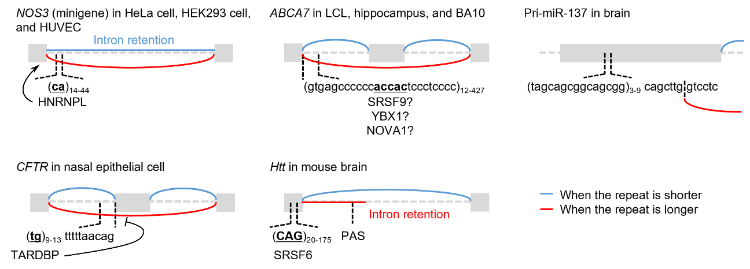
Figure S1. Summary of previous reports of spl-TR candidates
Shown are exon and intron structures and affected splicing patterns when the associated TR is shorter or longer in NOS3 (Hui et al. 2003), ABCA7 (De Roeck et al. 2018), Pri-miR-137 (Pacheco et al. 2019), CFTR (Cuppens et al. 1998; Buratti and Baralle 2001; Buratti et al. 2001), and Htt (Sathasivam et al. 2013). RBPs bound to the repeats are shown below the bold and underlined binding motif. For ABCA7, the RBPs were predicted only in silico. Normal and blunt arrows represent enhanced or weakened exon inclusion by RBPs. LCL: lymphoblastoid cell line; BA10: brain Brodmann area 10; HeLa: Henrietta Lacks; HEK: human embryonic kidney; HUVEC: human umbilical vein endothelial cell; PAS: poly-adenylation site.

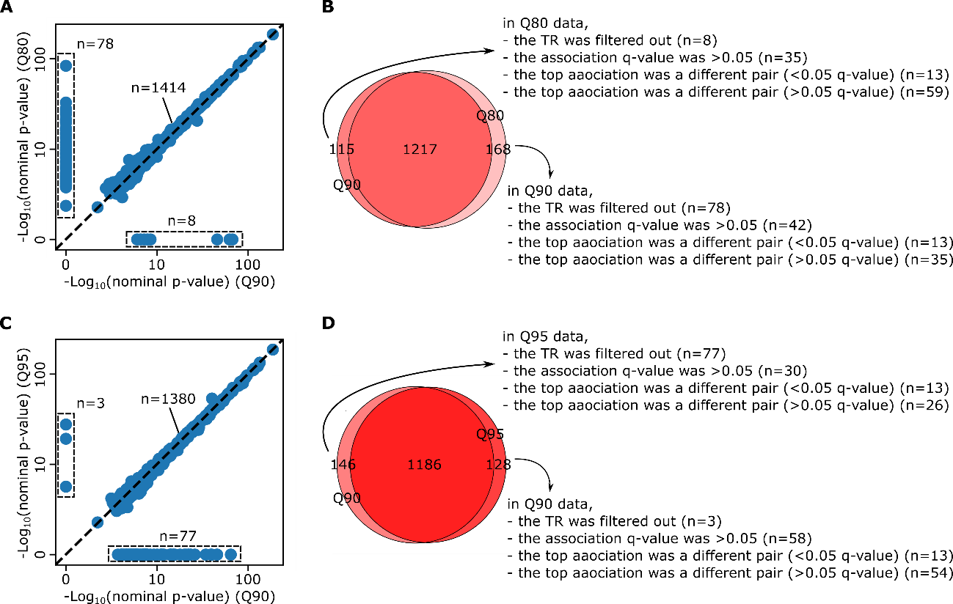
Figure S2. Effects of genotype quality thresholds on spl-TR mapping
(A and C) Correlation of nominal p-value of whole blood TR-splicing associations significant (< 0.05 q-value) in spl-TR mapping employing genotype quality (Q) thresholds of 0.9 or 0.8 (A) and 0.9 or 0.95 (C). Dashed diagonal lines: y = x. (B and D) Overlap between TR-splicing associations significant (< 0.05 q-value) in spl-TR mapping employing genotype quality thresholds of 0.9 or 0.8 (B) and 0.9 or 0.95 (D). The reasons why some associations were observed solely in either of the two sets of data were classified into four groups: 1) the TR was filtered out; 2) the q-value of the association was > 0.05; 3) the top association in the gene was a different pair of TR and splicing (< 0.05 q-value); and 4) the top association in the gene was a different pair of TR and splicing (> 0.05 q-value).

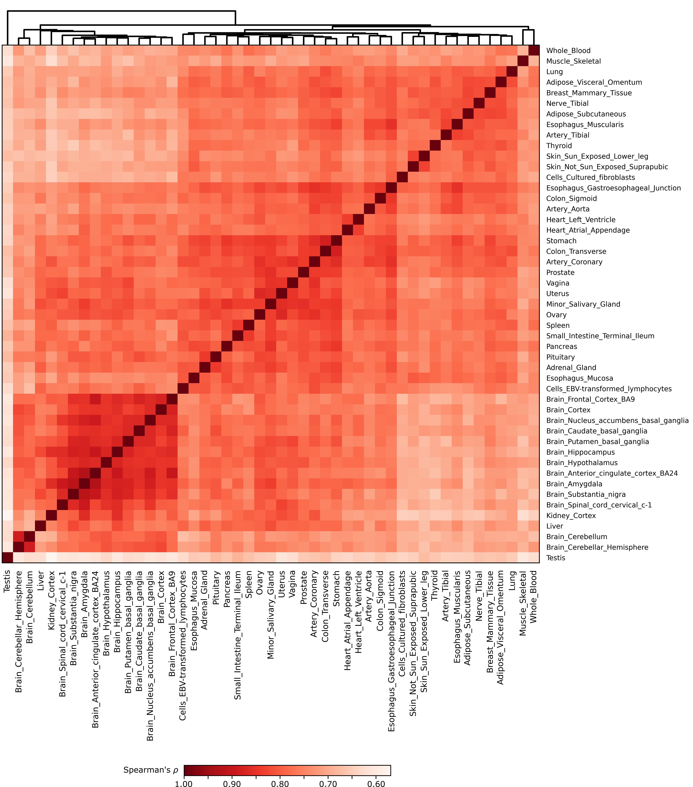
Figure S3. Spl-TR sharing across tissues
Tissue clustering with pairwise Spearman’s correlation of effect sizes of TR-splicing pairs. Only TR-splicing pairs significant (q-value < 0.05) in at least one of the two tissues were considered in each cell. Rows and columns are clustered using hierarchical clustering. The color bar represents Spearman’s correlation coefficient (ρ).
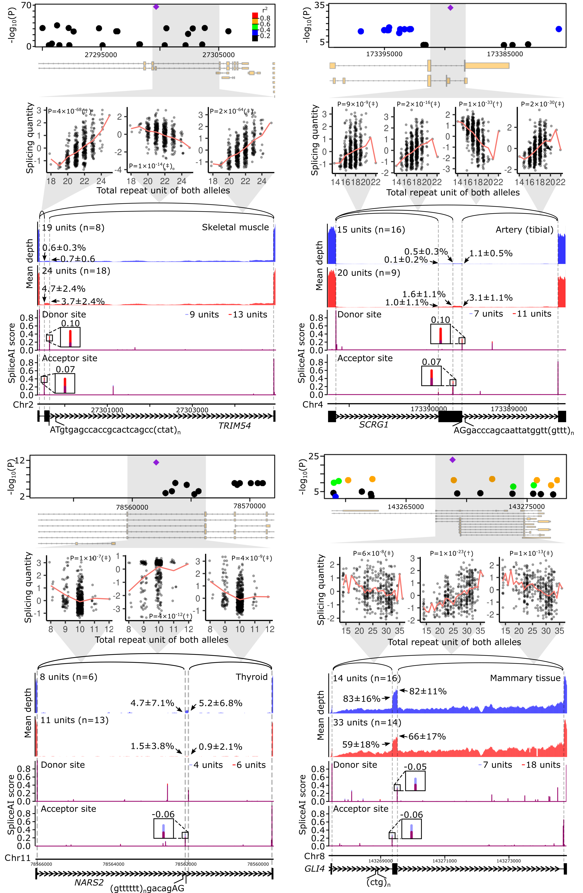
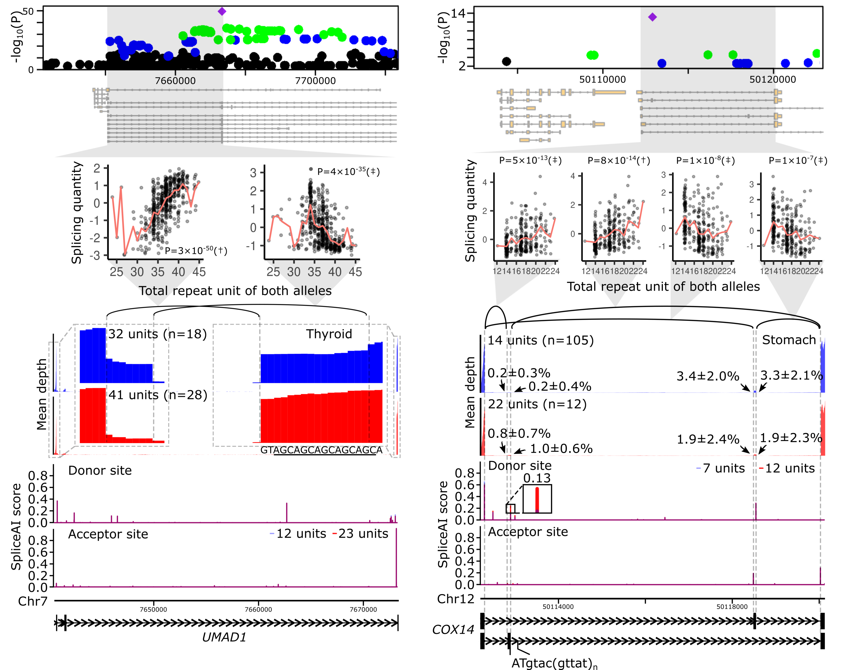
Figure S4. Examples of TR-splicing associations independent of nearby variants
Representative spl-TRs associated with splicing variation independently of nearby variants. Shown are associations of spl-TRs and neighboring variants with splicing quantity (top panel), correlations between TR dosages and splicing quantities (second panel from the top), mean RNA-seq depth of samples with a smaller or larger TR dosage (third panel from the top), SpliceAI scores of splice donor or acceptor site for sequences having a shorter or longer TR allele (fourth panel from the top), and representative exon–intron structures (bottom). (Top panel) Only variants whose nominal p-value was < 0.01 are shown. Purple diamond: spl-TR; circle: other variants color-coded according to Pearson correlation coefficient between dosages of the variant and the spl-TR. (Second panel from the top) The splicing quantity indicates the normalized proportion in clustered splicing events (see “Mapping of spl-TRs” in Methods). The red line indicates the mean at each TR dosage. Nominal p-values of linear regression analysis in FastQTL are shown in each plot. †: the top association in the gene (q-value < 0.05); ‡: other significant associations (p-value threshold: TRIM54: 6.1 × 10⁻⁵; SCRG1: 8.3 × 10⁻⁵; NARS2: 3.7 × 10⁻⁵; GLI4: 3.7 × 10⁻⁵; UMAD1: 7.3 × 10⁻⁵; COX14: 4.4 × 10⁻⁵; see “Identification of all significant TR-splicing pairs in each gene” in Methods). (Third panel from the top) arrow: mean ± standard deviation of ψ₅ or ψ₃ of the junction. (Fourth panel from the top) Because SpliceAI scores are almost the same between shorter (blue) and longer (red) TR alleles, the bars look purple in the most plotted region. The inset is a magnified image of junctions of splicing events whose alteration by TRs was supported by SpliceAI. The differences in SpliceAI scores between shorter and longer TR alleles are shown above or below insets.
.

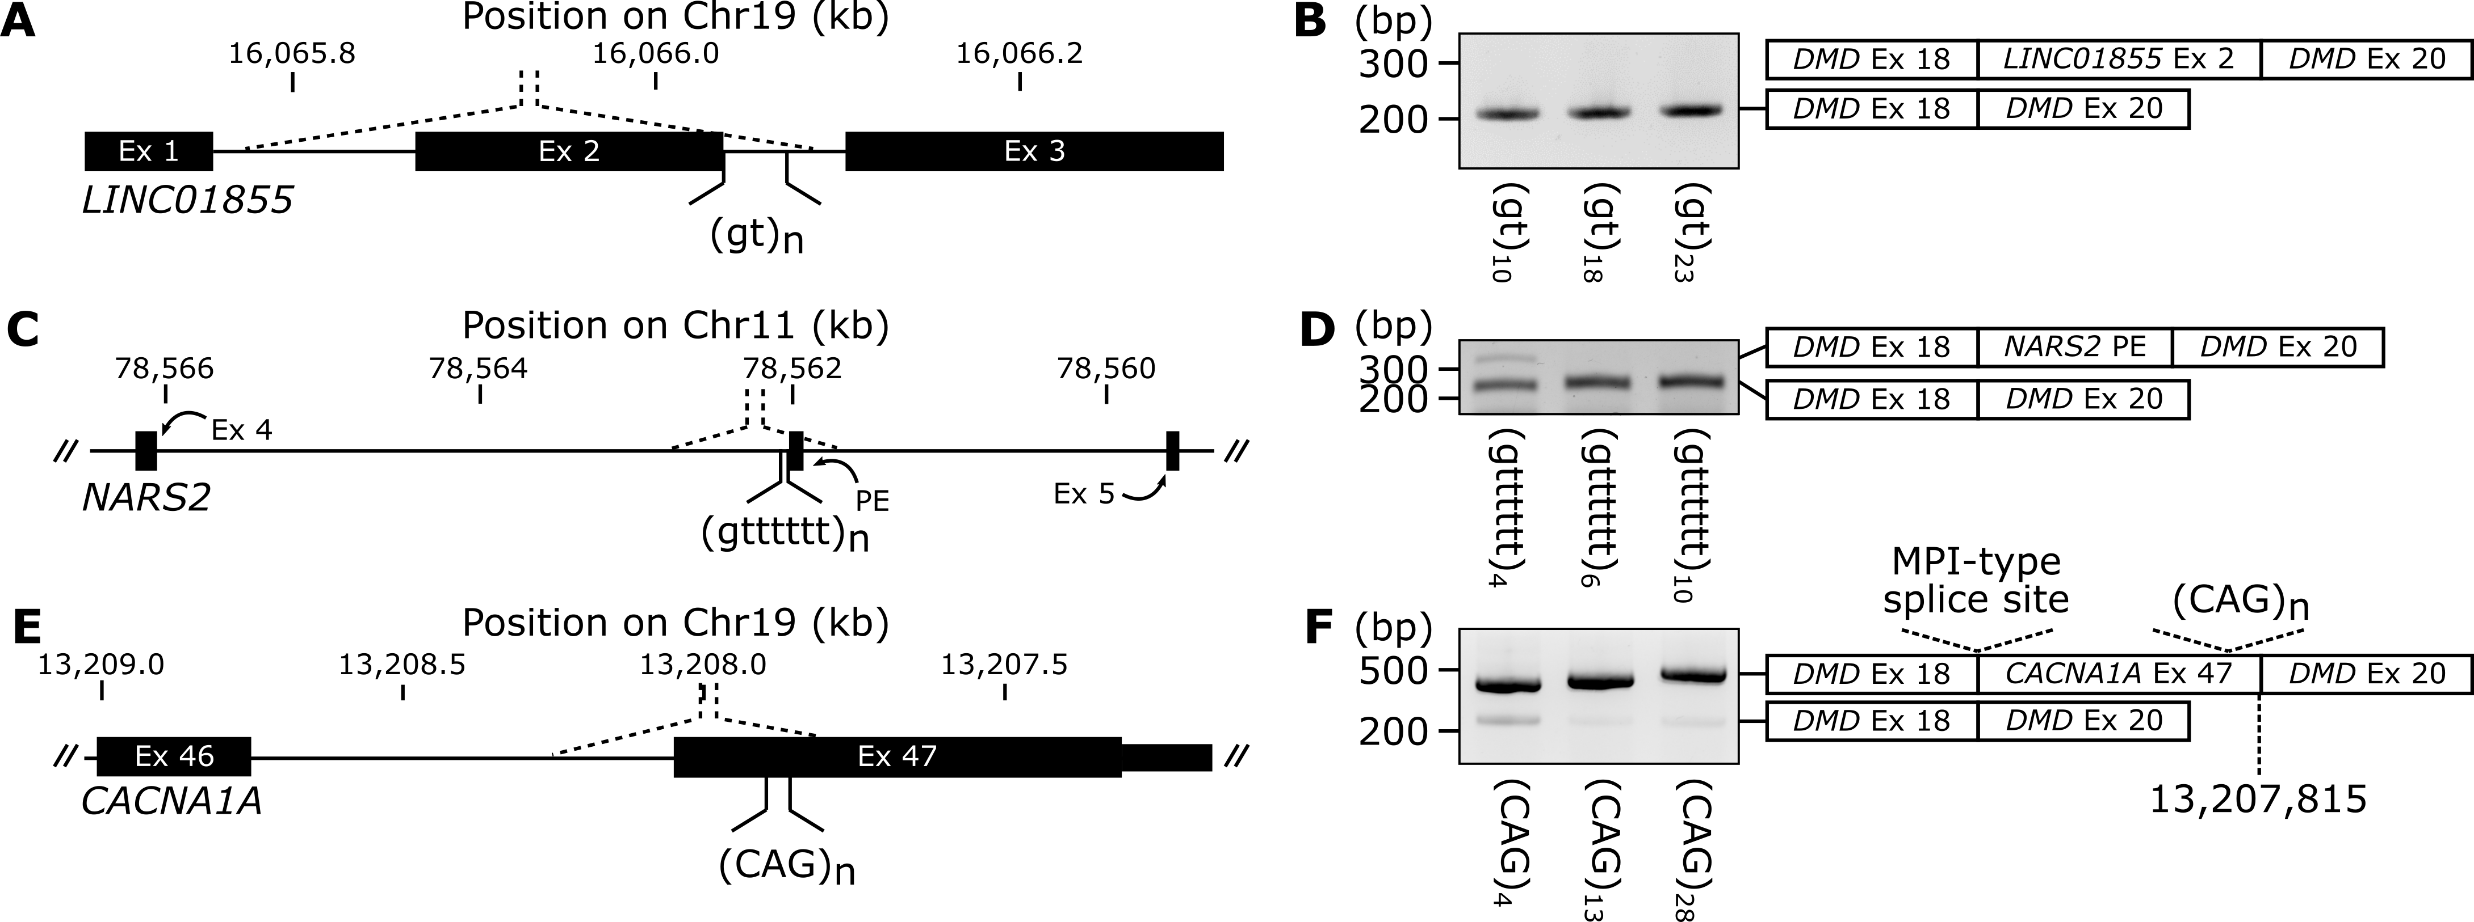
Figure S5. Mini-gene vector assay of representative spl-TRs
(A, C, and E) Schematic representation of inserts of mini-gene vectors (see Fig. 3E): A, LINC01855 (Fig. 2C); C, NARS2 (Fig. S4); and E, CACNA1A (Fig. 4A). Dotted line indicates the inserted genomic region. (B, D, and F) RT-PCR products of minigene assay for LINC01855 (B), NARS2 (D), and CACNA1A (F). Shown on the right is a schematic description of the products. For CACNA1A, the longer product adopted the MPI-type splice site for the first 3’ splice site (see Fig. 4A) and the nucleotide at Chr19:13,207,815 for the second 5’ splice site (F). Since isoforms harboring the MPc- or MPII-type splice site were not observed, the effect of TR size on isoform switching could not be evaluated in this experimental system. Ex: exon; PE: pseudoexon.

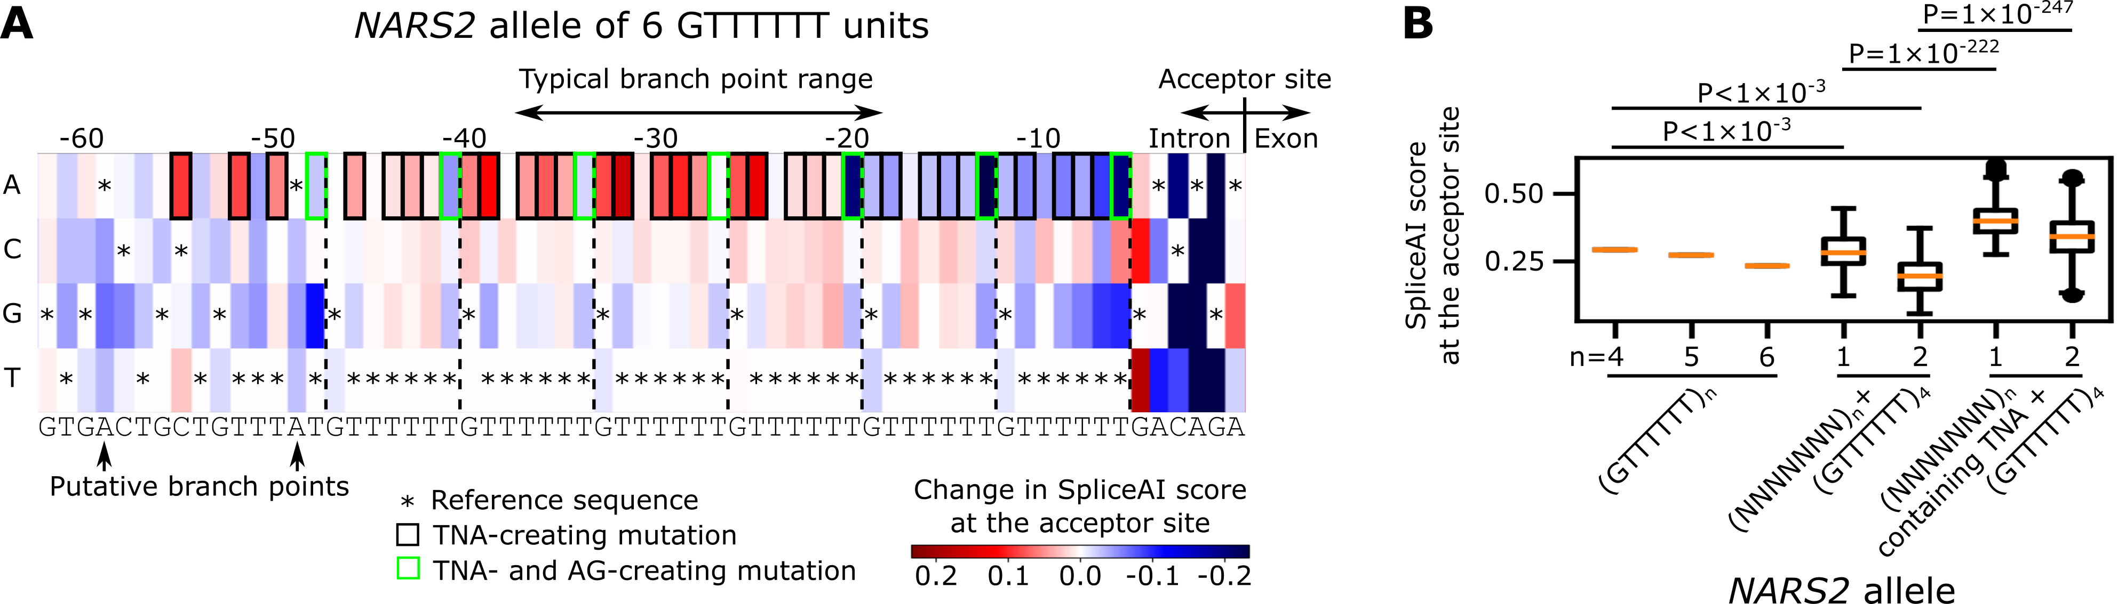
Figure S6. In-silico mutagenesis of NARS2 allele using SpliceAI
(A) In silico saturated mutagenesis analysis of the spl-TR and flanking sequences (Chr11:78,562,027–78,562,082) at the 3′-splice site of NARS2 using SpliceAI. Column: base position in the sequence; row: the reference base and three possible base substitutions; cell color: change in the SpliceAI probability that the rightmost column is an acceptor site; *: reference base. Mutations creating TNA (branch site motif) and AG (acceptor site motif) are bordered as indicated below. (B) Box plots summarizing SpliceAI probabilities that Chr11:78,562,027 (the rightmost column in A) was an acceptor site when the NARS2 spl-TR at Chr11:78,562,032-78,562,066 (GTTTTTT repeat) was mutated. The GTTTTTT repeat was replaced by three types of sequences: 1) (GTTTTTT)_{4, 5, or 6}, 2) (NNNNNNN)_{1 or 2} (not containing TNA, AG, and TTT) + (GTTTTTT)₄, and 3) (NNNNNNN)_{1 or 2} (not containing AG and TTT but TNA) + (GTTTTTT)₄. For the latter two types, 200 random sequences were generated. Difference in medians between the first and second sequence types were assessed using the bootstrapping method while that between the second and third were done with Wilcoxon rank sum test.
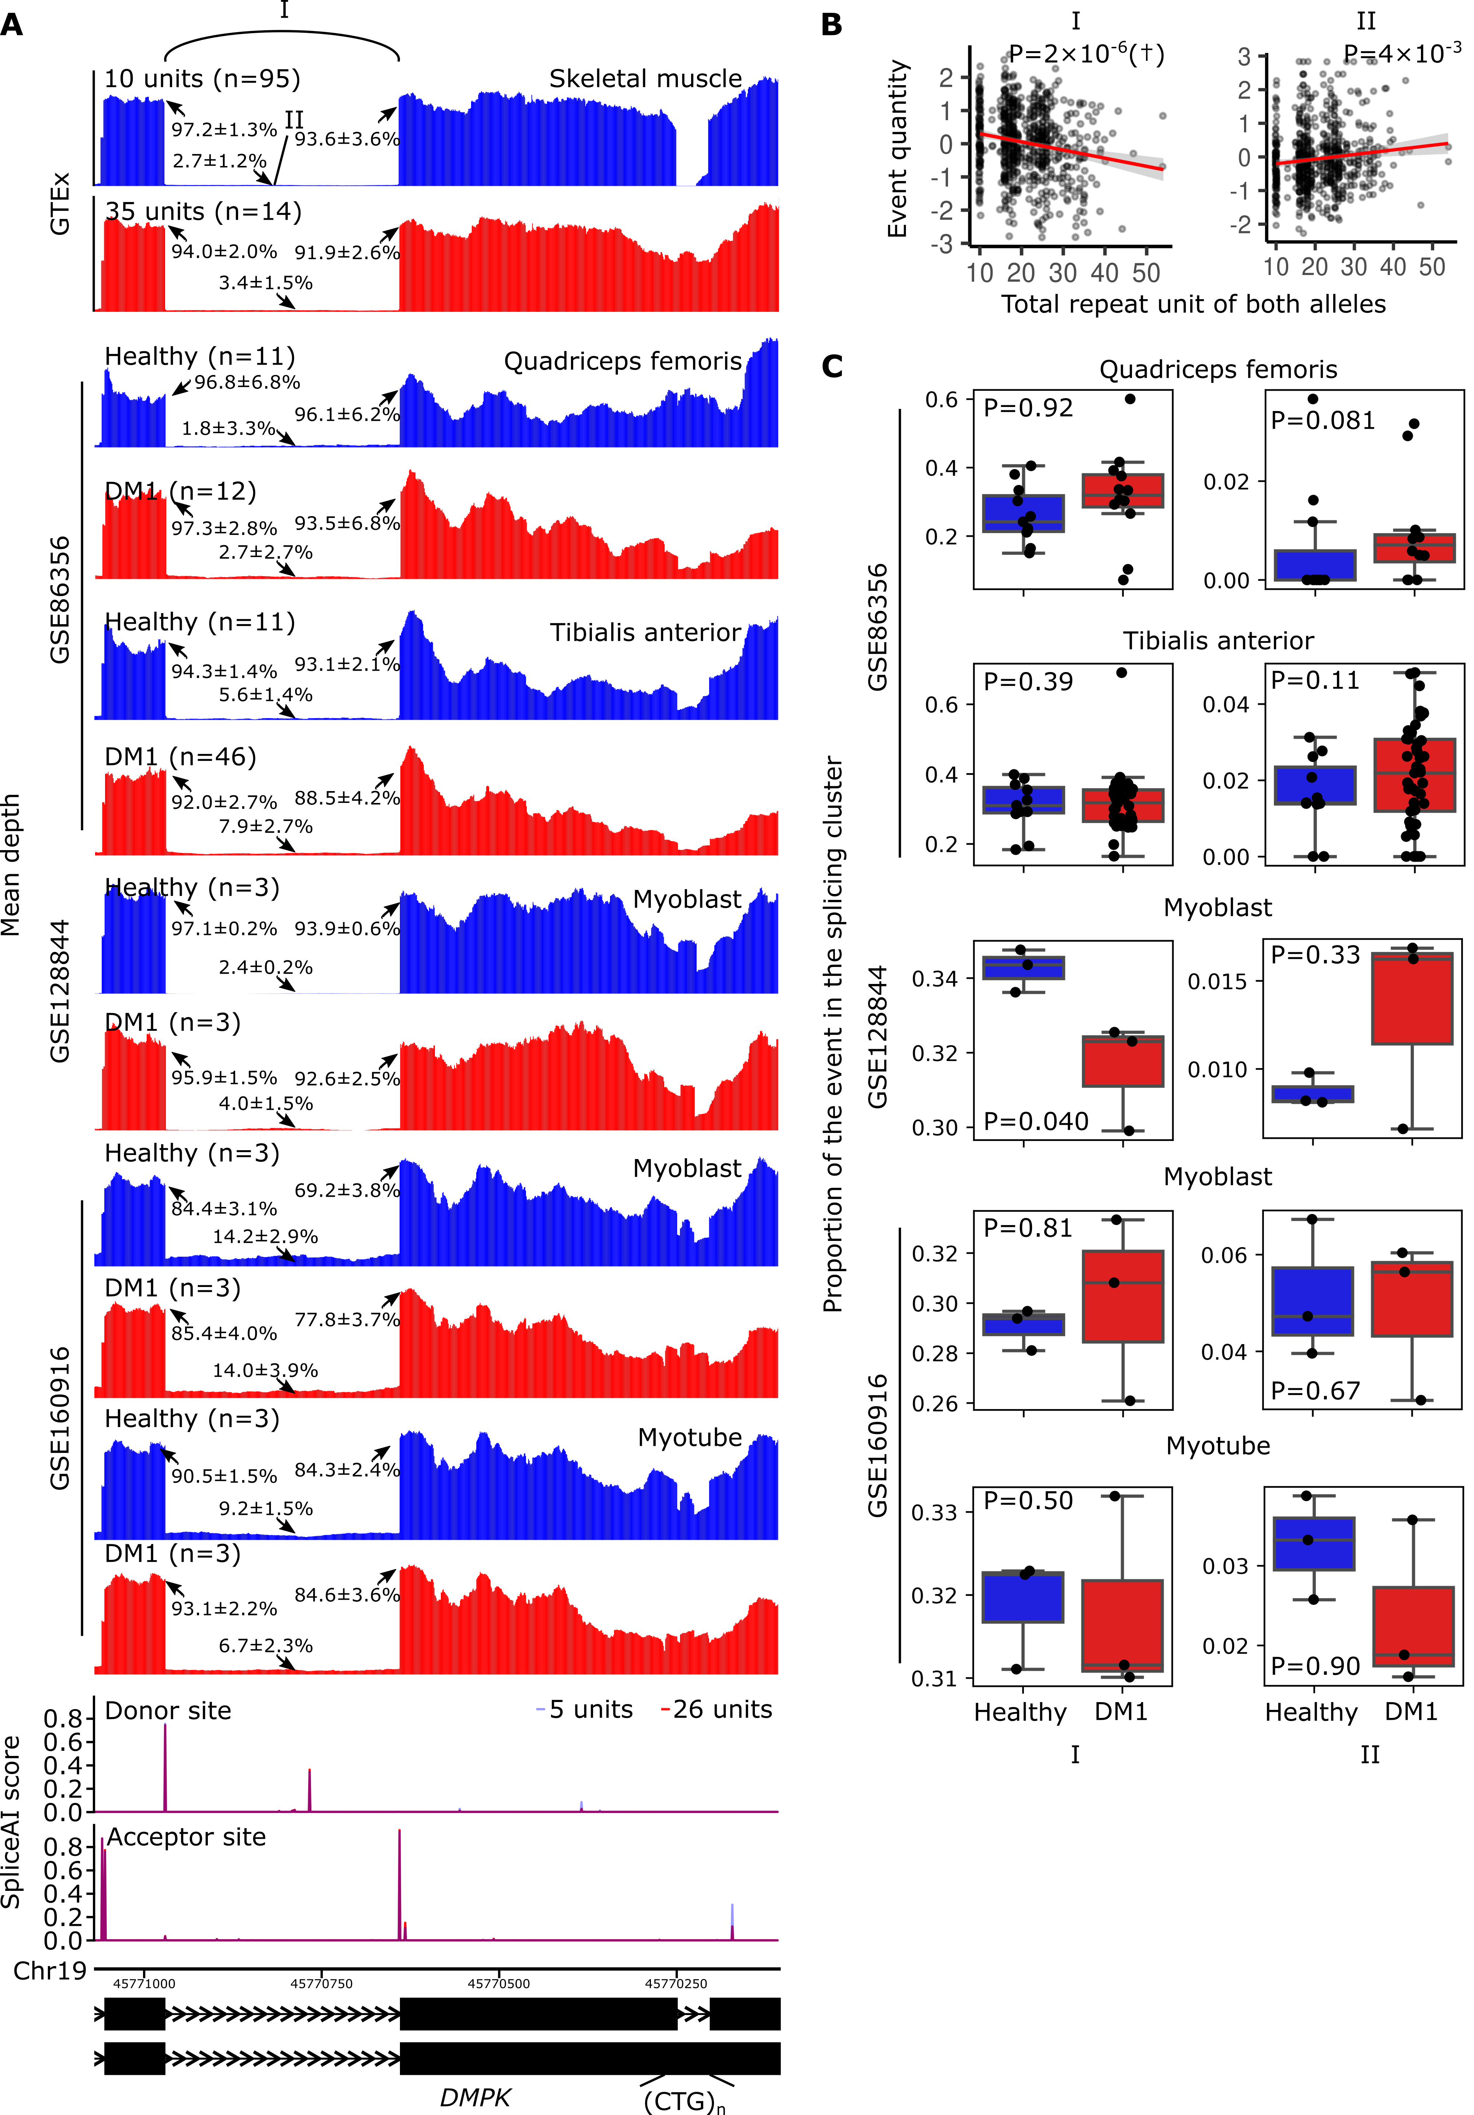Figure S7. Splicing alterations by the spl-TR in DM1
(A) Mean RNA-seq coverage of samples with a smaller or larger TR dosage in GTEx data and DM1 and healthy control samples in GSE86356 (quadriceps femoris and tibialis anterior), GSE128844 (myoblast), and GSE160916 (myoblast and myotube) data. SpliceAI scores of splice donor or acceptor site for sequences having a shorter or longer TR allele, and exon–intron structures (ENST00000618091.4 and bottom: ENST00000600757.5) are shown below. Arrows indicate mean ± standard deviation of θ₅ or θ₃ of the splicing or (θ₅ + θ₃) / 2 of the intron retention. (B) Correlations between TR dosages and splicing or intron quantities among GTEx skeletal muscle samples. The splicing quantity indicates the normalized proportion in clustered splicing events (see “Mapping of spl-TRs” in Methods). The nominal p-values of linear regression performed by FastQTL are shown above. The nominal p-value threshold for all TR-splicing pairs in DMPK was 2 × 10⁻⁵. The red line and gray shading represent the regression line and 95% confidence interval, respectively. The marks, I and II, corresponds to those in panel A. †: the top association in the gene (q-value < 0.05). (C) Box plot summarizing the proportion of the splicing (left) or intron retention (right) event in the splicing cluster in GSE86356, GSE128844, and GSE160916 data. P-values of one-sided Wilcoxon rank sum test are shown. The significance threshold was 0.01, Bonferroni-corrected threshold for the number of tests (n = 5). The marks, I and II, correspond to those in panel A.

Supplemental References
Buratti E, Baralle FE. 2001. Characterization and functional implications of the RNA binding properties of nuclear factor TDP-43, a novel splicing regulator of CFTR exon 9. The Journal of biological chemistry 276: 36337-36343. doi:10.1074/jbc.M104236200.
Buratti E, Dörk T, Zuccato E, Pagani F, Romano M, Baralle FE. 2001. Nuclear factor TDP-43 and SR proteins promote in vitro and in vivo CFTR exon 9 skipping. The EMBO journal 20: 1774-1784. doi:10.1093/emboj/20.7.1774.
Cuppens H, Lin W, Jaspers M, Costes B, Teng H, Vankeerberghen A, Jorissen M, Droogmans G, Reynaert I, Goossens M et al. 1998. Polyvariant mutant cystic fibrosis transmembrane conductance regulator genes. The polymorphic (Tg)m locus explains the partial penetrance of the T5 polymorphism as a disease mutation. The Journal of clinical investigation 101: 487-496. doi:10.1172/jci639.
De Roeck A, Duchateau L, Van Dongen J, Cacace R, Bjerke M, Van den Bossche T, Cras P, Vandenberghe R, De Deyn PP, Engelborghs S et al. 2018. An intronic VNTR affects splicing of ABCA7 and increases risk of Alzheimer's disease. Acta neuropathologica 135: 827-837. doi:10.1007/s00401-018-1841-z.
Hui J, Stangl K, Lane WS, Bindereif A. 2003. HnRNP L stimulates splicing of the eNOS gene by binding to variable-length CA repeats. Nature structural biology 10: 33-37. doi:10.1038/nsb875.
Pacheco A, Berger R, Freedman R, Law AJ. 2019. A VNTR Regulates miR-137 Expression Through Novel Alternative Splicing and Contributes to Risk for Schizophrenia. Scientific reports 9: 11793. doi:10.1038/s41598-019-48141-0.
Sathasivam K, Neueder A, Gipson TA, Landles C, Benjamin AC, Bondulich MK, Smith DL, Faull RL, Roos RA, Howland D et al. 2013. Aberrant splicing of HTT generates the pathogenic exon 1 protein in Huntington disease. Proceedings of the National Academy of Sciences of the United States of America 110: 2366-2370. doi:10.1073/pnas.1221891110.

