Supplemental Figures for

Coordination of zygotic genome activation entry and exit by H3K4me3 and H3K27me3 in porcine early embryos
Guowei Bu ^{1,2†}, Wei Zhu ^{1,2†}, Xin Liu ^{1,2†}, Jingjing Zhang ^{1,2}, Longtao Yu ^{1,2}, Kai Zhou ^{1,2}, Shangke Wang ^{1,2}, Zhekun Li ^{1,2}, Zhengang Fan ^{1,2}, Tingting Wang ^{1,2}, Taotao Hu ^{1,2}, Ruifeng Hu ^{1,2}, Zhiting Liu ^{1,2}, Tao Wang ^{1,2}, Linhui Wu ^{1,2}, Xia Zhang ^{1,2}, Shuhong Zhao ² and Yi-Liang Miao ^{1,2,3,4,5*}

*Corresponding author. Email: miaoyl@mail.hzau.edu.cn

Supplemental_Fig_S1
Supplemental_Fig_S1. Quality assessments of ULI-NChIP-seq dataset. (A) Scatter plots showing the Pearson’s correlations of replicates for H3K4me3 and H3K27me3 ChIP-seq data. Samples are porcine germinal vesicle (GV) and metaphase II (MII) oocytes, and in vitro fertilized (IVF) embryos at the zygote (1C), two-cell (2C), four-cell (4C), eight-cell (8C), morula (Mo), and blastocyst (Bl) stages. (B) Box plots summarizing the peak width and peak enrichment of H3K4me3 and H3K27me3 at promoter and distal regions in porcine oocytes and early embryos. (C) A genome browser snapshot showing H3K27me3 dynamics in porcine oocytes and early embryos (left panel). Evaluation of H3K27me3 ChIP-seq library complexity (right panel) by Non-Redundant Fraction (NRF), PCR Bottleneck 1 (PCB1) and PCR Bottleneck 2 (PCB2) with 10 M sequencing fragments in each sample. Zygotic H3K27me3 exhibits the lowest parameters for ChIP-seq library complexity.

Supplemental_Fig_S2
Supplemental_Fig_S2. The dynamics of H3K4me3 and H3K27me3 in porcine oocytes and early embryos. (A) Immunostaining of H3K4me3 (red), H3K27me3 (red) and DNA (blue) in porcine MII oocytes and IVF embryos at the 1C, 2C, 4C, 8C, Mo and Bl stages. Porcine fetus fibroblast (PFF) is used as a positive control. One of the nuclei in each sample is magnified 9-fold. Scale bar, 50 μm. (B) Boxplots showing the fluorescent intensity of H3K4me3 and H3K27me3 in porcine oocytes and early embryos.
Supplemental_Fig_S3
Supplemental_Fig_S3. Distal H3K4me3 resetting in porcine and mouse oocyte PMDs. (A) Heatmaps and aggregate profile plots showing the dynamics of distal H3K4me3 in porcine oocyte PMDs. PMDs were ordered descending by their H3K4me3 intensities in MII oocytes. (B) Genome browser snapshots showing that broad H3K4me3 domains reshape into sharp peaks during porcine ZGA (4C to 8C). DNA methylation levels [5-methylcytosines in CpG (mCG)] in oocyte and spermatozoa are also shown. (C) Heatmaps and aggregate profile plots showing the dynamics of distal H3K4me3 in mouse oocyte PMDs. PMDs were ordered descending by their H3K4me3 intensities in MII oocytes. (D) Genome browser snapshots showing that broad H3K4me3 domains reshape into sharp peaks during mouse ZGA (2C). DNA methylation levels (mCG) in oocyte and spermatozoa are also shown. (E) Bar plots showing the Gene Ontology (GO) terms enriched for each gene cluster in Fig. 2A. (F) Bar plots showing the fraction of porcine ZGA genes in each gene cluster in Fig. 2A. (G) DNA methylation profiles of promoter regions in porcine gametes and early embryos. Average DNA methylation levels are summarized at promoter regions [transcription start sites (TSS) ± 3 kb] for all genes (left panel), genes in Cluster 2a (middle panel) and Cluster 2b (right panel).

Supplemental_Fig_S4
Supplemental_Fig_S4. Knockdown of KDM5B and KDM5C in porcine early embryos. (A) Heatmaps showing the transcriptional levels [average fragments per kb per million reads (FPKM)] of KDM5 members in porcine, human and mouse oocytes and embryos. e2C and l2C stand for early and late 2-cell embryos, respectively. (B) Bar plot showing the knockdown efficiencies of KDM5B and KDM5C (siKDM5B/C) measured via quantitative PCR. Error bars represent the SD. (n=3, 30 embryos per repeat). ** denotes P<0.01 by two-tailed t-test. Ctrl denotes the control group. (C-D) Immunostaining of H3K4me3 (red) and DNA (blue) (C) and the fluorescent intensity of H3K4me3 (D) in siKDM5B/C and control embryos at the 4-cell stage. One of the nuclei in each sample is magnified 9-fold. Scale bar, 50 μm. ** denotes P<0.01 by two-tailed t-test. (E) Line plots showing the transcriptional levels (FPKM) of six ZGA genes (Fig. 3E) in porcine oocytes and early embryos from the RNA sequencing (RNA-seq) data. (F) Bar plots showing the transcriptional levels (FPKM) of six ZGA genes (Fig. 3E) in siKDM5B/C and control embryos at the 4-cell stage from the RNA-seq data. *** denotes P<0.001 by two-tailed t-test. (G) Bar plots showing the overlapping gene percentages and numbers (n) of the differentially expressed genes (DEGs) derived from siKDM5B/C blastocysts versus control blastocysts when compared to the DEGs derived from cleavage embryos (4-cell, 8-cell, and morula) versus control blastocysts. (H) Heatmaps showing the change of H3K4me3 enrichment in porcine oocyte PMDs in 2- to 4-cell embryos and siKDM5B/C 4-cell embryos. PMDs were ordered descending by their H3K4me3 intensities in MII oocytes. (I) Genome browser snapshots showing H3K4me3 enrichment in PMDs was maintained as those in 2-cell embryos in siKDM5B/C 4-cell embryos. DNA methylation levels (mCG) in oocyte and spermatozoa are also shown.

Supplemental_Fig_S5
Supplemental_Fig_S5. Distal H3K27me3 resetting in porcine and mouse early embryos. (A) Heatmaps and aggregate profile plots showing the dynamics of distal H3K27me3 in mouse oocyte PMDs. PMDs were ordered descending by their H3K27me3 intensities in MII oocytes. (B) Genome browser snapshots showing the persistence of H3K27me3 in PMDs in mouse oocytes and early embryos. DNA methylation levels (mCG) in oocyte and spermatozoa are also shown. (C) Bar plots showing the GO terms enriched for the genes established with distal H3K27me3 peaks on their gene body regions at the 2- to 4-cell stages (Fig. 4C). (D) Experimental design of GSK126 incubation in porcine IVF embryos to prevent H3K27me3 establishment at the 2- to 4-cell stages. (E-F) Immunostaining of H3K27me3 (red) and DNA (blue) (E) and the fluorescent intensity of H3K27me3 (F) in GSK126-treated (GSK126) and control (Ctrl) embryos at the 4-cell stage. One of the nuclei in each sample is magnified 9-fold. Scale bar, 50 μm. * denotes P<0.05 by two-tailed t-test. (G) Scatter plot showing the DEGs by comparing the RNA-seq data derived from GSK126-treated and control embryos at the 4-cell stage. (H) Bar plots showing the GO terms enriched for porcine oocyte-specific (MII only), morula-specific (Mo only) and overlapping (MII & Mo) bivalent genes in Fig. 5F. (I-J) Heatmaps and aggregate profile plots (I) and a genome browser snapshot (J) showing the co-localization between H3K27me3 and H3K9me3 at gene body regions in porcine 4-cell embryos.

Supplemental_Fig_S6
Supplemental_Fig_S6. Histone modifications at HOXA gene clusters in mammalian early development. Genome browser snapshots showing the dynamics of H3K4me3 and H3K27me3 at HOXA gene clusters in porcine, human and mouse oocyte and early embryos. DNA methylation levels (mCG) in oocyte and spermatozoa are also shown.

Supplemental_Fig_S7
Supplemental_Fig_S7. Comparison of CpG densities at promoters of different gene clusters in mouse and porcine samples. Wilcoxon test was used to determine the significance between different groups.

Supplemental_Fig_S8
Supplemental_Fig_S8. H3K4me3/H3K27me3 bivalency at ZGA gene promoters of porcine, mouse and human early embryos. (A-B) Heatmaps and aggregate profile plots showing the dynamics of H3K4me3 (A) and H3K27me3 (B) at ZGA gene promoters in porcine, mouse and human oocytes and early embryos. (C) Genome browser snapshots showing the H3K4me3/H3K27me3 bivalency and transcriptional levels (FPKM) of candidate ZGA genes in porcine, mouse and human oocytes and early embryos. Broad H3K4me3 was established at ZGA gene promoters in porcine and human pre-ZGA embryos (pig: 1C-2C; human: 4C), which was observed in mouse embryos before ZGA and fertilization (mouse: GV-1C). In porcine, human and mouse peri-ZGA embryos (pig: 4C-8C; human: 8C; mouse: 2C), broad H3K4me3 domains were transformed into sharp peaks. Sharp H3K27me3 was established at ZGA gene promoters in porcine and human post-ZGA embryos (pig: Mo-Bl; human: ICM), but not in mouse (mouse: after 2C).
Supplemental_Fig_S9
Supplemental_Fig_S9. GSK126 treatment in porcine peri- to post-ZGA embryos. (A) Experimental design of GSK126 incubation in porcine peri- to post-ZGA embryos to prevent H3K27me3 establishment after ZGA. (B) Bar plot showing the blastocyst formation rates in GSK126-treated (GSK126) and control (Ctrl) groups when compared to the harvested 4-cell embryos. Error bars represent the SD. (n=3, 100 oocytes per repeat). ** denotes P<0.01 by two-tailed t-test. (C) Microscopy images showing the blastocyst formation in GSK126-treated and control groups. Scale bar, 200 μm. (D-E) Immunostaining of H3K27me3 (red) and DNA (blue) (D) and the fluorescent intensity of H3K27me3 (E) in GSK126-treated and control blastocysts. One of the nuclei in each sample is magnified 9-fold. Scale bar, 50 μm. ** denotes P<0.01 by two-tailed t-test. (F-G) Box plots showing the transcriptional levels (FPKM) of bivalent genes (F) and ZGA genes (G) in GSK126-treated and control blastocysts. *** denotes P<0.001 by Wilcox test. (H) Bar plot showing the expression of AK4 in GSK126-treated and control blastocysts. *** denotes P<0.001 by two-tailed t-test. (I) Bar plot showing the relative mRNA expression of six porcine ZGA genes in GSK126-treated and control blastocysts. Error bars represent the SD. (n=3, 30 embryos per repeat). *, ** denote P<0.05 and 0.01 by two-tailed t-test, respectively.

Supplemental_Fig_S10
Supplemental_Fig_S10. Comparing H3K4me3 and H3K27me3 modifications in SCNT 4-cell embryos and donor cells. (A) Heatmaps and aggregate profile plots showing the H3K4me3 and H3K27me3 enrichment at gene promoters in somatic cell nuclear transfer (SCNT) embryos at the 4-cell stage, as well as the difference between donor cell PFF and SCNT embryos [Δ(SCNT-PFF): SCNT enrichment values minus PFF enrichment values]. Gene clusters were defined in Fig. 2A. (B) Heatmaps and aggregate profile plots showing the H3K4me3 and H3K27me3 enrichment in oocyte PMDs of SCNT embryos at the 4-cell stage, as well as the difference between donor cell PFF and SCNT embryos [Δ(SCNT-PFF)]. (C) Genome browser snapshot showing the histone modifications in IVF/SCNT embryos and donor cells. Promoter regions (i and ii) shaded in green indicates abnormal high H3K4me3 enrichment in SCNT embryos, while a PMD region (iii) shaded in green indicates normal H3K4me3 enrichment in SCNT embryos. The same PMD region (iv) shaded in orange indicates abnormal high H3K27me3 enrichment.

Supplemental_Fig_S11
Supplemental_Fig_S11. H3K4me3/H3K27me3 enrichment and transcriptional levels at the mouse H3K27me3-dependent imprinting gene loci in porcine and mouse embryos. (A-B) Genome browser snapshots showing the H3K4me3 and H3K27me3 modifications enriched at the mouse H3K27me3-dependent imprinting gene loci in mouse (A) and porcine (B) IVF and somatic cell nuclear transfer (SCNT) embryos. DNA methylation levels (mCG) in oocyte and spermatozoa are also shown. (C) Heatmaps showing the transcriptional levels (FPKM) of the orthologous mouse H3K27me3-dependent imprinting genes in porcine IVF and SCNT embryos at the 4-cell and blastocyst stages, and in porcine donor cells PFF.

Supplemental_Fig_S12
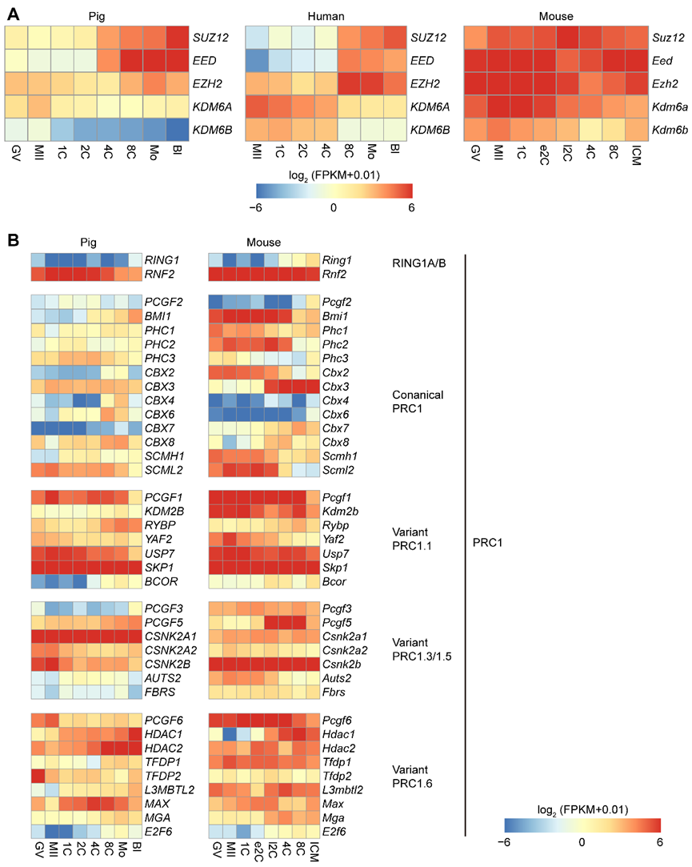
Supplemental_Fig_S12. Transcriptional levels of H3K27me3 regulators and PRC1 components among porcine, mouse and human oocytes and early embryos. (A) Heatmaps showing the transcriptional levels (FPKM) of genes related to H3K27me3 establishment (EED, EZH2, SUZ12) and removal (KDM6A and KDM6B) in porcine, mouse and human oocytes and early embryos. (B) Heatmaps showing the transcriptional levels (FPKM) of PRC1 component genes in porcine, mouse oocytes and early embryos. The ZGA timings of porcine, mouse and human are 4- to 8-cell embryos (4C-8C), late 2-cell embryos (l2C) and 8-cell embryos (8C), respectively. e2C, early 2-cell embryos.

