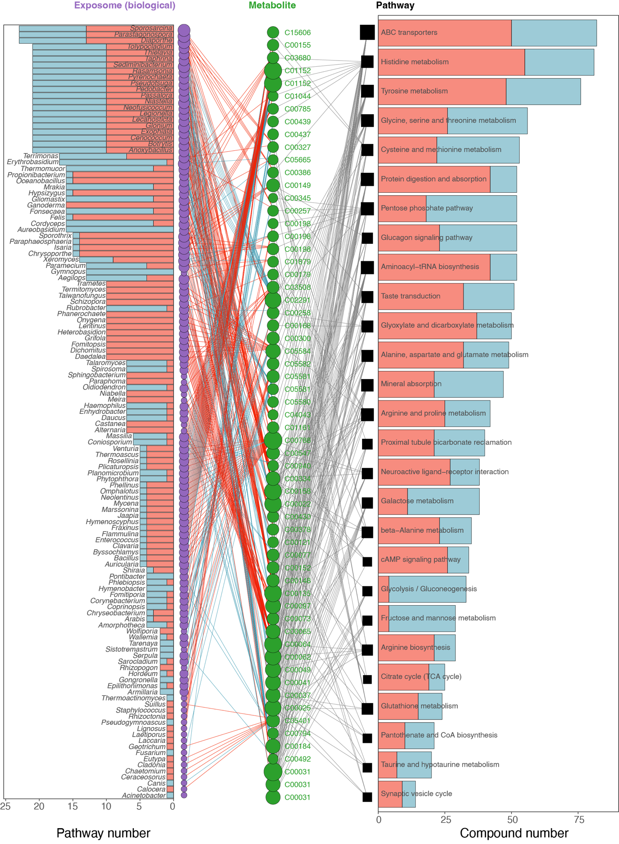
Figure S8. The complete network between the exposome and metabolite for each metabolic pathway (|r| > 0.9; q-value < 0.05).

