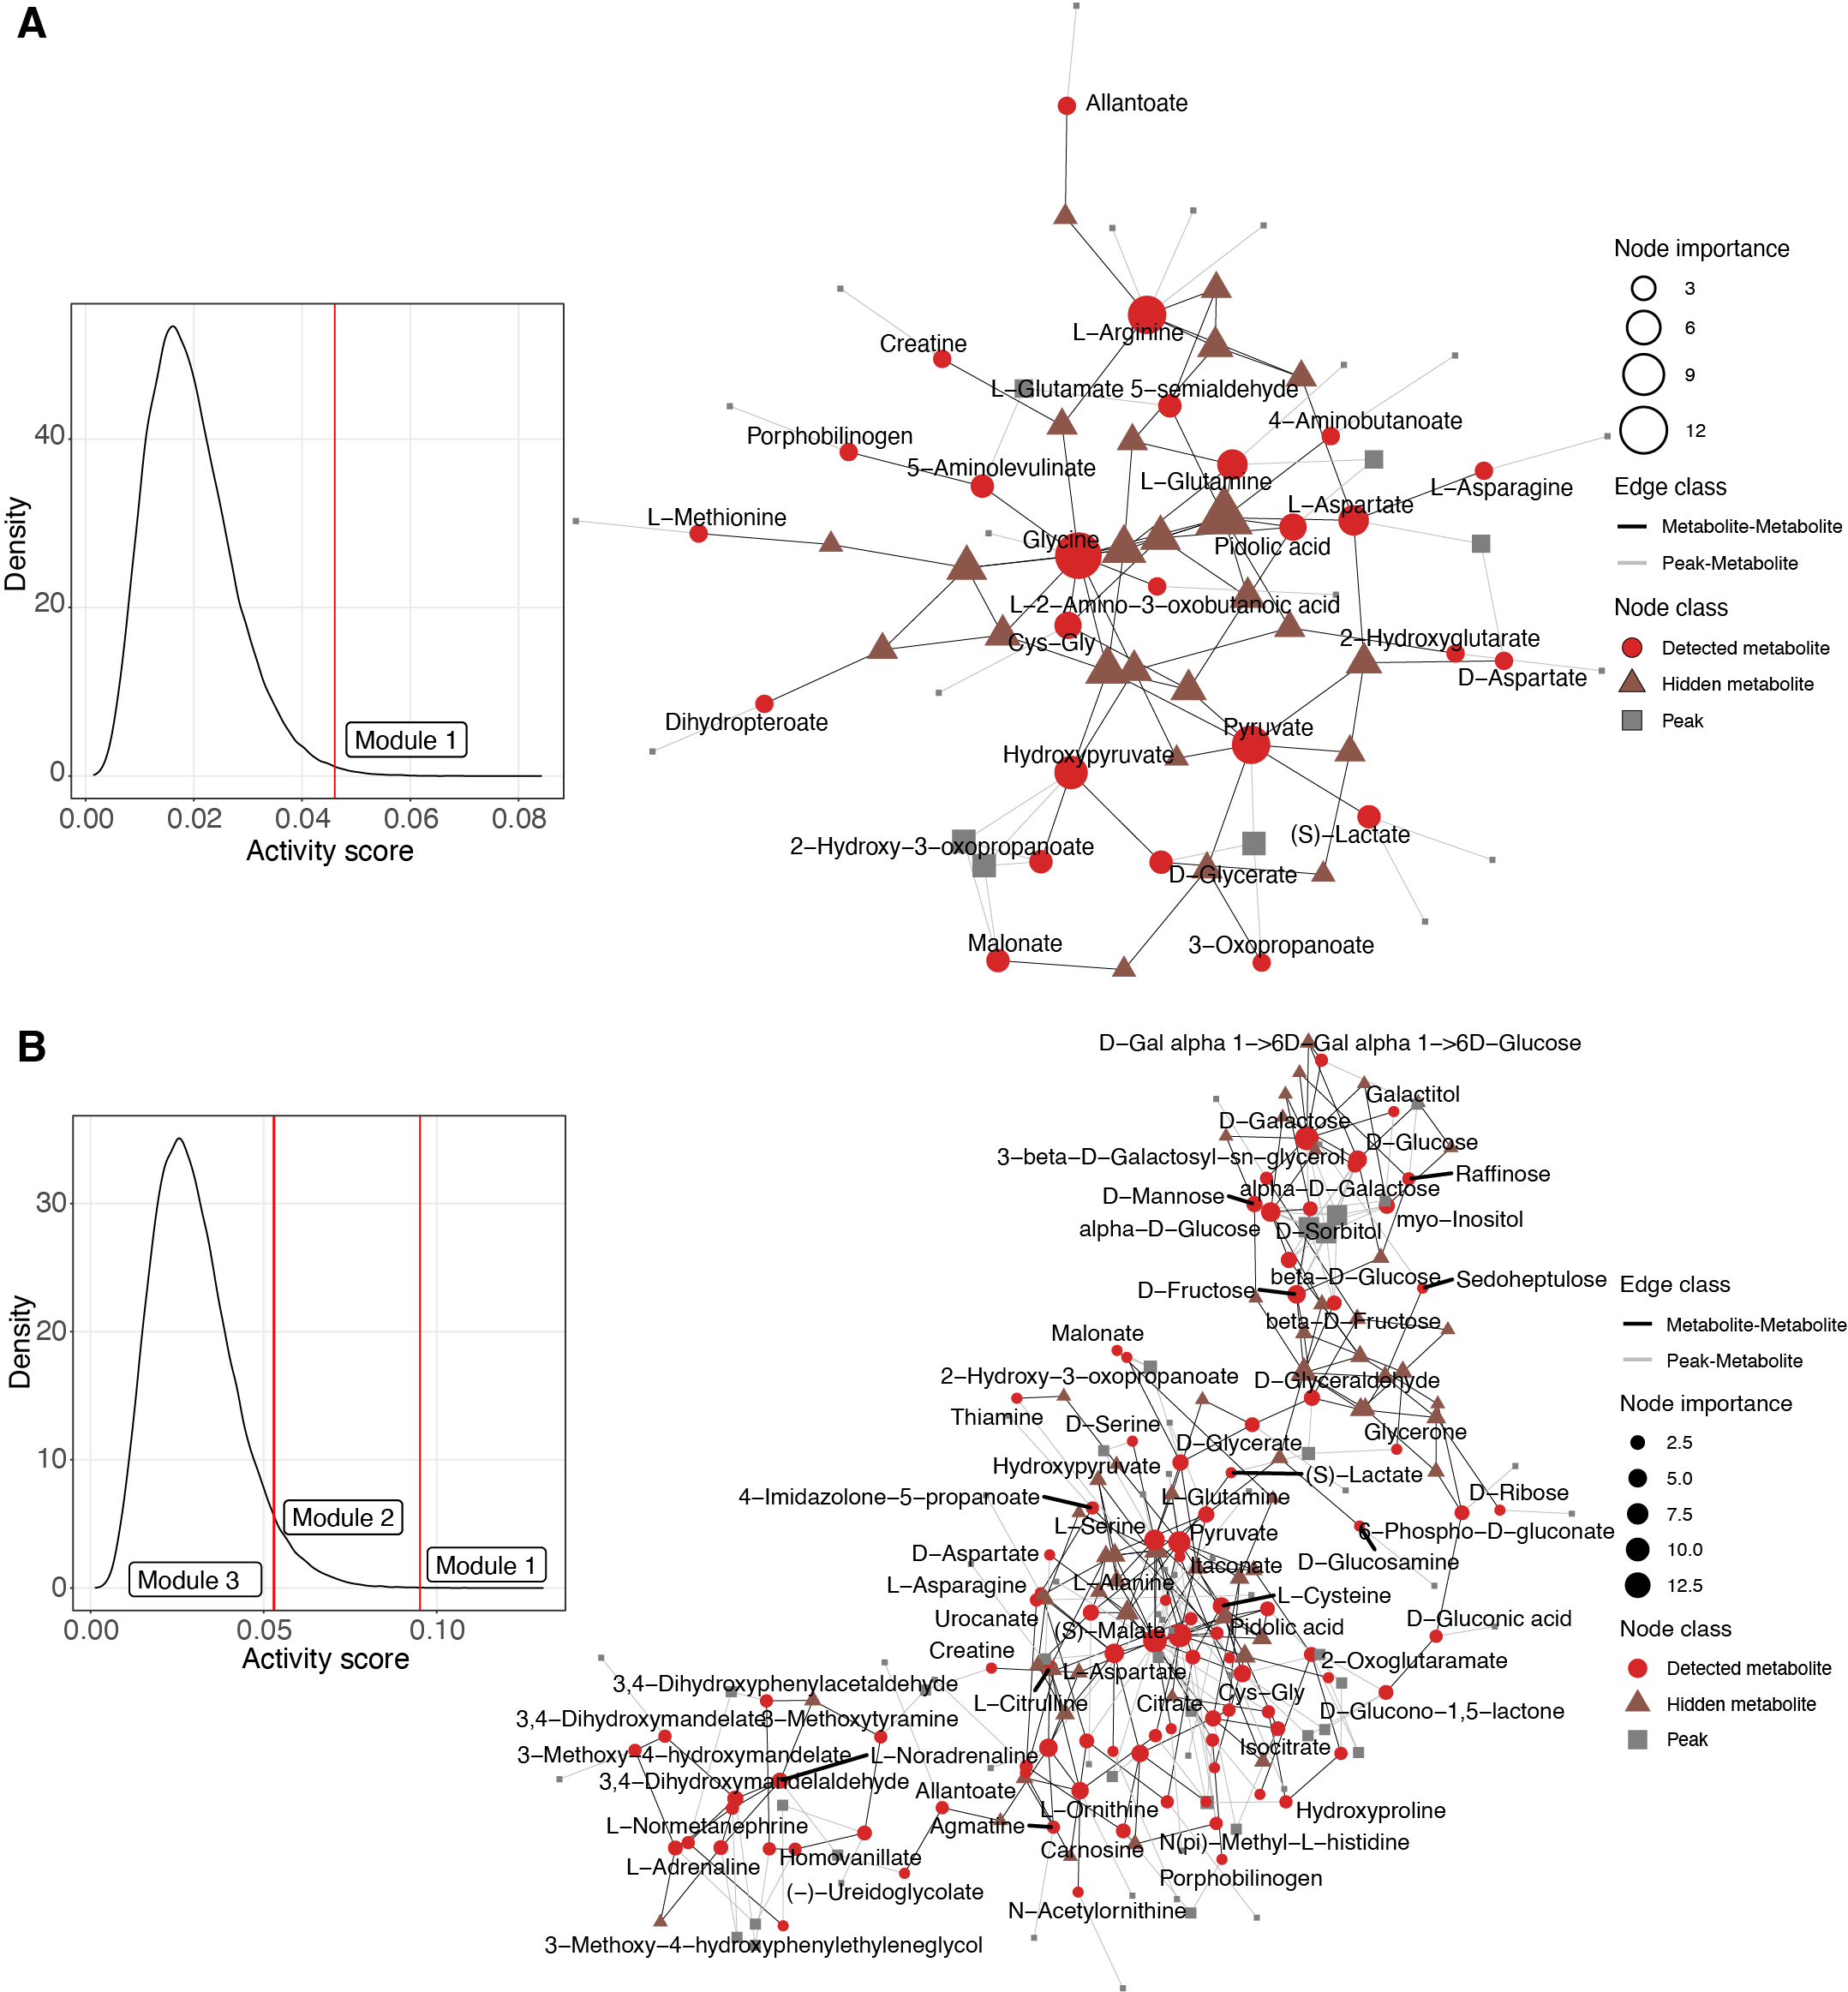
Figure S7. Feature-based network analysis for metabolic features significantly correlated with the exposome (Methods). (a) Chemical exposome. Left panel, the null distribution of activity scores and only module 1 was significant. Right panel, network constructed by significant modules. (b) Biological exposome. Left panel, the null distribution of activity scores and modules 1, 2 and 3 were significant. Right panel, network constructed by significant modules.

