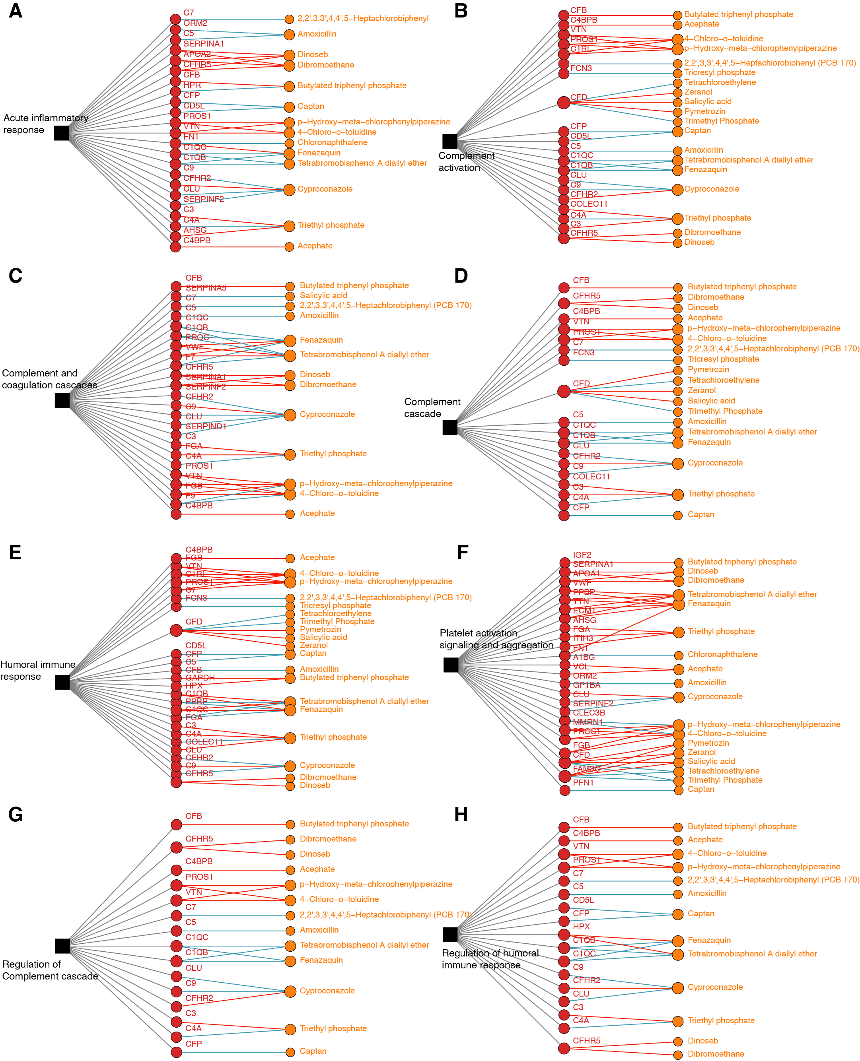
Figure S6. The detailed networks between the exposome and proteins for each signaling pathway (|r| > 0.9; q-value < 0.05).

