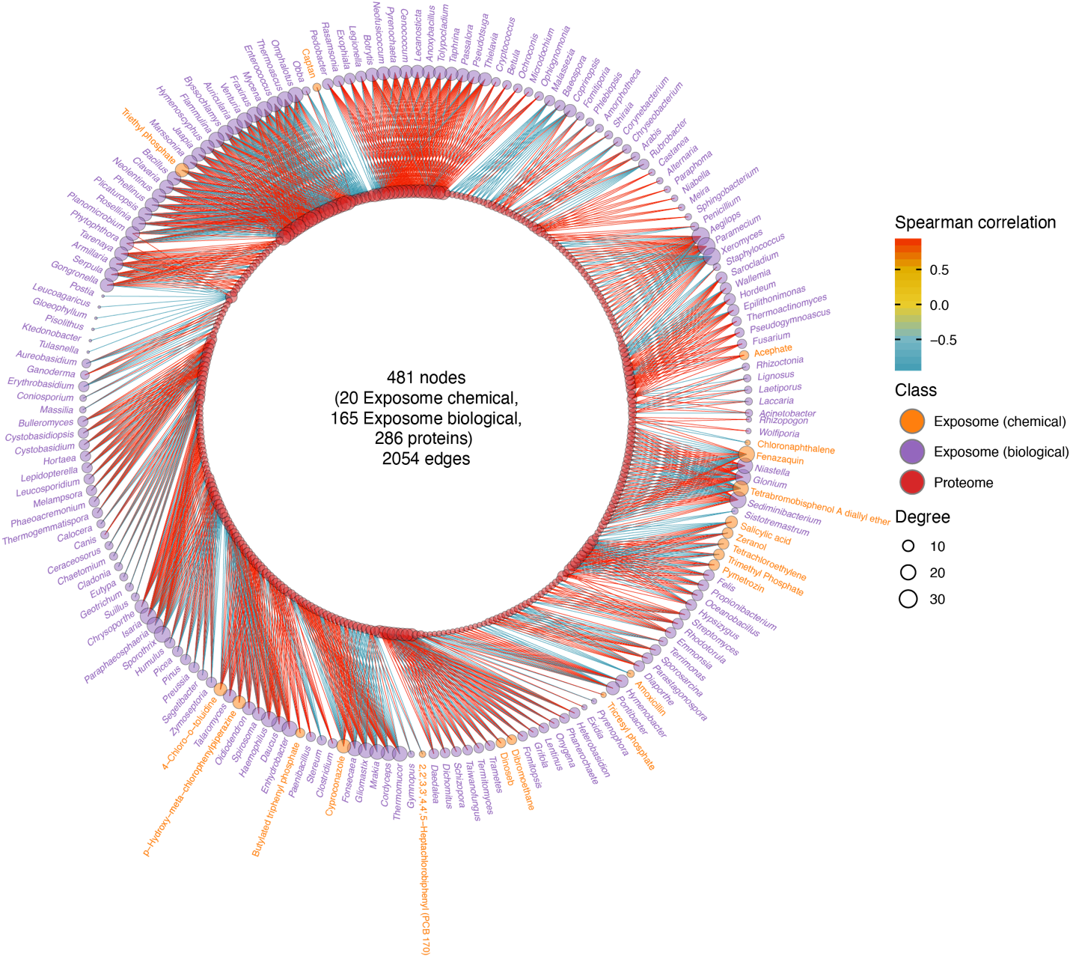
Figure S5. The complete correlation network between the exposome and proteome (|r| > 0.9; q-value < 0.05).

