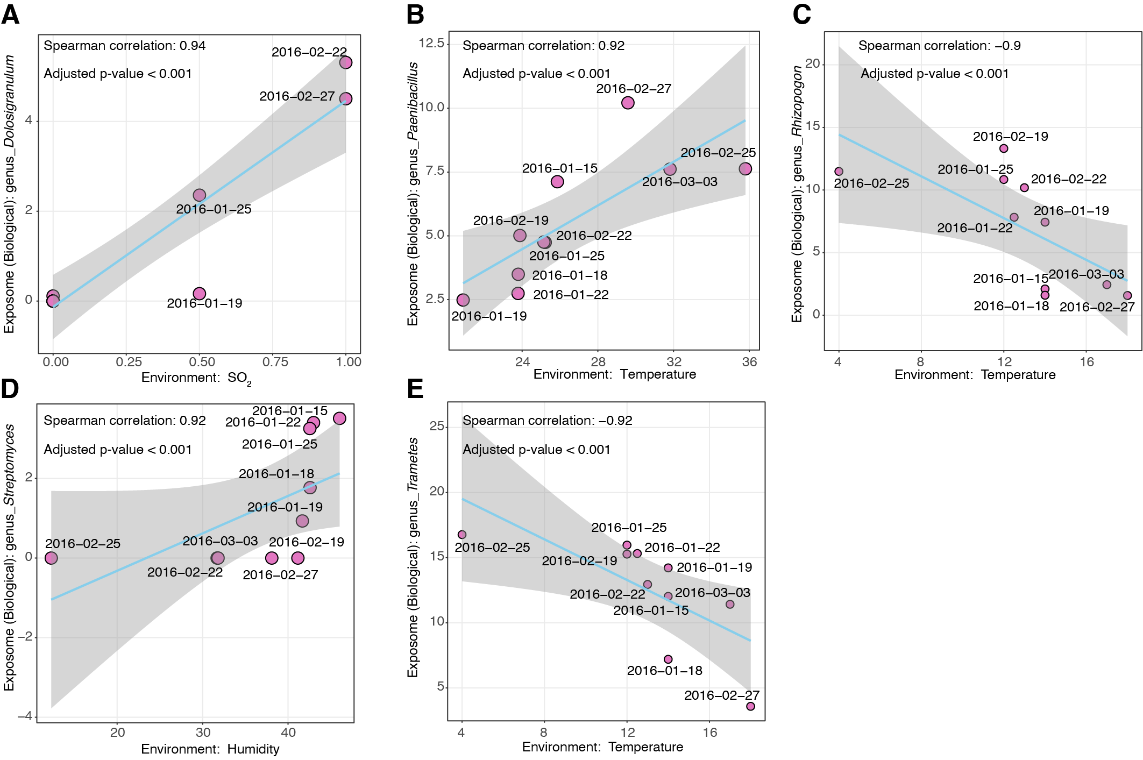
Figure S3. Representative Spearman correlation plots between environment factors and microbes.

