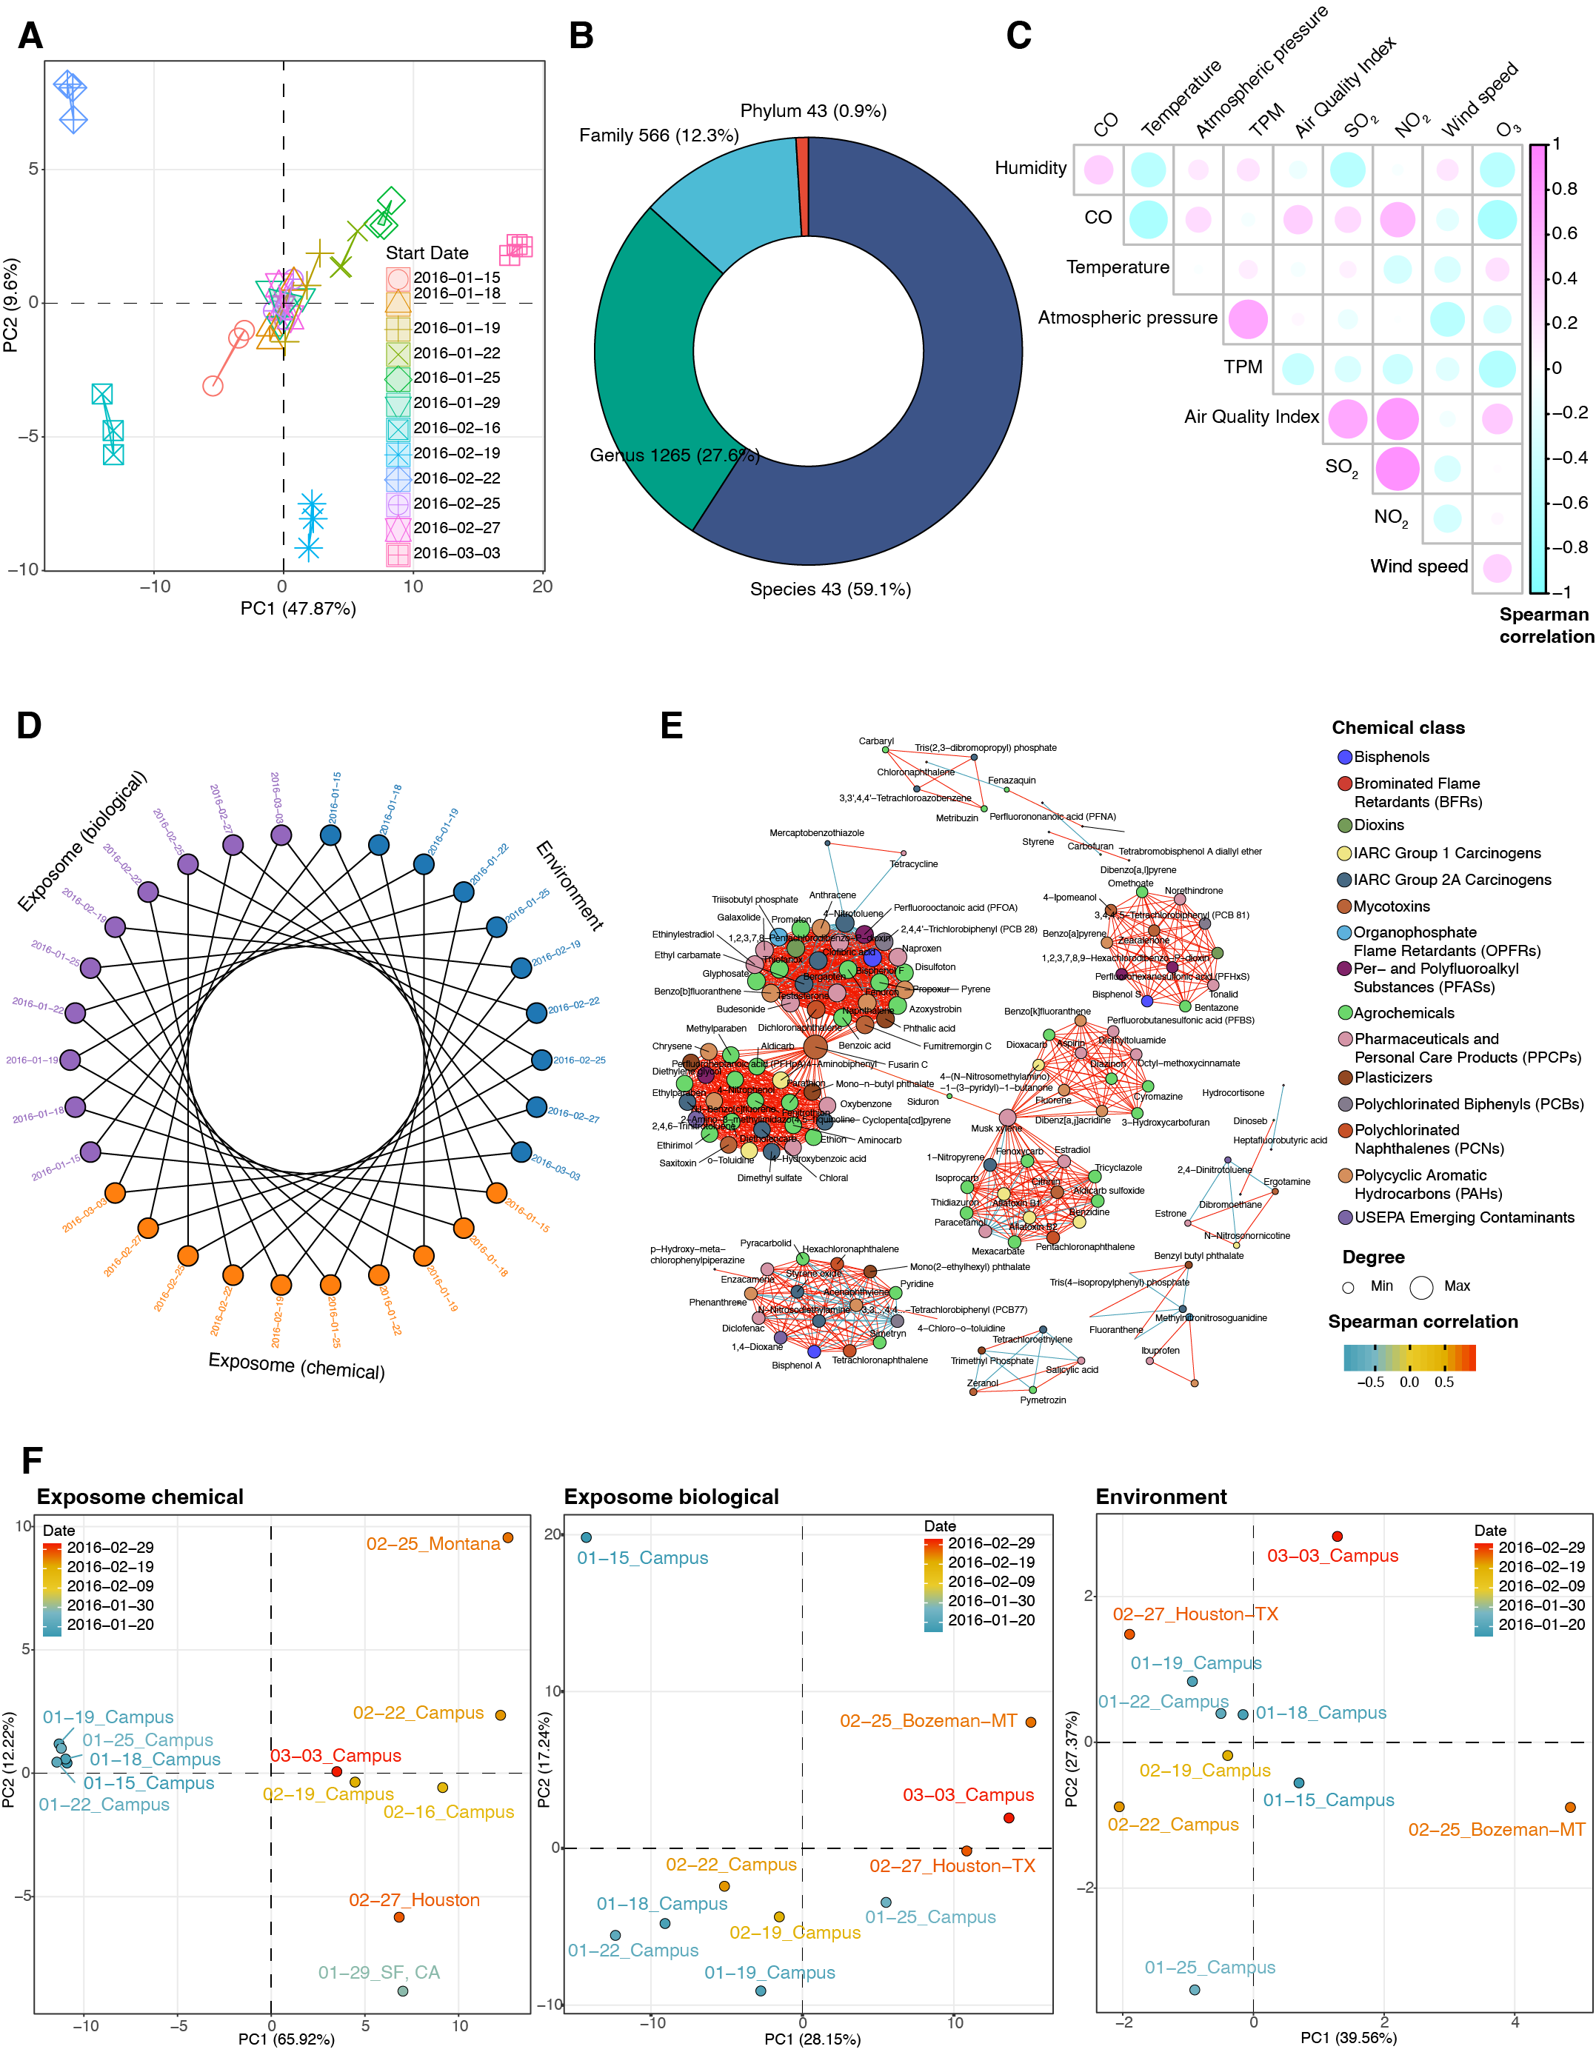
Figure S2. Overview of the exposome data. (a) PCA plot shows the data quality of chemical exposome data. For each sample, 3 repeats were acquired. (b) The number and percentage of biological exposome data at different taxonomic ranks. (c) Correlation plots with coefficients among all environmental factors. (d) Sample matching for 3 exposome domains. (e) Intra correlation network for the chemical exposome. (f) PCA plots of the 3 exposome domains based on the sampling time and locations.

