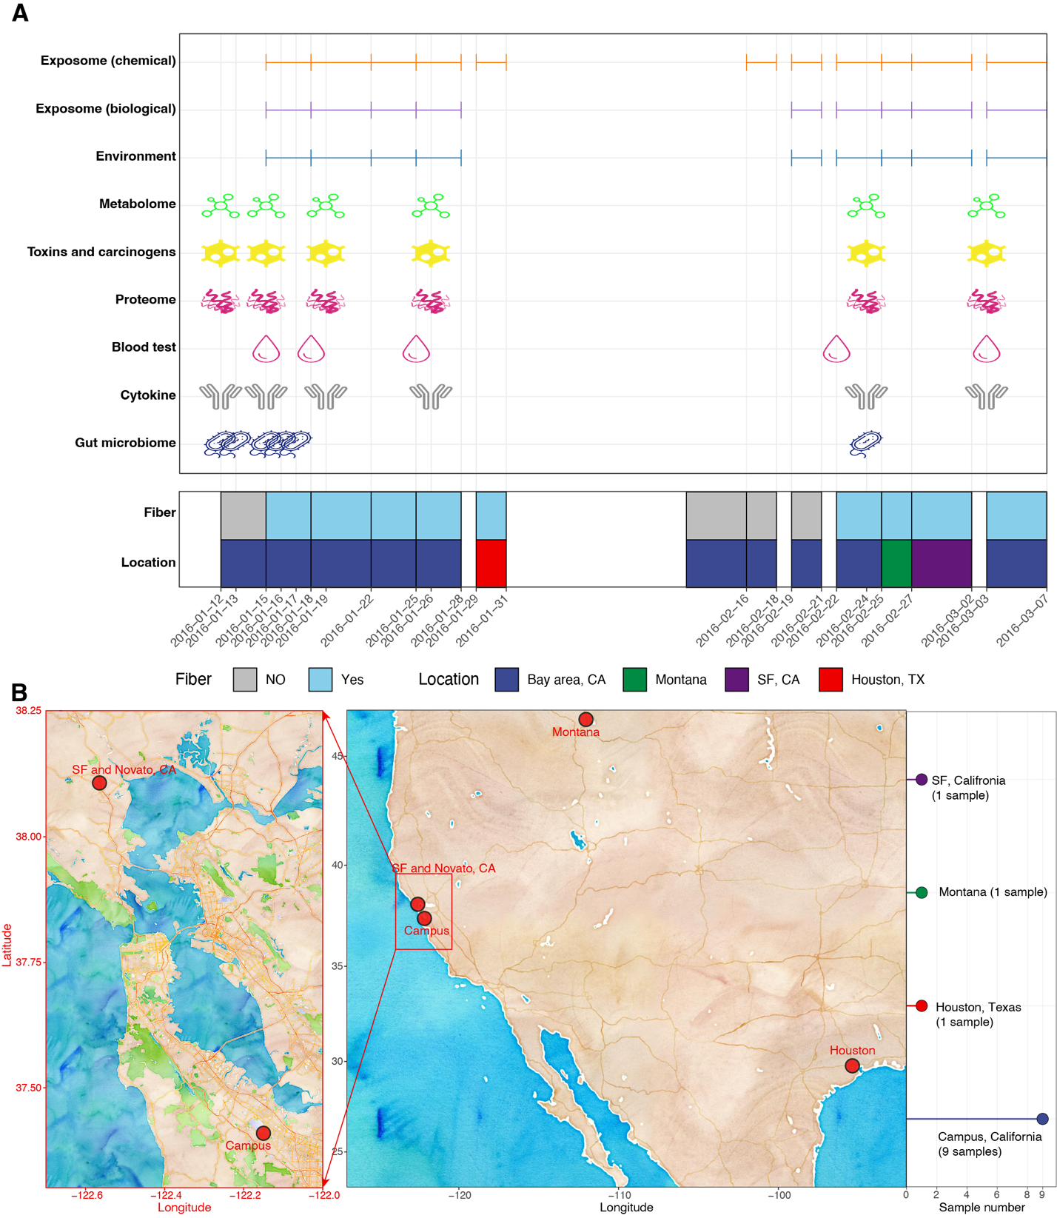
Figure S1. A detailed overview of sample collection. (a) Sample collection time points/periods for all exposome and internal multi-omics datasets. Corresponding fiber intake and geographical locations were also provided. (b) Collection locations for the exposome samples.

